Math, Actually

Volume 2 - From Multivariable Calculus to Set Theory & Logic
A Volume in the Math, Actually Series

Lothar J. Musiol

Copyright © 2026 Lothar J. Musiol
All rights reserved. No part of this publication may be reproduced, distributed, or transmitted in any form or by any means, including photocopying, recording, or other electronic or mechanical methods, without the prior written permission of the author, except in the case of brief quotations embodied in critical reviews and certain other non-commercial uses permitted by copyright law.
First edition, 2026.
The mathematics in this book has been checked with care. No book of this size is entirely free of error, and the author would rather hear about a mistake than have it quietly inherited by the next reader. The useful report names the volume, the chapter, and the section.
Math, Actually series

Table of Contents
Also in This Series 1
About This Volume 1
How to Use This Book 1
How This Book Is Organized 1
Where the Foundations Are 1
Reading Routes 1
Notation Used in This Volume 1
This Volume’s Chapters 1
Chapter 13: Multi-Variable Functions 1
Section 13.1: What a Function of Several Variables Is 1
Section 13.2: Domains, Graphs, and Level Sets 1
Section 13.3: Limits and Continuity in Several Variables 1
Section 13.4: Partial Derivatives 1
Section 13.5: The Gradient and Directional Derivatives 1
Section 13.6: The Chain Rule in Several Variables 1
Section 13.7: Tangent Planes and Linear Approximation 1
Section 13.8: Extrema and the Second-Derivative Test 1
Chapter 13 in One Page 1
Section 13.9: Where This Goes Next (Optional): From Multi-Variable Functions to Multi-Variable Calculus 1
Chapter 14: Multi-Variable Calculus 1
Section 14.1: Double Integrals and Iterated Integrals 1
Section 14.2: Triple Integrals and Applications 1
Section 14.3: Change of Variables and Jacobians 1
Section 14.4: Vector Fields and Line Integrals 1
Section 14.5: Conservative Fields and Potential Functions 1
Section 14.6: Surface Integrals and Flux 1
Section 14.7: Green’s Theorem 1
Section 14.8: Stokes’ Theorem and the Divergence Theorem 1
Chapter 14 in One Page 1
Section 14.9: Where This Goes Next (Optional): From Multi-Variable Calculus to Vector Calculus Applications and Beyond 1
Chapter 15: Vector Calculus 1
Section 15.1: Vector Fields Revisited 1
Section 15.2: The Gradient, Divergence, and Curl 1
Section 15.3: Identities and the Algebra of Differential Operators 1
Section 15.4: Line Integrals and Conservative Fields 1
Section 15.5: Surface Integrals and Flux 1
Section 15.6: Green’s, Stokes’, and Gauss’s Theorems Revisited 1
Section 15.7: Potential Theory and Helmholtz Decomposition 1
Section 15.8: Physical Applications 1
Chapter 15 in One Page 1
Section 15.9: Where This Goes Next (Optional): Differential Forms, Manifolds, and Beyond 1
Chapter 16: Series 1
Section 16.1: What a Series Is 1
Section 16.2: Numerical Series: Convergence Tests 1
Section 16.3: Power Series and Radius of Convergence 1
Section 16.4: Taylor and Maclaurin Series 1
Section 16.5: Operations on Power Series 1
Section 16.6: Fourier Series: The Basic Theory 1
Section 16.7: Convergence of Fourier Series and Applications 1
Section 16.8: Other Expansions and Generating Functions 1
Chapter 16 in One Page 1
Section 16.9: Where This Goes Next (Optional): From Series to Transforms and Functional Analysis 1
Chapter 17: Fourier Transforms and FFT 1
Section 17.1: From Fourier Series to the Fourier Transform 1
Section 17.2: The Fourier Transform on the Line 1
Section 17.3: Inversion, Plancherel, and Parseval 1
Section 17.4: Convolution and the Convolution Theorem 1
Section 17.5: The Discrete Fourier Transform 1
Section 17.6: The Fast Fourier Transform 1
Section 17.7: Applications: Filtering, PDEs, and Signal Processing 1
Section 17.8: Windows, Uncertainty, and Limitations 1
Chapter 17 in One Page 1
Section 17.9: Where This Goes Next (Optional): From Fourier to Laplace, Wavelets, and Spectral Theory 1
Chapter 18: Laplace Transform 1
Section 18.1: What the Laplace Transform Actually Is 1
Section 18.2: Basic Transforms and Operational Rules 1
Section 18.3: The Inverse Transform and Partial Fractions 1
Section 18.4: Solving Linear Differential Equations 1
Section 18.5: Discontinuous and Impulsive Forcing 1
Section 18.6: Convolution and the Convolution Theorem 1
Section 18.7: Systems and Transfer Functions 1
Section 18.8: Further Properties and Techniques 1
Section 18.9: The Working Tables 1
Chapter 18 in One Page 1
Section 18.10: Looking Back, and Where This Goes Next (Optional) 1
Chapter 19: Integral Geometry 1
Section 19.1: What Integral Geometry Actually Is 1
Section 19.2: Invariant Measures on Spaces of Lines and Planes 1
Section 19.3: The Cauchy–Crofton Formula 1
Section 19.4: Crofton Formulas in the Plane and in Space 1
Section 19.5: Kinematic Formulas and the Principal Kinematic Formula 1
Section 19.6: The Radon Transform 1
Section 19.7: Inversion of the Radon Transform and Tomography 1
Section 19.8: Stereology and Practical Measurement 1
Chapter 19 in One Page 1
Section 19.9: Where This Goes Next (Optional): From Integral Geometry to Geometric Measure Theory and Advanced Topics 1
Chapter 20: Matrices 1
Section 20.1: What a Matrix Is 1
Section 20.2: Matrix Arithmetic: Addition, Scalar Multiplication, Multiplication 1
Section 20.3: The Identity, Inverses, and Elementary Matrices 1
Section 20.4: Determinants 1
Section 20.5: Row Reduction, Rank, and Solving Systems 1
Section 20.6: Matrices as Linear Maps 1
Section 20.7: Eigenvalues and Eigenvectors: A First Look 1
Section 20.8: Special Matrices and Factorizations 1
Chapter 20 in One Page 1
Section 20.9: Where This Goes Next (Optional): From Matrices to Linear Algebra 1
Chapter 21: Linear Algebra 1
Section 21.1: Vector Spaces and Subspaces 1
Section 21.2: Linear Independence, Bases, and Dimension 1
Section 21.3: Linear Maps and Matrices with Respect to Bases 1
Section 21.4: Rank, Nullity, and the Fundamental Theorem 1
Section 21.5: Eigenvalues, Eigenvectors, and Diagonalization 1
Section 21.6: Inner-Product Spaces and Orthogonality 1
Section 21.7: The Spectral Theorem and Quadratic Forms 1
Section 21.8: Jordan Form, SVD, and Canonical Forms 1
Chapter 21 in One Page 1
Section 21.9: Where This Goes Next (Optional): From Linear Algebra to Modules, Representations, and Functional Analysis 1
Chapter 22: Analytic Geometry 1
Section 22.1: What Analytic Geometry Is 1
Section 22.2: Lines and Planes in Coordinates 1
Section 22.3: Distances, Angles, and Projections 1
Section 22.4: Circles, Spheres, and Simple Quadric Surfaces 1
Section 22.5: Conic Sections: Classification and Properties 1
Section 22.6: The General Second-Degree Equation 1
Section 22.7: Quadric Surfaces in Space 1
Section 22.8: Transformations and Invariants 1
Chapter 22 in One Page 1
Section 22.9: Where This Goes Next (Optional): From Analytic Geometry to Differential Geometry and Algebraic Geometry 1
Chapter 23: Complex Analysis 1
Section 23.1: Complex Numbers and the Complex Plane 1
Section 23.2: Holomorphic Functions and the Cauchy–Riemann Equations 1
Section 23.3: Contour Integrals and Cauchy’s Theorem 1
Section 23.4: The Cauchy Integral Formula and Power Series 1
Section 23.5: Laurent Series and Singularities 1
Section 23.6: The Residue Theorem and Applications 1
Section 23.7: Conformal Mapping and the Riemann Mapping Theorem 1
Section 23.8: Harmonic Functions and Boundary-Value Problems 1
Chapter 23 in One Page 1
Section 23.9: Where This Goes Next (Optional): From Complex Analysis to Riemann Surfaces and Several Complex Variables 1
Chapter 24: Counting Carefully 1
Section 24.1: What Discrete Mathematics Is 1
Section 24.2: Counting Principles and Generating Functions 1
Section 24.3: Recurrence Relations 1
Section 24.4: Graph Theory: Basics, Paths, and Trees 1
Section 24.5: Connectivity, Colorings, and Matchings 1
Section 24.6: Logic, Proofs, and Boolean Algebra 1
Section 24.7: Sets, Relations, and Functions (Discrete View) 1
Section 24.8: Introduction to Algorithms and Complexity 1
Chapter 24 in One Page 1
Section 24.9: Where This Goes Next (Optional): From Discrete Mathematics to Combinatorics, Graph Theory, and Theoretical CS 1
Chapter 25: Set Theory & Logic 1
Section 25.1: What Set Theory and Logic Actually Are 1
Section 25.2: Naive Set Theory: Operations, Relations, Functions 1
Section 25.3: Infinite Sets, Cardinality, and Cantor’s Theorems 1
Section 25.4: The Axiom of Choice and Its Equivalents 1
Section 25.5: Ordinals, Well-Ordering, and Transfinite Induction 1
Section 25.6: Propositional and Predicate Logic 1
Section 25.7: Formal Proofs, Completeness, and Soundness 1
Section 25.8: Incompleteness and Undecidability 1
Chapter 25 in One Page 1
Section 25.9: Where This Goes Next (Optional): From Foundations to Category Theory, Model Theory, and Beyond 1
Epilogue — Between Volumes 1
Answer Key 1
Solutions to the Problems 1
Answers to the Practice Sets 1
Symbol & Notation Glossary 1
Appendix — Further Reading 1
Subject Index 1
Also by Lothar J. Musiol 1
A Note Before You Go 1

Also in This Series
Volume 1 — From Arithmetic to Calculus
Counting and number theory, algebra, functions and graphs, coordinates, Euclidean geometry, trigonometry, logarithms, systems of equations, vectors, limits, the derivative, and the integral. Chapters 1–12; it reads on its own through single-variable calculus.
Volume 3 — From Differential Equations to Abstract Algebra
Differential and integro-differential equations, partial differential equations, optimization and the calculus of variations, numerical methods, differential geometry, topology, advanced integral geometry, tensors and manifolds, functional analysis, measure theory, and abstract algebra. Chapters 26–37.
Volume 4 — From Category Theory to the Frontier
Category theory, information theory, wavelets, game theory, statistics and probability, computational geometry, control theory, dynamical systems and chaos, mathematical physics, advanced optimization and numerical methods, and mathematical modeling. Chapters 38–50.
Also by Lothar J. Musiol: Physics, Actually, the companion series on the physical world, and Quanta, Actually, on the quantum world. Every title is listed on the Also by Lothar J. Musiol page at the back of this volume.

About This Volume
This is Volume 2 of Math, Actually, one continuous fifty-chapter book about mathematics published in four volumes. Volume 1 (Chapters 1–12) runs from arithmetic to single-variable calculus and holds the full preface. If this is your first volume, the short notes that follow explain how the book is organized and where its foundations are; references to earlier volumes are given as a topic name with its volume, for example “Limits (Volume 1)”.
This volume covers Chapters 13 through 25: multivariable and vector calculus, series and integral transforms, matrices and linear algebra, analytic and integral geometry, complex analysis, counting and discrete mathematics, and set theory and logic. Thirteen chapters that take everything Volume 1 built in one variable and generalize it — more dimensions, more structure, and, by the end, a first proper look at the foundations mathematics itself stands on.
Volume 1 ended with the integral. This volume opens by asking what happens to the derivative and the integral when a function depends on more than one number, and it closes with the logic and set theory on which every earlier chapter quietly relied. Volume 3 takes up differential equations, optimization, and the geometry that holds them together.

How to Use This Book

What this book is, and what it is not
A word on what the series is trying to do, so that it can be judged for that rather than for something it never attempted. This is a map of mathematics, not a replacement for the mathematics it maps. Fifty chapters cannot do the work of fifty textbooks, and this book does not pretend otherwise.
What it offers instead is a single continuous walk through the whole book, so that afterwards no section in it is entirely unfamiliar. That is a different achievement from expertise, and a more useful one than it sounds. Mathematics punishes the reader who meets an idea cold and rewards the one who has met it before, however briefly. A reader who half-remembers what a tensor is will read a physics paper very differently from one who has never seen the word.

The worked examples are the exercises
There are 1,585 worked examples in the series, 435 of them in this volume, and they are the most valuable thing in it — but only if you use them properly.
When you reach one, stop. Cover everything below the first line, take a pencil, and attempt it yourself before reading on. A worked example read passively teaches almost nothing. The same example, attempted first and then checked against the book, teaches a great deal, because the value lies entirely in comparing your reasoning against the book’s and noticing where the two diverged.
This is not a moral instruction. It is the closest thing to a free lunch that the study of mathematics offers, and it costs about two minutes per example. Read that way, the series contains 1,585 such exercises, 435 of them in this volume, the worked solution attached to each — more practice, already checked, than most textbooks provide. That count does not include the Check Your Understanding and end-of-chapter Problems: those are real exercises too, but their answers live in the Answer Key and Solutions to the Problems at the back of the volume, not next to the question, so attempt them with a pencil before you turn there.

The questions at the end of each chapter
Every chapter closes with a short set of Check Your Understanding questions, a Fluency Drill and a set of Problems. Full answers to the Check Your Understanding questions are in the Answer Key, full solutions to the Problems are in Solutions to the Problems, and the answers to every Try it now, Keep only this and drill question are in Answers to the Practice Sets, all at the back of the volume.
Those questions are deliberately conceptual rather than mechanical. They tend to ask why something is true, or why a plausible-looking claim is false — why a series whose terms shrink to zero can still diverge, why a function can be infinitely differentiable and still refuse its Taylor series, why the rational numbers can be dense and still countable. Answers to questions of that kind survive; answers to “differentiate the following” tend not to.

When a chapter genuinely interests you, read beyond the book
The Further Reading appendix names one or two real textbooks for each region of the series — chosen because they are the ones people actually finish rather than the ones that look most impressive unopened.
Working through one of them properly, slowly, with a pencil and a certain amount of suffering, is the only method anyone has ever found that reliably turns acquaintance into competence. No survey substitutes for it, and this one does not try to. The series’ job is to help you decide which book to pick up, and to make sure that when you open it, the vocabulary is already familiar.

How each section is built
Every chapter and section uses the same parts, so you always know where you are and what to do next. Exercises are the backbone: you meet one every few pages, graded from easy to challenging, and every one has a full worked answer that names the mistake it most often provokes.
Core, Extension, Preview. A small label under each chapter and section title. Core material is needed later in the series. Extension material deepens a topic but nothing later depends on it. A Preview — optional section, always the last in its chapter under the heading “Where This Goes Next (Optional)”, looks ahead and can be skipped. Each label also gives an estimated reading time.
Before you begin. At the start of each chapter: what you will be able to do, why the chapter comes where it does, the required chapters (each a link), assumed skills with refresher links, three “Do not proceed until you can…” questions with answers, and a realistic study time.
Worked examples. Blue boxes. Cover the solution and attempt the example first.
Theorem boxes. Gold boxes stating a central result, followed by a checklist of its hypotheses (□) and a line on why it matters. Check every hypothesis before you use the theorem.
Try it now. A short check inside the section, marked by a gold bar, after the first worked example. Do it before you read on; the answer is one click away.
Keep only this. A gold box at the end of each section: the one idea, the core formulas, the most common mistake, a minimal example, and three practice questions graded Easy, Medium and Challenge. Every practice question is answered in full, with its common mistake named, in Answers to the Practice Sets.
Context. Grey boxes of history and background, marked optional. Skip them and you lose no mathematics.
Chapter N in One Page. Before each chapter’s preview section: a one-page summary, the key definitions, the key theorems with their hypotheses, one canonical example, the common errors, and a readiness checklist.
Fluency Drill. Eight short questions before the Problems — five minutes of routine (subspace tests, ranks, projections, pole orders, enclosure, bipartite tests, quantifiers, growth rates) so that the Problems test ideas rather than arithmetic.
Check Your Understanding and Problems. At the end of each chapter. Every item carries one of six tags, the same as in Volume 1: [Concept] and [Explain] ask what an idea means or why it holds; [Compute] asks for a calculation; [Model] applies one to a real situation with units; [Prove] asks for a complete argument; [Challenge] goes beyond the section. Every answer and every solution, proofs included, is worked in full in the back of the book.

How This Book Is Organized
The fifty chapters of Math, Actually run continuously across the four volumes, so Chapter 13 opens Volume 2 and Chapter 50 closes Volume 4. Each chapter is one broad territory of mathematics. Each section within a chapter is one idea, numbered by its chapter: Section 6.3 is the third section of Chapter 6. Each chapter ends with Check Your Understanding questions and a set of Problems; their answers are at the back of the volume.
Whenever a section uses an idea from somewhere else, it names that section by its topic. Inside this volume the name is a link: follow it and you land on the section, and the Back button of your reader brings you home again. An idea from another volume cannot be linked across files, so it is named with its volume instead — “Limits (Volume 1)” — and the Subject Index of that volume will find it.
Every section is built in the same order. It opens in plain language: what the idea is, why it matters, and what it feels like, usually with numbers you can check by hand. The definitions and formulas come next, once you have seen why they are needed. The worked examples follow and put the formulas to use.
One more convention, purely visual. Worked examples appear in shaded boxes rather than running paragraphs, so that your eye can find them again on a later skim. A blue box marks an example that works through actual numbers, or through the general case when numbers would not illuminate anything — either way, one clean argument from start to finish. A purple box marks the rarer case where you get both: the concrete instance and the general pattern beside it, on the theory that seeing the same idea twice, once with numbers and once without, is worth the extra half-page far more often than authors like to admit.

Where the Foundations Are
One structural confession, best made early. The book begins with counting, because that is where a human being begins. But the logical foundations of mathematics — the axioms of set theory, the rules of inference, the machinery that says what a proof is — are not in Chapter 1. They are in Chapter 25, at the end of Volume 2, which is an odd place to put a foundation.
This is deliberate, and it is not a compromise. Mathematics was not discovered in logical order. Counting is some tens of thousands of years old; the axioms that justify it were written down in the 1920s. Children learn arithmetic long before they learn what a set is, and the ones who go on to learn what a set is do not thereby discover that their arithmetic was wrong. The foundations were laid underneath a subject that was already well established and doing perfectly well.
So you do not need Chapter 25 to read the chapters before it. You will want to read it eventually, for the same reason anyone eventually looks at foundations: not because anything is falling down, but because you have started to wonder what is holding it all up. Readers who prefer their logic first are welcome to read Chapter 25 early. It assumes very little and says so.

Reading Routes
The chapters run in one line, from multivariable calculus to logic, and the jumps between them are real: from the SVD to conics, from conics to residues, from residues to graphs. Read straight through if you can. If you have a particular goal, one of the routes below picks the chapters that serve it, in an order that works. Sections labelled Core in the chapters on a route are the minimum; Extension and Preview sections can wait.
Applied route (engineering, physics, data). Chapters 13 → 14 → 15 for calculus in several variables and the integral theorems; 16 → 17 → 18 for series, Fourier and Laplace transforms; 20 → 21 for matrices, the spectral theorem and the SVD; then 23.1–23.6 for complex numbers and residues, which evaluate the integrals and inverse transforms of Chapters 17–18. Chapter 19 (tomography) is a good optional extra.
Pure route (toward analysis, algebra and geometry). Chapters 13 → 14 → 16 for limits, integrals and convergence; 20 → 21 → 22 for linear algebra and its geometry; 23 in full for complex analysis; then 25 for sets, cardinality and logic. Chapter 15 can be read lightly, and Chapter 24.6–24.7 is a short bridge to Chapter 25.
Computer-science route. Chapters 24 → 25 first (they assume little from earlier chapters), then 20 → 21 for linear algebra, 16.1–16.5 and 16.8 for series and generating functions, and 17.5–17.6 for the discrete and fast Fourier transforms. Chapter 13 provides the gradients used in optimization.
General enrichment route. One chapter from each family, read for ideas: 13 (functions of several variables), 17 (Fourier), 21 (linear algebra, especially 21.7–21.8), 23 (complex analysis, especially 23.6–23.7), 24 (graphs and P versus NP) and 25 (infinity and incompleteness). Do each section’s Try it now; leave the Problems for a second reading.
Whichever route you take, each chapter’s “Before you begin” box names exactly which earlier chapters it needs, and its three diagnostic questions tell you whether you are ready.

Notation Used in This Volume
The same symbol means the same thing throughout this volume. Notation is typed rather than typeset, so that it survives every e-reader; the table shows how each idea is written and where it is first set up.
Vectors and matrices
Symbol | Meaning | Where it is set up
v, (x, y, z) | a vector, written by its components | Chapter 13
[a b; c d] | a matrix written inline, rows separated by semicolons; displayed matrices are drawn as grids | Chapter 20
Aᵀ, A⁻¹ | transpose; inverse | Chapter 20
A* | adjoint (conjugate transpose), A* = conj(A)ᵀ; equals Aᵀ for real A | Chapter 21
det A, tr A | determinant; trace | Chapter 20
I, Iₙ | identity matrix | Chapter 20

Inner products and norms
Symbol | Meaning | Where it is set up
u · v | dot product in ℝⁿ | Chapter 13
⟨u, v⟩ | inner product; for complex vectors linear in the first slot and conjugate-linear in the second: ⟨u, v⟩ = Σ uₖ v̄ₖ | Chapter 21
⟨f, g⟩ = ∫[−π, π] f(x) ḡ(x) dx | inner product of functions (Fourier series) | Chapter 16
|v|, ‖f‖ | length (norm) of a vector or function | Chapters 13, 16

Complex numbers and contours
Symbol | Meaning | Where it is set up
z̄ | complex conjugate of a single symbol, z̄ = x − iy | Chapter 23
conj(·) | conjugate of a compound expression, such as conj(A) or conj(Xₖ) | Chapters 17, 21
|z|, arg z | modulus; argument | Chapter 23
∮ᵧ f(z) dz, ∮[C] | integral round a closed contour γ or C, counterclockwise unless stated | Chapter 23
Res[z = a] f | residue of f at a: the coefficient of (z − a)⁻¹ | Chapter 23

Integrals, series and transforms
Symbol | Meaning | Where it is set up
∫[a, b] f(x) dx | definite integral from a to b | Volume 1
∬_{R}, ∭_{E} | double and triple integrals over a region | Chapter 14
Σ[n = 0 to ∞] | sum over the stated range | Chapter 16
f̂(ξ) = ∫ f(x) exp(−2πixξ) dx | Fourier transform in ordinary frequency ξ; with angular frequency ω = 2πξ, factors of 2π move into the inverse | Chapter 17
L{f}(s) | Laplace transform | Chapter 18
f ∗ g | convolution | Chapters 17, 18
exp(x) | the exponential, written exp(·) when the exponent is long | throughout

Calculus in several variables
Symbol | Meaning | Where it is set up
f_{x}, f_{y}, ∂f/∂x | partial derivatives | Chapter 13
∇f, ∇ · F, ∇ × F | gradient, divergence, curl | Chapters 13, 15
lim[x→a] | limit as x tends to a (also lim[(x, y) → (a, b)]) | Volume 1, Chapter 13

Logic, sets and complexity
Symbol | Meaning | Where it is set up
∀, ∃, ¬, ∧, ∨, →, ↔ | quantifiers and connectives | Chapters 24, 25
|S|, P(S) | cardinality; power set | Chapter 25
ℵ₀, ω | cardinality of ℕ; first infinite ordinal | Chapter 25
O(g), Ω(g), Θ(g) | at most, at least, exactly the growth of g, up to constant factors for large n | Chapter 24
P, NP | polynomial-time solvable; polynomial-time verifiable | Chapter 24

This Volume’s Chapters
Every chapter in this volume, one line each, with what it assumes you already know. Follow a title to jump straight there.
Volume 2 — From Multivariable Calculus to Set Theory & Logic
Chapter 13 — Multi-Variable Functions
Needs Volume 1’s limits (Chapter 10) and derivatives (Chapter 11), and vectors in the plane.
Chapter 14 — Multi-Variable Calculus
Needs Chapter 13: partial derivatives, gradients and the chain rule. Single-variable integration from Volume 1.
Chapter 15 — Vector Calculus
Needs Chapter 14’s line and surface integrals; it gathers them into gradient, divergence, curl and the three integral theorems.
Chapter 16 — Series
Needs Volume 1’s limits and integrals; Chapter 15 is not required. Fourier series use integration by parts.
Chapter 17 — Fourier Transforms and FFT
Needs Chapter 16’s Fourier series and complex exponentials.
Chapter 18 — Laplace Transform
Needs Chapter 17’s transform idea and Volume 1’s integration; partial fractions are reviewed.
Chapter 19 — Integral Geometry
An Extension chapter. Needs Chapter 14 (iterated integrals, Jacobians) and basic probability; Chapter 17 helps with Sections 19.6–19.7.
Chapter 20 — Matrices
No hard prerequisites beyond algebra and simultaneous equations.
Chapter 21 — Linear Algebra
Needs Chapter 20: matrix multiplication, inverses, determinants, row reduction and 2 × 2 eigenvalues.
Chapter 22 — Analytic Geometry
Needs Chapter 21’s spectral theorem for the classification of conics and quadrics (Sections 22.6–22.7); the earlier sections need only Chapter 20.
Chapter 23 — Complex Analysis
Needs Chapter 13’s partial derivatives, Chapter 14’s line integrals and Green’s theorem, and Chapter 16’s power series.
Chapter 24 — Counting Carefully
Needs little beyond algebra and induction; generating functions use Chapter 16, and spectral graph theory uses Chapter 21.
Chapter 25 — Set Theory & Logic
Needs Chapter 24’s logic and sets (Sections 24.6–24.7); it re-derives the numbers of Volume 1’s first chapters from sets.

Math, Actually

Chapter 13

Multi-Variable Functions
Surfaces, Level Sets, and the Art of Depending on More Than One Thing
Twelve chapters behind us now, and in every one of them the variable has been singular — dignified, well-behaved, content to sit alone on the horizontal axis while we did unspeakable things to it with derivatives and integrals. We differentiated it, integrated it, took limits of it, occasionally set it equal to zero and asked it to explain itself. Through it all, x never had to share the stage.
That arrangement ends here. Reality, rather inconveniently, tends to depend on more than one thing at once. Temperature depends on both latitude and longitude. Profit depends on both price and quantity. The height of the hillside you are walking on depends on both how far east and how far north you have wandered from the trailhead. A function of one variable was always a laboratory condition; Chapter 13 is where we let the experiment out into the weather.
A small and entirely honest confession before we begin: the jump from one variable to several is a good deal larger than the notation suggests. Adding a subscript feels like a modest act of housekeeping — f(x) becomes f(x, y), a comma appears, and one might reasonably expect the rest of calculus to follow along meekly, subscripts and all. It does not. Limits that exist along every straight line through a point can still fail to exist. Points where every partial derivative vanishes can turn out to be neither peaks nor valleys but something new — a saddle, a mountain pass, a place where the ground rises in one direction and falls in another. The extra dimensions are not merely more of the same; they are qualitatively new territory
Before you begin — Chapter 13 · Core chapter
By the end of this chapter you will be able to:
1. Evaluate a function of two or three variables and describe its domain, graph and level sets.
2. Show that a two-variable limit fails by finding two paths with different limits, and prove one exists by squeezing.
3. Compute partial derivatives, the gradient and directional derivatives, and interpret the gradient as the direction of steepest ascent.
4. Apply the multivariable chain rule along a curve and through a change of variables.
5. Write a tangent plane and use it for linear approximation.
6. Find critical points and classify them with the second-derivative test.
Why it comes here. Volume 1 ended with calculus of one variable. Almost every quantity worth modeling depends on several inputs at once, so the first job of this volume is to carry limits, derivatives and the tangent line over to functions of two and three variables. Everything in Chapters 14 and 15 is built on this chapter.
Required chapters. Limits and continuity, Chapter 10 (Volume 1); Derivatives, Chapter 11 (Volume 1); Integrals, Chapter 12 (Volume 1).
Assumed skills. differentiate polynomials, products, quotients and compositions of one variable; find and classify critical points of a one-variable function; work with vectors in the plane: length, dot product, unit vectors.
If you are rusty. Derivatives and the chain rule — Chapter 11 (Volume 1); Vectors and the dot product — Volume 1; the second-derivative test in one variable — Chapter 11 (Volume 1).
Do not proceed until you can…
1. Differentiate g(t) = t² sin(3t). Answer →
2. Find the unit vector in the direction of (3, 4), and the dot product of (1, 2) with (3, 4). Answer →
3. Classify the critical point of h(x) = x³ − 3x at x = 1. Answer →
Estimated study time. About 10–12 hours over a week, including the examples and exercises. Work every Try it now before reading on, finish each section’s Keep only this practice before starting the next, and do the Fluency Drill before the Problems.

Section 13.1: What a Function of Several Variables Is
In Which the Input Gets Company
CORE · about 15 minutes · later chapters build on this
A weather station reports the temperature as a function of the time of day. Nine in the morning, it says 12°C; noon, 18°C; six in the evening, 14°C. One number goes in — the time — and one number comes out — the temperature — and you have been reading graphs shaped exactly like this since primary school. There is nothing here to trip over.
Take that same weather station and move it to a mountain, though, and the trouble starts immediately. At 9 a.m., a thermometer at the base of the mountain reads 15°C. At the very same moment, a thermometer at the summit reads 5°C. Same time, same day, same mountain — and two completely different temperatures, because there is a second thing going on that the base-only reading never had to account for: altitude.
The old function — temperature as a function of time alone — has nothing whatsoever to say about that ten-degree gap. It was built to take one number, the time, and it was never given altitude to look at in the first place. Asking it why the summit reads differently is like asking a doorbell why nobody answered when you rang the wrong house: it isn’t wrong, it was never wired up to answer that question.
Try to rescue it with a bigger table, and the trouble gets worse before it gets better. For one input, a single table works beautifully: one column of times, one column of temperatures, and every time gets exactly one entry. For two inputs, that trick collapses. Every time now needs its own column of altitudes, and every altitude needs its own row of times, because the temperature at 9 a.m. depends on which altitude you mean, and the temperature at the summit depends on which time you mean. A single list, one entry per time, can no longer capture what is going on; what is needed is a whole grid.
So the question has to change. Not “what is the temperature at this time?” — that question no longer has a single answer — but “what is the temperature at this time, at this altitude?”, with both numbers supplied together, as a pair, before the machine is allowed to answer at all.
And here is the reassuring part: fixing this does not call for new machinery, only a slightly bigger envelope for the input. Feed the function an ordered pair — (time, altitude) — instead of a single number, and everything about “function” that already made sense keeps making sense. One input goes in. Exactly one number comes out. The only thing that has changed is that the input itself is now a pair of numbers instead of one, and the machine has learned to look at both before it answers.
Definition — A function f of two variables assigns to each point (x, y) in some domain a single real number f(x, y). Nothing more mysterious is going on than in the single-variable case — you feed the machine an input and it hands back one number — except that now the input itself has two parts, and the machine has to look at both before it answers.
A function of three variables does the same thing for points (x, y, z), and the pattern generalizes without resistance to n variables: the domain is some subset of ℝⁿ (real n-dimensional space, the set of all ordered lists of n real numbers), and the codomain — where the output lives — is still ℝ, the ordinary real line. Only the input has grown; the output remains a single, solitary number, as respectable as ever.
Numeric example — Feeding a point to a two-variable function. Let f(x, y) = x² + y², and evaluate it at the point (3, 4).
f(3, 4) = 3² + 4² = 9 + 16 = 25
That is the entire computation — no calculus required yet, just arithmetic. Notice, incidentally, that this is the same 9 + 16 = 25 that has been running the Pythagorean theorem since Chapter 1 (Volume 1): f(x, y) = x² + y² is, geometrically, the squared distance from the point (x, y) to the origin.
The function hasn’t changed; we have given it two independent things to keep track of instead of one.
Try it now — Let f(x, y) = 3x − y². Compute f(2, 1) and f(1, 2), and say why they differ. Answer →
Nothing in the definition insists that the two variables be spatial coordinates. They might just as easily be price and quantity, temperature and pressure, or rainfall and crop yield.
The geometric language of ℝ² and ℝ³ — planes, points, distances — is the most convenient vocabulary available for discussing dependence on several quantities, borrowed for convenience rather than imposed by necessity. An economist writing profit as a function of price and quantity sold is doing the same kind of mathematics as a physicist writing temperature as a function of latitude and longitude; both have a single output depending on two independent inputs, and both can be studied with the same machinery.
Numeric example — A function with no geometry in sight. Suppose a small publisher sells a book at price p per copy and sells q copies, at a printing cost of 3 per copy plus a fixed cost of 50 for the print run. Profit is a perfectly ordinary function of two variables that never once mentions a coordinate plane:
π(p, q) = pq − 3q − 50
At p = 10, q = 20, revenue is:
pq = 10 × 20 = 200
printing cost is:
3 × 20 = 60
and total cost is:
60 + 50 = 110
Profit is:
π(10, 20) = 200 − 110 = 90
We shall return to this function in Partial Derivatives, where its partial derivatives reveal how sensitive profit is to price and to quantity, taken one at a time.
The graph of a function of two variables is the set of all points (x, y, f(x, y)) in three-dimensional space — no longer a curve, as it was for one variable, but a surface, a genuine sheet hovering over the xy-plane at a height determined by f.
The graph of a function of three variables would need to live in four-dimensional space, since we require three axes for the input and one more for the output, and four-dimensional pictures are notoriously unavailable to anyone without either a very unusual imagination or a willingness to lie about what they can visualize.
We manage perfectly well without drawing it directly, by studying it through slices and level sets instead — tools that Domains, Graphs, and Level Sets develops properly.
Numeric example — A function too big to draw. Let g(x, y, z) = x² + y² + z², and evaluate it at the point (1, 2, 2):
g(1, 2, 2) = 1² + 2² + 2² = 1 + 4 + 4 = 9
Its graph would be a surface living in ℝ⁴ — four coordinates, one per input variable plus one for the output — and no amount of squinting at the page will produce it. What we can draw, and what turns out to be just as informative, is a level set: the set of points where g equals a constant.
Since g(1, 2, 2) = 9, the point (1, 2, 2) lies on the level surface
g(x, y, z) = 9
which is the sphere of radius 3 centered at the origin (because √9 = 3, and g is the squared distance from the origin, echoing the previous example).
We cannot draw the graph; we can draw the sphere, and the sphere tells us a great deal.
The central questions of this chapter are the same ones that occupied us for a single variable, and that is meant as reassurance, not a trick: Where is the function defined? Where is it continuous? Where does it attain its largest and smallest values? How does it change as the inputs change?
Only the answers grow more elaborate, because a point in the plane or in space has infinitely many directions in which to move away from it, where a point on the real line had only two. Everything that follows in this chapter is, in one sense, the working-out of that single observation.
Keep only this · Section 13.1: What a Function of Several Variables Is
The idea. A function of several variables is still one output per input; the input is simply a point (x, y) or (x, y, z) rather than a single number.
Core.
f : ℝ² → ℝ, (x, y) ↦ f(x, y)
one output for each input point
Typical mistake. Thinking that a function you cannot draw is not really a function. A three-input function such as x² + y² + z² is evaluated exactly like any other.
Minimal example. Area A(l, w) = lw: A(3, 2) = 6.
Practice. Easy to challenge; full worked answers, with the usual mistake, are in Answers to the Practice Sets at the back.
Easy — For f(x, y) = x² − 2y, compute f(1, 3) and f(3, 1). Answer →
Medium — The volume of a cylinder is V(r, h) = πr²h. By what factor does V change if r doubles and h halves? Answer →
Challenge — Give a function of two variables whose values depend only on the distance from the origin, and say what its level sets look like. Answer →

Section 13.2: Domains, Graphs, and Level Sets
Reading the Contour Map Before You Climb the Mountain
CORE · about 15 minutes · later chapters build on this
A walker’s map does not show a mountain in three dimensions. It shows contour lines, each joining points at the same height, and with a little practice you can read peaks, valleys and passes straight off the flat page. Functions of two variables can be drawn the same way: the input is a position on the ground, the output is a height, and each level set is one contour line. Before drawing anything, though, we need to know where the function makes sense at all. A formula that takes the square root of one minus the squared distance from the center only works within distance 1 of the center, a disk of radius 1.
Definition — The domain of a function of several variables is, as before, the set of input points for which the defining expression actually produces a real number.
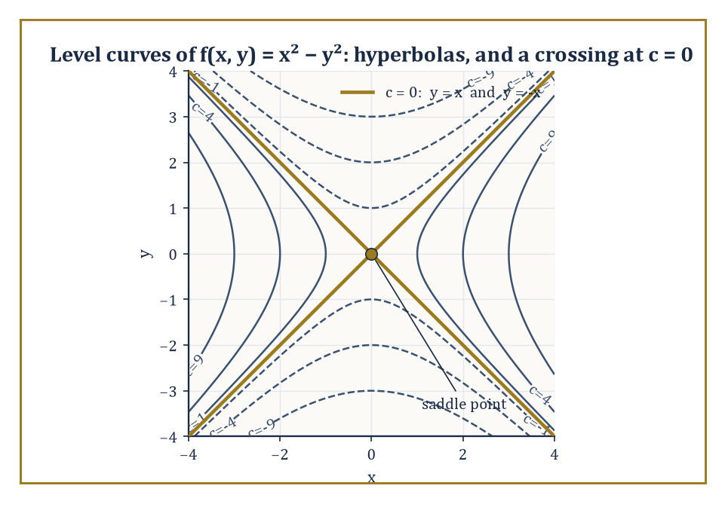
Figure 13.1 — Nested hyperbolas everywhere except at c = 0, where they snap straight and cross — the ground’s way of announcing a mountain pass.
For f(x, y) = √(1 − x² − y²), the expression under the square root must be non-negative, so we need:
x² + y² ≤ 1
That is the closed unit disk, all points within (or on) distance 1 of the origin. For f(x, y) = 1/(x − y), the only forbidden inputs are those making the denominator zero, so the domain is the entire plane with the line x = y removed — a plane with a single straight scar running through it.
Sketching the domain is a routine but necessary first step in any multi-variable problem; a function is meaningless outside it, however elegant the formula looks.
Numeric example — Testing points against a domain. Take f(x, y) = √(1 − x² − y²) again. Is the point (0.5, 0.5) in its domain? Compute:
1 − x² − y² = 1 − 0.25 − 0.25 = 0.5
This is non-negative, so yes:
f(0.5, 0.5) = √0.5 ≈ 0.707
Now try (1, 1):
1 − 1² − 1² = 1 − 1 − 1 = −1
This is negative, so (1, 1) is outside the domain — the square root of a negative number is not a real number, and f refuses to answer. The boundary between yes and no here is exactly the circle
x² + y² = 1
which is why the domain came out to be a disk in the first place.
Try it now — Is (1, 1) in the domain of f(x, y) = √(1 − x² − y²)? What is the level curve f = 0? Answer →
The graph z = f(x, y) is a surface, and while the object itself is perfectly well-defined, getting a useful picture of it usually requires some assistance.
A trace is the curve obtained by intersecting the surface with a vertical plane — setting y equal to a constant, for instance, and seeing what curve remains in the resulting xz-plane. A contour map does the opposite: it fixes the height z and records the resulting curve in the xy-plane.
The same surface, viewed from different angles or sliced in different ways, can look startlingly different; the mathematical object f itself never changes, only our vantage point on it.
Numeric example — Two traces of a paraboloid. Let f(x, y) = x² + y². The trace at y = 0 is obtained by substituting:
z = x² + 0² = x²
That is an ordinary upward parabola in the xz-plane. The trace at x = 0 is, by the same logic:
z = y²
a parabola in the yz-plane. Both traces are parabolas opening upward, which is a strong hint (confirmed properly in Extrema and the Second-Derivative Test) that the surface itself is a paraboloid — a bowl-shaped surface, symmetric about the z-axis, with its lowest point at the origin.
A level set — a level curve in the plane, a level surface in space — is the set of all points where f takes one particular constant value:
f(x, y) = c
Level curves are the contour lines on a topographic map, each one tracing out the points at a fixed altitude.
The geometry of the family of level sets, taken as a whole, encodes the geometry of the function almost completely: level sets that crowd close together indicate a steep function (a small step sideways produces a large change in height), while widely spaced level sets indicate a gentle slope.
We will make this precise in The Gradient and Directional Derivatives, where it turns out that the function changes fastest in the direction perpendicular to its level sets — but the intuition is available already, from any map with contour lines on it.
Numeric example — Level curves of a paraboloid. For f(x, y) = x² + y² again, the level curve at c = 9 is the set of points satisfying:
x² + y² = 9
That is a circle of radius 3 centered at the origin (since √9 = 3). At c = 4 it is a circle of radius 2; at c = 0 it degenerates to the single point (0, 0), the bottom of the bowl.
As c increases, the circles grow steadily larger, matching the picture of a bowl that widens as you rise up its sides. Nested, evenly spaced circles growing outward: that is what a paraboloid looks like from above, on a contour map.
Reading a contour map is, properly understood, an exercise in reading a function of two variables without ever seeing its formula. The spacing of the contours tells you the steepness; closed contours that shrink down toward a point indicate a local extremum, a peak or a pit, at that point.
Contours that cross — or, more precisely, the degenerate case where the level curve at one particular height is not a smooth closed loop but a pair of crossing lines — indicate something more interesting: a saddle point, a mountain pass between two peaks, where the ground rises in one direction and falls in the perpendicular one.
Abstract example — The telltale contour of a saddle. Consider f(x, y) = x² − y², a function whose level curves are:
x² − y² = c
For c > 0 these are hyperbolas opening left and right; for c < 0 they are hyperbolas opening up and down; but at the critical value c = 0, the equation
x² − y² = 0
factors as
(x − y)(x + y) = 0
giving the two straight lines y = x and y = −x, crossing at the origin. That crossing is the signature of a saddle: as you approach the origin along y = x, the function is
f(x, x) = x² − x² = 0
the whole way, perfectly flat; but move instead along the x-axis (y = 0), and
f(x, 0) = x²
rises; move along the y-axis (x = 0), and
f(0, y) = −y²
falls. The same point is simultaneously a minimum in one direction and a maximum in another — what a contour map with crossing lines is trying to tell you. We meet this function again, formally classified, in Extrema and the Second-Derivative Test.
Keep only this · Section 13.2: Domains, Graphs, and Level Sets
The idea. A level curve f(x, y) = c is a slice of the graph at height c, drawn in the input plane; a contour map is a stack of them, and crowded contours mean a steep surface.
Core.
domain = all inputs where the formula makes sense
level set: {(x, y) : f(x, y) = c}
Typical mistake. Confusing the graph z = f(x, y), which lives in three dimensions, with a level curve, which lives in the xy-plane.
Minimal example. f(x, y) = √(4 − x² − y²): domain is the disk x² + y² ≤ 4; the level set f = 0 is the circle of radius 2.
Practice. Easy to challenge; full worked answers, with the usual mistake, are in Answers to the Practice Sets at the back.
Easy — Find the domain of f(x, y) = 1/(x − y). Answer →
Medium — Describe the level curves of f(x, y) = y − x² for c = 0, 1, −1. Answer →
Challenge — What are the level surfaces of g(x, y, z) = x² + y² − z²? Answer →

Section 13.3: Limits and Continuity in Several Variables
Where the Plane Starts Making Trouble
CORE · about 15 minutes · later chapters build on this
Definition — The limit of f(x, y) as (x, y) approaches (a, b) is L if f(x, y) gets arbitrarily close to L whenever (x, y) gets sufficiently close to (a, b) — and the crucial phrase, doing all the work in that sentence, is ‘however (x, y) approaches’, by any route whatsoever.
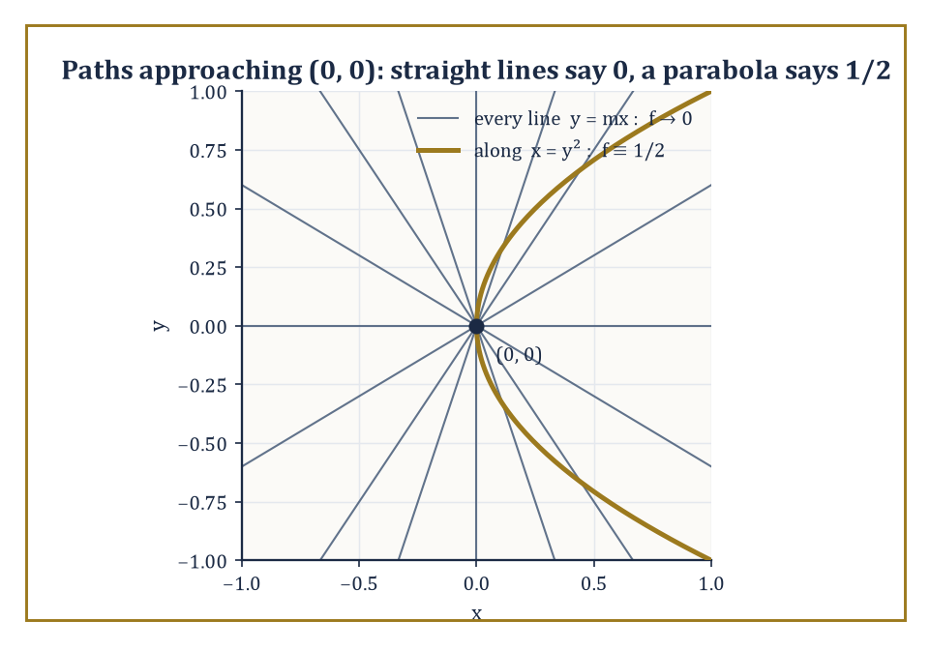
Figure 13.2 — Every straight road into the origin insists the limit is 0; the one curved road that matters insists on 1/2.
On the real line there were only two directions of approach, from the left and from the right, and checking both was enough. In the plane there is a full disk of directions, and the precise ε–δ definition (recall Chapter 10 (Volume 1)’s careful treatment of limits) replaces the interval neighborhood of one variable with a disk neighborhood: for every ε > 0 there must exist a δ > 0 such that whenever the distance from (x, y) to (a, b) is less than δ, the distance from f(x, y) to L is less than ε.
The bookkeeping generalizes painlessly; the consequences do not.
Numeric example — A straightforward limit, before the complications begin. Not every multi-variable limit is a minefield; most of them are perfectly tame, and it would be unfair to introduce the subject as nothing but hazards. Let f(x, y) = x² + 3y, and consider the limit as (x, y) → (2, 1).
Because f is a polynomial, it is continuous everywhere (a fact this section confirms properly in a moment), and for a continuous function the limit at a point equals the value of the function there: substitute directly,
f(2, 1) = 2² + 3(1) = 4 + 3 = 7
No ε–δ argument, no checking of paths, no cause for alarm — the limit is 7, exactly as evaluating the function directly suggests.
The suspicion that occupies the rest of this section is reserved for functions that are not so obliging at the point in question, typically because the formula collapses to 0/0 there; a plain polynomial has never given anyone that kind of trouble.
Try it now — Along the line y = x, what value does f(x, y) = xy/(x² + y²) approach at the origin? Along y = 0? Answer →
The extra directions of approach create a new phenomenon that has no analogue on the line: a limit can exist and agree along every straight-line path through the point, and still fail to exist overall, because some more devious curved path — a parabola, say — produces a different value.
This is the first place where multi-variable calculus stops being ‘single-variable calculus with subscripts’ and starts requiring its own suspicion.
To prove a limit does exist, one typically needs an algebraic estimate — often a squeeze, bounding |f(x, y) − L| by something that shrinks uniformly across the whole disk, not just along one path. To prove a limit does not exist, it suffices to exhibit just two paths yielding two different answers; the asymmetry between proving existence and proving non-existence is worth sitting with, because it recurs throughout analysis.
Numeric example — Proving a limit exists, by squeezing it. Before seeing a limit fail to exist, it is worth seeing one succeed, honestly, by the squeeze method. Let f(x, y) = x²y/(x² + y²) for (x, y) ≠ (0, 0), and consider the limit as (x, y) → (0, 0).
Since x² ≤ x² + y² always (because y² ≥ 0), we have:
x²/(x² + y²) ≤ 1 for every (x, y) ≠ (0, 0)
Multiplying both sides by |y| gives:
|f(x, y)| = |x²y/(x² + y²)| = [x²/(x² + y²)]·|y| ≤ 1·|y| = |y|
As (x, y) → (0, 0), certainly |y| → 0, and since
0 ≤ |f(x, y)| ≤ |y| → 0
the squeeze theorem (Chapter 10 (Volume 1)’s old friend, still working) forces f(x, y) → 0 as well.
Unlike the checking-every-straight-line approach, which can never rule out some cleverer curved path lurking undetected, this bound |f(x, y)| ≤ |y| holds uniformly over the whole disk around the origin, for every path simultaneously — which is the kind of estimate a genuine existence proof requires.
Numeric example — A limit that fools every straight line. Let f(x, y) = xy²/(x² + y⁴), and consider the limit as (x, y) → (0, 0). First, approach along any straight line through the origin, y = mx, for a fixed slope m. Substituting:
f(x, mx) = x(mx)²/(x² + (mx)⁴) = m²x³/(x² + m⁴x⁴) = m²x³/[x²(1 + m⁴x²)] = m²x/(1 + m⁴x²)
As x → 0, the numerator m²x → 0 and the denominator → 1, so the whole expression → 0, for every single value of m, including the vertical line x = 0, where:
f(0, y) = 0/y⁴ = 0
Every straight-line approach gives 0. It is tempting, and wrong, to conclude the limit is 0. Now approach along the parabola x = y²:
f(y², y) = y² · y²/((y²)² + y⁴) = y⁴/(y⁴ + y⁴) = y⁴/(2y⁴) = 1/2, for every y ≠ 0
Along this curved path the function is constantly 1/2, however close y gets to 0 — utterly different from the 0 obtained along every straight line. Since two paths give two different limiting values, the limit of f at (0, 0) does not exist. Straight lines, it turns out, were never enough to settle the question.
Continuity is defined as it was for a single variable: f is continuous at (a, b) if the limit as (x, y) → (a, b) exists and equals f(a, b) itself.
Sums, products, quotients, and compositions of continuous functions remain continuous wherever they are defined, by the same combination rules proved back in Chapter 10 (Volume 1); in particular, every polynomial in several variables is continuous everywhere, and every rational function (a quotient of polynomials) is continuous on its entire domain — meaning everywhere except where the denominator vanishes.
Numeric example — Continuity and its exceptions. Let g(x, y) = 1/(x² + y² − 1). This is a rational function, hence continuous throughout its domain — which is the entire plane except the unit circle
x² + y² = 1
where the denominator vanishes and g is undefined. At (0, 0):
x² + y² − 1 = 0 + 0 − 1 = −1
so
g(0, 0) = 1/(−1) = −1
perfectly well-defined and, since (0, 0) is comfortably away from the unit circle, continuous there too. The statement ‘g is continuous on its domain’ is not a dodge — it is the precise and complete claim: everywhere g is defined, it is also continuous; the unit circle was never part of the domain to begin with.
The subtlety uncovered above is the first proper warning, delivered early and deliberately, that multi-variable calculus is not merely single-variable calculus wearing extra subscripts.
Every later tool in this chapter — partial derivatives, the gradient, tangent planes — is built on limits and inherits the same caution: checking a couple of obvious paths never settles the matter.
Keep only this · Section 13.3: Limits and Continuity in Several Variables
The idea. One path can disprove a limit; no number of paths can prove one. To prove a limit exists, squeeze |f − L| below something that tends to zero, often in polar form.
Core.
two paths with different limits ⇒ no limit
|f(x, y) − L| ≤ g(r) with g(r) → 0 ⇒ limit L
Typical mistake. Checking every straight line and concluding the limit exists. The function xy²/(x² + y⁴) agrees on every line and still has no limit.
Minimal example. x²y/(x² + y²) → 0, since its absolute value is at most |y|.
Practice. Easy to challenge; full worked answers, with the usual mistake, are in Answers to the Practice Sets at the back.
Easy — Compute lim[(x, y) → (1, 2)] (x² + y). Answer →
Medium — Show that lim[(x, y) → (0, 0)] (x² − y²)/(x² + y²) does not exist. Answer →
Challenge — Does x²y/(x⁴ + y²) have a limit at the origin? (Try lines, then the parabola y = x².) Answer →

Section 13.4: Partial Derivatives
Differentiating One Variable at a Time, Politely Ignoring the Others
CORE · about 15 minutes · later chapters build on this
Definition — A partial derivative is an ordinary derivative taken with respect to one variable while every other variable is held rigidly, temporarily, fixed — frozen in place like a well-behaved constant, which for the duration of the calculation is just what it is.
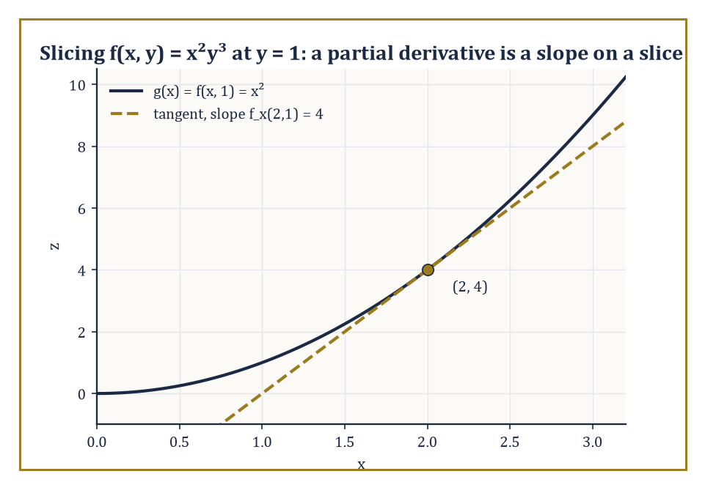
Figure 13.3 — Freeze y at 1, and the surface’s slice through x is an ordinary parabola with an ordinary tangent line.
The partial derivative of f with respect to x at the point (a, b) is defined as the ordinary derivative, in the sense of Chapter 11 (Volume 1), of the single-variable function g(x) = f(x, b) — that is, f with y nailed down at the value b — evaluated at x = a.
Geometrically, this is the slope of the tangent line to the curve you get by slicing the surface z = f(x, y) with the vertical plane y = b: hold y still, watch how z changes as x moves, and you have your partial derivative.
Numeric example — A partial derivative, computed two ways. Let f(x, y) = x²y³, and find the partial derivatives at the point (2, 1). Treating y as a constant, differentiate with respect to x:
fₓ(x, y) = 2xy³, so fₓ(2, 1) = 2(2)(1)³ = 4
Treating x as a constant, differentiate with respect to y:
f_{y}(x, y) = 3x²y², so f_{y}(2, 1) = 3(2)²(1)² = 3(4)(1) = 12
Now verify fₓ(2, 1) = 4 the slow way, as the definition demands: slice at y = 1 to get:
g(x) = f(x, 1) = x²(1)³ = x²
an ordinary single-variable function. Then:
g′(x) = 2x, and g′(2) = 4
matching fₓ(2, 1) precisely. The shortcut (treat the other variable as a constant, differentiate as usual) and the slow method (slice the surface, differentiate the resulting curve) agree, as they must.
Try it now — For f(x, y) = x²y + y³, find f_{x} and f_{y} at (1, 2). Answer →
Notation for partial derivatives comes in several dialects that all mean the same thing: ∂f/∂x, fₓ, and Dₓ f are interchangeable.
Higher-order partial derivatives are obtained by differentiating again, and here a pleasant surprise awaits: the mixed partial derivatives f_{xy} and f_{yx} (differentiating twice, once with respect to each variable, in opposite orders) turn out to be equal, provided both are continuous.
This is Clairaut’s theorem, and it is one of those results that feels like it ought to require heroic effort and instead falls out almost for free once continuity is assumed; the order in which you take two partial derivatives does not matter, under mild and usually automatically-satisfied conditions.
Theorem — Clairaut (equality of mixed partials)
If f_{xy} and f_{yx} exist and are continuous near a point, then f_{xy} = f_{yx} at that point.
Hypotheses — check each one before you use it:
□ both mixed partials exist on an open disk around the point
□ both are continuous there
Why it matters. It halves the work of computing second derivatives and is what makes the Hessian symmetric, which the second-derivative test and Chapter 21’s spectral theorem both use.
Numeric example — Checking Clairaut’s theorem. Continue with f(x, y) = x²y³. We have fₓ = 2xy³, so differentiating that with respect to y gives:
f_{xy} = ∂/∂y(2xy³) = 6xy²
We also have f_{y} = 3x²y², so differentiating that with respect to x gives:
f_{yx} = ∂/∂x(3x²y²) = 6xy²
The two mixed partials, computed in opposite orders, are algebraically identical: both equal 6xy². At the point (2, 1):
f_{xy}(2,1) = 6(2)(1)² = 12, and f_{yx}(2, 1) = 6(2)(1)² = 12
the same number, exactly as Clairaut’s theorem promises for a smooth polynomial like this one.
The mechanics of computing a partial derivative are pure ordinary differentiation, with the added discipline of remembering, at every step, which letters are currently allowed to vary and which are frozen.
Every rule from earlier chapters — product rule, quotient rule, chain rule for single-variable compositions — applies as before within the variable you are differentiating; the algebra has not changed one bit. Only the geometric meaning has: a derivative used to be the slope of a tangent line to a curve, and now it is the slope of a tangent line to a slice of a surface, one direction at a time.
Numeric example — A partial derivative with a product inside. Let f(x, y) = sin(xy) + x³, and compute the partial derivatives at (0, π). Differentiating with respect to x, treating y as constant, requires the chain rule on sin(xy):
fₓ = y·cos(xy) + 3x²
Differentiating with respect to y, treating x as constant:
f_{y} = x·cos(xy)
(the x³ term vanishes, since it contains no y). At (0, π):
xy = 0 × π = 0, so cos(xy) = cos(0) = 1
Then:
f_{x}(0, π) = π·(1) + 3(0)² = π + 0 = π, and f_{y}(0, π) = 0·(1) = 0
The x-partial is π; the y-partial is 0 — sensible, since at x = 0 the surface’s cross-section in the y-direction,
f(0, y) = sin(0) + 0 = 0
is constant, and constants have zero slope.
Partial derivatives have a second life outside pure geometry: in economics, and in applied mathematics generally, they are usually called marginal quantities.
The partial derivative of a profit function with respect to price is the marginal effect of price on profit — how much profit changes for a small increase in price, quantity held fixed — and the partial with respect to quantity is the marginal effect of quantity, price held fixed.
This is the same operation as slicing a surface with a vertical plane; economics gives the slice a more evocative name.
Numeric example — Marginal profit, revisited from What a Function of Several Variables Is. Recall the publisher’s profit function from What a Function of Several Variables Is:
π(p, q) = pq − 3q − 50
The partial derivatives are:
π_{p} = q (the q and the −3q term vanish, leaving q), and π_{q} = p − 3
At the point (p, q) = (10, 20), where we computed π(10, 20) = 90 back in What a Function of Several Variables Is:
πₚ(10, 20) = 20
meaning a small increase in price, quantity held fixed, increases profit at a rate of about 20 per unit of price; and:
π_{q}(10, 20) = 10 − 3 = 7
meaning a small increase in the number of copies sold, price held fixed, increases profit at a rate of about 7 per extra copy. Price, at this particular combination, is the far more sensitive lever — which is exactly the sort of fact a partial derivative is built to reveal at a glance, without re-deriving the whole profit formula.
Partial derivatives measure the rate of change of f only in the two special coordinate directions — purely along x, or purely along y — and say nothing directly about what happens if you set off diagonally, or in any other direction of your choosing.
To measure the rate of change in an arbitrary direction, we need two new ideas that turn out to be the same idea viewed from different angles: the directional derivative, and the gradient. That is the business of The Gradient and Directional Derivatives.
Keep only this · Section 13.4: Partial Derivatives
The idea. A partial derivative is an ordinary derivative with the other variables frozen; Clairaut’s theorem says the mixed partials agree when they are continuous.
Core.
fₓ: differentiate in x with y held fixed
f_{y}: differentiate in y with x held fixed
Typical mistake. Freezing a variable at the wrong moment: substitute the point only after differentiating, never before.
Minimal example. f = x³y²: f_{x} = 3x²y², f_{y} = 2x³y.
Practice. Easy to challenge; full worked answers, with the usual mistake, are in Answers to the Practice Sets at the back.
Easy — Find f_{x} and f_{y} for f(x, y) = 5x + xy − y². Answer →
Medium — For f(x, y) = eˣ sin y, find all four second partials. Answer →
Challenge — Show that u(x, t) = sin(x − 3t) satisfies u_{tt} = 9u_{xx}. Answer →

Section 13.5: The Gradient and Directional Derivatives
The Single Vector That Knows Which Way Is Up
CORE · about 15 minutes · later chapters build on this
Stand on the hillside z = x² + y² at the point (3, 4), where the height is 25. Section 13.4’s partial derivatives give you two slopes. Walking due east, in the x-direction, the ground rises at f_{x} = 2x = 6 units per unit walked. Walking due north, it rises at f_{y} = 2y = 8.
Which way is steepest, and how steep is it? North, at 8, is the tempting answer. But east and north are only two directions out of a whole circle of them. For a step of length 1 in a direction ⟨u₁, u₂⟩, a smooth surface rises by about 6u₁ from the eastward part of the step and 8u₂ from the northward part, so the rate of climb is 6u₁ + 8u₂. Try some directions:
east, ⟨1, 0⟩: 6
north, ⟨0, 1⟩: 8
north-east, ⟨0.707, 0.707⟩: 9.899
⟨0.8, 0.6⟩: 9.6
⟨0.6, 0.8⟩: 10
The steepest rate in the table, 10, is larger than either partial derivative, and it comes in the direction ⟨0.6, 0.8⟩, which is ⟨6, 8⟩ scaled down to length 1. That is no coincidence. The rate 6u₁ + 8u₂ is the dot product of ⟨6, 8⟩ with the direction, and a dot product with a unit vector is largest when the two point the same way. Its largest value is the length of ⟨6, 8⟩, which is √(36 + 64) = 10.
So the two partial derivatives, written together as the single vector ⟨6, 8⟩, already know the answer: they point up the steepest line, and their length is the steepest slope. That vector is the gradient, ∇f. The worked examples in this section use the same hill and the same point, and find 10, 9.899 and −10 again.
Definition — The gradient of f is the vector formed by collecting all the first partial derivatives together:
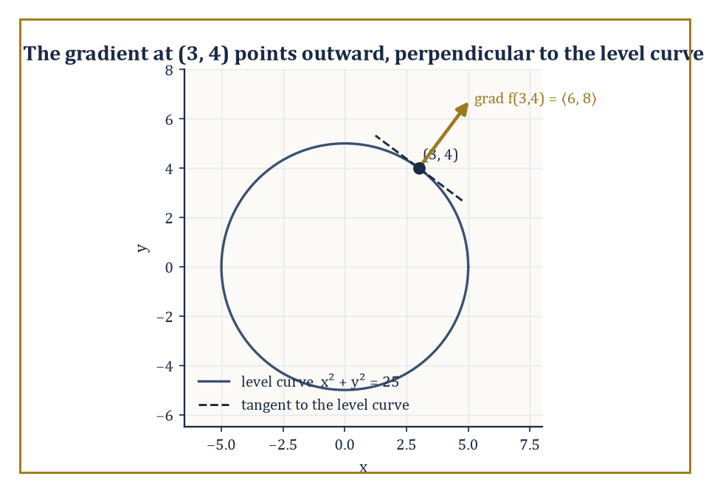
Figure 13.4 — The gradient points straight out along the radius, at a right angle to the very circle it lives on.
∇f = ⟨f_{x}, f_{y}⟩ in the plane, or ⟨f_{x}, f_{y}, f_{z}⟩ in space
The symbol ∇ (nabla) is read ‘grad’ or ‘del’, and the object it produces is not a number but a vector — one that lives at each point of the domain and points in the direction in which f increases most rapidly at that point, with its length (magnitude) equal to the rate of that fastest increase.
It is, in a real sense, the correct generalization of ‘the derivative’ to several variables: a single object that captures everything the partials capture, and arranges it usefully as a direction and a speed.
Numeric example — Computing a gradient and its magnitude. Let f(x, y) = x² + y², our familiar paraboloid from What a Function of Several Variables Is and Domains, Graphs, and Level Sets. Its gradient is:
∇f = ⟨2x, 2y⟩
At the point (3, 4):
∇f(3, 4) = ⟨6, 8⟩
The magnitude of this vector is:
|∇f(3,4)| = √(6² + 8²) = √(36 + 64) = √100 = 10
So at (3, 4), the function is increasing fastest in the direction ⟨6, 8⟩ — or, normalized to a unit vector, ⟨3/5, 4/5⟩ — and the rate of that fastest increase is exactly 10. Geometrically, this makes complete sense: the paraboloid gets steeper the farther out you go from its center, and (3, 4) is a fair distance from the origin (5 units, in fact — another old friend, the 3-4-5 triangle, still turning up on Chapter 13).
Try it now — For f(x, y) = x² + y² at (3, 4), find the directional derivative in the direction (1, 0) and the maximum possible rate. Answer →
The directional derivative of f at a point, in the direction of a unit vector u (a vector of length exactly 1, so that it specifies a pure direction with no extra scaling), is the ordinary rate of change of f as you move from that point along the straight line in direction u. Rather than recomputing this from first principles every time, there is a remarkably clean formula:
directional derivative = ∇f · u
Since the dot product of a fixed vector with a unit vector is maximized exactly when the unit vector points the same way as the fixed vector, and minimized when it points the opposite way, this single formula immediately tells us that the directional derivative is largest when u is the direction of ∇f, and smallest (most negative) when u points directly away from ∇f.
Numeric example — Directional derivatives in three directions. Continue with f(x, y) = x² + y² at (3, 4), where we found ∇f(3, 4) = ⟨6, 8⟩. First, take u = ⟨1/√2, 1/√2⟩, the unit vector pointing north-east at 45°. The directional derivative is:
∇f · u = 6(1/√2) + 8(1/√2) = 14/√2 = 7√2 ≈ 9.899
This is less than the maximum possible rate of 10 found in the previous example, as it should be, since u is not quite aligned with the gradient direction ⟨3/5, 4/5⟩. Second, take u pointing opposite to the gradient’s direction, u = ⟨−3/5, −4/5⟩: the directional derivative is:
6(−3/5) + 8(−4/5) = −18/5 − 32/5 = −50/5 = −10
This is the minimum possible value, the negative of the maximum found before, confirming that moving directly toward the origin decreases f as fast as possible.
Third, take u = ⟨−4/5, 3/5⟩, at right angles to the gradient:
6(−4/5) + 8(3/5) = −24/5 + 24/5 = 0
Moving at right angles to the gradient, f does not change at all, to first order. That direction runs along the level curve through (3, 4), which is the next fact.
Perhaps the single most useful geometric fact about the gradient is that it is always orthogonal (perpendicular) to the level set passing through that point.
This one fact explains, in a single stroke, why the contour lines on any topographic map are perpendicular to the direction of steepest ascent — hikers who want the gentlest route around a hillside walk along a contour line, because that direction produces zero change in height, while the direction of maximum change (the gradient) cuts straight across the contours at a right angle.
Abstract example — Gradient meets level curve, at right angles. Take f(x, y) = x² + y² once more. The level curve through (3, 4) is:
x² + y² = 25 (since 3² + 4² = 25)
a circle of radius 5 centered at the origin. We found ∇f(3, 4) = ⟨6, 8⟩, which is twice the radius vector ⟨3, 4⟩ — pointing straight outward from the center of the circle, along the radius. The tangent direction to a circle at the point (3, 4), meanwhile, is perpendicular to the radius, and one such tangent vector is ⟨−4, 3⟩ (swap the coordinates and negate one — a standard trick for rotating a vector 90°). Checking orthogonality with a dot product:
⟨6, 8⟩ · ⟨−4, 3⟩ = 6(−4) + 8(3) = −24 + 24 = 0
The gradient and the tangent to the level curve are perpendicular, as the general theorem promised, and this was no coincidence of the particular numbers chosen — it holds at every point, for every differentiable function.
Once the gradient is in hand, a whole cluster of first-order questions collapse into short calculations with vectors rather than fresh derivations each time: the rate of change of f in any given direction is a single dot product; the direction of fastest increase is ‘the direction the gradient points’; and, as Tangent Planes and Linear Approximation will show, the equation of the tangent plane to a surface falls out of the gradient almost as an afterthought.
Keep only this · Section 13.5: The Gradient and Directional Derivatives
The idea. D_{û} f = ∇f · û for a unit vector û. The gradient points uphill fastest, its length is that fastest rate, and it is perpendicular to the level curve.
Core.
∇f = (f_{x}, f_{y})
D_{u} f = ∇f · u for a unit vector u
max rate |∇f|, in the direction of ∇f
Typical mistake. Dotting the gradient with an unnormalized vector such as (3, 4), which inflates the answer by its length.
Minimal example. f = xy at (1, 2): ∇f = (2, 1), steepest rate √5.
Practice. Easy to challenge; full worked answers, with the usual mistake, are in Answers to the Practice Sets at the back.
Easy — Find ∇f for f(x, y) = x²y at (1, 3). Answer →
Medium — For f(x, y) = x² + xy at (1, 1), find the directional derivative toward (3, 4). Answer →
Challenge — Show that ∇f is perpendicular to the level curve of f through each point. Answer →

Section 13.6: The Chain Rule in Several Variables
What Happens When the Inputs Have Their Own Inputs
CORE · about 15 minutes · later chapters build on this
Definition — When each input variable of f is itself a function of some further variable — say a single parameter t, tracing out a path through the domain — the derivative of the resulting composite function is given by a multi-variable chain rule. If z = f(x, y) with x = x(t) and y = y(t), then:
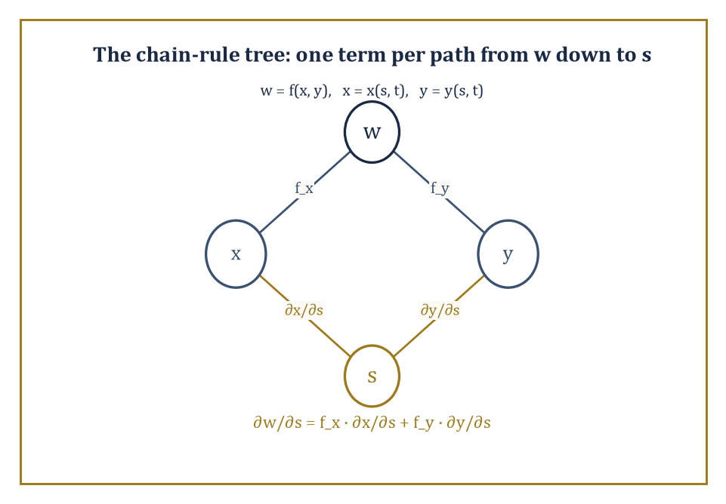
Figure 13.5 — One branch per intermediate variable, one term per branch — the chain rule’s bookkeeping, drawn instead of memorized.
dz/dt = f_{x} · dx/dt + f_{y} · dy/dt
Read geometrically, this is precisely the directional derivative of f (from The Gradient and Directional Derivatives) taken in the direction of the path’s velocity vector ⟨dx/dt, dy/dt⟩ — the chain rule and the directional derivative turn out to be the same calculation, wearing two different names depending on context.
Numeric example — The chain rule, verified against direct substitution. Let z = f(x, y) = x²y, with x(t) = t² and y(t) = t + 1. We want dz/dt at t = 1. First, via the chain rule:
f_{x} = 2xy, f_{y} = x², dx/dt = 2t, dy/dt = 1, so dz/dt = 2xy · 2t + x² · 1
At t = 1:
x = 1² = 1, y = 1 + 1 = 2, so f_{x} = 2(1)(2) = 4, f_{y} = 1² = 1, dx/dt = 2(1) = 2, dy/dt = 1
Then:
dz/dt = 4(2) + 1(1) = 8 + 1 = 9
Now check this the slow way, by substituting first and differentiating a single-variable function:
z(t) = x(t)²y(t) = (t²)²(t + 1) = t⁴(t + 1) = t⁵ + t⁴, so dz/dt = 5t⁴ + 4t³
and at t = 1:
dz/dt = 5(1) + 4(1) = 5 + 4 = 9
Both methods give 9. The chain rule is not a separate fact requiring separate faith; it is a bookkeeping shortcut that always agrees with direct substitution, and is indispensable once direct substitution becomes too painful to attempt.
Try it now — Let z = xy with x = t² and y = 3t. Find dz/dt at t = 1 by the chain rule, then check by substitution. Answer →
When there are more intermediate variables, or more final variables, the pattern grows more terms, each of the same shape: for every intermediate variable, take the partial derivative of f with respect to that intermediate, and multiply it by the derivative of that intermediate with respect to the final variable, then sum all such contributions.
Tree diagrams — drawing f branching down to its intermediate variables, and each of those branching down further to the ultimate variables — are the standard bookkeeping device for keeping every term accounted for and none double-counted or forgotten.
Numeric example — Two intermediate variables, two final variables. Let w = f(x, y) = xy, with x(s, t) = s + t and y(s, t) = s − t. To find ∂w/∂s, the tree diagram has two branches from w down to x and y, and one branch each from x and y down to s:
∂w/∂s = f_{x} · ∂x/∂s + f_{y} · ∂y/∂s
Here:
f_{x} = y, f_{y} = x, ∂x/∂s = 1, ∂y/∂s = 1, so ∂w/∂s = y(1) + x(1) = x + y = (s + t) + (s − t) = 2s
Checking directly by substitution:
w(s, t) = (s + t)(s − t) = s² − t², so ∂w/∂s = 2s
The two methods agree, and notice that with two intermediate variables (x and y) feeding into one final variable (s), the chain rule needed exactly two terms — one per intermediate variable — just as the tree diagram predicts.
The chain rule also settles, quietly and elegantly, a question that might otherwise seem to need entirely new machinery: implicit differentiation. If a curve is defined implicitly by an equation F(x, y) = 0 — the variables tangled together rather than one solved neatly in terms of the other — we can regard y as some function y(x) along the curve and differentiate F(x, y(x)) = 0 with respect to x using the chain rule:
F_{x} + F_{y}·(dy/dx) = 0
Since the right-hand side is constantly zero and hence has derivative zero, solving gives:
dy/dx = −F_{x}/F_{y}
a formula that replaces the sometimes-impossible task of solving for y explicitly with the comparatively painless task of computing two partial derivatives.
Numeric example — Implicit differentiation, on an old friend of a circle. Let F(x, y) = x² + y² − 25, so that F(x, y) = 0 describes the circle x² + y² = 25 — the very circle of radius 5 that carried the point (3, 4) through Section 13.5’s gradient examples. Find dy/dx at (3, 4) via the chain-rule formula:
F_{x} = 2x = 6 and F_{y} = 2y = 8, so dy/dx = −F_{x}/F_{y} = −6/8 = −3/4
Checking directly: on the upper half of the circle,
y = √(25 − x²), so dy/dx = −x/√(25 − x²)
and at x = 3 this is:
−3/√(25 − 9) = −3/√16 = −3/4
The two methods agree, and the implicit method needed no square root at all — only two partial derivatives and a division, a considerable saving when F is messier than a circle.
The multi-variable chain rule is not merely a convenience; it is the mechanism that lets us differentiate functions built from complicated substitutions without ever having to substitute them out explicitly, and it is the algebraic engine behind related-rates problems in several variables — the natural extension of the related-rates work from Chapter 11 (Volume 1), now with several quantities changing simultaneously and interacting through a shared function.
It will resurface, more importantly still, as the foundation of change-of-variables in multiple integrals in the next chapter, where switching from Cartesian to polar or spherical coordinates is, underneath the hood, nothing but a careful application of this rule.
Keep only this · Section 13.6: The Chain Rule in Several Variables
The idea. The multivariable chain rule adds one term per intermediate variable: dz/dt = (∂z/∂x)(dx/dt) + (∂z/∂y)(dy/dt).
Core.
dz/dt = f_{x} dx/dt + f_{y} dy/dt
∂z/∂s = f_{x} ∂x/∂s + f_{y} ∂y/∂s
Typical mistake. Evaluating the partial derivatives at the wrong point; they must be evaluated at (x(t), y(t)), not at t.
Minimal example. z = x² + y², x = cos t, y = sin t: dz/dt = −2 cos t sin t + 2 sin t cos t = 0, as z ≡ 1.
Practice. Easy to challenge; full worked answers, with the usual mistake, are in Answers to the Practice Sets at the back.
Easy — z = x + y², x = t, y = t². Find dz/dt. Answer →
Medium — z = xy with x = s + t, y = s − t. Find ∂z/∂s and ∂z/∂t. Answer →
Challenge — If f(x, y) is any differentiable function and g(r, θ) = f(r cos θ, r sin θ), find g_{θ}. Answer →

Section 13.7: Tangent Planes and Linear Approximation
The Best Flat Guess at a Curved Truth
CORE · about 15 minutes · later chapters build on this
Definition — The tangent plane to the surface z = f(x, y) at a point (a, b, f(a, b)) is the plane that best approximates the surface in the immediate neighborhood of that point — the direct generalization of the tangent line from single-variable calculus, now flattened out into two dimensions instead of one. Its equation is:
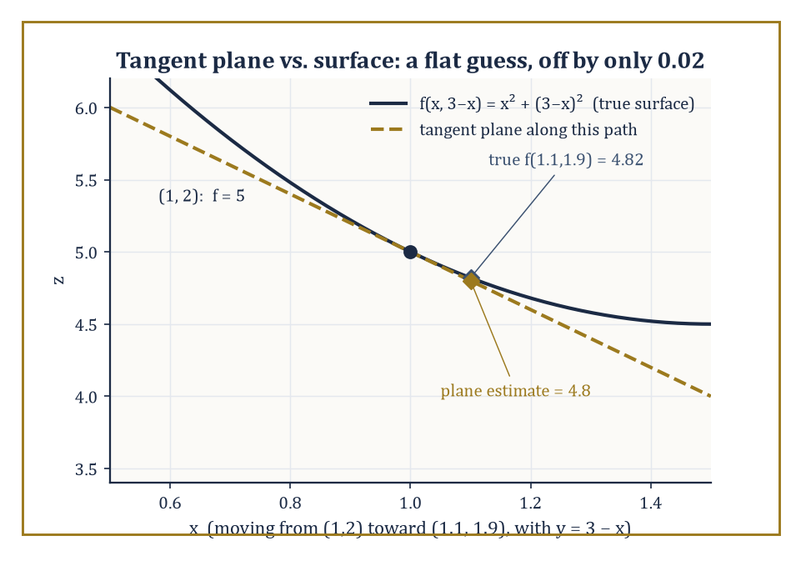
Figure 13.6 — A flat plane, glued on at (1, 2), tracks the bowl closely enough that nobody two decimal places away would notice the difference.
z = f(a, b) + f_{x}(a, b)(x − a) + f_{y}(a, b)(y − b)
Start at the known height f(a, b), then add a correction proportional to how far x has moved (scaled by the x-slope) and a correction proportional to how far y has moved (scaled by the y-slope).
In vector language, this plane is the plane orthogonal to the gradient of F(x, y, z) = f(x, y) − z, a fact that ties the tangent plane directly back to the gradient developed in The Gradient and Directional Derivatives.
Numeric example — Building a tangent plane, and testing it. Let f(x, y) = x² + y² at the point (1, 2). First:
f(1, 2) = 1² + 2² = 1 + 4 = 5
The partials are f_{x} = 2x and f_{y} = 2y, so:
f_{x}(1, 2) = 2 and f_{y}(1, 2) = 4
The tangent plane is:
z = 5 + 2(x − 1) + 4(y − 2) = 5 + 2x − 2 + 4y − 8 = 2x + 4y − 5
Sanity check at the base point:
2(1) + 4(2) − 5 = 2 + 8 − 5 = 5
matching f(1, 2) exactly, as it must. Now use the plane to estimate f at a nearby point, (1.1, 1.9), without touching the original formula: the plane gives:
2(1.1) + 4(1.9) − 5 = 2.2 + 7.6 − 5 = 4.8
The true value is:
f(1.1, 1.9) = 1.1² + 1.9² = 1.21 + 3.61 = 4.82
The tangent plane’s estimate, 4.8, is off by only 0.02 — a small, flat, linear guess getting remarkably close to a small step of a curved truth.
Try it now — Write the tangent plane to z = xy at (2, 3, 6) and use it to estimate f(2.1, 2.9). Answer →
The linear approximation, sometimes called the total differential, is the correction terms of the tangent plane, repackaged as a statement about small increments:
Δf ≈ f_{x} Δx + f_{y} Δy
where Δx and Δy are small changes in x and y and Δf is the resulting (approximate) change in f. This is the exact multi-variable analogue of the single-variable approximation Δf ≈ f′(a)Δx from Chapter 11 (Volume 1) — the same idea of using the slope (now two slopes) to predict a small change without recomputing the function from scratch.
Numeric example — Estimating a change with the linear approximation. Continuing with f(x, y) = x² + y² at (1, 2), take Δx = 0.1 and Δy = −0.1 (moving to the same point (1.1, 1.9) as before, approached from the increment side). The linear approximation gives:
Δf ≈ f_{x}(1,2)Δx + f_{y}(1,2)Δy = 2(0.1) + 4(−0.1) = 0.2 − 0.4 = −0.2
The true change is:
Δf = f(1.1, 1.9) − f(1, 2) = 4.82 − 5 = −0.18
The approximation, −0.2, is close to the true value, −0.18 — the same small error of 0.02 seen in the previous example, arrived at from the increment point of view rather than the absolute-value point of view. Both are the same calculation wearing different clothes.
Differentiability in several variables turns out to be a genuinely stronger condition than the mere existence of the two partial derivatives f_{x} and f_{y}, and this is one of the more startling surprises of the multi-variable world.
True differentiability requires that the linear approximation be a good approximation, in the precise technical sense that the error between f and its tangent plane shrinks to zero faster than the distance to the base point shrinks to zero — not merely that two particular slices of the surface (along the x-axis and along the y-axis) happen to have well-defined slopes.
If the partial derivatives are themselves continuous near the point, differentiability is guaranteed; but continuity of the partials is a sufficient condition, not a necessary one, and the mere existence of f_{x} and f_{y} — with no continuity assumed — is not enough to guarantee differentiability at all.
Worked example — Partials that exist, but a function that is not even continuous. Define f(x, y) = xy/(x² + y²) for (x, y) ≠ (0, 0), and f(0, 0) = 0. Check the partial derivative fₓ(0, 0) directly from its definition, using the difference quotient along the x-axis:
fₓ(0, 0) = lim[h→0] [f(h, 0) − f(0, 0)]/h
Since:
f(h, 0) = h·0/(h² + 0²) = 0 for every h ≠ 0
the difference quotient is [0 − 0]/h = 0 for all h, so f_{x}(0, 0) = 0. By the same argument along the y-axis, f_{y}(0, 0) = 0 as well. Both partial derivatives exist at the origin, and both are zero — everything looks perfectly innocent along the two coordinate axes. But now approach the origin along the diagonal line y = x instead: for x ≠ 0,
f(x, x) = x·x/(x² + x²) = x²/(2x²) = 1/2
a constant value of 1/2 no matter how close x gets to 0. Since f(0,0) = 0 but the function equals 1/2 arbitrarily close to the origin along this diagonal, f is not even continuous at (0, 0) — let alone differentiable there — despite both partial derivatives existing and being perfectly well-defined. Existence of the partials was never enough; this is the trap the previous paragraph’s theorem is warning against.
Keep only this · Section 13.7: Tangent Planes and Linear Approximation
The idea. Near a point where f is differentiable, f(a + Δx, b + Δy) ≈ f(a, b) + f_{x} Δx + f_{y} Δy; the error shrinks faster than the step.
Core.
z ≈ f(a, b) + f_{x}(a, b)(x − a) + f_{y}(a, b)(y − b)
Typical mistake. Assuming that existing partial derivatives make a function differentiable. They do not: xy/(x² + y²) has both partials at the origin and is not even continuous there.
Minimal example. f = x² + y² at (1, 1): z ≈ 2 + 2(x − 1) + 2(y − 1).
Practice. Easy to challenge; full worked answers, with the usual mistake, are in Answers to the Practice Sets at the back.
Easy — Tangent plane to z = x² + 3y at (1, 1, 4). Answer →
Medium — Use the tangent plane of f(x, y) = √(xy) at (4, 4) to estimate √(4.1 · 3.9). Answer →
Challenge — For f(x, y) = xy, how large is the error of the tangent-plane estimate at (1 + h, 1 + k)? Answer →

Section 13.8: Extrema and the Second-Derivative Test
Peaks, Pits, and the Treacherous Mountain Pass
CORE · about 15 minutes · later chapters build on this
Definition — A local maximum or minimum of a function of several variables, exactly as in the single-variable case, can occur only at a critical point — a point where the gradient vanishes entirely (every partial derivative is zero) or fails to exist.
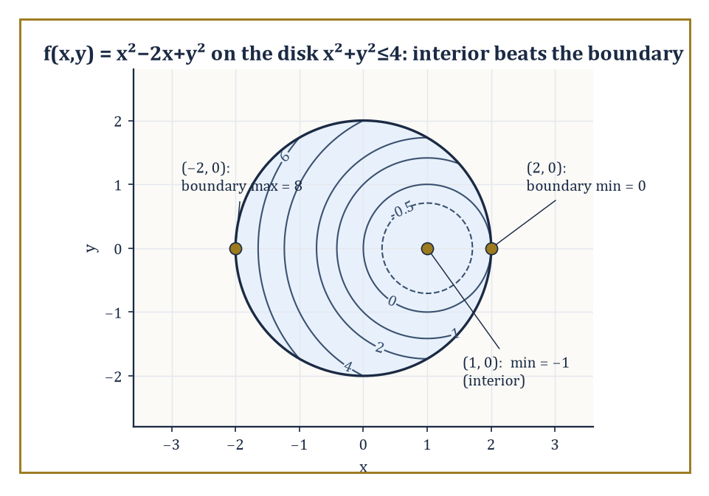
Figure 13.7 — The disk’s quietest point beats every noisy point on its rim — the boundary does not automatically win.
This is a necessary condition, not a sufficient one: finding a critical point tells you where to look for an extremum, not that you have found one, since (as Section 13.2’s saddle-point example already hinted) plenty of critical points turn out to be neither maxima nor minima at all.
Numeric example — Finding a critical point. Let f(x, y) = x² + y² − 4x + 6y + 13. To find critical points, set both partials to zero:
f_{x} = 2x − 4 = 0 gives x = 2; f_{y} = 2y + 6 = 0 gives y = −3
The only critical point is (2, −3). Evaluating there:
f(2, −3) = 2² + (−3)² − 4(2) + 6(−3) + 13 = 4 + 9 − 8 − 18 + 13 = 0
In fact this f is secretly a disguised sum of squares — completing the square gives:
f(x, y) = (x − 2)² + (y + 3)²
which is manifestly never negative and equals zero exactly at (2, −3) — so we already know, by inspection, that this critical point is not merely a local minimum but the global minimum. The second-derivative test below will confirm this by more general means, ones that work even when no convenient algebraic trick is available.
Try it now — Classify the critical point of f(x, y) = x² + 3y² − 2x. Answer →
The second-derivative test for a function of two variables uses the Hessian determinant,
H = f_{xx} f_{yy} − (f_{xy})²
a single number built from the three distinct second partial derivatives (recall f_{xy} = f_{yx} by Clairaut’s theorem, Partial Derivatives, so there really are only three, not four).
Theorem — Second-derivative test
Let (a, b) be a critical point of f and D = f_{xx} f_{yy} − f_{xy}² evaluated there. If D > 0 and f_{xx} > 0, f has a local minimum; if D > 0 and f_{xx} < 0, a local maximum; if D < 0, a saddle. If D = 0 the test says nothing.
Hypotheses — check each one before you use it:
□ ∇f(a, b) = 0 (it is a critical point)
□ the second partials are continuous near (a, b)
□ D ≠ 0, or else look at higher-order terms directly
Why it matters. It turns a three-dimensional shape question into the sign of two numbers, and it is the two-variable case of the eigenvalue test for the Hessian.
If H > 0 and fₓₓ > 0, the critical point is a local minimum; if H > 0 and fₓₓ < 0, it is a local maximum; if H < 0, it is a saddle point — a mountain pass, rising in one direction and falling in another; and if H = 0, the test is inconclusive and finer methods are required.
Numeric example — Applying the Hessian test, twice. First, revisit f(x, y) = x² + y² − 4x + 6y + 13 from the previous example, with critical point (2, −3). The second partials are f_{xx} = 2, f_{yy} = 2, and f_{xy} = 0 (constants, so the same everywhere). The Hessian is:
H = (2)(2) − 0² = 4
which is positive, and fₓₓ = 2 is also positive — so the test confirms a local minimum, matching the sum-of-squares reasoning above. Second, revisit g(x, y) = x² − y² from Section 13.2’s saddle example. Critical points:
g_{x} = 2x = 0 gives x = 0; g_{y} = −2y = 0 gives y = 0
the only critical point is (0, 0). The second partials are g_{xx} = 2, g_{yy} = −2, g_{xy} = 0, so:
H = (2)(−2) − 0² = −4
which is negative — the test confirms a saddle point, matching the crossing-contour-lines picture from Domains, Graphs, and Level Sets. It is satisfying, and not an accident, that the algebraic test and the geometric contour picture agree perfectly.
Absolute (global) extrema of a function on a closed, bounded region are found by comparing the values at the interior critical points with the extreme values attained on the boundary of the region — the same two-step strategy used for single-variable extreme-value problems on a closed interval in Chapter 11 (Volume 1).
The second step (the boundary analysis) itself typically reduces to a single-variable or constrained optimization problem, since the boundary of a two-dimensional region is usually a one-dimensional curve.
Numeric example — Absolute extrema on a disk. Let f(x, y) = x² − 2x + y² on the closed disk x² + y² ≤ 4 (radius 2, centered at the origin). Interior critical point:
f_{x} = 2x − 2 = 0 gives x = 1; f_{y} = 2y = 0 gives y = 0
The point (1, 0) satisfies 1² + 0² = 1 ≤ 4, so it lies inside the disk. There:
f(1, 0) = 1 − 2 + 0 = −1
Checking the Hessian:
f_{xx} = 2, f_{yy} = 2, f_{xy} = 0, so H = 4 > 0 and f_{xx} > 0
a local minimum, value −1. For the boundary, parametrize the circle x² + y² = 4 as x = 2cos θ, y = 2sin θ, so:
f = 4cos²θ − 4cos θ + 4sin²θ = 4(cos²θ + sin²θ) − 4cos θ = 4 − 4cos θ
using cos²θ + sin²θ = 1. Since cos θ ranges over [−1, 1], the expression 4 − 4cos θ ranges over:
[4 − 4(1), 4 − 4(−1)] = [0, 8]
So on the boundary, f reaches a minimum of 0 (at θ = 0, the point (2, 0)) and a maximum of 8 (at θ = π, the point (−2, 0)). Comparing all candidates — the interior critical value −1, and the boundary range [0, 8] — the absolute minimum of f on the whole disk is −1, attained at the interior point (1, 0), and the absolute maximum is 8, attained at the boundary point (−2, 0). Note that the interior point actually beats every boundary point for the minimum — a useful reminder that the boundary does not automatically win.
Constrained optimization — finding the extrema of f subject to some side condition g(x, y) = c, rather than searching the whole plane — receives its proper, general treatment through Lagrange multipliers in the next chapter.
But even without that machinery, a constraint that can be solved explicitly for one variable in terms of the other reduces the problem to an ordinary single-variable optimization, using nothing more than the tools already in hand.
Numeric example — A constrained optimization by direct substitution. Maximize f(x, y) = xy subject to the constraint x + y = 10. Solve the constraint for y: y = 10 − x, and substitute into f to get a single-variable function:
h(x) = x(10 − x) = 10x − x²
Differentiate:
h′(x) = 10 − 2x, which is zero when x = 5
Then:
y = 10 − 5 = 5, and h(5) = 5(10 − 5) = 5(5) = 25
Checking that this is a maximum rather than a minimum:
h″(x) = −2
which is negative everywhere, so h is concave down throughout, confirming x = 5 gives the global maximum of h — and hence of f along the constraint — with maximum value xy = 25 at (5, 5). This is precisely the kind of problem Lagrange multipliers will handle more systematically once the constraint cannot be solved so conveniently by hand.
Keep only this · Section 13.8: Extrema and the Second-Derivative Test
The idea. At a critical point, D = f_{xx} f_{yy} − f_{xy}² decides: D > 0 with f_{xx} > 0 is a minimum, D > 0 with f_{xx} < 0 a maximum, D < 0 a saddle, D = 0 no verdict.
Core.
critical point: ∇f = 0
D = f_{xx}f_{yy} − f_{xy}²
D > 0, fₓₓ > 0 min; D > 0, fₓₓ < 0 max; D < 0 saddle; D = 0 no verdict
Typical mistake. Reading D = 0 as “saddle”. It means the second-order test is silent and the point must be examined directly.
Minimal example. f = x² − y²: D = −4 < 0 at (0, 0), a saddle.
Practice. Easy to challenge; full worked answers, with the usual mistake, are in Answers to the Practice Sets at the back.
Easy — Classify the critical point of f(x, y) = 4 − x² − y². Answer →
Medium — Find and classify the critical points of f(x, y) = x³ − 3x + y². Answer →
Challenge — For f = x⁴ + y⁴, the test gives D = 0 at the origin. Decide by another argument. Answer →

Chapter 13 in One Page
A function of several variables takes a point and returns a number. Its graph is a surface and its level curves are a contour map. Limits must agree along every path, which makes them harder to prove and easier to disprove. Partial derivatives freeze all variables but one; together they form the gradient, which points uphill fastest and is perpendicular to level curves. The chain rule adds one term per intermediate variable, the tangent plane is the best linear approximation, and the Hessian determinant classifies critical points.
Key definitions
• Level curve: the set of points with f(x, y) = c.
• Partial derivative f_{x}: the derivative in x with y held fixed.
• Gradient ∇f = (f_{x}, f_{y}): the vector of first partials.
• Directional derivative D_{û} f = ∇f · û, for a unit vector û.
• Critical point: a point where ∇f = 0 (or ∇f fails to exist).
Key theorems, with their hypotheses
• Clairaut: f_{xy} = f_{yx} — hypotheses: both mixed partials continuous near the point.
• Differentiability: if the partials exist and are continuous near a point, f is differentiable there and the tangent-plane approximation holds.
• Second-derivative test — hypotheses: critical point, continuous second partials, D ≠ 0.
Canonical example
• f(x, y) = x² + y² at (3, 4): ∇f = (6, 8), steepest rate 10 in direction (3/5, 4/5), level circle x² + y² = 25 perpendicular to ∇f, tangent plane z = 25 + 6(x − 3) + 8(y − 4).
Common errors
• Testing a limit along straight lines only.
• Forgetting to normalize the direction vector.
• Substituting the point before differentiating.
• Treating D = 0 as a saddle.
Readiness checklist — you are ready for what comes next when you can:
□ compute any first or second partial derivative of a polynomial or elementary function
□ find a gradient and a directional derivative and say what each means
□ show that a two-variable limit fails to exist using two paths
□ write a tangent plane and use it to estimate a value
□ find and classify critical points with the D test
Section 13.9 that follows is a preview, marked optional: it says where these ideas lead in later chapters and volumes. Nothing in it is needed for the exercises.

Section 13.9: Where This Goes Next (Optional): From Multi-Variable Functions to Multi-Variable Calculus
Packing the Toolbox for the Next Chapter
PREVIEW — OPTIONAL · about 15 minutes · optional; read for orientation, nothing is examined
Overview — We have, over the last eight sections, acquired the basic vocabulary needed to talk sensibly about functions of several variables: domains and graphs and level sets (Domains, Graphs, and Level Sets); the genuine subtleties of limits and continuity that several variables introduce and one variable never could (Limits and Continuity in Several Variables); partial derivatives, computed one direction at a time (Partial Derivatives); the gradient and directional derivatives, which gather those partials into a single vector that knows which way is steepest (The Gradient and Directional Derivatives); the chain rule for composite functions built from several intermediate variables (The Chain Rule in Several Variables); tangent planes and the linear approximation they encode (Tangent Planes and Linear Approximation); and finally the second-derivative test for telling peaks from pits from mountain passes (Extrema and the Second-Derivative Test).
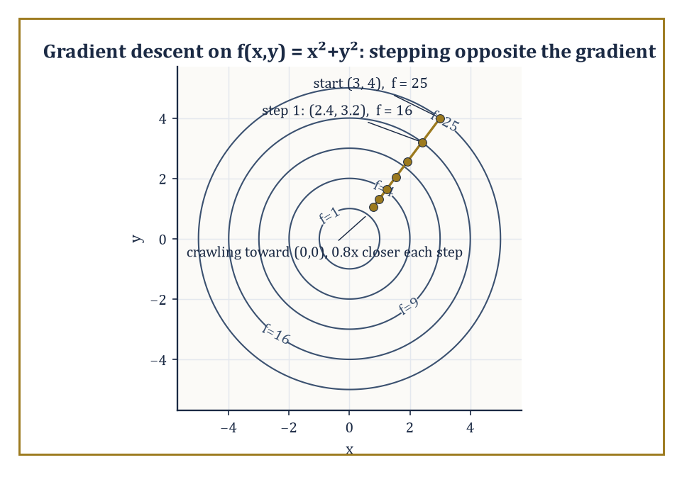
Figure 13.8 — Each step shrinks the distance to the minimum by a fixed 20 percent, whether or not anyone is watching.
Each tool generalizes something familiar from the single-variable chapters behind us, and each one, in the generalizing, revealed something new that a single variable was never rich enough to show.
It is worth pausing, before we go further, on a small piece of comedy inherent in the phrase ‘critical point’. In everyday English a crisis is a moment of maximal urgency; in mathematics a critical point is often nothing of the sort.
In the presence of enough variables, saddles vastly outnumber maxima and minima: for a critical point to be either, every eigenvalue of the Hessian must agree on a sign, and unanimity of that kind grows vanishingly rare as the dimension climbs. The typical critical point is therefore a saddle — a mountain pass of supreme indifference, neither triumph nor disaster, rising here and falling there with no opinion on the matter whatsoever. The universe of smooth functions is, on this evidence, considerably more equanimous than the committees named after them.
These are the tools Chapter 14 will build on directly, developing the full differential and integral calculus of several variables: multiple integrals over regions of the plane and of space, the vector calculus of fields that assign a vector (rather than a scalar) to every point, and the three classical capstone theorems — Green’s, Stokes’, and Gauss’s (the Divergence Theorem) — that tie derivatives and integrals together across dimensions in ways that make the Fundamental Theorem of Calculus from Chapter 12 (Volume 1) look, in hindsight, like a modest special case of something much larger.
Almost nothing worth measuring in physics, economics, biology, or engineering depends on exactly one influence in isolation; multi-variable functions are the honest mathematical description of that fact, and the geometric and analytic language built for a single variable across Chapters 1 through 12 (Volume 1) extends upward to meet it — with genuine new phenomena at every turn, as we have seen, but without ever losing its footing.
Numeric example — A capstone example: every tool from this chapter, on one function. Let f(x, y) = 4 − x² − y², a downward-opening paraboloid, a dome rather than a bowl. Domain: the expression is defined for every real (x, y), so the domain is all of ℝ² — no restrictions to sketch this time.
Level sets: setting 4 − x² − y² = c gives:
x² + y² = 4 − c
a circle of radius √(4 − c) whenever c < 4, shrinking to the single point (0, 0) at c = 4, and empty for c > 4 (since x² + y² can never be negative).
Gradient:
∇f = ⟨−2x, −2y⟩; at (1, 1), this is ⟨−2, −2⟩, with magnitude √((−2)² + (−2)²) = √8 = 2√2
pointing back toward the center of the dome, as intuition about a dome-shaped surface would suggest.
Critical point: ∇f = ⟨0, 0⟩ requires x = 0 and y = 0, giving the single critical point (0, 0), where f(0, 0) = 4.
Second-derivative test:
f_{xx} = −2, f_{yy} = −2, f_{xy} = 0, so H = (−2)(−2) − 0² = 4 > 0 and f_{xx} < 0
a local maximum, and by the same sum-of-squares-in-disguise reasoning as Extrema and the Second-Derivative Test, the global maximum, value 4.
Tangent plane at (0, 0, 4):
z = f(0,0) + f_{x}(0,0)(x − 0) + f_{y}(0,0)(y − 0) = 4 + 0(x) + 0(y) = 4
a perfectly horizontal plane — which is exactly what geometric common sense demands at the very top of a smooth dome, where the surface momentarily has no tilt in any direction at all, echoing f′(x) = 0 at a single-variable extremum all the way back in Chapter 11 (Volume 1).
Every tool acquired in this chapter, applied to one function, tells a single consistent story: a dome, centered at the origin, rising to height 4, perfectly flat at its summit, and sloping away symmetrically in every direction. That consistency is not a coincidence arranged for the example; it is what it means for a body of mathematics to hang together.
Try it now — One gradient-descent step on f(x, y) = x² + y² from (3, 4) with step size 0.1 lands where? Answer →
Numeric example — One step of gradient descent, by hand. The gradient’s role as ‘the direction of fastest increase’ has a famous practical inversion: moving opposite the gradient is the fastest way to decrease f, which is the idea behind gradient descent, the workhorse optimization algorithm underneath most of modern machine learning.
Take the bowl f(x, y) = x² + y² from What a Function of Several Variables Is, and start at (3, 4), where The Gradient and Directional Derivatives computed ∇f(3, 4) = ⟨6, 8⟩ and f(3, 4) = 25. One step of gradient descent, with a chosen step size (learning rate) of 0.1, moves to a new point:
(3, 4) − 0.1⟨6, 8⟩ = (3 − 0.6, 4 − 0.8) = (2.4, 3.2)
Evaluating there:
f(2.4, 3.2) = 2.4² + 3.2² = 5.76 + 10.24 = 16.00
That is down from 25 to 16 in a single step, by walking a short distance opposite the gradient. Repeat this enough times, shrinking the step size as the gradient itself shrinks near the minimum at the origin, and the sequence of points crawls its way down to the bottom of the bowl, f = 0, at (0, 0).
No new theory is required for this — only the gradient, computed at each new point in turn — which is as good a demonstration as any that the modest vector ⟨f_{x}, f_{y}⟩ introduced in The Gradient and Directional Derivatives is running rather more of the modern world, unannounced, than its two subscripts would suggest.
We arrived at this chapter with a single respectable variable and its single respectable derivative, and we leave it with vectors of partial derivatives, planes tangent to bowls and domes, and a healthy new suspicion of any limit we haven’t personally interrogated from at least two directions. That suspicion, if it feels uncomfortable, is doing its job: multi-variable functions are not a cosmetic extension of what came before, and pretending otherwise is how good students end up ambushed by saddle points, without warning.
The series continues. The functions have learned to depend on more than one thing at once, and — rather touchingly, for objects with no feelings whatsoever — they seem entirely unbothered by the extra responsibility.
Keep only this · Section 13.9: Where This Goes Next (Optional): From Multi-Variable Functions to Multi-Variable Calculus
The idea. Gradient, tangent plane and Hessian are the local picture; integrals over regions, the subject of the next chapter, are the global one.
Core.
gradient descent: xₙ₊₁ = xₙ − η∇f(xₙ)
Typical mistake. Taking a large gradient-descent step: it can overshoot the minimum and diverge.
Minimal example. f = x²: x ↦ x − 0.1(2x) = 0.8x, which halves the error in about three steps.
Practice. Easy to challenge; full worked answers, with the usual mistake, are in Answers to the Practice Sets at the back.
Easy — One descent step on f(x) = x² from x = 5 with η = 0.25? Answer →
Medium — For f(x) = x², which step sizes η make x ↦ x − 2ηx converge? Answer →
Challenge — Why does the Hessian, the matrix of second partials, matter for optimization in many variables? Answer →

Check Your Understanding — Chapter 13
Answers are in the Answer Key at the back of the book — have a go before you look.
1. [Explain] For f(x, y) = xy²/(x² + y⁴), every straight-line path through the origin gives a limit of 0 as (x, y) → (0, 0). Does that prove the limit is 0? Justify your answer using this chapter’s example.
See the answer →
2. [Compute] For f(x, y) = x²y³, compute the mixed partial derivatives f_{xy} and f_{yx} and confirm Clairaut’s theorem.
See the answer →
3. [Compute] Use implicit differentiation to find dy/dx on the circle x² + y² = 25 at the point (3, 4), and explain why this method avoided needing a square root.
See the answer →
4. [Concept] Classify the critical point of g(x, y) = x² − y² at the origin using the Hessian test, and relate the result to its contour map.
See the answer →

Fluency Drill — Chapter 13
Five minutes, no notes, before the harder problems. These are the moves the Problems assume are automatic; if one takes you more than a minute, reread the section it names. Worked answers, each with the usual slip, are in Answers to the Practice Sets.
1. [Compute] f(x, y) = x³y². Find f_{x} and f_{y}. Answer →
2. [Compute] Find ∇f at (1, −1) for f(x, y) = x² − xy. Answer →
3. [Compute] The unit vector in the direction (1, 1)? Answer →
4. [Concept] What shape are the level curves of f(x, y) = x² + 4y²? Answer →
5. [Compute] Domain of f(x, y) = ln(x − y)? Answer →
6. [Concept] f_{x} = f_{y} = 0 at a point and D = −3. What is the point? Answer →
7. [Compute] dz/dt for z = x + y², x = t, y = t² at t = 1. Answer →
8. [Compute] Linear estimate of f(x, y) = xy at (1.1, 2) from (1, 2). Answer →

Problems — Chapter 13
The step from one variable to several is where calculus stops being a machine you crank and starts being a subject you have to think about. Twelve problems follow, grouped by section. Each problem carries a skill tag (Concept, Compute, Explain, Prove, Model or Challenge; see How to Use This Book) and a link to its full worked solution, which ends with the usual mistake.
Domains, level sets, limits
1. [Concept] Describe the domain of f(x, y) = ln(4 − x² − y²) and sketch its level set f = 0. Solution →
2. [Compute] Evaluate lim(x,y)→(0,0) of (x²y)/(x² + y²), or show the limit fails to exist. Solution →
3. [Prove] Show that lim(x,y)→(0,0) of (xy)/(x² + y²) does not exist. Solution →
Partial derivatives and the gradient
4. [Compute] For f(x, y) = x³y − 4xy² + 7, find f_{x}, f_{y}, and the gradient at (1, 2). Solution →
5. [Compute] Find the directional derivative of f(x, y) = x² + 3xy at the point (2, 1) in the direction of the vector (3, 4). Solution →
6. [Explain] For f(x, y) = x² + y², explain why the gradient at any point is perpendicular to the level circle through that point, and verify it at (3, 4). Solution →
Chain rule, tangent planes, approximation
7. [Compute] Let z = x²y with x = cos t and y = sin t. Find dz/dt at t = π/2, using the chain rule. Solution →
8. [Compute] Find the equation of the tangent plane to z = x² + y² at the point (1, 2, 5). Solution →
9. [Model] Use linear approximation at (3, 4) to estimate √(3.1² + 3.9²), and compare with the true value. Solution →
Extrema
10. [Compute] Find and classify all critical points of f(x, y) = x² + y² − 4x + 6y. Solution →
11. [Prove] Show that f(x, y) = x² − y² has exactly one critical point and that it is a saddle. Solution →
12. [Challenge] The second-derivative test fails when the discriminant D = 0. Give an example where D = 0 at a point that is a minimum, and one where D = 0 at a saddle, and say what this tells you about the test. Solution →

Math, Actually

Chapter 14

Multi-Variable Calculus
Multiple Integrals, Vector Fields, and the Art of Integrating Over Regions and Flows
Chapter 13 left us in a peculiar state: fluent in the differential habits of functions of several variables, able to find a gradient, spot a saddle point, and interrogate a surface about its steepest ascent, but with no way whatsoever to add anything up. We could describe the slope of a mountain at every point on it; we could not yet weigh the mountain, or work out how much rain it would catch, or how hard the wind would have to blow to knock a flag off its summit. Differentiation without integration is a magnificent diagnostic tool and a fairly useless accountant. This chapter exists to fix that.
The fix, as usual in this series, is to take an idea that worked perfectly well on the number line and drag it into higher dimensions. The single-variable integral summed a quantity along an interval; we now sum quantities over regions of the plane, over solid chunks of space, along curves, and across surfaces. The Riemann sum survives the journey more or less intact — chop, sample, multiply, add, take a limit — but the bookkeeping around it grows considerably more elaborate, because regions in the plane do not queue up politely between two endpoints the way intervals do. Expect more sketching than you are used to. Expect it to matter.
The payoff, and it is a substantial one, is a suite of theorems — Green’s, Stokes’, and the Divergence Theorem of Gauss — that all say the same single beautiful thing in three different dialects: what happens inside a region is completely determined by what happens on its boundary, provided you differentiate correctly on the way out. This is the Fundamental Theorem of Calculus again, wearing a series of increasingly elaborate disguises, and part of the quiet pleasure of this chapter is watching the disguise slip a little more with each theorem until, by the end, you can see the same face underneath all three.
A note on what lies ahead: the computations here are heavier than anything in Chapter 13. Setting up limits of integration correctly is a skill that punishes carelessness swiftly — get the region wrong and every later line of arithmetic computes the wrong thing beautifully. Practice is not optional. The reward is a toolkit that underwrites classical physics and much of engineering, and that the next chapter, Vector Calculus, puts to work on electromagnetism and fluid flow. Let us integrate in higher dimensions.
Before you begin — Chapter 14 · Core chapter
By the end of this chapter you will be able to:
1. Set up and evaluate double and triple integrals as iterated integrals, choosing the order of integration.
2. Change variables with the Jacobian, including polar, cylindrical and spherical coordinates.
3. Evaluate line integrals of vector fields, and test for and use potential functions.
4. Compute flux through parametrized surfaces.
5. Apply Green’s, Stokes’ and the divergence theorems, checking orientation and hypotheses.
Why it comes here. Chapter 13 differentiated functions of several variables; this chapter integrates them, over regions, along curves and across surfaces. The three big theorems at the end (Green, Stokes, divergence) connect the two halves, and Chapter 15 then turns them into the working language of physics.
Required chapters. Multi-Variable Functions (Chapter 13); Integrals, Chapter 12 (Volume 1).
Assumed skills. compute partial derivatives and gradients; evaluate single-variable integrals by substitution and by parts; compute a 2 × 2 determinant; parametrize a line segment and a circle.
If you are rusty. Partial Derivatives; The Gradient and Directional Derivatives; substitution in one variable — Chapter 12 (Volume 1).
Do not proceed until you can…
1. Evaluate ∫₀² x√(1 + x²) dx. Answer →
2. Compute det [3 1; 2 4]. Answer →
3. Parametrize the unit circle once counterclockwise and the segment from (0, 0) to (1, 2). Answer →
Estimated study time. About 12–14 hours over one to two weeks. Work every Try it now before reading on, finish each section’s Keep only this practice before starting the next, and do the Fluency Drill before the Problems.

Section 14.1: Double Integrals and Iterated Integrals
Or: How to Add Up Infinitely Many Infinitesimal Rectangles Without Losing Your Nerve
CORE · about 20 minutes · later chapters build on this
Key idea — A double integral of a function f over a region D in the plane begins life the way the single-variable integral did: as a Riemann sum. Chop D into a great many small rectangles (or, for the fastidious, small pieces of any convenient shape that tile the region), pick a sample point in each piece, multiply the value of f there by the area of that piece, and add everything up. Refine the chopping — smaller pieces, more of them — and take the limit. Assuming f is not being deliberately difficult, the sums settle down to a single number, written
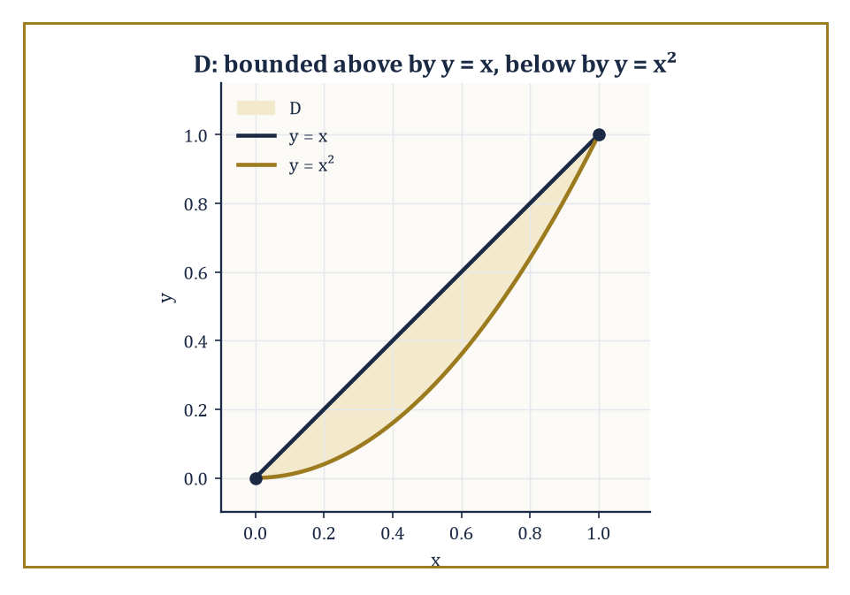
Figure 14.1 — The region D between y = x and y = x², the shaded sliver whose area the worked example finds to be 1/6.
∬[D] f(x, y) dA
This is the same ritual that built the single integral, with one change of scenery: the ‘width’ of each little piece is now an area rather than a length, and D is free to be almost any shape at all, rather than an interval sitting patiently between two endpoints. Geometrically, when f ≥ 0, the double integral measures the volume trapped between the surface z = f(x, y) and the region D beneath it in the xy-plane — a solid slab of variable height, weighed by integration instead of by scales. When f represents a density, the same integral gives a mass; when f is 1, it gives an area. The double integral, in short, is the single all-purpose machine for accumulating anything spread continuously over a region.
Numeric example — mass from a density. Let D be the unit square, 0 ≤ x ≤ 1 and 0 ≤ y ≤ 1, and suppose a thin metal lamina occupying D has density ρ(x, y) = x + y (grams per square unit, heavier toward the far corner). Its total mass is
M = ∬[D] (x + y) dA
Working the inner integral over x first, treating y as a constant:
∫₀¹ (x + y) dx = [x²/2 + xy]₀¹ = 1/2 + y
Now integrate that result over y:
∫₀¹ (1/2 + y) dy = [y/2 + y²/2]₀¹ = 1/2 + 1/2 = 1
So M = 1 gram. Note how little drama was involved: two ordinary single-variable integrals, performed one after the other, and the double integral falls out. Keep this lamina — density x + y, mass 1 gram — in mind; it returns shortly.
Try it now — Evaluate ∫₀¹∫₀¹ (x + y) dy dx. Answer →
The double integral would be dreadful to compute directly from its defining limit — nobody wants to take a limit of Riemann sums by hand, and certainly not more than once — so mathematicians did what mathematicians always do when faced with drudgery: found a theorem that lets someone else, namely the ordinary single-variable integral, do the actual work. Fubini’s theorem is the labor-saving device of multivariable calculus. It states that, provided f and D are reasonably well-behaved (continuity on a bounded region will more than suffice here), the double integral can be evaluated as an iterated integral: integrate first with respect to one variable, holding the other fixed, to produce a function of the remaining variable, then integrate that. In symbols,
∬[D] f dA = ∫∫ f(x, y) dy dx
worked from the inside out, rather like nested Russian dolls, or a bureaucratic form that requires you to fill in section 2 before section 1 will accept your signature. The genuine work in any double-integral problem is not the integration itself — that is routine — but determining the correct limits, which requires looking honestly at the shape of D rather than integrating on autopilot.
Numeric example — an iterated integral over a rectangle. Evaluate ∬[D] xy dA where D is the rectangle 0 ≤ x ≤ 2, 0 ≤ y ≤ 3. By Fubini,
∬[D] xy dA = ∫₀² ∫₀³ xy dy dx
Inner integral, x held fixed:
∫₀³ xy dy = x·[y²/2]₀³ = x·(9/2) = 9x/2
Outer integral:
∫₀² (9x/2) dx = (9/2)·[x²/2]₀² = (9/2)·2 = 9
So ∬[D] xy dA = 9. Reversing the order changes nothing except the order of typing:
∫₀³ ∫₀² xy dx dy = ∫₀³ y·2 dy = 2·[y²/2]₀³ = 9
as it must, since D here is a plain rectangle and both orders are equally painless — the interesting decisions about order only arise once D stops being a rectangle.
Because Fubini’s theorem sanctions either order of integration — dy dx or dx dy — one is free to choose whichever produces the friendlier antiderivatives. This is sometimes a matter of taste and sometimes a matter of survival: one order yields an elementary antiderivative in three lines, the other produces an integral nobody can finish by hand (the function exp(x²) makes a habit of appearing where you least want it, and it has no elementary antiderivative at all). The discipline that prevents disaster is simple to state and, under exam pressure, curiously easy to abandon: sketch the region D before writing a single limit of integration. Only once the region is actually visible on paper — its boundary curves, where they intersect, which curve bounds it from above and which from below, for a given order — can you write down limits that describe D rather than limits that merely look plausible and describe something else entirely.
Numeric example — area between two curves. Find the area of the region D bounded above by y = x and below by y = x², for x between 0 and 1 (sketch mentally: the two curves meet at (0, 0) and (1, 1), and the straight line sits above the parabola throughout that interval, since for 0 < x < 1 we have x² < x). The area is ∬[D] 1 dA, and because D is described most by fixing x and letting y run between the two curves, the natural order is dy dx:
A = ∫₀¹ ∫[x², x] dy dx
Inner integral:
∫[x², x] dy = x − x²
Outer integral:
∫₀¹ (x − x²) dx = [x²/2 − x³/3]₀¹ = 1/2 − 1/3 = 1/6
The area between the two curves is 1/6 of a square unit — a small, tidy number for a region that, without the sketch, would have been easy to set up backwards.
Once the machinery is running, double integrals compute almost anything describable as ‘add up this quantity, continuously, over a region.’ Set f = 1 and you recover the area of D, as above. Let f = ρ(x, y), a density, and the integral gives the total mass of a flat lamina shaped like D, as in the very first example of this section. Weight each infinitesimal piece of mass by its (signed) distance from an axis and integrate, and you get a moment; the ratio of a moment to the total mass gives one coordinate of the center of mass — the single point at which the lamina would balance on the tip of a needle, a claim from physics that pure calculus is happy to make good on. Weight instead by the square of the distance from an axis, and the integral gives the moment of inertia, which measures how reluctant the lamina is to be spun up around that axis. Finally, dividing ∬[D] f dA by the area of D gives the average value of f over the region: the single flat height that, spread evenly across D, would enclose exactly the same volume as the original, bumpier surface. All four quantities are the same integral, differently dressed.
Numeric example — center of mass of the density-x+y lamina. Return to the unit-square lamina of density ρ(x, y) = x + y, whose mass we found to be M = 1. Its center of mass (x̄, ȳ) is given by
x̄ = (1/M) ∬[D] x·ρ(x, y) dA, ȳ = (1/M) ∬[D] y·ρ(x, y) dA
For x̄:
∬[D] x(x + y) dA = ∬[D] (x² + xy) dA = ∫₀¹∫₀¹ x² dx dy + ∫₀¹∫₀¹ xy dx dy = (1/3)·1 + (1/2)·(1/2) = 1/3 + 1/4 = 7/12
Since M = 1, x̄ = 7/12. By the symmetry of the density under swapping x and y, the same computation for ȳ gives
∬[D] (xy + y²) dA = 1/4 + 1/3 = 7/12
so ȳ = 7/12 as well. The center of mass sits at (7/12, 7/12) ≈ (0.583, 0.583) — pulled, sensibly, away from the center of the square (0.5, 0.5) and toward the far corner (1, 1), exactly where the density is heaviest. Calculus, once again, confirming what common sense suspected, but this time with a number attached.
Keep only this · Section 14.1: Double Integrals and Iterated Integrals
The idea. A double integral is an iterated pair of ordinary integrals; Fubini lets you choose the order, and the limits always come from a sketch of the region.
Core.
∬_{R} f dA = ∫[a, b] ∫[c, d] f(x, y) dy dx (Fubini)
Typical mistake. Writing limits that “look plausible” without sketching the region, especially when the inner limits should depend on the outer variable.
Minimal example. ∬ over [0, 1] × [0, 2] of xy dA = (1/2)(2) = 1.
Practice. Easy to challenge; full worked answers, with the usual mistake, are in Answers to the Practice Sets at the back.
Easy — Evaluate ∫[0, 1] ∫[0, 1] (x + y) dy dx. Answer →
Medium — Find the area-weighted integral of x over the triangle 0 ≤ y ≤ x ≤ 1. Answer →
Challenge — Reverse the order: ∫[0, 1] ∫[y, 1] exp(x²) dx dy. Answer →

Section 14.2: Triple Integrals and Applications
Or: The Same Trick, One Dimension Fatter
CORE · about 15 minutes · later chapters build on this
Definition — Triple integrals extend the double-integral idea to solid regions in three-dimensional space, and the extension is almost insultingly straightforward once the double-integral machinery is in place: chop a solid E into small blocks of volume, sample f at a point in each, multiply and sum, take the limit, and call the result
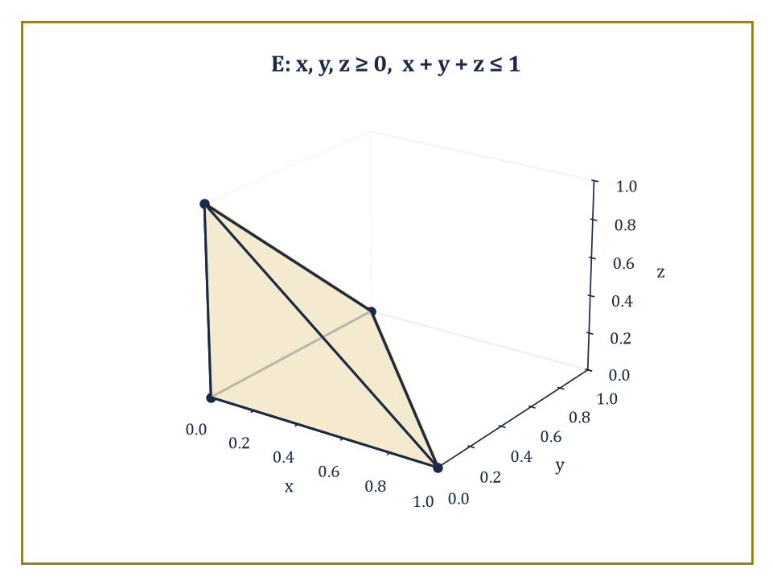
Figure 14.2 — The tetrahedron E in the first octant bounded by the plane x + y + z = 1, whose volume the worked example finds to be 1/6.
∭[E] f(x, y, z) dV
There is no new conceptual content here — only one more dimension to keep track of, which in practice means one more integral sign and one more variable’s worth of limits to determine correctly. Fubini’s theorem again reduces the triple integral to an iterated integral, now with three nested single integrations rather than two; the trick, as before, is entirely in describing E correctly, this time in three dimensions, which usually means picturing (or sketching, badly, on the back of an envelope) how the solid looks when sliced by planes of constant x, or constant z, or whichever variable you have chosen to peel off first.
Numeric example — volume of a tetrahedron. Let E be the solid tetrahedron in the first octant bounded by the coordinate planes and the plane x + y + z = 1 (so x, y, z ≥ 0 and x + y + z ≤ 1). Its volume is
V = ∭[E] dV = ∫₀¹ ∫₀¹⁻ˣ ∫₀¹⁻ˣ⁻ʸ dz dy dx
The innermost integral is immediate:
∫₀¹⁻ˣ⁻ʸ dz = 1 − x − y
For the next integral, fix x and write u = 1 − x for brevity:
∫₀ᵘ (u − y) dy = [uy − y²/2]₀ᵘ = u² − u²/2 = u²/2
Substituting back, this is (1 − x)²/2. Finally,
∫₀¹ (1 − x)²/2 dx = [−(1 − x)³/6]₀¹ = (0) − (−1/6) = 1/6
The tetrahedron has volume 1/6 — which matches the schoolroom formula (1/3)·(base area)·(height) = (1/3)·(1/2)·1 = 1/6 exactly, a small comfort confirming that all this machinery agrees with the geometry you already trusted.
Try it now — Volume of the box 0 ≤ x ≤ 2, 0 ≤ y ≤ 3, 0 ≤ z ≤ 1 as a triple integral. Answer →
The applications transfer unchanged from the plane, now describing solids rather than laminas. Set f = 1 and ∭[E] dV gives the volume of E. Let f = ρ(x, y, z) be a density and the integral gives the mass of a body whose density varies from point to point, the way a planet is denser at its core than at its crust. Centers of mass now have three coordinates x̄, ȳ, z̄, each found by weighting the density by that coordinate and dividing by the mass; moments of inertia weight by the squared distance from an axis. The only price of the extra dimension is one more integral sign and more careful bookkeeping of limits.
Numeric example — mass of a solid cube. A solid occupying the unit cube 0 ≤ x, y, z ≤ 1 has density ρ(x, y, z) = x² + y² + z² (grams per cubic unit — denser toward the far corner (1,1,1), and zero, somewhat implausibly, at the origin, but it is only an exercise). Its mass is M = ∭ (x² + y² + z²) dV over the cube. By linearity, split this into three separate triple integrals:
M = ∭ x² dV + ∭ y² dV + ∭ z² dV
By the symmetry of the cube, each of these three integrals has the same value; compute just the first.
∭ x² dV = ∫₀¹∫₀¹∫₀¹ x² dz dy dx = ∫₀¹ x² dx · ∫₀¹ dy · ∫₀¹ dz = (1/3)·1·1 = 1/3
since x² does not depend on y or z, and the two trailing integrals are each the length of the unit interval. By symmetry the y² and z² integrals also each equal 1/3. Total mass M = 1/3 + 1/3 + 1/3 = 1 gram — a suspiciously clean answer, but a correct one, and a useful reminder that symmetry, spotted early, can save two-thirds of the arithmetic.
When the solid E has rotational symmetry — around an axis, or around a point — Cartesian coordinates become an act of self-sabotage, and cylindrical coordinates take over. Cylindrical coordinates describe a point by (r, θ, z): the same polar radius and angle as in the plane, applied to the x and y coordinates, with z left alone. The volume element transforms from dx dy dz into
r dr dθ dz
that extra factor of r is not decorative; it is the same area-scaling factor that appears in plane polar coordinates, carried along for the ride, and it accounts for the fact that a thin shell of fixed angular width sweeps out more actual area the further out it sits from the axis.
Numeric example — volume of a cone via cylindrical coordinates. Find the volume of a right circular cone of base radius 2 and height 5, apex pointing upward, base sitting in the plane z = 0. At height z, the cross-sectional disk has shrunk linearly from radius 2 (at z = 0) to radius 0 (at z = 5); solving for the radius as a function of height, the disk at height z has radius rₘₐₓ(z) = 2(1 − z/5), or equivalently, at a fixed radius r, the cone extends in z from 0 up to zₘₐₓ(r) = (5/2)(2 − r). Using cylindrical coordinates and integrating in the order z, then r, then θ:
V = ∫[0, 2π] ∫₀² ∫[0, (5/2)(2−r)] r dz dr dθ
Inner integral:
∫[0, (5/2)(2−r)] r dz = r·(5/2)(2 − r) = (5/2)(2r − r²)
Next:
∫₀² (5/2)(2r − r²) dr = (5/2)·[r² − r³/3]₀² = (5/2)·(4 − 8/3) = (5/2)·(4/3) = 10/3
Outer integral over θ multiplies by 2π:
V = 2π·(10/3) = 20π/3
This matches the schoolroom cone-volume formula (1/3)πr²h = (1/3)π(4)(5) = 20π/3 exactly — cylindrical coordinates, correctly wielded, reproduce a formula you have known since school, which is the reassurance one wants from a new technique before trusting it on a shape with no textbook formula at all.
When the solid instead has spherical symmetry — centered on the origin, indifferent to direction — spherical coordinates (ρ, φ, θ) take over, where ρ is distance from the origin, φ is the angle down from the positive z-axis (colatitude), and θ is the familiar angle around the z-axis. The volume element becomes
ρ² sin φ dρ dφ dθ
a factor stranger-looking than the cylindrical case but built from the same idea: it measures how much actual volume a small box in (ρ, φ, θ)-space corresponds to once mapped into ordinary xyz-space, and that correspondence depends on both how far out you are (hence ρ²) and how close to the poles you are (hence sin φ, which vanishes at the poles themselves, where meridians of longitude all crowd together to a single point and a full range of θ sweeps out almost no actual space at all).
Numeric example — volume of a sphere via spherical coordinates. Find the volume of a solid sphere of radius 3 centered at the origin. In spherical coordinates the sphere is 0 ≤ ρ ≤ 3, 0 ≤ φ ≤ π, 0 ≤ θ ≤ 2π — about as painless a description as a region ever gets.
V = ∫[0, 2π] ∫[0, π] ∫₀³ ρ² sin φ dρ dφ dθ
The three integrals separate completely, since the integrand factors and none of the limits depend on the other variables:
∫₀³ ρ² dρ = [ρ³/3]₀³ = 9
∫[0, π] sin φ dφ = [−cos φ]₀^{π} = (−cos π) − (−cos 0) = 1 + 1 = 2
∫[0, 2π] dθ = 2π
Multiplying:
V = 9 · 2 · 2π = 36π
Compare against the schoolroom formula (4/3)πr³ = (4/3)π(27) = 36π — exact agreement, as it should be, since the schoolroom formula was itself proved by essentially this calculation, long before either of us was born.
Keep only this · Section 14.2: Triple Integrals and Applications
The idea. Triple integrals add one more nested integral; cylindrical coordinates carry the factor r and spherical coordinates the factor ρ² sin φ.
Core.
∭_{E} f dV, iterated three times
mass = ∭ ρ dV
Typical mistake. Dropping the volume factor r or ρ² sin φ after switching coordinates.
Minimal example. Volume of the unit cube: ∭ 1 dV = 1.
Practice. Easy to challenge; full worked answers, with the usual mistake, are in Answers to the Practice Sets at the back.
Easy — Evaluate ∫[0, 1] ∫[0, 1] ∫[0, 1] xyz dz dy dx. Answer →
Medium — Find the volume of the tetrahedron x, y, z ≥ 0, x + y + z ≤ 1. Answer →
Challenge — A cube [0, 1]³ has density ρ = x. Find its mass and the x-coordinate of its center of mass. Answer →

Section 14.3: Change of Variables and Jacobians
Or: Substitution, But It Brought a Determinant
CORE · about 15 minutes · later chapters build on this
Definition — A change of variables in a multiple integral is the higher-dimensional descendant of ordinary substitution — the trick, familiar from single-variable calculus, of replacing x by some function of a new variable u to make an awkward integral tractable. In several variables the substitution becomes a transformation: a map x = x(u, v), y = y(u, v) sending a region in the uv-plane onto the region of integration in the xy-plane. The integral transforms according to
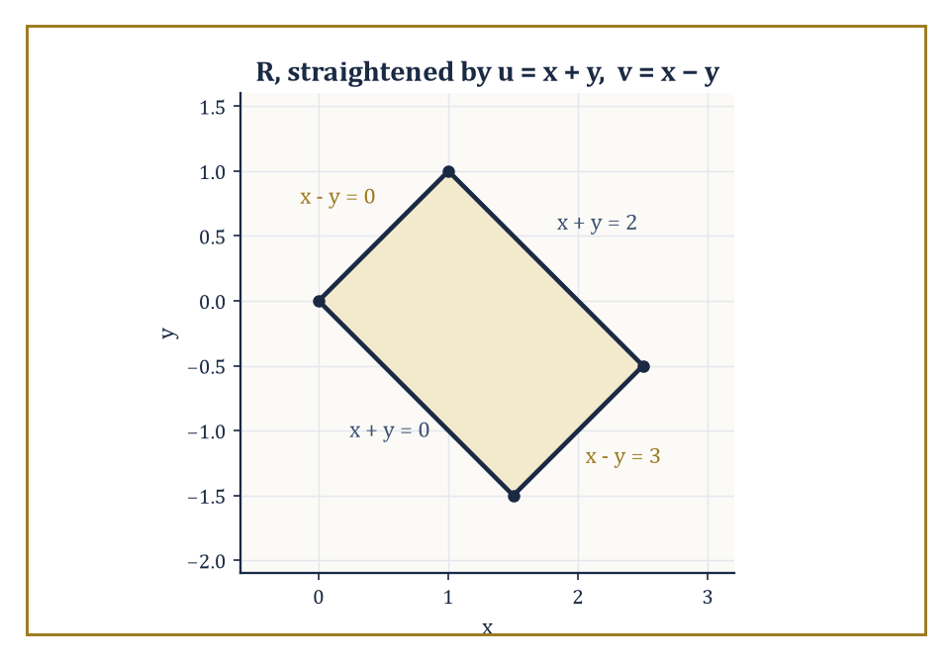
Figure 14.3 — The slanted parallelogram R, straightened into a plain rectangle by u = x + y, v = x − y before the Jacobian ever has to do any work.
∬[D_{xy}] f(x, y) dA = ∬[D_{uv}] f(x(u,v), y(u,v)) |J| du dv
where J is the Jacobian determinant of the transformation — the determinant of the matrix of partial derivatives ∂(x,y)/∂(u,v). This is not an arbitrary decoration; it is forced by the same reasoning that produced the ordinary substitution rule dx = (dx/du) du in one variable, applied to the way small rectangles in uv-space get stretched, squashed, and sheared into small parallelograms in xy-space. The absolute value is there because area, unlike a signed one-dimensional length, does not care which way the transformation happens to be oriented.
Numeric example — deriving the polar Jacobian. The most familiar change of variables is plane polar coordinates, x = r cos θ, y = r sin θ. Its Jacobian is computed just as the definition demands, from the four partial derivatives ∂x/∂r = cos θ, ∂x/∂θ = −r sin θ, ∂y/∂r = sin θ, ∂y/∂θ = r cos θ, arranged into a 2×2 determinant:
J = (∂x/∂r)(∂y/∂θ) − (∂x/∂θ)(∂y/∂r) = (cos θ)(r cos θ) − (−r sin θ)(sin θ) = r cos²θ + r sin²θ = r(cos²θ + sin²θ) = r
So |J| = r (since r ≥ 0, the absolute value changes nothing), and dA = r dr dθ — precisely the area element you were handed, on trust, back when polar coordinates were first introduced. Now you know where that stray factor of r came from: it is not decoration, it is a determinant, doing its job unannounced, measuring how a small rectangle of sides dr and dθ in (r, θ)-space gets stretched into a small, r-scaled, roughly-rectangular patch out in the xy-plane.
Try it now — Compute the Jacobian of x = 2u, y = 3v, and the area of the image of the unit square. Answer →
Polar coordinates, and their solid-geometry cousins cylindrical and spherical coordinates, are the three most common special cases of this general formula, each with its own Jacobian computed once and then reused forever (r for polar and cylindrical, ρ² sin φ for spherical, as met in the previous section). But the change-of-variables formula is not limited to these three celebrities. It is useful whenever a region or an integrand simplifies dramatically under some other, less famous transformation — a linear map that straightens a parallelogram into a rectangle, for instance, or a substitution tailored to an elliptical region so that the ellipse becomes a circle in the new coordinates. The general principle is: if the region D looks awkward in xy-coordinates but would look like a plain rectangle in some other coordinates (u, v), find the transformation, compute its Jacobian once, and let the awkwardness dissolve.
Numeric example — straightening a parallelogram. Evaluate ∬[R] (x + y) eˣ⁻ʸ dA, where R is the parallelogram bounded by the four lines x + y = 0, x + y = 2, x − y = 0, and x − y = 3. Set u = x + y and v = x − y. Solving back for x and y: x = (u + v)/2, y = (u − v)/2. The Jacobian of this inverse transformation is computed from ∂x/∂u = 1/2, ∂x/∂v = 1/2, ∂y/∂u = 1/2, ∂y/∂v = −1/2:
J = (1/2)(−1/2) − (1/2)(1/2) = −1/4 − 1/4 = −1/2
so |J| = 1/2. In (u, v)-coordinates the parallelogram R becomes the plain rectangle 0 ≤ u ≤ 2, 0 ≤ v ≤ 3 — the point of the substitution — and the integrand x + y = u, x − y = v become u eᵛ. The integral becomes
∬[0≤u≤2,\ 0≤v≤3] u eᵛ · (1/2) du dv = (1/2) ∫₀² u du · ∫₀³ eᵛ dv = (1/2)·2·(e³ − 1) = e³ − 1
So ∬[R] (x + y) eˣ⁻ʸ dA = e³ − 1 ≈ 19.09 — a value that would have been a nightmare to extract directly from the slanted parallelogram in xy-coordinates, and fell out in three lines once the region was straightened.
Mastery of the Jacobian is, in a very real sense, the technical key that unlocks a large fraction of the otherwise-intractable multiple integrals one meets in practice. There is a certain dry satisfaction in this: an entire integral, hopeless in its original coordinates, capitulates the moment you find the right disguise for it and compute one determinant. The single most celebrated instance of the technique — the one every mathematician remembers fondly, the way one remembers a favorite conjuring trick — evaluates an integral that has no elementary antiderivative at all, by the cunning expedient of squaring it first.
Numeric example — the Gaussian integral by polar substitution. The function exp(−x²) has no elementary antiderivative — none of the usual functions differentiate to give it back — so ∫[−∞, ∞] exp(−x²) dx cannot be evaluated by finding an antiderivative and plugging in limits, the standard trick does not apply. Call this unknown value I. The trick is to consider I² instead, written as a product of two copies of the same integral in different dummy variables, then recombined into a double integral:
I² = (∫[−∞, ∞] exp(−x²) dx)(∫[−∞, ∞] exp(−y²) dy) = ∬[ℝ²] exp(−(x²+y²)) dA
since the two separate single integrals over the whole line multiply out, term by term, into a double integral over the whole plane. Now switch to polar coordinates: x² + y² = r², and dA = r dr dθ.
I² = ∫[0, 2π] ∫[0, ∞] exp(−r²) r dr dθ
The inner integral yields to the ordinary substitution s = r², ds = 2r dr:
∫[0, ∞] exp(−r²) r dr = (1/2) ∫[0, ∞] e⁻ˢ ds = (1/2)[−e⁻ˢ]₀∞ = (1/2)(0 − (−1)) = 1/2
The outer integral is ∫[0, 2π] dθ = 2π. So
I² = 2π · (1/2) = π, therefore I = √π
The Jacobian factor r, which looked like a bureaucratic nuisance when it first appeared, is the single ingredient that makes this integral — otherwise permanently stuck — collapse into a number. It is one of the more pleasing moments in the entire subject, and no one who has seen it forgets it.
Keep only this · Section 14.3: Change of Variables and Jacobians
The idea. dA = |∂(x, y)/∂(u, v)| du dv: the absolute Jacobian is the local area magnification of the substitution.
Core.
dx dy = |∂(x, y)/∂(u, v)| du dv
polar: dA = r dr dθ
spherical: dV = ρ² sin φ dρ dφ dθ
Typical mistake. Forgetting the absolute value, or forgetting the Jacobian altogether.
Minimal example. Area of the disk of radius a: ∫[0, 2π] ∫[0, a] r dr dθ = πa².
Practice. Easy to challenge; full worked answers, with the usual mistake, are in Answers to the Practice Sets at the back.
Easy — Compute the Jacobian of x = 2u, y = 3v. Answer →
Medium — Evaluate ∬ over the unit disk of exp(−(x² + y²)) dA. Answer →
Challenge — Find the volume of the ball of radius a with spherical coordinates. Answer →

Section 14.4: Vector Fields and Line Integrals
Or: Arrows Everywhere, and What Happens When You Walk Through Them
CORE · about 15 minutes · later chapters build on this
Definition — A vector field assigns not a number but a vector to each point of a region — an arrow, with both length and direction, planted at every point of the plane or of space. The familiar physical examples are a force field (the pull of gravity, differing in direction and strength from place to place), the velocity field of a moving fluid (a different current speed and direction at every point of a river), and — a link back to Chapter 13 — the gradient field of a scalar function, whose arrow at each point points in the direction of steepest ascent and has length equal to the steepness there. In components, a vector field in the plane is written
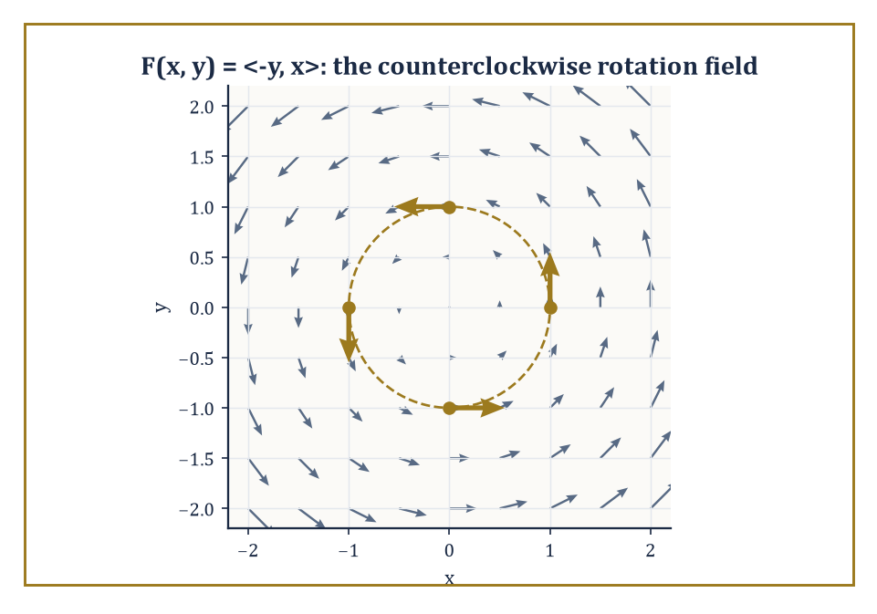
Figure 14.4 — The rotation field F = ⟨−y, x⟩, with the four sample points from the worked example picked out in gold on the unit circle.
F = ⟨P(x, y), Q(x, y)⟩
a pair of ordinary scalar functions bundled together as the two components of the arrow at (x, y); in space a third component R(x, y, z) joins them. Nothing here is conceptually new — it is two or three ordinary multivariable functions traveling together, relabeled as the components of an arrow rather than treated as separate unrelated quantities.
Numeric example — plotting a rotation field by hand. Consider the vector field F(x, y) = ⟨−y, x⟩, and evaluate it at a few sample points to see what kind of arrow-pattern it draws.
At (1, 0): F = ⟨−0, 1⟩ = (0, 1)
At (0, 1): F = ⟨−1, 0⟩ = (−1, 0)
At (−1, 0): F = ⟨0, −1⟩
At (0, −1): F = ⟨1, 0⟩
At (1, 0) the arrow points straight up; at (0, 1) it points left; at (−1, 0) it points down; at (0, −1) it points right. Notice the pattern: at each of these four points on the unit circle, the arrow is perpendicular to the position vector and points in the counterclockwise direction around the origin. This is not a coincidence of the four points chosen — F = ⟨−y, x⟩ is, at every point in the plane, the position vector ⟨x, y⟩ rotated 90° counterclockwise. It is the vector field of a rigid body spinning counterclockwise about the origin at unit angular speed, and it will reappear, not at all by accident, in every section for the rest of this chapter.
Try it now — Compute ∫_{C} F · dr for F = (1, 0) along the segment from (0, 0) to (3, 4). Answer →
A line integral of a vector field F along a curve C measures the work done by the field in dragging a particle along C — or, if F is the velocity field of a fluid, the circulation of the flow along C. It is defined as
∫[C] F · T ds
integrating the component of F along the curve’s unit tangent direction T with respect to arc length; in components this becomes
∫[C] P dx + Q dy
(with an R dz term added in space), evaluated by parametrizing the curve and reducing everything to a single ordinary integral over the parameter. Physically: F · T at a point measures how much of the field’s push is aligned with the direction of travel at that instant — a headwind contributes negatively, a tailwind positively, a crosswind not at all — and the line integral totals this contribution along the whole journey.
Numeric example — work along a straight path. Compute the line integral of F = ⟨y, x⟩ along the straight-line path C from (0, 0) to (1, 1), parametrized by x = t, y = t for t running from 0 to 1 (so dx = dt, dy = dt). The line integral is
∫[C] P dx + Q dy = ∫₀¹ (y dx + x dy) = ∫₀¹ (t · dt + t · dt) = ∫₀¹ 2t dt = [t²]₀¹ = 1
So the work done by F in moving a particle along this straight path from the origin to (1, 1) is 1 unit. This particular field, as it happens, is unusually well-behaved — hold that thought; the next section explains exactly why, and what makes it different from the rotating field met a moment ago.
The value of a line integral depends, in general, on the specific path taken between two points, not merely on where it starts and ends — push a particle around by two different routes through a swirling fluid, and the total work done can come out different each time, since one route might spend longer riding with the current and the other longer fighting against it. When, for a particular field, the line integral happens to depend only on the endpoints and never on the path connecting them, the field earns the name conservative, and its line integral reduces to the difference of a single scalar potential function evaluated at the two endpoints — a considerable simplification, since it replaces an integral along a possibly complicated curve with the evaluation of one function at two points. Whether a given field has this pleasant property is the subject of the next section; for now, the crucial test case is the rotating field F = ⟨−y, x⟩ met above, taken all the way around a closed loop back to its own starting point.
Numeric example — circulation around a closed loop. Compute the line integral of the rotation field F = ⟨−y, x⟩ around the unit circle, traversed once counterclockwise, parametrized by x = cos t, y = sin t for t from 0 to 2π (so dx = −sin t dt, dy = cos t dt). The line integral is
∫[C] P dx + Q dy = ∫[0, 2π] [(−sin t)(−sin t dt) + (cos t)(cos t dt)] = ∫[0, 2π] (sin²t + cos²t) dt = ∫[0, 2π] 1 dt = 2π
The circulation around the closed loop is 2π — not zero. Since the path starts and ends at the very same point, (1, 0), a path-independent (conservative) field would have been forced to give zero here, the difference of a potential function with itself. That it instead gives a stubbornly nonzero 2π is the field’s way of announcing, loudly, that it is not conservative — there is genuine rotation baked into it, and a particle carried once around the loop picks up real net work from the field, purely from having gone in a circle. Conservative Fields and Potential Functions makes this diagnosis precise; Green’s Theorem explains just where the number 2π comes from.
Keep only this · Section 14.4: Vector Fields and Line Integrals
The idea. A line integral of a vector field adds up F · dr: only the component of F along the path counts.
Core.
∫_{C} F · dr = ∫[a, b] F(r(t)) · r′(t) dt
Typical mistake. Parametrizing the right curve in the wrong direction; reversing the path flips the sign.
Minimal example. F = (−y, x) around the unit circle: ∫[0, 2π] 1 dt = 2π.
Practice. Easy to challenge; full worked answers, with the usual mistake, are in Answers to the Practice Sets at the back.
Easy — F = (1, 0) along r(t) = (t, t), 0 ≤ t ≤ 1. Answer →
Medium — F = (y, x) along y = x² from (0, 0) to (1, 1). Answer →
Challenge — Explain why reversing the direction of C changes the sign of ∫_{C} F · dr but not of ∫_{C} f ds. Answer →

Section 14.5: Conservative Fields and Potential Functions
Or: Fields That Remember Where They Started and Fields That Don’t
CORE · about 15 minutes · later chapters build on this
Carry a suitcase up three flights of stairs and back down again, and gravity has, on balance, done no work on it: whatever it took on the way up it returned on the way down, and the route you chose made no difference. Forces like that are called conservative, and they are exactly the ones that allow an energy account, a single number at each point, the potential, from which the force can be read off. Friction is the opposite. Drag a box round a room and back to where it started, and you have paid all the way. This section shows how to tell the two kinds apart and how to recover the potential when it exists.
Definition — A vector field is called conservative if it is the gradient of some scalar function f, that is,
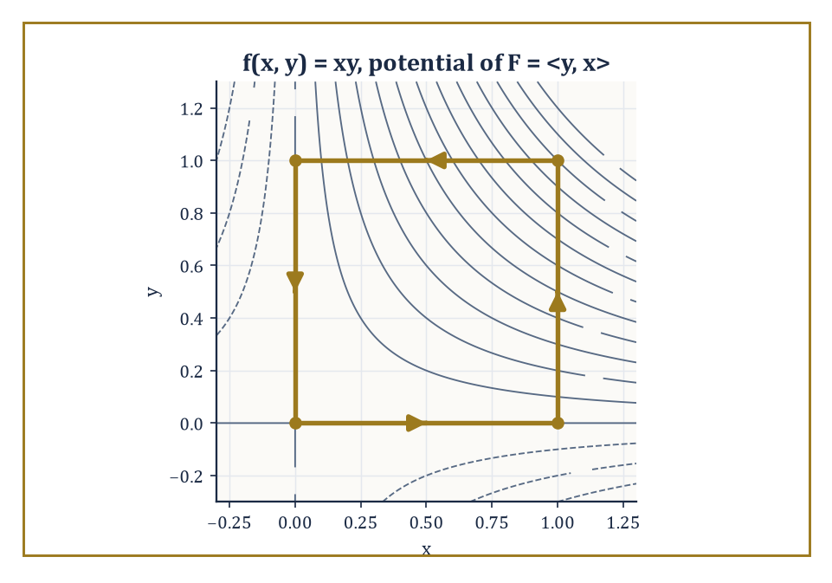
Figure 14.5 — Level curves of the potential f(x, y) = xy, with the closed unit-square path from the worked example traced in gold — same start and end point, hence zero net work.
F = ∇f
This single algebraic condition turns out to be equivalent to two other, more physically flavored descriptions met in the previous section: the field’s line integrals are path-independent (depending only on endpoints), and equivalently again, its integral around every closed curve vanishes. In a simply connected domain — loosely, a region with no holes for a loop to snag on — a continuously differentiable field is conservative if and only if its curl vanishes; in the plane this reduces to the tidy condition
∂P/∂y = ∂Q/∂x
a single equation, checkable by two quick partial derivatives, that settles the entire question without ever needing to compute a single line integral. This is the test that would have flagged the difference between the two fields of the previous section before any integration was attempted at all.
Worked example — testing both fields from the previous section. For F = ⟨y, x⟩, so P = y and Q = x:
∂P/∂y = 1, ∂Q/∂x = 1
These are equal, so the curl test passes and F = ⟨y, x⟩ is conservative — consistent with the tidy, path-looking answer of 1 obtained for its line integral along the straight segment from (0,0) to (1,1) in the previous section. For F = ⟨−y, x⟩, so P = −y and Q = x:
∂P/∂y = −1, ∂Q/∂x = 1
These are not equal (they differ by 2), so the curl test fails and F = ⟨−y, x⟩ is not conservative — consistent with its stubbornly nonzero circulation of 2π around the unit circle. Two derivatives, computed in seconds, would have predicted both outcomes before a single line integral was set up. This is the payoff of the curl test: diagnosis without computation.
Try it now — Is F = (y, x + 1) conservative? If so, find a potential. Answer →
When a field passes the curl test, finding its potential function f is a matter of successive integration, undone one partial derivative at a time — a kind of detective work in which each clue narrows down f a little further, up to an unavoidable ambiguity that the next clue then resolves. Integrate P with respect to x, treating y as a constant, to get f up to an unknown function of y alone (since differentiating that unknown function with respect to x would have given zero, it is invisible to the first integration). Then differentiate this partial result with respect to y, compare against Q, and solve for the unknown function. The procedure generalizes routinely to three variables, one extra unknown function and one extra comparison at a time.
Numeric example — finding a potential and computing work from it. Let F = ⟨2xy + 3, x² − 4y⟩. First, the curl test:
∂P/∂y = 2x, ∂Q/∂x = 2x
Equal, so F is conservative and a potential f exists. Integrate P = 2xy + 3 with respect to x:
f(x, y) = x²y + 3x + g(y)
where g(y) is the as-yet-unknown function invisible to differentiation in x. Now differentiate this f with respect to y:
∂f/∂y = x² + g′(y)
This must equal Q = x² − 4y, so g′(y) = −4y, giving g(y) = −2y² + C for an arbitrary constant C (which may as well be taken as 0, since only differences of f will ever be used). So
f(x, y) = x²y + 3x − 2y²
The work done by F moving a particle from (0, 0) to (2, 1), along any path whatsoever, is
f(2, 1) − f(0, 0) = [(4)(1) + 3(2) − 2(1)] − [0] = (4 + 6 − 2) − 0 = 8
No parametrization of any path was ever needed — the entire calculation reduced to evaluating one function at two points, which is the whole point of finding the potential in the first place.
Conservative fields are, in fact, an old acquaintance under a new name: they are the gradient fields first met in Chapter 13, and the scalar function whose gradient they are is exactly the kind of function that section studied. The work done by a conservative field along a path is the difference in potential energy between the endpoints — a phrase borrowed directly from physics, where it earns its keep: gravity and the electrostatic field, in regions free of electric charge, are the two great classical examples of conservative fields, and it is precisely their conservativeness that lets physicists speak of ‘potential energy’ at all, as a well-defined quantity attached to a position rather than to a particular route traveled to reach it.
Numeric example — a closed loop, checked directly. As a direct confirmation that a conservative field really does give zero around every closed loop, take F = ⟨y, x⟩ (shown conservative above, with potential f = xy) and integrate it around the boundary of the unit square, traversed counterclockwise: (0,0) → (1,0) → (1,1) → (0,1) → (0,0).
Segment 1, (0,0)→(1,0): y = 0, x = t, dy = 0, t: 0→1; integrand y dx + x dy = 0·dt + t·0 = 0; contributes 0.
Segment 2, (1,0)→(1,1): x = 1, y = t, dx = 0, t: 0→1; integrand = t·0 + 1·dt = dt; contributes
∫₀¹ dt = 1
Segment 3, (1,1)→(0,1): y = 1, x = 1−t, dx = −dt, dy = 0, t: 0→1; integrand = 1·(−dt) + (1−t)·0 = −dt; contributes
∫₀¹ (−dt) = −1
Segment 4, (0,1)→(0,0): x = 0, y = 1−t, dx = 0, dy = −dt; integrand = y·0 + 0·(−dt) = 0; contributes 0.
Total:
0 + 1 − 1 + 0 = 0
as the potential-function shortcut predicted — f(0,0) − f(0,0) = 0, trivially, since the loop begins and ends at the same point. It is a small ceremony, checking by brute force what theory already guaranteed, but it is a reassuring one, and it is this kind of arithmetic that Green’s theorem, two sections from now, will explain in one stroke rather than four.
Keep only this · Section 14.5: Conservative Fields and Potential Functions
The idea. On a simply connected region, F = (P, Q) is conservative exactly when ∂P/∂y = ∂Q/∂x; then the work along any path is f(end) − f(start).
Core.
F = ∇f ⇒ ∫_{C} F · dr = f(end) − f(start)
plane test (simply connected domain): ∂P/∂y = ∂Q/∂x
Typical mistake. Applying the curl test on a region with a hole, such as the punctured plane.
Minimal example. F = (2x, 2y) = ∇(x² + y²): from (0, 0) to (1, 1) the integral is 2.
Practice. Easy to challenge; full worked answers, with the usual mistake, are in Answers to the Practice Sets at the back.
Easy — Is F = (y, x) conservative? Find a potential. Answer →
Medium — Is F = (y, −x) conservative? Answer →
Challenge — F = (−y, x)/(x² + y²) passes the curl test away from the origin but has circulation 2π around the unit circle. Why is there no contradiction? Answer →

Section 14.6: Surface Integrals and Flux
Or: How Much Is Passing Through, and Which Way
CORE · about 15 minutes · later chapters build on this
Definition — A surface integral of a scalar function is the natural extension of a plain surface-area calculation: instead of merely measuring the area of a curved surface, it accumulates the values of some function g over that surface, weighting each infinitesimal patch of area by g there — mass of a curved shell of variable density, say, rather than of a flat lamina. Both a surface’s area and this weighted accumulation are computed by parametrizing the surface with two parameters, say u and v, forming the two tangent vectors rᵤ and rᵥ at each point, and taking the magnitude of their cross product |rᵤ × rᵥ| as the local area-scaling factor — the two-dimensional cousin of the single derivative that scaled arc length along a curve, and a close relative of the Jacobian met two sections ago. The surface integral is then
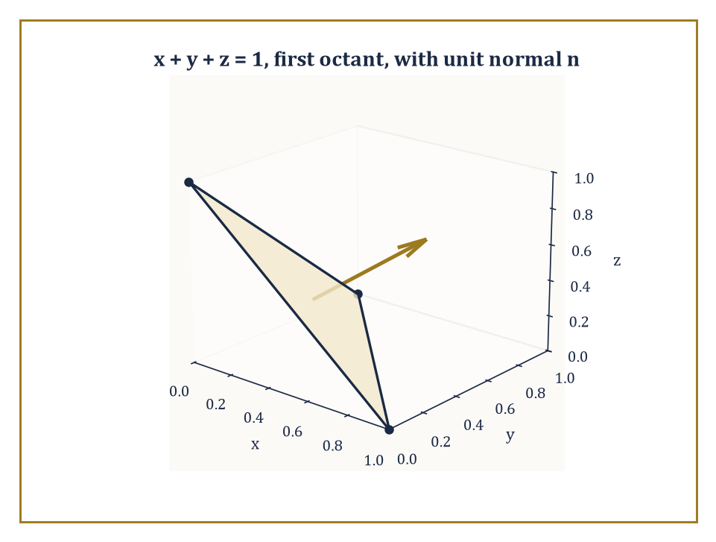
Figure 14.6 — The tilted triangular patch x + y + z = 1 in the first octant, with its upward unit normal — the surface whose area (√3/2) and flux (1/2) the section’s worked examples compute.
∬ g |rᵤ × rᵥ| du dv
an ordinary double integral over the flat parameter domain, dressed up to account for however the surface is stretched, tilted, or curved in actual space.
Numeric example — area of a tilted plane. Find the surface area of the portion of the plane x + y + z = 1 lying in the first octant (x, y, z ≥ 0) — a flat triangular patch, tilted at an angle to all three coordinate axes. Parametrize by x and y directly, writing z = 1 − x − y, so r(x, y) = (x, y, 1 − x − y). The two tangent vectors are r_{x} = (1, 0, −1) and r_{y} = (0, 1, −1). Their cross product:
r_{x} × r_{y} = (0·(−1) − (−1)·1,\ (−1)·0 − 1·(−1),\ 1·1 − 0·0) = (0 + 1,\ 0 + 1,\ 1) = (1, 1, 1)
of magnitude √(1²+1²+1²) = √3. The parameter domain D is the triangle in the xy-plane where x ≥ 0, y ≥ 0, x + y ≤ 1 — a right triangle of legs 1 and 1, area 1/2. So the surface area is
∬[D] √3 dA = √3 · (area of D) = √3 · (1/2) = √3/2 ≈ 0.866
The constant factor √3, notice, is the ratio by which the tilted plane’s area exceeds its flat ‘shadow’ triangle’s area of 1/2 in the xy-plane — a tilted roof always covers more actual roofing material than its footprint on the ground, and √3 is precisely how much more, for a plane tilted equally in all three directions.
Try it now — What is the flux of F = (0, 0, 2) up through the unit square in the plane z = 0? Answer →
A surface integral of a vector field — the flux integral — measures something different in kind: not an accumulated scalar quantity but the flow of the field through the surface, the net rate at which whatever the field represents (fluid, electric field lines, heat) crosses from one side to the other. It is defined by
∬[S] F · n dS
integrating the component of F along the surface’s unit normal vector n, so that only the part of F piercing the surface counts — a component of F running parallel to the surface, however large, contributes nothing to the flux, exactly as a tailwind blowing along the plane of a sail contributes nothing to filling it. Crucially, a surface has two possible normal directions at every point, and choosing one over the other — orienting the surface — determines both the direction n and hence the sign of the resulting flux; flip the orientation and the flux changes sign.
Numeric example — flux through the tilted plane. Compute the flux of the constant vector field F = (0, 0, 1) — a uniform flow straight upward — through the same triangular plane surface x + y + z = 1 in the first octant, oriented so its normal points upward (has positive z-component). Using the parametrization above, the (non-unit, area-scaling) normal vector is r_{x} × r_{y} = (1, 1, 1), already computed, and it does have positive z-component, so it matches the requested orientation without needing to flip sign. The flux is
∬[D] F(x, y, z(x,y)) · (r_{x} × r_{y}) dA = ∬[D] (0, 0, 1) · (1, 1, 1) dA = ∬[D] 1 dA = area of D = 1/2
The flux of the upward-pointing field through this upward-tilted surface is 1/2. Notice this is a smaller number than the raw surface area √3/2 found above — makes sense, since the plane is tilted away from the vertical field direction, so only part of the flow pierces it rather than skimming along its slanted face.
Flux is best pictured as the continuous version of counting field lines: imagine the vector field sketched as a dense pattern of arrows or streamlines, and the flux through a surface as (roughly) the net number of those lines crossing from the negative side to the positive side, positive crossings counted plus and negative crossings counted minus, so that a surface sitting entirely parallel to the flow, or a field that enters and leaves in equal measure, contributes zero net flux even though plenty of field is passing nearby. This bookkeeping quantity — signed, orientation-dependent, additive over pieces of a surface — is the central actor in the Divergence Theorem two sections from now, and it is the mathematical language behind conservation laws throughout physics: the total electric flux through a closed surface tells you the total charge enclosed; the total mass flux through the boundary of a region tells you whether fluid is accumulating or draining inside.
Numeric example — orientation reverses the sign. Recompute the previous flux example with the surface’s orientation flipped, so the normal now points downward instead. The downward normal is the negative of the one used before: −(1, 1, 1) = (−1, −1, −1). The flux becomes
∬[D] (0, 0, 1) · (−1, −1, −1) dA = ∬[D] (−1) dA = −(area of D) = −1/2
As promised: reversing orientation reversed the sign of the flux, from +1/2 to −1/2, while the magnitude — the sheer amount of field crossing the surface — stayed the same. Orientation is bookkeeping, not physics; it tells you which direction you have chosen to call ‘positive’, and the physical flow through the plane has not changed one drop, or one field line, by your having chosen differently.
Keep only this · Section 14.6: Surface Integrals and Flux
The idea. Flux = ∬ F · n dS: it measures how much of the field crosses the surface, with the chosen normal deciding which way counts as positive.
Core.
∬_{S} F · n dS = ∬_{D} F(r(u, v)) · (r_{u} × r_{v}) du dv
Typical mistake. Computing a surface area integral when the question asks for flux, or the reverse.
Minimal example. F = (0, 0, 1) through the unit square in z = 0, upward: flux 1.
Practice. Easy to challenge; full worked answers, with the usual mistake, are in Answers to the Practice Sets at the back.
Easy — Flux of F = (0, 0, 3) upward through the disk x² + y² ≤ 4 in the plane z = 1. Answer →
Medium — Flux of F = (x, y, z) outward through the sphere of radius 2. Answer →
Challenge — For the graph z = g(x, y), show the upward normal r_{x} × r_{y} is (−g_{x}, −g_{y}, 1). Answer →

Section 14.7: Green’s Theorem
Or: The Fundamental Theorem of Calculus, Now With a Boundary
CORE · about 15 minutes · later chapters build on this
A surveyor can find the area of an irregular plot without stepping inside it, simply by walking the boundary and keeping a running tally; a brass instrument called a planimeter does the same thing mechanically. Green’s theorem is the mathematics behind the trick: a total over a region equals a tally taken around its edge. It is the fundamental theorem of calculus moved up one dimension, where an integral over an interval was settled by the values at its two endpoints. As a test, walking once round an ellipse with half-widths 3 and 2 and adding up the right quantity along the way returns its area, six times pi, about 18.85, without visiting the interior.
Key idea — Green’s theorem relates a line integral around the positively oriented boundary of a plane region D (counterclockwise, by the standard convention, so that D always sits to the left as you walk the boundary) to a double integral over the region itself:
Theorem — Green’s theorem
∮[C] P dx + Q dy = ∬[D] (∂Q/∂x − ∂P/∂y) dA
Hypotheses — check each one before you use it:
□ D is a bounded region whose boundary C is a piecewise smooth closed curve (or several)
□ C is positively oriented: D stays on your left as you walk
□ P and Q have continuous first partial derivatives on an open set containing D and C
Why it matters. It trades a line integral for an area integral or the reverse, whichever is easier, and it is the plane case of Stokes’ theorem.
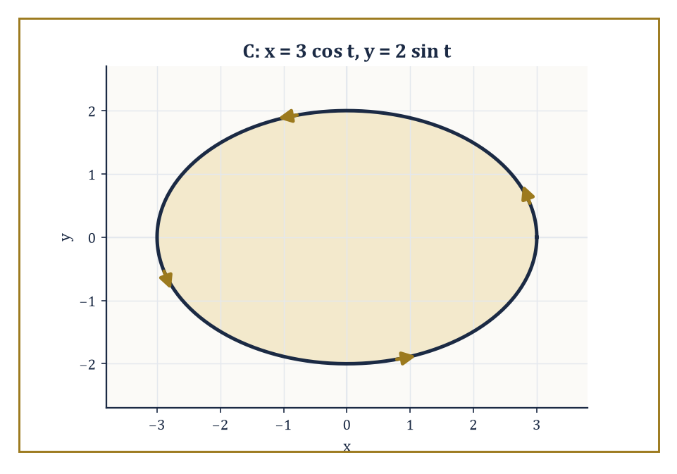
Figure 14.7 — The ellipse x = 3 cos t, y = 2 sin t, walked once counterclockwise — its area, 6π, read off entirely from this boundary via Green’s theorem.
∮[C] P dx + Q dy = ∬[D] (∂Q/∂x − ∂P/∂y) dA
The quantity ∂Q/∂x − ∂P/∂y in the integrand is the curl test from Conservative Fields and Potential Functions, no longer merely checked for being zero but now integrated in its own right whenever it is not — it measures, at each point, the local rotational tendency (the two-dimensional curl) of the field, and Green’s theorem says that adding up all this local spin across the whole region gives the total circulation observed on the boundary. It is the precise planar analogue of the ordinary Fundamental Theorem of Calculus,
∫ₐᵇ f′(x) dx = f(b) − f(a)
there, the integral of a derivative over an interval equals the values of the original function at the interval’s boundary (its two endpoints); here, the integral of a derivative-like quantity over a two-dimensional region equals a suitably summed version of the original field on the region’s boundary (now an entire curve, rather than two points).
Numeric example — verifying the theorem on the rotation field. Verify Green’s theorem directly for F = ⟨−y, x⟩ around the unit circle, the exact pairing already computed by brute force in Vector Fields and Line Integrals. The left-hand side — the line integral — was found there to equal 2π. The right-hand side requires ∂Q/∂x − ∂P/∂y with P = −y, Q = x:
∂Q/∂x = 1, ∂P/∂y = −1
so the integrand is 1 − (−1) = 2, a constant, at every point of the disk. The double integral is then 2 times the area of the unit disk:
∬[D] 2 dA = 2 · (π · 1²) = 2π
Both sides equal 2π exactly. Green’s theorem has converted a line integral, requiring a trigonometric parametrization and a page of algebra, into an area integral of a constant, requiring nothing more than knowing the area of a circle — the theorem has done, in one line, what took four lines of segment-by-segment work back in Conservative Fields and Potential Functions for the analogous square-boundary example, and would have taken considerably more for any boundary curve less obliging than a circle.
Try it now — Use Green’s theorem to find ∮ (−y dx + x dy) around the circle of radius 2. Answer →
The practical uses of Green’s theorem run in both directions. Read left to right, it converts an awkward line integral — a boundary that twists and turns, defying easy parametrization — into a double integral over the enclosed region, which is very often the easier of the two calculations. Read right to left, and specialized suitably, it computes the area of a region purely from a line integral around its boundary: choosing P = −y/2, Q = x/2 makes ∂Q/∂x − ∂P/∂y = 1/2 + 1/2 = 1 everywhere, so
∮[C] (−y/2) dx + (x/2) dy = area of D
a formula prized by anyone who has ever needed to find the area enclosed by a complicated closed curve and would rather integrate along its edge than describe its interior.
Numeric example — area of an ellipse by boundary integral. Find the area enclosed by the ellipse x = 3 cos θ, y = 2 sin θ (semi-axes a = 3, b = 2), using the boundary formula A = (1/2) ∮[C] (x dy − y dx). Here dx = −3 sin θ dθ and dy = 2 cos θ dθ, for θ running from 0 to 2π. Compute the integrand:
x dy − y dx = (3 cos θ)(2 cos θ dθ) − (2 sin θ)(−3 sin θ dθ) = 6 cos²θ dθ + 6 sin²θ dθ = 6(cos²θ + sin²θ) dθ = 6 dθ
So
A = (1/2) ∫[0, 2π] 6 dθ = (1/2)·6·2π = 6π
This matches the standard formula for the area of an ellipse, πab = π·3·2 = 6π, exactly — obtained here without ever writing down the ellipse’s interior at all, purely by walking once around its rim.
Green’s theorem also settles, in a single stroke, the question that occupied the whole of Conservative Fields and Potential Functions: whether a given field is conservative. Since a conservative field has ∂P/∂y = ∂Q/∂x everywhere, its integrand ∂Q/∂x − ∂P/∂y vanishes identically, and the double integral over any region is automatically zero — which, by Green’s theorem, forces the line integral around every closed curve bounding that region to be zero as well, the path-independence criterion from two sections back, now derived rather than merely observed. Green’s theorem is, in this sense, the machine that manufactures the closed-loop-integral-equals-zero property, rather than a separate fact requiring its own separate proof.
Numeric example — Green’s theorem confirms the earlier zero. Recheck the closed-loop calculation for F = ⟨y, x⟩ around the unit square from Conservative Fields and Potential Functions, this time via Green’s theorem rather than four separate segment integrals. Here P = y, Q = x, so
∂Q/∂x − ∂P/∂y = 1 − 1 = 0
at every point — the field’s curl vanishes identically, consistent with it having been shown conservative back in Conservative Fields and Potential Functions. The double integral is then ∬[D] 0 dA = 0, regardless of the shape or size of D, so in particular it is 0 for the unit square. This instantly reproduces the answer obtained the hard way, segment by segment, in the previous section — and it would reproduce the same zero for absolutely any closed boundary at all, a square, a circle, an amoeba-shaped blob, without a single new calculation. That is the entire point of the theorem: it turns an infinite family of separate closed-loop calculations into one glance at a single partial-derivative identity.
Keep only this · Section 14.7: Green’s Theorem
The idea. Green’s theorem: ∮[C] P dx + Q dy = ∬[D] (∂Q/∂x − ∂P/∂y) dA, for C the counterclockwise boundary of D.
Core.
∮_{C} P dx + Q dy = ∬_{D} (∂Q/∂x − ∂P/∂y) dA, C counterclockwise
Typical mistake. Using a clockwise boundary, or a region containing a point where P or Q blows up.
Minimal example. Area of a region = (1/2)∮ (x dy − y dx).
Practice. Easy to challenge; full worked answers, with the usual mistake, are in Answers to the Practice Sets at the back.
Easy — Use Green’s theorem for ∮ (−y dx + x dy) around the unit circle counterclockwise. Answer →
Medium — Evaluate ∮ (x² dx + xy dy) around the square [0, 1]², counterclockwise. Answer →
Challenge — Use the area formula to find the area inside x = a cos t, y = b sin t. Answer →

Section 14.8: Stokes’ Theorem and the Divergence Theorem
Or: Green’s Theorem Learns to Fly and Then Learns to Enclose Volume
CORE · about 15 minutes · later chapters build on this
Key idea — Stokes’ theorem lifts Green’s theorem out of the flat plane and onto a curved surface hanging in three-dimensional space: it states that the line integral of a vector field F around the oriented boundary curve of a surface S equals the surface integral, over S itself, of curl F — the three-dimensional generalization of the two-dimensional curl quantity ∂Q/∂x − ∂P/∂y met in the previous section, now a full vector, ∇ × F, whose component in the direction of the surface’s chosen normal is what actually gets integrated. When the surface S happens to be flat and lying in the xy-plane, Stokes’ theorem collapses back down to Green’s theorem — not a coincidence, not an analogy, but literally the very same statement, viewed from a vantage point one dimension higher.
Theorem — Stokes’ theorem and the divergence theorem
∮[∂S] F · dr = ∬[S] (curl F) · n dS and ∯[∂E] F · n dS = ∭[E] div F dV
Hypotheses — check each one before you use it:
□ Stokes: S is an oriented, piecewise smooth surface with boundary curve ∂S, oriented by the right-hand rule
□ Divergence: E is a bounded solid whose boundary ∂E is a closed, piecewise smooth surface with outward normal n
□ F has continuous first partial derivatives on an open set containing S (or E)
Why it matters. They are the integral form of the physical laws in Chapter 15: circulation equals enclosed curl, outward flux equals enclosed sources.
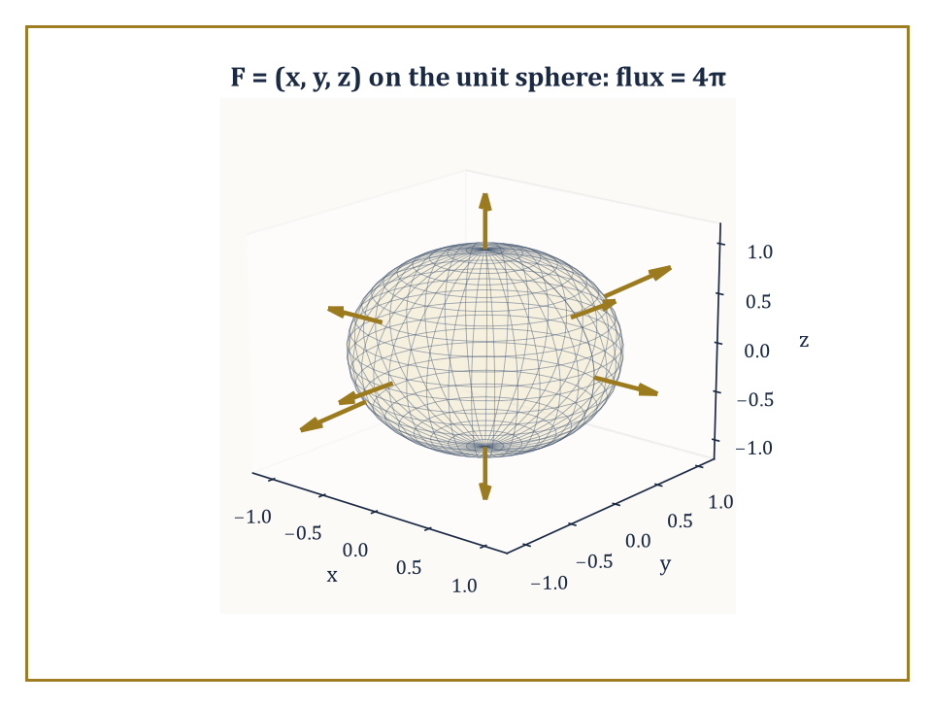
Figure 14.8 — The outward radial field F = (x, y, z) piercing the unit sphere everywhere perpendicular to its surface, giving the Divergence Theorem’s worked flux of 4π.
Numeric example — Stokes’ theorem on a flat disk. Take F = ⟨−y, x, 0⟩ — the familiar rotation field from Vector Fields and Line Integrals and Green’s Theorem, now written with an explicit (zero) third component so it lives properly in three-dimensional space — and let S be the flat unit disk x² + y² ≤ 1 sitting in the plane z = 0, oriented with upward normal n = (0, 0, 1), whose boundary is then the unit circle traversed counterclockwise (matching the orientation used throughout this chapter). First, curl F: with P = −y, Q = x, R = 0,
curl F = ∇ × F = (∂R/∂y − ∂Q/∂z,\ ∂P/∂z − ∂R/∂x,\ ∂Q/∂x − ∂P/∂y) = (0 − 0,\ 0 − 0,\ 1 − (−1)) = (0, 0, 2)
The surface integral of curl F over the flat disk, with normal (0,0,1), reduces to
∬[S] curl F · n dS = ∬[S] 2 dA = 2 · (area of unit disk) = 2π
This equals the boundary line integral of F around the unit circle, already computed in Vector Fields and Line Integrals by brute-force parametrization to be exactly 2π. The two calculations — one purely in space via curl and a surface integral, one purely on the boundary via parametrization — agree perfectly, and indeed they had no choice, since for a flat disk in the xy-plane, Stokes’ theorem is Green’s theorem wearing a slightly more three-dimensional-looking coat.
Try it now — Use the divergence theorem to find the outward flux of F = (x, 0, 0) through the unit cube [0, 1]³. Answer →
The Divergence Theorem, also called Gauss’s theorem, plays the same game one dimension further still, and declines to apologize for how greedy it is: it states that the flux of a vector field F through the entire closed boundary surface of a solid region E equals the triple integral, throughout the volume of E, of div F — the divergence,
∇ · F = ∂P/∂x + ∂Q/∂y + ∂R/∂z
a single scalar measuring how much the field is ‘spreading out’ (a positive divergence, a point behaving like a tiny source) or ‘converging’ (a negative divergence, a point behaving like a tiny drain) at each point. It is the three-dimensional cousin of the two-dimensional curl-quantity that drove Green’s theorem, though it has traded rotation for plumbing: it measures expansion and contraction rather than spin.
Numeric example — divergence theorem on the unit sphere. Let F = ⟨x, y, z⟩, the outward-pointing position-vector field, and let E be the solid unit ball, its closed boundary the unit sphere. Compute the divergence, a constant:
div F = ∂x/∂x + ∂y/∂y + ∂z/∂z = 1 + 1 + 1 = 3
By the divergence theorem, the total outward flux through the unit sphere equals
∭[E] 3 dV = 3 · (volume of the unit ball) = 3 · (4π/3) = 4π
This can be checked directly, without invoking the theorem at all: on the unit sphere, the outward unit normal at any point equals the position vector itself, n = (x, y, z), since the sphere has radius 1 and the outward normal at a point on a sphere always points straight away from the center, scaled to unit length — but on the unit sphere the position vector already has length 1, so n = (x, y, z) exactly. Then
F · n = (x, y, z) · (x, y, z) = x² + y² + z² = 1
everywhere on the sphere (since the sphere’s equation is exactly x² + y² + z² = 1). So the flux integral is
∬[sphere] 1 dS = surface area of the unit sphere = 4π
Both routes — the volume integral of the divergence, and the direct surface integral of the flux — give 4π, in perfect agreement, and the direct route required nothing more than recognizing that F · n happened to equal 1 at every single point of the sphere, a small piece of luck that the divergence theorem did not need at all.
Green’s theorem, Stokes’ theorem, and the Divergence Theorem are, at bottom, three dialects of one sentence: the integral of a derivative over a region equals the integral of the original quantity over the region’s boundary. The derivative in question is the two-dimensional curl for Green, the full curl for Stokes, and the divergence for Gauss; the region is a plane area, a curved surface, and a solid volume respectively; the boundary is a bounding curve in the first two cases and a bounding surface in the third. All three are continuous descendants of the humble telescoping sum that underlies the one-dimensional Fundamental Theorem of Calculus itself — a fact easy to state and worth pausing over, since it is the single organizing idea beneath this entire chapter.
Worked example — the telescoping sum underneath everything. The discrete ancestor of all three theorems is the elementary observation that a sum of consecutive differences collapses to the difference of the two ends:
Σₖ₌₁ⁿ (aₖ − aₖ₋₁) = aₙ − a₀
because every interior term cancels against its neighbor, leaving only the first and last. Take aₖ = k² for k = 0, 1, 2, 3, 4, so a₀ = 0, a₁ = 1, a₂ = 4, a₃ = 9, a₄ = 16. The individual differences are
(1−0) + (4−1) + (9−4) + (16−9) = 1 + 3 + 5 + 7 = 16
and indeed a₄ − a₀ = 16 − 0 = 16 — the sum of differences equals the difference of the ends, just as claimed, with every interior value (1, 4, 9) canceling invisibly in the middle. This is the mechanism, in miniature, that the Fundamental Theorem of Calculus performs in the continuous limit — ∫ₐᵇ f′(x) dx telescopes infinitesimal differences of f into f(b) − f(a) — and it is the very same mechanism, generalized to regions and their boundaries rather than intervals and their endpoints, that Green, Stokes, and Gauss each perform in their own dimension. One idea; three costumes; a great many exam questions.
Keep only this · Section 14.8: Stokes’ Theorem and the Divergence Theorem
The idea. Stokes: circulation round the edge equals the flux of the curl through the surface. Divergence: outward flux through a closed surface equals the integral of div F inside.
Core.
Stokes: ∮[∂S] F · dr = ∬_{S} (∇ × F) · n dS
divergence: ∯[∂E] F · n dS = ∭_{E} ∇ · F dV
Typical mistake. Applying the divergence theorem to a surface that is not closed.
Minimal example. F = (x, y, z) on the unit ball: ∇ · F = 3, flux = 3 · 4π/3 = 4π.
Practice. Easy to challenge; full worked answers, with the usual mistake, are in Answers to the Practice Sets at the back.
Easy — Find the outward flux of F = (x, 0, 0) through the boundary of the unit cube. Answer →
Medium — Use Stokes to find ∮ F · dr for F = (−y, x, 0) around the unit circle in z = 0, counterclockwise from above. Answer →
Challenge — The field F = r/|r|³ has ∇ · F = 0 away from the origin but flux 4π through every sphere around it. Why does the divergence theorem not give 0? Answer →

Chapter 14 in One Page
Integration in several variables is iterated single-variable integration over a region whose shape fixes the limits. Changing variables multiplies by the absolute Jacobian. Vector fields are integrated along curves (work, circulation) and across surfaces (flux). A field is conservative when it is a gradient, and then line integrals depend only on endpoints. Green’s, Stokes’ and the divergence theorem convert integrals over a region into integrals over its boundary.
Key definitions
• Double integral ∬[D] f dA and its iterated form.
• Jacobian ∂(x, y)/∂(u, v): the determinant of the matrix of partial derivatives.
• Line integral ∫[C] F · dr = ∫ F(r(t)) · r′(t) dt.
• Conservative field: F = ∇f for some potential f.
• Flux ∬[S] F · n dS.
Key theorems, with their hypotheses
• Fubini: the order of integration may be swapped — hypotheses: f continuous (or integrable) on the region, limits rewritten for the new order.
• Change of variables — hypotheses: the map is one-to-one with continuous partials and non-zero Jacobian on the interior.
• Green, Stokes, divergence — hypotheses: piecewise smooth boundary with the correct orientation, continuously differentiable field on the whole region.
Canonical example
• F = (−y, x) on the unit circle: direct parametrization gives circulation 2π, and Green’s theorem gives ∬ 2 dA = 2π — the same number from opposite ends.
Common errors
• Limits that ignore the region’s shape.
• A missing r or ρ² sin φ.
• Wrong orientation of the boundary.
• Using the curl test on a region with a hole.
Readiness checklist — you are ready for what comes next when you can:
□ set up a double integral in both orders from a sketch
□ evaluate integrals in polar, cylindrical and spherical coordinates
□ compute a line integral from a parametrization
□ decide whether a field is conservative and find its potential
□ apply Green’s theorem and the divergence theorem, checking their hypotheses
Section 14.9 that follows is a preview, marked optional: it says where these ideas lead in later chapters and volumes. Nothing in it is needed for the exercises.

Section 14.9: Where This Goes Next (Optional): From Multi-Variable Calculus to Vector Calculus Applications and Beyond
Or: We Have Learned to Add Up in Every Direction At Once
PREVIEW — OPTIONAL · about 15 minutes · optional; read for orientation, nothing is examined
Overview — We have now acquired the full working vocabulary of multi-variable calculus: double and triple integrals and the iterated integrals that make them computable, the change-of-variables formula and its Jacobian, vector fields and the line integrals that measure work and circulation along them, conservative fields and the potential functions that tame them, surface integrals and the flux integrals that measure flow through them, and finally the three great integral theorems — Green’s, Stokes’, and Gauss’s — that tie the interior of a region to its boundary in exact analogy with the one-dimensional Fundamental Theorem of Calculus. It has been, by any honest accounting, the most computationally demanding chapter so far in this series; if your hand is tired from limits of integration, it has earned the rest.
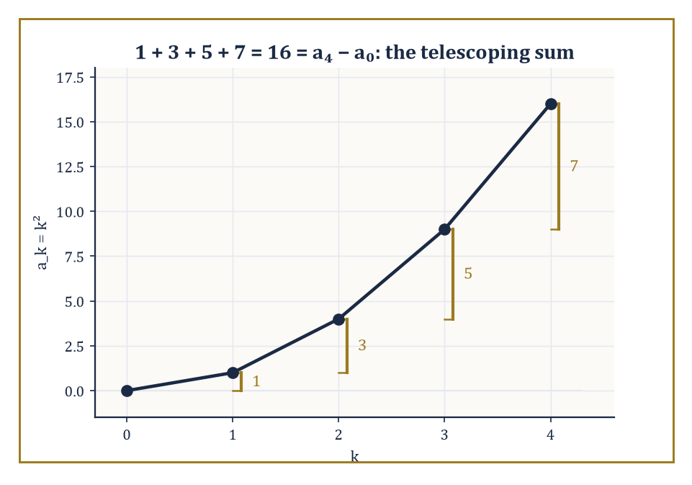
Figure 14.9 — The telescoping sum 1 + 3 + 5 + 7 = 16, the humble discrete ancestor of Green’s, Stokes’, and Gauss’s theorems alike.
This vocabulary is the direct foundation for the next chapter, Vector Calculus, where these same fields, flows, and flux integrals go to work in earnest on the physics of electricity, magnetism, and fluid motion — the equations of that chapter will be written almost entirely in the div, curl, and flux notation assembled here, and the three integral theorems of Stokes’ Theorem and the Divergence Theorem will be invoked, by name, on nearly every page. Later in the series, differential geometry will perform these same integrals over curved manifolds rather than flat regions of the plane or ordinary Euclidean space; partial differential equations will lean on divergence and curl to write down the classical field equations of physics; and eventually, differential forms will arrive to unify Green’s, Stokes’, and Gauss’s theorems — three separate-looking statements in this chapter — into one single formula,
∫[M] dω = ∫[∂M] ω
valid on a manifold M of any dimension whatsoever.
Abstract example — one formula, four familiar faces. The abstract unifying formula ∫[M] dω = ∫[∂M] ω instantiates, at the level of introductory calculus, into every theorem this chapter has met. Take M to be an interval [a, b] (a one-dimensional manifold) and ω to be a function f (what a later chapter will call a zero-form); then dω is f′ dx, and the formula reads
∫ₐᵇ f′(x) dx = f(b) − f(a)
the ordinary Fundamental Theorem of Calculus. Take M to be a plane region D (two-dimensional) and ω to be P dx + Q dy (a one-form); then dω works out to (∂Q/∂x − ∂P/∂y) dx∧dy, and the formula reads
∬[D] (∂Q/∂x − ∂P/∂y) dA = ∮[∂D] P dx + Q dy
Green’s theorem. Take M to be a curved surface S in space, with the same kind of one-form ω = P dx + Q dy + R dz; then dω encodes the curl of F, and the formula becomes Stokes’ theorem. Take M to be a solid E and ω a two-form built from the components of F; then dω encodes the divergence, and the formula becomes the Divergence Theorem. Four theorems, met across three separate sections of this chapter, each independently checked by hand against a concrete numeric example — all turn out, from sufficiently far up the series, to be one single sentence, said in four different accents. That is not a coincidence to be marveled at from a safe distance; it is the entire subject, quietly confessing that it was one idea all along.
Try it now — Which of the three theorems turns ∭ div F dV into a surface integral? Answer →
It has been the most arithmetically demanding chapter of the series so far, and if a small, weary part of you is relieved to have reached the end of it, that part of you has been paying proper attention.
Keep only this · Section 14.9: Where This Goes Next (Optional): From Multi-Variable Calculus to Vector Calculus Applications and Beyond
The idea. All three theorems say the same thing: integrating a derivative over a region equals integrating the original over the boundary.
Core.
Every integral theorem: ∫ over ∂M of ω = ∫ over M of dω
Typical mistake. Applying an integral theorem without checking that the field is smooth on the whole region.
Minimal example. The fundamental theorem of calculus is the one-dimensional case: ∫[a, b] f′ = f(b) − f(a).
Practice. Easy to challenge; full worked answers, with the usual mistake, are in Answers to the Practice Sets at the back.
Easy — Which theorem relates a line integral around a closed plane curve to a double integral? Answer →
Medium — Name the boundary of the solid unit ball, and the boundary of that boundary. Answer →
Challenge — Why does “the boundary of a boundary is empty” make ∇ · (∇ × F) = 0 plausible? Answer →

Check Your Understanding — Chapter 14
Answers are in the Answer Key at the back of the book — have a go before you look.
1. [Explain] Why must you sketch the region D before writing the limits of a double integral, rather than just writing down limits that ‘look plausible’?
See the answer →
2. [Compute] A solid unit cube has density ρ(x,y,z) = x² + y² + z². Find its mass, and explain how symmetry shortens the calculation.
See the answer →
3. [Compute] Without computing a line integral, how can you tell whether F = ⟨2xy + 3, x² − 4y⟩ is conservative, and if so, what is its potential function?
See the answer →
4. [Explain] State what Green’s theorem says, and use it to explain why a conservative field always gives zero circulation around any closed loop.
See the answer →

Fluency Drill — Chapter 14
Five minutes, no notes, before the harder problems. These are the moves the Problems assume are automatic; if one takes you more than a minute, reread the section it names. Worked answers, each with the usual slip, are in Answers to the Practice Sets.
1. [Compute] ∫₀¹∫₀² 1 dy dx. Answer →
2. [Compute] Rewrite ∫₀¹∫₀ˣ f dy dx with the order reversed. Answer →
3. [Concept] What factor appears when dA is written in polar coordinates? Answer →
4. [Compute] Jacobian of x = u + v, y = u − v. Answer →
5. [Compute] ∫_{C} F · dr for F = ∇(x²y) from (0, 0) to (1, 3). Answer →
6. [Concept] Is F = (−y, x) conservative? Answer →
7. [Compute] div F and curl F for F = (y, −x, 0). Answer →
8. [Compute] Outward flux of F = (x, y, z) through the unit sphere. Answer →

Problems — Chapter 14
This chapter is where integration acquires a geometry. The commonest failures here are not conceptual but bookkeeping — wrong limits, forgotten Jacobians, unclosed contours — so these twelve problems are weighted toward setting integrals up correctly. Each problem carries a skill tag (Concept, Compute, Explain, Prove, Model or Challenge; see How to Use This Book) and a link to its full worked solution, which ends with the usual mistake.
Multiple integrals
1. [Compute] Evaluate ∫₀¹∫₀² (x + 2y) dy dx. Solution →
2. [Concept] Sketch the region bounded by y = x² and y = 2x, and set up the double integral of f(x, y) over it in both orders of integration. Evaluate one of them for f = 1 to find the area. Solution →
3. [Compute] Evaluate the triple integral of 1 over the solid bounded by the coordinate planes and the plane x + y + z = 1. Solution →
Change of variables
4. [Compute] Use polar coordinates to evaluate the double integral of exp(−(x²+y²)) over the disk x² + y² ≤ 1. Solution →
5. [Prove] Show that the Jacobian of the polar transformation x = r cos θ, y = r sin θ equals r, and explain what goes wrong if the factor is omitted. Solution →
Line integrals and conservative fields
6. [Compute] Evaluate the line integral of F = (y, x) along the straight path from (0, 0) to (1, 2). Solution →
7. [Compute] Show that F = (2xy, x²) is conservative, find a potential function, and use it to evaluate the line integral from (0, 0) to (2, 3) along any path. Solution →
8. [Prove] Show that F = (−y, x)/(x² + y²) has zero curl on the punctured plane yet is not conservative there. Solution →
The big theorems
9. [Compute] Use Green’s theorem to evaluate ∮[C] (x²y dx + xy² dy) where C is the unit circle traversed counterclockwise. Solution →
10. [Compute] Use the divergence theorem to compute the outward flux of F = (x, y, z) through the sphere of radius 2 centered at the origin. Solution →
11. [Explain] Compute div F and curl F for F = (x², y², z²) and state what each tells you about the field. Solution →
12. [Challenge] Green’s, Stokes’ and the divergence theorem are usually presented as three results. In what sense are they one result, and what is the single statement that contains all three? Solution →

Math, Actually

Chapter 15

Vector Calculus
Fields, Flux, Circulation, and the Art of Differentiating and Integrating in Space
Chapter 14 left us fluent in a particular kind of geometry: integrating over blobs, curves, and surfaces embedded in space, and differentiating functions of several variables until the partial derivatives ran out of new things to say. What we did not yet ask, seriously, is what happens when the thing you are integrating is itself a vector — when instead of a scalar height field you have an arrow attached to every point of space, an arrow that might represent a velocity or a force. That is the business of this chapter.
Vector calculus is where multivariable calculus meets physics and discovers they have been secretly compatible the whole time. Three new differential operators — the gradient, the divergence, and the curl — turn scalar and vector fields into each other, measuring uphill slope, local expansion, and local spin respectively. Three integral theorems — Green’s, Stokes’, and the divergence theorem — turn out to be one and the same idea wearing three different coats: what happens inside a region is entirely accounted for by what happens on its boundary. It is, when you say it like that, suspiciously close to a moral principle, and mathematicians have learned not to trust moral principles that turn out to be theorems, or theorems that turn out to be moral principles.
None of this is optional scenery. Fluid flow, electromagnetism, gravity, and the stresses inside a bent girder are all written natively in this language; a physicist who cannot compute a divergence is not so much handicapped as monolingual in a country where everyone else speaks four languages fluently and one of them is Latin. We shall try to leave you at least trilingual.
Before you begin — Chapter 15 · Core chapter
By the end of this chapter you will be able to:
1. Compute the gradient, divergence and curl of fields in Cartesian coordinates and interpret each physically.
2. Use the identities curl grad = 0 and div curl = 0, and the product rules for ∇.
3. Decide whether a field is conservative and find its potential.
4. Apply the three integral theorems as one family, with correct orientations.
5. Describe the Helmholtz decomposition and the vector-calculus form of Maxwell’s and the heat equations.
Why it comes here. Chapter 14 built the integrals; this chapter gives the three differential operators (gradient, divergence, curl) their physical meaning and shows how the integral theorems become the laws of fluids and fields. Section 15.6 revisits Green, Stokes and Gauss with full hypotheses, so a reader who found Chapter 14’s versions quick will meet them again here.
Required chapters. Multi-Variable Calculus (Chapter 14); Multi-Variable Functions (Chapter 13).
Assumed skills. compute partial derivatives, including mixed partials; evaluate line and surface integrals from a parametrization; compute a cross product of two vectors in ℝ³.
If you are rusty. Vector Fields and Line Integrals; Surface Integrals and Flux; Stokes’ Theorem and the Divergence Theorem.
Do not proceed until you can…
1. Compute (1, 0, 0) × (0, 1, 0). Answer →
2. Find ∂²/∂x∂y of x²y³. Answer →
3. Work done by F = (2x, 0) along the segment from (0, 0) to (3, 0). Answer →
Estimated study time. About 10–12 hours over one to two weeks. Work every Try it now before reading on, finish each section’s Keep only this practice before starting the next, and do the Fluency Drill before the Problems.

Section 15.1: Vector Fields Revisited
In Which Arrows Move In
CORE · about 15 minutes · later chapters build on this
Open any weather forecast and look at the wind map. At every town there is a small arrow. Its direction says which way the wind is blowing there, and its length says how hard. Over the open sea the arrows are long. In a sheltered valley they shrink to stubs. Around a storm they swing round in a great ring.
Nobody reads that map as one arrow. It is a whole crowd of them, one for every place, and what the forecaster cares about is how they change from place to place. Is the air spreading out from this town, or piling in toward it? Is it turning round this spot, the way it turns round the eye of a storm?
Vector Fields and Line Integrals met this picture and used it for one job: adding up the push of the arrows along a path. This chapter stays with the picture longer and gives each of those forecaster’s questions a number. First, the picture itself, with names attached.
Definition — A vector field on a region of space assigns to each point a vector — not a number, an arrow. In coordinates we write:
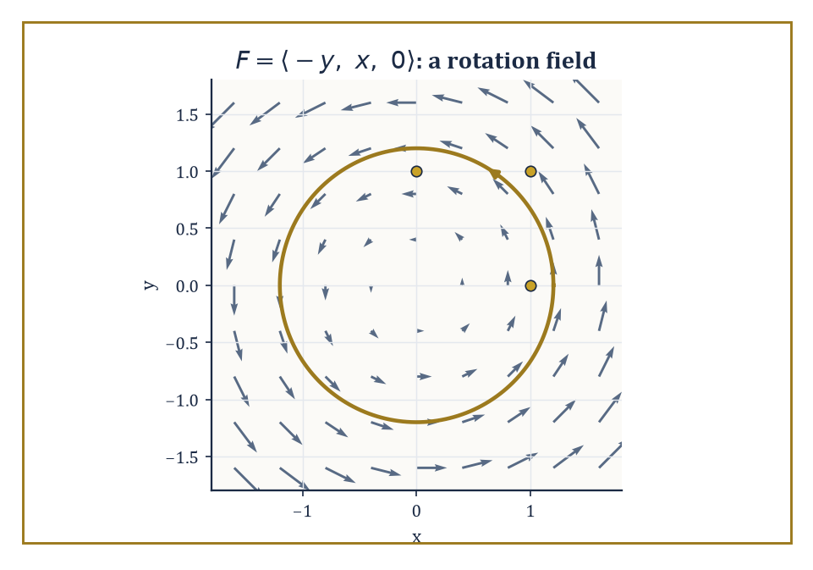
Figure 15.1 — The rotation field F = ⟨−y, x, 0⟩, its arrows curling faithfully around the z-axis, with one streamline traced counterclockwise.
F = ⟨P, Q, R⟩
P, Q, and R are themselves ordinary scalar functions of x, y, and z, one supplying each component of the arrow at that point. Geometrically, imagine a small arrow sprouting from every point of space, its length and direction changing smoothly as you move about; physically, that arrow might be a velocity (how fast and which way the wind is blowing right here), a force (how hard and which way gravity is pulling right here), or a flux density (how much of something is flowing through right here, and in which direction).
The scalar fields of the last chapter told you the temperature at each point. Vector fields tell you which way the wind is blowing while it happens.
Numeric example — evaluating a field. Take the field defined on all of ℝ³ by:
F(x, y, z) = ⟨−y, x, 0⟩
At the point (1, 0, 0) it evaluates to an arrow pointing straight along the positive y-axis:
F = ⟨0, 1, 0⟩
At (0, 1, 0) it evaluates to an arrow pointing along the negative x-axis:
F = ⟨−1, 0, 0⟩
At (1, 1, 0) it gives:
⟨−1, 1, 0⟩
Plot enough of these arrows and a pattern announces itself: every arrow is perpendicular to the position vector at that point, and all of them curl the same way around the z-axis. This is, unsurprisingly, a rotation field — the velocity field of a rigid body spinning about the z-axis at one radian per second — and we shall meet it so often in this chapter that you would do well to make its acquaintance now.
Try it now — Evaluate F = (yz, −x, 1) at (1, 2, 3). Answer →
Visualizing a vector field is as much art as arithmetic. One approach draws a representative sample of arrows, each scaled to its magnitude, dotted around the domain like iron filings around a magnet — which is, not coincidentally, what iron filings are doing.
A second approach draws streamlines (also called integral curves): curves that are everywhere tangent to the field, so that a particle released into the flow follows the arrows wherever they lead.
A third, available only when the field happens to be a gradient (The Gradient, Divergence, and Curl will explain why this is a special privilege, not a general right), draws the level surfaces orthogonal to the field.
Computer plots make all three easier, but the mental picture — arrows, streamlines, and the shape they trace out together — remains the thing you need in your head when a differential equation later asks you to imagine a fluid in motion.
Abstract example — finding streamlines. Continue with F = ⟨−y, x, 0⟩ from above, and ask for its streamlines: curves (x(t), y(t), z(t)) whose velocity vector at every instant equals F evaluated at that point. That means:
dx/dt = −y, dy/dt = x, dz/dt = 0
Guess a circular orbit of fixed radius r:
x(t) = r cos t, y(t) = r sin t, z(t) = 0
Check it. First:
dx/dt = −r sin t
and this matches, since −y = −r sin t exactly.
dy/dt = r cos t
This too matches, since x = r cos t exactly. So every circle centered on the z-axis, at any radius r and any height, is a streamline of this field, traced out at unit angular speed. The rotation field’s arrows, followed faithfully, go round in circles forever — which is either a satisfying confirmation of the obvious or a fairly bleak metaphor for a Monday, depending on your mood.
Vector fields can be added pointwise (add the arrows at each point separately), multiplied by a scalar function (stretch or shrink each arrow, possibly by a different factor at each point), and composed with scalar functions in various ways. None of this is deep; it is the linear algebra of arrows, done one point at a time.
What is deep — and what occupies the rest of this chapter — is the differential structure: whether a field expands or compresses as you move through it, whether it swirls, and whether it can be written as the gradient of some underlying scalar potential. Those questions are answered by three operators we are about to meet, and once the answers are known they tell you almost everything about the field’s behavior without your having to stare at a picture of arrows at all.
Numeric example — combining fields. Consider two fields together:
F = ⟨−y, x, 0⟩, G = ⟨1, 0, 0⟩
G is a uniform field blowing steadily in the x-direction, like a light and very well-behaved wind. At the point (0, 1, 0), F evaluates to ⟨−1, 0, 0⟩ and G evaluates to ⟨1, 0, 0⟩, since G is the same everywhere — that being rather the point of it.
The combined field H = F + 2G evaluates at that point to:
H = ⟨−1, 0, 0⟩ + 2⟨1, 0, 0⟩ = ⟨−1 + 2, 0, 0⟩ = ⟨1, 0, 0⟩
Physically: a spinning disk sitting in a steady crosswind twice as strong as the disk’s own rim speed there. The wind wins, locally, and the arrow points downwind.
Keep only this · Section 15.1: Vector Fields Revisited
The idea. A vector field attaches an arrow to every point; its streamlines are the curves that follow those arrows.
Core.
F(x, y, z) = (P, Q, R): a vector at every point
flow line: r′(t) = F(r(t))
Typical mistake. Confusing a field’s value at a point with the position vector of that point.
Minimal example. F = (−y, x): flow lines are circles about the origin.
Practice. Easy to challenge; full worked answers, with the usual mistake, are in Answers to the Practice Sets at the back.
Easy — Evaluate F = (xy, z, x²) at (1, 2, 3). Answer →
Medium — Find the flow lines of F = (x, y). Answer →
Challenge — Is F = (x, y)/(x² + y²) defined on all of ℝ²? Describe its magnitude. Answer →

Section 15.2: The Gradient, Divergence, and Curl
Three Operators, One Nabla, Considerable Existential Content
CORE · about 30 minutes · later chapters build on this
Stand on a hillside and three questions come naturally. Which way is straight uphill, and how steep is it? If water is flowing past, is more of it leaving this spot than arriving? And would a small paddle wheel dropped here start to spin? Vector calculus answers the three questions with the gradient, the divergence and the curl. All three are built from the same partial derivatives, combined in different ways, and together they describe almost everything a field can do near a point. For a temperature or a height that depends on position, the gradient is an arrow pointing in the direction of fastest increase, and its length gives the rate of that increase.
Definition — The gradient of a scalar field f is the vector field built from the partial derivatives of Partial Derivatives, gathered into a single arrow:
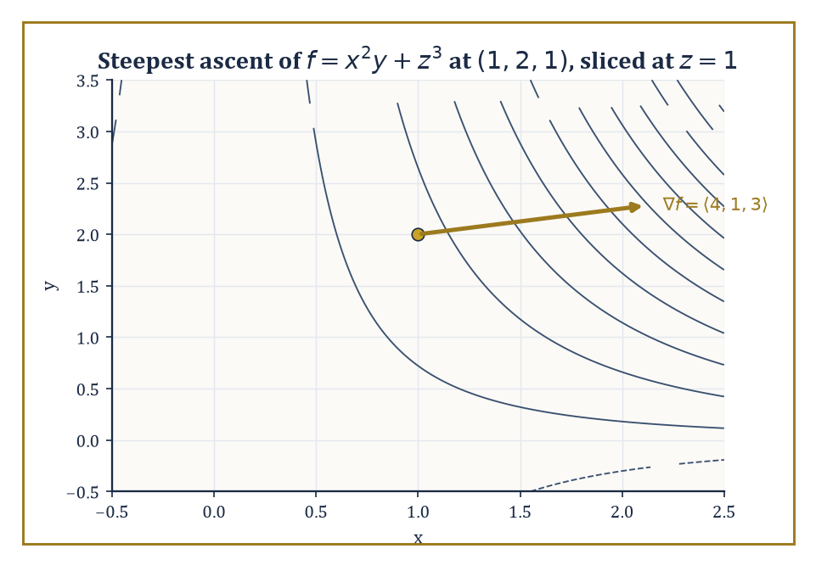
Figure 15.2 — Level curves of f = x²y + z³ sliced at z = 1, with the gradient ⟨4, 1, 3⟩ at (1, 2, 1) pointing, as it must, straight uphill and perpendicular to the contour through that point.
∇f = ⟨∂f/∂x, ∂f/∂y, ∂f/∂z⟩
It points in the direction of steepest ascent of f — the direction a thirsty, ambitious raindrop rolling uphill (an unlikely raindrop, granted) would travel fastest — and its magnitude |∇f| is the rate of that ascent, i.e. how steep the steepest slope is.
For any unit vector u, the directional derivative of f in the direction u — the rate of change of f if you walk in direction u instead of straight uphill — is given by the elegantly compact formula:
∇f · u
Walking straight uphill (u parallel to ∇f) gives the maximum possible rate, |∇f|; walking along a level contour (u perpendicular to ∇f) gives zero, because you are, by definition, not going up or down at all.
Numeric example — gradient and directional derivative. Let:
f(x, y, z) = x²y + z³
Then the partial derivatives are:
∂f/∂x = 2xy, ∂f/∂y = x², ∂f/∂z = 3z²
so:
∇f = ⟨2xy, x², 3z²⟩
At the point (1, 2, 1):
∇f = ⟨2·1·2, 1², 3·1²⟩ = ⟨4, 1, 3⟩
This is the direction of steepest ascent at that point, and its magnitude is how steep that ascent is:
√(16+1+9) = √26 ≈ 5.10
Now take the direction u = ⟨1/√2, 1/√2, 0⟩, a unit vector, since:
(1/√2)² + (1/√2)² + 0² = 1
The directional derivative there is:
∇f · u = 4·(1/√2) + 1·(1/√2) + 3·0 = 5/√2 = 5√2/2 ≈ 3.54
This is less than the maximum 5.10, exactly as it should be, since u is not the steepest direction, merely a direction.
Try it now — Compute div F and curl F for F = (x, y, 0). Answer →
The gradient took a landscape of numbers and produced arrows. The next two operators go the other way. They take a field of arrows and ask what it is doing near a point. Begin with something you can already do.
Stand at the door of a shop for an hour and count. Forty people come in and forty-seven go out. The shop is now seven people emptier than it was, and you know that without ever looking inside. Counting at the doors is enough: out minus in, at the boundary, tells you what happened within.
Now try the same thing with the wind. Picture a box in the air, one meter along each edge, and count the air crossing its six walls. That still works. Out minus in tells you whether the box is gaining air or losing it. But the answer belongs to the box, not to any point inside it. Make the box twice as big and the count changes. Slide it along a little and it changes again. A field has an arrow at every single point, and the box count is not about any one of them.
So change the question. Not ‘how much air leaves this box’, but ‘how much is leaving per cubic meter, right here, at this one point’?
And here is the difficulty, which is worth feeling properly before we get rid of it. Counting needs walls, and dividing needs a volume. A point has no walls to count through and no volume to divide by. The outflow is zero, the volume is zero, and zero divided by zero tells you precisely nothing.
The way round it is the same move that rescued the derivative in What the Derivative Is (Volume 1), and it is no more a cheat here than it was there. Do not count at the point. Build a small box with the point at its center, count what leaves through the walls, and divide by the volume of the box. That is outflow per cubic meter, for a real box. Then shrink the box and watch the ratio.
Try it on the field F = ⟨x², y², z²⟩ at the point (1, 1, 1), with a box of side 1, so that its walls sit at 0.5 and 1.5 in each direction. On the right-hand wall, where x = 1.5, every arrow has x-component 1.5² = 2.25, pointing out of the box. On the left-hand wall, where x = 0.5, the x-component is 0.5² = 0.25, pointing in. Only the x-component carries air through those two walls; the other two components slide along them. Each wall has area 1, so this pair of walls sends out 2.25 − 0.25 = 2. The front and back walls give 2 in the same way, and so do the top and bottom. The total outflow is 6, the volume is 1, and the ratio is 6.
Shrink the box to side 0.5. The walls now sit at 0.75 and 1.25, each wall has area 0.25, and each pair sends out (1.25² − 0.75²) × 0.25 = 1 × 0.25 = 0.25. Three pairs make 0.75, the volume is 0.125, and the ratio is 6 again.
That field is unusually cooperative: every box, of every size, gives exactly 6, because each component of its arrows grows at a steady rate across the box. Most fields are not so kind. Take G = ⟨x³, 0, 0⟩ at the point (1, 0, 0). Only the left and right walls carry anything now, and with a box of side h the ratio works out to 3 + h²/4. For h = 1, the walls are at 0.5 and 1.5, and the ratio is 1.5³ − 0.5³ = 3.375 − 0.125 = 3.25:
h = 1 outflow per unit volume = 3.25
h = 0.5 outflow per unit volume = 3.0625
h = 0.1 outflow per unit volume = 3.0025
h = 0.01 outflow per unit volume = 3.000025
Those numbers are walking straight at 3. Notice what they never do: they never arrive. Every one of them is the outflow of a real box, with real walls, divided by a real volume, so every one of them describes a box and not a point. Yet 3 is plainly the number they are aiming at.
That number is the divergence of the field at the point, and nothing more alarming is going on. It is the shop-door count, out minus in, divided by the size of the shop, with the shop shrunk down around the point. Positive means more leaves every small box around the point than arrives, so the point acts as a source. Negative means a sink. Zero means every small box breaks even. The formula that follows does the shrinking once and for all. It gives 6 for F at (1, 1, 1), as the next example shows, and 3x² for G, which is 3 at x = 1.
The divergence of a vector field F = ⟨P, Q, R⟩ is the scalar field:
div F = ∇ · F = ∂P/∂x + ∂Q/∂y + ∂R/∂z
It measures the local rate at which the field is expanding — imagine a tiny balloon of fluid centered at the point, carried along by the flow, and ask whether it is inflating or deflating as it moves.
Where div F > 0, the point behaves like a source (fluid is being created, or at least spreading outward, locally); where div F < 0, it behaves like a sink; where div F = 0 everywhere, the flow is incompressible — fluid neither piles up nor thins out anywhere, it merely rearranges itself, which is rather the fluid-dynamical equivalent of shuffling deckchairs.
Numeric example — divergence of two fields. For:
F = ⟨x², y², z²⟩
the divergence is:
div F = ∂(x²)/∂x + ∂(y²)/∂y + ∂(z²)/∂z = 2x + 2y + 2z
At (1, 1, 1) this is:
2+2+2 = 6
strongly positive — a genuine expansion, the field’s arrows growing longer the further out you go in every direction, like a rather enthusiastic explosion frozen mid-frame.
Contrast this with the rotation field from Vector Fields Revisited:
F = ⟨−y, x, 0⟩
div F = ∂(−y)/∂x + ∂(x)/∂y + ∂(0)/∂z = 0 + 0 + 0 = 0
A spinning disk of fluid neither inflates nor deflates as it spins — it only turns — and the vanishing divergence confirms mathematically what your intuition already told you for free.
Divergence counted what crosses the walls of a box. Curl counts what flows around the edge of a square. Drop a cork into a stream and watch it. It drifts downstream, and sometimes it also turns. It turns when the water on one side of it is moving faster than the water on the other, so that the push around its rim does not cancel out.
Measure that push by walking once around a small square, counterclockwise. On each side, take the part of the field pointing along your walk, multiply by the length of the side, and add the four results. The total is the circulation around the square. It has the same problem the box count had: it belongs to the square, not to a point. The cure is the same too. Divide by the area of the square, then shrink the square around the point.
Try the rotation field F = ⟨−y, x, 0⟩ from Vector Fields Revisited, around a square of side h centered at the origin in the xy-plane. On the right-hand side, where x = h/2, the field is ⟨−y, h/2, 0⟩, and the part of it pointing up along your walk is h/2 at every point. Times the length h, that side gives h²/2. The field looks the same from every side of the square, so each of the other three sides also gives h²/2. The circulation is 2h², the area is h², and the ratio is 2. With h = 1 you can check it with a pencil: four sides, each giving 1/2, total 2, area 1.
Again the field is being cooperative, and gives 2 for every square. For one that bends, walk around squares centered at (1, 0, 0) in the field ⟨0, x³, 0⟩. Only the two upright sides count, because the field has no part along the other two, and the ratios come out exactly as the box ratios did: 3.25, 3.0625, 3.0025, 3.000025. They close in on 3 and never reach it.
The number they close in on is the curl’s component along the axis the square turns around, here the z-axis. Lay the square in the yz-plane instead and the same count gives the x-component; in the xz-plane it gives the y-component. Together those three numbers make the vector curl F. The formula below gives ⟨0, 0, 2⟩ for the rotation field, as the example after it shows, and ⟨0, 0, 3x²⟩ for ⟨0, x³, 0⟩, which is ⟨0, 0, 3⟩ at x = 1.
The curl of F is the vector field curl F = ∇ × F, computed by the formula:
curl F = ⟨∂R/∂y − ∂Q/∂z, ∂P/∂z − ∂R/∂x, ∂Q/∂x − ∂P/∂y⟩
Where divergence measured expansion, curl measures local rotation. Its direction is the axis about which the field is locally spinning (by the right-hand rule: curl your right-hand fingers in the direction of rotation and your thumb points along curl F), and its magnitude is exactly twice the angular speed of the rigid rotation that best approximates the field near that point.
A field with curl F = 0 everywhere is called irrotational: it may still flow, expand, or contract, but it never locally spins — a leaf dropped into it would translate and stretch, but never pirouette.
Numeric example — curl of the rotation field. Return once more to F = ⟨−y, x, 0⟩, so P = −y, Q = x, R = 0. Then:
curl F = ⟨∂R/∂y − ∂Q/∂z, ∂P/∂z − ∂R/∂x, ∂Q/∂x − ∂P/∂y⟩ = ⟨0 − 0, 0 − 0, 1 − (−1)⟩ = ⟨0, 0, 2⟩
The curl points along the z-axis, the axis we already identified by eye as the axis of rotation, and its magnitude is 2.
Since magnitude equals twice the angular speed, the angular speed is 1 radian per second — precisely the speed at which our streamlines from Vector Fields Revisited traced out their circles. Everything the algebra says agrees with everything the picture already told you; this happy agreement is either deeply reassuring or a sign that we chose an unusually cooperative example, and in this chapter it is always slightly both.
Higher-order differential operators are built by composing these three. The Laplacian of a scalar field is:
∇²f = div(grad f) = ∂²f/∂x² + ∂²f/∂y² + ∂²f/∂z²
It measures how the value at a point compares to the average of its immediate neighbors, and turns up everywhere from heat flow to Chapter 16’s discussion of Fourier series.
Two further facts — that the curl of a gradient always vanishes, and that the divergence of a curl always vanishes — are so important, and so consequence-laden, that they earn their own section next.
Numeric example — the Laplacian. For f(x, y, z) = x²y + z³ from earlier, the second partial derivatives are:
∂²f/∂x² = ∂(2xy)/∂x = 2y, ∂²f/∂y² = ∂(x²)/∂y = 0, ∂²f/∂z² = ∂(3z²)/∂z = 6z
So:
∇²f = 2y + 0 + 6z
At (1, 2, 1):
∇²f = 2·2 + 6·1 = 4 + 6 = 10
A positive Laplacian at a point roughly says the point is a local dip relative to its neighbors — like the bottom of a small dent in an otherwise smoother landscape — which, for a temperature field, is the situation in which heat would be flowing inward.
Keep only this · Section 15.2: The Gradient, Divergence, and Curl
The idea. div measures local outflow (a number), curl measures local spin (a vector), and ∇f points uphill (a vector).
Core.
∇f = (f_{x}, f_{y}, f_{z})
∇ · F = P_{x} + Q_{y} + R_{z}
∇ × F = (R_{y} − Q_{z}, P_{z} − R_{x}, Q_{x} − P_{y})
Typical mistake. Taking the divergence of a scalar or the gradient of a vector field; check that the operator matches the object.
Minimal example. F = (x, y, z): ∇ · F = 3, ∇ × F = 0.
Practice. Easy to challenge; full worked answers, with the usual mistake, are in Answers to the Practice Sets at the back.
Easy — Divergence of F = (x², y², z²). Answer →
Medium — Curl of F = (−y, x, 0). Answer →
Challenge — Find a field with zero divergence and non-zero curl, and one with the opposite. Answer →

Section 15.3: Identities and the Algebra of Differential Operators
Or: Nabla Behaves Itself, Mostly
CORE · about 15 minutes · later chapters build on this
Some combinations of operations always come to nothing. Wander over a hill and return to your starting point and your total change in height is zero, however you went; correspondingly, a slope field built from a height can never swirl. Water turning in a pure whirlpool has no source or drain anywhere; correspondingly, a field made purely of swirl never spreads out or bunches up. These facts become identities that hold for every field, alongside product rules much like those of single-variable calculus. They matter because they let physicists trade one description for another, most famously in electromagnetism, where one of them guarantees that magnetic field lines never begin or end.
Key idea — A handful of identities follow immediately from the definitions, courtesy of the equality of mixed partial derivatives (Clairaut’s theorem, doing enormous amounts of unglamorous labor behind the scenes since Chapter 14, unremarked). The two load-bearing ones are the curl of any gradient field, always, whatever f is:
curl(grad f) = 0
and the divergence of any curl field, always, whatever F is:
div(curl F) = 0
Alongside these sit the product rules:
div(f F) = f div F + ∇f · F
curl(f F) = f curl F + ∇f × F
These behave as the ordinary product rule from Chapter 11 (Volume 1) would lead you to expect, once you remember that ∇ is itself a kind of derivative and so insists on hitting every factor in turn.
Abstract example — verifying curl(grad f) = 0. Take f(x, y, z) = x²y + z³ once more (this field is getting rather a lot of use this chapter; it has earned its keep). We already found:
∇f = ⟨2xy, x², 3z²⟩
Compute its curl, with P = 2xy, Q = x², R = 3z²:
curl(∇f) = ⟨∂R/∂y − ∂Q/∂z, ∂P/∂z − ∂R/∂x, ∂Q/∂x − ∂P/∂y⟩ = ⟨0 − 0, 0 − 0, 2x − 2x⟩ = ⟨0, 0, 0⟩
The last component is the instructive one: it is 2x − 2x, not some more mysterious cancellation, and it vanishes because ∂²f/∂x∂y and ∂²f/∂y∂x are the same second-order mixed partial computed in two different orders. Every instance of curl(grad f) = 0 is, at bottom, this same equality of mixed partials, dressed up in three different coordinate slots simultaneously.
Try it now — Check curl(∇f) = 0 for f = xy. Answer →
The product rule:
div(f F) = f div F + ∇f · F
says that the divergence of a scaled field splits into a term from the field’s own expansion, weighted by the scale factor, plus a term from the scale factor’s own gradient dragging the field along with it.
It is the ordinary product rule for differentiation, applied component by component and then summed — the sort of identity that looks like it ought to require a footnote and, disappointingly for anyone hoping for drama, does not.
Abstract example — the divergence product rule. Let f = x and F = ⟨y, z, x⟩. Directly:
f F = ⟨xy, xz, x²⟩
div(f F) = ∂(xy)/∂x + ∂(xz)/∂y + ∂(x²)/∂z = y + 0 + 0 = y
Via the identity:
div F = ∂y/∂x + ∂z/∂y + ∂x/∂z = 0
and:
∇f = ⟨1, 0, 0⟩, so ∇f · F = 1·y + 0·z + 0·x = y
Then:
f div F + ∇f · F = x·0 + y = y
Both routes give y. The direct route was three differentiations and an addition; the identity route required no differentiation of F at all once div F and ∇f were known, which is rather the point of having identities lying around.
The curl product rule:
curl(f F) = f curl F + ∇f × F
works the same way but with a cross product replacing the dot product, since curl itself is built from a cross product (∇ × F) rather than a dot product — swap the operation throughout and the whole argument follows along obediently, asking no further questions.
Abstract example — the curl product rule. With the same f = x, F = ⟨y, z, x⟩: directly, f F = ⟨xy, xz, x²⟩, and:
curl(f F) = ⟨∂(x²)/∂y − ∂(xz)/∂z, ∂(xy)/∂z − ∂(x²)/∂x, ∂(xz)/∂x − ∂(xy)/∂y⟩ = ⟨0 − x, 0 − 2x, z − x⟩ = ⟨−x, −2x, z−x⟩
Via the identity:
curl F = ⟨∂x/∂y − ∂z/∂z, ∂y/∂z − ∂x/∂x, ∂z/∂x − ∂y/∂y⟩ = ⟨−1, −1, −1⟩
so:
f curl F = ⟨−x, −x, −x⟩
and:
∇f × F = ⟨1,0,0⟩ × ⟨y,z,x⟩ = ⟨0·x − 0·z, 0·y − 1·x, 1·z − 0·y⟩ = ⟨0, −x, z⟩
Adding:
⟨−x+0, −x−x, −x+z⟩ = ⟨−x, −2x, z−x⟩
The two routes agree exactly, component by component, which they had jolly well better, since the identity is a theorem and not a suggestion.
It helps to treat ∇ formally as a vector,
∇ = ⟨∂/∂x, ∂/∂y, ∂/∂z⟩
and apply the ordinary rules of vector algebra to it, remembering only that every derivative in the expression acts on everything sitting to its right and must not be allowed to sneak past a function it was meant to differentiate.
Treated this way, the vector-algebra identity for a triple cross product,
a × (b × c) = b(a·c) − c(a·b)
applied with a = b = ∇ and c = F, yields:
curl(curl F) = ∇(div F) − ∇²F
where ∇²F means the Laplacian applied separately to each component of F. This one identity quietly underlies the wave equation in electromagnetism and the viscous term in the Navier–Stokes equations, so it is worth more respect than its slightly menacing appearance suggests.
Abstract example — verifying curl(curl F) = ∇(div F) − ∇²F. Take F = ⟨xy, yz, zx⟩. First:
div F = y + z + x
so:
∇(div F) = ⟨1, 1, 1⟩
a constant field, since x+y+z has constant partial derivatives. Second, each component of F is a product of two different coordinates, and the Laplacian of any such product is zero — for instance ∂²(xy)/∂x² = 0 and ∂²(xy)/∂y² = 0 — so:
∇²F = ⟨0, 0, 0⟩
The identity therefore predicts:
curl(curl F) = ⟨1,1,1⟩ − ⟨0,0,0⟩ = ⟨1,1,1⟩
Now check directly. With P = xy, Q = yz, R = zx:
curl F = ⟨∂R/∂y − ∂Q/∂z, ∂P/∂z − ∂R/∂x, ∂Q/∂x − ∂P/∂y⟩ = ⟨0 − y, 0 − z, 0 − x⟩ = ⟨−y, −z, −x⟩
Taking the curl again, with P′ = −y, Q′ = −z, R′ = −x:
curl(curl F) = ⟨∂R′/∂y − ∂Q′/∂z, ∂P′/∂z − ∂R′/∂x, ∂Q′/∂x − ∂P′/∂y⟩ = ⟨0 − (−1), 0 − (−1), 0 − (−1)⟩ = ⟨1, 1, 1⟩
It matches the prediction exactly — a small but satisfying confirmation that treating ∇ as a bona fide vector, and trusting the algebra, genuinely works.
Keep only this · Section 15.3: Identities and the Algebra of Differential Operators
The idea. curl ∇f = 0 and div curl F = 0, both because mixed partials commute.
Core.
∇ × (∇f) = 0
∇ · (∇ × F) = 0
∇ · (fF) = ∇f · F + f ∇ · F
Typical mistake. Applying product rules for ∇ × (fF) with the terms in the wrong order; the cross product is not commutative.
Minimal example. f = xyz: ∇f = (yz, xz, xy), and its curl is (x − x, y − y, z − z) = 0.
Practice. Easy to challenge; full worked answers, with the usual mistake, are in Answers to the Practice Sets at the back.
Easy — What is ∇ · (∇ × F) for F = (yz, x², eˣ)? Answer →
Medium — Verify ∇ · (fF) = ∇f · F + f∇ · F for f = x, F = (x, y, 0). Answer →
Challenge — Compute ∇²f for f = 1/r in ℝ³ (r ≠ 0). Answer →

Section 15.4: Line Integrals and Conservative Fields
Potential, Realized
CORE · about 15 minutes · later chapters build on this
Push a supermarket trolley 5 meters along an aisle with a steady force of 10 newtons, aimed straight along the aisle, and you have done 10 × 5 = 50 joules of work. Push with the same 10 newtons aimed 60° away from the aisle and only the part along the aisle moves the trolley: 10 × cos 60° = 5 newtons of it, so 25 joules. Lean straight down on the handle and you can push as hard as you like. The trolley goes nowhere, and the work is zero.
A line integral is that same count for a path that bends and a force that changes from place to place. Chop the path into short steps. On each step, take the part of the field pointing along the step, multiply by the step’s length, and add. ‘The part along the step, times its length’ is the dot product F · Δr, so the total is a sum of F · Δr, and as the steps shrink it becomes the integral below. Vector Fields and Line Integrals introduced it. This section asks when the route stops mattering.
Key idea — The line integral of a vector field F along a curve C, written
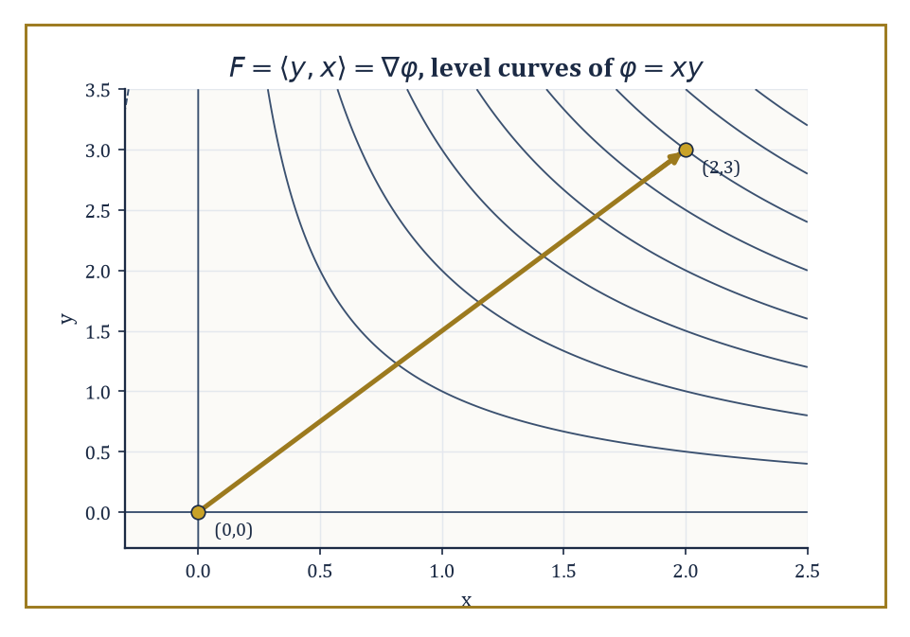
Figure 15.3 — Level curves of the potential φ = xy, with the straight path from (0,0) to (2,3) that made the line integral of F = ⟨y, x⟩ so cheap to compute.
∫[C] F · dr
measures the total work done by the field on a particle traveling along C — at each instant, only the component of F pointing along the direction of travel contributes, just as a force does no work when it pushes perpendicular to your motion. When the curve is closed, the same integral is called the circulation of F around the loop.
The central question of this section is when ∫[C] F · dr depends only on the endpoints of C, and not on the particular path taken between them — because when it doesn’t depend on the path, computing it becomes almost embarrassingly easy.
You already know one case where it does not matter. Walk up a hill by the steep path or by the long zigzag, and the height you gain is the same either way: it is the height at the top minus the height at the bottom. The work gravity does on you depends on that difference and nothing else. A field that behaves like this has a ‘height function’ of its own, and that function is the potential φ below.
This happens when F is conservative: when
F = ∇φ
for some scalar potential φ. On a simply connected domain (one with no holes to trip over — we will meet the exception shortly), a continuously differentiable field is conservative if and only if curl F = 0 everywhere on that domain.
Numeric example — a conservative field, two ways. Let F = ⟨y, x⟩, and guess the potential φ(x, y) = xy, since:
∇φ = ⟨y, x⟩ = F
Confirm conservativity, with P = y, Q = x, R = 0:
curl F = ⟨0, 0, ∂x/∂x − ∂y/∂y⟩ = ⟨0, 0, 1−1⟩ = 0
as required. Compute ∫[C] F · dr along the straight line C from (0,0) to (2,3), parametrized:
r(t) = (2t, 3t), t ∈ [0,1], so r′(t) = (2,3)
Then F(r(t)) = ⟨3t, 2t⟩, since the y-coordinate 3t feeds the first component of F and the x-coordinate 2t feeds the second, and:
F · r′ = 3t·2 + 2t·3 = 6t + 6t = 12t
So:
∫[C] F · dr = ∫₀¹ 12t dt = [6t²]₀¹ = 6
Now the lazy route: since F is conservative,
∫[C] F · dr = φ(2,3) − φ(0,0) = (2·3) − 0 = 6
Same answer, a fraction of the effort — and any other path from (0,0) to (2,3), however wandering, would give exactly 6 as well.
Try it now — Find ∫_{C} F · dr for F = (2x, 2y) from (1, 0) to (0, 1). Answer →
When a field is known to be conservative, its potential can be found by integrating one component at a time and patching the results together.
Integrate ∂φ/∂x = P with respect to x, which recovers φ up to an unknown function of y (and z); differentiate that partial result with respect to y and compare against Q to pin down the missing function; repeat with R if there is a third variable.
It is a small act of detective work, and like all good detective work it ends with a verification step you should never skip.
Numeric example — finding a potential. Let F = ⟨2xy, x² + 3y²⟩. Set ∂φ/∂x = 2xy and integrate with respect to x:
φ = x²y + g(y)
for some function g depending only on y. Differentiate with respect to y:
∂φ/∂y = x² + g′(y)
This must equal the second component, x² + 3y², so:
g′(y) = 3y², giving g(y) = y³
plus an arbitrary constant, which we may as well set to zero. So:
φ(x, y) = x²y + y³
Check:
∇φ = ⟨2xy, x² + 3y²⟩ = F
confirmed. The line integral of F from (0,0) to (1,1), along any path whatsoever, is now:
φ(1,1) − φ(0,0) = (1·1 + 1) − 0 = 2
For a conservative field, the circulation around any closed curve is zero:
∮[C] ∇φ · dr = φ(end) − φ(start) = φ(P) − φ(P) = 0
since a closed curve starts and ends at the same point. This is the continuous cousin of the fact that a function returns to its own value after a round trip — hardly a surprise once stated, though it is worth stating, because the converse is treacherous.
Vanishing curl everywhere on the domain does not, by itself, guarantee a global potential exists; it guarantees only a local one, valid near each point.
To upgrade ‘local potential everywhere’ to ‘one global potential’, the domain must have no holes for a loop to snag on — it must be simply connected. Where that fails, curl-free fields can still have nonzero circulation around loops that encircle the hole, and no potential exists that is single-valued on the whole domain.
Worked example — curl-free but not conservative. The standard counterexample is:
F = ⟨−y/(x²+y²), x/(x²+y²)⟩
defined everywhere except the single punctured point (0,0). A direct computation gives curl F = 0 everywhere on its domain — the field is irrotational away from the puncture.
Yet its circulation around the unit circle is nonzero. Parametrizing x = cos θ, y = sin θ for θ from 0 to 2π gives:
F = ⟨−sin θ, cos θ⟩, dr = ⟨−sin θ, cos θ⟩ dθ
so:
F · dr = sin²θ dθ + cos²θ dθ = dθ
and:
∮ F · dr = ∫[0, 2π] dθ = 2π
A curl-free field with a nonzero loop integral: the theorem’s topological hypothesis was not decoration, it was load-bearing, and the punctured plane — the plane with a single point removed — is the smallest possible hole through which this particular piece of mathematics can go wrong.
Common failure mode — Zero curl is not enough. F = (−y, x)/(x² + y²) has zero curl wherever it is defined and still circulates 2π round the unit circle. The theorem “curl-free ⇒ conservative” needs the region to be simply connected, and the punctured plane is not.
Keep only this · Section 15.4: Line Integrals and Conservative Fields
The idea. Path independence, zero circulation round every loop, and being a gradient are the same property on a simply connected region.
Core.
F = ∇f ⇔ ∮ F · dr = 0 for every loop ⇔ (simply connected domain) ∇ × F = 0
Typical mistake. Concluding a curl-free field is conservative on a region with a hole.
Minimal example. F = (2xy, x², 0) = ∇(x²y).
Practice. Easy to challenge; full worked answers, with the usual mistake, are in Answers to the Practice Sets at the back.
Easy — Is F = (y, x, 1) conservative? Find f. Answer →
Medium — ∫ of F = (2x, 2y, 2z) from (0, 0, 0) to (1, 2, 2) along any path. Answer →
Challenge — Find f with ∇f = (yz + 1, xz, xy). Answer →

Section 15.5: Surface Integrals and Flux
How Much Is Going Through
CORE · about 15 minutes · later chapters build on this
Hold a hoop out flat in steady rain. Say the rain is falling straight down at 10 liters per square meter per hour, which is a heavy downpour, and the hoop encloses 1 square meter. Held flat, it lets 10 liters an hour through. Tilt it 60° from flat and it lets through 5, because from the rain’s point of view the hoop now looks only half as wide: cos 60° = 1/2. Turn it edge-on and nothing gets through at all. The hoop has not changed size. What changed is the angle between the way the rain is falling and the way the hoop faces.
That is the whole idea of flux. ‘The way the hoop faces’ is a unit normal n, the rain is a field F, and the part of the rain that goes through is the dot product F · n, which already contains the cos 60°. Multiply by the area and you have the catch. For a curved surface, or rain that varies from place to place, cut the surface into small patches, do this on each one, and add; as the patches shrink, the sum becomes the surface integral below.
The first example in this section is the flat hoop: F · n comes out the same at every point, so the flux is that number times the area. The second is the tilted hoop, and it lands on the same lesson the rain taught: a straight-down field sees only the area a surface shows it from above.
Key idea — The flux of a vector field F through an oriented surface S measures the net amount of the field passing through the surface — ‘oriented’ meaning that one of the surface’s two possible unit normal directions, n, has been chosen as positive.
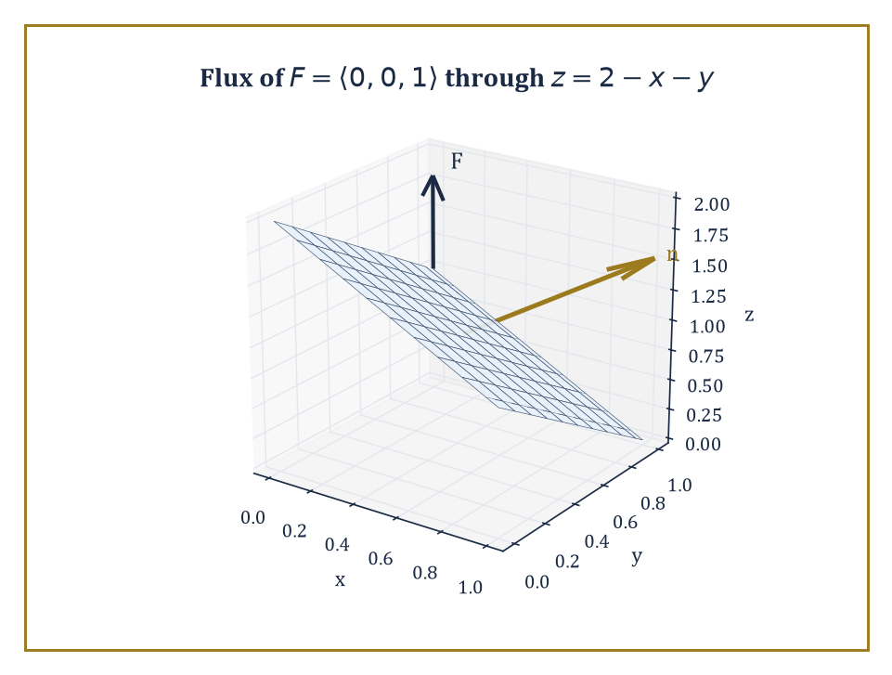
Figure 15.4 — The tilted plane z = 2 − x − y over the unit square, its normal ⟨1,1,1⟩ from r_{x} × r_{y} set against the uniform field F = ⟨0,0,1⟩ passing through it.
Flux is computed as the surface integral:
∬[S] F · n dS
At each point, only the component of F perpendicular to the surface contributes — a field flowing along the surface passes nothing through it, the same way a river flowing parallel to a fishing net catches no fish.
Numeric example — flux through a flat disk. Let F = ⟨x, y, z⟩, and let S be the disk of radius 1 lying in the plane z = 2, oriented with upward normal n = ⟨0,0,1⟩.
On S, every point has z = 2, so F restricted to S is ⟨x, y, 2⟩, and:
F · n = 2
at every point of the disk — the x and y components of F, however large, are killed by the dot product with a purely vertical normal. The flux is then this constant value times the area:
Flux = 2 × (π · 1²) = 2π
Try it now — Flux of F = (0, 0, 3) upward through the disk of radius 2 in the plane z = 1. Answer →
For a surface given as a parametrization r(u, v), the surface integral reduces to an ordinary double integral over the parameter domain, via:
∬[S] F · n dS = ∬ F(r(u,v)) · (rᵤ × rᵥ) du dv
The cross product of the two partial derivatives rᵤ and rᵥ does double duty: its magnitude supplies the area-scaling factor — how much a small rectangle in (u,v)-space gets stretched or squashed when mapped onto the curved surface — and its direction supplies the normal vector n itself, orientation included.
Numeric example — flux via parametrization. Let S be the portion of the plane z = 2 − x − y lying over the unit square 0 ≤ x ≤ 1, 0 ≤ y ≤ 1, parametrized by:
r(x,y) = ⟨x, y, 2−x−y⟩
using x and y themselves as the parameters, a common and convenient choice for graphs. Then:
r_{x} = ⟨1, 0, −1⟩, r_{y} = ⟨0, 1, −1⟩
and their cross product is:
r_{x} × r_{y} = ⟨(0)(−1) − (−1)(1), (−1)(0) − (1)(−1), (1)(1) − (0)(0)⟩ = ⟨1, 1, 1⟩
The positive z-component confirms this normal points broadly upward, matching an upward choice of orientation. Take F = ⟨0, 0, 1⟩, a uniform vertical field. Then:
F · (r_{x} × r_{y}) = 0 + 0 + 1 = 1
at every point, and the flux is:
∫₀¹∫₀¹ 1 dx dy = 1
As a sanity check: a purely vertical field passing through a tilted plane sees only the plane’s projected area onto the horizontal, which here is the unit square’s own area, 1 — the tilt does not matter for a field with no horizontal component, and the arithmetic duly confirms it.
Reversing the chosen orientation — swapping n for −n, or equivalently swapping the order of the parameters as r_{y} × r_{x} instead of r_{x} × r_{y} — reverses the sign of the flux and nothing else.
For closed surfaces (spheres, cubes, anything fully enclosing a region), the universal convention is to take the outward normal as positive; this convention is what makes the divergence theorem of Green’s, Stokes’, and Gauss’s Theorems Revisited come out with a plus sign rather than requiring a footnote every time it is invoked.
Numeric example — reversing orientation. Reversing the parametrization order in the previous example:
r_{y} × r_{x} = −⟨1,1,1⟩ = ⟨−1,−1,−1⟩
and:
F · (r_{y} × r_{x}) = −1
at every point, giving a flux of:
∫₀¹∫₀¹ (−1) dx dy = −1
the exact negative of before, and nothing more mysterious than a bookkeeping choice about which side of the plane counts as ‘through’.
Keep only this · Section 15.5: Surface Integrals and Flux
The idea. Flux needs an orientation; reversing the normal reverses the sign.
Core.
flux = ∬_{S} F · n dS
closed surfaces: outward n
Typical mistake. Forgetting |r_{u} × r_{v}| when parametrizing, or using r_{v} × r_{u} and flipping the orientation.
Minimal example. F = (0, 0, z) through the top of the unit cube (z = 1): flux 1.
Practice. Easy to challenge; full worked answers, with the usual mistake, are in Answers to the Practice Sets at the back.
Easy — Flux of F = (1, 2, 3) through the unit square in z = 0, normal (0, 0, 1). Answer →
Medium — Outward flux of F = (0, 0, z) through the sphere of radius 1. Answer →
Challenge — Why is flux through a Möbius strip not defined? Answer →

Section 15.6: Green’s, Stokes’, and Gauss’s Theorems Revisited
Three Theorems, One Sentence
CORE · about 15 minutes · revisits Chapter 14’s three theorems and checks each on this chapter’s fields
Definition — Green’s theorem, Stokes’ theorem, and the divergence theorem (also called Gauss’s theorem) are the three classical integral theorems of vector calculus, and they are, at heart, three dialects of a single sentence: the total behavior of a differential operator inside a region equals the corresponding behavior of the original field on the region’s boundary.
The three statements, their hypotheses and their proofs in outline are in Green’s Theorem and Stokes’ Theorem and the Divergence Theorem; this section checks each one on a field from this chapter.
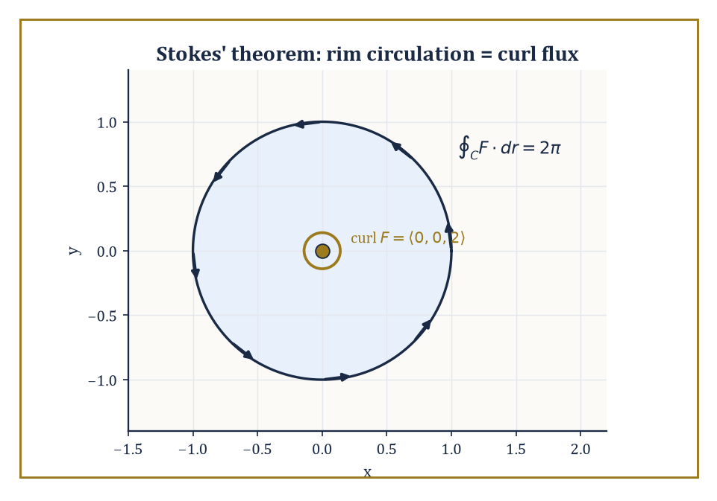
Figure 15.5 — Stokes’ theorem on the rotation field: circulation of 2π around the unit circle’s counterclockwise rim, exactly matched by the flux of curl F = ⟨0,0,2⟩ straight up through the disk it bounds.
Numeric example — Green’s theorem. Let P = xy, Q = x² on the unit square D = [0,1] × [0,1], boundary traversed counterclockwise. The right-hand side:
∂Q/∂x = 2x, ∂P/∂y = x
so the integrand is 2x − x = x, and:
∬[D] x dA = ∫₀¹∫₀¹ x dx dy = (∫₀¹ x dx)(∫₀¹ dy) = (1/2)(1) = 1/2
The left-hand side, computed the hard way around all four sides. On the bottom edge (y=0, x: 0→1):
F·dr = P dx = (x·0) dx = 0
contributing 0. On the right edge (x=1, y: 0→1):
F·dr = Q dy = 1·dy, contributing ∫₀¹ dy = 1
On the top edge (y=1, x: 1→0):
F·dr = P dx = x dx, contributing ∫₁⁰ x dx = −1/2
On the left edge (x=0, y: 1→0):
F·dr = Q dy = 0·dy
contributing 0. Total:
0 + 1 − 1/2 + 0 = 1/2
The two sides agree, as advertised, and note how much less arithmetic the area integral required.
Try it now — Use the divergence theorem: outward flux of F = (x, y, z) through the cube [0, 1]³. Answer →
Numeric example — Stokes’ theorem. Let F = ⟨−y, x, 0⟩, our recurring rotation field, S the unit disk in the plane z = 0 with upward normal, and C its boundary, the unit circle, traversed counterclockwise. We already found curl F = ⟨0,0,2⟩ in The Gradient, Divergence, and Curl. The flux of curl F through S is:
∬[S] ⟨0,0,2⟩ · ⟨0,0,1⟩ dA = 2 × (area of unit disk) = 2π
The circulation ∮[C] F · dr, computed directly as in Line Integrals and Conservative Fields: on the unit circle:
F = ⟨−sin θ, cos θ, 0⟩, dr = ⟨−sin θ, cos θ, 0⟩ dθ
so:
F · dr = sin²θ + cos²θ = 1
per unit dθ, giving:
∮[C] F · dr = 2π
Both sides equal 2π: the flux of the spin through the disk matches the circulation around its rim exactly, which is Stokes’ theorem doing what it says on the tin.
Numeric example — the divergence theorem. Let F = ⟨x, y, z⟩, so:
div F = 1 + 1 + 1 = 3
a constant. Let E be the solid unit ball. The right-hand side:
∭[E] 3 dV = 3 × (volume of unit ball) = 3 × (4π/3) = 4π
The left-hand side: on the unit sphere, the outward unit normal at a point (x,y,z) is the position vector itself, n = ⟨x,y,z⟩, since the sphere has radius 1 and position vectors on it already have length 1. So:
F · n = x² + y² + z² = 1
at every point of the sphere, because the sphere’s equation is x²+y²+z²=1. The flux is therefore:
∬ₛₚₕₑᵣₑ 1 dS = surface area of the unit sphere = 4π
Both sides equal 4π, and the divergence theorem again earns its keep.
All three theorems demand some regularity — continuously differentiable fields, sufficiently smooth boundaries, compatible orientations — and violating the fine print is how careless students, and the occasional careless don, generate apparent paradoxes out of thin air.
Used correctly, though, the theorems are a choice of which side of an equation is easier to compute, and a competent practitioner reaches automatically for whichever side that is.
Keep only this · Section 15.6: Green’s, Stokes’, and Gauss’s Theorems Revisited
The idea. Each theorem has the shape “integral of a derivative over a region = integral over the boundary”, with an orientation rule attached.
Core.
Green, Stokes and Gauss: integral of a derivative over a region = integral over its boundary
Typical mistake. Ignoring the orientation convention: counterclockwise for Green, right-hand rule for Stokes, outward for Gauss.
Minimal example. Gauss for F = (x, y, z) on the cube [0, 1]³: ∭ 3 dV = 3 = total flux.
Practice. Easy to challenge; full worked answers, with the usual mistake, are in Answers to the Practice Sets at the back.
Easy — Which theorem would you use for the outward flux through a closed surface? Answer →
Medium — Use Gauss to find the outward flux of F = (x, 2y, 3z) through the unit sphere. Answer →
Challenge — Two surfaces S₁, S₂ share the boundary circle C. Why does ∬ (∇ × F) · n dS have the same value on both? Answer →

Section 15.7: Potential Theory and Helmholtz Decomposition
Every Field Is a Rotation Plus a Push, More or Less
EXTENSION · about 15 minutes · enrichment; nothing later depends on it
Definition — A scalar potential for a vector field F is a scalar function φ with ∇φ = F; we met these in Line Integrals and Conservative Fields.
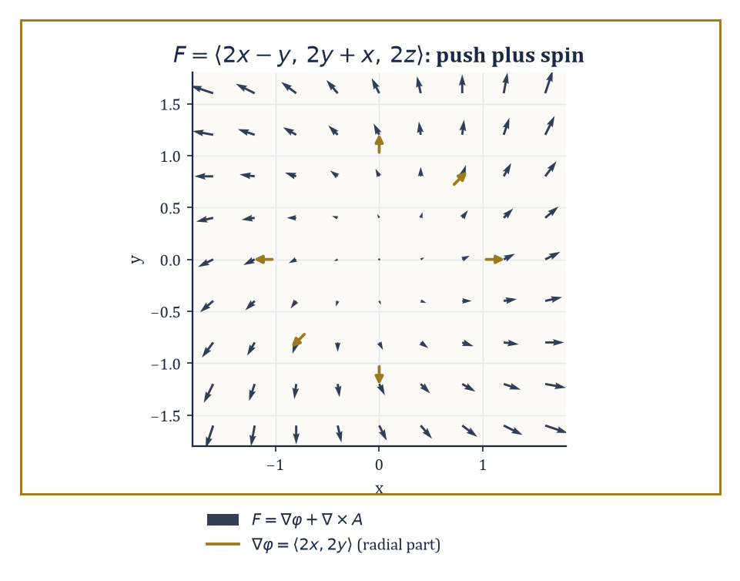
Figure 15.6 — F = ⟨2x−y, 2y+x, 2z⟩ in the xy-plane, its spiral shape visibly the sum of a radial push ∇φ = ⟨2x,2y⟩ (gold) and the familiar rotation field underneath.
A vector potential is the less familiar cousin: a vector field A with curl A = F.
Existence of a scalar potential requires curl F = 0 (plus, as we saw, the right topology); existence of a vector potential requires div F = 0 (again, plus topology, since div(curl A) = 0 is compulsory for any A, so a field with nonzero divergence can never be a pure curl, however much it might privately wish otherwise).
Abstract example — a vector potential. Take the uniform field F = ⟨0, 0, 1⟩ — think of a constant magnetic field pointing straight up. A vector potential is:
A = ⟨−y/2, x/2, 0⟩
Check, with P = −y/2, Q = x/2, R = 0:
curl A = ⟨∂R/∂y − ∂Q/∂z, ∂P/∂z − ∂R/∂x, ∂Q/∂x − ∂P/∂y⟩ = ⟨0 − 0, 0 − 0, 1/2 − (−1/2)⟩ = ⟨0, 0, 1⟩ = F
confirmed. Note div F = 0 here trivially, since F is constant, consistent with the necessary condition.
Try it now — Find a vector potential A with curl A = (0, 0, 1). Answer →
The Helmholtz decomposition theorem states that, under mild decay conditions at infinity (the field must not misbehave too badly far from the origin), any sufficiently smooth vector field F on ℝ³ can be written uniquely as:
F = ∇φ + ∇ × A
the sum of a curl-free (‘irrotational’) part and a divergence-free (‘solenoidal’) part.
It is the field-theoretic analogue of splitting a square matrix into its symmetric and antisymmetric halves, or a vector into components parallel and perpendicular to a fixed direction — in each case, an arbitrary object of some type decomposes uniquely into two pieces from complementary, non-overlapping subtypes.
It also explains, retrospectively, why the two conditions curl F = 0 and div F = 0 kept showing up throughout this chapter as the natural things to check: they are the conditions under which one half of the decomposition vanishes and the field is purely the other kind.
Abstract example — an explicit decomposition. A fully general Helmholtz decomposition requires solving a Poisson equation (more on those in later chapters), which is not an afternoon’s hand computation. But a small, honestly worked instance is within reach.
Let F = ⟨2x − y, 2y + x, 2z⟩. Split it as:
F = ⟨2x, 2y, 2z⟩ + ⟨−y, x, 0⟩
The first piece is ∇φ for φ = x² + y² + z², direct check:
∇φ = ⟨2x, 2y, 2z⟩
correct, and a gradient is automatically curl-free by the identity of Identities and the Algebra of Differential Operators.
The second piece, ⟨−y, x, 0⟩, is our familiar rotation field, already shown in The Gradient, Divergence, and Curl to have zero divergence, and it is also a genuine curl: with A = ⟨0, 0, −(x²+y²)/2⟩:
curl A = ⟨∂R/∂y − ∂Q/∂z, ∂P/∂z − ∂R/∂x, ∂Q/∂x − ∂P/∂y⟩ = ⟨−y − 0, 0 − (−x), 0 − 0⟩ = ⟨−y, x, 0⟩
matching exactly. So:
F = ∇φ + ∇×A, with φ = x²+y²+z² and A = ⟨0,0,−(x²+y²)/2⟩
a fully explicit, fully verified decomposition, even though most fields are not considerate enough to arrange themselves this tidily in advance.
One warning keeps that tidiness honest. This F does not fade away far from the origin: it grows without limit, so the theorem’s decay condition fails, and with it the promise of a unique answer. Here is a second split of the same field, every bit as valid. The field ⟨y, x, 0⟩ is the gradient of xy, so it is curl-free, and its divergence is 0 + 0 + 0 = 0, so it is divergence-free as well. A field that is both can be moved from one half of the decomposition to the other without changing the sum:
F = ⟨2x + y, 2y + x, 2z⟩ + ⟨−2y, 0, 0⟩
The first piece is ∇φ for φ = x² + y² + z² + xy, since ∇φ = ⟨2x + y, 2y + x, 2z⟩. The second is curl A for A = ⟨0, 0, −y²⟩, since that curl is ⟨∂(−y²)/∂y, −∂(−y²)/∂x, 0⟩ = ⟨−2y, 0, 0⟩. Add the two pieces and the y-terms in the first component, +y and −2y, combine to the −y of the original F.
Two different decompositions, both checked. The freedom comes from fields like ∇(xy), which are curl-free and divergence-free at once; they are the gradients of functions whose Laplacian (The Gradient, Divergence, and Curl) is zero, and the Laplacian of xy is 0 + 0 + 0 = 0. On a field that fades away at infinity, the only such field that also fades away is the zero field. That is exactly why the decay condition is there, and why, with it, the theorem can promise one answer.
Keep only this · Section 15.7: Potential Theory and Helmholtz Decomposition
The idea. Helmholtz: a well-behaved field splits into a curl-free part (a gradient) plus a divergence-free part (a curl).
Core.
F = −∇φ + ∇ × A (Helmholtz)
∇²φ = −∇ · F
Typical mistake. Expecting a unique vector potential.
Minimal example. F = (x, y, z) + (−y, x, 0): the first part is a gradient, the second a curl.
Practice. Easy to challenge; full worked answers, with the usual mistake, are in Answers to the Practice Sets at the back.
Easy — Which part of F = (x − y, y + x, 0) is curl-free? Answer →
Medium — What potential φ has −∇φ = (x, y, z)? Answer →
Challenge — Why is a Helmholtz decomposition not unique on a bounded region without boundary conditions? Answer →

Section 15.8: Physical Applications
Where All This Turns Out to Matter
EXTENSION · about 15 minutes · the applied route reads this; later chapters do not depend on it
Key idea — In fluid dynamics, the velocity field u of an incompressible flow satisfies div u = 0 — the defining condition, as we saw in The Gradient, Divergence, and Curl, of a flow in which fluid neither accumulates nor thins anywhere.
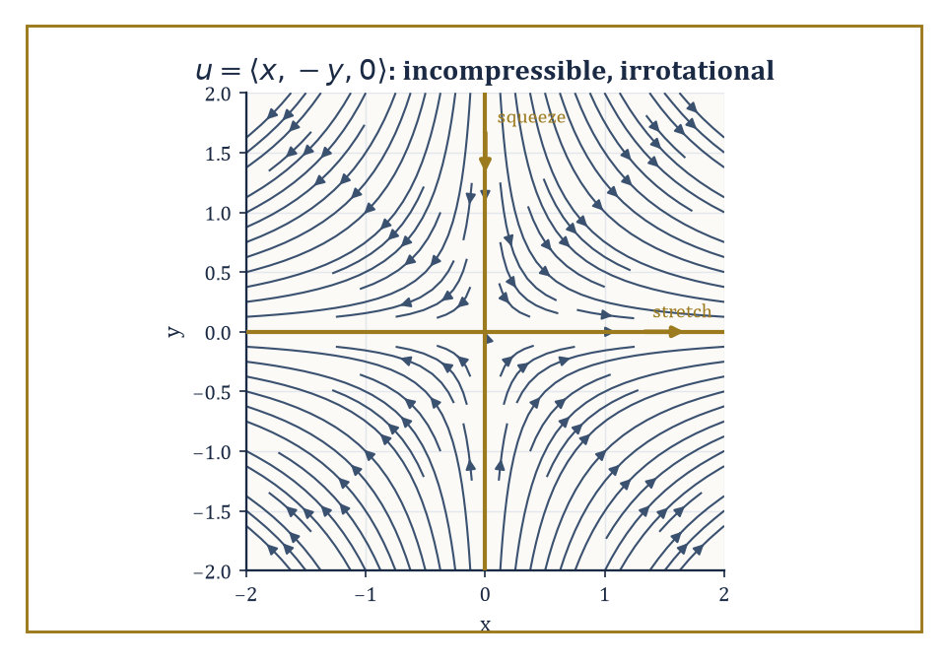
Figure 15.7 — The straining flow u = ⟨x, −y, 0⟩: streamlines stretching fluid along the x-axis and squeezing it along the y-axis, all while conserving volume unnoticed.
The vorticity of the flow, curl u, measures the local spin of fluid parcels: whirlpools and eddies are precisely the regions where vorticity is large.
Euler’s equations (for an ideal, frictionless fluid) and the Navier–Stokes equations (which add viscosity) are, at their core, statements about how these divergence and curl properties of u evolve in time under the influence of pressure and external forces — a great deal of hard-won physics, when you strip away the notation, for the simple observation that fluid is not allowed to teleport.
Abstract example — an incompressible, irrotational flow. Let u = ⟨x, −y, 0⟩, a simple ‘straining’ flow, stretching fluid along the x-axis while squeezing it along the y-axis, like dough being rolled in one direction and compressed in the perpendicular one.
Check incompressibility:
div u = 1 + (−1) + 0 = 0
confirmed: this flow conserves fluid volume even while dramatically reshaping it.
Check vorticity, with P=x, Q=−y, R=0:
curl u = ⟨0−0, 0−0, 0−0⟩ = ⟨0,0,0⟩
The flow is also irrotational; it stretches and squeezes fluid parcels but never spins them. Contrast this with the rotation field of Vector Fields Revisited, which was incompressible but maximally rotational: two flows, both volume-preserving, doing entirely different things to a small blob of dye dropped into them.
Try it now — Is u = (y, x, 0) incompressible? Irrotational? Answer →
In electromagnetism, Maxwell’s equations relate the divergence and curl of the electric field E and magnetic field B to the charge density and current density that generate them. Their integral forms — Gauss’s law for electricity and magnetism, and the Maxwell–Faraday and Ampère–Maxwell laws — are the divergence theorem and Stokes’ theorem, respectively, applied to E and B.
This is not an analogy or a loose resemblance; the integral and differential forms of Maxwell’s equations are literally the same physical laws, related to each other by the theorems of Green’s, Stokes’, and Gauss’s Theorems Revisited.
Numeric example — Gauss’s law for a point charge. Take a point charge q = 2 at the origin, choosing units in which Coulomb’s constant k = 1, purely for arithmetical tidiness, producing an electric field directed radially outward, of magnitude:
|E| = kq/R² = q/R²
at distance R. On a sphere of radius R = 3 centered at the charge:
|E| = 2/9
at every point of the sphere, directed along the outward normal, so E · n = 2/9 everywhere on it. The flux through the sphere is therefore:
|E| × (surface area) = (2/9) × 4π(3)² = (2/9) × 36π = 8π
Gauss’s law predicts this flux should equal:
4πkq = 4π(1)(2) = 8π
The two agree, and note that R dropped out of the final answer entirely — the flux through any sphere centered on the charge is the same 8π regardless of its radius, because the field weakens by exactly the same factor (1/R²) as the sphere’s area grows (by R²), and the two effects cancel perfectly.
This cancellation is the entire content of the inverse-square law, restated as a flux computation.
In gravitation and electrostatics alike, the field is the gradient of a scalar potential (Newtonian potential or electrostatic potential respectively), and that potential satisfies Poisson’s equation:
∇²φ = −ρ
up to constants depending on convention, where ρ is the mass or charge density generating the field.
Away from any mass or charge — in the vacuum — this becomes Laplace’s equation:
∇²φ = 0
and functions satisfying it are called harmonic: they have the pleasant property, already hinted at when we discussed the Laplacian in The Gradient, Divergence, and Curl, of having no local dips or bumps relative to their neighbors anywhere in the vacuum region.
Worked example — Laplace’s equation for the 1/r potential. The potential of a point mass (or charge) at the origin is proportional to f = 1/r, where r = √(x²+y²+z²). Differentiating, from the chain rule applied to (x²+y²+z²)^{−1/2}:
∂f/∂x = −x/r³
and a second differentiation gives:
∂²f/∂x² = −1/r³ + 3x²/r⁵
with matching expressions for y and z by symmetry. Summing:
∇²f = −3/r³ + 3(x²+y²+z²)/r⁵ = −3/r³ + 3r²/r⁵ = −3/r³ + 3/r³ = 0
Laplace’s equation holds everywhere except at the singular point r=0 itself, as advertised.
As a numerical check, evaluate the x-term at the point (1,1,1), where r² = 3, r = √3, r³ = 3√3, r⁵ = 9√3:
∂²f/∂x² = −1/(3√3) + 3(1)/(9√3) = −1/(3√3) + 1/(3√3) = 0
By the symmetry of x=y=z=1, the y- and z-terms vanish identically too, and the sum is 0, matching the general result.
Keep only this · Section 15.8: Physical Applications
The idea. Incompressible means div u = 0; irrotational means curl u = 0; Gauss’s law is the divergence theorem for the electric field.
Core.
∇ · E = ρ/ε₀
∇ · B = 0
u_{t} = k∇²u
Typical mistake. Forgetting the constant k (or 1/ε₀) when quoting Gauss’s law.
Minimal example. A point charge: E = q r/(4πε₀r³), flux q/ε₀ through every enclosing sphere.
Practice. Easy to challenge; full worked answers, with the usual mistake, are in Answers to the Practice Sets at the back.
Easy — What does ∇ · B = 0 say in words? Answer →
Medium — A steady temperature field satisfies u_{t} = 0. What equation does u satisfy? Answer →
Challenge — Use Gauss’s law to find E at distance r from a charge q. Answer →

Chapter 15 in One Page
The gradient, divergence and curl are the three first-order derivatives of vector calculus: the gradient of a scalar points uphill, the divergence of a field measures its local outflow, and the curl measures its local spin. Two identities, curl ∇f = 0 and div curl F = 0, follow from the symmetry of mixed partials. Line integrals measure work and circulation, surface integrals measure flux, and Green’s, Stokes’ and Gauss’s theorems tie each derivative to an integral over a boundary. In physics these become conservation laws and Gauss’s law.
Key definitions
• div F = ∂P/∂x + ∂Q/∂y + ∂R/∂z.
• curl F = (R_{y} − Q_{z}, P_{z} − R_{x}, Q_{x} − P_{y}).
• Laplacian ∇²f = f_{xx} + f_{yy} + f_{zz}.
• Scalar potential: φ with ∇φ = F; vector potential: A with curl A = F.
Key theorems, with their hypotheses
• curl ∇f = 0 and div curl F = 0 — hypothesis: f, F twice continuously differentiable.
• Curl-free ⇒ conservative — hypothesis: simply connected domain.
• Stokes and Gauss — hypotheses: piecewise smooth oriented boundary, continuously differentiable field on the closed region.
Canonical example
• F = (−y, x, 0): div F = 0 and curl F = (0, 0, 2); its circulation round the unit circle is 2π, which Stokes reproduces as the flux 2 × π of the curl through the disk.
Common errors
• Curl test on a region with a hole.
• Wrong orientation in Stokes or Gauss.
• Order of terms in the curl components.
• Forgetting k = 1 conventions in physical formulas.
Readiness checklist — you are ready for what comes next when you can:
□ compute gradient, divergence, curl and Laplacian of explicit fields
□ prove the two vector identities from Clairaut
□ decide whether a field is conservative and find its potential
□ apply Stokes’ and Gauss’s theorems with the correct orientation
Section 15.9 that follows is a preview, marked optional: it says where these ideas lead in later chapters and volumes. Nothing in it is needed for the exercises.

Section 15.9: Where This Goes Next (Optional): Differential Forms, Manifolds, and Beyond
One Derivative to Rule Them All
PREVIEW — OPTIONAL · about 15 minutes · optional; read for orientation, nothing is examined
Overview — We have now assembled the classical apparatus of vector calculus in full: the three differential operators, the three integral theorems that relate them to boundaries, potential theory, and the leading physical applications that make all of it worth doing.
It is a formidable toolkit, and also — let us be honest with each other, this deep into the series — a slightly untidy one. Gradient, divergence, and curl are three different operators, defined by three different formulas, obeying three different-looking product rules, and Green’s, Stokes’, and the divergence theorem look, on first meeting, like three unrelated theorems that happen to share a family resemblance.
They are not three unrelated theorems. The modern language that reveals this is the calculus of differential forms, in which the gradient, divergence, and curl all become special cases, in dimension three, of a single operator called the exterior derivative, usually written d.
Green’s theorem, Stokes’ theorem, and the divergence theorem all become special cases of a single generalized Stokes’ theorem, valid on manifolds of any dimension whatsoever:
∫[M] dω = ∫[∂M] ω
Later chapters on differential geometry and manifolds will build this language properly. For now, a single small taste is worth the detour.
Abstract example — the exterior derivative recovers the gradient. In the language of forms, a scalar field f is called a 0-form, and its exterior derivative df is defined as:
df = (∂f/∂x) dx + (∂f/∂y) dy + (∂f/∂z) dz
Take f(x,y,z) = xyz: then:
∂f/∂x = yz, ∂f/∂y = xz, ∂f/∂z = xy
so:
df = yz dx + xz dy + xy dz
Strip away the dx, dy, dz ‘basis labels’ and read off the coefficients in order — (yz, xz, xy) — and you have recovered exactly ∇f, the ordinary gradient, computed by the same partial derivatives as always.
The exterior derivative of a 0-form is the gradient; applied to a suitably encoded vector field (a 1-form) it becomes the curl; applied again (to a 2-form) it becomes the divergence. One operator, one rule (d² = 0, which is the forms-language version of curl(grad f) = 0 and div(curl F) = 0 simultaneously), infinitely reusable in any number of dimensions.
Three operators were, it turns out, always secretly one operator wearing three different disguises appropriate to three different low-dimensional situations — rather like discovering, late in a long-running detective novel, that three seemingly unrelated suspects were the same person in three different hats.
Try it now — In the language of forms, what is d of the 0-form f = x²y? Answer →
None of this retires the classical apparatus. Working engineers, physicists, and most working mathematicians continue to write ∇·, ∇×, and ∇ rather than d, for the excellent reason that the classical notation is faster to compute with and carries physical intuition — expansion, rotation, uphill — that the more austere forms language deliberately strips away in exchange for its generality.
The next chapter, however, takes a rather different turn. Series — Taylor’s, Fourier’s, and their relatives — trade the geometry of fields in space for the more arithmetical business of approximating an awkward function by an infinite, well-behaved sum of simple pieces: polynomials in Taylor’s case, sines and cosines in Fourier’s. It is a shift from ‘what does this field do’ to ‘what is this function secretly made of’, and after a chapter spent worrying about orientations, boundaries, and the fine print of simple connectivity, there is something almost restful about an infinite sum. Almost.
The fields have learned to differentiate and integrate. The series continues.
Keep only this · Section 15.9: Where This Goes Next (Optional): Differential Forms, Manifolds, and Beyond
The idea. d d = 0 is the single identity behind curl grad = 0 and div curl = 0.
Core.
d ∘ d = 0
∫[M] dω = ∫[∂M] ω
Typical mistake. Reading d(dω) = 0 as a statement about numbers rather than about forms.
Minimal example. For a 0-form f, df = f_{x} dx + f_{y} dy + f_{z} dz is the gradient written as a form.
Practice. Easy to challenge; full worked answers, with the usual mistake, are in Answers to the Practice Sets at the back.
Easy — Which vector-calculus identity does d(df) = 0 encode? Answer →
Medium — Compute d(x dy) in the plane. Answer →
Challenge — Why is the general Stokes theorem one theorem rather than three? Answer →

Check Your Understanding — Chapter 15
Answers are in the Answer Key at the back of the book — have a go before you look.
1. [Explain] The rotation field F = ⟨−y, x, 0⟩ has zero divergence but nonzero curl. Why do both facts make sense physically?
See the answer →
2. [Compute] Given F = ⟨2xy, x² + 3y²⟩, find ∫[C] F · dr from (0,0) to (1,1) along any path.
See the answer →
3. [Explain] What does Stokes’ theorem say relates the circulation of a field around a loop to its curl, and how was this confirmed for the rotation field on the unit disk?
See the answer →
4. [Explain] Why does the electric flux of a point charge through a surrounding sphere not depend on the sphere’s radius?
See the answer →

Fluency Drill — Chapter 15
Five minutes, no notes, before the harder problems. These are the moves the Problems assume are automatic; if one takes you more than a minute, reread the section it names. Worked answers, each with the usual slip, are in Answers to the Practice Sets.
1. [Compute] div (x², y², z²) at (1, 1, 1). Answer →
2. [Compute] curl (0, 0, x). Answer →
3. [Compute] ∇²(x² + y² + z²). Answer →
4. [Concept] Is (y, −x, 0) a source field, a rotation, or both? Answer →
5. [Concept] Which operator applies to a scalar and returns a vector? Answer →
6. [Compute] Potential of F = (y + 1, x). Answer →
7. [Compute] Flux of curl F through any closed surface. Answer →
8. [Explain] Why does the flux of r̂/r² through any sphere about the origin equal 4π? Answer →

Problems — Chapter 15
Vector calculus is where the operators earn their physical meanings, so these twelve problems lean deliberately on interpretation as well as computation — a divergence you can compute but not read is only half learned. Each problem carries a skill tag (Concept, Compute, Explain, Prove, Model or Challenge; see How to Use This Book) and a link to its full worked solution, which ends with the usual mistake.
The three operators
1. [Compute] For f(x, y, z) = x²y + yz³, compute ∇f and evaluate it at (1, 2, 1). Solution →
2. [Compute] For F = (xy, yz, zx), compute div F and curl F. Solution →
3. [Explain] Compute div F for F = (x, 0, 0) and for F = (−y, x, 0), and explain in physical terms why one is a source field and the other is not. Solution →
Identities
4. [Prove] Show that curl(∇f) = 0 for any twice-continuously-differentiable scalar field f. Solution →
5. [Prove] Show that div(curl F) = 0 for any twice-continuously-differentiable vector field F. Solution →
6. [Compute] Verify the identity div(fF) = f div F + ∇f · F for f = x and F = (y, z, x). Solution →
Circulation and flux
7. [Compute] Compute the circulation of F = (−y, x, 0) around the unit circle in the xy-plane, traversed counterclockwise. Solution →
8. [Compute] Compute the outward flux of F = (0, 0, z) through the closed surface of the unit cube [0,1]³. Solution →
9. [Explain] Explain why the flux of any curl field through a closed surface is zero, and verify it for F = curl(0, 0, xy) through the unit sphere. Solution →
Physical reading
10. [Model] The velocity field of a fluid rotating rigidly about the z-axis with angular speed ω is v = (−ωy, ωx, 0). Compute curl v and relate the answer to the angular speed. Solution →
11. [Compute] A radial inverse-square field is F = r̂/r² = (x, y, z)/(x²+y²+z²)^{3/2}. Compute its divergence away from the origin. Solution →
12. [Challenge] The inverse-square field of the previous problem has zero divergence everywhere it is defined, yet its outward flux through any sphere centered at the origin is 4π, not 0. Reconcile these two facts, and say what the resolution is called in physics. Solution →

Math, Actually

Chapter 16

Series
Taylor, Fourier, Power Series, and the Art of Approximating the Infinite by the Finite
We have just come down from a chapter thick with arrows — gradients pointing uphill, curls spinning as though something has gone briefly wrong with the plumbing, divergence theorems solemnly reassuring us that whatever leaves a region is exactly what was produced inside it. This chapter is not like that. This chapter is about infinity, deployed responsibly.
A series is an infinite sum: a₁ + a₂ + a₃ + …, an addition problem that never finishes, handed to you anyway as though it might. The entire discipline exists to answer one deceptively small question: does it add up to something? Sometimes yes, gloriously and computably. Sometimes no, and the refusal turns out to be just as informative. And sometimes — this is the part that would keep an analyst up at night, if analysts slept — the answer depends on the order in which you insist on adding the terms, which ought to be against the rules and, for a while, appears not to be.
There are two great families waiting in this chapter. Power series, built from powers of (x − a), let us replace a complicated smooth function with a polynomial of arbitrarily high degree — the Taylor series being the family’s most famous member, the one that gets its photograph on the syllabus. Fourier series do something stranger, and in its own way more useful: they replace a periodic function — a heartbeat, a sound wave, a swinging pendulum — with an infinite chord of sines and cosines, each one a pure frequency, combined in the right proportions to reconstruct the original signal. One expansion is about smoothness; the other is about rhythm. Both convert a stubborn analytic object into a list of numbers, its coefficients, which can be computed, estimated, and reasoned about far more easily than the object itself.
A small confession, since we are all friends by chapter sixteen: series are where analysis first starts treating infinity as a practical, load-bearing idea rather than a philosophical embarrassment. You write down an expression with no last term, and then — this is the entire trick — you prove that the finite partial sums, the ones you can actually compute, settle down and stop moving. The leap of faith is not really a leap; it is fully underwritten by estimates on how far a partial sum can still be from the truth. Those estimates, the remainders, are the real content of the subject; everything else is bookkeeping, tastefully arranged. For now: let’s sum to infinity, carefully.
Before you begin — Chapter 16 · Core chapter
By the end of this chapter you will be able to:
1. Decide convergence of a numerical series with the right test, and distinguish absolute from conditional convergence.
2. Find the radius and interval of convergence of a power series.
3. Build Taylor series and use them to approximate, with an error bound.
4. Differentiate, integrate and multiply power series term by term inside the radius.
5. Compute Fourier coefficients and predict where a Fourier series converges, including the Gibbs overshoot.
6. Use generating functions to solve simple counting and recurrence problems.
Why it comes here. Chapters 13–15 dealt with functions given by formulas. This chapter asks when an infinite sum of simple pieces — powers of x, or sines and cosines — adds up to a function at all. Power series lead to complex analysis (Chapter 23), and Fourier series lead directly to the Fourier transform in the next chapter.
Required chapters. Limits, derivatives and integrals, Chapters 10–12 (Volume 1); Partial Derivatives (Section 13.4) for the term-by-term arguments.
Assumed skills. take limits of sequences, including ratios like (n + 1)/n; integrate by parts; sum a finite geometric series; use the identities for sin A sin B and cos A cos B.
If you are rusty. limits of sequences — Chapter 10 (Volume 1); integration by parts — Chapter 12 (Volume 1); Taylor polynomials — Chapter 11 (Volume 1).
Do not proceed until you can…
1. Find lim (n + 1)/(2n) as n → ∞. Answer →
2. Sum 1 + 1/3 + 1/9 + … + 1/3⁵. Answer →
3. Evaluate ∫[0, π] x sin x dx. Answer →
Estimated study time. About 12–14 hours over two weeks. Work every Try it now before reading on, finish each section’s Keep only this practice before starting the next, and do the Fluency Drill before the Problems.

Section 16.1: What a Series Is
In which adding forever turns out to have rules
CORE · about 15 minutes · later chapters build on this
Suppose a debt of $1 is being paid off in a peculiar way: today you pay 50 cents, tomorrow 25 cents, the day after 12.5 cents, and so on, each payment exactly half of the one before it, forever.
After the first payment, $0.50 has been paid. After the second, $0.50 + $0.25 = $0.75. After the third, $0.75 + $0.125 = $0.875. After the fourth, $0.875 + $0.0625 = $0.9375. Every single payment is smaller than the last, and every one of them is a perfectly ordinary number a calculator produces without complaint — yet the running total keeps creeping closer to a dollar without ever seeming to reach it in any of these finitely many steps.
“Forever” is the uncomfortable word here. You cannot literally add up infinitely many payments one at a time, the way the first four were added above; nobody, however patient, has infinite time, and the debt collector retired years ago without waiting around for the process to finish. And yet everyone’s intuition insists that this debt does eventually get paid off — that the running total is heading straight for $1 and has no intention of stopping short or overshooting.
So the question has to change, from “what do all the payments add up to?”, which literally demands infinitely many additions and therefore cannot be answered by adding, to something that actually can be computed: “what do the first n payments add up to, and where does that running total appear to be heading as n grows?”
That running total after n payments — $0.50, then $0.75, then $0.875, and so on — is called a partial sum, and every one of them is an entirely ordinary, finite number, the kind no calculator has ever refused to produce. The infinite sum itself is then defined, not by carrying out infinitely many additions, but by asking what those partial sums are approaching as more terms are added. That is the one small act of cowardice this whole chapter rests on: never add infinitely many numbers at once — only watch, patiently, where the finite sums are going.
Nothing about this idea is special to halving debts. Replace the numbers 0.50, 0.25, 0.125, and so on with any list of numbers a₁, a₂, a₃, … at all, and exactly the same question can be asked: does the running total of the first n terms settle down as n grows, or does it wander off, or refuse to make up its mind either way? Whatever it does, the object being studied is called a series, and the first thing worth knowing about one is never “what is the answer”, but “does the running total even approach one?”
Definition — A series is an expression a₁ + a₂ + a₃ + …, and the whole subject rests on one small act of cowardice we perform to avoid adding infinitely many numbers: we look at the partial sums instead.
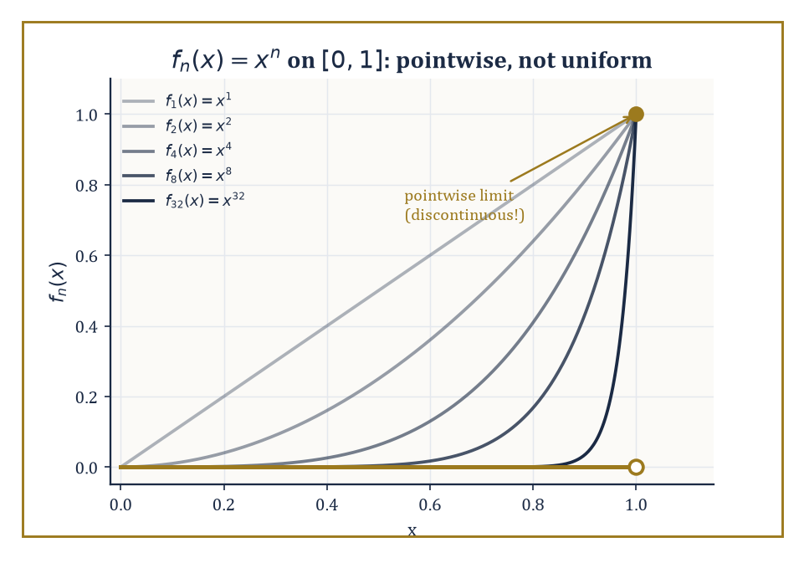
Figure 16.1 — fₙ(x) = xⁿ converges to 0 at every point short of x = 1 — pointwise, obediently, and without ever agreeing to do it at a uniform rate.
sₙ = a₁ + a₂ + … + aₙ
This n-th partial sum is a perfectly ordinary finite number, computable in a perfectly ordinary finite amount of time. The series is then said to converge to S if the sequence s₁, s₂, s₃, … converges to S in the ordinary sequence sense; otherwise the series diverges.
This is not a new kind of limit dressed up to look impressive — it is the limit machinery of sequences, applied to a sequence we happen to have built by repeated addition. Everything we already know about convergent sequences — uniqueness of the limit, the algebra of limits, the Cauchy criterion — transfers over immediately, which is one of the more comforting facts in analysis.
Numeric example — a geometric series and its remainder. Consider the series formed by adding successive tenths of 3, i.e. Σ 3·(1/10)ⁿ for n = 0, 1, 2, …:
S = 3 + 0.3 + 0.03 + 0.003 + …
The partial sums are:
s₁ = 3, s₂ = 3.3, s₃ = 3.33, s₄ = 3.333
In general:
sₙ = 3.33…3 (n threes) = 10/3 − (1/3)·(1/10)ⁿ⁻¹
As n → ∞ the correction term shrinks to nothing, so the partial sums converge to the familiar repeating decimal:
sₙ → 10/3 = 3.333…
The remainder after four terms is:
R₄ = S − s₄ = 10/3 − 3.333 = 0.000333…
You can check directly that this equals the ‘rest of the series’:
0.0003 + 0.00003 + … = 3·(1/10)⁴/(1 − 1/10) = 0.0003/0.9 = 0.000333…
This is the whole game in miniature: a partial sum you can actually write down, plus a remainder you can bound, adding up to a limit you never quite reach but can approximate as closely as you like.
Try it now — Sum Σ[n ≥ 0] 2·(1/3)ⁿ. Answer →
Absolute convergence means that the series of absolute values, Σ|aₙ|, converges. This is a strictly stronger demand than ordinary (‘conditional’) convergence, and it buys something valuable: an absolutely convergent series can be rearranged — its terms shuffled into any order whatsoever — without changing the sum.
Ordinary convergence offers no such guarantee, and the next section contains an unsettling example of what goes wrong when you rely on it anyway.
Numeric example — an absolutely convergent alternating series. Take the series:
Σ (−1)ⁿ⁻¹/n² = 1 − 1/4 + 1/9 − 1/16 + …
Its series of absolute values is Σ1/n², which converges (we will confirm this properly with the integral test in the next section), so the original series converges absolutely.
The partial sums are:
s₁ = 1, s₂ = 0.75, s₃ = 0.75 + 0.1111 = 0.8611, s₄ = 0.8611 − 0.0625 = 0.7986, s₅ = 0.7986 + 0.04 = 0.8386
These values are visibly oscillating but visibly settling. The true value is a named constant, π²/12 ≈ 0.822467 (a close cousin of the more famous Σ1/n² = π²/6, which we will meet again before this chapter ends).
Because the convergence here is absolute, you may add these terms in any order you fancy — leaves-of-a-tree order, if you like — and still land on π²/12.
Everything above concerned series of numbers. A function series is a series whose terms are themselves functions, Σ fₙ(x), and now there are two flavors of convergence to keep straight.
Pointwise convergence asks, for each individual x, that the numerical series Σ fₙ(x) converge — a separate, private negotiation at every point of the domain.
Uniform convergence is the more demanding and more useful notion: it asks that the rate of convergence not depend on x, that one tail estimate work simultaneously across the whole domain.
Uniform convergence is worth the extra effort because it preserves continuity of the limit, and — under mild further hypotheses — it licenses differentiating or integrating the series term by term, which is usually the entire point of writing the series down in the first place.
Abstract example — pointwise without uniform. Let fₙ(x) = xⁿ on the interval [0, 1]. For each fixed x in [0, 1), the numbers xⁿ shrink to 0, so fₙ(x) → 0.
At x = 1, fₙ(1) = 1 for every n, so fₙ(1) → 1.
The pointwise limit function is therefore f(x) = 0 for x < 1 and f(1) = 1 — a function with a jump, glued together from infinitely many perfectly smooth, perfectly continuous functions xⁿ.
Since a uniform limit of continuous functions is always continuous (a theorem worth memorizing because it is so useful in the contrapositive), and our limit f is not continuous, the convergence here cannot be uniform.
Nothing went wrong; this is what pointwise convergence is allowed to do when nobody is enforcing a uniform rate.
The practical power of all this lies in approximation. A partial sum is a finite object you can compute on a calculator, a computer, or the back of an envelope; the remainder tells you the price you pay for stopping early.
Controlling that remainder — bounding it, shrinking it, choosing how many terms are ‘enough’ — is the central technical task of the whole subject, and it is the thread that runs through convergence tests, Taylor’s theorem, and Fourier analysis alike.
Every worked example in this chapter is, underneath the notation, an exercise in just that.
Keep only this · Section 16.1: What a Series Is
The idea. A series converges when its partial sums converge; terms tending to 0 is necessary but not sufficient.
Core.
Σaₙ converges ⇔ partial sums Sₙ converge
geometric: Σ arⁿ = a/(1 − r) for |r| < 1
Typical mistake. Concluding convergence from aₙ → 0, as the harmonic series shows.
Minimal example. 1 + 1/2 + 1/4 + … = 2.
Practice. Easy to challenge; full worked answers, with the usual mistake, are in Answers to the Practice Sets at the back.
Easy — Sum Σ[n = 0 to ∞] (1/3)ⁿ. Answer →
Medium — Does Σ n/(n + 1) converge? Answer →
Challenge — Find Σ 1/(n(n + 1)) from n = 1. Answer →

Section 16.2: Numerical Series: Convergence Tests
A field guide to things that do, and do not, add up
CORE · about 15 minutes · later chapters build on this
Definition — Deciding whether Σaₙ converges is, in general, hard — hard enough that mathematicians have assembled a small arsenal of tests, each suited to a different shape of term.
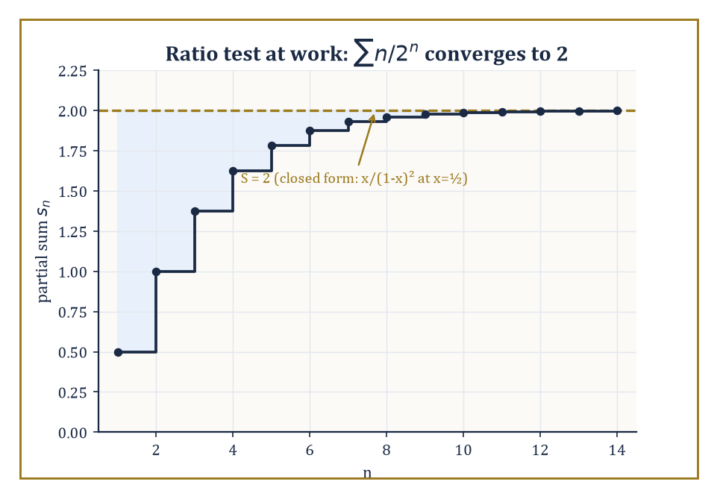
Figure 16.2 — The partial sums of Σ n/2ⁿ climb the staircase the ratio test promised, settling in on 2 and never overshooting.
The comparison test says that if 0 ≤ aₙ ≤ bₙ and Σbₙ converges, then Σaₙ converges too (and, run backwards, that if Σaₙ diverges then so does the larger Σbₙ).
The limit-comparison test relaxes this to aₙ/bₙ → L for some finite positive L, which is often easier to check.
The ratio test looks at the limit of |aₙ₊₁/aₙ|: if it is less than 1 the series converges absolutely, if greater than 1 it diverges, and if exactly 1 the test shrugs and declines to comment.
Numeric example — the ratio test. Take Σ n/2ⁿ for n = 1, 2, 3, …. The ratio of consecutive terms is:
aₙ₊₁/aₙ = [(n+1)/2ⁿ⁺¹] / [n/2ⁿ] = (n+1)/(2n)
This ratio tends to 1/2 as n → ∞. Since 1/2 < 1, the series converges absolutely.
In fact this series has a closed form — it is a standard identity that:
Σ n xⁿ = x/(1−x)², for |x| < 1
At x = 1/2 this gives:
(1/2)/(1/2)² = (1/2)/(1/4) = 2
Check it against partial sums:
s₁ = 0.5, s₂ = 0.5 + 0.5 = 1.0, s₃ = 1.0 + 0.375 = 1.375, s₄ = 1.375 + 0.25 = 1.625, s₅ = 1.625 + 0.15625 = 1.78125, s₆ = 1.78125 + 0.09375 = 1.875
These partial sums climb steadily toward 2, as the ratio test promised it would settle down, and exactly as the closed form confirms it must.
Try it now — Ratio test on Σ 2ⁿ/n!. Answer →
The root test asks instead for the limit of |aₙ|^{1/n}: less than 1 means convergence, greater than 1 means divergence, and 1 again means no verdict.
It is especially well suited to terms that already come dressed as n-th powers — which, not coincidentally, is the shape a power series coefficient takes, so this test will do most of the heavy lifting when the radius of convergence appears in the next section.
Numeric example — the root test. Take Σ (n/(2n+1))ⁿ. Here:
|aₙ|^{1/n} = n/(2n+1) → 1/2, as n → ∞
(Divide top and bottom by n to see it: 1/(2 + 1/n) → 1/2.) Since 1/2 < 1, the series converges.
The individual terms confirm the decay is fast:
a₁ = (1/3)¹ ≈ 0.3333, a₂ = (2/5)² = 0.16, a₃ = (3/7)³ ≈ 0.0787, a₄ = (4/9)⁴ ≈ 0.0390
Each term is comfortably smaller than the last, well before the limiting ratio of 1/2 has fully kicked in, and the partial sums settle to a finite value with no drama at all.
The integral test compares a series of positive, decreasing terms to the improper integral of the corresponding function: Σaₙ converges exactly when ∫f(x)dx converges, where f(n) = aₙ.
It is the tool of choice for the borderline p-series Σ1/nᵖ and its logarithmic cousins, and it is where the harmonic series first reveals its bad manners.
Numeric example — the integral test on two p-series. For Σ1/n² compare to the integral:
∫[1, ∞] dx/x² = [−1/x]₁∞ = 0 − (−1) = 1
This is a finite value, so the series converges (its exact sum, famously, is π²/6 ≈ 1.644934 — the Basel problem, and we have not seen the last of it).
For Σ1/n compare to the integral:
∫[1, ∞] dx/x = [ln x]₁∞
This diverges to infinity because ln x has no ceiling. The harmonic series therefore diverges, despite its terms shrinking to zero — a fact every student meets once and never quite recovers from.
The dividing line sits exactly at p = 1: any exponent above it converges, any exponent at or below it diverges.
The alternating-series test (Leibniz’s test) covers series whose terms alternate in sign and decrease in absolute value to zero: such a series always converges, and — usefully — the error after truncating is never larger than the size of the first omitted term.
This is what lets us distinguish absolute convergence from the merely conditional kind: the alternating harmonic series Σ(−1)ⁿ⁺¹/n converges by Leibniz’s test, even though the harmonic series of absolute values does not.
Rearrangement theorems then deliver the alarming punchline: a conditionally convergent series can be reordered to converge to any real number you like, or to diverge entirely, simply by choosing which terms to add when.
Absolute convergence is what restores the ordinary schoolbook freedom to add things in whatever order is convenient.
Numeric example — Leibniz’s test in action. For the alternating harmonic series:
Σ(−1)ⁿ⁺¹/n = 1 − 1/2 + 1/3 − 1/4 + …
the partial sums are:
s₁ = 1, s₂ = 0.5, s₃ = 0.8333, s₄ = 0.5833, s₅ = 0.7833, s₆ = 0.6167, s₇ = 0.7595
These values are visibly oscillating, each one landing between its two predecessors. The true sum is ln 2 ≈ 0.693147.
Leibniz’s error bound says |S − sₙ| ≤ aₙ₊₁; check n = 6:
|0.693147 − 0.6167| = 0.0765, and a₇ = 1/7 ≈ 0.1429
Indeed 0.0765 < 0.1429. The series converges, but conditionally: strip the signs away and you are left with the divergent harmonic series, so this convergence is entirely a gift of cancellation, not of decay.
Abstract example — rearranging to order. Riemann’s rearrangement theorem is best understood by watching it work. The alternating harmonic series has a divergent positive part (1 + 1/3 + 1/5 + … diverges to +∞) and a divergent negative part (−1/2 − 1/4 − 1/6 … diverges to −∞).
To force the rearranged series toward a target value L — say L = 1 — proceed greedily: add positive terms 1, 1/3, 1/5, … until the running total first exceeds 1; then add negative terms −1/2, −1/4, … until the running total first drops back below 1; then resume adding unused positive terms until it exceeds 1 again, and so on forever.
Because the positive terms alone sum to infinity, you can always find enough of them to push the total back above L; because the negative terms alone sum to negative infinity, you can always find enough of them to pull it back below.
The overshoots and undershoots get smaller each pass, since the individual terms 1/n shrink to zero, so the running total is squeezed ever closer to L.
The same construction, aimed at any other target, or aimed at no target at all, produces a rearrangement that diverges. The terms never changed; only the order did.
None of this is idle classification. These tests measure how fast terms must decay for an infinite sum to be meaningful at all.
That same decay-rate bookkeeping is precisely what will let us pin down a power series’ radius of convergence, bound a Taylor remainder, and justify swapping a sum with an integral or a derivative — every one of which is coming up before this chapter is out.
Keep only this · Section 16.2: Numerical Series: Convergence Tests
The idea. Pick the test by the shape: geometric-like terms → ratio or root; p-series-like → comparison or integral; alternating with shrinking terms → Leibniz.
Core.
terms ↛ 0 ⇒ diverges
p-series Σ1/nᵖ converges ⇔ p > 1
ratio: lim |aₙ₊₁/aₙ| < 1 ⇒ converges
Typical mistake. Treating a ratio-test limit of 1 as convergence.
Minimal example. Σ 1/n² converges (p = 2); Σ 1/n diverges (p = 1).
Practice. Easy to challenge; full worked answers, with the usual mistake, are in Answers to the Practice Sets at the back.
Easy — Does Σ 1/n^{1.01} converge? Answer →
Medium — Ratio test on Σ n!/10ⁿ. Answer →
Challenge — Does Σ (−1)ⁿ/n converge absolutely, conditionally or not at all? Answer →

Section 16.3: Power Series and Radius of Convergence
Every power series owns a comfortable disk, and declines to discuss the edge
CORE · about 15 minutes · later chapters build on this
Definition — A power series centered at a is an expression Σ cₙ(x − a)ⁿ — a polynomial, in spirit, that never stops.
Theorem — Radius of convergence
For Σ cₙ(x − a)ⁿ there is an R with 0 ≤ R ≤ ∞ such that the series converges absolutely for |x − a| < R and diverges for |x − a| > R. When the limit exists, 1/R = lim |cₙ₊₁/cₙ|; in general 1/R = limsup |cₙ|^{1/n}.
Hypotheses — check each one before you use it:
□ the series is a power series in (x − a)
□ the ratio formula needs the limit to exist; the root formula always works
□ the endpoints |x − a| = R are not covered and must be tested separately
Why it matters. It tells you exactly where term-by-term calculus is safe, and Chapter 23 explains R as the distance to the nearest complex singularity.
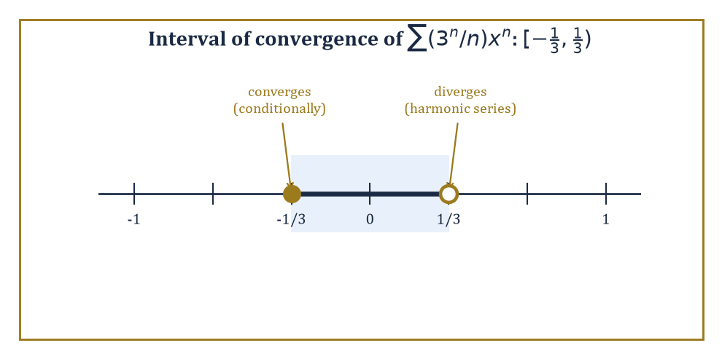
Figure 16.3 — Σ(3ⁿ/n)xⁿ converges on [−1/3, 1/3) — a radius that is perfectly symmetric right up until you check the endpoints.
Fix any particular x, and it becomes an ordinary numerical series of the kind we spent the last section dissecting; ask for which x it converges, and the answer is always strikingly tidy: an interval centered at a, called the interval of convergence, whose half-width R is the radius of convergence.
R can be 0 (the series converges only at the single point x = a), finite, or infinite (the series converges everywhere).
The radius is read directly off the coefficients, using the ratio and root tests from the previous section:
1/R = lim|cₙ₊₁/cₙ| or 1/R = limsup|cₙ|^{1/n}
whichever limit is easier to compute. Inside the open interval (a − R, a + R) the series converges absolutely; outside it, the terms do not even shrink to zero, so it diverges outright.
On the two endpoints, x = a ± R, both formulas go silent — the ratio or root tends to exactly 1 — and the endpoints have to be checked by hand, one at a time, using whichever test from the previous section is willing to help.
Numeric example — a radius with an asymmetric endpoint. Consider Σ (3ⁿ/n) xⁿ for n = 1, 2, 3, …, so cₙ = 3ⁿ/n. The ratio is:
|cₙ₊₁/cₙ| = [3ⁿ⁺¹/(n+1)] / [3ⁿ/n] = 3n/(n+1) → 3, as n → ∞
So 1/R = 3, giving R = 1/3. Now check the endpoints by substituting directly.
At x = 1/3, the n-th term is:
(3ⁿ/n)(1/3)ⁿ = (3 · 1/3)ⁿ/n = 1ⁿ/n = 1/n
and Σ1/n is the harmonic series — divergent.
At x = −1/3, the n-th term is:
(3ⁿ/n)(−1/3)ⁿ = (−1)ⁿ/n
and Σ(−1)ⁿ/n converges conditionally by Leibniz’s test (it is, up to an overall sign, the alternating harmonic series again).
So the full interval of convergence is [−1/3, 1/3) — closed on the left, open on the right, a genuinely asymmetric boundary that no amount of squinting at the formula for R alone would have revealed. This is why the endpoints always require a separate, individual trial: the radius formula cannot see them.
Try it now — Radius of convergence of Σ xⁿ/2ⁿ. Answer →
Numeric example — three flavors of endpoint. A quick gallery, for contrast.
Σ xⁿ/n² has R = 1 (ratio n²/(n+1)² → 1), and at both endpoints x = ±1 the series is Σ±1/n² or Σ1/n², absolutely convergent by the p = 2 integral test — so the interval is the fully closed [−1, 1].
Σ nⁿxⁿ has cₙ = nⁿ, and |cₙ|^{1/n} = n → ∞, so 1/R = ∞ and R = 0: the series converges only at the single point x = 0, and is otherwise useless as a function.
Between these extremes sits the earlier example, converging on one side and not the other. A power series, in short, can hug its boundary tightly, reject it entirely, or embrace only half of it — and there is no substitute for checking.
One more subtlety about that boundary before we leave it alone: Abel’s theorem promises that if a power series does converge at an endpoint, its sum there is the limit of the sum function as x approaches that endpoint from inside the interval — the function does not develop some rogue, disconnected value right at the edge.
This is what licenses reading a convergent endpoint sum as ‘the value of the function there’, rather than as some unrelated number the series happens to add up to.
Numeric example — Abel’s theorem cashing in a boundary sum. The Maclaurin series for ln(1+x) has radius R = 1:
ln(1+x) = x − x²/2 + x³/3 − x⁴/4 + …
At the right endpoint x = 1 it becomes the alternating harmonic series:
1 − 1/2 + 1/3 − 1/4 + …
which Numerical Series already showed converges (conditionally) to ln 2 ≈ 0.693147 by Leibniz’s test.
Abel’s theorem guarantees this is not a coincidence: since the series converges at x = 1, its sum there must equal:
limₓ→1⁻ ln(1+x) = ln 2
the same ln 2, arrived at from two different directions, precisely because the theorem forbids the series from disagreeing with the function it approximates right up to a convergent edge.
Inside its interval of convergence, a power series does not merely converge — it defines an honest function, and that function turns out to be infinitely differentiable there, with derivatives obtainable by differentiating the series term by term (a fact that needs uniform convergence on compact sub-intervals to justify properly, which the theory duly supplies).
Evaluate enough of those derivatives at the center a, and the coefficients fall out:
cₙ = f⁽ⁿ⁾(a)/n!
This single formula is the bridge to the next section — it says that if a function happens to be the sum of some power series, that power series was forced to be a very particular one, built entirely from the function’s own derivatives at the center.
Abstract example — recovering coefficients from derivatives. Suppose:
f(x) = Σ cₙxⁿ = c₀ + c₁x + c₂x² + c₃x³ + …
for x in some interval around 0. Evaluate at x = 0: every term with a positive power of x vanishes, leaving f(0) = c₀.
Differentiate once, term by term:
f′(x) = c₁ + 2c₂x + 3c₃x² + …
and evaluate at 0: f′(0) = c₁.
Differentiate again:
f″(x) = 2c₂ + 6c₃x + …
so f″(0) = 2c₂, i.e. c₂ = f″(0)/2!.
One more round:
f‴(x) = 6c₃ + 24c₄x + …
so f‴(0) = 6c₃ = 3!c₃, i.e. c₃ = f‴(0)/3!.
The pattern is now unmistakable and easy to prove by induction: each differentiation multiplies the surviving constant term by the next integer, so after k differentiations the constant term is k! · cₖ, giving:
cₖ = f⁽ᵏ⁾(0)/k!, for every k
Nothing here used any specific function — it is a purely structural fact about power series, and it is the formula the next section promotes to a definition.
Keep only this · Section 16.3: Power Series and Radius of Convergence
The idea. A power series converges absolutely inside its radius, diverges outside, and must be checked by hand at the endpoints.
Core.
Σ cₙ(x − a)ⁿ converges for |x − a| < R, diverges for |x − a| > R
1/R = lim |cₙ₊₁/cₙ| (when it exists)
Typical mistake. Assuming the interval of convergence is symmetric about the centre including endpoints.
Minimal example. Σ xⁿ/n: R = 1; converges at x = −1, diverges at x = 1.
Practice. Easy to challenge; full worked answers, with the usual mistake, are in Answers to the Practice Sets at the back.
Easy — Radius of Σ xⁿ/2ⁿ. Answer →
Medium — Interval of convergence of Σ (x − 3)ⁿ/n². Answer →
Challenge — Radius of Σ n! xⁿ and of Σ xⁿ/n!. Answer →

Section 16.4: Taylor and Maclaurin Series
Turning a function into the polynomial it always secretly wanted to be
CORE · about 15 minutes · later chapters build on this
A calculator can add and multiply, and very little else. So how does it produce exp(0.1) = 1.10517…? It cannot store an answer for every possible input. It needs a recipe made only of additions and multiplications, which means a polynomial.
Start with what the derivative already gives you. Near x = 0 the curve y = eˣ is close to its tangent line, which has the same height there, 1, and the same slope, 1. So the line is y = 1 + x, and at x = 0.1 it gives 1.1, off by about 0.005. A straight line cannot bend, and eˣ does.
So match more than the slope. The second derivative of eˣ at 0 is also 1, so add a term with second derivative 1 that changes nothing else at x = 0. The term x² has second derivative 2, so the right term is x²/2. The third derivative is 1 too, and x³ has third derivative 6, so add x³/6. Each new derivative to match adds the next term, xⁿ divided by n!:
1 + x: 1.1
1 + x + x²/2: 1.105
… + x³/6: 1.1051667
… + x⁴/24: 1.1051708
true value: 1.1051709…
Each new term makes the error more than ten times smaller, and no single term makes it zero. The polynomial with every term, carried on for ever, is the Taylor series of eˣ, and for this function it adds up to eˣ exactly, at every x.
The recipe works for any function that can be differentiated as often as you like: read off its derivatives at one point, divide the nth by n!, and use them as coefficients. Whether the infinite sum then really adds up to the function is a separate question, and this section shows that it can fail.
Definition — The Taylor series of a smooth function f about a point a is the power series:
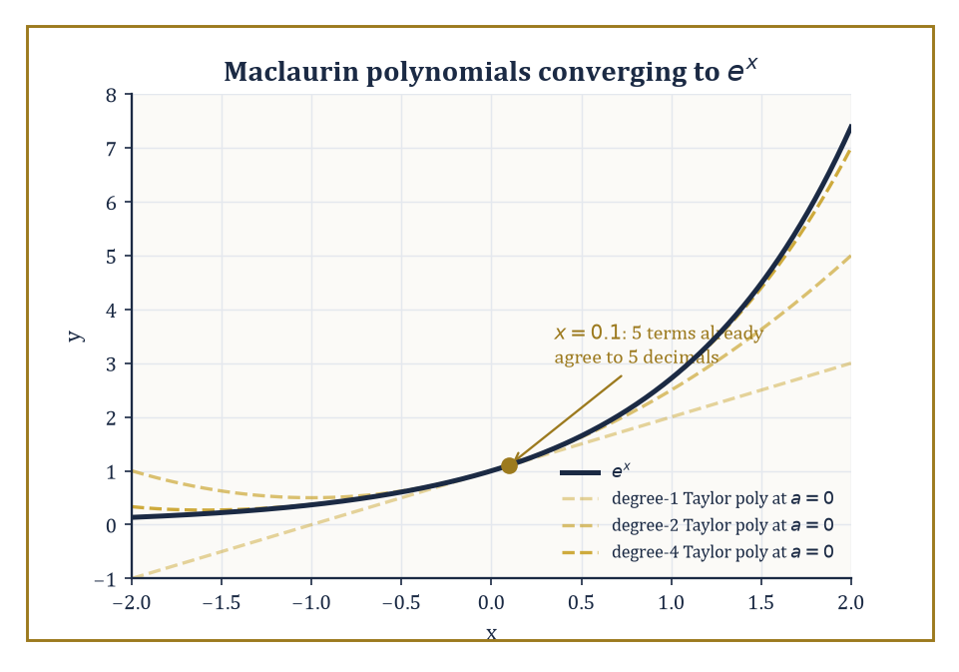
Figure 16.4 — Degree by degree, the Maclaurin polynomials hug eˣ ever more tightly near the origin — and by x = 0.1 they have already all but arrived.
Σ [f⁽ⁿ⁾(a)/n!](x − a)ⁿ
the coefficients the previous section forced upon us, built entirely from the derivatives of f at a. When a = 0 it goes by the friendlier name Maclaurin series.
If this series converges to f(x) itself, for x in some neighborhood of a, we say f is analytic at a — a strong and slightly demanding compliment, not automatically earned by mere smoothness.
Numeric example — the Maclaurin series for eˣ near x = 0.1. The Maclaurin series for eˣ is:
eˣ = Σ xⁿ/n! = 1 + x + x²/2! + x³/3! + x⁴/4! + …
It converges to eˣ for every real x (radius of convergence infinite). At x = 0.1, the terms are:
term 0 = 1, term 1 = 0.1, term 2 = 0.01/2 = 0.005, term 3 = 0.001/6 ≈ 0.0001667, term 4 = 0.0001/24 ≈ 0.0000042
The running total is:
1, 1.1, 1.105, 1.1051667, 1.1051708
The true value is exp(0.1) = 1.10517091808…, so after just five terms (through x⁴) the approximation is accurate to about five decimal places.
Each new term visibly shrinks the gap by a factor of more than ten, which is just what you would expect from a series whose terms behave like (0.1)ⁿ/n! for a radius-infinite function.
Try it now — Write the Maclaurin series of cos x up to x⁴ and estimate cos 0.2. Answer →
Here is the demanding compliment made concrete: not every infinitely differentiable function is analytic. There exist perfectly smooth, nonzero functions whose Taylor series at some point is identically the zero series — a series that converges everywhere, just not to the function that produced it.
For the elementary functions we actually use day to day, though, the news is good: eˣ, sin x, and cos x are analytic everywhere (infinite radius); ln(1+x), arctan x, and algebraic functions with singularities are analytic only out to the distance of their nearest bad behavior, giving a finite radius.
Abstract example — a smooth function with a lying Taylor series. Define f(x) = exp(−1/x²) for x ≠ 0 and f(0) = 0.
As x → 0, 1/x² races off to +∞, so exp(−1/x²) races down to 0 — and it does so faster than any power of x can keep up, because exponential decay always beats polynomial growth in the long run.
Each derivative of f, computed away from 0 by the chain rule, turns out to be some rational function of 1/x multiplied by exp(−1/x²); since the exponential factor crushes any polynomial-in-1/x factor as x → 0, every derivative also tends to 0 there.
A short induction confirms f⁽ⁿ⁾(0) = 0 for every n ≥ 0. Plug these all-zero derivatives into the Taylor formula and the series is:
0 + 0x + 0x² + …
identically zero, converging (trivially) to the constant function 0 everywhere. But f(x) is strictly positive for every x ≠ 0.
The Taylor series exists, converges, and is describing the wrong function. This is why ‘smooth’ and ‘analytic’ are different words.
The Lagrange and integral forms of the remainder rescue the situation for practical purposes by quantifying how wrong a truncated Taylor series is allowed to be.
The Lagrange form states that the error after the degree-n term equals:
f⁽ⁿ⁺¹⁾(ξ)/(n+1)! · (x−a)ⁿ⁺¹
for some (unknown, but existent) ξ between a and x — and even without knowing ξ exactly, one can usually bound f⁽ⁿ⁺¹⁾(ξ) over the whole interval and so bound the error outright.
This is the analytic engine behind every ‘this many terms guarantees this much accuracy’ claim in numerical computation.
Numeric example — certifying the eˣ approximation with a remainder bound. Return to exp(0.1) truncated after the x³ term (so n = 3, remainder governed by the 4th derivative). The Lagrange remainder is:
R₃ = exp(ξ) · (0.1)⁴/4!, for some ξ between 0 and 0.1
Since eˣ is increasing, exp(ξ) < exp(0.1) < 1.2 comfortably, so:
|R₃| < 1.2 × 0.0001/24 ≈ 0.000005
Compare to the true error computed above:
|1.10517092 − 1.1051667| ≈ 0.0000042
This is safely under the certified bound of 0.000005, exactly as the theorem promised, and without needing to know exp(0.1) in advance to say so.
Beyond eˣ, a short list of standard expansions does most of the working mathematician’s heavy lifting.
sin x = x − x³/3! + x⁵/5! − …
cos x = 1 − x²/2! + x⁴/4! − …
Both of these have infinite radius of convergence.
ln(1+x) = x − x²/2 + x³/3 − …
arctan x = x − x³/3 + x⁵/5 − …
Both of these have radius 1, for reasons that become clear once you meet complex analysis and see where their nearest singularities sit.
(1+x)ᵅ = 1 + αx + [α(α−1)/2!]x² + …
This binomial series reduces to the schoolbook binomial theorem when α is a positive integer, and becomes an infinite series otherwise.
Numeric example — ln(1+x) at the edge of comfort. Take x = 0.5, so we are approximating ln(1.5). The terms are:
x − x²/2 + x³/3 − x⁴/4 + x⁵/5 − x⁶/6 + … = 0.5 − 0.125 + 0.041667 − 0.015625 + 0.00625 − 0.0026042 + …
Partial sums:
s₁ = 0.5, s₂ = 0.375, s₃ = 0.416667, s₄ = 0.401042, s₅ = 0.407292, s₆ = 0.404688
The true value is ln 1.5 = 0.405465…, so the error after six terms is about 0.000777.
Leibniz’s bound (this series alternates and decreases) certifies the error is under the next term:
a₇ = (0.5)⁷/7 ≈ 0.001116
Indeed 0.000777 < 0.001116. Convergence here is noticeably slower than for eˣ at x = 0.1, because x = 0.5 is roughly half-way to the radius of convergence R = 1, whereas 0.1 was well inside eˣ’s infinite one.
The closer you push toward the boundary of convergence, the more terms you must pay for the same accuracy — a foretaste of the endpoint delicacy from the previous section.
Keep only this · Section 16.4: Taylor and Maclaurin Series
The idea. cₙ = f⁽ⁿ⁾(a)/n!, and the remainder term, not the number of terms, tells you how good a truncation is.
Core.
f(x) = Σ f⁽ⁿ⁾(a)(x − a)ⁿ/n!
remainder |Rₙ| ≤ M|x − a|ⁿ⁺¹/(n + 1)!
Typical mistake. Assuming every smooth function equals its Taylor series; exp(−1/x²) does not.
Minimal example. eˣ = 1 + x + x²/2! + x³/3! + …
Practice. Easy to challenge; full worked answers, with the usual mistake, are in Answers to the Practice Sets at the back.
Easy — Maclaurin series of cos x up to x⁴. Answer →
Medium — Estimate exp(0.1) with three terms and bound the error. Answer →
Challenge — Why does the Taylor series of exp(−1/x²) (extended by 0 at 0) fail to represent it? Answer →

Section 16.5: Operations on Power Series
What you are allowed to do to an infinite polynomial without a permit
CORE · about 15 minutes · later chapters build on this
An infinite polynomial would be of little use if you could not do arithmetic with it. Happily, inside the range where it converges, a power series can be added, multiplied, differentiated and integrated term by term, exactly as if it were an ordinary long polynomial. That turns a few known series into a factory for new ones. Multiply the geometric series, one plus x plus x squared and so on, by itself, collect like powers, and you get one plus two x plus three x squared plus four x cubed, and so on. At x equal to one half the geometric series adds up to 2, and the new series adds up to 4, its square, exactly as it should.
Key idea — Within their common interval of convergence, power series behave almost exactly like ordinary polynomials: they may be added term by term, differentiated term by term, integrated term by term, and multiplied together using the Cauchy product, in which the coefficient of xⁿ in the product is:
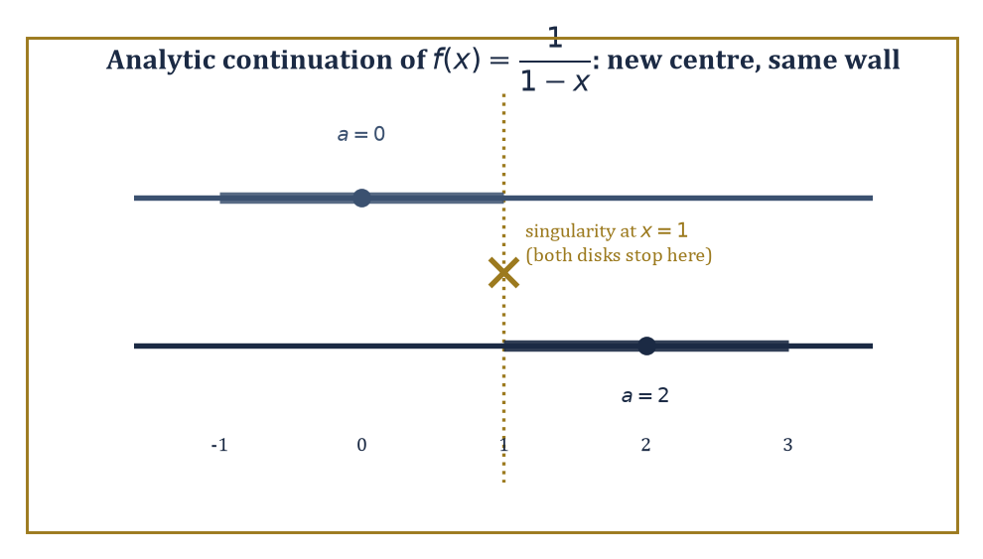
Figure 16.5 — Re-centering at a = 2 opens up new territory for 1/(1−x) — but the singularity at x = 1 still pins both disks to the same wall.
Σₖ₌₀ⁿ aₖbₙ₋ₖ
This is the rule you would get by multiplying out two long polynomials and collecting like powers. In every case, the resulting series converges (on the smaller of the two radii, at least) to the corresponding operation performed on the original sum functions.
Numeric example — the Cauchy product of a geometric series with itself. Let:
f(x) = Σ[n ≥ 0] xⁿ = 1/(1−x), for |x| < 1
Its Cauchy product with itself has coefficient of xⁿ equal to Σₖ₌₀ⁿ 1·1 = n+1, so:
f(x)² = Σ[n ≥ 0] (n+1)xⁿ = 1/(1−x)²
At x = 0.5, the closed form gives:
1/(1−0.5)² = 1/0.25 = 4
The series gives terms (n+1)(0.5)ⁿ:
1, 1.0, 0.75, 0.5, 0.3125, 0.1875, 0.109375, 0.0625, …
with partial sums:
1, 2, 2.75, 3.25, 3.5625, 3.75, 3.859375, 3.921875
These sums climb steadily toward 4, confirming the two computations agree.
Try it now — Differentiate Σ xⁿ = 1/(1 − x) term by term to find Σ n xⁿ⁻¹. Answer →
This term-by-term freedom is more than a convenience: it turns differential equations into recurrence relations for coefficients, letting you solve an ODE by guessing a power series solution and matching powers of x on both sides.
It is also the algebraic backbone of generating functions, which we will meet properly a little further along, and of the asymptotic expansions used to approximate functions that resist a clean closed form.
Abstract example — solving f′ = f by power series. Suppose we do not yet know that f′(x) = f(x) with f(0) = 1 has solution eˣ, and want to find it by brute force. Guess:
f(x) = Σ[n ≥ 0] cₙxⁿ
Differentiating term by term:
f′(x) = Σ[n ≥ 1] n·cₙxⁿ⁻¹ = Σ[m ≥ 0] (m+1)cₘ₊₁xᵐ
(relabeling m = n−1). Demanding f′(x) = f(x) forces the coefficients of each power of x to match:
(m+1)cₘ₊₁ = cₘ, for every m ≥ 0
i.e. the recurrence cₘ₊₁ = cₘ/(m+1). The initial condition f(0) = 1 gives c₀ = 1. Unrolling the recurrence:
c₁ = c₀/1 = 1, c₂ = c₁/2 = 1/2, c₃ = c₂/3 = 1/6
and in general cₙ = 1/n!.
The power series method has, entirely on its own, rediscovered:
f(x) = Σ xⁿ/n! = eˣ
the Maclaurin series from the previous section, arrived at from the opposite direction.
Integration term by term is the differentiation trick run backwards, and it is often the more useful direction in practice, since it can manufacture a series for a function whose derivative you already know but whose own Maclaurin series you have not yet bothered to compute directly.
Numeric example — integrating the geometric series. Since Σ[n ≥ 0] tⁿ = 1/(1−t) for |t| < 1, integrate both sides from 0 to x term by term:
Σ[n ≥ 0] xⁿ⁺¹/(n+1) = ∫₀ˣ dt/(1−t) = −ln(1−x)
Relabel m = n+1 to read this as:
x + x²/2 + x³/3 + … = −ln(1−x)
At x = 0.5, the right side is:
−ln(0.5) = ln 2 ≈ 0.693147
(That same constant, turning up for the third time this chapter — it has rather a habit of doing that.)
The series gives terms:
0.5, 0.125, 0.041667, 0.015625, 0.00625, 0.0026042, …
with partial sums:
0.5, 0.625, 0.666667, 0.682292, 0.688542, 0.691146
These are closing in steadily on 0.693147, as the closed form demands, and obtained here without ever having differentiated −ln(1−x) in the first place.
Analytic continuation is the technique of extending a function beyond its original disk of convergence by re-expanding its power series about a new center, chosen so that the new disk of convergence reaches into territory the old one never touched.
What ultimately blocks continuation is a singularity — a point where the function misbehaves — sitting on the boundary of every disk that tries to avoid it; the distance to the nearest such singularity is, in fact, just what determines the radius of convergence in the first place.
Worked example — continuing past a boundary without touching it. The function f(x) = 1/(1−x) has Maclaurin series Σxⁿ, converging only for x in (−1, 1), because of the singularity sitting at x = 1.
Re-expand about a = 2 instead: write x = 2 + t, so:
f = 1/(1 − 2 − t) = 1/(−1−t) = −1/(1+t) = −Σ(−t)ⁿ = Σ(−1)ⁿ⁺¹tⁿ, for |t| < 1, i.e. for x in (1, 3)
This new series, centered at 2, reaches values like x = 2.5 that the original series centered at 0 could never touch — genuine new territory, unlocked purely by re-expanding.
And yet both disks, (−1,1) and (1,3), still have their boundary pinned at x = 1: the singularity has not moved, and no clever re-centering anywhere in the real line will ever produce a disk that swallows it.
Analytic continuation extends the reach of a single power series representation; it cannot abolish the obstruction that limited the first one.
The upshot is that the formal algebra of power series — addition, multiplication, differentiation, re-centering — is simultaneously a hands-on computational toolkit and a window onto something deeper: the complex-analytic structure of the function being expanded, in which singularities are not embarrassments to be worked around but genuine geographical features that determine, in advance, how far any given expansion is permitted to travel.
We will return to this picture properly once complex analysis enters the series.
Keep only this · Section 16.5: Operations on Power Series
The idea. Inside the radius you may add, multiply, differentiate and integrate power series term by term; the radius does not change.
Core.
inside |x| < R: differentiate and integrate term by term; R is unchanged
Typical mistake. Applying term-by-term operations at or beyond the endpoint.
Minimal example. 1/(1 + x²) = Σ (−1)ⁿx²ⁿ; integrating gives arctan x = Σ (−1)ⁿx²ⁿ⁺¹/(2n + 1).
Practice. Easy to challenge; full worked answers, with the usual mistake, are in Answers to the Practice Sets at the back.
Easy — Differentiate Σ xⁿ term by term. Answer →
Medium — Series for ln(1 + x) from 1/(1 + x). Answer →
Challenge — Find Σ n/2ⁿ from n = 1. Answer →

Section 16.6: Fourier Series: The Basic Theory
Every rhythm is secretly a sum of pure tones
CORE · about 15 minutes · later chapters build on this
Key idea — A Fourier series represents a periodic function as an infinite linear combination of sines and cosines — or, in the more compact complex notation, of complex exponentials — at harmonically related frequencies: the fundamental, twice the fundamental, three times it, and so on forever.
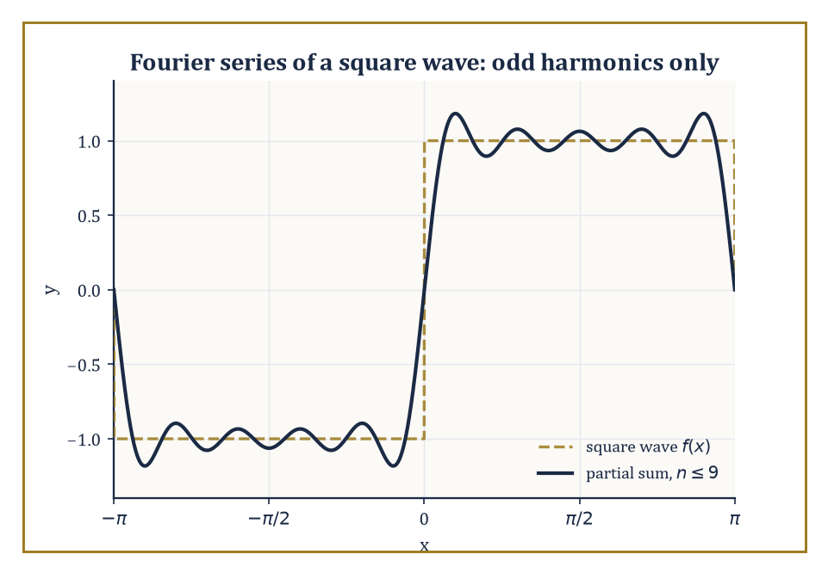
Figure 16.6 — Nine odd harmonics are already enough to rough out the square wave, ripples and all.
For a function f of period 2π, the coefficients are extracted by the integrals:
aₙ = (1/π)∫f(x)cos(nx)dx, bₙ = (1/π)∫f(x)sin(nx)dx
each taken over one full period, with a₀ carrying a slight normalizing adjustment (a factor of 1/2 by convention). In the complex form, the single family of coefficients is the integral of f(x)e⁻ⁱⁿˣ.
These formulas are not arbitrary; they are answers to the question ‘how much of pure frequency n is present in f’, extracted by a kind of averaging that we are about to see is really a projection.
Numeric example — the Fourier coefficients of a square wave. Let f(x) = 1 for 0 < x < π and f(x) = −1 for −π < x < 0, extended with period 2π — the archetypal square wave.
Because f is an odd function (f(−x) = −f(x)) and cos(nx) is even, the product f(x)cos(nx) is odd, and the integral of an odd function over a symmetric interval is 0; so aₙ = 0 for every n.
For bₙ, f(x)sin(nx) is even (odd times odd), so:
bₙ = (2/π)∫[0, π] sin(nx)dx = (2/π)[−cos(nx)/n]₀^{π} = (2/(nπ))[1 − cos(nπ)]
Since cos(nπ) = (−1)ⁿ, this bracket is 2 when n is odd and 0 when n is even. So bₙ = 4/(nπ) for odd n, and bₙ = 0 for even n.
Numerically:
b₁ = 4/π ≈ 1.27324, b₃ = 4/(3π) ≈ 0.42441, b₅ = 4/(5π) ≈ 0.25465
The odd harmonics alone, decaying like 1/n, carry the entire square wave.
Try it now — Is f(x) = x² on (−π, π) even or odd, and which Fourier coefficients vanish? Answer →
These particular formulas fall out of one structural fact: the trigonometric functions {1, cos x, sin x, cos 2x, sin 2x, …} are orthogonal with respect to the L² inner product
⟨f, g⟩ = ∫[−π, π] f(x) ḡ(x) dx
on one period, here [−π, π] (the bar over g is complex conjugation: it changes nothing for real functions, and it is what keeps ⟨f, f⟩ positive once complex exponentials appear later in this chapter) — meaning the integral of the product of any two distinct members of the family is exactly zero.
Orthogonality is what turns the seemingly hard problem of finding the best mean-square approximation to f by a trigonometric sum into a sequence of completely independent one-dimensional projections, one frequency at a time, with no cross-talk between them.
This is precisely the same idea as projecting a vector onto a set of mutually perpendicular axes — a picture we will make fully explicit before this chapter closes.
Numeric example — verifying orthogonality directly. Check that sin(2x) and sin(3x) are orthogonal on [−π, π]. Using the product-to-sum identity sin A sin B = ½[cos(A−B) − cos(A+B)] with A = 2x, B = 3x:
sin(2x)sin(3x) = ½[cos(x) − cos(5x)]
Now:
∫₋π^{π} cos(x)dx = [sin x]₋π^{π} = sin π − sin(−π) = 0 − 0 = 0
∫₋π^{π} cos(5x)dx = [sin(5x)/5]₋π^{π} = (sin 5π − sin(−5π))/5 = 0
So the whole integral is ½[0 − 0] = 0, exactly as orthogonality demands.
The same product-to-sum trick proves it for every pair of distinct frequencies, which is why the coefficient formulas above could isolate a single aₙ or bₙ without any interference from the other terms in the sum.
The complex exponential form deserves a word of its own, since it is the version that survives into the next chapter unscathed. Euler’s formula lets every sine and cosine pair be repackaged as a single exponential:
eⁱᶿ = cos θ + i sin θ
The complex coefficients cₙ relate to the real ones by:
cₙ = (aₙ − ibₙ)/2, for n > 0; c₋ₙ = conjugate of cₙ; c₀ = a₀/2
The payoff is not merely tidiness: a single formula
f(x) = Σcₙeⁱⁿˣ
with a single integral formula for cₙ, replaces the separate bookkeeping of aₙ and bₙ, and it is this exponential form — not the sines-and-cosines form — that generalizes directly into the Fourier transform once periodicity is abandoned.
Numeric example — converting the square wave’s b₁ to complex form. For the square wave, a₁ = 0 and b₁ = 4/π, so:
c₁ = (0 − i·4/π)/2 = −i(2/π) ≈ −0.6366i, and c₋₁ = i(2/π) ≈ 0.6366i
(c₋₁ is the conjugate of c₁.) Reconstructing the first harmonic:
c₁eⁱˣ + c₋₁e⁻ⁱˣ = −i(2/π)(cos x + i sin x) + i(2/π)(cos x − i sin x)
Expand: the cos x terms are:
−i(2/π)cos x + i(2/π)cos x = 0
and the sin x terms are:
−i(2/π)(i sin x) + i(2/π)(−i sin x) = (2/π)sin x + (2/π)sin x = (4/π)sin x
Total:
(4/π)sin x = b₁ sin x
This is the real first harmonic from the earlier calculation, recovered intact from its two complex conjugate pieces, as it must be whenever f is real-valued.
Fourier series are the natural language of anything that repeats: a vibrating string, heat diffusing around a ring, the square waves of digital electronics, the frequency spectrum of any recurring signal.
There is even a pleasant physical parable hiding in the square-wave example above — a clarinet, whose bore is (roughly) closed at one end and open at the other, supports predominantly odd harmonics, which is structurally the same phenomenon we just computed (bₙ = 0 for even n), and it is a large part of why a clarinet and a violin playing the identical fundamental pitch still sound unmistakably different: the timbre lives entirely in the relative sizes of the higher coefficients.
Keep only this · Section 16.6: Fourier Series: The Basic Theory
The idea. The Fourier coefficients are projections onto orthogonal sines and cosines: aₙ = (1/π)∫[−π, π] f(x) cos nx dx and bₙ = (1/π)∫[−π, π] f(x) sin nx dx.
Core.
aₙ = (1/π) ∫[−π, π] f(x) cos nx dx
bₙ = (1/π) ∫[−π, π] f(x) sin nx dx
a₀/2 + Σ (aₙ cos nx + bₙ sin nx)
Typical mistake. Dropping the conjugate in the complex inner product, or the factor 1/π (or 1/2π) of the convention in use.
Minimal example. f(x) = x on (−π, π): bₙ = 2(−1)ⁿ⁺¹/n, all aₙ = 0.
Practice. Easy to challenge; full worked answers, with the usual mistake, are in Answers to the Practice Sets at the back.
Easy — Which coefficients vanish for an even function? Answer →
Medium — Compute ⟨sin 2x, sin 3x⟩ = ∫[−π, π] sin 2x sin 3x dx. Answer →
Challenge — Fourier coefficients of the square wave f = 1 on (0, π), −1 on (−π, 0). Answer →

Section 16.7: Convergence of Fourier Series and Applications
The series usually knows the answer, except at the cliff edge
CORE · about 15 minutes · later chapters build on this
Definition — Pointwise convergence of a Fourier series is more delicate than for a Taylor series, but the rules are still clean for reasonably well-behaved (piecewise smooth) functions.
Theorem — Dirichlet’s convergence theorem
If f is 2π-periodic and piecewise smooth, its Fourier series converges at every x to (f(x⁺) + f(x⁻))/2: to f(x) where f is continuous, and to the midpoint of the jump where it is not.
Hypotheses — check each one before you use it:
□ f is periodic with period 2π
□ f and f′ are piecewise continuous (finitely many jumps per period)
□ at a jump, read the conclusion as the midpoint, not f(x)
Why it matters. It is the guarantee that a Fourier series means something pointwise, and the reason Gibbs’ overshoot is about how, not whether, the series converges.
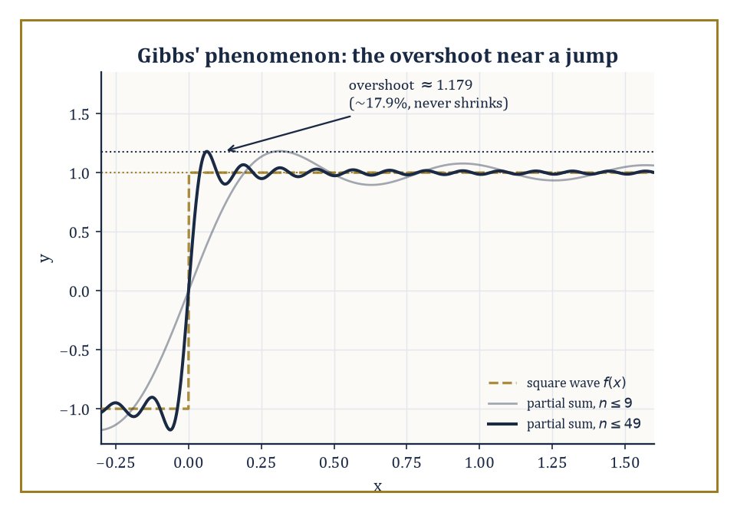
Figure 16.7 — Add as many terms as you like — the partial sums peak near 1.179 beside the jump, an overshoot of about 9% of the jump’s size 2, and the peak refuses to shrink however many terms are added.
At a point where f is continuous, the series converges to f(x) itself. At a jump discontinuity, it converges instead to the average of the left-hand and right-hand limits — splitting the difference, in a very literal sense.
Uniform convergence, when it holds, requires f to be continuous and periodic with coefficients decaying fast enough to be summable outright.
Numeric example — convergence at a continuity point, and at a jump. Return to the square wave from the previous section, with bₙ = 4/(nπ) for odd n. At x = π/2, a point of continuity (strictly between 0 and π), the partial sum is:
Sₙ(π/2) = (4/π)Σ[k odd ≤ n] sin(kπ/2)/k
Since sin(π/2) = 1, sin(3π/2) = −1, sin(5π/2) = 1, sin(7π/2) = −1, …, the bracketed sum is exactly:
1 − 1/3 + 1/5 − 1/7 + … = π/4
(This is the Leibniz series.) So:
Sₙ(π/2) → (4/π)(π/4) = 1
This matches f(π/2) = 1 precisely, though the partial sums oscillate on the way there:
with 1, 3, 5, 7, 9 terms: 1.273, 0.849, 1.104, 0.922, 1.063
These values bounce above and below 1 but visibly close in, because the bracketed sum is itself a named alternating series: the Leibniz series for π/4 converges by the test met in Numerical Series, and it is a cousin of Section 16.1’s π²/12 in the small family of tidy constants that alternating series are prone to producing.
At the jump x = 0, the average of the left- and right-hand limits is (1 + (−1))/2 = 0, and indeed every partial sum gives Sₙ(0) = 0 outright, since sin(k·0) = 0 for every k — the series simply reports the honest midpoint of a discontinuity it cannot otherwise describe.
Try it now — At the jump x = 0 of the square wave, what value does its Fourier series converge to? Answer →
Mean-square, or L², convergence is a gentler and more robust notion: for any function whose square is integrable, the Fourier partial sums converge to it in the L² norm regardless of how badly behaved f might be pointwise.
Parseval’s identity is the accounting statement that comes with this: the ‘energy’ of the function exactly equals the sum of the squared coefficients —
(1/π)∫f(x)²dx = a₀²/2 + Σ(aₙ² + bₙ²)
the total energy split, with no leftovers, among the frequencies.
Numeric example — Parseval’s identity, checked exactly. For the square wave, f(x)² = 1 everywhere (since f is always ±1), so the left side of Parseval’s identity is:
(1/π)∫₋π^{π} 1 dx = (1/π)(2π) = 2
On the right side, a₀ = aₙ = 0 for all n, so we need:
Σ[n odd] bₙ² = Σ[n odd] [4/(nπ)]² = (16/π²) Σ[n odd] 1/n²
We already know Σ1/n² = π²/6 (Numerical Series); splitting into even and odd parts, the even part is:
Σ1/(2n)² = (1/4)(π²/6) = π²/24
so the odd part is:
π²/6 − π²/24 = (4π² − π²)/24 = 3π²/24 = π²/8
So the right side is:
(16/π²)(π²/8) = 2
This matches the left side exactly. No approximation, no rounding: both sides really are 2, which is Parseval’s identity confirming, in a single concrete case, that not one drop of the square wave’s energy has gone missing among its harmonics.
Applications follow immediately from this machinery: the heat equation and the wave equation are both solved by separation of variables into a Fourier series in space, whose coefficients then evolve independently in time; periodic forcing terms in ordinary differential equations are handled the same way, one harmonic at a time; and the whole apparatus underlies the practical computation of frequency spectra in signal processing.
One persistent wrinkle deserves its own name: Gibbs’ phenomenon, the stubborn overshoot that Fourier partial sums exhibit near a jump, which does not shrink no matter how many terms you add — it merely narrows in width, hugging the jump ever more tightly while the height of the overshoot stays put.
Worked example — Gibbs’ overshoot, and how fast heat forgets detail. For the square wave (jump from −1 to +1), the partial sums, however many terms are used, overshoot the target value of 1 near x = 0⁺, peaking at approximately 1.179 before settling back down — an overshoot of about 17.9% of the half-jump (about 9% of the full jump of 2) that refuses to shrink, a small monument to the fact that pointwise convergence and uniform convergence are genuinely different promises.
Contrast this with the heat equation’s much friendlier behavior: if an initial temperature profile is expanded in a Fourier series, each mode of frequency n decays over time like:
exp(−n²t)
At t = 0.1, the fundamental (n = 1) has decayed only to exp(−0.1) ≈ 0.9048 of its original size, while the tenth harmonic (n = 10) has collapsed to e⁻¹⁰ ≈ 0.0000454 — roughly twenty thousand times smaller.
Heat, unlike a plucked string’s overtones, is a ruthless low-pass filter: fine detail (high n) is smoothed away almost instantly, which is the everyday experience that a lump of ice melts into a featureless puddle rather than retaining its jagged edges.
The classical trigonometric case is, in the end, the prototype for a much larger family: the same ideas extend to Fourier series in other orthogonal systems (Legendre polynomials, Chebyshev polynomials, wavelets — we will meet a taste of these in the next section), and, once the assumption of periodicity is finally discarded altogether, to the Fourier transform on the whole real line, which is where the next chapter begins.
Keep only this · Section 16.7: Convergence of Fourier Series and Applications
The idea. At a jump a Fourier series converges to the midpoint; near the jump the partial sums overshoot by about 9% of the jump forever (Gibbs).
Core.
at a jump the series converges to the midpoint
Gibbs overshoot ≈ 9% of the jump
Parseval: (1/π)∫|f|² = a₀²/2 + Σ(aₙ² + bₙ²)
Typical mistake. Expecting the Gibbs overshoot to shrink with more terms; it narrows but does not shrink.
Minimal example. Square wave: partial sums peak near 1.179 next to the jump of size 2.
Practice. Easy to challenge; full worked answers, with the usual mistake, are in Answers to the Practice Sets at the back.
Easy — To what does the square-wave series converge at x = 0? Answer →
Medium — Does adding more terms make the Gibbs overshoot smaller? Answer →
Challenge — Use Parseval on f(x) = x to find Σ 1/n². Answer →

Section 16.8: Other Expansions and Generating Functions
A miscellany drawer, though every item still owes you a proof
EXTENSION · about 15 minutes · a preview of Laurent series (Section 23.5) and generating functions (Section 24.3)
Definition — A Laurent series generalizes a power series by allowing negative powers of (z − a) as well as positive ones, and it is the natural tool for describing a function near an isolated singularity: the ‘principal part’ — the collection of negative-power terms — classifies what kind of singularity it is, from a tame removable one, through poles of finite order, to the wild essential singularities.
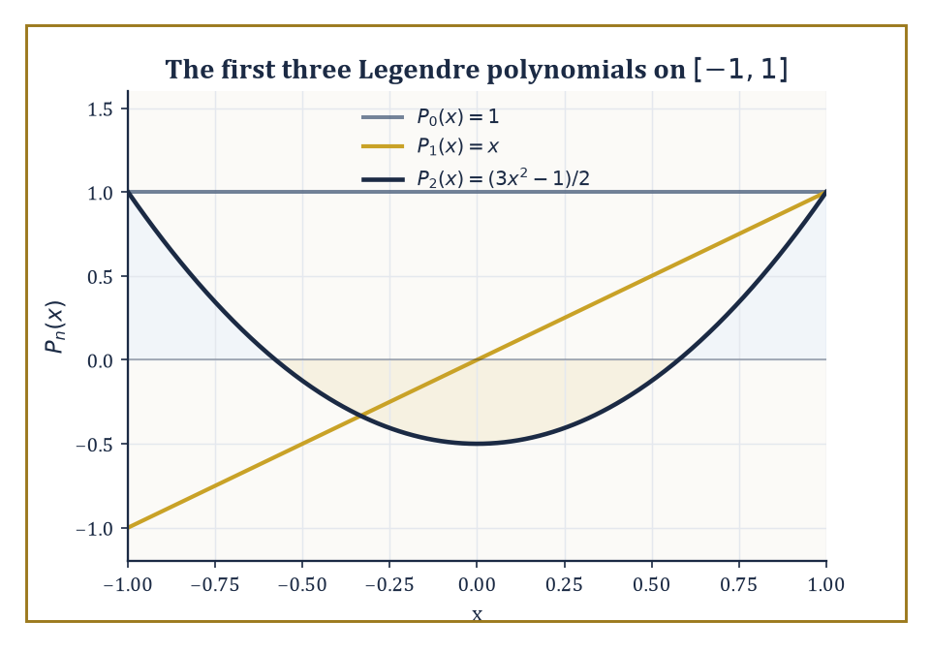
Figure 16.8 — P₀, P₁, and P₂ — the first three Legendre polynomials, orthogonal on [−1,1] by the same odd-function trick that made the Fourier coefficients behave.
We will treat this properly once complex analysis arrives; for now, a single concrete case shows the flavor.
Numeric example — a Laurent series around a simple pole. Let f(z) = 1/(z(z−1)). Partial fractions give:
1/(z(z−1)) = −1/z + 1/(z−1) = −1/z − 1/(1−z)
The second piece expands as an ordinary geometric series for |z| < 1:
1/(1−z) = Σ[n ≥ 0] zⁿ
So:
f(z) = −1/z − 1 − z − z² − z³ − … , valid for 0 < |z| < 1
The principal part is the single term −1/z, marking z = 0 as a simple pole (a first-order singularity, the mildest kind).
Check numerically at z = 0.1: directly,
f(0.1) = 1/(0.1 × (0.1 − 1)) = 1/(0.1 × −0.9) = 1/(−0.09) = −11.1111
From the series:
−1/0.1 − 1/(1 − 0.1) = −10 − 1.1111 = −11.1111
The two agree exactly, as they must.
Try it now — From 1/(1 − x − x²) = Σ cₙ xⁿ, what are c₀, c₁, c₂? Answer →
A generating function takes an entire sequence of numbers and encodes it as the coefficients of a single power series, converting questions about the sequence into questions about the function.
In particular, it converts a recurrence relation on the sequence into an algebraic or differential equation on the generating function itself, which can then often be solved in closed form.
Numeric example — the Fibonacci generating function. The Fibonacci numbers satisfy the recurrence:
Fₙ = Fₙ₋₁ + Fₙ₋₂, for n ≥ 2, with F₀ = 0, F₁ = 1
Let G(x) = ΣFₙxⁿ. Then:
G(x) − xG(x) − x²G(x) = Σ(Fₙ − Fₙ₋₁ − Fₙ₋₂)xⁿ
By the recurrence, every coefficient with n ≥ 2 vanishes; the n = 0 coefficient is just F₀ = 0, and the n = 1 coefficient is F₁ − F₀ = 1 − 0 = 1.
So:
G(x)(1 − x − x²) = x
giving the closed form:
G(x) = x/(1 − x − x²)
Expanding this back out as a power series (by matching coefficients against the same recurrence, run in reverse) reproduces:
0, 1, 1, 2, 3, 5, 8, 13, …
This is the Fibonacci sequence itself, now packaged as the Taylor coefficients of a single rational function, with all the tools of this chapter (radius of convergence, singularity location) available to study its growth rate.
Asymptotic series — including, remarkably, divergent ones — provide approximations that get better and better for a fixed number of terms as some parameter tends to a limit, even though summing the whole infinite series would not converge to anything at all.
Stirling’s series for the factorial is the classic specimen: it is a spectacularly good approximation for large n, and a spectacularly bad idea to sum indefinitely.
Numeric example — Stirling’s approximation for 10!. Stirling’s formula states:
n! ≈ √(2πn)(n/e)ⁿ
At n = 10:
√(2π × 10) = √62.8319 ≈ 7.9267, and (10/e)¹⁰ ≈ 453999.3
(using 10/e ≈ 3.678794 and computing the tenth power carefully). Multiplying:
7.9267 × 453999.3 ≈ 3,598,716
The true value is 10! = 3,628,800, so Stirling’s approximation is off by about 30,084 — a relative error of roughly 0.83%, comfortably under 1% from a formula that never once multiplied ten numbers together.
The catch, and the reason this is called an asymptotic rather than a convergent series, is that adding further correction terms to Stirling’s series improves the approximation only up to a certain point; push too many terms in and the series turns on you and starts making things worse.
A useful friend, but not one to be trusted indefinitely — a sentiment with obvious resonances for anyone who has ever taken on one PhD student too many.
Orthogonal expansions with respect to a weight function on some interval generalize the trigonometric orthogonality of the previous two sections, and produce the classical families of orthogonal polynomials — Legendre, Chebyshev, Hermite, Laguerre — each tailored to a particular geometry or differential operator, and each forming a complete toolkit for approximation and for the spectral methods used to solve differential equations numerically.
Numeric example — Legendre polynomials, checked for orthogonality. The first three Legendre polynomials, orthogonal on [−1, 1] with weight 1, are:
P₀(x) = 1, P₁(x) = x, P₂(x) = (3x² − 1)/2
Check:
⟨P₁,P₂⟩ = ∫₋1¹ x · (3x²−1)/2 dx = (1/2)∫₋1¹ (3x³ − x) dx
Both 3x³ and x are odd functions, and the integral of an odd function over the symmetric interval [−1,1] is always 0. So the whole integral is 0, confirming orthogonality just as the theory demands — the same structural fact that made the trigonometric coefficients in Fourier Series into independent projections is at work here too, just with a different family of building blocks.
Keep only this · Section 16.8: Other Expansions and Generating Functions
The idea. A generating function packs a sequence into a power series, so algebra on the function becomes facts about the sequence.
Core.
generating function G(x) = Σ aₙxⁿ
recurrence → algebra on G
Typical mistake. Confusing the generating function x/(1 − x − x²), which starts F₀ = 0, with 1/(1 − x − x²), which starts at 1.
Minimal example. aₙ = 2ⁿ: G(x) = 1/(1 − 2x).
Practice. Easy to challenge; full worked answers, with the usual mistake, are in Answers to the Practice Sets at the back.
Easy — Sequence generated by 1/(1 − 3x). Answer →
Medium — Solve aₙ = 2aₙ₋₁ + 1, a₀ = 0, with a generating function or by guessing and checking. Answer →
Challenge — What sequence has generating function 1/(1 − x)²? Answer →

Chapter 16 in One Page
An infinite series is the limit of its partial sums. Convergence tests (comparison, ratio, root, integral, alternating) decide whether the limit exists. A power series converges inside a radius R and may be differentiated and integrated term by term there; Taylor series are the power series built from derivatives, and the remainder says how good a truncation is. Fourier series expand periodic functions in orthogonal sines and cosines; they converge to the midpoint at jumps, overshoot near them (Gibbs), and satisfy Parseval’s identity.
Key definitions
• Partial sum Sₙ = a₁ + … + aₙ; convergence means Sₙ → S.
• Absolute convergence: Σ|aₙ| converges.
• Radius of convergence R of Σ cₙ(x − a)ⁿ.
• Taylor coefficient cₙ = f⁽ⁿ⁾(a)/n!.
• Fourier coefficients aₙ, bₙ (or cₙ = (1/2π)∫[−π, π] f(x) exp(−inx) dx).
Key theorems, with their hypotheses
• Ratio test — hypothesis: the limit L = lim |aₙ₊₁/aₙ| exists; conclusion only if L ≠ 1.
• Term-by-term differentiation — hypothesis: inside the open interval of convergence.
• Taylor’s theorem with remainder — hypothesis: f has n + 1 continuous derivatives on the interval.
• Dirichlet’s theorem — hypothesis: f periodic and piecewise smooth.
• Parseval — hypothesis: f square-integrable over one period.
Canonical example
• The square wave: bₙ = 4/(nπ) for odd n and 0 for even n; the series converges to 0 at the jump, overshoots to about 1.179 beside it, and Parseval gives Σ[n odd] 1/n² = π²/8.
Common errors
• aₙ → 0 taken as proof of convergence.
• Endpoints of the interval of convergence not tested.
• Smooth taken to mean analytic.
• Wrong normalization constant in Fourier coefficients.
Readiness checklist — you are ready for what comes next when you can:
□ choose and apply an appropriate convergence test
□ find a radius and interval of convergence
□ write and truncate Taylor series with an error bound
□ compute Fourier coefficients using symmetry
□ state what a Fourier series converges to at a jump
Section 16.9 that follows is a preview, marked optional: it says where these ideas lead in later chapters and volumes. Nothing in it is needed for the exercises.

Section 16.9: Where This Goes Next (Optional): From Series to Transforms and Functional Analysis
From counting terms to trusting spaces
PREVIEW — OPTIONAL · about 15 minutes · optional; read for orientation, nothing is examined
Overview — We have, in the course of nine sections, assembled the basic vocabulary of series: the convergence tests that decide whether a numerical sum makes sense at all, the power series and Taylor expansions that replace smooth functions with polynomials, the Fourier series that replace periodic functions with sums of pure tones, and a small museum of related expansions — Laurent series, generating functions, asymptotic series, orthogonal polynomials — each converting some stubborn object into a more manageable list of coefficients.
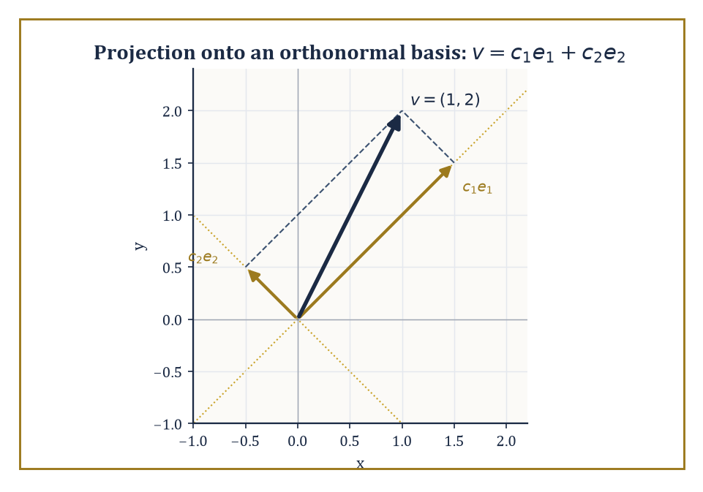
Figure 16.9 — Two projections, dot products in disguise, reassemble v = (1, 2) exactly — the whole of Fourier analysis, rehearsed in two dimensions.
This vocabulary is not decorative; it is the foundation the next several chapters are built on.
Most immediately, the Fourier transform extends the Fourier series from periodic functions to functions defined on the whole real line, and becomes one of the central tools of analysis and of signal processing — the mathematics behind, among a great many other things, every audio compression format and medical scanner you have ever benefited from.
Numeric example — watching the frequency comb turn into a continuum. A function of period 2π has Fourier frequencies spaced one integer apart: n = …, −1, 0, 1, 2, …, a spacing of 1.
Stretch the period out to 20π instead, and the same construction produces frequencies spaced:
2π/(20π) = 1/10
apart — ten times as many frequencies packed into the same range. Stretch the period to 2000π and the spacing shrinks to 1/1000.
As the period grows without bound, the comb of discrete frequencies grows finer and finer, and in the limit of an infinite period — a function that is no longer periodic at all — the sum over a discrete comb of frequencies becomes an integral over a continuum of frequencies.
That limiting process, made rigorous, is the passage from Fourier series to the Fourier transform, and it is where the next chapter picks up the thread.
Try it now — If Fourier frequencies are spaced 1/L apart for period 2πL, what happens to the spacing as L → ∞? Answer →
Generating functions and formal power series will resurface almost immediately once combinatorics enters the series, where they become the standard device for counting: encode a sequence you want to count as the coefficients of a power series, manipulate the series algebraically, and read the answer back off the coefficients — the Fibonacci trick of Other Expansions and Generating Functions, generalized to counting almost anything.
Functional analysis, several chapters later, will take the single idea underlying this entire chapter — orthogonality turning approximation into independent projection — and abstract it fully into the language of Hilbert and Banach spaces, where ‘function’ is a point in an infinite-dimensional space and a Fourier series is nothing more exotic than expressing that point in a convenient coordinate system.
Numeric example — the finite-dimensional rehearsal for Hilbert space. Take the ordinary vector v = (1, 2) in the plane, and the orthonormal basis e₁ = (1/√2, 1/√2), e₂ = (1/√2, −1/√2) (two perpendicular unit vectors, rotated 45° from the usual axes).
The coordinates of v in this new basis are given by dot products — projections — as Fourier coefficients are given by integrals:
c₁ = v·e₁ = (1)(1/√2) + (2)(1/√2) = 3/√2 ≈ 2.1213
c₂ = v·e₂ = (1)(1/√2) + (2)(−1/√2) = −1/√2 ≈ −0.7071
Reconstructing:
c₁e₁ = (3/√2)(1/√2, 1/√2) = (3/2, 3/2)
c₂e₂ = (−1/√2)(1/√2, −1/√2) = (−1/2, 1/2)
Adding them back together:
(3/2 − 1/2, 3/2 + 1/2) = (1, 2)
This is v, recovered from its two projections. This is the entire content of Fourier analysis, shrunk down to two dimensions: decompose an object along an orthogonal basis by projection, then reassemble it by summing the projections back up.
Function spaces simply replace the two basis vectors with an infinite orthonormal family — sines and cosines, say — and replace the dot product with an integral. Nothing conceptually new happens; the picture just gets an infinite number of axes.
There is one more piece of foreshadowing worth planting here, because it explains why Hilbert spaces insist on being built from L² functions rather than merely continuous ones.
Convergence of Fourier Series and Applications showed that the partial sums of the square wave’s Fourier series — themselves perfectly smooth, perfectly continuous trigonometric polynomials — get closer and closer to each other in the L² sense as more terms are added, which is exactly what it means to be a Cauchy sequence. And yet their limit, the square wave itself, is not continuous at all.
A sequence of well-behaved objects, drawing arbitrarily close together, whose natural limit escapes the space they started in: that is precisely the disease that motivates completing a space in the first place.
Abstract example — the same disease that builds the real numbers. Compare this to a far older example: the sequence of rationals:
1, 1.4, 1.41, 1.414, 1.4142, …
gets arbitrarily close together (it is Cauchy) entirely within the rational numbers, yet its limit, √2, is not rational — it escapes the space the sequence lived in.
The real numbers are, by one standard construction, the rationals with every such escaping limit glued back in, i.e. the completion of the rationals.
Hilbert space performs the identical repair on the continuous, trigonometric-polynomial functions Convergence of Fourier Series and Applications was working with: the Fourier partial sums of the square wave are a Cauchy sequence in the L² sense whose limit — a genuine jump discontinuity — does not belong to the space of continuous functions, so the space of continuous functions is not complete, and analysts complete it by admitting L² functions (discontinuities and all) as legitimate points of the space.
This is the single technical reason Fourier theory is properly a theorem about L² functions rather than about continuous ones, and it is exactly the notion of completeness that will earn a full section to itself once functional analysis arrives.
The deeper lesson of this chapter, stripped of its coefficients and its remainder estimates, is a simple and slightly beautiful one: an enormous number of complicated functions are, underneath, infinite combinations of simple ones, and the coefficients of that combination carry the entire essential information about the original object — its smoothness, its energy, its symmetries, all legible directly from a list of numbers.
The next chapter picks the thread up just where Where This Goes Next: From Series to Transforms and Functional Analysis left it dangling: let the period of a Fourier series grow without bound, watch the discrete comb of frequencies aₙ, bₙ dissolve into a continuous spectrum, and the Fourier transform is born — followed shortly by a piece of pure algorithmic cunning, the Fast Fourier Transform, that computes the whole business in roughly N log N operations instead of N², and which invisibly runs a sizable fraction of the audio, imaging, and communications technology in your pocket.
The series continues. We have learned to expand; next, we learn to let the period go — politely, and with the error bars still firmly attached.
Keep only this · Section 16.9: Where This Goes Next (Optional): From Series to Transforms and Functional Analysis
The idea. Letting the period grow turns Fourier series into the Fourier transform of the next chapter.
Core.
periodic f ↦ discrete spectrum (series)
non-periodic f ↦ continuous spectrum (transform)
Typical mistake. Treating a Fourier series and a Fourier transform as interchangeable: one is for periodic functions, the other for functions on the whole line.
Minimal example. As the period L → ∞, frequencies n/L fill the line and the sum becomes an integral.
Practice. Easy to challenge; full worked answers, with the usual mistake, are in Answers to the Practice Sets at the back.
Easy — Which tool fits a non-repeating pulse: a Fourier series or a Fourier transform? Answer →
Medium — With period 2L, the frequencies are n/(2L). What is the spacing, and what happens as L → ∞? Answer →
Challenge — Name the space in which Fourier series converge in the mean, and its inner product. Answer →

Check Your Understanding — Chapter 16
Answers are in the Answer Key at the back of the book — have a go before you look.
1. [Explain] The harmonic series Σ1/n has terms that shrink to zero, yet it diverges. How does the integral test show this?
See the answer →
2. [Concept] The power series Σ(3ⁿ/n)xⁿ has radius of convergence R = 1/3. Is its full interval of convergence symmetric around 0?
See the answer →
3. [Explain] The function f(x) = exp(−1/x²) (with f(0) = 0) is infinitely differentiable everywhere, yet its Taylor series at 0 fails to represent it. Why?
See the answer →
4. [Explain] For the square wave (f = 1 on (0,π), f = −1 on (−π,0)), why do the Fourier coefficients bₙ vanish for every even n?
See the answer →

Fluency Drill — Chapter 16
Five minutes, no notes, before the harder problems. These are the moves the Problems assume are automatic; if one takes you more than a minute, reread the section it names. Worked answers, each with the usual slip, are in Answers to the Practice Sets.
1. [Concept] Does Σ 1/n^{1.01} converge? Answer →
2. [Compute] Σ[n ≥ 1] (1/2)ⁿ. Answer →
3. [Compute] Radius of Σ n xⁿ. Answer →
4. [Compute] Coefficient of x³ in the Maclaurin series of sin x. Answer →
5. [Concept] Σ (−1)ⁿ/√n: absolutely or conditionally convergent? Answer →
6. [Compute] b₁ for f(x) = x on (−π, π). Answer →
7. [Concept] f is odd on (−π, π). Which coefficients vanish? Answer →
8. [Compute] Value of the Fourier series of the square wave at x = π/2. Answer →

Problems — Chapter 16
Series is the chapter where a great deal of later mathematics is quietly decided. Whether a function can be represented, differentiated term by term, or approximated at all comes down to convergence, and convergence rewards practice more than intuition. Twelve problems follow. Each problem carries a skill tag (Concept, Compute, Explain, Prove, Model or Challenge; see How to Use This Book) and a link to its full worked solution, which ends with the usual mistake.
Convergence of numerical series
1. [Compute] Determine whether Σ 1/n² converges, and whether Σ 1/n converges. State which test settles each. Solution →
2. [Compute] Use the ratio test on Σ n!/nⁿ and state the conclusion. Solution →
3. [Explain] The alternating series Σ (−1)ⁿ⁺¹/n converges while Σ 1/n diverges. Name this phenomenon and explain what it costs you. Solution →
Power series and Taylor expansions
4. [Compute] Find the radius and interval of convergence of Σ xⁿ/n, and check both endpoints separately. Solution →
5. [Compute] Find the Maclaurin series of eˣ up to the x⁴ term, and use the first four terms to estimate exp(0.1). Solution →
6. [Compute] Find the Maclaurin series of 1/(1 − x) and state where it is valid. Use it to write the series for 1/(1 + x²). Solution →
7. [Prove] Show that f(x) = exp(−1/x²) for x ≠ 0, with f(0) = 0, has every derivative equal to zero at the origin, and hence that its Maclaurin series converges to the wrong function. Solution →
Fourier series
8. [Compute] Find the Fourier sine series of f(x) = x on the interval (0, π), extended as an odd function of period 2π. Solution →
9. [Explain] Explain why the Fourier series of a square wave overshoots near the jump no matter how many terms are taken, and name the effect. Solution →
10. [Compute] Use Parseval’s identity applied to the sine series of Problem 8 to evaluate Σ 1/n². Solution →
Wider expansions
11. [Compute] The generating function of the Fibonacci numbers is x/(1 − x − x²). Verify by expanding to the x⁵ term that the coefficients are the Fibonacci numbers. Solution →
12. [Challenge] A Taylor series is a local statement — it encodes behavior near one point — while a Fourier series is a global one, encoding behavior over a whole interval. What practical consequence follows from that difference, and which should you reach for when a function has a corner in it? Solution →

Math, Actually

Chapter 17

Fourier Transforms and FFT
Frequency, Spectrum, and the Art of Decomposing Signals into Waves
Chapter 16 taught us to break a periodic function into a sum of sines and cosines — a Fourier series — and to worry, properly, about whether the sum converges back to the function we started with. That worry was not wasted effort; it is about to pay for itself. This chapter takes the single most audacious step in the whole argument: let the period grow without bound, and watch the discrete chord of frequencies dissolve into a continuous spectrum. What emerges is the Fourier transform, a machine of startling generality that turns differentiation into multiplication, convolution into a simple product, and a great many differential equations into algebra a moderately diligent sixth-former could finish before lunch.
Then, because mathematics rarely pauses to admire its own results for long, we make the whole apparatus computable. The discrete Fourier transform (DFT) does for finite lists of numbers what the continuous transform does for functions defined on the whole line, and the fast Fourier transform (FFT) computes it not in the n² operations a naïve algorithm would demand, but in n log n — a saving so large that for signals of any serious length it is the difference between an algorithm that finishes and one that doesn’t, this side of the heat death of the universe. Without the FFT your phone would have no spectrum analyzer, your hospital’s MRI scanner would produce no image, and digital audio would still be a rumor whispered by analog engineers.
A small confession: the Fourier transform is one of those objects that seems almost too good to be true. A single integral operator diagonalizes every constant-coefficient linear differential operator you are ever likely to meet, converts convolution to multiplication, and admits an algorithm that scales almost linearly. The price is paid elsewhere — the transform is nonlocal, so a single sharp spike in frequency space corresponds to a wave rippling across the whole of space, and making the business fully rigorous requires some care about which function spaces we are permitted to work in. We shall enjoy the power and pay the price honestly, in that order.
If series taught us to build functions out of simpler pieces, Fourier analysis teaches us to build them out of pure oscillation — and to hear a signal not as a sequence of moments but as a chord of frequencies sounding together. Let’s go and listen.
Before you begin — Chapter 17 · Core chapter
By the end of this chapter you will be able to:
1. Explain how the Fourier transform arises from Fourier series as the period grows without bound.
2. Compute transforms of basic functions (pulses, exponentials, Gaussians) with the convention f̂(ξ) = ∫ f(x) exp(−2πixξ) dx.
3. Use inversion, Plancherel and Parseval, and the shift, scaling and differentiation rules.
4. Compute convolutions and apply the convolution theorem.
5. Compute a small DFT by hand and explain why the FFT costs O(N log N) instead of O(N²).
6. Explain windowing, leakage and the uncertainty principle.
Why it comes here. Fourier series (Chapter 16) handle periodic functions. Letting the period grow without bound turns the series into the Fourier transform, which treats any reasonable signal as a continuum of frequencies. The discrete transform and the FFT then make it computable, which is why this chapter sits between the theory of series and the engineering of the Laplace transform in Chapter 18.
Required chapters. Series (Chapter 16), especially Fourier Series: The Basic Theory; complex numbers and exp(iθ) = cos θ + i sin θ, Volume 1.
Assumed skills. compute Fourier coefficients of a simple periodic function; multiply complex numbers in polar form and use exp(iθ); evaluate improper integrals of exponentials; count operations in a nested loop.
If you are rusty. Fourier Series: The Basic Theory; Convergence of Fourier Series and Applications; complex numbers — Volume 1.
Do not proceed until you can…
1. Simplify exp(iπ/2) and exp(−iπ). Answer →
2. Evaluate ∫[0, ∞] exp(−2t) dt. Answer →
3. Which Fourier coefficients of an odd function vanish? Answer →
Estimated study time. About 12–14 hours over two weeks. Work every Try it now before reading on, finish each section’s Keep only this practice before starting the next, and do the Fluency Drill before the Problems.

Section 17.1: From Fourier Series to the Fourier Transform
Letting the Period Run Away to Infinity
CORE · about 20 minutes · later chapters build on this
Set a metronome to tick once every 4 seconds and leave it running. Chapter 16 taught you to take a repeating sound like that apart into pure tones. Because the pattern repeats every 4 seconds, the only tones it can contain are the ones that also fit a whole number of times into 4 seconds: 0 cycles per second, 1/4, 2/4, 3/4, and so on. On a chart of frequency those tones sit like the teeth of a comb, 1/4 of a cycle per second apart.
Slow the metronome to one tick every 8 seconds and the teeth move closer together, 1/8 apart. At one tick every 16 seconds they are 1/16 apart. The slower the repeat, the finer the comb.
Now clap your hands once. The clap does not repeat at all. Chapter 16’s method needs a period, and this sound has none, unless you call its period infinite.
So change the question. Not ‘which tones make up a sound that repeats every T seconds’, but ‘which tones make up a sound that happens once’?
Here is the wall, and it is worth standing in front of it. Put an infinite period into Chapter 16’s formulas and everything collapses at once. The teeth of the comb are 1/T apart, and 1/T is zero, so there is no spacing left. Each coefficient carries a factor 1/T in front of its integral, so every coefficient is zero too. The method reports that a handclap contains no tones at all, and you heard it.
The way round it is to sneak up on infinity instead of jumping there. Think of the clap as one tick of a metronome that is being slowed down without limit, and watch two things as the period grows: how far apart the teeth are, and the size of each coefficient multiplied back up by T, so that the 1/T in front cannot drag it to zero. Take the rectangular pulse this section uses below, width 1, and look at the tone 1/4 cycle per second:
T = 4: teeth 0.25 apart, T·cₙ at frequency 0.25 = 0.9003
T = 8: teeth 0.125 apart, T·cₙ at frequency 0.25 = 0.9003
T = 16: teeth 0.0625 apart, T·cₙ at frequency 0.25 = 0.9003
The spacing halves every time and never reaches zero: at every finite period the comb is still a comb, with gaps between its teeth. The rescaled coefficient, meanwhile, refuses to vanish. It holds at 0.9003 however far you go. Something survives the limit, and it is a number attached to each frequency.
That surviving function of frequency is the Fourier transform of the pulse. It is still a list of how much of each tone the sound contains, as in Chapter 16. The list is now continuous instead of a comb, and each entry has been scaled up by T so that it survives.
Definition — Here is the setup from Chapter 16, written out so that the limit can be taken properly. A function f that repeats itself with period T can be written as a sum of complex exponentials whose frequencies are integer multiples of the fundamental frequency 1/T, where the sum runs over all integers n, positive and negative:
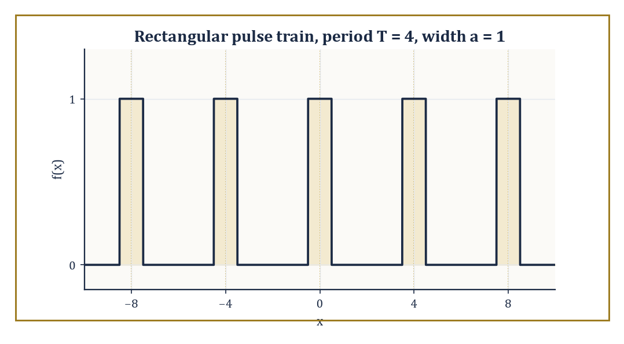
Figure 17.1 — The period-4 pulse train of width 1 whose Fourier coefficients cₙ this Section computes — stretch the gaps to infinity and the comb of frequencies becomes a continuum.
f(x) = Σₙ cₙ exp(2πinx/T)
Each coefficient cₙ is obtained by projecting f against the corresponding exponential — an inner product, as one projects a vector onto a coordinate axis:
cₙ = (1/T) ∫₀ᵀ f(x) exp(−2πinx/T) dx
The allowed frequencies n/T form a discrete comb, evenly spaced 1/T apart along the frequency axis. Whether the resulting sum converges back to f, and in what sense (pointwise, uniform, or merely in the averaged L² sense), was the subject of a large and historically important literature that we will not re-litigate here; we take the well-behaved cases as given and press on.
Numeric example — Fourier coefficients of a rectangular pulse train. Let f be periodic with period T = 4, equal to 1 on the interval [−0.5, 0.5] and 0 elsewhere within each period — a narrow pulse of width a = 1 repeating every 4 units. A short calculation (integrate exp(−2πinx/T) across the pulse and simplify) gives the general formula, where sinc(x) = sin(πx)/(πx) and sinc(0) = 1 by the usual limiting convention:
cₙ = (a/T)·sinc(na/T)
With a = 1, T = 4:
c₀ = (1/4)·sinc(0) = 0.25
c₁ = (1/4)·sinc(0.25) = (1/4)·[sin(π/4)/(π/4)] = (1/4)·(0.7071/0.7854) = (1/4)·0.9003 = 0.2251
c₂ = (1/4)·sinc(0.5) = (1/4)·[sin(π/2)/(π/2)] = (1/4)·(1/1.5708) = (1/4)·0.6366 = 0.1592
Notice the coefficients shrink as |n| grows but never vanish entirely — a narrow pulse in time needs contributions from a broad range of frequencies to build its sharp edges, a theme that will return with interest in Windows, Uncertainty, and Limitations.
Try it now — A pulse train has period T = 4. How far apart are its Fourier frequencies n/T? Answer →
Now perform the limiting argument that gives this Section its name. Let the period T grow without bound while the shape of the pulse (its width a) stays fixed. The spacing between adjacent frequencies, 1/T, shrinks toward zero, so the discrete comb of frequencies n/T thickens into a continuum; write ξ = n/T for this continuous frequency variable. The sum over n, each term weighted by the small spacing 1/T, starts to look like a Riemann sum for an integral over ξ. Formally:
f(x) = Σₙ cₙ exp(2πi(n/T)x) = Σₙ (T·cₙ) exp(2πi(n/T)x) · (1/T) → ∫ f̂(ξ) exp(2πixξ) dξ
where the rescaled coefficient T·cₙ converges to a genuine function of the continuous variable ξ. That limiting function is precisely what we shall soon name the Fourier transform, f̂(ξ), and the limiting sum is the Fourier inversion formula we meet properly in Inversion, Plancherel, and Parseval. Series become integrals; sums over a discrete ledger of frequencies become continuous spectra.
Numeric example — watching the rescaled coefficients converge. Return to the pulse of width a = 1, but now hold the frequency ξ = n/T fixed at 0.25 while letting T grow.
T = 4, n = 1: T·c₁ = 4 × 0.2251 = 0.9003 (using the value computed above)
T = 8, n = 2: cₙ = (1/8)·sinc(2/8) = (1/8)·sinc(0.25) = (1/8)×0.9003 = 0.11254, so T·cₙ = 8 × 0.11254 = 0.9003
T = 16, n = 4: cₙ = (1/16)·sinc(4/16) = (1/16)×0.9003 = 0.056269, so T·cₙ = 16 × 0.056269 = 0.9003
All three agree exactly, because for this particular pulse the rescaled coefficient T·cₙ depends only on the ratio ξ = n/T and not on T and n separately — a foretaste of the Poisson summation formula met in later analysis, which says that periodizing a function with period T samples its Fourier transform at the points n/T: the coefficients are cₙ = (1/T) f̂(n/T). That relation holds whether or not the copies overlap; what non-overlap buys is only that one period of the train still looks like the original pulse. A less obliging function would show the coefficients merely approaching a limit as T grows rather than sitting on it from the start, but the moral — rescaled series coefficients tend to the transform — is the same either way.
The transition from series to transform is therefore two things happening at once: a limiting process (period to infinity, sum to integral) and a change of subject matter (periodic phenomena, which repeat forever, to arbitrary signals that need only be defined once, on the whole real line). A periodic function is really just one pattern stamped out infinitely often; letting the stamping interval run to infinity leaves a single, unrepeated pattern — which is usually the object one actually wants to analyze, whether it is a clap of thunder, a spoken vowel, or a single pulse in a radar system.
Abstract example — from a picket fence to a single post. Picture the period-4 pulse train of the first example as a picket fence: an identical narrow post every 4 units, forever in both directions. Now imagine grabbing the fence at both ends and stretching it — posts stay the same width, but the gaps between them grow.
As the period T increases from 4 to 40 to 4,000, the picture within any fixed viewing window (say, the interval [−10, 10]) tends toward a single isolated post sitting at the origin, with no neighbors in sight; everything else has been pushed off to infinity. The Fourier transform of that single isolated post is the sinc function met above, viewed now as a continuous function of ξ rather than a sequence of samples cₙ. This is the structural content of the limit: periodicity is repetition at a fixed spacing, and removing the repetition by sending the spacing to infinity is what turns a discrete spectrum into a continuous one.
Keep only this · Section 17.1: From Fourier Series to the Fourier Transform
The idea. The transform is what the Fourier coefficients become, rescaled by T, as the period T → ∞ and the frequency spacing 1/T → 0.
Core.
period T → ∞: frequencies n/T fill the line
cₙ ≈ (1/T) f̂(n/T)
Typical mistake. Taking the limit of the coefficients without rescaling; unscaled, they all tend to 0.
Minimal example. A pulse repeated every T: the spectrum lines get closer as T grows, tracing out sinc.
Practice. Easy to challenge; full worked answers, with the usual mistake, are in Answers to the Practice Sets at the back.
Easy — For period T = 10, how far apart are the Fourier-series frequencies n/T? Answer →
Medium — Why must the coefficients cₙ shrink like 1/T as T grows, for a fixed single pulse? Answer →
Challenge — Explain how the sum Σ cₙ exp(2πinx/T) becomes ∫ f̂(ξ) exp(2πixξ) dξ. Answer →

Section 17.2: The Fourier Transform on the Line
One Integral, Every Frequency
CORE · about 15 minutes · later chapters build on this
Chapter 16 found the tones inside a repeating signal by a simple test. Multiply the signal by one pure wave and add up the area under the product. If the signal contains that wave, the product stays mostly on one side of zero and the area is large. If it does not, the product swings evenly above and below zero and the area cancels away. From Fourier Series to the Fourier Transform showed that the same test still makes sense for a signal that happens only once, provided every frequency is allowed, not just the teeth of a comb.
Here is the test carried out by hand on the unit pulse: height 1 for x between −1/2 and 1/2, and 0 everywhere else. Multiply it by the wave cos(2πξx), for a few frequencies ξ, and find the area:
ξ = 0: the wave is the constant 1, so the area is the pulse’s own area, 1
ξ = 1/2: the area under cos(πx) from −1/2 to 1/2 is 2/π ≈ 0.6366
ξ = 1: exactly one full cycle fits across the pulse, so the area is 0
The sine wave sin(2πξx) gives an area of 0 at every frequency, because the pulse is symmetric about x = 0 and the sine is not: its area on the left cancels its area on the right.
Doing the test at every frequency at once gives a whole function of ξ, and that function is the Fourier transform. The integral below is exactly this test, with the cosine and the sine wrapped together into one complex exponential. Its very first worked example is the unit pulse, and it gets 1, 0.6366 and 0 again.
Definition — For an integrable function f on the real line, define its Fourier transform by
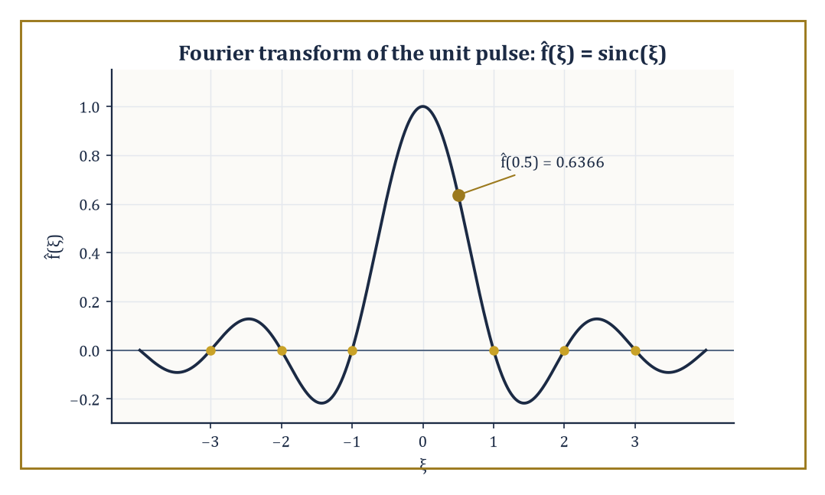
Figure 17.2 — The transform of the unit pulse: f̂(ξ) = sinc(ξ), still rippling long after the box itself has stopped.
f̂(ξ) = ∫[−∞, ∞] f(x) exp(−2πixξ) dx
Conventions for where the factors of 2π and the sign of the exponent go vary maddeningly between textbooks, physics papers, and engineering handbooks; we fix the unitary, ordinary-frequency convention used above, in which ξ is measured in cycles per unit x rather than radians per unit x, and no stray constants clutter the inversion formula later.
The transform is linear (the transform of a sum is the sum of the transforms, and constants factor out), it is defined and continuous for every f in L¹ (every absolutely integrable function), and it maps the Schwartz space — smooth functions that, together with all their derivatives, decay faster than any power of x — back into itself. Intuitively, f̂(ξ) measures how strongly the pure oscillation exp(2πixξ) is present inside f: it is the amplitude and phase of the ξ-frequency component of the signal.
Numeric example — the transform of a rectangular pulse. Let f(x) = 1 for |x| < 0.5 and f(x) = 0 otherwise (a single rectangular pulse of width 1 centered at the origin — the isolated post from the previous Section). Then
f̂(ξ) = ∫[−0.5, 0.5] exp(−2πixξ) dx = [exp(−2πixξ)/(−2πiξ)]_{−0.5}^{0.5}
= (exp(−πiξ) − exp(πiξ))/(−2πiξ) = (−2i sin(πξ))/(−2πiξ)
= sin(πξ)/(πξ) = sinc(ξ)
Evaluate: at ξ = 0.5,
f̂(0.5) = sin(π/2)/(π/2) = 1/1.5708 = 0.6366
At ξ = 1,
f̂(1) = sin(π)/π = 0/π = 0
— the transform vanishes at every nonzero integer frequency, giving the sinc function its characteristic string of zero crossings. A box in time becomes a ripple in frequency, and that ripple never quite dies away — the price, as promised, of a sharp edge in time.
Try it now — If f̂(ξ) = sinc(ξ), what is the transform of f(x − 3)? Answer →
A handful of algebraic rules, each provable by direct manipulation of the defining integral (differentiate under the integral sign, or substitute), turn the transform into a genuine computational tool rather than a curiosity.
Differentiation becomes multiplication: the transform of f′ is
2πiξ·f̂(ξ)
so differentiating in x corresponds to multiplying by a frequency factor in ξ — this single fact is why constant-coefficient differential equations become algebraic equations after transforming.
Translation becomes modulation: if g(x) = f(x − a), then
ĝ(ξ) = exp(−2πiaξ)·f̂(ξ)
— shifting a signal in time doesn’t change the magnitude of its spectrum at all, only twists the phase of each frequency component by an amount proportional to that frequency. And a Gaussian transforms to another Gaussian, a fact so useful it earns its own worked example below.
Numeric example — verifying the shift rule. Take the unit pulse f above, with f̂(ξ) = sinc(ξ), and shift it two units to the right: g(x) = f(x − 2), i.e. g equals 1 on [1.5, 2.5] and 0 elsewhere. The shift rule predicts
ĝ(ξ) = exp(−4πiξ)·sinc(ξ)
At ξ = 0.25 this gives
ĝ(0.25) = exp(−4πi(0.25))·sinc(0.25) = exp(−πi)·0.9003 = (−1)(0.9003) = −0.9003
Check this directly:
ĝ(0.25) = ∫[1.5, 2.5] exp(−iπx/2) dx
(since 2πξ = π/2). The antiderivative is (2i/π)exp(−iπx/2); evaluating at x = 2.5 (angle 1.25π = 225°, cos = −0.7071, sin = −0.7071, so exp(−i1.25π) = −0.7071 + 0.7071i) and at x = 1.5 (angle 0.75π = 135°, cos = −0.7071, sin = 0.7071, so exp(−i0.75π) = −0.7071 − 0.7071i), the difference is
(−0.7071 + 0.7071i) − (−0.7071 − 0.7071i) = 1.4142i
Multiplying by (2i/π):
(2i/π)(1.4142i) = 2.8284·i²/π = −2.8284/π = −0.9003
The direct calculation and the shift-rule prediction agree exactly.
The differentiation rule has a deeper reading than mere bookkeeping: it says that the complex exponentials exp(2πixξ) are eigenfunctions of the differentiation operator d/dx, with eigenvalue 2πiξ. An eigenfunction is a function that an operator sends to a scalar multiple of itself — differentiate exp(2πixξ) and you get 2πiξ·exp(2πixξ) back, unchanged in shape, merely rescaled.
Any operator built from d/dx (any constant-coefficient linear differential operator) therefore acts on each frequency component of a signal by simple multiplication, which is exactly why the Fourier transform turns calculus into algebra. This is the fundamental change of variables of harmonic analysis: swap the standard basis of “value at each point x” for the basis of “amplitude at each frequency ξ”, and the operators that mattered in the first basis become diagonal — multiplication operators — in the second.
Abstract example — the Gaussian that transforms to itself. Let f(x) = exp(−πx²). A standard (if slightly fiddly) contour-shifting calculation shows
f̂(ξ) = exp(−πξ²)
— under this particular normalization, the Gaussian is its own Fourier transform, a genuine mathematical curiosity with real consequences (it is the reason the Gaussian saturates the uncertainty principle in Windows, Uncertainty, and Limitations). Sanity check at the origin: f(0) = 1, and
f̂(0) = ∫ exp(−πx²) dx = 1
using the classical Gaussian integral ∫ exp(−ax²) dx = √(π/a) with a = π, giving √(π/π) = 1. The values agree, as self-duality demands. At ξ = 1,
f̂(1) = exp(−π) ≈ 0.04321
— a small but nonzero tail, mirroring how f(1) = exp(−π) as well.
The shift rule has a mirror image, modulation, which will matter enormously once we reach filtering in Applications: Filtering, PDEs, and Signal Processing: multiplying a function by a pure oscillation exp(2πiax) in the time domain shifts its entire spectrum sideways by a in the frequency domain. Symbolically, if g(x) = exp(2πiax)f(x), then
ĝ(ξ) = f̂(ξ − a)
This is the mathematical operation underlying radio broadcasting: a low-frequency audio signal (speech or music, occupying perhaps 0 to 15 kHz) is multiplied by a high-frequency carrier wave, which shifts — modulates — its whole spectrum up to sit around the assigned broadcast frequency, far enough from every other station’s assigned slot that a receiver can isolate it again with a suitably tuned band-pass filter.
Numeric example — modulation shifts the spectrum sideways. Take the unit pulse f(x) again, f̂(ξ) = sinc(ξ), and modulate it by a = 3: g(x) = exp(2πi·3x)f(x). The modulation rule predicts
ĝ(ξ) = f̂(ξ − 3) = sinc(ξ − 3)
Evaluate at ξ = 3.5: ĝ(3.5) should equal
sinc(3.5 − 3) = sinc(0.5) = 0.6366
the same numerical value computed for f̂(0.5) in the very first worked example of this Section — merely relocated three units along the frequency axis, as the rule promises. The shape of the spectrum (a sinc bump) is preserved perfectly; only its location moves, which is why a radio receiver can tune across the dial and pick up the same audio content wherever the broadcaster chose to park its carrier frequency.
Keep only this · Section 17.2: The Fourier Transform on the Line
The idea. Shift in x ↔ phase factor in ξ; modulation in x ↔ shift in ξ; stretching x by a ↔ compressing ξ by 1/a.
Core.
f̂(ξ) = ∫[−∞, ∞] f(x) exp(−2πixξ) dx
pulse on [−1/2, 1/2] ↦ sin(πξ)/(πξ)
exp(−πx²) ↦ exp(−πξ²)
Typical mistake. Mixing conventions: with exp(−2πixξ) there is no 1/(2π) anywhere; with exp(−iωt) it moves into the inverse.
Minimal example. The unit pulse has f̂(0) = 1, its area.
Practice. Easy to challenge; full worked answers, with the usual mistake, are in Answers to the Practice Sets at the back.
Easy — What is f̂(0) in terms of f? Answer →
Medium — Transform of f(x) = exp(−x) for x ≥ 0 (0 for x < 0). Answer →
Challenge — Use scaling to find the transform of exp(−πa²x²), a > 0. Answer →

Section 17.3: Inversion, Plancherel, and Parseval
Getting the Function Back, With Its Energy Intact
CORE · about 15 minutes · later chapters build on this
A graphic equalizer splits music into frequencies, lets you turn some up and others down, and then reassembles the sound. That only works because the splitting loses nothing: from the full list of frequency ingredients you can rebuild the original signal exactly. The inversion theorem says the Fourier transform has this property, and that its reverse is almost the same formula with a single sign flipped. Plancherel and Parseval add a second guarantee. The total energy of a signal, measured over time, equals its total energy measured across frequencies. Nothing is gained or lost in translation, which is why engineers can work in whichever description is easier and trust the answer in the other.
Key idea — A transform that could not be undone would be a curiosity, not a tool. Under suitable hypotheses on f (Schwartz class is more than enough; L¹ ∩ L² usually suffices), the original function is recovered from its transform by the inverse Fourier transform:
Theorem — Fourier inversion and Plancherel
f(x) = ∫ f̂(ξ) exp(2πixξ) dξ and ∫ |f(x)|² dx = ∫ |f̂(ξ)|² dξ
Hypotheses — check each one before you use it:
□ inversion: f and f̂ both integrable (for example, f in the Schwartz class); at a jump, read the midpoint
□ Plancherel: f square-integrable
□ the ξ convention exp(−2πixξ); with exp(−iωt) the inverse carries 1/(2π) and Plancherel reads ∫|f|² dt = (1/2π)∫|F|² dω
Why it matters. Nothing is lost in the transform, and energy is the same on both sides, so errors can be measured in whichever domain is easier.
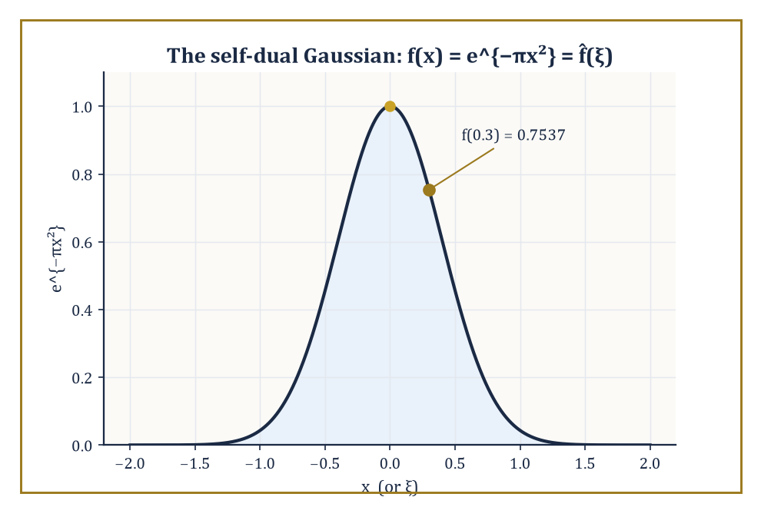
Figure 17.3 — The one function that sits still under the transform: exp(−πx²) is its own Fourier transform, digit for digit.
f(x) = ∫ f̂(ξ) exp(2πixξ) dξ
This is the same formula as the forward transform, but with the sign of the exponent flipped. It is the reconstruction formula that fell out of the limiting argument in From Fourier Series to the Fourier Transform: the continuum analogue of resumming a Fourier series.
Its importance is not merely aesthetic. It guarantees that passing to frequency space loses no information whatsoever — the transform is a genuine change of representation, a relabeling of the same data, not a lossy projection onto some smaller space. Anything one computes in frequency space (a filtered spectrum, a solved differential equation) can always be brought back to the original variable by this one formula.
Numeric example — inversion checked on the self-dual Gaussian. Take f(x) = exp(−πx²) and f̂(ξ) = exp(−πξ²) from The Fourier Transform on the Line, and verify inversion at x = 0.3. Directly:
f(0.3) = exp(−π(0.3)²) = exp(−π(0.09)) = exp(−0.28274) = 0.7537
Now compute the inversion integral:
∫ exp(−πξ²) exp(2πi(0.3)ξ) dξ
Complete the square in the exponent:
−πξ² + 0.6πiξ = −π(ξ² − 0.6iξ) = −π[(ξ − 0.3i)² + 0.09] = −π(ξ − 0.3i)² − 0.09π
So the integral equals:
exp(−0.09π) ∫ exp(−π(ξ − 0.3i)²) dξ
Shifting the contour of integration off the real axis is justified because the Gaussian is entire and decays in every direction of the strip swept out, and the shifted Gaussian integral still equals 1 (the same value as the unshifted one). So the integral equals:
exp(−0.09π) × 1 = exp(−0.28274) = 0.7537
This matches f(0.3) exactly. The formula, and the machinery, both check out.
Try it now — The unit pulse has energy ∫|f|² dx = 1. What is ∫|sinc(ξ)|² dξ? Answer →
Plancherel’s theorem strengthens inversion into a statement about size: the Fourier transform extends to a unitary operator on L², meaning it preserves the L² norm exactly:
∫|f(x)|² dx = ∫|f̂(ξ)|² dξ
This is Parseval’s identity in its self-paired form. The more general Parseval identity equates the inner product of two functions with the inner product of their transforms:
∫ f(x)·conj(g(x)) dx = ∫ f̂(ξ)·conj(ĝ(ξ)) dξ
Physically, if |f(x)|² is interpreted as an energy density in time (as it is for an electrical signal or a sound wave), then Plancherel says the total energy can be computed equally well by integrating |f̂(ξ)|² over frequency — hence |f̂(ξ)|² is called the energy density (or power spectral density) in frequency. Energy is neither created nor destroyed by the change of representation; it is merely redistributed across the frequency axis, and Plancherel tells us just how much stays where.
Numeric example — Plancherel for the pulse and its sinc. Take again the unit-width, unit-height pulse f(x) = 1 on (−0.5, 0.5), 0 elsewhere, with f̂(ξ) = sinc(ξ) from The Fourier Transform on the Line. The time-domain energy is:
∫|f(x)|² dx = ∫[−0.5, 0.5] 1² dx = 1
A box of height 1 and width 1 has area 1. Plancherel demands that the frequency-domain energy match:
∫|sinc(ξ)|² dξ = ∫ [sin(πξ)/(πξ)]² dξ
This is a classical definite integral whose value is exactly 1 — a nontrivial fact (it is usually proved via Parseval itself, or by contour integration), but here it serves as a numerical confirmation: 1 = 1, energy preserved to the last decimal place, even though the pulse is compactly supported and the sinc function most emphatically is not.
It is worth pausing on why this matters beyond bookkeeping. Inversion says nothing is lost; Plancherel says nothing is lost in a quantitative, measurable sense — the total ‘size’ of the signal, however you like to measure size, is the same whichever axis you total it up along.
Together they are the two pillars that make the Fourier transform a genuine change of coordinates rather than a one-way street: you can go from time to frequency and back with total confidence, and every calculation you might want to perform (filtering, solving a differential equation, compressing a signal by discarding small frequency components) can be justified by appeal to how much energy such a discarding operation would throw away.
Abstract example — Parseval as Pythagoras in infinite dimensions. In ordinary two-dimensional space, a vector v = (3, 4) has length:
|v| = √(3² + 4²) = √25 = 5
This is just Pythagoras’s theorem: the squared length is the sum of the squared coordinates in any orthonormal basis. The complex exponentials exp(2πixξ), one for every real number ξ, form an (uncountably infinite, continuously indexed) orthonormal basis for L², and f̂(ξ) is exactly the ‘coordinate’ of f along the ξ-th basis direction.
Plancherel’s identity,
∫|f|² = ∫|f̂|²
is Pythagoras’s theorem transplanted to this infinite-dimensional setting: the squared length of f equals the sum (now an integral, since the index ξ is continuous rather than discrete) of the squared sizes of its coordinates. The Fourier transform is, in this sense, nothing more exotic than a rotation of coordinate axes in an infinite-dimensional space — a rotation that happens to be extraordinarily well chosen, because it diagonalizes differentiation.
One practical consequence of unitarity is worth flagging before we move on, since it will resurface the moment we start computing rather than merely proving theorems. Because the Fourier transform preserves length exactly, it cannot amplify rounding error: a small numerical mistake made while representing a signal in the time domain corresponds to an equally small mistake in the frequency domain, and vice versa, with no hidden factor sneaking in to make things worse.
This stability is taken for granted every time an engineer trusts a computed spectrum, and it is one further way in which Plancherel earns its keep well beyond the tidiness of the proof.
Numeric example — an error does not grow when it crosses domains. Take the unit pulse f(x) again, with f̂(ξ) = sinc(ξ), and imagine a measurement error that adds a small constant bump ε(x) = 0.01 on the tiny sliver (0.49, 0.5) to the recorded signal, so the mistake has time-domain energy:
∫|ε(x)|² dx = (0.01)² × 0.01 = 0.000001
(height squared times width). Plancherel guarantees this error cannot show up in the spectrum with more energy than it started with:
∫|ε̂(ξ)|² dξ = 0.000001
This must hold exactly, not some inflated multiple of it. Contrast this with an ordinary matrix that is not unitary — multiplying a vector of length 0.001 by, say, the matrix [10 0; 0 10] would blow the error up to length 0.01, a hundredfold increase in squared energy. The Fourier transform, having no such stretching directions available to it, can only ever preserve the error’s size, never magnify it — which is exactly why a numerically computed spectrum can be trusted not to have quietly manufactured noise out of nothing.
Keep only this · Section 17.3: Inversion, Plancherel, and Parseval
The idea. Inversion recovers f from f̂; Plancherel says ∫|f|² = ∫|f̂|² (in the ξ convention).
Core.
f(x) = ∫ f̂(ξ) exp(2πixξ) dξ
∫|f|² dx = ∫|f̂|² dξ (Plancherel)
Typical mistake. Forgetting the factor 1/(2π) when using the ω convention.
Minimal example. The unit pulse has energy 1, so ∫ (sin(πξ)/(πξ))² dξ = 1.
Practice. Easy to challenge; full worked answers, with the usual mistake, are in Answers to the Practice Sets at the back.
Easy — How does the inversion formula differ from the forward transform? Answer →
Medium — Compute ∫ |f̂|² for f = exp(−πx²). Answer →
Challenge — If f is real and even, what can you say about f̂? Answer →

Section 17.4: Convolution and the Convolution Theorem
Multiplication’s Quieter, More Useful Cousin
CORE · about 20 minutes · later chapters build on this
Begin with a rain gauge. Over three days it collects 1, 2 and 3 millimeters, and then the weather clears. A forecaster wants a two-day running total, so each day’s figure becomes that day plus the day before. Day one has no day before, so it reports 1. Day two reports 1 + 2 = 3. Day three reports 2 + 3 = 5. Day four, dry, still reports 3, the rain from day three. The running totals are 1, 3, 5, 3. You can do it in your head, and it smooths the record: one sharp wet spell becomes a gentler rise and fall.
That procedure is a recipe with two ingredients: the signal (1, 2, 3) and the window you slide along it (1, 1, meaning ‘this day and the one before, each counted once’). A photo-editing blur does the same thing in two dimensions, with a window that counts the neighbors of each pixel.
Now try it on a signal that does not come in days. A temperature trace, or a sound wave, has a value at every instant. Ask for its running average over the last second and the recipe stops working as written. There is no ‘the day before’. There are infinitely many earlier instants, and each one lasts for no time at all.
So change the question. Not ‘add up the neighbors’, but ‘how do you slide a window along a signal that has a value at every point, and add up what lies under it’?
The trouble is the same one the integral had in Chapter 12 (Volume 1). Infinitely many contributions, each of zero width, and you are being asked for their total.
And the rescue is the same too: multiply each value by the window’s weight at that point and integrate instead of adding. Try it with the simplest continuous window there is, a box of height 1 and width 1 centered at 0, slid across an identical box. Where the two overlap the product is 1, and elsewhere it is 0, so the integral is the length of the overlap:
window centered at 0 → overlap 1
window centered at 0.3 → overlap 0.7
window centered at 0.6 → overlap 0.4
window centered at 1 → overlap 0 (the boxes only touch)
Two flat boxes with sharp edges produce a tent: 1 at the center, falling in a straight line to 0 at distance 1 on either side. The sharp corners have been averaged away, exactly as the rain record was smoothed.
That sliding, weighted total is the convolution of the two functions, and nothing more alarming is going on. The formula below writes it as an integral. Its first example is this same pair of boxes, at 0, 0.3 and 1, and the last example in the section is the rain gauge: [1, 2, 3] with the window [1, 1], giving [1, 3, 5, 3].
Theorem — Convolution theorem
transform of (f ∗ g) at ξ = f̂(ξ) · ĝ(ξ)
Hypotheses — check each one before you use it:
□ f and g integrable on the real line
□ for sequences: circular convolution of length n matches the length-n DFT product; pad with zeros for ordinary convolution
Why it matters. It turns filtering (a convolution) into multiplication, and with the FFT it makes long convolutions cheap.
Definition — The convolution of two functions f and g is defined by the following.
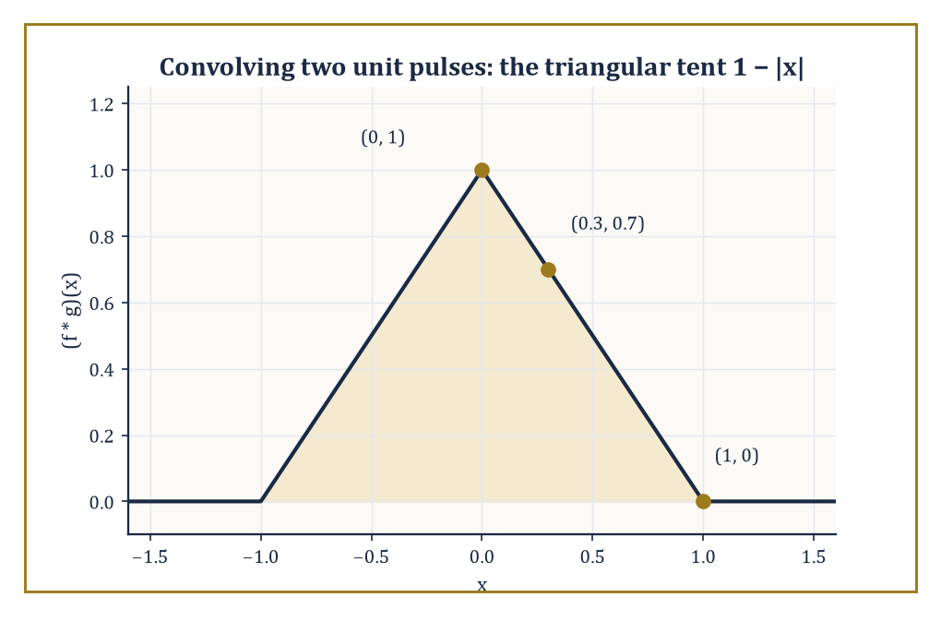
Figure 17.4 — Two sharp-edged unit pulses convolve into one smooth-topped triangle — sharpness averaged away by sliding one box across the other.
(f ∗ g)(x) = ∫ f(y) g(x − y) dy
Read it as a moving, weighted average: to compute (f ∗ g) at the point x, slide a mirror-imaged, shifted copy of g across f, multiply pointwise, and sum (integrate) the result.
It is the continuous analogue of a running average, and it is what happens whenever one linear, time-invariant system (an amplifier, a lens, a resistor–capacitor circuit, a length of optical fiber) processes the output of another, or processes a single signal passing through it: the output is the convolution of the input with the system’s characteristic response.
Convolution obeys the same friendly algebra as ordinary multiplication — commutative (f ∗ g = g ∗ f), associative ((f ∗ g) ∗ h = f ∗ (g ∗ h)), and distributive over addition — despite looking, on first encounter, considerably more alarming than multiplication.
Numeric example — convolving two rectangular pulses. Let f = g be the unit pulse from before: 1 on (−0.5, 0.5), 0 elsewhere. Their convolution (f ∗ g)(x) equals the length of the overlap between the interval (−0.5, 0.5) and its shift (x − 0.5, x + 0.5).
At x = 0: the two intervals coincide exactly, overlap length 1, so
(f ∗ g)(0) = 1
At x = 0.3: the shifted interval is (−0.2, 0.8); intersecting with (−0.5, 0.5) gives (−0.2, 0.5), length 0.7 — matching the general formula for the triangular ‘tent’ function:
(f ∗ g)(x) = 1 − |x|, for |x| ≤ 1
since
1 − 0.3 = 0.7
exactly.
At x = 1: the shifted interval is (0.5, 1.5), which just touches (−0.5, 0.5) at a single point — overlap length 0, so
(f ∗ g)(1) = 0
again matching
1 − |1| = 0
Two sharp-edged boxes convolve into one smooth-topped (if still pointed) triangle — convolution is a smoothing operation, which is why moving averages are used to smooth noisy data.
Try it now — Convolve [1, 1] with itself. Answer →
The convolution theorem is the payoff: the Fourier transform turns convolution into ordinary pointwise multiplication.
(f ∗ g)ˆ(ξ) = f̂(ξ) · ĝ(ξ)
There is a dual statement too — the transform of a pointwise product is a convolution of the transforms (with a normalizing constant depending on convention) — but it is the first direction that does most of the practical work.
Filtering a signal in the frequency domain is nothing more than multiplying its spectrum by a chosen transfer function; the equivalent operation back in the time domain is convolving the signal with that transfer function’s inverse transform, called the impulse response.
This equivalence — a fiddly integral in one domain becoming a simple product in the other — is arguably the single most useful computational fact in the whole of Fourier analysis, and it is the reason the FFT (The Fast Fourier Transform) is so often used not to look at spectra at all, but as a fast way to compute a convolution.
Numeric example — checking the convolution theorem by direct integration. Continue with f = g = unit pulse, so f̂ = ĝ = sinc, and the convolution theorem predicts
(f ∗ g)ˆ(ξ) = sinc²(ξ)
At ξ = 0:
(f ∗ g)ˆ(0) = ∫(f ∗ g)(x) dx = area under the triangular tent = ½ × base × height = ½ × 2 × 1 = 1
sinc²(0) = 1² = 1
— agreed.
At ξ = 0.5, sinc(0.5) = 0.6366 (computed in The Fourier Transform on the Line), so
sinc²(0.5) = 0.4053
Checking directly:
(f ∗ g)ˆ(0.5) = ∫₋₁¹ (1 − |x|) exp(−iπx) dx
and by symmetry this equals
2∫₀¹ (1 − x)cos(πx) dx
Now
∫₀¹ cos(πx) dx = [sin(πx)/π]₀¹ = 0
and by parts
∫₀¹ x cos(πx) dx = [x sin(πx)/π]₀¹ − ∫₀¹ sin(πx)/π dx = 0 − (1/π)[−cos(πx)/π]₀¹ = −(1/π)[(1/π) + (1/π)] = −2/π²
So
∫₀¹(1−x)cos(πx) dx = 0 − (−2/π²) = 2/π²
and doubling gives
4/π² = 4/9.8696 = 0.4053
— matching sinc²(0.5) exactly.
This same idea, stripped down to finite lists of numbers, is the discrete convolution that will reappear constantly once we reach the DFT: given two finite sequences, slide one across the other, multiply overlapping entries, and sum.
It is what a moving-average filter, a digital equalizer, or a simple blur on an image is doing under the bonnet.
Numeric example — a discrete convolution (a taste of things to come). Let a = [1, 2, 3] and let b = [1, 1] be a two-tap moving-average filter. Their (linear) convolution c = a ∗ b has entries
cₖ = Σⱼ aⱼ bₖ₋ⱼ
computed as:
c₀ = a₀b₀ = 1×1 = 1
c₁ = a₀b₁ + a₁b₀ = 1×1 + 2×1 = 3
c₂ = a₁b₁ + a₂b₀ = 2×1 + 3×1 = 5
c₃ = a₂b₁ = 3×1 = 3
So
c = [1, 3, 5, 3]
— each output entry is the sum of a pair of neighboring input entries, the running-sum behavior one would want from a length-2 moving-average filter (up to the missing division by 2). The Discrete Fourier Transform will show how to compute this kind of sum via the DFT and the convolution theorem, and The Fast Fourier Transform will show how to do it fast.
The dual statement, mentioned only in passing above, deserves a moment’s honesty: transforming a pointwise product of two functions gives (up to a normalizing constant that depends on the convention chosen) a convolution of their transforms,
(fg)ˆ = f̂ ∗ ĝ
This is why truncating a signal to a finite observation window — a pointwise product with a window function that is 1 on the window and 0 outside — smears its spectrum by convolving it with the window’s own transform, an unavoidable side effect that becomes the central concern of Windows, Uncertainty, and Limitations.
The two convolution theorems are dual to one another, one living in each domain, and a working Fourier analyst ends up reaching for whichever one turns the calculation at hand from an integral into a product rather than the other way round.
Abstract example — squaring the pulse is windowing it against itself. Let f(x) be the familiar unit pulse, 1 on (−0.5, 0.5) and 0 elsewhere, and consider the pointwise product f(x)·f(x). Since f only ever takes the values 0 and 1, multiplying it by itself changes nothing:
f(x)·f(x) = f(x)
exactly, because 0×0 = 0 and 1×1 = 1. The dual convolution theorem therefore predicts
(f·f)ˆ = f̂ ∗ f̂
i.e. sinc ∗ sinc must equal sinc itself, on pain of contradiction.
This looks alarming until one recalls what convolving with a rectangular pulse’s transform does structurally: f is what mathematicians call idempotent under pointwise multiplication (f·f = f), and the transform of an idempotent function is correspondingly a fixed point of convolution with itself under this theorem — a fact worth filing away precisely because it feels surprising the first time, and is a useful sanity check whenever a window function happens to be 0/1-valued, as the rectangular window of Windows, Uncertainty, and Limitations is.
Keep only this · Section 17.4: Convolution and the Convolution Theorem
The idea. Convolution in time is multiplication in frequency: the transform of f ∗ g is f̂ · ĝ.
Core.
(f ∗ g)(x) = ∫ f(y) g(x − y) dy
the transform of f ∗ g is f̂ · ĝ
Typical mistake. Forgetting to flip one sequence (or function) before sliding it.
Minimal example. The unit pulse convolved with itself is the triangle of width 2 and height 1.
Practice. Easy to challenge; full worked answers, with the usual mistake, are in Answers to the Practice Sets at the back.
Easy — Transform of the triangle that is the pulse convolved with itself. Answer →
Medium — Compute (f ∗ f)(0) for f = the unit pulse on [−1/2, 1/2]. Answer →
Challenge — Why does convolution with a narrow positive bump of area 1 blur but not shift a signal? Answer →

Section 17.5: The Discrete Fourier Transform
Fourier Analysis for Finite Lists of Numbers
CORE · about 15 minutes · later chapters build on this
Key idea — Real data — a recorded sound, a digitized image row, a sensor reading — arrives as a finite list of numbers, not a function on the whole real line, so we need a version of the Fourier transform that eats finite sequences. The discrete Fourier transform (DFT) of a sequence x₀, x₁, …, xₙ₋₁ is another sequence of length n, defined by:
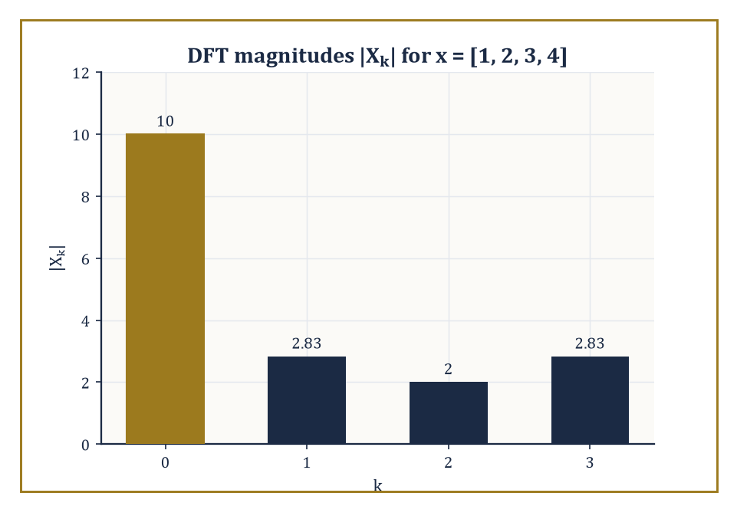
Figure 17.5 — The DFT magnitudes of x = [1, 2, 3, 4] — a lopsided little spectrum, dominated by its own average.
Xₖ = Σⱼ₌₀ⁿ⁻¹ xⱼ exp(−2πijk/n), for k = 0, 1, …, n − 1
It is the exact finite-dimensional analogue of the continuous transform: each output Xₖ measures how strongly the discrete oscillation of frequency k is present in the input. It is invertible by a closely related formula:
xⱼ = (1/n) Σₖ₌₀ⁿ⁻¹ Xₖ exp(2πijk/n)
This is the same structure as the forward transform, with the sign of the exponent flipped and a normalizing factor of 1/n inserted, mirroring the forward/inverse pair for the continuous transform in Inversion, Plancherel, and Parseval.
Numeric example — the DFT of a length-4 sequence. Let x = [1, 2, 3, 4] (n = 4), and write ω = exp(−2πi/4) = exp(−iπ/2) = −i, so that ω² = −1, ω³ = i, ω⁴ = 1. Then the four outputs work out as follows.
X₀ = 1 + 2 + 3 + 4 = 10
X₁ = 1·ω⁰ + 2·ω¹ + 3·ω² + 4·ω³ = 1 + 2(−i) + 3(−1) + 4(i) = (1 − 3) + (−2 + 4)i = −2 + 2i
X₂ = 1·ω⁰ + 2·ω² + 3·ω⁴ + 4·ω⁶ = 1 + 2(−1) + 3(1) + 4(−1) = 1 − 2 + 3 − 4 = −2
X₃ = 1·ω⁰ + 2·ω³ + 3·ω⁶ + 4·ω⁹ = 1 + 2(i) + 3(−1) + 4(−i) = (1 − 3) + (2 − 4)i = −2 − 2i
So X = [10, −2+2i, −2, −2−2i].
Since the input is real, we expect conjugate symmetry, Xₙ₋ₖ = conj(Xₖ). Here that predicts X₃ = conj(X₁):
X₃ = conj(X₁) = conj(−2+2i) = −2−2i
This matches the direct computation of X₃ exactly — a useful self-check that costs nothing and catches a great many arithmetic slips.
Try it now — Compute the DFT of [1, 1] (n = 2). Answer →
The DFT can equally well be written as a matrix multiplication:
X = F·x, where Fₖⱼ = ωᵏʲ, ω = exp(−2πi/n)
Because the rows of F are successive powers of the same n numbers (the n-th roots of unity, 1, ω, ω², …, ωⁿ⁻¹), F is a Vandermonde matrix — a matrix built entirely from powers of a fixed list of values, well known throughout algebra for its role in polynomial interpolation, and rather less well known for turning up, uninvited, wherever roots of unity are allowed to mingle.
This matrix structure is what makes the DFT diagonalize circulant matrices (matrices whose rows are cyclic shifts of one another, which describe periodic/cyclic convolution exactly as ordinary convolution described in Convolution and the Convolution Theorem (Chapter 17)), and it is what lets the DFT compute discrete convolutions via the same convolution theorem met on the continuous line.
Computed naïvely — literally carrying out the matrix–vector multiplication X = F·x term by term, with no cleverness whatsoever — this costs O(n²) arithmetic operations: n outputs, each a sum of n terms, and not one of them aware that The Fast Fourier Transform is about to make ninety per cent of that labor unnecessary.
Abstract example — the DFT matrix for n = 4, made explicit. With ω = exp(−2πi/4) = −i as above, the 4×4 DFT matrix F has entries Fₖⱼ = ωᵏʲ, giving the following four rows.
row k = 0: (ω⁰, ω⁰, ω⁰, ω⁰) = (1, 1, 1, 1)
row k = 1: (ω⁰, ω¹, ω², ω³) = (1, −i, −1, i)
row k = 2: (ω⁰, ω², ω⁴, ω⁶) = (1, −1, 1, −1)
row k = 3: (ω⁰, ω³, ω⁶, ω⁹) = (1, i, −1, −i)
This is a genuine Vandermonde matrix, built from powers of the four fourth roots of unity {1, −i, −1, i}.
Multiplying row k = 1 by x = [1, 2, 3, 4]ᵀ gives:
1(1) + (−i)(2) + (−1)(3) + (i)(4) = 1 − 2i − 3 + 4i = −2 + 2i
This is X₁ from the worked example above — the matrix picture and the direct-sum picture are the same calculation viewed two ways, but seeing the matrix laid out makes the Vandermonde structure, and the O(n²) cost of using it naïvely, visually unmistakable.
The DFT is, in short, the natural tool for the spectral analysis of any signal that is finite, or periodic, or (as is overwhelmingly the common case in practice) sampled at evenly spaced instants from a continuous signal one is trying to approximate.
It is also, on its own, computationally embarrassing: doubling the length of a signal quadruples the work required to transform it via the naïve matrix–vector product, which for the kind of signal lengths that arise in audio (tens of thousands of samples per second) or imaging (millions of pixels) would make the DFT a theoretical nicety rather than a practical tool.
The DFT is the object that the FFT, met next, computes efficiently — without changing a single one of its mathematical properties, only the arithmetic cost of extracting them.
Before leaving the DFT, it is worth checking that Section 17.3’s Plancherel identity survives the crossing from the continuous line to the finite, discrete setting — it does, with the same 1/n factor that appears in the inversion formula. The discrete Parseval identity states that total energy in the samples equals a rescaled total energy in the spectrum:
Σⱼ|xⱼ|² = (1/n) Σₖ|Xₖ|²
Numeric example — discrete Parseval for x = [1, 2, 3, 4]. Using x = [1, 2, 3, 4] and X = [10, −2+2i, −2, −2−2i] from above, the time-domain energy is:
Σⱼ|xⱼ|² = 1² + 2² + 3² + 4² = 1 + 4 + 9 + 16 = 30
The frequency-domain side is:
(1/n)Σₖ|Xₖ|² = (1/4)(|10|² + |−2+2i|² + |−2|² + |−2−2i|²)
Evaluating each term individually:
|10|² = 100
|−2+2i|² = (−2)² + 2² = 4 + 4 = 8
|−2|² = 4
|−2−2i|² = (−2)² + (−2)² = 4 + 4 = 8
Summing:
100 + 8 + 4 + 8 = 120, and (1/4)(120) = 30
This matches the time-domain energy exactly, digit for digit, confirming that the DFT (with this normalization) is just as energy-faithful as its continuous ancestor.
Keep only this · Section 17.5: The Discrete Fourier Transform
The idea. Xₖ = Σⱼ xⱼ ωᵏʲ with ω = exp(−2πi/n); the DFT is multiplication by an n × n matrix of roots of unity.
Core.
X_{k} = Σ[n = 0 to N − 1] xₙ exp(−2πikn/N)
Typical mistake. Indexing from 1 instead of 0, which shifts every exponent.
Minimal example. x = (1, 0, 0, 0): X = (1, 1, 1, 1).
Practice. Easy to challenge; full worked answers, with the usual mistake, are in Answers to the Practice Sets at the back.
Easy — DFT of x = (1, 1, 1, 1). Answer →
Medium — DFT of x = (1, −1, 1, −1). Answer →
Challenge — For a real signal, how is X_{N−k} related to X_{k}? Answer →

Section 17.6: The Fast Fourier Transform
The Same Answer, For Considerably Less Effort
CORE · about 15 minutes · later chapters build on this
Definition — The fast Fourier transform (FFT) computes exactly the DFT defined in The Discrete Fourier Transform — bit for bit the same output — but in O(n log n) arithmetic operations rather than O(n²), when n is a power of two (more elaborate versions of the algorithm handle general n, at some cost in elegance).
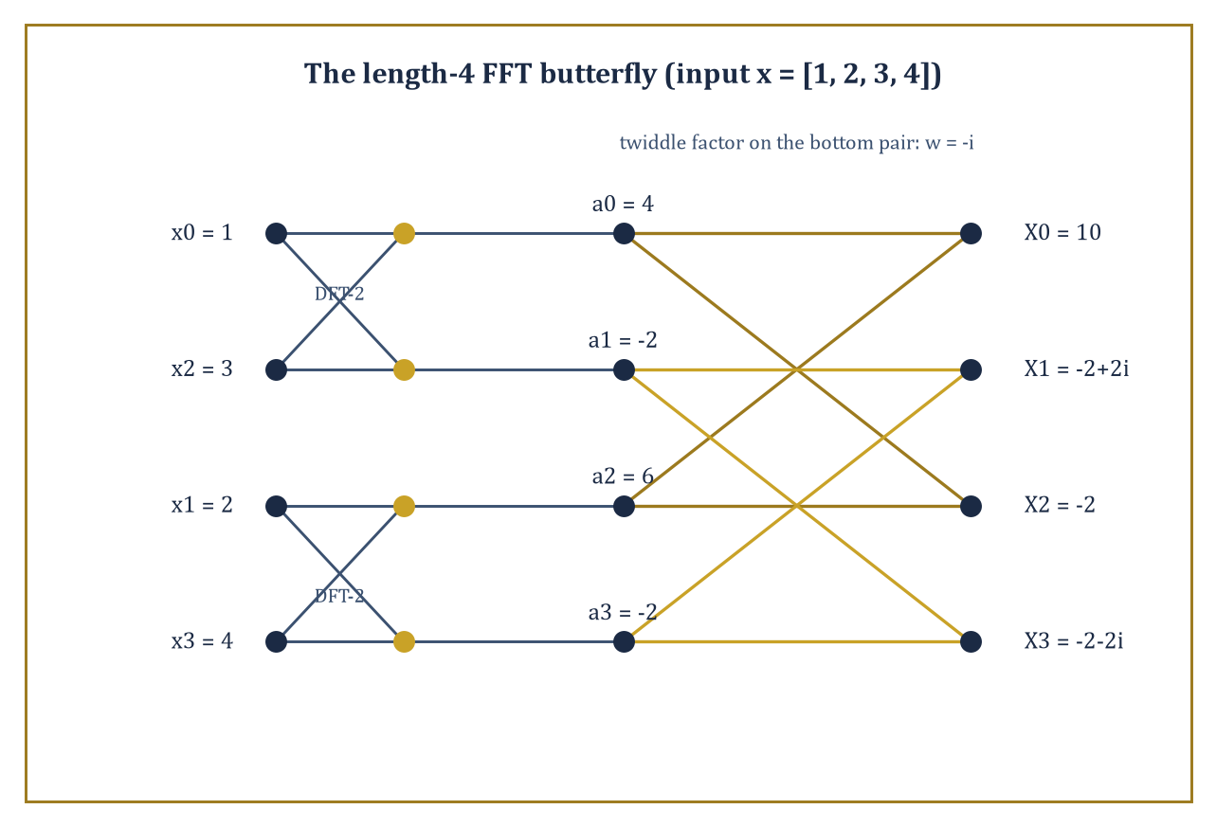
Figure 17.6 — The length-4 FFT butterfly, split and recombined on x = [1, 2, 3, 4] — the same ten, minus-two-plus-two-i answer, for a fraction of the arithmetic.
The classical Cooley–Tukey algorithm achieves this by divide and conquer: split the length-n sum defining Xₖ into two half-length sums, one over the even-indexed inputs and one over the odd-indexed inputs, each of which is itself a length-(n/2) DFT. Combine the two half-length results with a handful of multiplications by ‘twiddle factors’ (powers of ω) to recover the full length-n answer.
Apply the same splitting trick recursively to each half-length DFT, and the recursion bottoms out after log₂n levels, since each level halves the problem size. The total work across all levels — n operations per level, log₂n levels — is O(n log n).
Numeric example — computing the length-4 DFT the fast way. Reuse x = [1, 2, 3, 4] from The Discrete Fourier Transform.
Split into the even-indexed entries [x₀, x₂] = [1, 3] and the odd-indexed entries [x₁, x₃] = [2, 4]. Each is a length-2 DFT, computed by the trivial two-point formula (sum and difference):
E₀ = 1 + 3 = 4
E₁ = 1 − 3 = −2
O₀ = 2 + 4 = 6
O₁ = 2 − 4 = −2
Combine using the butterfly formulas below, with ω = exp(−2πi/4) = −i (n = 4, so k ranges over 0 and 1):
Xₖ = Eₖ + ωᵏ·Oₖ
X_{k+n/2} = Eₖ − ωᵏ·Oₖ
For k = 0, ω⁰ = 1, giving:
X₀ = E₀ + 1·O₀ = 4 + 6 = 10
X₂ = E₀ − 1·O₀ = 4 − 6 = −2
For k = 1, ω¹ = −i, giving:
X₁ = E₁ + (−i)·O₁ = −2 + (−i)(−2) = −2 + 2i
X₃ = E₁ − (−i)·O₁ = −2 − 2i
The result, X = [10, −2+2i, −2, −2−2i], matches the direct computation from The Discrete Fourier Transform exactly — as it must, since the FFT computes nothing new, only faster.
Notice the arithmetic performed: two tiny two-point DFTs (pure additions and subtractions, no multiplication at all) plus exactly two nontrivial multiplications in the combine step (by ω⁰ = 1, which is free, and ω¹ = −i).
For n = 4 the saving over the naïve O(n²) route is invisible; scale n up to a million and the saving is the difference between a transform that finishes while you wait and one that doesn’t finish this side of the heat death of the universe.
Try it now — About how many operations does an FFT of length 1024 need, compared with a direct DFT? Answer →
The same divide-and-conquer idea, once you have it, turns out to be reusable well beyond spectrum analysis. Fast discrete convolution (via the convolution theorem of Convolution and the Convolution Theorem (Chapter 17): transform both sequences with the FFT, multiply pointwise, transform back) beats direct convolution for anything but the shortest sequences.
Multiplication of very large integers — the kind of arithmetic needed for cryptography or for computing digits of π — can be phrased as a convolution of digit sequences and accelerated the same way. And certain structured linear systems (those built from circulant or Toeplitz matrices) can be solved via the FFT rather than by general-purpose linear algebra.
Modern software implementations layer further cleverness on top of the basic recursive idea: exploiting cache hierarchies so data stays close to the processor, using vector instructions that perform several arithmetic operations per clock cycle, and exploiting the extra symmetry available when the input data is real-valued (as it usually is) rather than fully complex, to approach the theoretical minimum operation count.
Numeric example — multiplying integers by convolving their digits. Multiplying 23 × 21 can be recast as convolving two short sequences.
Write 23 as the coefficient list [3, 2] (units digit first, then tens digit):
23 = 3 + 2×10
and 21 as [1, 2]:
21 = 1 + 2×10
Convolve them as in Convolution and the Convolution Theorem (Chapter 17):
c₀ = 3×1 = 3
c₁ = 3×2 + 2×1 = 6 + 2 = 8
c₂ = 2×2 = 4
The convolved coefficients [3, 8, 4] represent the polynomial:
3 + 8×10 + 4×100 = 3 + 80 + 400 = 483
Check by ordinary multiplication:
23 × 21 = 483
That’s correct. For two three-digit numbers or two thousand-digit numbers the idea is identical; only the digit sequences get longer, and it is then that computing the convolution via the FFT (transform, multiply pointwise, invert) rather than directly becomes worth the trouble, turning an O(n²) digit-by-digit multiplication into an O(n log n) one.
A fair question at this point: what happens when n is not a conveniently round power of two? Real signal lengths rarely oblige a mathematician’s preference for tidy numbers.
The classical fix is to pad the sequence with zeros up to the next power of two — harmless, since appending zeros to a signal doesn’t change the information it carries, merely the length of the list storing it — and more elaborate algorithms (Bluestein’s algorithm chief among them) handle arbitrary n directly, at the cost of a slightly more intricate derivation, by re-expressing an arbitrary-length DFT as a convolution that itself can be computed by a power-of-two FFT.
Either way, the qualitative conclusion survives intact: essentially any DFT, of essentially any length, can be computed in very close to n log n time, and the days of paying n² for the privilege are, outside of teaching examples like the ones in this Section, comfortably behind us.
Keep only this · Section 17.6: The Fast Fourier Transform
The idea. The FFT splits a length-n DFT into two length-n/2 DFTs and recombines them in O(n), giving O(n log n) overall.
Core.
split even and odd samples: X_{k} = E_{k} + exp(−2πik/N) O_{k}
cost O(N log N)
Typical mistake. Thinking the FFT computes an approximation; it computes exactly the same numbers as the DFT.
Minimal example. N = 1024: direct about 10⁶ operations, FFT about 10⁴.
Practice. Easy to challenge; full worked answers, with the usual mistake, are in Answers to the Practice Sets at the back.
Easy — How many halvings does an FFT of length 1024 need? Answer →
Medium — Compare N² and N log₂ N for N = 2²⁰. Answer →
Challenge — Why does the radix-2 FFT need N to be a power of 2, and what is done otherwise? Answer →

Section 17.7: Applications: Filtering, PDEs, and Signal Processing
What All This Machinery Is Actually For
CORE · about 15 minutes · later chapters build on this
Definition — Linear filtering — removing noise, isolating a wanted frequency band, boosting the bass on a stereo — is, in the frequency domain, nothing more than multiplying a signal’s spectrum by a chosen transfer function. A low-pass filter keeps a transfer function near 1 for frequencies below some cutoff and near 0 above it; a high-pass filter does the reverse; a band-pass filter keeps a window in the middle and suppresses everything outside it.
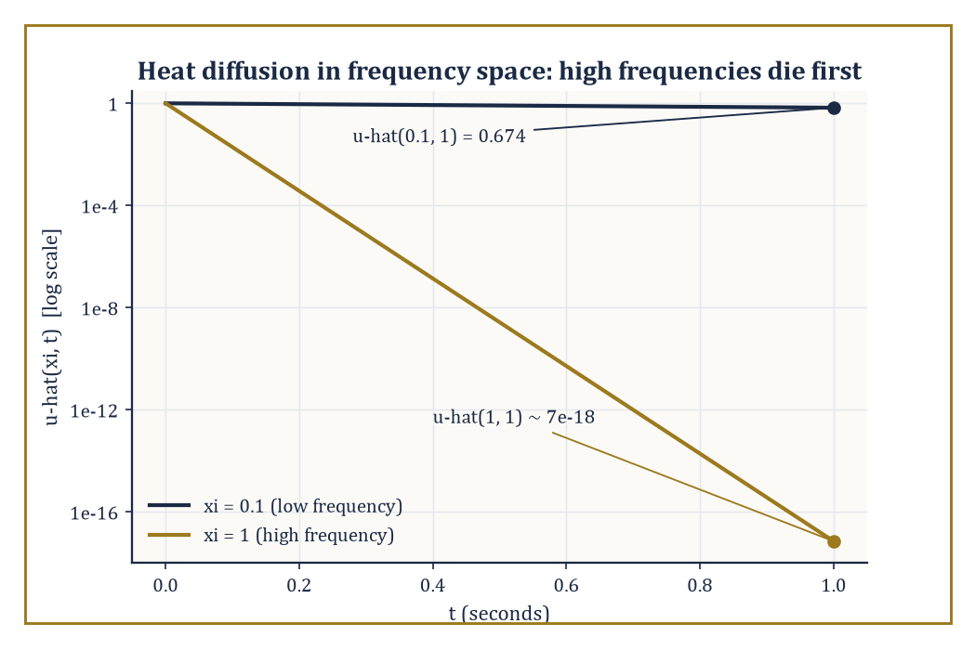
Figure 17.7 — The heat equation solved by inspection in frequency space: high frequencies are annihilated almost at once, low ones linger.
One designs the filter by specifying the desired shape of the transfer function directly in frequency space (where the requirement — ‘remove everything above 4 kHz’ — is easy to state), then either applies it there via the DFT/FFT, or transforms it back to a time-domain impulse response and applies it as a convolution, whichever is computationally cheaper for the task at hand.
Numeric example — the simplest possible low-pass filter. Take the DFT computed in The Discrete Fourier Transform:
x = [1, 2, 3, 4], X = [10, −2+2i, −2, −2−2i]
The crudest imaginable low-pass filter keeps only the zero-frequency (DC) component and discards everything else:
Y = [10, 0, 0, 0]
Inverting via xⱼ = (1/n)Σₖ Yₖ exp(2πijk/n) gives, since only the k = 0 term survives,
xⱼ = (1/4)(10) = 2.5 for every j
The filtered output is the constant sequence [2.5, 2.5, 2.5, 2.5] — and indeed the mean of the original data (1+2+3+4)/4 = 2.5. Keeping only the DC component of a spectrum and inverting always returns the average of the signal: the most extreme possible low-pass filter, with a cutoff of essentially zero, degenerates to computing a mean. Every less extreme low-pass filter interpolates between this constant output and the original, unfiltered signal.
Try it now — In the heat equation uₜ = uₓₓ, how does the mode with frequency ξ decay? Answer →
Numeric example — and its complementary high-pass filter. The complementary high-pass filter does the opposite: discard only the DC term and keep everything else,
Z = [0, −2+2i, −2, −2−2i]
Because the original spectrum splits just as X = Y + Z (low-pass component plus high-pass component, with no overlap and nothing double-counted), the corresponding time-domain signals must also add back to the original: inverting Z gives zⱼ = xⱼ − 2.5, namely
z = [−1.5, −0.5, 0.5, 1.5]
Check: adding the low-pass output [2.5, 2.5, 2.5, 2.5] to this high-pass output gives
[2.5, 2.5, 2.5, 2.5] + [−1.5, −0.5, 0.5, 1.5] = [1, 2, 3, 4]
the original signal, exactly. A high-pass filter, in other words, is precisely what is left over after the mean has been subtracted away — it captures fluctuation around the average, discarding the average itself, which is why high-pass filtering is the standard first step in removing a slowly drifting baseline from a noisy measurement.
Constant-coefficient linear partial differential equations, defined on the whole line or on a periodic domain (a torus), become ordinary differential equations — or, after also transforming time, plain algebraic equations — once Fourier-transformed in the spatial variable. The reason is the eigenfunction fact from The Fourier Transform on the Line: spatial derivatives become multiplication by powers of 2πiξ, so a differential operator in x becomes a polynomial in ξ acting by multiplication. The heat equation, the wave equation, and Laplace’s equation all become transparent — often trivial — once transformed; the inverse transform then returns the solution in the original physical variables.
Numeric example — the heat equation in Fourier space. The heat equation uₜ = uₓₓ, Fourier-transformed in x (using the rule that ∂²/∂x² becomes multiplication by (2πiξ)² = −4π²ξ²), turns into the ordinary differential equation, for each fixed frequency ξ:
∂û/∂t = −4π²ξ²·û(ξ,t)
This solves immediately:
û(ξ,t) = û(ξ,0)·exp(−4π²ξ²t)
Suppose û(ξ,0) = 1 at ξ = 0.1 (an arbitrarily normalized low-frequency component). After t = 1 second:
û(0.1, 1) = exp(−4π²(0.01)(1)) = exp(−0.3948) = 0.674
the component has decayed to about two-thirds of its initial strength. Compare a higher frequency, ξ = 1, under the same conditions:
û(1,1) = exp(−4π²(1)(1)) = exp(−39.48) ≈ 7 × 10⁻¹⁸
— indistinguishable from zero. High-frequency components (sharp spatial detail) are annihilated by diffusion almost instantly, while low-frequency components (broad, smooth features) persist; this is the Fourier-space explanation of why heat diffusion smooths everything it touches, blurring fine detail long before it erodes the broad shape of a temperature distribution.
In signal processing more broadly, the DFT and FFT are the working engines behind spectrum analysis (turning a recorded waveform into a picture of which frequencies it contains), OFDM communication (splitting a data stream across many narrow, mutually orthogonal frequency subcarriers — orthogonal in the inner-product sense of Inversion, Plancherel, and Parseval — so that many independent channels can share one transmission band without interfering), and MRI reconstruction (where the raw data collected by a scanner is literally samples of the Fourier transform of the tissue’s spatial density, and the image itself is recovered by an inverse two-dimensional FFT).
The mathematical structure underneath all three is identical; only the physical meaning attached to the variables x and ξ changes — time and audio frequency, or antenna time-slot and radio frequency, or spatial position and spatial frequency.
It is worth dwelling for a moment on just how strange the MRI case is, because it inverts the usual intuition about what is ‘directly observed’. A scanner never measures tissue density itself; the physics of nuclear magnetic resonance hands the machine samples of the Fourier transform of that density, point by point, arranged on a grid engineers call k-space. The clinically useful picture — the image a radiologist reads — exists only after an inverse two-dimensional FFT has been applied to that raw data. Every MRI scan performed anywhere in the world is, quite literally, an application of Section 17.3’s inversion formula to real, physical measurements; the abstract machinery of this chapter is not a metaphor for medical imaging; it is medical imaging.
Keep only this · Section 17.7: Applications: Filtering, PDEs, and Signal Processing
The idea. Filtering is multiplication in frequency space; PDEs with constant coefficients become ODEs, one per frequency.
Core.
filter: multiply f̂ by H(ξ), then invert
heat equation: û(ξ, t) = û(ξ, 0) exp(−4π²kξ²t)
Typical mistake. Forgetting that a filter applied to a DFT acts on a periodic extension of the data.
Minimal example. A low-pass filter sets f̂(ξ) = 0 for |ξ| > ξ₀.
Practice. Easy to challenge; full worked answers, with the usual mistake, are in Answers to the Practice Sets at the back.
Easy — Which frequencies does the heat equation damp fastest? Answer →
Medium — What does differentiating f do to f̂? Answer →
Challenge — Why does an ideal (brick-wall) low-pass filter produce ringing in time? Answer →

Section 17.8: Windows, Uncertainty, and Limitations
You Cannot Have It All, and Here Is the Proof
CORE · about 15 minutes · later chapters build on this
Definition — Every real signal is finite in duration — nobody has ever recorded a sound for all eternity, however long certain lectures may have felt. Analyzing a finite chunk of an otherwise longer signal is mathematically equivalent to multiplying the ideal (infinite) signal by a window function that is 1 over the observed interval and 0 outside it, and multiplication in time is convolution in frequency (the dual of the convolution theorem from Convolution and the Convolution Theorem (Chapter 17)).
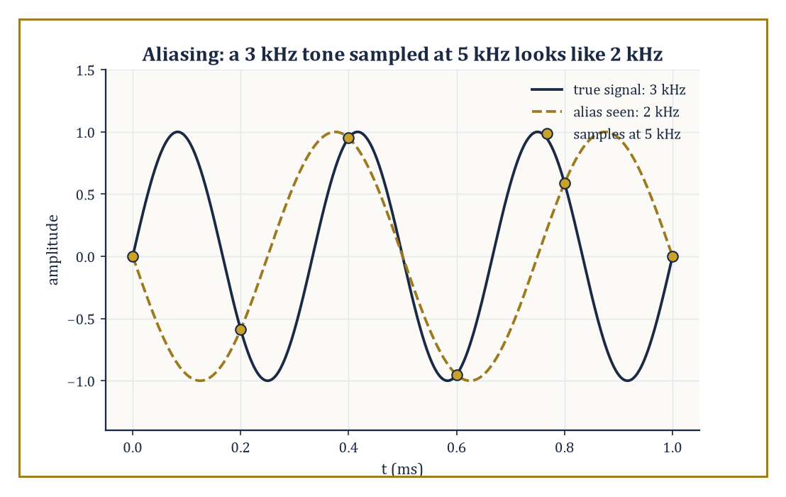
Figure 17.8 — A 3 kHz tone sampled below the Nyquist rate lands, unrecoverably, on the same samples as a 2 kHz tone.
The observed spectrum is therefore not the true spectrum but the true spectrum smeared — convolved — with the transform of the window. A rectangular window (chopping the signal off) has a transform that is the sinc function of The Fourier Transform on the Line, whose fat, slowly decaying side-lobes smear energy from a true, sharp spectral line out across many neighboring frequencies, an effect called spectral leakage.
Softer windows (Hann, Hamming, Kaiser, and other named shapes, each a small taper toward zero at the ends of the observed interval rather than an abrupt cut) trade a wider central lobe (less precise localization of a true frequency) for smaller side-lobes (less leakage into neighboring frequencies) — there is no window that improves both simultaneously.
Numeric example — how leaky is a plain rectangular window?. The rectangular window’s transform is sinc(ξ), with its first zero at ξ = 1 and its first side-lobe peak shortly afterward, near ξ ≈ 1.5. Evaluate there:
sinc(1.5) = sin(1.5π)/(1.5π) = sin(270°)/(4.712) = (−1)/4.712 = −0.2122
Relative to the main peak, sinc(0) = 1, this side-lobe has magnitude 0.2122, or in decibels:
20 log₁₀(0.2122) = 20 × (−0.6733) = −13.5 dB
That figure — a rectangular window’s leakage sits only around 13 dB below its main peak, a rather modest amount of suppression — is the textbook justification for reaching for a gentler window whenever a weak spectral feature needs to be resolved next to a strong one; the strong one’s leakage would otherwise bury it.
Try it now — A 900 Hz tone is sampled at 1000 Hz. At what frequency does it appear? Answer →
Underneath all window design lies a hard mathematical limit, not merely an engineering inconvenience: the uncertainty principle. It states that a function and its Fourier transform cannot both be arbitrarily sharply concentrated — informally, a signal that is very short in time necessarily has a very broad spread of frequencies, and a signal built from a very narrow band of frequencies necessarily rings on for a very long time.
Quantitatively, if σₓ and σξ denote the standard deviations (a measure of spread) of |f(x)|² and |f̂(ξ)|² respectively, then:
σₓ·σξ ≥ 1/(4π)
Equality is achieved only by the Gaussian. This is not a statement about measurement technology or clever engineering getting around a limitation; it is a theorem, as unforgiving as anything in this series, and it is the mathematical reason every spectrogram (a picture of how a signal’s frequency content changes over time) faces an inescapable trade-off between time resolution and frequency resolution.
Worked example — the Gaussian achieves the uncertainty bound exactly. Take f(x) = exp(−πx²) once more, so |f(x)|² = exp(−2πx²). Its variance in x is:
σₓ² = ∫x²exp(−2πx²)dx / ∫exp(−2πx²)dx
Using the standard Gaussian-integral ratio:
∫x²exp(−ax²)dx / ∫exp(−ax²)dx = 1/(2a)
with a = 2π, this gives:
σₓ² = 1/(4π) ≈ 0.0796, so σₓ ≈ 0.2821
Because f̂(ξ) = exp(−πξ²) has the same functional form (self-duality again earning its keep), the same computation on the transform side gives:
σξ² = 1/(4π) ≈ 0.0796, so σξ ≈ 0.2821
The product is:
σₓ²σξ² = 1/(16π²), i.e. σₓσξ = 1/(4π) ≈ 0.0796
This lands exactly on the uncertainty bound, with equality rather than strict inequality. No other function does better; the Gaussian is, in this precise sense, the most simultaneously localized shape that a signal and its spectrum can ever jointly achieve, which is why it turns up as the ‘ideal’ window shape in more sophisticated time-frequency analysis, and (not coincidentally) why it saturates the analogous quantum-mechanical uncertainty relation between position and momentum.
A second, entirely separate limitation deserves mention before we leave this Section, since it governs the sampling rate rather than the window shape: the Nyquist–Shannon sampling theorem. It states that a signal containing no frequency component above some limit B can be perfectly reconstructed from samples taken at a rate of at least 2B per unit time; sample any slower, and distinct high frequencies become indistinguishable from — literally fold down onto — lower ones, a phenomenon called aliasing.
This is not a subtle numerical artifact but a hard mathematical consequence of the DFT machinery: sampling a continuous signal is itself a kind of modulation with the sampling comb, and the convolution theorem of Convolution and the Convolution Theorem (Chapter 17) says the resulting spectrum is periodic with period equal to the sampling rate, so any true frequency above half that rate gets reflected back into the range the sampled data can represent.
Numeric example — aliasing a signal sampled too slowly. Suppose a pure tone at 3 kHz is sampled at 5 kHz — well-intentioned, but short of the 6 kHz that the Nyquist rate (twice the signal frequency) would require. The Nyquist frequency for this sampling rate is half of 5 kHz, i.e. 2.5 kHz, and the true 3 kHz component lies above it, so it cannot be represented faithfully.
The alias it folds down to is found by reflecting 3 kHz around the Nyquist frequency of 2.5 kHz: the reflected frequency is
2×2.5 − 3 = 2 kHz
A listener examining only the sampled data would see, incorrectly but unambiguously, a tone at 2 kHz — the original 3 kHz information is not merely attenuated but permanently and unrecoverably relabeled as a lower frequency that was never actually present. This is why audio equipment places an anti-aliasing (low-pass) filter before the analog-to-digital converter, removing any content above half the sampling rate before it has the chance to masquerade as something it isn’t.
Understanding these limitations is not a footnote to Fourier analysis; it is half of the subject. Every practical use of the transform — every spectrum plotted, every filter designed, every PDE solved numerically — is an approximation shaped by the finite window one was forced to use, the finite sampling rate at which the continuous world was digitized, and the finite precision with which a computer represents a real number.
Signals with transient features (a sudden click, a short burst) are handled poorly by plain Fourier methods because of the uncertainty trade-off just proved; this is the opening through which wavelets, waiting in Chapter 40 (Volume 4), make their entrance — they deliberately sacrifice some frequency purity in exchange for simultaneous localization in time, a bargain that plain sines and cosines, being infinitely long-lived oscillations by nature, are constitutionally unable to strike.
Keep only this · Section 17.8: Windows, Uncertainty, and Limitations
The idea. Sample faster than twice the highest frequency present; otherwise high frequencies alias to low ones. Short windows blur frequency.
Core.
Δx · Δξ ≥ 1/(4π)
equality for Gaussians
Typical mistake. Believing a better instrument beats the uncertainty principle; it is a property of waves.
Minimal example. Halve a pulse’s width and its spectrum doubles in width.
Practice. Easy to challenge; full worked answers, with the usual mistake, are in Answers to the Practice Sets at the back.
Easy — A signal is made shorter in time. What happens to its spread in frequency? Answer →
Medium — Why does multiplying by a window before a DFT reduce leakage? Answer →
Challenge — Which functions achieve equality in the uncertainty principle? Answer →

Chapter 17 in One Page
The Fourier transform f̂(ξ) = ∫ f(x) exp(−2πixξ) dx measures how much of each frequency a signal contains. It turns shifts into phases, derivatives into multiplication by 2πiξ, and convolution into multiplication. Inversion and Plancherel say nothing is lost. The discrete Fourier transform does the same for n samples, and the FFT computes it in O(n log n). Sampling, windows and uncertainty set the practical limits.
Key definitions
• Fourier transform f̂(ξ) (ordinary frequency) and F(ω) (angular frequency, ω = 2πξ).
• Convolution (f ∗ g)(x) = ∫ f(y) g(x − y) dy.
• DFT Xₖ = Σⱼ xⱼ exp(−2πijk/n).
• Nyquist frequency: half the sampling rate.
Key theorems, with their hypotheses
• Inversion — hypothesis: f and f̂ integrable.
• Plancherel — hypothesis: f square-integrable; factor 1/(2π) in the ω convention.
• Convolution theorem — hypothesis: f, g integrable (circular for the DFT).
• Sampling theorem — hypothesis: the signal contains no frequency at or above half the sampling rate.
Canonical example
• The unit pulse on (−1/2, 1/2): f̂(ξ) = sinc(ξ) = sin(πξ)/(πξ); Plancherel gives ∫ sinc² = 1, and the pulse convolved with itself is a triangle whose transform is sinc².
Common errors
• Mixing the ξ and ω conventions.
• Forgetting to flip in a convolution.
• Sign of the exponent in the DFT.
• Aliasing ignored when sampling.
Readiness checklist — you are ready for what comes next when you can:
□ compute the transform of a pulse, a decaying exponential and a Gaussian
□ apply the shift, scaling and derivative rules
□ convolve short sequences and check with the convolution theorem
□ compute a small DFT by hand and explain the FFT saving
□ predict the alias of an undersampled tone
Section 17.9 that follows is a preview, marked optional: it says where these ideas lead in later chapters and volumes. Nothing in it is needed for the exercises.

Section 17.9: Where This Goes Next (Optional): From Fourier to Laplace, Wavelets, and Spectral Theory
The View From the End of This Chapter
PREVIEW — OPTIONAL · about 15 minutes · optional; read for orientation, nothing is examined
Overview — We have now assembled the core of Fourier analysis, and it is worth taking stock of the whole journey rather than just the last step.
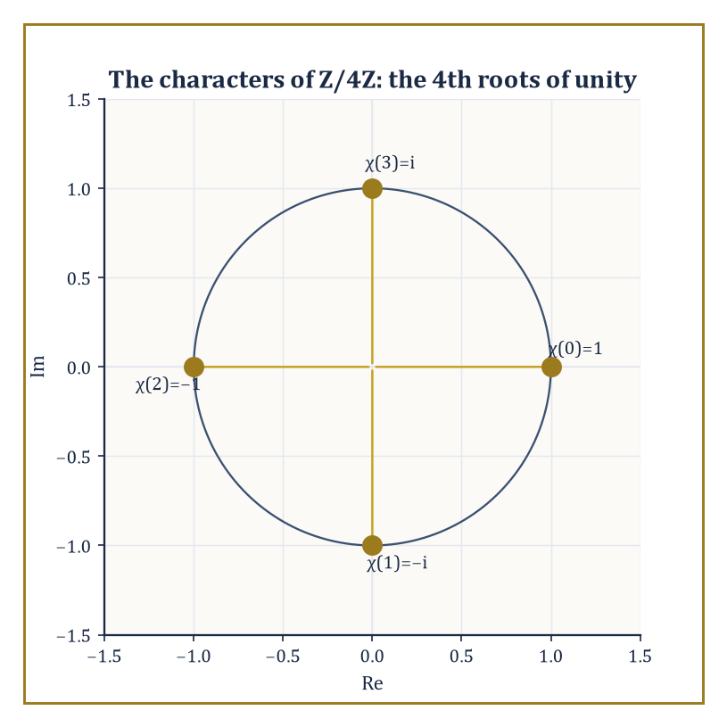
Figure 17.9 — The 4th roots of unity, the characters of ℤ/4ℤ — every DFT matrix entry in this chapter was one of these four points all along.
Fourier series (Chapter 16) decomposed periodic functions into a discrete comb of pure oscillations; letting the period run to infinity (From Fourier Series to the Fourier Transform) turned that comb into a continuum, giving the Fourier transform on the line (The Fourier Transform on the Line).
Inversion and Plancherel (Inversion, Plancherel, and Parseval) confirmed that nothing was lost in the process, only relabeled, and that the relabeling preserves a natural notion of energy; the convolution theorem (Convolution and the Convolution Theorem (Chapter 17)) turned the transform into the single most useful computational shortcut in the whole toolkit.
The DFT (The Discrete Fourier Transform) transplanted every one of these ideas to finite, computer-friendly data; the FFT (The Fast Fourier Transform) made that transplant fast enough to matter at scale; and Applications: Filtering, PDEs, and Signal Processing put the machinery to work on filters, on partial differential equations, and on the signal-processing technologies that run unnoticed in the background of modern life, before Windows, Uncertainty, and Limitations insisted, rightly, that none of this comes for free.
All of this generalizes.
The deepest structural fact underlying the entire chapter is that translation-invariant linear operators — operators that treat every point of space or every moment of time alike, with no preferred origin — are the operators diagonalized by the Fourier transform.
Convolution with a fixed function h is one such operator, and we have already seen it act as multiplication by ĥ(ξ) on each frequency component.
This single idea reappears, essentially unchanged in spirit, throughout mathematics and physics: as the spectral theorem for translation-invariant operators (Chapter 35 (Volume 3) and beyond), as the machinery of Fourier analysis on finite groups and on more exotic algebraic structures such as the adeles in number theory, and as the mathematical language of quantum mechanics, where the Fourier transform relates the position and momentum representations of a quantum state and the uncertainty principle of Windows, Uncertainty, and Limitations is, quite literally, the Heisenberg uncertainty principle in another guise.
Abstract example — a convolution operator, viewed as a diagonal matrix in disguise. Let h be a filter with transfer function
ĥ(ξ) = 1/(1 + ξ²)
A smooth, everywhere-positive low-pass shape that suppresses high frequencies without ever fully zeroing them out. Consider the pure oscillation exp(2πix(2)), i.e. the frequency-2 component of some signal. Convolving with h acts on this component as an eigenvalue would:
(h ∗ exp(2πi·2x)) = ĥ(2)·exp(2πi·2x) = [1/(1+4)]·exp(2πi·2x) = 0.2·exp(2πi·2x)
The shape of the oscillation is completely unchanged, only its amplitude is scaled, here down to a fifth of its original size. Compare the frequency-0 (constant) component:
ĥ(0) = 1/(1+0) = 1
Left entirely alone. This is the whole content of ‘diagonalization’ in one small, checkable instance: in the basis of pure frequencies, the convolution operator h* is represented not by some complicated matrix mixing frequencies together, but by a diagonal matrix whose k-th diagonal entry is ĥ(k) — an infinite-dimensional analogue of a diagonal matrix in ordinary linear algebra, where multiplying by a diagonal matrix scales each coordinate axis independently and leaves the axes themselves untouched.
Try it now — What does the Laplace transform add to the Fourier transform? Answer →
The DFT of The Discrete Fourier Transform, in particular, is nothing other than Fourier analysis on the cyclic group of order n — the group ℤ/nℤ of integers modulo n under addition.
Its n eigen-frequencies, the n-th roots of unity, are precisely the group’s characters: the homomorphisms from ℤ/nℤ into the complex numbers of modulus 1, each one respecting the group’s addition — a character χ satisfies
χ(a+b) = χ(a)χ(b)
Every finite abelian group has its own such family of characters and its own version of the DFT built from them; the classical DFT is the case of a single cyclic group, chosen because it is the shape that time, sampled at evenly spaced instants, naturally takes.
Abstract example — the roots of unity as group characters. Take n = 4 again, so the group is ℤ/4ℤ = {0, 1, 2, 3} under addition modulo 4, and consider the character
χ(k) = ωᵏ = (−i)ᵏ
Used throughout The Discrete Fourier Transform and The Fast Fourier Transform. Check the defining property χ(a+b) = χ(a)χ(b) for a = 1, b = 2 (so a+b = 3 mod 4):
χ(1)χ(2) = (−i)(−1) = i
χ(3) = (−i)³ = i
They agree. Check also a = 3, b = 2 (so a+b = 5 mod 4 = 1):
χ(3)χ(2) = (i)(−1) = −i
χ(1) = −i
Agreed again. This is the abstract fact hiding inside every DFT computation in this chapter: the entries ωʲᵏ of the DFT matrix are not an arbitrary convenient choice, but the characters of the group of sample indices, and the DFT is the special case, for this particular group, of a construction (Fourier analysis on locally compact abelian groups) that also produces the classical Fourier series (the group is the circle), the Fourier transform on the line (the group is the real numbers themselves), and — considerably later in the series — Fourier analysis on the adeles that underlies parts of modern number theory.
The Fourier transform’s near neighbor, waiting immediately next door in Chapter 18, is the Laplace transform — built from the same family of exponentials but weighted by a real (or complex, with positive real part) decay rate rather than a purely imaginary oscillation frequency, which suits it particularly well to causal signals (those that switch on at a definite starting moment and are silent before it) and to initial-value problems, where one is given the state of a system at time zero and asked to predict its future rather than to analyze an eternally-existing signal.
Where the Fourier transform asks ‘which frequencies are present, for all time’, the Laplace transform asks ‘given where we start, how does the system evolve’ — a change of emphasis rather than a change of underlying machinery, and one that will feel remarkably familiar by the time we arrive.
The deeper lesson of this entire chapter, stated plainly, is that a great many of the operators nature hands us are diagonalized by waves — and that the mathematics of those waves, having started as a slightly suspicious trick for solving the heat equation two centuries ago, has become both theoretically deep and practically indispensable in roughly equal measure.
We have learned to hear the frequencies hidden inside a signal — to take an object that lives, stubbornly, in one variable (time, or position) and rewrite it, losing nothing, in terms of another (frequency) in which the operators we care about become almost embarrassingly simple. That rewriting, and the fast algorithm that makes it affordable at any scale worth caring about, is one of the genuine load-bearing pillars of the last hundred years of applied mathematics; very little of modern engineering would run without it, and a surprising amount of pure mathematics leans on it too.
Chapter 18 waits next door with the Laplace transform, built from the same exponentials but tuned to systems that switch on at a definite moment and evolve forward from it. Mind the step — and bring your new taste for diagonalizing operators with you.
Keep only this · Section 17.9: Where This Goes Next (Optional): From Fourier to Laplace, Wavelets, and Spectral Theory
The idea. Laplace, wavelets and spectral theory each keep one feature of Fourier analysis and relax another.
Core.
Laplace: F(s) = ∫[0, ∞] f(t) exp(−st) dt, s = σ + 2πiξ
Typical mistake. Applying the Fourier transform to growing functions such as eᵗ, which it cannot handle; that is the Laplace transform’s job.
Minimal example. eᵗ has no Fourier transform, but its Laplace transform 1/(s − 1) exists for Re s > 1.
Practice. Easy to challenge; full worked answers, with the usual mistake, are in Answers to the Practice Sets at the back.
Easy — Which transform suits a signal that switches on at t = 0 and grows? Answer →
Medium — What is the Laplace transform at s = 2πiξ of a function that is 0 for t < 0 and decays? Answer →
Challenge — What do wavelets give that the Fourier transform does not? Answer →

Check Your Understanding — Chapter 17
Answers are in the Answer Key at the back of the book — have a go before you look.
1. [Explain] Why does differentiating a function correspond, after Fourier transforming, to multiplying by 2πiξ?
See the answer →
2. [Compute] Convolve the sequences a = [1, 2, 3] and b = [1, 1] directly, and say what real-world operation this small example represents.
See the answer →
3. [Explain] In outline, why does the Cooley–Tukey FFT algorithm compute an n-point DFT in O(n log n) operations instead of the O(n²) a direct matrix multiplication would take?
See the answer →
4. [Model] A pure 3 kHz tone is sampled at 5 kHz, below the 6 kHz Nyquist rate the signal would require. What frequency does it appear as in the sampled data, and why?
See the answer →

Fluency Drill — Chapter 17
Five minutes, no notes, before the harder problems. These are the moves the Problems assume are automatic; if one takes you more than a minute, reread the section it names. Worked answers, each with the usual slip, are in Answers to the Practice Sets.
1. [Compute] DFT of [1, 0, 0, 0]. Answer →
2. [Compute] DFT of [1, 1, 1, 1]. Answer →
3. [Compute] [1, 2] ∗ [1, −1]. Answer →
4. [Concept] What does a time shift do to |f̂(ξ)|? Answer →
5. [Compute] Sampling at 8 kHz: the Nyquist frequency? Answer →
6. [Compare] O(n), O(n log n), O(n²) for n = 10⁶: rough sizes? Answer →
7. [Concept] The transform of a narrower pulse is…? Answer →
8. [Compute] Using F(ω) = ∫ f(t) exp(−iωt) dt, transform of exp(−|t|). Answer →

Problems — Chapter 17
The Fourier transform is used far more often than it is derived, and the practical skill is knowing which property to reach for. These twelve problems emphasize the operational rules and the reasoning behind the FFT. One convention note before you start: the sections write f̂(ξ) = ∫ f(x) exp(−2πixξ) dx with ordinary frequency ξ, while Problems 1–7 use the angular-frequency form F(ω) = ∫ f(t) exp(−iωt) dt common in engineering. The two are related by ω = 2πξ, and in the ω convention the inverse transform and Plancherel’s theorem carry a factor 1/(2π). Each problem carries a skill tag (Concept, Compute, Explain, Prove, Model or Challenge; see How to Use This Book) and a link to its full worked solution, which ends with the usual mistake.
The transform and its properties
1. [Compute] Compute the Fourier transform of the rectangular pulse f(t) = 1 for |t| ≤ a and 0 otherwise, using the convention F(ω) = ∫f(t)exp(−iωt) dt. Solution →
2. [Explain] The transform of the pulse in Problem 1 is 2 sin(aω)/ω. Describe what happens to the transform as the pulse is made narrower, and state the principle involved. Solution →
3. [Compute] Using the shifting property, write the transform of f(t − t₀) in terms of F(ω), and state what happens to the magnitude spectrum. Solution →
4. [Prove] Show that the Fourier transform of a real, even function is real and even. Solution →
Convolution, Plancherel, and duality
5. [Explain] State the convolution theorem and explain why it makes filtering practical. Solution →
6. [Compute] Given that the transform of exp(−a|t|) is 2a/(a² + ω²), use Plancherel’s theorem to evaluate ∫[−∞, ∞] dω/(a² + ω²)². Solution →
7. [Challenge] The Fourier transform of a Gaussian is another Gaussian, and a narrow one transforms to a wide one. What general principle does this illustrate, and what is its name in physics? Solution →
Discrete transforms and the FFT
8. [Compute] Compute the 4-point DFT of the sequence x = (1, 0, −1, 0). Solution →
9. [Explain] Explain in one paragraph why the FFT costs O(N log N) rather than O(N²), identifying the structural fact that makes the saving possible. Solution →
10. [Model] A signal is sampled at 1000 Hz. State the Nyquist frequency, and say what happens to a 700 Hz component present in the signal. Solution →
11. [Prove] Show that the DFT of a real sequence satisfies X[N − k] = conj(X[k]), and say how many independent values that leaves. Solution →
12. [Challenge] Windowing a signal before transforming it is universally recommended, yet a window distorts the very signal you are trying to measure. Why is that trade worth making, and what would happen without a window? Solution →

Math, Actually

Chapter 18

Laplace Transform
Turning Differential Equations into Algebra, and the Art of Transforming the Time Domain
In the previous chapter we spent a good while inside the Fourier transform, coaxing a function defined for all eternity — t running from minus infinity to plus infinity — into a spectrum of pure frequencies. It was gorgeous work, and symmetric in the particular way that only things which have never had to meet a deadline can afford to be. Somewhere below the stairwell, though, an engineer was tapping her foot. Her circuits do not exist from the dawn of time; they get switched on at a specific moment, generally by someone flicking a specific switch, and she would very much like a transform willing to agree that history begins at t = 0, thank you, and not one instant before.
That transform already existed, invented — or at least popularized, with a recklessness that scandalized the pure mathematicians of the day — by Oliver Heaviside, an engineer who treated differentiation as an algebraic symbol you could multiply and divide like any other, got startlingly correct answers, and left it to later generations to explain, with some embarrassment, why it had worked all along. The Laplace transform is the tidied-up, fully rigorous version of Heaviside’s cheek. It multiplies a function f(t), living only on t ≥ 0, by a decaying exponential e⁻ˢᵗ and integrates the product from 0 to ∞. That single act of discounting the future is enough to tame integrals that would leave the Fourier transform (which insists on the whole real line and no such discount) staring blankly into space.
What that one act buys us is remarkable: differentiation in time becomes multiplication by s. Integration becomes division by s. A linear differential equation with constant coefficients — the sort of thing we spent earlier chapters solving by separation, integrating factors, and the characteristic-equation trick — collapses into a plain algebraic equation for a new unknown, F(s), which any reasonably numerate teenager can solve. Discontinuous switches and instantaneous shocks, the sort of forcing that makes classical methods break out in a rash of case distinctions, are handled by two or three elementary transform pairs and no drama whatsoever. This chapter builds that machine from its definition upward: the basic transforms, the operational rules, the inverse transform by partial fractions, the application to differential equations and systems, the handling of switches and impulses, the convolution theorem, and a first glimpse of the transfer-function language that control engineers speak fluently and everyone else pretends to.
A small confession before we start: the Laplace transform feels like cheating the first time you use it, and it does not entirely stop feeling that way. An equation that looked formidable in the time domain turns, almost insultingly easily, into a rational function that any first-year student can decompose by partial fractions. The cheating is legitimate. The transform has simply relocated the difficulty to a section where ordinary algebra is on duty. Let’s transform.
Before you begin — Chapter 18 · Core chapter
By the end of this chapter you will be able to:
1. Compute Laplace transforms from the definition and from the table, with the region of convergence.
2. Use linearity, the shift rules and the derivative rule.
3. Invert transforms by partial fractions and completing the square.
4. Solve linear constant-coefficient initial-value problems, including step and impulse forcing.
5. Use convolution and transfer functions to analyze linear systems, reading stability from the poles.
Why it comes here. The Fourier transform of Chapter 17 cannot handle signals that grow, and it has no place for initial conditions. Adding a decay factor exp(−st) and starting the clock at t = 0 fixes both, and turns linear differential equations into algebra. This is the engineer’s workhorse and the bridge to the differential equations of Volume 3.
Required chapters. Fourier Transforms and FFT (Chapter 17); integration by parts and partial fractions, Volume 1.
Assumed skills. integrate by parts and evaluate improper integrals of exponentials; decompose a rational function into partial fractions; complete the square in a quadratic; solve a first-order linear ODE by an integrating factor (helpful, not essential).
If you are rusty. The Fourier Transform on the Line; Convolution and the Convolution Theorem; partial fractions — Volume 1.
Do not proceed until you can…
1. Decompose 1/((s − 1)(s + 2)). Answer →
2. Complete the square: s² + 4s + 13. Answer →
3. Evaluate ∫[0, ∞] t exp(−t) dt. Answer →
Estimated study time. About 12–14 hours over two weeks. Work every Try it now before reading on, finish each section’s Keep only this practice before starting the next, and do the Fluency Drill before the Problems.

Section 18.1: What the Laplace Transform Actually Is
In Which a Function Meets a Damping Factor and Agrees to Behave
CORE · about 20 minutes · later chapters build on this
Long before calculators existed, anyone faced with multiplying two large numbers — say, 100 by 1000 — reached for a table of logarithms rather than multiplying directly. Look up log(100) = 2 and log(1000) = 3, add the two logarithms to get 5, then look up which number has logarithm 5: it is 100000, and indeed 100 × 1000 = 100000. Multiplication, a genuinely effortful operation by hand for large numbers, was replaced by addition, an easy one, by moving into a different set of numbers — logarithms — and moving back again once the easy operation was done.
Differential equations could use exactly this kind of favor, and for a good reason: solving one directly means untangling derivatives, sums, products, and boundary conditions all at once, in whatever order they happen to appear, and the untangling gets harder, not easier, as more terms pile in. There is no algebraic maneuver that removes a derivative from an equation the way cross-multiplying removes a stubborn fraction; a derivative is not an obstacle you can cancel, only one you can, with enough machinery, eventually get rid of.
So the question worth asking is not “how do I solve this differential equation term by term?” but “is there some other space to step into — the way logarithms step into the world of exponents — where the hard operation, differentiating, turns into an easy one, multiplying, so that the equation can be solved there instead, and the answer carried back afterward?”
There is such a space, and reaching it looks, at first glance, like a strange thing to try: take the function f(t), multiply it at every instant t by a weight that decays over time, e⁻ˢᵗ, and add up all of those weighted values by integrating from 0 to ∞. Why multiply by a decaying weight in particular, and why should integrating the result help with a derivative anywhere in sight? It looks like a trick pulled from nowhere — and it is worth admitting that outright, rather than pretending it is not.
The justification is not a leap of faith; it is one integration by parts away. Watch what this operation does to a derivative under the integral sign in Basic Transforms and Operational Rules, and the reason a decaying exponential earns its keep stops being a mystery and starts being a fact you have checked yourself.
Definition — Take a function f(t), defined for t ≥ 0 — no need to worry about what it was doing before the clock started, which is one of the small mercies of this whole enterprise. Multiply it, at every instant t, by the weight e⁻ˢᵗ, where s is a number (real for now, complex in general) chosen large enough that the weight decays fast. Add up all those weighted values by integrating from 0 to ∞. The result is a new function, F(s), called the Laplace transform of f, and written L{f(t)} or F(s) interchangeably depending on how lazy the author is feeling.
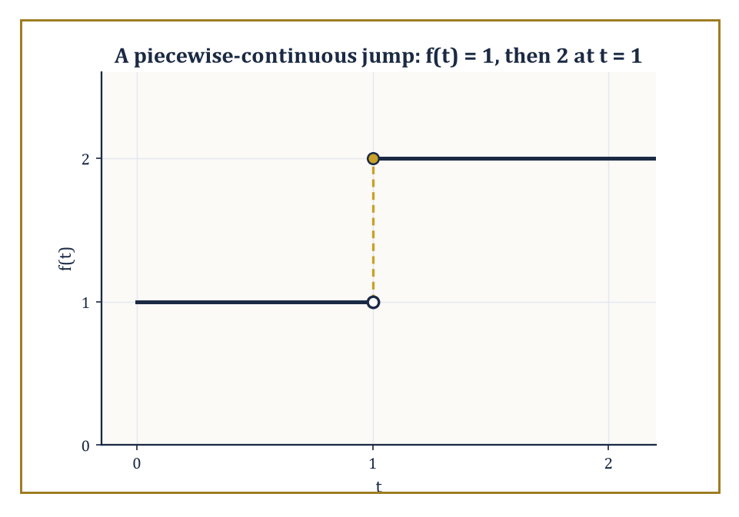
Figure 18.1 — A function that doubles in height at t = 1 — piecewise continuity is all the smoothness the integral ever asks for.
F(s) = ∫[0, ∞] e⁻ˢᵗ f(t) dt
This holds provided the improper integral converges. Think of s as an impatience dial: turn it up, and the transform cares less and less about what f does far in the future, weighting early behavior heavily and later behavior into near-irrelevance. This is the discounting that lets the transform succeed where an infinite, undiscounted sum over all of time — the Fourier transform’s playground — sometimes fails.
Numeric example — the transform of a constant. Let f(t) = 1 for all t ≥ 0. By the definition,
F(s) = ∫[0, ∞] e⁻ˢᵗ·1 dt
Antidifferentiate:
∫ e⁻ˢᵗ dt = −e⁻ˢᵗ/s
Evaluate between 0 and ∞, assuming s > 0 so that e⁻ˢᵗ → 0 as t → ∞:
F(s) = [−e⁻ˢᵗ/s]₀∞ = (0) − (−1/s) = 1/s
So L{1} = 1/s, the single most-used entry in the entire table, and a fine illustration of the mechanism: a function that never decays on its own borrows its decay entirely from e⁻ˢᵗ, and the integral converges because s was chosen positive enough to win that race.
Try it now — Compute L{e^{2t}} and say for which s it exists. Answer →
The variable s deserves a proper introduction. In general it is complex, s = σ + iω, and the transform converges for all s with real part σ large enough — a half-plane called the region of convergence. For most of the elementary work in this chapter you may picture s as a large positive real number without losing anything essential; the complex picture becomes indispensable later, in the discussion of poles, stability, and the inversion integral (Systems and Transfer Functions and Further Properties and Techniques will need it).
Notice, too, the deliberate asymmetry with the Fourier transform of the previous chapter: Fourier integrated over the whole real line and needed f to be absolutely integrable there, which ruled out perfectly sensible functions such as f(t) = eᵗ or even f(t) = t. Laplace only needs f defined for t ≥ 0, and the decaying weight e⁻ˢᵗ can absorb a considerable amount of growth in f, provided that growth is at worst exponential — a function is said to be ‘of exponential order’ if |f(t)| ≤ M eᶜᵗ for some constants M, c and all large t. Nearly everything you meet in an undergraduate differential-equations course qualifies.
Numeric example — the transform of an exponential. Let f(t) = eᵃᵗ for a fixed real constant a. Then
F(s) = ∫[0, ∞] e⁻ˢᵗ eᵃᵗ dt = ∫[0, ∞] e⁻⁽ˢ⁻ᵃ⁾ᵗ dt
This is the same integral as before with s replaced by s − a, so by the previous result F(s) = 1/(s − a), valid whenever s > a (so that s − a > 0 and the integral converges). Check the boundary behavior explicitly:
[−e⁻⁽ˢ⁻ᵃ⁾ᵗ/(s−a)]₀∞ = 0 − (−1/(s−a)) = 1/(s−a)
So L{eᵃᵗ} = 1/(s − a). Setting a = 0 recovers L{1} = 1/s from the previous example, as it must.
Two structural facts make the whole chapter possible. First, the transform is linear:
L{αf(t) + βg(t)} = αF(s) + βG(s)
This is immediate from the linearity of the integral itself — nothing to prove, everything to exploit. Second, and far less obvious, the transform is essentially one-to-one on the well-behaved functions that show up in applications: this is Lerch’s theorem, which says that if two functions, both continuous and of exponential order, have the same Laplace transform, then they are identical. (‘Essentially’ is doing a small amount of work in that sentence, and we will pin down exactly how much in a moment.) Because the map from f to F is injective on this class, it makes sense to speak of the inverse transform, L⁻¹{F(s)}, as a well-defined operation — solve the algebra for F, and there is exactly one sensible f waiting to be recovered, which is the entire strategy of Solving Linear Differential Equations in a single sentence.
Abstract example — when the discount isn’t enough, and when uniqueness is only ‘essential’. Consider f(t) = exp(t²). For any fixed s, the integrand is e⁻ˢᵗ exp(t²) = exp(t² − st), and since t² eventually outgrows st for any fixed s no matter how large, the exponent t² − st → +∞ as t → ∞. The integral diverges for every value of s: f grows faster than exponential order can absorb, and it has no Laplace transform.
Contrast this with a subtler case that tests Lerch’s theorem itself. Let g(t) = 1 for all t ≥ 0 except g(2) = 100. Since a single point contributes nothing to the value of an integral (it has zero width),
G(s) = ∫[0, ∞] e⁻ˢᵗ g(t) dt = ∫[0, ∞] e⁻ˢᵗ·1 dt = 1/s
This is the same transform as the honest constant function 1. Two genuinely different functions, one Laplace transform between them — which is why Lerch’s theorem is stated for continuous functions, where such isolated sabotage cannot happen, and why ‘the’ inverse transform is unique only up to alterations on a set that never affects anything you would compute.
One further practical point, easy to overlook and worth stating plainly: the functions admitted to this club need not be continuous, only piecewise continuous, meaning they are allowed a finite number of jump discontinuities on every bounded interval, provided the left- and right-hand limits exist at each jump. This matters enormously in practice, because it is what licenses the switch-like functions of Discontinuous and Impulsive Forcing — a voltage that snaps from 0 to 5 volts the instant a switch closes is not continuous, but it is piecewise continuous, and the integral defining F(s) does not notice a jump any more than it noticed the isolated altered point in the abstract example above. A single instant of discontinuity, like a single point, has zero width and contributes nothing to the area under the curve.
Numeric example — a genuine jump, handled by splitting the integral. Let f(t) = 1 for 0 ≤ t < 1, and f(t) = 2 for t ≥ 1 — a step that doubles in height at t = 1 rather than switching on from nothing, so this is not simply the earlier constant-function example in disguise. The integral defining F(s) does not mind the jump; it merely needs splitting at t = 1:
F(s) = ∫₀¹ e⁻ˢᵗ·1 dt + ∫[1, ∞] e⁻ˢᵗ·2 dt
The first piece is
[−e⁻ˢᵗ/s]₀¹ = (1 − e⁻ˢ)/s
The second is
2[−e⁻ˢᵗ/s]₁∞ = 2(0 − (−e⁻ˢ/s)) = 2e⁻ˢ/s
Adding them:
F(s) = (1 − e⁻ˢ)/s + 2e⁻ˢ/s = (1 + e⁻ˢ)/s
One discontinuity, one extra line of bookkeeping, and the integral converges as happily as it did for the honest constant function of the very first example — proof, in miniature, that piecewise continuity is all the smoothness this transform ever asks for.
What is still missing is a library — we do not want to re-derive 1/(s − a) from scratch every time an exponential turns up in a differential equation, and we certainly do not want to integrate by parts four times to find the transform of t³. Basic Transforms and Operational Rules builds that library, along with the operational rules that turn ‘the transform of a derivative’ into a one-line algebraic substitution — the single fact on which the rest of this chapter depends.
Keep only this · Section 18.1: What the Laplace Transform Actually Is
The idea. L{f}(s) = ∫₀∞ f(t) exp(−st) dt: a weighted average of f that exists once s beats f’s growth rate.
Core.
L{f}(s) = ∫[0, ∞] f(t) exp(−st) dt
Typical mistake. Using a transform formula outside its region of convergence.
Minimal example. L{1} = 1/s for s > 0.
Practice. Easy to challenge; full worked answers, with the usual mistake, are in Answers to the Practice Sets at the back.
Easy — Compute L{exp(3t)} and say for which s it exists. Answer →
Medium — Compute L{t} from the definition. Answer →
Challenge — Why does exp(t²) have no Laplace transform? Answer →

Section 18.2: Basic Transforms and Operational Rules
A Short, Smug Table, and the Rules That Make It Sing
CORE · about 15 minutes · later chapters build on this
Definition — The transforms of the elementary functions — constants, powers, exponentials, sines, cosines, and their hyperbolic cousins — are all rational functions of s, and every one of them can be computed directly from the definition, usually by a single integration by parts or by differentiating under the integral sign with respect to a parameter (the same Feynman-style trick that solves an alarming number of otherwise stubborn integrals). Rather than re-derive each entry here, note the pattern for powers of t: repeated integration by parts on ∫[0, ∞] tⁿ e⁻ˢᵗ dt peels off one power of t and one factor of n/s at a time, giving the tidy closed form
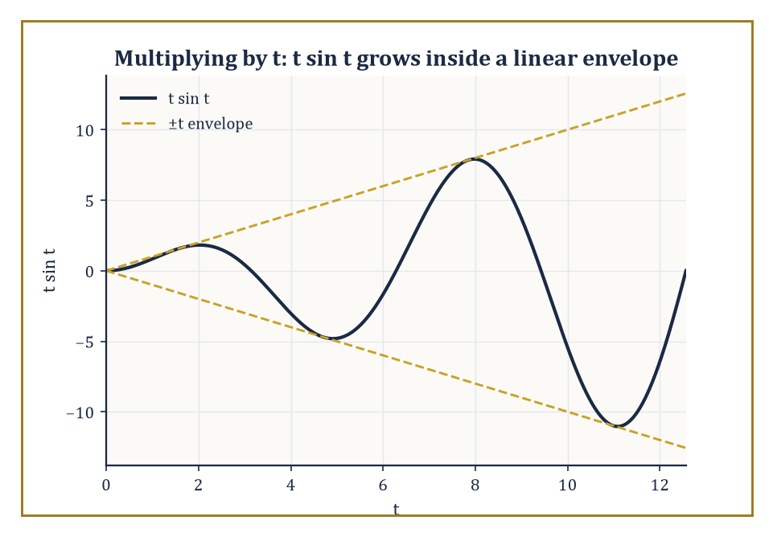
Figure 18.2 — Multiplying by t in the time domain does just what it sounds like: it lets the oscillation grow, trapped between the lines ±t.
L{tⁿ} = n!/sⁿ⁺¹, for any non-negative integer n
Set n = 0 and this correctly reduces to 0!/s = 1/s, the constant function’s transform from What the Laplace Transform Actually Is.
Numeric example — the transform of t³. By the formula above with n = 3:
L{t³} = 3!/s⁴ = 6/s⁴
To see the pattern that produces it, integrate by parts once: ∫[0, ∞] t³ e⁻ˢᵗ dt, with u = t³, dv = e⁻ˢᵗ dt, so du = 3t² dt, v = −e⁻ˢᵗ/s. This gives
[−t³e⁻ˢᵗ/s]₀∞ + (3/s)∫[0, ∞] t² e⁻ˢᵗ dt
The boundary term vanishes at both ends (0 at t = 0 since t³ = 0; 0 as t → ∞ since the exponential beats any power of t to zero), leaving (3/s)L{t²}. Repeating the same trick twice more strips off a 2/s and then a 1/s, and finally L{1} = 1/s, so altogether
L{t³} = (3/s)(2/s)(1/s)(1/s) = 6/s⁴
— the ‘3!’ is the record of three such peelings.
Try it now — Find L{e^{−t} cos 2t}. Answer →
The table of basic pairs is useful, but the operational rules are the actual engine of the subject, because they are what let a differential equation become an algebraic one. Linearity has already been noted. Far more important is the derivative rule:
L{f′(t)} = sF(s) − f(0)
One derivative in the time domain becomes one multiplication by s in the transform domain, minus a correction term that is nothing but the initial condition, arriving automatically and free of charge. Differentiate again and the pattern iterates:
L{f″(t)} = s²F(s) − s f(0) − f′(0)
This is the single fact that makes Solving Linear Differential Equations possible — an initial-value problem transforms directly into an algebraic equation with the initial conditions already built in, with no separate step of ‘now apply the initial conditions to the general solution’ ever required.
Numeric example — checking the derivative rule against direct differentiation. Let f(t) = cos(2t), so f(0) = 1 and F(s) = L{cos(2t)} = s/(s² + 4) (a standard pair, derivable the same way as L{sin(bt)} = b/(s² + b²) by differentiating under the integral or by direct integration by parts twice). The derivative rule predicts
L{f′(t)} = sF(s) − f(0) = s·s/(s²+4) − 1 = s²/(s²+4) − 1 = (s² − (s²+4))/(s²+4) = −4/(s²+4)
Now check directly: f′(t) = −2 sin(2t), and
L{−2 sin(2t)} = −2·(2/(s²+4)) = −4/(s²+4)
The two computations agree exactly, as the rule guarantees they always will.
Two further rules round out the operational toolkit for now. The first shifting theorem: multiplying f(t) by eᵃᵗ shifts the transform sideways,
L{eᵃᵗ f(t)} = F(s − a)
— an exponential in time becomes a translation in the frequency-like variable s. The second, less obvious rule concerns multiplying f(t) by t itself: this corresponds to differentiating the transform with respect to s and flipping the sign,
L{t f(t)} = −F′(s)
(A second shifting theorem, going the other way — shifting in time rather than in s — is coming in Discontinuous and Impulsive Forcing, once we have a function worth shifting.)
Numeric example — first shifting theorem. Find L{e³ᵗ sin(2t)}. Start from F(s) = L{sin(2t)} = 2/(s² + 4). By the first shifting theorem with a = 3,
L{e³ᵗ sin(2t)} = F(s − 3) = 2/((s−3)² + 4)
No new integration required — the exponential envelope relocates the pole structure of the plain sine transform three units to the right along the real s-axis.
Numeric example — multiplication by t. Find L{t sin t}. Here F(s) = L{sin t} = 1/(s² + 1) (taking b = 1). Differentiate:
F′(s) = d/ds[(s²+1)⁻¹] = −(2s)/(s²+1)²
By the multiplication-by-t rule,
L{t sin t} = −F′(s) = 2s/(s²+1)²
A quick sanity check on the exponents: t sin t grows only linearly against an oscillation, so a transform with a double pole at s = ±i (rather than the single pole of plain sin t) is the kind of ‘slightly worse decay, slightly higher-order pole’ behavior one should expect from an extra factor of t.
The hyperbolic functions round out the basic library, and are worth a moment because they show linearity earning its keep rather than sitting there as a throwaway remark. Recall
sinh(at) = (eᵃᵗ − e⁻ᵃᵗ)/2, cosh(at) = (eᵃᵗ + e⁻ᵃᵗ)/2
Since the transform is linear and the transform of each exponential piece is already known from What the Laplace Transform Actually Is, both hyperbolic transforms follow with no new integration whatsoever.
Numeric example — a hyperbolic transform from linearity alone. Find L{sinh(2t)}. Write sinh(2t) = (e²ᵗ − e⁻²ᵗ)/2. By linearity,
L{sinh(2t)} = (1/2)[L{e²ᵗ} − L{e⁻²ᵗ}] = (1/2)[1/(s−2) − 1/(s+2)]
Put the bracket over a common denominator:
1/(s−2) − 1/(s+2) = [(s+2) − (s−2)]/((s−2)(s+2)) = 4/(s²−4)
So
L{sinh(2t)} = (1/2)·4/(s²−4) = 2/(s²−4)
This matches the general pattern L{sinh(at)} = a/(s²−a²) with a = 2, and the same argument gives L{cosh(at)} = s/(s²−a²) — note the family resemblance to L{sin(bt)} = b/(s²+b²) and L{cos(bt)} = s/(s²+b²), with a plus sign turned, unannounced, into a minus. That sign flip is the entire algebraic distance between oscillation and exponential growth, and it will resurface the moment a denominator’s roots turn out to be real instead of complex.
With this small collection — powers, exponentials, sines and cosines, hyperbolic functions, linearity, the derivative rule, and the two shifting theorems — most transforms encountered in an elementary course can be written down by inspection rather than by integration. The next task is to run the whole apparatus in reverse: given an F(s) that arose from solving an algebraic equation, how does one recover the f(t) that produced it? That is the inverse transform, and The Inverse Transform and Partial Fractions is where partial fractions, already familiar from integral calculus, get a second career.
Keep only this · Section 18.2: Basic Transforms and Operational Rules
The idea. Multiplying by e^{at} shifts s to s − a; differentiating f multiplies by s and subtracts f(0); multiplying by t differentiates F and flips the sign.
Core.
L{tⁿ} = n!/sⁿ⁺¹
L{sin bt} = b/(s² + b²), L{cos bt} = s/(s² + b²)
L{eᵃᵗf} = F(s − a)
L{f′} = sF − f(0)
Typical mistake. Forgetting the −f(0) (and −f′(0)) terms in the derivative rule.
Minimal example. L{e²ᵗ sin 3t} = 3/((s − 2)² + 9).
Practice. Easy to challenge; full worked answers, with the usual mistake, are in Answers to the Practice Sets at the back.
Easy — L{3 + 2t²}. Answer →
Medium — L{exp(−t) cos 2t}. Answer →
Challenge — Use the derivative rule to find L{f″} in terms of F. Answer →

Section 18.3: The Inverse Transform and Partial Fractions
Undoing What We Did, One Fraction at a Time
CORE · about 20 minutes · later chapters build on this
Adding fractions is something you can already do: 1/2 + 1/3 = 3/6 + 2/6 = 5/6. This section needs the same sum run backwards. Given 5/6, and told that it was made from a piece over 2 and a piece over 3, recover the pieces.
The reason is the Laplace table of Basic Transforms and Operational Rules. It lists simple pieces: 1/(s − 1) is the transform of eᵗ, and 1/(s + 2) is the transform of e⁻²ᵗ. Solving a differential equation hands back something less tidy, such as (3s + 5)/((s − 1)(s + 2)), which appears in no table.
So un-add it. Look for numbers A and B with A/(s − 1) + B/(s + 2) equal to it. Put the two pieces over the common bottom (s − 1)(s + 2) and the top becomes A(s + 2) + B(s − 1), which must equal 3s + 5 for every s. Choose s = 1 and the B term vanishes: 3A = 8, so A = 8/3. Choose s = −2 and the A term vanishes: −3B = −1, so B = 1/3.
Check at a value not used yet, say s = 2. The original is 11/(1 × 4) = 11/4. The pieces give 8/3 + (1/3)/4 = 32/12 + 1/12 = 33/12, which is 11/4 again.
Each piece is now in the table, so the answer can be read off: f(t) = (8/3)eᵗ + (1/3)e⁻²ᵗ. Breaking F(s) into table-sized pieces is partial-fraction decomposition, and undoing the transform is the inverse Laplace transform. The first worked example below is this same F(s); the later ones deal with the awkward cases, repeated factors and quadratics that will not split.
Definition — Recovering f(t) from F(s) is the inverse Laplace transform, written
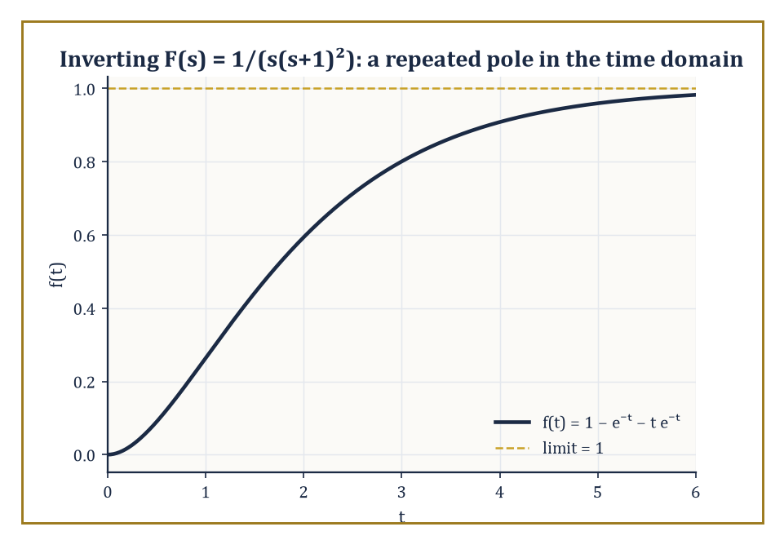
Figure 18.3 — The time-domain payoff of a repeated pole: 1/(s(s+1)²) inverts to a curve that climbs steadily toward 1 and never overshoots.
f(t) = L⁻¹{F(s)}
What the Laplace Transform Actually Is already established, via Lerch’s theorem, that this operation is well-defined (up to the harmless isolated-point ambiguity we saw there) whenever f is continuous and of exponential order — which covers essentially everything this chapter will ask of it.
For the rational functions that arise from solving linear differential equations with constant coefficients, the standard method is partial-fraction decomposition: break F(s) into a sum of simple pieces, each of which is immediately recognizable from the Basic Transforms and Operational Rules table.
The algebra involved is identical to the partial-fraction technique from integral calculus; the only difference is that instead of integrating each piece, one reads its inverse transform off the table.
Numeric example — distinct linear factors. Invert F(s) = (3s + 5)/((s − 1)(s + 2)). Write it as a partial-fraction decomposition:
(3s+5)/((s−1)(s+2)) = A/(s−1) + B/(s+2)
Clear denominators:
3s + 5 = A(s+2) + B(s−1)
Set s = 1, which kills the B term:
3(1)+5 = A(1+2) → 8 = 3A → A = 8/3
Set s = −2, which kills the A term:
3(−2)+5 = B(−2−1) → −1 = −3B → B = 1/3
So:
F(s) = (8/3)/(s−1) + (1/3)/(s+2)
and reading each term off the table:
f(t) = (8/3)eᵗ + (1/3)e⁻²ᵗ
Try it now — Invert F(s) = 3/(s + 2) − 1/s². Answer →
There is a shortcut for the distinct-linear-factor case worth knowing, informally called the cover-up method, and it is pure Heaviside in spirit: to find the coefficient of 1/(s−r) in the decomposition, literally cover up the (s−r) factor in the original denominator with a thumb and evaluate everything else at s = r.
It is what happened algebraically above when we set s = 1 and s = −2 to kill off unwanted terms — the cover-up method skips the intermediate step of writing out the cleared-denominator equation.
Numeric example — the cover-up method. Reconsider F(s) = (3s+5)/((s−1)(s+2)) from the previous example. To find A, the coefficient of 1/(s−1), cover up (s−1) and evaluate the rest at s = 1:
A = (3(1)+5)/(1+2) = 8/3
To find B, the coefficient of 1/(s+2), cover up (s+2) and evaluate the rest at s = −2:
B = (3(−2)+5)/(−2−1) = (−1)/(−3) = 1/3
Both values match the ones found the longer way, in a fraction of the writing — though the cover-up trick only survives intact when the factors are distinct and linear; repeated or quadratic factors need the fuller method demonstrated next.
Repeated linear factors behave a little differently, and it is worth having the mechanism in hand before it appears, unannounced, in the middle of a differential equation.
A factor of (s − r)ᵏ in the denominator does not just contribute A/(s−r); it contributes a whole chain of terms:
A₁/(s−r) + A₂/(s−r)² + … + Aₖ/(s−r)ᵏ
This is because the inverse transforms of 1/(s−r)², 1/(s−r)³, and so on are, respectively, t eʳᵗ, (t²/2)eʳᵗ, and further powers of t multiplying the same exponential — repetition in the pole structure becomes a polynomial-in-t envelope in the time domain.
Numeric example — a repeated linear factor. Invert F(s) = 1/(s(s+1)²). Set up the partial-fraction decomposition:
1/(s(s+1)²) = A/s + B/(s+1) + C/(s+1)²
Clear denominators:
1 = A(s+1)² + Bs(s+1) + Cs
Set s = 0:
1 = A(1)² = A, so A = 1
Set s = −1:
1 = C(−1) = −C, so C = −1
To find B, expand and match the coefficient of s²: A(s+1)² contributes A = 1 to the s² coefficient, Bs(s+1) contributes B, and Cs contributes nothing to s². The right-hand side must equal the constant 1 (no s or s² term), so:
1 + B = 0, giving B = −1
As a check, the s¹ coefficient is:
2A + B + C = 2(1) + (−1) + (−1) = 0
as required. So:
F(s) = 1/s − 1/(s+1) − 1/(s+1)²
and inverting term by term:
f(t) = 1 − e⁻ᵗ − t e⁻ᵗ
Irreducible quadratic factors — ones that do not split over the reals — call for a third technique: complete the square in the denominator to expose a shifted sine or cosine, exactly the pattern produced by the first shifting theorem of Basic Transforms and Operational Rules.
A denominator s² + 2as + b becomes:
s² + 2as + b = (s+a)² + (b − a²)
and a numerator can usually be split into a piece proportional to (s+a) — which pairs with the shifted cosine — and a piece that is a pure constant, which pairs with the shifted sine.
Numeric example — an irreducible quadratic factor. Invert F(s) = (s+1)/(s² + 2s + 5). Complete the square in the denominator:
s² + 2s + 5 = (s+1)² + 4
So:
F(s) = (s+1)/((s+1)² + 4)
Compare against the shifted-cosine pattern:
L{e⁻ᵃᵗ cos(bt)} = (s+a)/((s+a)²+b²)
Here a = 1 and b = 2 match exactly, with numerator (s+1) already in the required form and no leftover constant term to split off. Hence:
f(t) = e⁻ᵗ cos(2t)
One loose end: what if F(s) is improper, meaning the numerator’s degree is at least the denominator’s? Long division peels off a polynomial in s, leaving a proper fraction to be handled as above.
The polynomial part corresponds, in the rigorous theory, to derivatives of the Dirac delta function — singular objects belonging to distribution theory, well beyond elementary work.
In practice, differential-equation problems at this level are set up so that Y(s) always comes out proper, and the issue never bites; it is flagged here only so that, if it ever does turn up, it is recognized as a known phenomenon and not a mistake in the algebra.
Numeric example — an improper F(s), and where the leftover points. Suppose a calculation produced F(s) = (s³+2)/(s²+1) — improper, since the numerator’s degree (3) is at least the denominator’s (2), unlike every Y(s) solved in this chapter. Long divide:
s³+2 = s·(s²+1) + (2−s)
so:
F(s) = s + (2−s)/(s²+1)
The remainder is proper and inverts normally:
(2−s)/(s²+1) = 2/(s²+1) − s/(s²+1)
giving 2 sin t − cos t by the ordinary table.
The leading term, a bare s left over from the division, has no such well-behaved partner; running the derivative rule backward, a plain factor of s in the transform domain is exactly what a derivative of the Dirac delta function would produce in the time domain.
Nothing here is a mistake — it is a reminder of why every Y(s) actually met in this chapter came out proper: an improper one is asking, without saying so outright, for an object this chapter has declined to define.
With partial fractions and the completed-square trick in hand, and Lerch’s theorem guaranteeing that whatever f(t) they produce is the correct one, the machinery is complete: transform an equation, solve algebraically, invert.
Solving Linear Differential Equations puts that three-step routine to work on actual differential equations, where its full advantage over the classical methods of earlier chapters finally becomes visible.
Keep only this · Section 18.3: The Inverse Transform and Partial Fractions
The idea. Inverse transforms are table look-ups after partial fractions and completing the square.
Core.
split into partial fractions, then read each piece off the table
Typical mistake. Missing a repeated factor’s extra terms in the partial-fraction set-up.
Minimal example. 1/(s(s + 1)) = 1/s − 1/(s + 1) ↦ 1 − exp(−t).
Practice. Easy to challenge; full worked answers, with the usual mistake, are in Answers to the Practice Sets at the back.
Easy — Invert 5/(s − 2). Answer →
Medium — Invert (s + 3)/((s + 1)(s + 2)). Answer →
Challenge — Invert (s + 1)/(s² + 2s + 5). Answer →

Section 18.4: Solving Linear Differential Equations
Where Calculus Quietly Clocks Off and Algebra Takes the Late Shift
CORE · about 15 minutes · later chapters build on this
Here is a differential equation of the kind earlier chapters solved: y′ + 2y = e⁻ᵗ, with y(0) = 0. The classical method takes two stages. First, guess a solution shaped like the right-hand side, y = Ce⁻ᵗ. Substituting gives −Ce⁻ᵗ + 2Ce⁻ᵗ = e⁻ᵗ, so C = 1. But y = e⁻ᵗ starts at 1, not 0, so the second stage adds a solution of the equation without its right-hand side, De⁻²ᵗ, and fits D to the starting value: 1 + D = 0, so D = −1. The answer is y = e⁻ᵗ − e⁻²ᵗ.
That works, but it needed a good guess, and the guess depends on the right-hand side. A different forcing term needs a different guess, and a forcing term that matches the equation’s own natural behavior needs a special trick.
The Laplace transform removes the guessing. Basic Transforms and Operational Rules showed that it turns y′ into sY − y(0), and turns e⁻ᵗ into 1/(s + 1). So the whole equation, starting value included, becomes ordinary algebra:
transform: sY + 2Y = 1/(s + 1)
solve for Y: Y = 1/((s + 1)(s + 2))
split into pieces (The Inverse Transform and Partial Fractions): Y = 1/(s + 1) − 1/(s + 2)
read off the table: y = e⁻ᵗ − e⁻²ᵗ
The same answer, with no guess and no separate step for the starting value: y(0) = 0 went in on the first line. That recipe of transform, solve and invert is the method of this section, and this equation is its second worked example.
Definition — The procedure is now entirely mechanical, which is precisely its charm.
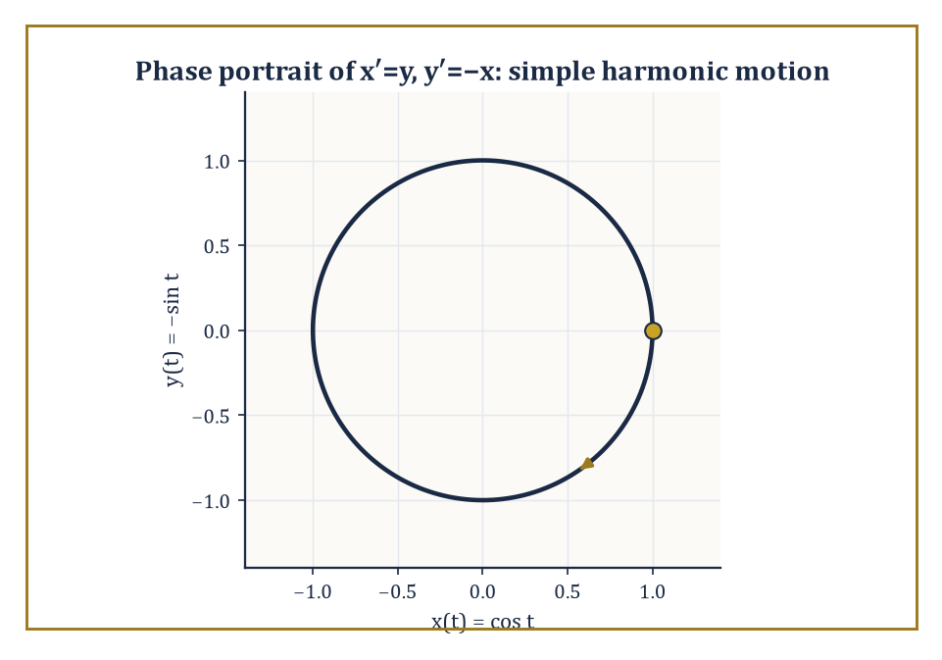
Figure 18.4 — The system x′=y, y′=−x solved purely by algebra, traced out where it always lived: a circle in the phase plane.
Transform both sides of the differential equation, using the derivative rule of Basic Transforms and Operational Rules to insert the initial conditions the moment they appear — not afterward, as in the classical method, but immediately, as an unavoidable part of transforming y′ and y″.
Solve the resulting algebraic equation for Y(s), the transform of the unknown function. Invert Y(s) by partial fractions (The Inverse Transform and Partial Fractions) or any other applicable method.
What comes out is the unique function satisfying both the differential equation and the prescribed initial conditions — no separate constant-fitting step, because the constants were fitted the instant the initial conditions were substituted into the algebra.
Numeric example — a homogeneous initial-value problem. Solve y″ + 3y′ + 2y = 0, with y(0) = 1 and y′(0) = 0. Transform every term:
L{y″} = s²Y − s·y(0) − y′(0) = s²Y − s
L{3y′} = 3(sY − y(0)) = 3sY − 3
L{2y} = 2Y
Summing to zero:
s²Y − s + 3sY − 3 + 2Y = 0
(s² + 3s + 2)Y = s + 3
Y(s) = (s+3)/(s²+3s+2) = (s+3)/((s+1)(s+2))
Partial fractions:
(s+3)/((s+1)(s+2)) = A/(s+1) + B/(s+2)
s+3 = A(s+2) + B(s+1)
At s = −1:
2 = A(1), A = 2
At s = −2:
1 = B(−1), B = −1
So:
Y(s) = 2/(s+1) − 1/(s+2)
y(t) = 2e⁻ᵗ − e⁻²ᵗ
Check:
y(0) = 2 − 1 = 1 ✓
y′(t) = −2e⁻ᵗ + 2e⁻²ᵗ, y′(0) = −2+2 = 0 ✓
y″+3y′+2y = (2e⁻ᵗ−4e⁻²ᵗ) + 3(−2e⁻ᵗ+2e⁻²ᵗ) + 2(2e⁻ᵗ−e⁻²ᵗ) = 0
for every t, as required.
Try it now — Solve y′ + y = 0, y(0) = 3, by Laplace. Answer →
Nonzero forcing terms need no special treatment whatsoever — the transform of the right-hand side is computed by the same table and added into the algebra as another term.
This is one of the transform method’s genuine advantages over the classical approach, which must guess a particular solution in a form matching the forcing function (a polynomial for polynomial forcing, an exponential for exponential forcing, and an increasingly awkward set of rules for anything more exotic — and a positively miserable set of rules when the forcing happens to match a term already present in the homogeneous solution, the notorious ‘resonance case’ that earlier chapters handled by multiplying a guess by an extra power of t and hoping for the best).
The Laplace method needs no such guesswork; it treats every forcing function identically, provided its transform is known, resonance and all.
Numeric example — a forced first-order equation. Solve y′ + 2y = e⁻ᵗ, with y(0) = 0. Transform:
L{y′} = sY − y(0) = sY
L{2y} = 2Y
L{e⁻ᵗ} = 1/(s+1)
So:
sY + 2Y = 1/(s+1)
Y(s+2) = 1/(s+1)
Y(s) = 1/((s+1)(s+2))
Partial fractions:
1/((s+1)(s+2)) = A/(s+1) + B/(s+2)
1 = A(s+2) + B(s+1)
At s = −1:
1 = A(1), A = 1
At s = −2:
1 = B(−1), B = −1
So:
Y(s) = 1/(s+1) − 1/(s+2)
y(t) = e⁻ᵗ − e⁻²ᵗ
Check:
y(0) = 1 − 1 = 0 ✓
y′(t) = −e⁻ᵗ+2e⁻²ᵗ
y′+2y = (−e⁻ᵗ+2e⁻²ᵗ) + 2(e⁻ᵗ−e⁻²ᵗ) = e⁻ᵗ
matching the forcing term exactly ✓.
Systems of linear differential equations with constant coefficients are handled in the same spirit.
Transforming every equation in the system converts it into a system of linear algebraic equations for the several unknown transforms, which can be solved by ordinary elimination or matrix algebra just as one would solve any linear system, and then inverted componentwise, one transform at a time, using the tools already in hand.
No new machinery is required — only patience with slightly more bookkeeping, and for larger systems, a willingness to let Cramer’s rule or Gaussian elimination do the tedious part while you keep track of which transform belongs to which unknown.
Numeric example — a system of two first-order equations. Solve x′ = y, y′ = −x, with x(0) = 1, y(0) = 0. Transforming both equations:
sX − 1 = Y
sY − 0 = −X
i.e.:
Y = sX − 1
Y = −X/s
Set these equal:
sX − 1 = −X/s
Multiply through by s:
s²X − s = −X
X(s² + 1) = s
X(s) = s/(s²+1)
— the transform of cos t. So x(t) = cos t. Then:
Y = −X/s = −1/(s²+1)
the transform of −sin t, so y(t) = −sin t. Check against the original system:
x′(t) = −sin t
which indeed equals y(t) ✓;
y′(t) = −cos t
which indeed equals −x(t) ✓. (This pair is, unsurprisingly, the Laplace-transform route to simple harmonic motion — the same oscillator that earlier chapters reached by the characteristic-equation method, arriving here purely by algebra.)
It is worth naming, before the next section arrives, why this method earns its keep beyond mere convenience.
The classical route to an initial-value problem finds the general solution first — a family of curves depending on arbitrary constants — and only afterward pins those constants down by substituting the initial conditions, a two-stage process that must be repeated in full whenever the forcing term changes character partway through the motion.
The Laplace route never separates those stages at all: the initial conditions are absorbed the instant the derivative rule is applied.
So far, though, every example here has had smooth, everywhere-defined forcing, which rather undersells the point.
The transform method’s real advantage over the classical toolkit shows up when the forcing switches on and off, or strikes instantaneously — the situations that turn classical methods into a thicket of case-by-case matching conditions.
Discontinuous and Impulsive Forcing introduces the two special functions built for exactly that job.
Keep only this · Section 18.4: Solving Linear Differential Equations
The idea. Transform, solve the algebraic equation for Y(s), split into table entries, invert: initial conditions enter at the first step.
Core.
transform the equation
solve for Y(s)
invert
Typical mistake. Applying initial conditions again at the end, which double-counts them.
Minimal example. y′ + y = 0, y(0) = 2: Y = 2/(s + 1), y = 2 exp(−t).
Practice. Easy to challenge; full worked answers, with the usual mistake, are in Answers to the Practice Sets at the back.
Easy — Solve y′ − 3y = 0, y(0) = 1. Answer →
Medium — Solve y″ + y = 0, y(0) = 0, y′(0) = 1. Answer →
Challenge — Solve y′ + 2y = 4, y(0) = 0. Answer →

Section 18.5: Discontinuous and Impulsive Forcing
Switches, Bangs, and the Algebra of Interruptions
CORE · about 15 minutes · later chapters build on this
Real systems get switched on, switched off and struck. A heater is flicked on at noon and left running; a circuit sees its voltage jump from nothing to 12 volts; a bell is hit once with a hammer. Smooth formulas describe such events badly, so engineers use two idealized building blocks. The step is off until a chosen instant and on forever afterwards. The impulse is a blow so brief that only its total size matters, like a hammer tap delivering one unit of kick in no time at all. The Laplace transform handles both with almost no effort, which is a large part of the reason control engineers are so fond of it.
Definition — The unit step function, also called the Heaviside function after the same Heaviside from this chapter’s opening, is defined as off, then at the instant t = c it switches on and stays on.
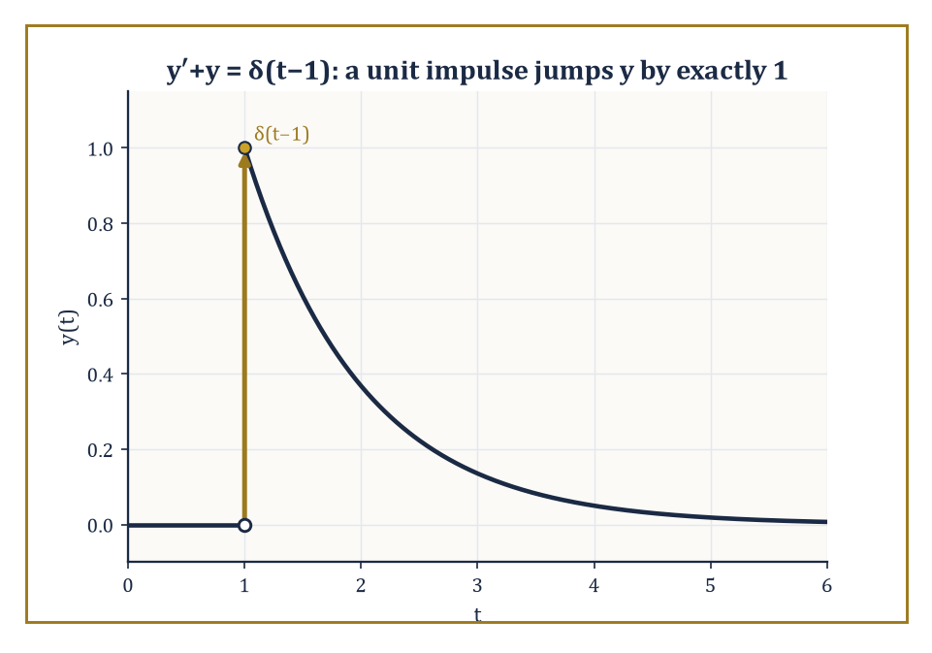
Figure 18.5 — A hammer blow at t = 1: the solution to y′+y=δ(t−1) sits at rest, jumps by exactly one unit, and settles back down.
u_{c}(t) = 0 for t < c, u_{c}(t) = 1 for t ≥ c
Its transform is computed directly from the definition, since the integral only picks up contributions from t ≥ c.
L{u_{c}(t)} = e⁻ᶜˢ/s
Multiplying any forcing term by u_{c}(t) switches that term on at the prescribed instant c and leaves everything before c untouched — the language needed for a circuit closed at t = 3 seconds, or a light turned on at t = c and never off.
Numeric example — transform of a delayed step. Directly from the formula with c = 3:
L{u₃(t)} = e⁻³ˢ/s
To combine a step with a shifted function, the second shifting theorem states:
L{u_{c}(t) f(t−c)} = e⁻ᶜˢ F(s)
where F is the transform of f itself (not shifted). For instance, to find L{u₂(t)(t−2)²}, identify f(t) = t² (so that f(t−2) = (t−2)²) and c = 2. Since L{t²} = 2/s³, the theorem gives:
L{u₂(t)(t−2)²} = e⁻²ˢ·2/s³
Notice the pairing with the first shifting theorem of Basic Transforms and Operational Rules: that one shifted the s-domain when multiplying by an exponential in time; this one shifts the time domain when multiplying by a step, and the roles of s and t trade places in a pleasingly symmetric way.
Try it now — Transform u(t − 2), the unit step switched on at t = 2. Answer →
A single step is enough, by itself, to build any rectangular pulse: switch a forcing term on at one instant and off again at a later instant by subtracting two steps. The difference u_{a}(t) − u_{b}(t), for a < b, is 1 on the interval a ≤ t < b and 0 everywhere else — a forcing term that is on only for the duration of the pulse, and by linearity its transform is the difference of the two individual step transforms, no new theorem required.
Numeric example — a rectangular pulse from two steps. A forcing term is switched on at t = 1 and off again at t = 3:
f(t) = u₁(t) − u₃(t)
By linearity and the step transform from the previous example:
L{f(t)} = L{u₁(t)} − L{u₃(t)} = e⁻ˢ/s − e⁻³ˢ/s = (e⁻ˢ − e⁻³ˢ)/s
No new machinery was needed — the whole pulse is just two applications of a single formula, subtracted.
The Dirac delta function δ(t − c) models an idealized, instantaneous impulse — a hammer blow, a lightning strike, a sudden kick — concentrated entirely at the instant t = c and carrying unit total effect (formally, it is the limit of an increasingly tall, increasingly narrow pulse of constant area 1, though the fully rigorous treatment belongs to distribution theory, which Looking Back, and Ahead will nod toward without entering).
Its Laplace transform is remarkably simple, a direct consequence of the delta function’s defining ‘sifting’ property, which plucks out the value of e⁻ˢᵗ at t = c without any integration drudgery at all.
L{δ(t−c)} = e⁻ᶜˢ
A system forced by a delta function responds with a jump: in a first-order equation, the solution itself jumps at t = c; in a second-order equation, it is the derivative that jumps, while the solution stays continuous.
Numeric example — an impulse-forced equation. Solve y′ + y = δ(t − 1), with y(0) = 0. Transform both sides:
L{y′} + L{y} = L{δ(t−1)}
(sY − 0) + Y = e⁻ˢ
Y(s+1) = e⁻ˢ
Y(s) = e⁻ˢ/(s+1)
Since L⁻¹{1/(s+1)} = e⁻ᵗ, the second shifting theorem gives:
y(t) = u₁(t) e⁻⁽ᵗ⁻¹⁾
That is, y(t) = 0 for t < 1, and y(t) = e⁻⁽ᵗ⁻¹⁾ for t ≥ 1. At t = 1 the solution jumps from 0 to e⁰ = 1: a jump of size exactly 1, matching the ‘strength’ of the unit impulse that caused it, and then decays exponentially afterward, as one would expect of a system that got hit once, sharply, and is now settling back down.
Periodic forcing that is not sinusoidal — a square wave, a sawtooth, a train of pulses — can be handled by writing the function as a sum of shifted step functions, or more efficiently, by a general formula for the transform of any function periodic with period T.
F(s) = [1/(1 − e⁻ˢᵀ)] ∫₀ᵀ e⁻ˢᵗ f(t) dt
The integral is taken over just one period, and the factor 1/(1 − e⁻ˢᵀ) accounts for the infinitely repeating copies via a geometric series in e⁻ˢᵀ (each successive period contributing a further factor of e⁻ˢᵀ, just as a geometric series sums 1 + r + r² + … to 1/(1−r)).
Numeric example — transform of a square wave. Let f(t) have period T = 2, with f(t) = 1 for 0 < t < 1 and f(t) = 0 for 1 < t < 2, repeating forever — a simple on-off square wave. Compute the one-period integral:
∫₀¹ e⁻ˢᵗ·1 dt + ∫₁² e⁻ˢᵗ·0 dt = [−e⁻ˢᵗ/s]₀¹ = (1 − e⁻ˢ)/s
By the periodic formula:
F(s) = (1/(1−e⁻²ˢ)) · (1−e⁻ˢ)/s
Factor the denominator using the difference of squares:
1 − e⁻²ˢ = (1−e⁻ˢ)(1+e⁻ˢ)
The common factor (1−e⁻ˢ) cancels top and bottom, leaving the tidy result:
F(s) = 1/(s(1+e⁻ˢ))
A single closed-form transform standing in for an infinite train of on-off switches, with no sum ever explicitly carried out.
Steps, impulses, and periodic switching cover the forcing terms that appear discontinuously in time; but many differential equations also involve products of two functions of t whose combined behavior is not simply read off any table — most notably, the response of a system to an arbitrary input, expressed in terms of its response to a single idealized impulse. That relationship is convolution, and it is the subject of Convolution and the Convolution Theorem (Chapter 18).
Keep only this · Section 18.5: Discontinuous and Impulsive Forcing
The idea. A delay by c multiplies the transform by e^{−cs}; the impulse δ(t − c) transforms to e^{−cs}.
Core.
L{u(t − a) f(t − a)} = exp(−as)F(s)
L{δ(t − a)} = exp(−as)
Typical mistake. Writing f(t)u(t − c) when the delayed function is f(t − c)u(t − c).
Minimal example. A unit push at t = 2: L{δ(t − 2)} = exp(−2s).
Practice. Easy to challenge; full worked answers, with the usual mistake, are in Answers to the Practice Sets at the back.
Easy — L{u(t − 3)}. Answer →
Medium — Invert exp(−2s)/s². Answer →
Challenge — Solve y′ + y = δ(t − 1), y(0) = 0. Answer →

Section 18.6: Convolution and the Convolution Theorem
Multiplying in One Domain, Smearing in the Other
CORE · about 15 minutes · later chapters build on this
Stand in a room with an echo and clap once: what you hear is the clap followed by a dying tail. Speak continuously and what reaches you is every recent syllable overlaid with its own fading echo. That overlaying of an input with the system’s response to a single blow is convolution, and it describes any system with memory: a loudspeaker, a car’s suspension, a bloodstream absorbing a drug. A capacitor charging through a resistor is the cleanest example. Feed it a steady input and each instant’s contribution fades away exponentially, but the contributions pile up, so the output climbs smoothly toward its final value of 1 without ever overshooting.
Definition — The convolution of two functions f and g, both defined for t ≥ 0, is itself a new function of t, defined by the integral:
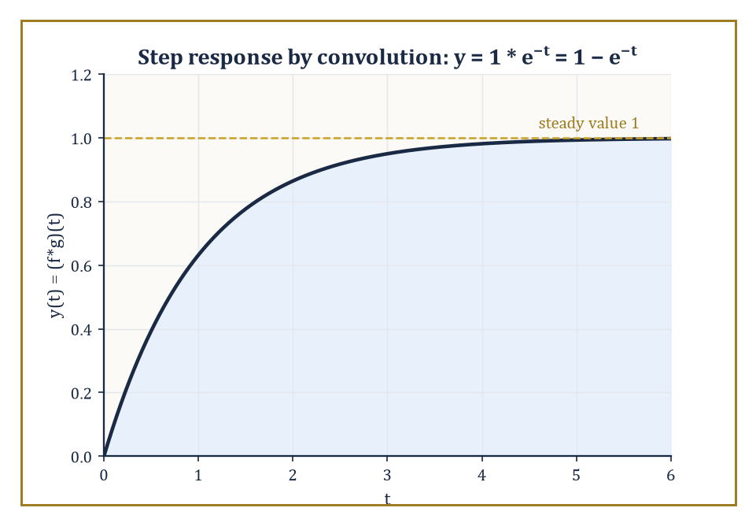
Figure 18.6 — The classic charging curve: a constant input smeared through a decaying impulse response, rising to a steady value of 1 and never overshooting.
(f ∗ g)(t) = ∫₀ᵗ f(τ) g(t−τ) dτ
Intuitively, it smears f through g (or equally, g through f — convolution is symmetric): at each output time t, it sums up contributions from every earlier instant τ, weighted by how f behaved at τ and how g behaves after a further delay of t−τ.
This is the shape of a system with memory — its output at time t depends on the entire history of the input, filtered through the system’s own characteristic response.
Numeric example — convolution computed directly. Compute (f ∗ g)(t) for f(t) = eᵗ and g(t) = e²ᵗ. By the definition:
(f∗g)(t) = ∫₀ᵗ exp(τ) exp(2(t−τ)) dτ = e²ᵗ ∫₀ᵗ exp(τ − 2τ) dτ = e²ᵗ ∫₀ᵗ exp(−τ) dτ
The remaining integral is:
[−exp(−τ)]₀ᵗ = −e⁻ᵗ − (−1) = 1 − e⁻ᵗ
So:
(f∗g)(t) = e²ᵗ(1 − e⁻ᵗ) = e²ᵗ − eᵗ
Try it now — Use the convolution theorem to invert 1/(s(s + 1)). Answer →
The convolution theorem states that the Laplace transform converts this rather involved-looking integral into plain multiplication:
L{f ∗ g} = F(s)G(s)
(The proof is a short exercise in swapping the order of a double integral — Fubini’s theorem, doing its job unnoticed — followed by a substitution; it is omitted here but is entirely elementary.)
The practical payoff is a genuine shortcut: given a product of two transforms, one may either grind through partial fractions, or recognize the product as F(s)G(s) for two known pairs and write down the convolution integral directly, whichever is less work in a given problem — and, as a bonus, the two routes provide an automatic check on each other.
Numeric example — the same answer, reached via the transform. Take F(s) = L{eᵗ} = 1/(s−1) and G(s) = L{e²ᵗ} = 1/(s−2), so:
F(s)G(s) = 1/((s−1)(s−2))
Partial fractions:
1/((s−1)(s−2)) = A/(s−1) + B/(s−2)
so:
1 = A(s−2) + B(s−1)
At s=1:
1 = A(−1), A = −1
At s=2:
1 = B(1), B = 1
So the inverse transform is:
−eᵗ + e²ᵗ = e²ᵗ − eᵗ
— the result obtained by direct convolution above. The convolution theorem and brute-force partial fractions have, as promised, agreed with each other to the letter.
In the language of linear systems — the language Systems and Transfer Functions will speak almost exclusively — the convolution theorem says something both simple and organizing: the output of a linear time-invariant system equals its input convolved with its impulse response, the system’s characteristic reply to a single instantaneous kick.
That one sentence, sometimes called Duhamel’s principle, quietly underlies a large fraction of elementary linear-system theory, from circuit analysis to signal processing, and it is the reason the phrase ‘impulse response’ gets treated with such reverence in those fields: know it once, and the response to any input whatsoever follows by convolution.
Numeric example — the step response of a first-order system. A first-order system with impulse response g(t) = e⁻ᵗ (a system obeying y′ + y = x(t), whose response to a single unit impulse is e⁻ᵗ) is fed a constant unit input, f(t) = 1 for all t ≥ 0.
The output is the convolution:
y(t) = (f∗g)(t) = ∫₀ᵗ 1·exp(−(t−τ)) dτ = e⁻ᵗ ∫₀ᵗ exp(τ) dτ = e⁻ᵗ(eᵗ − 1) = 1 − e⁻ᵗ
This is the classic ‘charging curve’ of a first-order system — rising smoothly from 0 toward a steady value of 1, never overshooting, governed entirely by the single time constant built into its impulse response. It will reappear, verified by an entirely different route, in Further Properties and Techniques.
Convolution obeys the same civilized arithmetic as ordinary multiplication — it is commutative (f∗g = g∗f, already implicit in calling it symmetric above), associative, and distributes over addition — which is unsurprising once one remembers it corresponds, via the theorem, to actual multiplication of transforms, and multiplication is commutative and associative on the nose.
One special case deserves to be singled out, because it closes a loop opened in Discontinuous and Impulsive Forcing: convolving any function f with the Dirac delta returns f itself, undelayed.
This is not a coincidence but a restatement of the delta function’s sifting property in convolution’s own language, and it identifies δ as the ‘do nothing’ element of convolution — its identity, in the same sense that 0 is the identity for addition and 1 for multiplication.
Abstract example — the delta function as convolution’s identity element. Let f be any reasonable function and consider:
(f ∗ δ)(t) = ∫₀ᵗ f(τ) δ(t−τ) dτ
The delta function δ(t−τ), as a function of τ, is concentrated entirely at τ = t; the sifting property of the delta function says that integrating any (continuous) function against δ(t−τ) evaluates that function at τ = t.
So the integral collapses to f(t) exactly:
(f∗δ)(t) = f(t)
Confirm this is consistent with the convolution theorem: L{f∗δ} should equal
F(s)·L{δ(t)} = F(s)·1 = F(s)
which is indeed the transform of f alone — the delta function, transform-side, multiplies by 1 and changes nothing, exactly mirroring what it does convolution-side.
Duhamel’s principle is not merely a slogan; it hands over an explicit formula for the solution of any linear constant-coefficient equation with an arbitrary forcing term, once the impulse response g(t) is known:
y(t) = (g ∗ x)(t) = ∫₀ᵗ g(t−τ) x(τ) dτ
valid for zero initial conditions. This is worth exercising on a forcing term messier than a constant, to see the convolution integral earning its place beside partial fractions rather than merely restating a result partial fractions could have found just as fast.
Numeric example — Duhamel’s formula with a ramp input. Solve y′ + y = t, with y(0) = 0, using convolution.
The impulse response of y′+y=x is g(t) = e⁻ᵗ (from the previous example), and the forcing is x(t) = t.
By Duhamel’s formula:
y(t) = ∫₀ᵗ exp(−(t−τ)) τ dτ = e⁻ᵗ ∫₀ᵗ exp(τ) τ dτ
The inner integral is done by parts:
∫τe^{τ}dτ = (τ−1)exp(τ) + C
so:
∫₀ᵗ τe^{τ}dτ = [(τ−1)exp(τ)]₀ᵗ = (t−1)eᵗ − (−1)e⁰ = (t−1)eᵗ + 1
Multiply by e⁻ᵗ:
y(t) = e⁻ᵗ[(t−1)eᵗ + 1] = (t−1) + e⁻ᵗ = t − 1 + e⁻ᵗ
Check:
y(0) = 0 − 1 + 1 = 0 ✓
Differentiate:
y′(t) = 1 − e⁻ᵗ
Then:
y′+y = (1−e⁻ᵗ) + (t−1+e⁻ᵗ) = t
matching the forcing exactly ✓ — the same answer partial fractions on Y(s) = 1/(s²(s+1)) would eventually produce, reached here entirely by smearing the ramp through the system’s memory of its own impulse response.
Keep only this · Section 18.6: Convolution and the Convolution Theorem
The idea. L{f ∗ g} = F G, with (f ∗ g)(t) = ∫₀ᵗ f(τ) g(t − τ) dτ.
Core.
(f ∗ g)(t) = ∫[0, t] f(τ) g(t − τ) dτ
L{f ∗ g} = F · G
Typical mistake. Inverting a product as the product of inverses.
Minimal example. 1 ∗ 1 = t, matching (1/s)(1/s) = 1/s².
Practice. Easy to challenge; full worked answers, with the usual mistake, are in Answers to the Practice Sets at the back.
Easy — Compute 1 ∗ t. Answer →
Medium — Invert 1/(s(s² + 1)) as a convolution. Answer →
Challenge — Why is convolution the right model for a system’s response to a whole input history? Answer →

Section 18.7: Systems and Transfer Functions
The System’s Signature, Written in s
CORE · about 15 minutes · later chapters build on this
Definition — For a linear, time-invariant system, the transfer function H(s) is defined as the Laplace transform of the system’s impulse response — equivalently, by the convolution theorem of Convolution and the Convolution Theorem (Chapter 18), it is the ratio of the transform of the output to the transform of the input, computed under the convenient fiction of zero initial conditions.
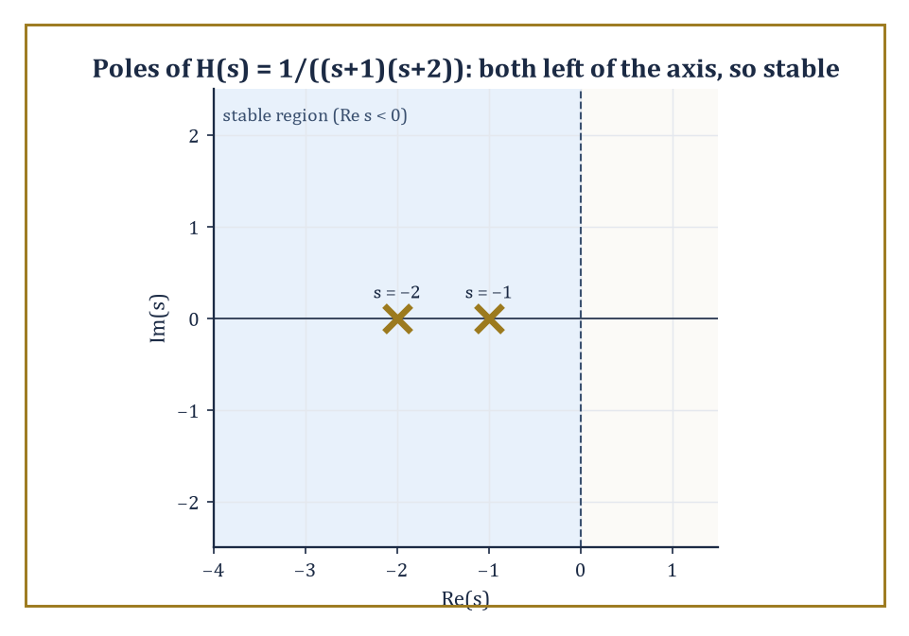
Figure 18.7 — The poles of H(s) = 1/((s+1)(s+2)) sit safely left of the imaginary axis — the entire stability verdict, read off at a glance.
H(s) = Y(s)/X(s)
Once H(s) is known for a system, its response to any input whatsoever follows immediately: multiply X(s) by H(s) and invert. The zeros and poles of H(s) — the values of s where it vanishes or blows up — carry essentially all the qualitative information about the system: poles govern the system’s free, unforced response and its stability; zeros govern which inputs the system tends to block or attenuate.
Numeric example — transfer function and impulse response. A system obeys y″ + 3y′ + 2y = x(t). With zero initial conditions, transforming gives
(s² + 3s + 2)Y(s) = X(s)
so
H(s) = Y(s)/X(s) = 1/(s² + 3s + 2) = 1/((s+1)(s+2))
The poles are at s = −1 and s = −2 — both with negative real part, which (as the next paragraph explains) means the system is stable. Partial fractions:
1/((s+1)(s+2)) = A/(s+1) + B/(s+2)
1 = A(s+2) + B(s+1)
at s=−1, A=1; at s=−2, B=−1. So
H(s) = 1/(s+1) − 1/(s+2)
and the impulse response is h(t) = e⁻ᵗ − e⁻²ᵗ — a response that rises briefly and then decays away to nothing, the signature of a stable, well-damped system.
Try it now — Is H(s) = 1/(s² + s − 2) stable? Answer →
Poles determine stability because each pole at s = p contributes a term proportional to eᵖᵗ to the free response. If the real part of p is negative, eᵖᵗ decays to zero as t → ∞ — the system settles down after a disturbance. If the real part of p is positive, eᵖᵗ explodes — the system’s response grows without bound, which in a real circuit or mechanical structure usually ends in smoke, snapped components, or a very apologetic engineering report.
(Poles on the imaginary axis produce persistent, undamped oscillation — the marginal case that keeps control engineers, and indeed anyone contemplating their own tenure prospects, awake at night.) Block diagrams, feedback loops, and elementary control systems are analyzed entirely by algebraic manipulation of transfer functions: connect two systems in series and their transfer functions multiply; close a feedback loop and a small piece of algebra produces the closed-loop transfer function directly.
Worked example — a feedback loop and its stability. A system with open-loop transfer function G(s) = K/(s+1) (a simple first-order plant with adjustable gain K) is placed in a unity-feedback loop, meaning the output is fed straight back and subtracted from the input. Standard feedback algebra gives the closed-loop transfer function
T(s) = G(s)/(1 + G(s)) = [K/(s+1)] / [1 + K/(s+1)]
Multiply numerator and denominator by (s+1):
T(s) = K/((s+1) + K) = K/(s + 1 + K)
The single closed-loop pole sits at s = −(1+K). The system is stable exactly when this pole has negative real part, i.e. when
−(1+K) < 0, which rearranges to K > −1
So for any non-negative gain K the loop is comfortably stable, but push K below −1 (a negative gain large enough to overwhelm the natural damping) and the pole crosses into the right half-plane, and the whole arrangement becomes unstable — a single inequality summarizing an entire design constraint.
Numeric example — a zero that blocks a constant input. A system has transfer function H(s) = s/(s+1), which has a zero at s = 0. Feed it a constant input, x(t) = 5 for all t ≥ 0, so X(s) = 5/s. The output transform is
Y(s) = H(s)X(s) = [s/(s+1)]·(5/s) = 5/(s+1)
where the zero at s = 0 has canceled against the pole at s = 0 contributed by the constant input. Inverting,
y(t) = 5e⁻ᵗ → 0 as t → ∞
despite a steady, unchanging input of size 5, the steady-state output decays away to nothing. The zero at the origin has ‘blocked’ the constant (zero-frequency, or ‘DC’) component of the input — the transfer-function equivalent of a system that only responds to change, and shrugs off anything that stays put.
One further wrinkle in the pole picture is worth flagging, because The Inverse Transform and Partial Fractions already handed us the tool to deal with it: repeated poles. When two poles coincide — a denominator with a factor (s−p)² rather than two distinct factors (s−p₁)(s−p₂) — the impulse response is no longer a simple sum of exponentials but includes a term of the form t eᵖᵗ, the same repeated-linear-factor pattern met while inverting F(s) = 1/(s(s+1)²) back in The Inverse Transform and Partial Fractions.
Physically, this is the boundary case between an oscillating (underdamped) system and a sluggish, non-oscillating (overdamped) one: the ‘critically damped’ system, the one an engineer designs for on purpose when overshoot is unacceptable but speed still matters.
Numeric example — a critically damped system. A system obeys y″ + 2y′ + y = x(t). Its transfer function is
H(s) = 1/(s²+2s+1) = 1/(s+1)²
a single repeated pole at s = −1 rather than two distinct poles. This is already a recognized pair from the table built in Basic Transforms and Operational Rules and The Inverse Transform and Partial Fractions:
L⁻¹{1/(s+1)²} = t e⁻ᵗ
So the impulse response is h(t) = t e⁻ᵗ — it rises from 0 (unlike the two-distinct-pole case, which jumps straight up), peaks once, at t = 1 (found by setting the derivative
h′(t) = e⁻ᵗ − t e⁻ᵗ = e⁻ᵗ(1−t)
to zero), and then decays back to zero without ever crossing it a second time. No oscillation, no overshoot, and the fastest possible settling for a system built from a single repeated real pole — precisely why critical damping is a design target, not merely a mathematical curiosity.
The Laplace transform therefore sits precisely at the junction of differential equations and classical control theory. The same operational calculus that solved an initial-value problem in Solving Linear Differential Equations also designs a compensator, predicts a closed-loop response, and tells an engineer, before a single prototype is built, which gains will make the thing oscillate itself to pieces. Very few pieces of undergraduate mathematics do quite so much useful work for quite so little algebraic effort.
Keep only this · Section 18.7: Systems and Transfer Functions
The idea. A system is stable when every pole of its transfer function has negative real part.
Core.
H(s) = Y(s)/X(s) with zero initial conditions
stable ⇔ all poles have Re s < 0
Typical mistake. Forgetting that a pole on the imaginary axis gives undamped (marginal) behaviour, not decay.
Minimal example. y′ + 2y = x: H(s) = 1/(s + 2), pole −2, stable.
Practice. Easy to challenge; full worked answers, with the usual mistake, are in Answers to the Practice Sets at the back.
Easy — Transfer function of y″ + 3y′ + 2y = x. Answer →
Medium — Is H(s) = 1/(s² − s + 1) stable? Answer →
Challenge — What steady response does H(s) = 1/(s + 1) give to x = sin t? Answer →

Section 18.8: Further Properties and Techniques
The Bag of Extra Tricks, For When the Table Runs Out
EXTENSION · about 15 minutes · enrichment; nothing later depends on it
Sometimes you do not need the whole answer, only how it starts or where it ends up. Will the motor settle at 1,500 revolutions per minute? Where does the tank level finish after the valve opens? The Laplace transform can answer such questions directly, reading the starting value and the final value off the transformed expression without ever converting back. It is a genuine shortcut, with one trap. A system that keeps oscillating forever, like a frictionless pendulum, has no final value at all, and the shortcut will cheerfully report a number anyway unless you first check that the system really settles. This section collects that shortcut and several more like it.
Key idea — Two theorems let you extract limiting behavior of f(t) directly from F(s), without ever performing the inversion. The final-value theorem recovers the steady-state value:
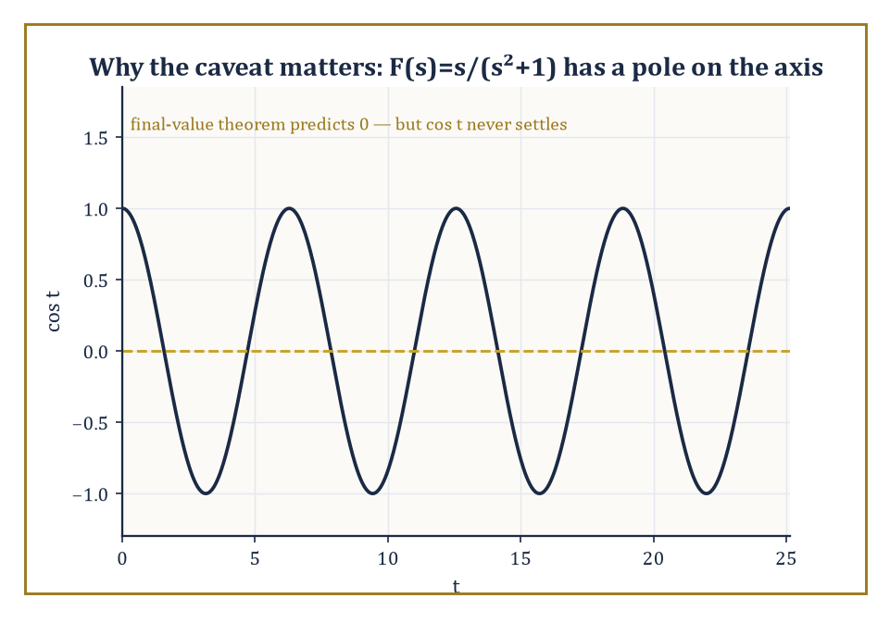
Figure 18.8 — cos t, oscillating forever without settling — the standing reminder that the final-value theorem is a shortcut, not a magic trick.
lim[t→∞] f(t) = lim[s→0] sF(s)
This is valid provided that limit exists and (technically) that sF(s) has no poles in the closed right half-plane other than possibly at the origin — a caveat that rules out applying it, say, to an undamped oscillation, which never settles to a steady value at all. The initial-value theorem, its mirror image, recovers the value f(0⁺) from the opposite limit:
f(0⁺) = lim[s→∞] sF(s)
Both are useful as sanity checks — a fast way to confirm a hard-won partial-fraction inversion without redoing the whole calculation.
Numeric example — checking both theorems at once. Take F(s) = 1/(s(s+1)).
Partial fractions:
1/(s(s+1)) = A/s + B/(s+1)
so 1 = A(s+1) + Bs; at s=0, A=1; at s=−1, 1=B(−1), B=−1.
F(s) = 1/s − 1/(s+1)
f(t) = 1 − e⁻ᵗ
Final-value theorem:
lim[s→0] sF(s) = lim[s→0] s/(s(s+1)) = lim[s→0] 1/(s+1) = 1
Directly:
lim[t→∞](1−e⁻ᵗ) = 1
They agree. Initial-value theorem:
lim[s→∞] sF(s) = lim[s→∞] 1/(s+1) = 0
Directly:
f(0) = 1 − e⁰ = 0
They agree too — both theorems confirmed on a single example, and incidentally the same function 1−e⁻ᵗ met already as the step response in Convolution and the Convolution Theorem (Chapter 18), now approached from the algebra rather than from convolution.
Try it now — Use the final-value theorem on F(s) = 2/(s(s + 4)). Answer →
Abstract example — why the caveat on the final-value theorem is not decorative. Take F(s) = s/(s²+1), the transform of f(t) = cos t (a standard pair from Basic Transforms and Operational Rules). Blindly apply the final-value theorem:
lim[s→0] sF(s) = lim[s→0] s²/(s²+1) = 0
But cos t has no limit at all as t → ∞ — it oscillates between −1 and 1 forever and never settles anywhere, so the theorem’s promised answer of 0 is wrong. The hypothesis quietly violated here is the one about pole locations: sF(s) = s²/(s²+1) has poles at s = ±i, sitting on the imaginary axis rather than strictly in the left half-plane, and the theorem’s guarantee evaporates the instant that happens.
The moral: the final-value theorem is a genuine shortcut, not a magic trick, and it is worth a two-second glance at the poles of sF(s) before trusting whatever number it hands back.
The differentiation-of-a-parameter trick from Basic Transforms and Operational Rules (multiplying f by t corresponds to differentiating F and flipping the sign) combines readily with the first shifting theorem to handle products like tⁿeᵃᵗ in one step, since:
L{tⁿ} = n!/sⁿ⁺¹
the shift s → s−a then gives:
L{tⁿeᵃᵗ} = n!/(s−a)ⁿ⁺¹
directly, without separately performing the differentiation and the shift.
Numeric example — a power times an exponential. Find L{t²e³ᵗ}. Using the combined formula with n=2, a=3:
L{t²e³ᵗ} = 2!/(s−3)³ = 2/(s−3)³
This can also be reached the long way — differentiate L{e³ᵗ} = 1/(s−3) twice with respect to s, picking up the appropriate signs — but the combined shift-and-power formula saves the trouble.
Just as multiplying f(t) by t differentiates F(s), dividing f(t) by t integrates F(s): provided the limit of f(t)/t exists as t → 0⁺,
L{f(t)/t} = ∫[s, ∞] F(σ) dσ
the mirror image of the multiplication-by-t rule from Basic Transforms and Operational Rules, now running the s-domain operation forward instead of backward.
Numeric example — dividing by t. Find L{(sin t)/t}. Here F(s) = L{sin t} = 1/(s²+1), and (sin t)/t does tend to a finite limit (namely 1) as t → 0⁺, so the rule applies:
L{(sin t)/t} = ∫[s, ∞] dσ/(σ²+1) = [arctan σ]ₛ∞ = (π/2) − arctan(s)
Using the identity arctan(s) + arctan(1/s) = π/2 for s > 0, this can equally be written arctan(1/s) — a compact closed form for the transform of a function, (sin t)/t, that has no elementary antiderivative at all in the ordinary sense. The transform did not care.
Completing the square, used already in The Inverse Transform and Partial Fractions to invert irreducible quadratic denominators, is not a special trick reserved for that one situation — it is the general technique for translating any quadratic factor that fails to split over the reals into the shifted sine-and-cosine pattern, and it is worth internalizing as a standing habit whenever a denominator refuses to factor cleanly into real linear pieces.
Occasionally partial fractions become unwieldy — a high-order pole, an awkward combination of factors — and a more powerful tool is available: the Bromwich integral, or inversion integral, which expresses f(t) directly as a contour integral in the complex s-plane:
f(t) = (1/2πi) ∫[γ−i∞, γ+i∞] eˢᵗ F(s) ds
taken along a vertical line to the right of every singularity of F. Evaluating such an integral is done by summing residues at the poles of F(s), a technique from complex analysis proper.
The method is not needed for anything in this chapter’s worked examples, but its mere existence is reassuring: it guarantees that an inverse transform exists, and can in principle always be computed, for a vastly larger class of functions than partial fractions alone can reach.
Abstract example — a residue recovering a familiar pair. Consider F(s) = 1/(s−a), which has a single simple pole at s = a. The Bromwich integral reduces, for a function with only isolated simple poles, to summing the residues of eˢᵗF(s) at each pole. Here eˢᵗF(s) = eˢᵗ/(s−a), and the residue at the simple pole s=a is found by the standard rule:
Resₛ₌ₐ = lim[s→a] (s−a)·eˢᵗ/(s−a) = eᵃᵗ
So the Bromwich integral returns:
f(t) = eᵃᵗ
exactly the pair L{eᵃᵗ} = 1/(s−a) established by direct integration all the way back in What the Laplace Transform Actually Is. Nothing new is learned about this particular pair, but the agreement is the point: the heavy complex-analytic machinery, when pointed at a case simple enough to check by hand, gives the answer elementary methods already gave, which is as reassuring a piece of consistency as mathematics ever offers.
Keep only this · Section 18.8: Further Properties and Techniques
The idea. Initial value: f(0⁺) = lim sF(s) as s → ∞. Final value: lim f(t) = lim sF(s) as s → 0, if the limit of f exists.
Core.
L{t f(t)} = −F′(s)
final value: lim[t → ∞] f(t) = lim[s → 0] sF(s), if the limit exists
Typical mistake. Using the final-value theorem on cos t, whose limit does not exist.
Minimal example. L{t sin t} = 2s/(s² + 1)².
Practice. Easy to challenge; full worked answers, with the usual mistake, are in Answers to the Practice Sets at the back.
Easy — Use L{t f} = −F′ to get L{t exp(t)}. Answer →
Medium — Final value of f if F(s) = 3/(s(s + 2)). Answer →
Challenge — Why does the final-value theorem give a wrong answer for F = 1/(s² + 1)? Answer →

Section 18.9: The Working Tables
Why Almost Nobody Evaluates the Integral
PREVIEW — OPTIONAL · about 20 minutes · reference tables: consult them while doing the problems
Here is a confession that ought to come earlier in most treatments than it does: practicing engineers and physicists almost never compute a Laplace transform. They look it up. The defining integral is what guarantees the transform exists and gives the subject its foundations, but the working method is pattern-matching against a table of known pairs, bent into shape by a handful of operational rules.
This is not laziness, and it is not a shortcut past understanding. It is the whole design. A table of two dozen entries plus a dozen rules covers an enormous fraction of the functions that arise in practice, because the rules are closed operations: add two table entries, multiply one by an exponential, delay it, differentiate it, convolve it with another, and the result is still expressible in terms of the table. The table is small because the rules do the reaching.
So the working procedure, in both directions, is the same three steps. Recognize the shape. Apply whichever rules turn your function into that shape (or your transform into a sum of shapes). Read the answer off the table. What follows is the table, the rules, and ten examples of the procedure in action — five going into the s-domain, five coming back.
The rules come first, because they are what make a short table sufficient. In every line below, F(s) = L{f(t)} and G(s) = L{g(t)}, and f is assumed to satisfy the growth and continuity conditions of What the Laplace Transform Actually Is.
Rule | Time domain | Transform domain
Linearity | a f(t) + b g(t) | a F(s) + b G(s)
First shifting (s-shift) | eᵃᵗ f(t) | F(s − a)
Second shifting (t-shift) | u(t − a) f(t − a), a ≥ 0 | e⁻ᵃˢ F(s)
Scaling | f(at), a > 0 | (1/a) F(s/a)
First derivative | f′(t) | s F(s) − f(0)
Second derivative | f″(t) | s² F(s) − s f(0) − f′(0)
nth derivative | f⁽ⁿ⁾(t) | sⁿF(s) − sⁿ⁻¹f(0) − … − f⁽ⁿ⁻¹⁾(0)
Integration | ∫₀ᵗ f(τ) dτ | F(s) / s
Multiplication by t | t f(t) | −F′(s)
Multiplication by tⁿ | tⁿ f(t) | (−1)ⁿ F⁽ⁿ⁾(s)
Division by t | f(t) / t | ∫[s, ∞] F(σ) dσ
Convolution | (f ∗ g)(t) = ∫₀ᵗ f(τ)g(t−τ) dτ | F(s) G(s)
Periodic f, period T | f(t + T) = f(t) | (1 − e⁻ˢᵀ)⁻¹ ∫₀ᵀ e⁻ˢᵗ f(t) dt
Initial value theorem | f(0⁺) | lim[s→∞] s F(s)
Final value theorem | lim[t→∞] f(t) | lim[s→0] s F(s) (poles in Re s < 0)

Two of those deserve a warning. The final value theorem is only valid when the limit it claims to compute actually exists — apply it to F(s) = 1/(s² + 1) and it cheerfully returns 0 for a function, sin t, that never settles anywhere. Check that every pole of s F(s) sits strictly in the left half-plane before trusting it. And the second shifting rule is about a delayed copy of f, not about f evaluated late: the factor u(t − a) switching the function on at t = a is part of the rule, not decoration.
Now the table itself. Every entry can be derived from the definition, and most of them were, somewhere in the preceding sections; collected here they become a working instrument rather than a sequence of results.
f(t), t ≥ 0 | F(s) = L{f(t)} | Valid for
1 | 1 / s | s > 0
t | 1 / s² | s > 0
tⁿ, n = 0, 1, 2, … | n! / sⁿ⁺¹ | s > 0
tᵖ, p > −1 | Γ(p + 1) / sᵖ⁺¹ | s > 0
eᵃᵗ | 1 / (s − a) | s > a
t eᵃᵗ | 1 / (s − a)² | s > a
tⁿ eᵃᵗ | n! / (s − a)ⁿ⁺¹ | s > a
sin ωt | ω / (s² + ω²) | s > 0
cos ωt | s / (s² + ω²) | s > 0
sinh at | a / (s² − a²) | s > |a|
cosh at | s / (s² − a²) | s > |a|
eᵃᵗ sin ωt | ω / ((s − a)² + ω²) | s > a
eᵃᵗ cos ωt | (s − a) / ((s − a)² + ω²) | s > a
t sin ωt | 2ωs / (s² + ω²)² | s > 0
t cos ωt | (s² − ω²) / (s² + ω²)² | s > 0
u(t − a), a ≥ 0 | e⁻ᵃˢ / s | s > 0
δ(t) | 1 | all s
δ(t − a), a ≥ 0 | e⁻ᵃˢ | all s
1 / √(πt) | 1 / √s | s > 0
2 √(t/π) | 1 / s^{3/2} | s > 0

A word on the two square-root entries, which look like typographical accidents and are not. They follow from the tᵖ line with p = −½ and p = +½, using Γ(½) = √π. They matter because half-integer powers are what diffusion problems produce, and a table without them sends the reader away believing the transform only handles polynomials and oscillations.
Five transforms, going in. The point of the selection is that no two of them use the same rule.
Numeric example — Linearity across three entries.
Transform f(t) = 3t² − 5e⁻²ᵗ + 4 sin 3t.
Nothing here needs an integral. Linearity splits the problem into three lookups: t² gives 2!/s³, e⁻²ᵗ gives 1/(s + 2) with a = −2, and sin 3t gives 3/(s² + 9) with ω = 3. Reassembling with the original coefficients:
F(s) = 6/s³ − 5/(s + 2) + 12/(s² + 9)
Total elapsed integration: none.
Try it now — Look up L{t sin 3t} in the tables. Answer →
Numeric example — First shifting.
Transform f(t) = e⁻³ᵗ cos 4t.
Strip the exponential off and what remains, cos 4t, is a table entry: s/(s² + 16). The first shifting rule says that multiplying by eᵃᵗ in time replaces s by s − a in the transform. Here a = −3, so every s becomes s + 3:
F(s) = (s + 3) / ((s + 3)² + 16)
This is worth doing once by hand and then never again. The pattern — damped oscillation in time becomes a shifted resonance in s — is the single most common shape in all of engineering mathematics.
Numeric example — Second shifting, with the step function earning its keep.
Transform f(t) = u(t − 2)(t − 2)³: a cubic that does not switch on until t = 2.
The second shifting rule handles delay directly. Transform the undelayed function first — L{t³} = 6/s⁴ — then attach the delay as an exponential factor:
F(s) = 6 e⁻²ˢ / s⁴
Note what did not happen: no integral from 2 to infinity, no change of variable. Delay in time is multiplication by e⁻ᵃˢ in s, and that is the entire content of the rule.
Numeric example — Multiplication by t, via differentiating the transform.
Transform f(t) = t sin 2t.
The table has sin 2t as 2/(s² + 4). The rule for multiplying by t says differentiate the transform and flip the sign:
F(s) = −d/ds [ 2/(s² + 4) ] = −2 · (−2s)/(s² + 4)² = 4s / (s² + 4)²
Cross-check against the t sin ωt entry with ω = 2: 2ωs/(s² + ω²)² = 4s/(s² + 4)². Agreement — which is the point of having both a rule and a table entry for the same thing. Either route works, and each checks the other.
Numeric example — The integration rule.
Transform f(t) = ∫₀ᵗ exp(−2τ) dτ.
You could evaluate the integral first — it is (1 − e⁻²ᵗ)/2 — and then transform termwise. The rule is faster: integrating from 0 to t divides the transform by s. Since L{e⁻²ᵗ} = 1/(s + 2),
F(s) = 1 / (s(s + 2))
Confirming the slow way: L{(1 − e⁻²ᵗ)/2} = ½(1/s − 1/(s+2)) = ½ · 2/(s(s+2)) = 1/(s(s + 2)). The same answer, with more work.
Five inverses, coming back. Going backwards is where the table earns its reputation, because the inverse transform has no convenient integral formula for hand use — the Bromwich contour integral of Further Properties and Techniques is a theoretical object, not a desk tool. In practice the inverse is performed entirely by algebra: manipulate F(s) until every term is a table entry read right-to-left.
Numeric example — Direct match, with a constant to fix.
Invert F(s) = 5/(s² + 9).
The shape is the sin ωt entry, ω/(s² + ω²), with ω = 3. But the table demands a numerator of 3 and we have 5. Manufacture it:
5/(s² + 9) = (5/3) · 3/(s² + 9) ⟹ f(t) = (5/3) sin 3t
Adjusting a constant to match a table entry is the most common single operation in inverse transforms, and it is worth doing deliberately rather than by eye.
Numeric example — Completing the square, then shifting back.
Invert F(s) = (2s + 3)/(s² + 4s + 13).
An irreducible quadratic in the denominator means a damped oscillation. Complete the square: s² + 4s + 13 = (s + 2)² + 9, so a = −2 and ω = 3. Now force the numerator to speak in terms of (s + 2): write 2s + 3 = 2(s + 2) − 1. Then
F(s) = 2 · (s + 2)/((s + 2)² + 9) − (1/3) · 3/((s + 2)² + 9)
and both terms are table entries under first shifting:
f(t) = 2 e⁻²ᵗ cos 3t − (1/3) e⁻²ᵗ sin 3t
Numeric example — Partial fractions, distinct poles.
Invert F(s) = 1/(s(s − 3)).
Two simple poles, so split them: 1/(s(s − 3)) = A/s + B/(s − 3), giving 1 = A(s − 3) + Bs. Setting s = 0 gives A = −1/3; setting s = 3 gives B = 1/3. Hence
f(t) = −1/3 + (1/3) e³ᵗ = (e³ᵗ − 1)/3
Sanity check with the initial value theorem: s F(s) = 1/(s − 3) → 0 as s → ∞, and indeed f(0) = (1 − 1)/3 = 0.
Numeric example — An exponential factor means a delay.
Invert F(s) = e⁻⁴ˢ/s².
Whenever e⁻ᵃˢ appears as a factor, peel it off and set it aside — it is not part of the algebra, it is an instruction to delay whatever the rest inverts to. Here the rest is 1/s², which inverts to t. So the answer is t, switched on at t = 4 and measured from there:
f(t) = u(t − 4) · (t − 4)
That is: nothing at all until t = 4, then a ramp climbing at unit rate. Reading e⁻⁴ˢ as “and none of this happens until four seconds in” turns an intimidating factor into a plain-language instruction.
Numeric example — A repeated pole.
Invert F(s) = 1/((s − 1)²(s + 2)).
A repeated factor needs one term per power, so the decomposition is A/(s − 1) + B/(s − 1)² + C/(s + 2), giving
1 = A(s − 1)(s + 2) + B(s + 2) + C(s − 1)²
Set s = 1: 1 = 3B, so B = 1/3. Set s = −2: 1 = 9C, so C = 1/9. Set s = 0: 1 = −2A + 2/3 + 1/9, which gives A = −1/9. Each term is now a table entry, the middle one being the t eᵃᵗ line:
f(t) = −(1/9) eᵗ + (1/3) t eᵗ + (1/9) e⁻²ᵗ
Check at t = 0: −1/9 + 0 + 1/9 = 0, as it must be, since F(s) decays like 1/s³ and the initial value theorem therefore demands f(0) = 0.
Notice what the ten examples have in common. Not one of them evaluated the defining integral, and not one of them needed to. Every forward transform was a table entry reshaped by a rule; every inverse was an algebraic manipulation — factoring, completing the square, splitting into partial fractions, peeling off an exponential — performed until the expression matched something already known.
That is why the Laplace transform became the working tool of engineering rather than a curiosity of analysis. The hard part was done once, by the people who built the table. What remains for the rest of us is recognition and bookkeeping, and bookkeeping is something a tired person can do correctly at four in the afternoon, which is more than can be said for contour integration.
Keep only this · Section 18.9: The Working Tables
The idea. Use the tables actively: match the shape, fix constants, then check one value.
Core.
read rows right to left to invert
always check the shift and the region of convergence
Typical mistake. Forcing a match by ignoring a constant factor in the numerator.
Minimal example. Row “1/(s − a) ↔ exp(at)” covers both directions.
Practice. Easy to challenge; full worked answers, with the usual mistake, are in Answers to the Practice Sets at the back.
Easy — Use the table to invert 6/s⁴. Answer →
Medium — Invert 2/((s − 1)² + 4). Answer →
Challenge — Invert s/(s² + 4)² using the table row L{t sin bt} = 2bs/(s² + b²)². Answer →

Chapter 18 in One Page
The Laplace transform F(s) = ∫₀∞ f(t) e^{−st} dt converts differentiation into multiplication by s, with the initial values attached. Linear differential equations with constant coefficients become algebraic equations; partial fractions and a table invert the answer. Steps and impulses model switching and kicks, convolution models a system’s response to an input, and the poles of the transfer function decide stability.
Key definitions
• L{f}(s) = ∫₀∞ f(t) e^{−st} dt.
• Unit step u(t − c) and impulse δ(t − c).
• Convolution (f ∗ g)(t) = ∫₀ᵗ f(τ)g(t − τ) dτ.
• Transfer function H(s) = Y(s)/X(s) with zero initial conditions.
Key theorems, with their hypotheses
• Existence — hypothesis: f piecewise continuous and of exponential order, s larger than the growth rate.
• Derivative rule L{f′} = sF − f(0) — hypothesis: f continuous, f′ piecewise continuous, both of exponential order.
• Shifting theorems — hypotheses: c ≥ 0 for the delay rule.
• Final-value theorem — hypothesis: all poles of sF(s) in the left half-plane.
Canonical example
• y″ + 3y′ + 2y = 0, y(0) = 1, y′(0) = 0: Y = (s + 3)/((s + 1)(s + 2)) = 2/(s + 1) − 1/(s + 2), so y = 2e^{−t} − e^{−2t}.
Common errors
• Dropping −f(0) in the derivative rule.
• Shifting s the wrong way.
• Delayed function written without the shift inside.
• Final-value theorem applied to an oscillation.
Readiness checklist — you are ready for what comes next when you can:
□ transform polynomials, exponentials, sines, cosines and their products with t
□ invert rational functions by partial fractions and completing the square
□ solve a second-order initial-value problem by Laplace
□ handle steps, impulses and convolutions
□ decide stability from the poles
Section 18.10 that follows is a preview, marked optional: it says where these ideas lead in later chapters and volumes. Nothing in it is needed for the exercises.

Section 18.10: Looking Back, and Where This Goes Next (Optional)
Where This Fits, and Where the Series Goes Next
PREVIEW — OPTIONAL · about 15 minutes · optional; read for orientation, nothing is examined
Overview — Take stock of the toolkit assembled across this chapter: the definition of F(s) as a discounted integral over t ≥ 0; the operational rules that turn differentiation into multiplication by s; the inverse transform by partial fractions; the mechanical three-step solution of linear differential equations and systems; the step and delta functions for switches and shocks; the convolution theorem linking products of transforms to smeared integrals of the originals; and the transfer-function language in which poles mean stability and zeros mean filtering. Each piece leaned on the one before it, and together they turn a differential equation — a statement about rates of change — into a statement about a rational function of a complex variable, solvable by algebra a good deal less sophisticated than the calculus it replaced.
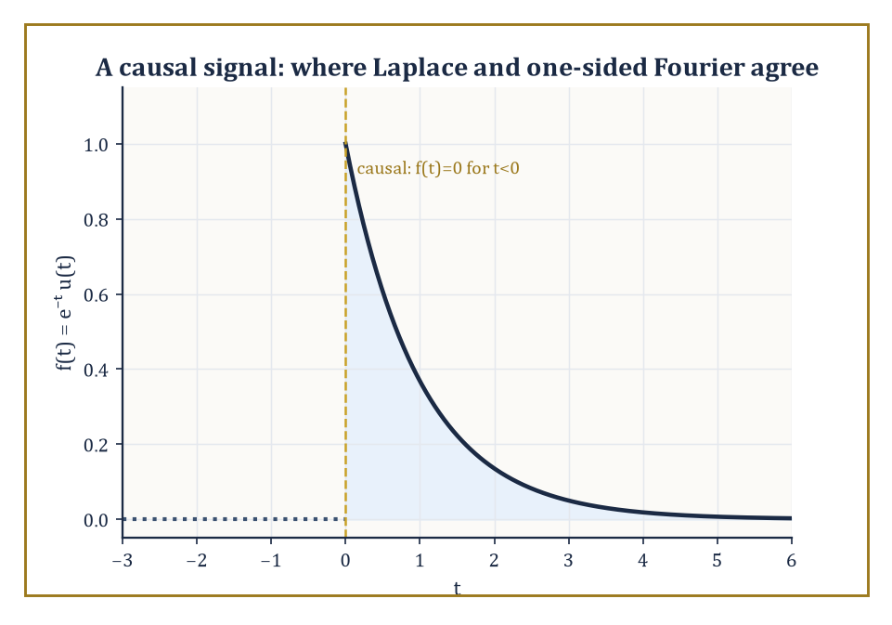
Figure 18.9 — A causal signal, silent before t = 0 — the one feature that quietly distinguishes Laplace from its whole-line cousin, Fourier.
It is worth pausing on the family resemblance to the chapter just before this one. The Fourier transform integrated exp(−iωt)f(t) over the whole real line; the Laplace transform integrates e⁻ˢᵗf(t) over the half-line t ≥ 0. Set s = iω in a Laplace transform, and — provided the function in question is causal (zero for t<0) and the imaginary axis lies inside its region of convergence — the two constructions coincide exactly. Laplace did not replace Fourier’s idea; it generalized the exponent from a pure oscillation iω into a full complex number σ + iω, trading Fourier’s requirement of absolute integrability over all time for a one-sided decay condition far more forgiving of the unruly, switch-on-at-t=0 functions that engineering produces.
Numeric example — Laplace reducing to Fourier. Let f(t) = e⁻ᵗ for t ≥ 0 (and f(t) = 0 for t < 0, making it causal).
Its Laplace transform, from What the Laplace Transform Actually Is, is valid over a region of convergence that comfortably contains the entire imaginary axis.
F(s) = 1/(s+1), valid for Re(s) > −1
Set s = iω.
F(iω) = 1/(iω + 1)
Now compute the one-sided Fourier transform directly, by the Fourier chapter’s own definition restricted to t ≥ 0.
∫[0, ∞] e⁻ᵗ exp(−iωt) dt = ∫[0, ∞] exp(−(1+iω)t) dt = 1/(1+iω)
This converges because:
Re(1+iω) = 1 > 0
The two results, 1/(iω+1) and 1/(1+iω), are identical. Laplace and Fourier were never really strangers — one is the other with its decay rate allowed to be a genuine number rather than fixed at zero.
Try it now — What does the Laplace transform of a causal f reduce to on the line s = iω? Answer →
None of this machinery arrived from nowhere. Every single technique in this chapter leaned on something built many chapters back: complex numbers, without which s could never have grown from a real dial into a full complex-frequency variable; integral calculus, without which the definition itself is meaningless; and the partial-fraction algebra of first-year integration, which did essentially all of the actual work of inverting a transform once the table of pairs was in hand. If there is a single throughline connecting this chapter to the rest of the series, it is that very little here was conceptually new — what was new was the arrangement, the decision to package differentiation as multiplication and let ordinary algebra do calculus’s job by proxy.
Two further chapters wait in the wings of this idea, both left unopened here. Heaviside’s own operational calculus, later placed on a fully rigorous algebraic footing by Jan Mikusiński, abstracts away the integral altogether and treats ‘differentiation’ and ‘the delta function’ as elements of a formal algebraic structure obeying their own consistent rules — vindicating, roughly a century late, the reckless engineer from this chapter’s opening paragraph. Distribution theory, in the hands of Laurent Schwartz, supplies the fully rigorous foundation for the delta function and its derivatives that this chapter has been carefully working around rather than confronting head-on. Both are, for now, left as promissory notes; a series with fifty chapters can only build so much scaffolding on any single chapter.
The deeper lesson, worth carrying into every remaining chapter, is that a well-chosen integral transform can convert a hard analytic problem into an easy algebraic one, and that the algebra is very often less trouble than the calculus it replaced. Learning to move fluently between the time domain and the transform domain — thinking in whichever domain makes the current problem tractable, and translating the answer back when finished — is a permanent, load-bearing habit of the working mathematician’s toolkit, not a trick specific to this one transform.
The next chapter abandons the time domain altogether. Integral Geometry stops asking what a function does moment to moment and asks instead what a shape looks like from every possible angle — integrating not against a decaying exponential but along every line, or every hyperplane, that can be drawn through a region. It sounds like a wild change of subject, and in one sense it is; but the projection-slice theorem ties it straight back to the Fourier transform one chapter back, and the Radon transform at its center is the actual mathematics running inside every CT scanner ever built: The family of integral transforms, it turns out, is rather larger — and rather more interested in staying in touch with its relatives — than any one chapter lets on.
We began this chapter with a discounted integral and a promise that differentiation would turn into multiplication. We leave it having solved initial-value problems by algebra, switched forcing terms on and off at will, detonated delta functions without flinching, smeared one function through another by convolution, and read the stability of an entire engineered system off the sign of a real part. Not bad for one chapter’s work, and not one differential equation was harmed by anything more advanced than partial fractions.
The series continues. We have learned to transform.
Keep only this · Section 18.10: Looking Back, and Where This Goes Next (Optional)
The idea. Laplace is Fourier with a decay factor and a starting time; Volume 3 uses it for whole classes of differential equations.
Core.
Laplace = Fourier of f(t) exp(−σt)
poles of F decide the long-run behaviour of f
Typical mistake. Thinking the Laplace transform is a separate subject; it is the Fourier transform with a decaying factor exp(−σt).
Minimal example. F = 1/(s + 2) ↦ exp(−2t): pole at −2, decay rate 2.
Practice. Easy to challenge; full worked answers, with the usual mistake, are in Answers to the Practice Sets at the back.
Easy — A transform has its only pole at s = −5. Does f grow or decay? Answer →
Medium — Which Volume 1 idea do derivative rules turn into algebra here? Answer →
Challenge — Why are complex-conjugate poles at −1 ± 3i a damped oscillation? Answer →

Check Your Understanding — Chapter 18
Answers are in the Answer Key at the back of the book — have a go before you look.
1. [Explain] Why does the Laplace transform converge for a function like f(t) = eᵗ, which the Fourier transform cannot handle at all?
See the answer →
2. [Explain] Why does solving an initial-value problem by Laplace transform never need a separate step where you ‘apply the initial conditions’ afterward?
See the answer →
3. [Explain] A system obeys y′ + y = δ(t − 1), with y(0) = 0. Describe the solution’s behavior at t = 1 and explain why.
See the answer →
4. [Concept] A system has transfer function H(s) = 1/((s+1)(s+2)). Is it stable, and what would happen if one pole moved to s = +1 instead?
See the answer →

Fluency Drill — Chapter 18
Five minutes, no notes, before the harder problems. These are the moves the Problems assume are automatic; if one takes you more than a minute, reread the section it names. Worked answers, each with the usual slip, are in Answers to the Practice Sets.
1. [Compute] L{5}. Answer →
2. [Compute] L{t³}. Answer →
3. [Compute] Inverse of 4/(s² + 16). Answer →
4. [Compute] Inverse of s/(s² + 9). Answer →
5. [Compute] L{y″} in terms of Y, y(0) = 1, y′(0) = 2. Answer →
6. [Compute] Inverse of e^{−3s}/s. Answer →
7. [Concept] Poles at −1 ± 2i: stable, and does it oscillate? Answer →
8. [Compute] 1 ∗ 1 (convolution on t ≥ 0). Answer →

Problems — Chapter 18
Reading a transform table is not the same as being able to use one. What follows is a graded set of thirteen problems: transforms going in, transforms coming back, and several that put the machinery on an actual physical system. Full solutions are in the appendix “Solutions to the Problems” at the back — a page turn away on purpose. Attempt first, check second; the gap between the two is where the learning happens.
Each problem carries a skill tag — Concept, Compute, Explain, Prove, Model or Challenge, explained in How to Use This Book — and every solution in the appendix is written out in full, proofs included, and ends with the mistake that problem most often provokes. Read the solution after you have an answer of your own, not instead of one.
Transforms going in
1. [Compute] Find L{4 − 3e⁵ᵗ + 2t⁴}. Solution →
2. [Compute] Find L{e²ᵗ sin 5t}. Solution →
3. [Compute] Find L{t² e⁻ᵗ}. Solution →
4. [Explain] Find the transform of the rectangular pulse f(t) = u(t − 1) − u(t − 3), which equals 1 between t = 1 and t = 3 and zero elsewhere. Explain why a pulse of finite width needs two step functions rather than one. Solution →
5. [Prove] Show that L{t cos 3t} = (s² − 9)/(s² + 9)², first by the multiplication-by-t rule, then confirm it against the table entry for t cos ωt. Solution →
Transforms coming back
6. [Compute] Find the inverse transform of F(s) = 7/(s + 4). Solution →
7. [Compute] Find the inverse transform of F(s) = (3s − 2)/(s² + 16). Solution →
8. [Compute] Find the inverse transform of F(s) = 1/((s + 1)(s + 4)). Solution →
9. [Prove] Show that the inverse transform of F(s) = (2s + 5)/(s² + 6s + 13) is 2e⁻³ᵗ cos 2t − ½e⁻³ᵗ sin 2t. Solution →
Putting it to work
10. [Compute] Solve y″ + 4y = 0 with y(0) = 2 and y′(0) = 0, using transforms rather than the characteristic equation. Solution →
11. [Model] A series RC circuit has R = 1 kΩ and C = 1 mF. The capacitor is uncharged when a switch closes at t = 0, connecting a constant 5 V source, so RC·v′(t) + v(t) = 5 with v(0) = 0. Find v(t), and state the voltage after one time constant. Solution →
12. [Model] A mass on a spring with a dashpot obeys x″ + 4x′ + 3x = 0, pulled to x(0) = 2 and released from rest. Show that x(t) = 3e⁻ᵗ − e⁻³ᵗ, and determine whether the motion oscillates. Solution →
13. [Challenge] Differentiation becomes multiplication by s under the Laplace transform, but multiplication by iω under the Fourier transform — and the Laplace rule carries an extra −f(0) that Fourier does not. Where does that term come from, and what does its presence tell you about which kinds of problem each transform is built for? Solution →

Math, Actually

Chapter 19

Integral Geometry
Measures on Spaces of Lines, Planes, and the Art of Reconstructing Shapes from Projections
This chapter performs a stranger and, I think, more beautiful trick: instead of transforming a function, we are going to integrate a shape — or rather, we are going to integrate over the space of all lines, or all planes, or all rigid motions, and discover that the geometry of a fixed object is encoded in how it interacts, on average, with everything that might pass through it.
This is a genuine change of gears, so it is worth being honest about the vertigo it induces the first time round. Ordinary calculus integrates a function over a fixed domain — you nail down the space (an interval, a disk, a solid) and let the integrand vary. Integral geometry does something closer to the reverse: it nails down the geometric object and lets the domain of integration itself be a space of geometric objects — the collection of all lines in the plane, say, each line now playing the role that a single point played in ordinary calculus. The question ‘what is the length of this curve?’ turns into the question ‘on average, how often does a random line cross it?’, and remarkably these turn out to be the same question wearing different coats.
None of this works unless we can say what ‘random line’ means without the answer depending on where you happened to put your coordinate axes — which is really the whole subject in one sentence. We will spend the early sections of this chapter pinning down the one honest notion of a uniformly random line or plane, and the rest of the chapter watching that single idea generate, with very little further effort, the classical formulas of Crofton and Blaschke, the mathematical machinery of the CT scanner, and a slightly startling amount of practical laboratory technique. If the Fourier transform taught us to hear a function as a chord of pure tones, integral geometry teaches us to reconstruct a shape from its shadows — which is, when you think about it, what a doctor asks a scanner to do to you.
Ahead lies a chapter of geometry behaving like geometry — curves, bodies, and the honest business of measuring them. Let us integrate over the space of lines.
Before you begin — Chapter 19 · Extension chapter
By the end of this chapter you will be able to:
1. Describe lines in the plane by (p, φ) and explain why dp dφ is the motion-invariant measure.
2. Compute the measure of lines meeting a convex set (its perimeter) and apply Buffon’s needle.
3. Use the Cauchy–Crofton formula to find lengths, and the Crofton area formula to find areas.
4. Apply the principal kinematic formula to two convex bodies.
5. Compute simple Radon transforms and explain how filtered back-projection inverts them.
6. Use stereological estimators such as Delesse’s principle.
Why it comes here. This chapter is an excursion, not a step on the main road: nothing later in the series depends on it, and the reading routes let you skip it. It sits here because it uses the multiple integrals of Chapter 14 and the Fourier transform of Chapter 17 together, to answer a practical question — how a CT scanner sees inside a body from measurements taken only outside it.
Required chapters. Multi-Variable Calculus (Chapter 14); Fourier Transforms and FFT (Chapter 17), for Sections 19.6–19.7.
Assumed skills. evaluate double integrals in polar coordinates; integrate |cos φ| and sin φ over [0, π]; compute a probability as a ratio of areas.
If you are rusty. Double Integrals and Iterated Integrals; Change of Variables and Jacobians; The Fourier Transform on the Line.
Do not proceed until you can…
1. Evaluate ∫[0, π] |cos φ| dφ. Answer →
2. A point is chosen uniformly in [0, 2] × [0, π]. What is the probability that its first coordinate is below 1? Answer →
3. Area of the disk of radius 2 in polar coordinates. Answer →
Estimated study time. About 8–10 hours; Sections 19.6–19.8 alone take about 4. Work every Try it now before reading on, finish each section’s Keep only this practice before starting the next, and do the Fluency Drill before the Problems.

Section 19.1: What Integral Geometry Actually Is
In which we stop integrating functions and start integrating geometry itself
EXTENSION · about 20 minutes · enrichment; nothing later depends on it
A CT scanner never looks inside a body directly, the way an ordinary photograph does. Instead, it fires a great many X-ray beams straight through the body, one after another, from every angle available, and for each individual beam it records a single number: how much of that beam’s energy was absorbed along its path. One line, one number — nothing more detailed than that per beam.
Picture a single dense object sitting inside an otherwise empty box. A beam that passes straight through the object reports back a large amount of absorption — call it 1, in whatever units the machine uses. A parallel beam, aimed a little higher, that misses the object entirely and passes through empty space, reports back 0. Between those two extremes lies the entire outline of the object, one line at a time, and no single beam, on its own, tells you the object’s shape — only the whole collection of them, compared against each other, does.
That is a strange kind of data to build a theory around. Ordinary calculus, up to this point in the series, has always integrated a function over a region: an interval, an area, a volume — some chunk of space you could point to and say “integrate over that.” Here, there is no single region playing that role. What varies from one measurement to the next is not a point inside a fixed region, but an entire line, and there are infinitely many lines available, at every possible position and every possible angle.
So the question is no longer “how does this quantity vary from point to point within a region?” but “how does this quantity vary from line to line, across the whole collection of lines that could have been fired?” — and answering that means integrating over a space whose points are themselves entire lines, not a space of ordinary points.
Building that space of lines honestly takes real care, more than it might look at first. Which lines count as “close” to one another? How do you add up a property across all of them without secretly favoring some directions — say, horizontal lines — over others, purely as an accident of how the space was set up? The fix is to insist that the way of measuring across lines stays exactly the same if the whole picture — scanner, body, everything — is rotated or slid to a new position. That single requirement, invariance under the natural symmetries of the space, is what turns “the collection of all lines” from a vague heap into a space that can be integrated over.
Key idea — Integral geometry studies a fixed geometric object — a curve, a region, a solid body — by integrating over spaces of other geometric elements that might interact with it: lines, planes, subspaces, or the rigid motions that slide and rotate one body until it meets another.
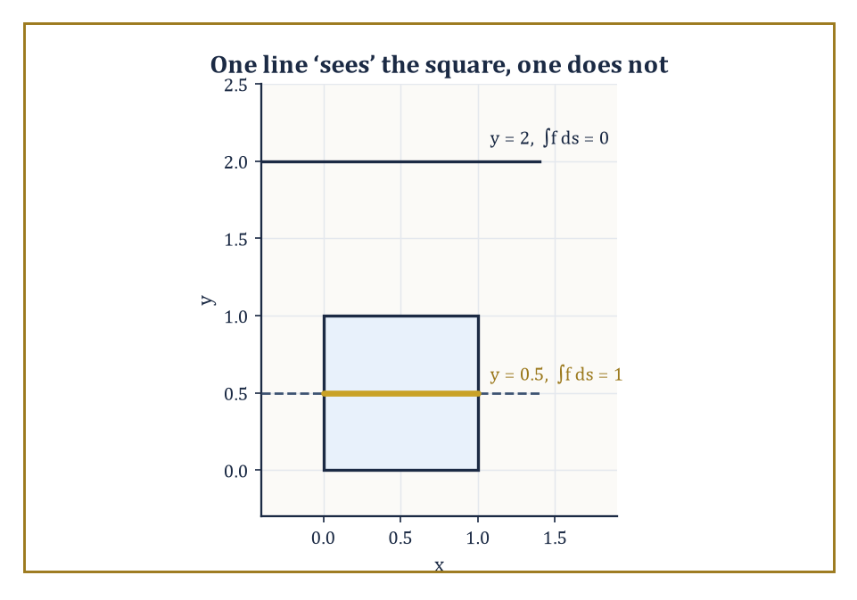
Figure 19.1 — One line reports back a length of 1; a parallel line two units higher reports nothing at all — between them, the raw material of a CT scan.
The measures used for this integration are not arbitrary; they are required to be invariant under the natural symmetries of the ambient space, meaning that translating or rotating everything in sight changes nothing about the answer. That single requirement, as we will see over the next two sections, turns out to pin the measure down almost uniquely, which is what saves the whole enterprise from being an arbitrary choice dressed up as a theorem.
Numeric example — A first taste of ‘line data’. Let f be the indicator function of the unit square [0,1]×[0,1] — that is, f(x,y)=1 for points inside the square and f(x,y)=0 outside it.
Consider the horizontal line y = 0.5. The integral of f along this line is the length of the segment where the line lies inside the square: the line enters at x=0 and leaves at x=1, so
∫f ds = 1
Now consider the line y = 2, which never touches the square at all:
∫f ds = 0
Each line gives us one number — how much of the square that particular line ‘sees’. Collect that number for every line in the plane, and you have the raw data a CT scanner works with: not the square itself, but everything every possible line-of-sight through it can tell you.
The Radon Transform and Inversion of the Radon Transform and Tomography are devoted to the (surprisingly good) news that this collection of numbers determines the square uniquely.
Try it now — Line data: what is the integral of the indicator of the unit square along the line y = 1/2? Answer →
The classic questions of the subject all have this shape: what is the average length of the intersection of a fixed curve with a random line? What is the average area of the intersection of a fixed surface with a random plane? And, running the whole idea backwards, can we recover a function entirely from the integrals of that function over every line, or every plane, that meets it?
The answers arrive as integral formulas whose kernels are disarmingly simple geometric quantities — a length, an area, a count of intersection points, an Euler characteristic — multiplied against the one true invariant measure on the relevant space of lines or planes. It is this last ingredient, the invariant measure, that does all the real work, and it is the subject of the very next section.
The subject therefore sits at a three-way junction: differential geometry supplies the objects (curves, surfaces, convex bodies), measure theory supplies the legal machinery for integrating over infinite spaces of them, and the representation theory of the Euclidean group — the group of all rigid motions of the plane or of space — supplies the reason the measures are unique.
Its applications range from the purely recreational geometric-probability puzzles of the eighteenth century (a needle, some floorboards, an afternoon to waste) to the entirely un-recreational business of reconstructing the inside of a human skull from X-rays without opening it up, which is the subject of The Radon Transform and Inversion of the Radon Transform and Tomography.
Abstract example — Invariance in miniature. Before facing an infinite continuous group, it is worth seeing the idea of an ‘invariant measure’ in a setting small enough to check by hand.
Let G be the finite group of the four rotations of a square about its center: 0°, 90°, 180°, 270°. Put the uniform probability distribution on G, assigning weight 1/4 to each rotation.
This distribution is invariant under G acting on itself by composition: if you take the distribution and shift it by ‘compose everything with a 90° rotation’, each rotation r just gets relabeled as r∘90°, which is still some rotation in the same four-element set, still carrying weight 1/4. Relabeling changes nothing, because every element already had the same weight.
That triviality is the entire content of invariance — no rotation is privileged over any other — and it is exactly this idea, transplanted onto the infinite, continuous group of rigid motions of the plane, that produces the measure dp∧dφ of Invariant Measures on Spaces of Lines and Planes.
The only difference between the finite case and the continuous case is that in the continuous case somebody (Alfréd Haar, as it happens) had to prove that such a measure exists and is unique at all; in the finite case, dividing by 4 is proof enough.
It is worth being explicit about why invariance is not a fussy technical nicety but the entire point, since the temptation to reach for a more familiar-looking coordinate system is real.
A line in the plane can just as well be written in slope-intercept form,
y = mx + c
and one might be tempted to declare dm∧dc the ‘uniform’ measure on lines instead of dp∧dφ. It is not — and the failure is not subtle.
Numeric example — Why slope-intercept coordinates betray you. Consider two families of lines: those with slope m near 0 (nearly horizontal) and those with slope m near, say, 1000 (nearly vertical).
Under dm∧dc, an interval of slopes of width 1 centered at m = 0 gets the same weight as an interval of slopes of width 1 centered at m = 1000.
But geometrically these are wildly unequal: as m runs from 999.5 to 1000.5, the corresponding lines barely rotate at all — they are already nearly vertical and stay nearly vertical — while as m runs from −0.5 to 0.5, the lines sweep through a very noticeable range of genuinely different directions.
A rotation of the whole plane by, say, 45° would map the ‘boring’ near-vertical family onto a completely different, much more spread-out range of slopes, and the measure dm∧dc of a fixed slope-window changes under that rotation — concretely, the map that describes how a 45° rotation transforms slopes is
m ↦ (m+1)/(1−m)
and this map has a derivative that is emphatically not 1 almost everywhere, so dm∧dc fails the Jacobian-determinant-equals-1 test that dp∧dφ passed in the previous example.
Slope-intercept coordinates are a perfectly good way to write down one line; they are a poor way to average over all of them, because they favor near-vertical lines over near-horizontal ones (or the reverse, depending on how you set them up) purely as an artifact of the coordinate chart, with no geometric justification whatsoever.
This is the kind of silent, coordinate-dependent bias that the invariance requirement of Invariant Measures on Spaces of Lines and Planes was designed to outlaw.
Keep only this · Section 19.1: What Integral Geometry Actually Is
The idea. Integral geometry studies a shape through integrals over lines (or planes) that meet it.
Core.
integral geometry: measure a shape by averaging over random lines, planes or motions
Typical mistake. Using slope–intercept coordinates for random lines; they are not rotation-invariant.
Minimal example. A CT scanner records ∫ f ds along many lines and rebuilds f.
Practice. Easy to challenge; full worked answers, with the usual mistake, are in Answers to the Practice Sets at the back.
Easy — A line crosses the unit square along its diagonal. What line integral of the square’s indicator does it record? Answer →
Medium — Why must “random line” be defined by an invariant measure? Answer →
Challenge — Why can line integrals in a single direction not determine a shape? Give two shapes with the same vertical chord lengths. Answer →

Section 19.2: Invariant Measures on Spaces of Lines and Planes
The one true way to pick a random line, and why there is only one
EXTENSION · about 15 minutes · enrichment; nothing later depends on it
Key idea — To integrate over the space of lines in the plane, we first need coordinates on that space, and then we need to know which measure on those coordinates deserves to be called ‘uniform’. The standard choice is the normal parametrization: a line ℓ is described by the angle φ that its normal direction makes with a fixed axis, and the signed distance p from the origin to the line, so that ℓ is given by:
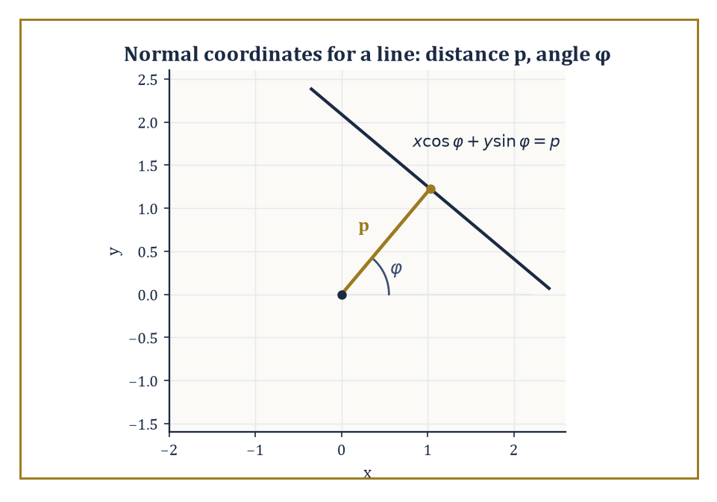
Figure 19.2 — A line’s entire biography, reduced to two honest numbers: how far it sits from the origin (p) and which way it faces (φ).
ℓ_{p,φ} = {(x,y) : x cos φ + y sin φ = p}
Taking φ ∈ [0,π) and p ∈ ℝ gives each line in the plane exactly one address, with no line counted twice. The claim — which we verify below rather than merely asserting — is that the measure dμ = dp ∧ dφ on this space is invariant under every rigid motion of the plane, and that up to an overall constant it is the only such measure. A measure with this property is called an invariant measure on the space of lines. It is inherited from the Haar measure of the group acting on that space — the translation-invariant measure which Alfréd Haar proved in the 1930s that any reasonably well-behaved group carries, and carries only one of (up to scale).
Abstract example — Checking invariance directly. Take the plane and rotate it about the origin by an angle α. A line with parameters (p,φ) keeps the same distance p from the origin — rotating about the origin cannot change how far a line sits from the point you are rotating about — while its normal direction rotates along with everything else, becoming φ+α (reduced mod π). So the transformation on coordinates is:
(p,φ) ↦ (p, φ+α)
Its Jacobian matrix is the identity matrix, determinant 1, so dp∧dφ is unchanged: rotation-invariance confirmed directly. Now take a translation of the plane by a fixed vector (a,b). A short calculation (project the translation vector onto the line’s normal direction) shows the new signed distance is:
p′ = p + (a cos φ + b sin φ)
Here φ is untouched — shove the line further out along its own normal and its distance from the origin grows, not shrinks, which the plus sign is merely confirming. The Jacobian of (p,φ) ↦ (p′,φ) is the triangular matrix with 1 on the diagonal (∂p′/∂p = 1, ∂φ/∂φ = 1) and some messy off-diagonal entry that does not affect the determinant of a triangular matrix — so again the determinant is 1, and dp∧dφ survives translation intact. Since every rigid motion of the plane is built from rotations and translations, dp∧dφ is invariant under the full Euclidean group, as claimed.
Try it now — What is the measure, in dp dφ, of the set of lines meeting a disk of radius 2? Answer →
In three-dimensional space the same idea produces an invariant measure on the space of planes (each plane described by a unit normal direction, living on the sphere, together with a signed distance from the origin — three parameters in all) and a four-dimensional invariant measure on the space of lines in space, since a line in ℝ³ needs a direction (two parameters, a point on the sphere) plus a point of closest approach to the origin within the plane perpendicular to that direction (two more parameters).
Existence and uniqueness of these measures follow from the same general Haar-measure machinery already invoked for the plane; the only work required for elementary calculations is writing the measures out in convenient coordinates, which has already been done for us by generations of geometers with more patience than most.
Numeric example — The measure of all lines meeting a disk. As a sanity check that dp∧dφ behaves the way a measure of ‘random lines’ ought to, compute the total measure of the set of lines that meet a disk of radius R = 3 centered at the origin. For a fixed direction φ, a line ℓ_{p,φ} meets the disk exactly when |p| < 3, i.e. when p ranges over an interval of length 2×3 = 6. This does not depend on φ at all, since the disk looks the same from every angle, so the total measure is:
μ = ∫[0, π] 6 dφ = 6π
For general radius R the same computation gives:
μ = 2πR
which, amusingly, is the circumference of a circle of that same radius. It is not a coincidence, and by the end of The Cauchy–Crofton Formula you will be able to see why in one line. For R = 3 this evaluates to 6π ≈ 18.850, and it is this number — the ‘total amount of random-line-ness’ available near a body of that size — that the Cauchy–Crofton and Crofton formulas of the next two sections turn into hard geometric quantities like length and area.
The ‘up to a constant’ clause in the uniqueness statement deserves a moment’s honesty: Haar’s theorem guarantees a unique invariant measure only up to an overall positive scale factor, and different textbooks make different choices for that scale — some absorb a factor of 2 or π into the measure itself, others leave the measure bare and instead adjust the constant sitting in front of each formula.
This chapter fixes the convention once and keeps it fixed throughout (bare dp∧dφ, fundamental domain φ∈[0,π)), so that the constants appearing in Sections 19.3 through 19.5 can be trusted at face value rather than re-derived from scratch every time a new formula appears.
It is not that any convention is more correct than another; it is that conventions, like Standard-track vs Circle-line platforms at a busy interchange, only cause trouble when two of them are used without announcing which is which.
Numeric example — The measure of lines meeting a square — and a small theorem for free. Take K to be a square of side s = 2, centered at the origin with sides parallel to the axes. Its support function — the maximum value of x cos θ + y sin θ over the square, for each direction θ — works out to:
h(θ) = (s/2)(|cos θ| + |sin θ|)
achieved at whichever corner has matching signs. The width of the square in direction θ (its full extent measured perpendicular to that direction), using the square’s symmetry about the origin, is:
w(θ) = h(θ) + h(θ+π) = s(|cos θ| + |sin θ|)
The total measure of lines meeting K is:
μ = ∫[0, π] w(θ) dθ = s ∫[0, π] (|cos θ| + |sin θ|) dθ
Both pieces were already computed in The Cauchy–Crofton Formula:
∫[0, π] |cos θ| dθ = 2
and, by the same reasoning (sin θ ≥ 0 throughout [0,π], so no sign-splitting is even needed):
∫[0, π] sin θ dθ = [−cos θ]₀^{π} = 1 − (−1) = 2
So:
μ = s(2+2) = 4s
and with s = 2 this gives μ = 8 — which is exactly the perimeter of a square of side 2 (namely 4×2 = 8). This is no accident: the same computation run in general —
μ = ∫[0, π] (h(θ)+h(θ+π)) dθ = ∫[0, 2π] h(θ) dθ
— and that last integral is precisely the classical formula for perimeter in terms of the support function, shows that the measure of lines meeting any convex body always equals that body’s perimeter, exactly, for every convex shape and not merely the round ones — a small, free theorem sitting inside the definitions, waiting to be noticed.
Keep only this · Section 19.2: Invariant Measures on Spaces of Lines and Planes
The idea. dp dφ is the measure on lines that is unchanged by rotations and translations.
Core.
ℓ_{p,φ} = {x cos φ + y sin φ = p}
invariant measure dp dφ
μ(lines meeting convex K) = perimeter(K)
Typical mistake. Double counting lines by letting both p and φ run over full ranges.
Minimal example. Lines meeting a disk of radius R: ∫[0, π] 2R dφ = 2πR.
Practice. Easy to challenge; full worked answers, with the usual mistake, are in Answers to the Practice Sets at the back.
Easy — Measure of lines meeting a segment of length 3. Answer →
Medium — Measure of lines meeting a square of side 2. Answer →
Challenge — What happens to p and φ when the plane is rotated by α about the origin? Answer →

Section 19.3: The Cauchy–Crofton Formula
Measuring a piece of string by asking how often it gets crossed
EXTENSION · about 15 minutes · enrichment; nothing later depends on it
Definition — The Cauchy–Crofton formula converts a question about length into a question about how often random lines hit a curve, and it is the prototype from which every other formula in this chapter is descended.
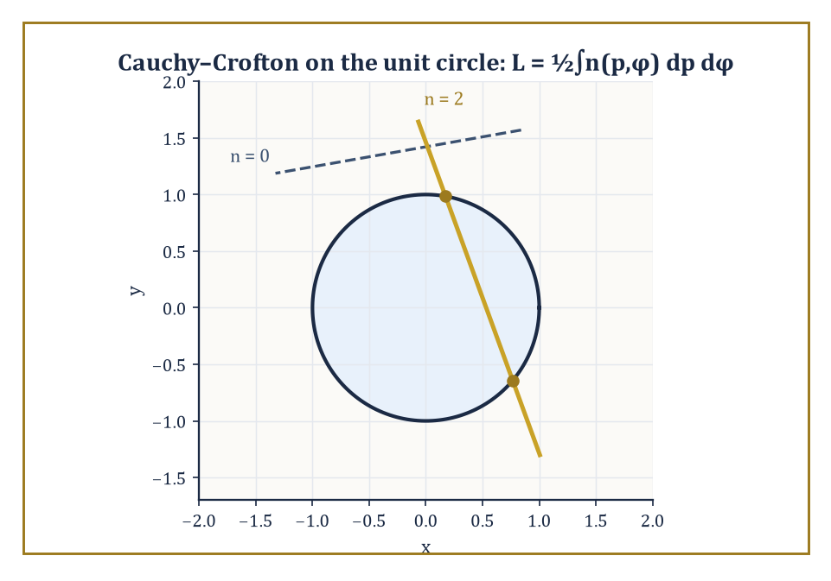
Figure 19.3 — A generic line meets the unit circle twice or not at all — Section 19.3’s whole argument, drawn rather than integrated.
Let C be a rectifiable curve — meaning, roughly, a curve whose length can be sensibly approximated by inscribed polygons, with the approximations converging to a finite number as the polygons get finer, so that ‘length’ is not an act of faith but an honest limit. For (almost) every line ℓ_{p,φ}, let n(p,φ) be the number of points where the line crosses C.
The Cauchy–Crofton formula states:
L(C) = ½ ∫[0, π] ∫[−∞, ∞] n(p,φ) dp dφ
Here φ ranges over the fundamental domain [0,π) of Invariant Measures on Spaces of Lines and Planes, in which every line is counted exactly once.
(You will occasionally meet this formula written with a constant of ¼ instead of ½ — that happens when the author lets φ range over the full circle [0,2π) instead, which counts every line twice over, since (p,φ) and (−p,φ+π) then describe the same line twice. Both conventions are correct; they simply disagree about whether a line gets one address or two, which is the sort of dispute mathematicians can sustain indefinitely without ever coming to blows.)
Numeric example — Recovering the circumference of a circle. Take C to be the unit circle, radius R = 1. A generic line meets this circle in exactly 2 points if it passes within distance 1 of the center, and 0 points otherwise (tangent lines, which meet it in exactly 1 point, form a measure-zero set of directions and can be ignored).
So n(p,φ) = 2 for p ∈ (−1,1), and n(p,φ) = 0 otherwise, regardless of φ.
Step 1: integrate over p for fixed φ:
∫₋₁¹ n(p,φ) dp = 2 × (length of the interval (−1,1)) = 2 × 2 = 4
Step 2: integrate that constant value over φ ∈ [0,π):
∫[0, π] 4 dφ = 4π
Step 3: apply the formula’s constant of ½:
L = ½ × 4π = 2π
The true circumference of a unit circle is 2π × 1 = 2π. They match exactly, and no approximation was involved anywhere — the formula is not a heuristic, it is an identity.
Try it now — A segment of length 3 lies along the x-axis. Using Cauchy–Crofton with ∫[0, π] |cos φ| dφ = 2, what length does it recover? Answer →
It is worth pausing on why the constant has to come out to ½ and not something else, because the reasoning generalizes to every Crofton-type formula in this chapter.
For a convex body, at each fixed direction φ the set of p-values for which the line meets the body is an interval whose length equals the body’s width in that direction, and on that interval n is constant, equal to 2 (the line goes in and comes back out).
Integrating n over p therefore gives twice the width; integrating the width over all φ ∈ [0,π) sums the widths in every direction across a half-turn, and a body’s total width summed across a half-turn of directions is its perimeter — this is itself a small, classical fact about convex bodies (their perimeter equals the integral of their support function over a full turn, and integrating width across a half-turn double-counts in the way that produces this same perimeter once you track the bookkeeping).
The upshot is that the p-and-φ integral always comes out to twice the length, and dividing by 2 undoes that automatically, whatever the shape of C.
This is also why a practical estimate of length is possible without ever computing an integral: overlay the curve with a grid of equally spaced parallel lines at several angles, count the crossings, and the average crossing count — suitably scaled — estimates the length.
Foresters, geologists, and pathologists have been doing just this since long before anyone told them it was a theorem; we will see the same trick made rigorous, as a proper unbiased estimator, in Stereology and Practical Measurement.
Numeric example — A straight segment, as a consistency check. For a straight segment (not a closed curve) of length L₀ = 5 lying along the x-axis, a generic line meets it in at most one point, so n(p,φ) ∈ {0,1}.
For direction φ, the segment’s projection onto the normal direction has length L₀|cos φ| (the projection of a horizontal segment onto a direction φ shrinks by a factor of |cos φ|), and a line in that direction crosses the segment exactly when p falls in that projected interval, contributing n = 1 throughout. So the inner integral over p is L₀|cos φ|.
The outer integral needs ∫[0, π] |cos φ| dφ, computed directly by splitting at φ = π/2:
∫[0, π] |cos φ| dφ = ∫[0, π/2] cos φ dφ + ∫[π/2, π] (−cos φ) dφ = [sin φ]₀^{π/2} + [−sin φ]_{π/2}^{π} = (1−0) + (0−(−1)) = 1 + 1 = 2
So the double integral is L₀ × 2 = 10, and the formula gives:
L = ½ × 10 = 5 = L₀
This recovers the segment’s own length. It is a slightly circular-feeling check — a formula for length gives back the length — but it confirms the constant ½ is correct for a shape simple enough to verify by hand, which is the sort of due diligence a formula deserves before you trust it on a coastline.
Nothing in the formula required C to be convex, or even connected, and it is worth seeing explicitly that non-convex and disconnected curves are handled without a single change to the machinery — n(p,φ) is allowed to exceed 2, and the integral totals everything up correctly regardless.
Numeric example — A disconnected curve, and n greater than 2. Let C be the disjoint union of two unit circles, one centered at the origin and the other centered at (5,0), far enough apart that they never overlap.
The horizontal line y = 0 (which has φ = π/2, p = 0 in the normal parametrization, since its normal direction points straight up) crosses the first circle at x = −1 and x = 1, and the second circle at x = 4 and x = 6 — four intersection points in total, so n(0, π/2) = 4 for this particular line, comfortably exceeding the value of 2 seen for a single convex curve.
The Cauchy–Crofton formula does not need to know, or care, that C is secretly two separate circles rather than one connected curve; it simply integrates n(p,φ) over the whole space of lines and, because the integral is linear, automatically returns:
L(C) = L(circle 1) + L(circle 2) = 2π + 2π = 4π
This is the correct total length of both circles combined, obtained without ever having to notice, let alone exploit, that the curve fell apart into pieces.
Keep only this · Section 19.3: The Cauchy–Crofton Formula
The idea. Length = (1/2) × the measure of lines, counted with the number of crossings.
Core.
L(C) = ½ ∫[0, π] ∫[−∞, ∞] n(p, φ) dp dφ
Typical mistake. Forgetting to count a line twice when it crosses a closed curve twice.
Minimal example. Unit circle: n = 2 for |p| < 1, so L = ½ · 4π = 2π.
Practice. Easy to challenge; full worked answers, with the usual mistake, are in Answers to the Practice Sets at the back.
Easy — Use Cauchy–Crofton on a segment of length 5. Answer →
Medium — A curve meets random lines on average twice as often as the unit circle does. How long is it? Answer →
Challenge — Buffon: needle length l, lines spacing d ≥ l. Show P(cross) = 2l/(πd). Answer →

Section 19.4: Crofton Formulas in the Plane and in Space
From counting crossings to measuring area, by the same trick one dimension up
EXTENSION · about 15 minutes · enrichment; nothing later depends on it
Key idea — The Cauchy–Crofton formula measured length via how often lines cross a curve. The next formula in the family measures area via how much of a line lies inside a region, and the reasoning behind it is, refreshingly, just Cavalieri’s principle wearing a disguise — the same slicing idea used long ago to compute volumes by integrating cross-sectional areas.
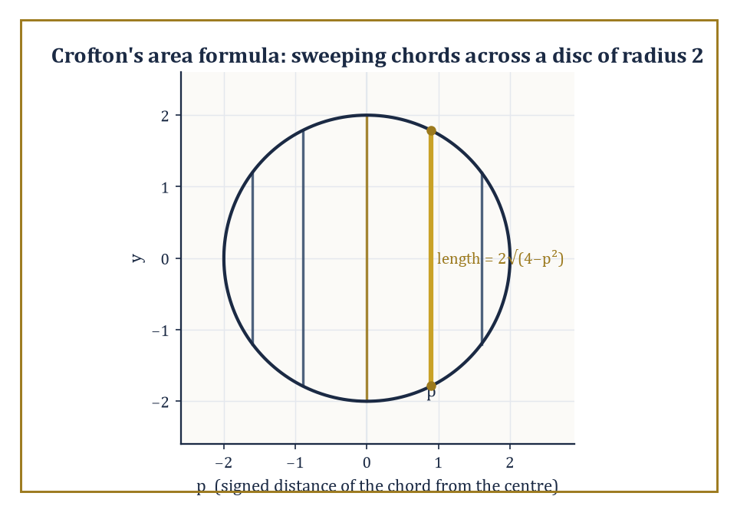
Figure 19.4 — Slicing the disk of radius 2 into parallel chords and adding up their lengths is Cavalieri’s principle wearing a Crofton hat.
Fix a direction φ. Slicing a convex body K by the family of parallel lines with that normal direction, and integrating the length of each slice over p, sweeps out the whole of K exactly once: that integral is Area(K), for every single φ, with no dependence on the direction chosen.
Now integrate that constant value of Area(K) over the half-turn of directions φ ∈ [0,π): the result is π × Area(K), since you are adding up the same number π times over (once for each infinitesimal direction, and there are ‘π radians worth’ of them). Divide by π to undo the redundancy, and you have the Crofton formula for area:
Area(K) = (1/π) ∫[0, π] ∫[−∞, ∞] length(K ∩ ℓ_{p,φ}) dp dφ
Numeric example — The area of a disk, the slow way. Take K to be a disk of radius R = 2, area πR² = 4π. Fix any φ; the chord of K at signed distance p from the center has length 2√(4−p²) for p ∈ (−2,2).
Step 1: integrate over p. This integral is the standard formula for the area of a disk of radius 2 computed by horizontal slicing (Cavalieri again), and it evaluates to π × 2² = 4π — as the general argument above predicted, independent of φ:
∫₋₂² 2√(4−p²) dp = π × 2² = 4π
Step 2: integrate that constant 4π over φ ∈ [0,π):
∫[0, π] 4π dφ = 4π × π = 4π²
Step 3: divide by the formula’s constant π:
4π²/π = 4π
This matches Area(K) = π(2)² = 4π exactly. Notice that the entire calculation was, in disguise, just computing the area of the disk twice — once by direct slicing, once by relentlessly re-deriving the same slicing formula and then dividing out the redundancy — which is either a reassuring consistency check or a slightly expensive way to learn that π×4=4π, depending on your mood.
Try it now — The width of a disk of radius R in any direction is 2R. What is its mean width? Answer →
In three-dimensional space the same family of ideas produces formulas for the volume of a solid via the measure of planes meeting it, for its surface area via the measure of lines meeting it, and for its mean width — the average, over every direction in space, of how far the body extends in that direction — via still other integral-geometric quantities.
Perhaps the most quotable of these is Cauchy’s projection formula: the surface area of a convex body in space equals 4 times the average area of its orthogonal shadow, averaged over all directions of projection with respect to the invariant measure on directions.
Numeric example — The surface area of a sphere, via its own shadow. Let K be a ball of radius R = 3. Because a ball is rotationally symmetric, its orthogonal projection onto a plane is a disk of radius 3 no matter which direction you project from — there is nothing to average, every shadow is identical. That shadow has area:
π(3)² = 9π
Cauchy’s formula then gives:
Surface area = 4 × 9π = 36π
The true surface area of a sphere of radius 3 is:
4πR² = 4π(9) = 36π
They agree exactly. For a lumpier convex body — an egg, say, or a lentil — the projected shadow does change shape as you rotate it, and the formula demands an honest average over all directions rather than this shortcut; but the ball, with its total indifference to direction, makes an excellent first specimen precisely because it lets you check the arithmetic without also having to compute an average.
One more plane intrinsic quantity is worth naming before we leave two dimensions for space: the mean width of a convex body is the average, over every direction θ ∈ [0,π), of the body’s width w(θ) in that direction — how far it extends, measured between two parallel supporting lines perpendicular to θ.
Invariant Measures on Spaces of Lines and Planes already computed, as an unplanned bonus, that the following integral equals the body’s perimeter exactly:
∫[0, π] w(θ) dθ = Perimeter
Dividing by the length π of the interval of directions turns that total into an average, so for every convex body in the plane, without exception:
mean width = Perimeter/π
Numeric example — Mean width, from a perimeter already in hand. For the disk of radius R from Invariant Measures on Spaces of Lines and Planes, the width is the same constant w(θ) = 2R in every direction (a disk looks equally wide from every angle), so its mean width is trivially 2R — its diameter, which is exactly what one would hope ‘average width’ means for a perfectly round object. Checking against the general formula:
Perimeter/π = 2πR/π = 2R
Agreement, as it should be. Now take the square of side s = 2 from Section 19.2’s other example, whose perimeter was computed there to be 8. Its mean width is:
Perimeter/π = 8/π ≈ 2.546
a single number sitting sensibly between the square’s smallest width (2, straight across a face) and its largest (2√2 ≈ 2.828, corner to corner), which is exactly the sort of sanity check a newly defined average ought to pass before being trusted.
These identities are stated most cleanly for convex bodies, where an intersection with a line or plane is itself convex (hence connected, hence easy to measure), but many of them survive, in modified form, for the wider class of sets of finite perimeter — sets whose boundary, however wrinkled or fractal-looking, still has finite (n−1)-dimensional measure.
Think of a coastline: it may be absurdly jagged, but so long as its total ‘edge length’ (suitably defined) stays finite, the Crofton machinery still applies. This is the first hint, in this chapter, of the more general geometric measure theory that Where This Goes Next: From Integral Geometry to Geometric Measure Theory and Advanced Topics gestures toward.
Keep only this · Section 19.4: Crofton Formulas in the Plane and in Space
The idea. Crofton formulas in the plane recover area and perimeter from chord lengths and widths.
Core.
Area(K) = (1/π) ∫[0, π] ∫ length(K ∩ ℓ_{p,φ}) dp dφ
mean width = perimeter/π (convex K)
Typical mistake. Confusing chord length (area formula) with crossing count (perimeter formula).
Minimal example. Disk of radius 2: inner integral 4π for each φ; total 4π²/π = 4π.
Practice. Easy to challenge; full worked answers, with the usual mistake, are in Answers to the Practice Sets at the back.
Easy — Mean width of a circle of radius 5. Answer →
Medium — Mean width of a square of side 1. Answer →
Challenge — Why does the area formula divide by π? Answer →

Section 19.5: Kinematic Formulas and the Principal Kinematic Formula
Inclusion–exclusion, but for two shapes bumping into each other at random
EXTENSION · about 15 minutes · enrichment; nothing later depends on it
Key idea — The Crofton formulas of the last two sections concerned a single fixed body meeting a random line or plane. The kinematic formulas of Blaschke and Santaló ask a richer question: given two bodies K and L, what is the measure of the set of rigid motions g (rotations combined with translations) that bring a moved copy gL into contact with K?
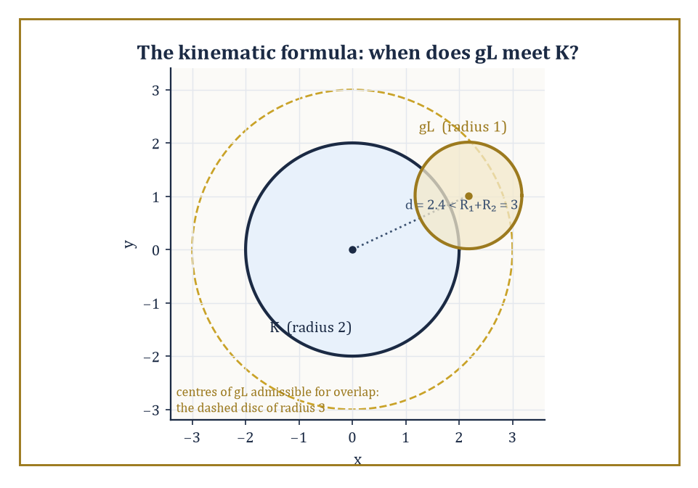
Figure 19.5 — Two disks collide exactly when their centers drift within R₁+R₂ of each other — the kinematic formula, made visible.
The answer is expressed in terms of the intrinsic volumes (also called Quermassintegrals, from the German for ‘cross-section-mass integrals’, a term coined by people who were clearly not being paid by the syllable) of the two bodies separately. In the plane there are three intrinsic volumes worth naming: the area, (a multiple of) the perimeter, and the Euler characteristic — a topological invariant equal to 1 for any body that is a single connected blob with no holes, and more generally counting connected pieces minus holes. In space there are four: volume, surface area, mean width, and Euler characteristic.
The principal kinematic formula for two convex bodies K, L in the plane reads:
∫ χ(K ∩ gL) dg = 2π(Area(K) + Area(L)) + Perimeter(K)·Perimeter(L)
Here dg is the invariant (Haar) measure on the group of rigid motions — a rotation angle ψ ∈ [0,2π) together with a translation in the plane — and χ(K∩gL) is 1 if the moved copy meets K and 0 if it misses entirely (since the intersection of two convex sets, when nonempty, is itself convex and hence connected, with Euler characteristic exactly 1).
Numeric example — Two unit disks bumping into each other. Let K and L both be disks of radius 1, so Area(K) = Area(L) = π and Perimeter(K) = Perimeter(L) = 2π. The formula gives:
∫ χ(K∩gL) dg = 2π(π+π) + (2π)(2π) = 2π·2π + 4π² = 4π² + 4π² = 8π²
Now check this independently, by direct geometric reasoning rather than the formula. Because a disk is rotationally symmetric, rotating L before placing it changes nothing, so the rotation angle ψ contributes a free factor of its own total range, 2π, doing no useful work.
All that matters is the translation: the two unit disks overlap exactly when their centers are less than 1+1 = 2 apart, i.e. when the translation vector t lands inside a disk of radius 2 around the origin, which has area:
π(2)² = 4π
So the total measure is (rotation range) × (translation area):
2π × 4π = 8π²
This agrees with the formula exactly. This case is unusually transparent because the rotational symmetry of the disk lets the two calculations be checked against each other in one’s head; for a less symmetric shape — a bent rod, say, or a stubbornly asymmetric amoeba — the rotation matters, and it is the perimeter term Perimeter(K)·Perimeter(L) in the general formula that accounts for the work rotation does.
Try it now — Inclusion–exclusion: |A ∪ B| with |A| = 5, |B| = 4, |A ∩ B| = 2? Answer →
Numeric example — Two disks of different sizes, for generality. The equal-disk example above is reassuring but slightly too symmetric to build full confidence, so it is worth repeating with two differently sized disks. Let K have radius 2 (area 4π, perimeter 4π) and L have radius 1 (area π, perimeter 2π). The formula gives:
∫χ(K∩gL) dg = 2π(4π+π) + (4π)(2π) = 2π(5π) + 8π² = 10π² + 8π² = 18π²
The direct check proceeds as before: rotating L still does nothing observable, since both bodies are round, so the rotational factor again contributes its full range 2π for free; the two disks overlap exactly when their centers are within R₁+R₂ = 2+1 = 3 of each other, a translation region of area:
π(3)² = 9π
Total measure:
2π × 9π = 18π²
This agrees with the formula. What has changed from the equal-radius case is only that the perimeter term (4π)(2π) = 8π² and the area term 2π(4π+π) = 10π² are no longer equal contributors in the same simple way they were when K = L — a first hint that for different bodies, area and perimeter pull their separate weight rather than moving in lockstep.
The three-dimensional principal kinematic formula follows the same architecture, with volume, surface area, mean width, and Euler characteristic of K and L combining pairwise (again with binomial-flavored coefficients tracking how many ways a given pair of intrinsic volumes can add up to the right total dimension) rather than just area and perimeter — the plane’s kinematic formula is the low-dimensional case of a pattern that keeps the same spirit however many intrinsic volumes join the party.
This chapter will not chase the exact three-dimensional coefficients, since doing so honestly requires the normalization constant of the Haar measure on the rotation group SO(3) — a number one should look up rather than reconstruct from memory under pressure, and the kind of bookkeeping detail that the valuation-theoretic viewpoint below exists to make painless.
The formula is the integral-geometric cousin of the inclusion–exclusion principle from elementary set theory, and it is worth seeing the family resemblance explicitly, since it demystifies why the kinematic formula has the additive structure it does.
Numeric example — Inclusion–exclusion, the finite ancestor. For finite sets A and B, the inclusion–exclusion principle states:
|A∪B| = |A| + |B| − |A∩B|
Take |A| = 5, |B| = 7, |A∩B| = 3: then
|A∪B| = 5 + 7 − 3 = 9
Both inclusion–exclusion and the kinematic formula are instances of a valuation — a set function v satisfying:
v(A∪B) = v(A) + v(B) − v(A∩B)
The intrinsic volumes (area, perimeter, Euler characteristic, and their higher-dimensional relatives) are the valuations that are also invariant under rigid motions and continuous in a suitable sense. A theorem of Hadwiger shows that, remarkably, these intrinsic volumes are essentially the only such valuations there are, which is why they keep reappearing as the universal currency of integral geometry rather than one convenient choice among many.
The principal kinematic formula is the source of a great many inequalities and average-value statements in geometric probability — how likely two randomly placed objects are to collide, on average how much overlap two random translates share, and so on.
Modern treatments derive it either from the theory of valuations sketched above or from the representation theory of the Euclidean group; the elementary route taken here, by successive integration of Crofton densities, is older, slower, and considerably easier to check by hand, which recommends it to anyone meeting the subject for the first time.
Keep only this · Section 19.5: Kinematic Formulas and the Principal Kinematic Formula
The idea. The kinematic formula measures how often one moving body meets another, in terms of their areas and perimeters.
Core.
∫ χ(K ∩ gL) dg = 2π(Area K + Area L) + Perimeter K · Perimeter L
Typical mistake. Dropping the perimeter cross term in the principal kinematic formula.
Minimal example. Two unit disks: 2π(2π) + (2π)² = 8π².
Practice. Easy to challenge; full worked answers, with the usual mistake, are in Answers to the Practice Sets at the back.
Easy — Kinematic measure for two disks of radii 1 and 2. Answer →
Medium — Check that answer by thinking of centers: the disks meet when the centers are within 3, for every rotation. Answer →
Challenge — A segment of length 1 (area 0, “perimeter” 2) is placed randomly against a unit disk. Find the measure of meeting positions. Answer →

Section 19.6: The Radon Transform
Turning a function into all of its shadows at once
EXTENSION · about 15 minutes · enrichment; nothing later depends on it
Definition — The Radon transform is the analytic heart of integral geometry, and it is the operator that turns the informal ‘line data’ of What Integral Geometry Actually Is into a proper mathematical object. For a function f on the plane, its Radon transform Rf assigns to every line ℓ_{p,φ} the integral of f along that line:
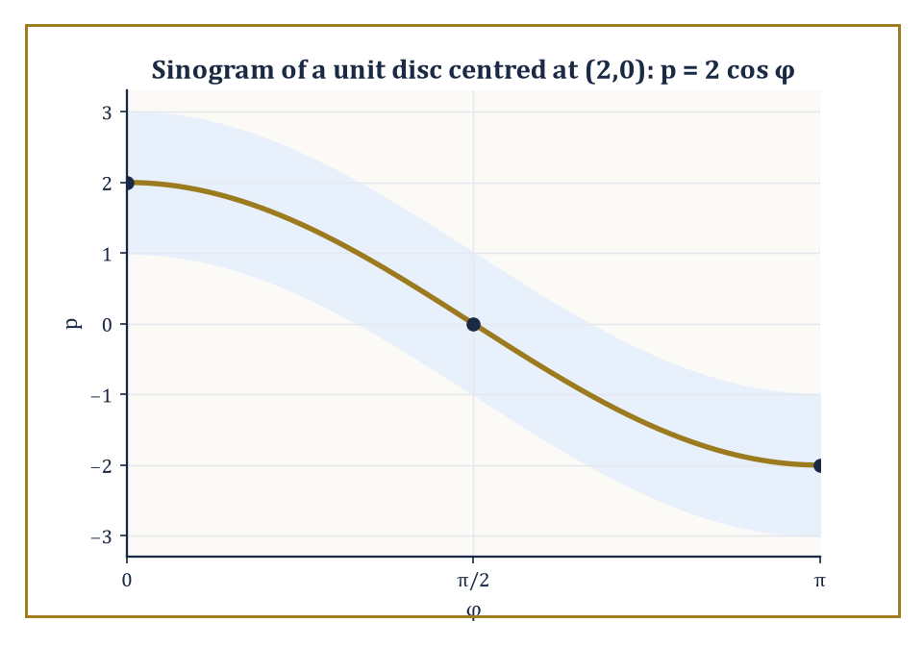
Figure 19.6 — Every off-center point traces a cosine curve through the projection data — which is the entire reason it’s called a sinogram.
(Rf)(φ,p) = ∫[ℓ_{p,φ}] f ds
So Rf is a new function, but its input is no longer a point of the plane — it is an entire line, addressed by the same (p,φ) coordinates of Invariant Measures on Spaces of Lines and Planes.
You have, in fact, already computed two Radon transforms without being told they wore that name: the chord-length function 2√(R²−p²) from the disk examples of Crofton Formulas in the Plane and in Space is the Radon transform of the disk’s indicator function, and it does not depend on φ only because the disk is rotationally symmetric — for a less symmetric shape, Rf genuinely depends on the viewing angle, which is why a CT scanner has to rotate around the patient rather than taking one X-ray and calling it a day.
Numeric example — The Radon transform of a disk, in numbers. Let f be the indicator function of the unit disk (R = 1). We already know its Radon transform, independent of φ:
Rf(φ,p) = 2√(1−p²), for |p| ≤ 1
At p = 0 (a line through the center):
Rf = 2√(1−0) = 2
This is correct, since a diameter of the unit disk has length exactly 2.
At p = 0.6 (a line offset from the center by 0.6):
Rf = 2√(1−0.36) = 2√0.64 = 2 × 0.8 = 1.6
This is the length of that particular chord.
At p = 1 (a tangent line, just grazing the boundary):
Rf = 2√(1−1) = 0
This correctly records that a tangent line meets the disk in a single point of zero length. Every one of these numbers is something an X-ray detector could, in principle, measure directly, as the total attenuation of a beam passing along that line.
Try it now — Radon transform of the indicator of the unit disk at distance p = 0.6 from the centre. Answer →
The deep link between the Radon transform and the Fourier transform (met several chapters back, in a life that now feels comfortingly free of lines and planes) is the projection-slice theorem: the one-dimensional Fourier transform, taken in the p variable, of the projection Rf(φ,·) at a fixed angle φ equals the restriction — the ‘slice’ — of the full two-dimensional Fourier transform of f along the line through the origin in direction φ.
In other words, each individual X-ray projection secretly hands you one entire radial line’s worth of the 2D Fourier transform of the patient’s interior, for free, and gathering projections from every angle gathers the whole 2D Fourier transform, one slice at a time — at which point an ordinary inverse Fourier transform finishes the job.
This is the theoretical engine behind the reconstruction algorithms of the next section.
In practice, Rf is displayed as an image in its own right, with one axis for the angle φ and the other for the offset p, and the resulting picture is called a sinogram — a name that turns out to be no mere flourish, as the next example shows directly, rather than by assertion.
Numeric example — Where the word ‘sinogram’ comes from. Let f be the indicator function of a unit disk, but now centered at (2,0) rather than at the origin. The line ℓ_{φ,p} has the equation:
x cos φ + y sin φ = p
The perpendicular distance from the center (2,0) to this line is:
|2 cos φ − p|
(This follows by substituting the center into the left-hand side and subtracting p, using that (cos φ, sin φ) is a unit vector.) Whenever this distance is less than 1, the line clips the disk, with chord length:
Rf(φ,p) = 2√(1 − (2 cos φ − p)²)
Rf(φ,p) = 0, otherwise
The brightest points of the sinogram — where the chord length peaks at its maximum value of 2, a full diameter — occur exactly when 2 cos φ − p = 0, that is, along the curve:
p = 2 cos φ
At φ = 0 this gives p = 2 (the line straight through the center, offset 2 from the origin, just as expected); at φ = π/2 it gives p = 0 (a line through the origin, which happens to also pass through the disk’s center once the geometry is followed through); at φ = π it returns to p = −2.
Plotted with φ along one axis and p along the other, the locus of brightest pixels is literally a cosine curve — a sine wave shifted by a quarter turn — which is why radiologists and their equipment manuals call the raw (φ,p) display of projection data a sinogram: every off-center point in the object being scanned really does trace out a sine curve across the data, and the reconstruction algorithm’s entire job is to read a whole picture’s worth of overlapping sine curves and infer where each bright point was.
Worked example — Projection-slice theorem, worked in full for a Gaussian. Let f(x,y) = exp(−π(x²+y²)), the two-dimensional Gaussian that is famously its own Fourier transform. Parametrize the line ℓ_{φ,p} as:
(x,y) = (p cos φ − t sin φ, p sin φ + t cos φ), for t ∈ ℝ
A short algebraic check (expand and use cos²+sin²=1, watching the cross terms cancel) shows:
x² + y² = p² + t²
This holds exactly, for every φ — rotating coordinates cannot change distance from the origin, which is really all this identity is saying. So f along the line becomes exp(−π(p²+t²)), and the Radon transform is:
Rf(φ,p) = ∫[−∞, ∞] exp(−π(p²+t²)) dt = exp(−πp²) ∫[−∞, ∞] exp(−πt²) dt = exp(−πp²) × 1 = exp(−πp²)
This uses the standard normalized Gaussian integral ∫exp(−πt²)dt = 1. Notice the projection is itself Gaussian, and — crucially for the theorem — it does not depend on φ at all.
Its one-dimensional Fourier transform is, by the self-duality of the Gaussian under this normalization:
exp(−πk²)
Compare this against the full 2D Fourier transform of f, which is (by the same self-duality, applied in two dimensions):
exp(−π(kx²+ky²))
Restricted to the line through the origin in direction φ, this reads exp(−πk²) — the exact same function. The slice matches the transformed projection precisely, confirming the projection-slice theorem in a case simple enough to check by hand rather than merely cite, which is exactly why Gaussians are the test pattern of choice when calibrating real scanning equipment.
Keep only this · Section 19.6: The Radon Transform
The idea. Rf(p, φ) is the integral of f along the line at distance p with normal angle φ — what one CT beam measures.
Core.
(Rf)(φ, p) = ∫ over ℓ_{p,φ} of f ds
Typical mistake. Treating a projection as a single number rather than a function of p for each angle.
Minimal example. Unit disk: Rf(φ, p) = 2√(1 − p²) for |p| ≤ 1.
Practice. Easy to challenge; full worked answers, with the usual mistake, are in Answers to the Practice Sets at the back.
Easy — Radon transform of the unit disk’s indicator at p = 0.6. Answer →
Medium — Why does a point mass at (a, 0) trace a cosine curve in the sinogram? Answer →
Challenge — Show that ∫ Rf(φ, p) dp is the same for every φ. Answer →

Section 19.7: Inversion of the Radon Transform and Tomography
Reconstructing the inside of something without cutting it open
EXTENSION · about 15 minutes · enrichment; nothing later depends on it
Key idea — Inversion formulas recovering f from Rf exist in every dimension, though they take a slightly different shape in even and odd dimensions — a mild but genuine asymmetry that traces back to how the Fourier transform’s inversion formula itself behaves differently depending on parity.
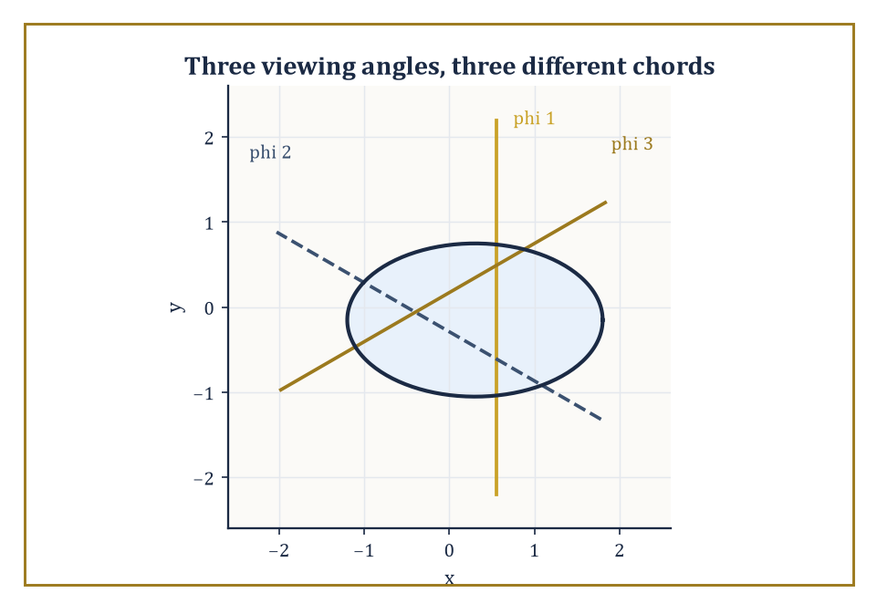
Figure 19.7 — Two viewing angles can leave two different objects looking identical; a third almost always tells them apart.
In two dimensions the standard route runs directly through the projection-slice theorem of the previous section: take the Fourier transform of every projection, assemble the results into the full two-dimensional Fourier transform (one radial slice at a time), and invert.
In practice, working directly with a discretely sampled grid of frequencies is numerically unpleasant, so real scanners instead use filtered back-projection: each 1D projection is first passed through a specific frequency filter (which compensates for the fact that naively smearing raw, unfiltered projections back across the image plane produces a characteristically blurred reconstruction, since low frequencies get over-represented when data arrives from many angles at once), and only then smeared — ‘back-projected’ — across the plane and summed over all angles.
Numeric example — Why one or two projections are never enough. Consider a 2×2 grid of unknown values a, b (top row), c, d (bottom row), and suppose we are told only the row sums and column sums — the crudest possible discrete stand-in for a two-angle X-ray scan.
a+b = 5, c+d = 3 (row projections)
a+c = 4, b+d = 4 (column projections)
One solution is a=2, b=3, c=2, d=1: check the row sums and column sums.
2+3=5 ✓, 2+1=3 ✓ (row sums); 2+2=4 ✓, 3+1=4 ✓ (column sums)
But a second, entirely different solution also fits: a=4, b=1, c=0, d=3, giving row sums and column sums that also check out.
4+1=5 ✓, 0+3=3 ✓ (row sums); 4+0=4 ✓, 1+3=4 ✓ (column sums)
Two different grids produce identical data from only two projection angles — the reconstruction is not unique, which is the toy-model version of the limited-angle artifacts mentioned below.
Add a third projection, the two diagonal sums:
For the first grid: a+d = 2+1 = 3 and b+c = 3+2 = 5
For the second grid: a+d = 4+3 = 7 and b+c = 1+0 = 1
These differ, so a single extra viewing angle is enough to tell the two grids apart. This is the whole justification, in miniature, for why a real scanner gathers projections from hundreds of angles rather than two: more angles do not just refine an existing answer, they can be the difference between a unique answer and an ambiguous one.
Try it now — A 2 × 2 grid has row sums (3, 7) and column sums (4, 6). Give two different grids with these sums. Answer →
The 2×2 grid example generalizes in a way worth stating precisely, since it explains why real scanners insist on so many viewing angles rather than settling for a tidy pair of perpendicular ones.
An n×n grid has n² unknown entries, but only 2n independent-looking equations arrive from row sums and column sums together — and even that count is generous, since the sum of all row sums always equals the sum of all column sums (both equal the grand total), so one equation is automatically redundant, leaving at most 2n−1 independent constraints.
For any n ≥ 2, n² comfortably outstrips 2n−1, and the shortfall grows without bound as n grows: two orthogonal projection directions, however finely you subdivide the grid, are never going to be enough.
Numeric example — The same ambiguity, one size up. Take the 3×3 grid with entries 1,2,3 / 4,5,6 / 7,8,9 (reading left to right, top to bottom). Its row sums and column sums are:
Row sums: 1+2+3=6, 4+5+6=15, 7+8+9=24
Column sums: 1+4+7=12, 2+5+8=15, 3+6+9=18
Now alter only the top-left 2×2 block by a ‘cycle swap’: add 1 to the entries at positions (row 1, col 1) and (row 2, col 2), and subtract 1 from the entries at (row 1, col 2) and (row 2, col 1), leaving row 3 untouched entirely. The new grid reads 2,1,3 / 3,6,6 / 7,8,9.
Check the row sums: all unchanged.
2+1+3=6 ✓, 3+6+6=15 ✓, 7+8+9=24 ✓
Check the column sums: also all unchanged.
2+3+7=12 ✓, 1+6+8=15 ✓, 3+6+9=18 ✓
Two visibly different 3×3 grids share every row sum and every column sum, just as the degrees-of-freedom count above predicted (9 unknowns, at most 5 independent constraints from two directions, leaving 4 dimensions worth of grids — including this one — all consistent with the same two-directional data).
The cycle-swap trick used here to manufacture the ambiguity is precisely the same bookkeeping move that turns up in transportation and assignment problems, which is a tidy reminder that tomography, logistics, and elementary linear algebra are, underneath the surface, having the same argument.
Stability estimates quantify how noise present in the raw projection data propagates into the reconstructed image — a delicate business, because the inversion formula involves a differentiation-like step (in the Fourier-domain picture, high frequencies get amplified by the filtering stage) that can turn small measurement noise into large reconstruction artifacts if one is not careful.
Incomplete data — a limited range of viewing angles, or angles sampled too sparsely — produces its own characteristic streaking and blurring artifacts, visible to any radiologist who has ever had to work with a scan taken too quickly, and understanding how much data suffices for a stable reconstruction remains an active area of research rather than a settled matter.
The same circle of ideas, with the details of what is being measured changed but the mathematics essentially untouched, underlies SPECT (single-photon emission computed tomography, tracking gamma rays emitted by a radioactive tracer injected into the patient) and PET (positron emission tomography, tracking the pairs of gamma rays produced when an emitted positron annihilates with a nearby electron) — and several other imaging modalities besides.
Integral geometry, which began this chapter as an elegant piece of pure geometric probability, ends up as unglamorous working machinery inside hospital basements the world over, which is about as good an advertisement for pure mathematics as the subject ever manages to produce.
Keep only this · Section 19.7: Inversion of the Radon Transform and Tomography
The idea. Inversion needs projections from many angles plus a filter; two directions never suffice.
Core.
projection-slice: the 1-D transform of Rf(φ, ·) is f̂ along the line through 0 in direction φ
filtered back-projection: filter by |ξ|, then back-project
Typical mistake. Back-projecting without filtering, which blurs the image.
Minimal example. Back-projecting without the filter gives a blurred image, roughly f convolved with 1/|x|.
Practice. Easy to challenge; full worked answers, with the usual mistake, are in Answers to the Practice Sets at the back.
Easy — What does back-projection do? Answer →
Medium — Why is the ramp filter |ξ| needed? Answer →
Challenge — Why do CT scanners need many angles? Answer →

Section 19.8: Stereology and Practical Measurement
Estimating a whole body from a few slices through it, honestly
EXTENSION · about 15 minutes · enrichment; nothing later depends on it
Definition — Stereology is the applied end of this chapter: the discipline of estimating geometric quantities — volume, surface area, length, number of objects — from lower-dimensional samples such as thin sections, projections, or probing lines, using the Crofton and kinematic formulas developed above, only now deployed by biologists and materials scientists rather than pure geometers.
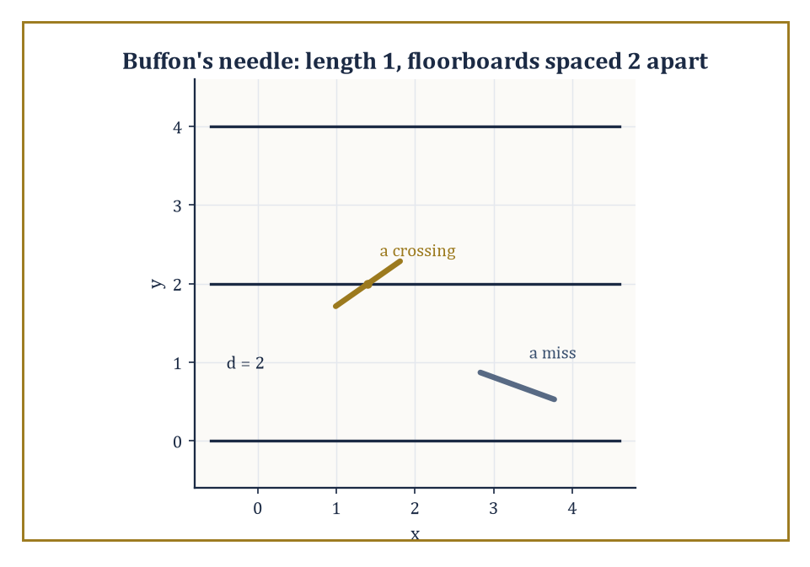
Figure 19.8 — A length-1 needle dropped onto floorboards 2 apart: sometimes it crosses a line, sometimes it doesn’t, and the ratio secretly knows π.
The two founding results of the field are Delesse’s principle and the Buffon needle problem, and it is worth seeing that the second of these is nothing but a disguised, probabilistic restatement of the Cauchy–Crofton formula of The Cauchy–Crofton Formula.
Numeric example — Buffon’s needle, as Cauchy–Crofton in a lab coat. Drop a needle of length ℓ = 1 at random onto a floor ruled with parallel lines spaced d = 2 apart (with ℓ ≤ d, so the needle cannot possibly cross two lines at once).
The classical result — provable directly from first principles, or read off as a special case of Section 19.3’s machinery applied to a random needle position rather than a random line — is that the probability the needle crosses a line equals:
p = 2ℓ/(πd)
Plugging in the numbers:
p = 2(1)/(π·2) = 2/(2π) = 1/π ≈ 0.3183
So roughly 31.83% of needle-drops should cross a line, and this single number, multiplied by a large sample of drops, gives an experimental (if slow and faintly ridiculous) way to estimate π — historically one of the earliest Monte Carlo methods, discovered a good two centuries before anyone owned a computer to run one properly.
Try it now — A needle of length 1 on lines 2 apart: in 600 drops, about how many crossings? Answer →
Numeric example — Running Buffon’s experiment the other way. The probability p = 2ℓ/(πd) can be inverted to estimate π from an observed crossing count, which is exactly how Buffon’s problem earned its footnote in the early history of Monte Carlo methods.
Suppose an (unusually patient) experimenter drops the same ℓ = 1, d = 2 needle N = 1000 times and observes 316 crossings.
Solving p = 2ℓ/(πd) for π gives:
π = 2ℓN/(d × crossings)
Substituting:
π̂ = 2(1)(1000) / (2 × 316) = 2000/632 ≈ 3.1646
Not a spectacular estimate — 1000 drops is a small sample, and the true value 3.14159… sits comfortably outside three decimal places of agreement — but it is an honest, unbiased one, and it is worth appreciating that this entire estimation procedure, historically first performed with actual needles and actual floorboards, is nothing more than the Cauchy–Crofton formula of The Cauchy–Crofton Formula run as a physical experiment rather than a symbolic integral.
It is, incidentally, a spectacularly inefficient way to compute π — modern algorithms manage millions of correct digits from a laptop in seconds — but as a demonstration that a random physical process can be made to compute something, it has never really been bettered for charm.
One caveat is worth stating plainly, since it is the theme this chapter opened with: none of these stereological estimators are unbiased unless the sampling is isotropic — the test grid (or the sectioning plane, or the probing line) must be applied at a uniformly random orientation with respect to the structure being measured, using the same invariant measure of Invariant Measures on Spaces of Lines and Planes, rather than always cutting sections in whatever direction happens to be convenient on the microtome.
A structure with a strong preferred orientation (muscle fibers, say, which mostly run one way) measured only with horizontal test lines will yield a systematically biased estimate no matter how many sections are counted; the fix is not more data but the right kind of data, sampled without favoritism as to direction — invariance, once again, doing the entire moral work of the theorem.
Delesse’s principle states that the area fraction occupied by a structure of interest on a random planar section, averaged over many sections, equals the volume fraction that structure occupies in the original three-dimensional body — a statement that sounds almost too convenient to be true, but which follows directly from the Crofton-style slicing argument of Crofton Formulas in the Plane and in Space (integrating the sliced area over all positions of the section recovers the volume, as integrating chord length over all p recovered area).
It licenses one of the most useful tricks in quantitative microscopy: the point-counting grid.
Numeric example — Estimating volume fraction by counting points. A pathologist overlays a regular grid of 200 test points on a microscope image of a tissue section and counts how many of those points fall on cell nuclei, finding 30.
By Delesse’s principle, the observed area fraction, computed as
30/200 = 0.15 = 15%
is an unbiased estimate of the volume fraction of nuclei within the original three-dimensional tissue sample, with no need to physically slice the tissue into infinitesimally thin layers and reconstruct it in 3D.
Repeating the count across several independent sections, and averaging, tightens the estimate in the usual statistical way (more samples, smaller standard error) without ever requiring anything cleverer than counting dots landing on purple blobs.
Modern stereology extends this same toolkit to unbiased estimators for surface area (via counting how often a test-line probe crosses a boundary — Cauchy–Crofton once more), for total length of a curved structure such as a blood vessel network (via counting intersections with a grid of test planes), and for the raw number of discrete objects such as cells, via cleverly designed three-dimensional counting frames that avoid double-counting objects straddling the edge of a sample.
None of the underlying mathematics is new — it is entirely the Crofton and kinematic formulas of Sections 19.3 through 19.5 — and the practical success of these methods, quietly running inside pathology labs worldwide, is a standing reminder that a piece of geometric measure theory need not stay abstract to remain elegant.
Keep only this · Section 19.8: Stereology and Practical Measurement
The idea. Stereology: area fraction on a random section estimates volume fraction (Delesse); point counting estimates area fraction.
Core.
Delesse: area fraction on a section = volume fraction
length per area L_{A} estimates surface per volume: S_{V} = (4/π)L_{A}
Typical mistake. Trusting a Buffon estimate of π to more than two digits after a few thousand drops.
Minimal example. 15% of a section’s area is fat ⇒ about 15% of the tissue volume.
Practice. Easy to challenge; full worked answers, with the usual mistake, are in Answers to the Practice Sets at the back.
Easy — Points of a grid land in a phase 30 times out of 200. Estimate its volume fraction. Answer →
Medium — Why must sections be taken at random positions and orientations? Answer →
Challenge — Lines of total length 10 cm cross boundaries 40 times. Estimate surface area per unit volume with S_{V} = 2P_{L}. Answer →

Chapter 19 in One Page
Integral geometry measures a shape by integrating over the lines or planes that meet it. The measure dp dφ on lines is the one that rigid motions leave unchanged. The Cauchy–Crofton formula recovers length from how often random lines cross a curve, Crofton formulas recover area and perimeter, and kinematic formulas count how often moving bodies meet. The Radon transform records every line integral of a function; inverting it, with filtering, is how computed tomography works. Stereology and Buffon’s needle are the same ideas used as measuring instruments.
Key definitions
• Line coordinates (p, φ): distance from the origin and angle of the normal.
• Invariant measure dp dφ.
• Radon transform Rf(p, φ) = ∫ f along the line ℓ(p, φ).
• Mean width of a convex body.
Key theorems, with their hypotheses
• Cauchy–Crofton: L = (1/2)∬ n(p, φ) dp dφ — hypothesis: a rectifiable curve, n the number of crossings.
• Buffon: P(cross) = 2ℓ/(πd) — hypothesis: ℓ ≤ d, uniform position and angle.
• Fourier slice theorem — hypothesis: f integrable on the plane.
• Delesse: area fraction estimates volume fraction — hypothesis: isotropic uniform random sections.
Canonical example
• The unit circle: almost every line meeting it crosses twice, the lines meeting it have measure 2π, so L = (1/2) · 2 · 2π = 2π.
Common errors
• Using slope–intercept measure.
• Double counting lines.
• Forgetting the factor 1/2 in Cauchy–Crofton.
• Unfiltered back-projection.
Readiness checklist — you are ready for what comes next when you can:
□ explain why dp dφ is the right measure on lines
□ recover a length with Cauchy–Crofton
□ compute a Radon projection of a disk
□ explain why CT needs many angles
□ set up the Buffon estimator for π
Section 19.9 that follows is a preview, marked optional: it says where these ideas lead in later chapters and volumes. Nothing in it is needed for the exercises.

Section 19.9: Where This Goes Next (Optional): From Integral Geometry to Geometric Measure Theory and Advanced Topics
What this chapter’s vocabulary quietly opens the door to
PREVIEW — OPTIONAL · about 15 minutes · optional; read for orientation, nothing is examined
Overview — We have, over the last eight sections, acquired a genuinely useful working vocabulary: invariant measures on spaces of lines and planes, the Cauchy–Crofton and higher Crofton formulas, the principal kinematic formula, the Radon transform together with its inversion, and the practical stereological toolkit built from all of the above. It is a shorter list than it feels while you are inside it, and that compression is itself the lesson of the subject — a great many classical formulas turn out to be the same one idea, applied at different orders.
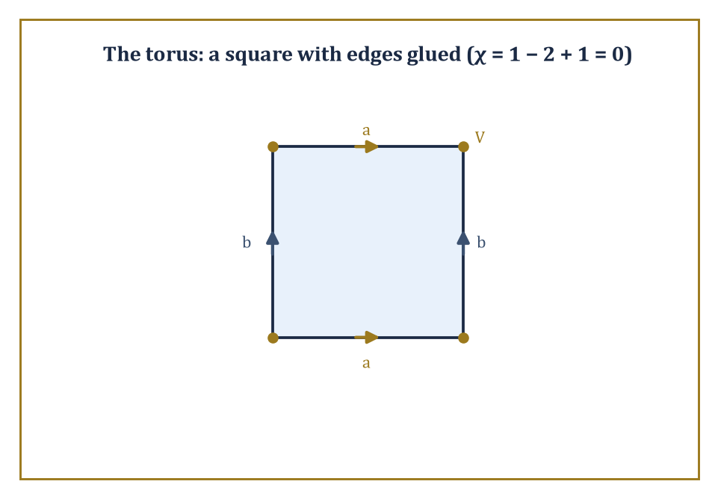
Figure 19.9 — Glue the edges of a square as marked and the four corners collapse into one vertex — a torus, and an Euler characteristic of zero, built from paper and tape.
Several later parts of the series grow directly out of this vocabulary.
Geometric measure theory supplies the analytic foundations — currents (roughly speaking, generalized oriented surfaces, defined not by parametrizing them directly but by how they act on differential forms, rather as a distribution is defined by how it acts on test functions) and varifolds (generalized, possibly singular surfaces equipped with a well-defined notion of area but without insisting on an orientation) — that let the classical Crofton and kinematic formulas extend far beyond smooth, well-behaved domains, into the realm of sets so ragged that ‘boundary’ itself needs a more careful definition than the one supplied by an ordinary calculus course.
Considerably later the series, a more advanced pass through this same territory takes up higher-rank kinematic formulas, the general theory of convex valuations gestured at in Kinematic Formulas and the Principal Kinematic Formula, and integral geometry on homogeneous spaces well beyond flat Euclidean space — hyperbolic and spherical geometry both have their own Crofton formulas, differing from the flat case in ways that are individually charming and collectively too much for one chapter.
Tomography and inverse problems, meanwhile, resurface wherever applied mathematics meets an instrument that can only look at something from the outside.
Numeric example — A first taste of a valuation beyond length, area, and volume. The Euler characteristic χ, introduced informally in Kinematic Formulas and the Principal Kinematic Formula as one of the intrinsic volumes, extends the family of length, area, and volume into purely topological territory — it measures connectivity rather than size, and geometric measure theory needs invariants of just this flavor once it starts admitting shapes too wild for ordinary measurement. For a cube, the classical formula is:
χ = V − E + F
where V, E, F count vertices, edges, and faces. A cube has V = 8 vertices, E = 12 edges, and F = 6 faces, giving:
χ = 8 − 12 + 6 = 2
— the same value obtained for any convex polyhedron, and indeed for any solid topologically equivalent to a sphere, which is the sense in which χ is a topological rather than a geometric quantity: it does not care whether your solid is a cube, a tetrahedron, or a lopsided potato, only how many holes it has (none, in every one of those cases).
Try it now — Euler characteristic of a solid cube and of a solid torus? Answer →
Numeric example — A torus, to show χ actually detects the hole. The cube’s Euler characteristic of 2 is shared by every solid topologically equivalent to a sphere, which raises the obvious question of what a shape with an actual hole in it gives instead. Take the surface of a doughnut (a torus), built from the standard construction of a single square with opposite edges glued together (top edge to bottom edge, left edge to right edge).
After gluing, all four corners of the square become a single point, so V = 1. The four edges of the square pair up into just two distinct edges after gluing (top-with-bottom becomes one loop, left-with-right becomes another), so E = 2. The interior of the square becomes a single face, so F = 1. This gives:
χ = V − E + F = 1 − 2 + 1 = 0
— different from the cube’s value of 2, and correctly so, since a torus has one handle (one hole) where a cube, topologically, has none.
The general pattern — each additional handle lowers χ by exactly 2 — is the first real evidence that χ is measuring something topological (a count of holes) rather than anything to do with size, angles, or curvature, which is exactly the flavor of invariant that geometric measure theory needs once it starts admitting shapes too singular for ordinary length and area to say anything useful about at all.
The deeper lesson of this chapter, if it must be compressed into one sentence on the way to the next chapter, is that a great many geometric quantities are most naturally expressed as integrals over spaces of lower-dimensional objects, and that the correct measures on those spaces are dictated entirely by invariance, not by convenience or convention.
Once that viewpoint is adopted, a large family of classical results — Buffon’s needle, the perimeter of a convex body, the surface area of a sphere via its own shadow, the mathematics inside a CT scanner — stops looking like a miscellany of clever tricks and starts looking like one idea, examined from several angles.
The next chapter turns to matrices — a rather different kind of object, admittedly, arrays of numbers rather than clouds of lines, but do not be surprised if the invariance instinct sharpened here keeps proving useful: eigenvalues, after all, are the numbers that stay put no matter which basis you rotate your coordinates into, which is a symmetry argument by any other name. The series continues.
Keep only this · Section 19.9: Where This Goes Next (Optional): From Integral Geometry to Geometric Measure Theory and Advanced Topics
The idea. Valuations such as length, area and the Euler characteristic are the invariants integral geometry measures.
Core.
Crofton-type formulas define length for very rough sets
Hadwiger: motion-invariant continuous valuations = combinations of intrinsic volumes
Typical mistake. Thinking geometric measure theory replaces integral geometry; it extends it to rough sets.
Minimal example. In the plane, every such valuation is a·Area + b·Perimeter + c·χ.
Practice. Easy to challenge; full worked answers, with the usual mistake, are in Answers to the Practice Sets at the back.
Easy — Name the three intrinsic volumes of a planar convex set. Answer →
Medium — Why can a fractal coastline have infinite Crofton length? Answer →
Challenge — What makes a set function a valuation? Answer →

Check Your Understanding — Chapter 19
Answers are in the Answer Key at the back of the book — have a go before you look.
1. [Explain] Why does dm∧dc (ordinary slope-intercept coordinates) fail as a ‘uniform’ measure on lines, while dp∧dφ succeeds?
See the answer →
2. [Compute] A straight segment of length 7 lies along the x-axis. Using the Cauchy–Crofton formula together with ∫[0, π] |cos φ| dφ = 2, what length does the formula recover?
See the answer →
3. [Explain] Why can two projection directions (row sums and column sums) never uniquely determine an n×n grid of values for n ≥ 2, and why does that matter for a real CT scanner?
See the answer →
4. [Model] In Buffon’s needle experiment with needle length ℓ=1 dropped on floorboards spaced d=2 apart, what is the theoretical crossing probability, and how is an observed crossing count turned into an estimate of π?
See the answer →

Fluency Drill — Chapter 19
Five minutes, no notes, before the harder problems. These are the moves the Problems assume are automatic; if one takes you more than a minute, reread the section it names. Worked answers, each with the usual slip, are in Answers to the Practice Sets.
1. [Compute] ∫[0, 2π] |sin φ| dφ. Answer →
2. [Compute] Chord length of the unit circle at distance p = 0.8. Answer →
3. [Concept] How many times does a generic line meeting a convex closed curve cross it? Answer →
4. [Compute] Buffon with ℓ = 2, d = 4: crossing probability? Answer →
5. [Compute] Measure of lines meeting a disk of radius 3. Answer →
6. [Concept] Point counting: 46 of 200 grid points land in a phase. Estimated area fraction? Answer →
7. [Concept] Can row and column sums determine a 3 × 3 grid? Answer →
8. [Compute] Rf for f the indicator of a disk of radius 2 at p = 0. Answer →

Problems — Chapter 19
Integral geometry is the least familiar chapter in this volume, and the one where a reader is most likely to nod along without having understood anything. These twelve problems are therefore weighted toward doing rather than admiring. Solutions are in the appendix.
Measures and the Cauchy–Crofton formula
1. [Explain] A line in the plane is parametrized by its distance p from the origin and the angle φ of its normal. Explain why dp dφ is the natural measure on the space of lines, and what would go wrong with a measure that weighted lines by their distance from the origin. Solution →
2. [Compute] The Cauchy–Crofton formula gives the length of a curve as L = (1/2)∬ n(p, φ) dp dφ, where n counts intersections. Use it to confirm the circumference of a circle of radius R. Solution →
3. [Compute] Use Cauchy–Crofton to find the perimeter of a unit square, given that a line at angle φ meeting the square crosses its boundary twice. Solution →
Crofton and kinematic formulas
4. [Explain] Buffon’s needle: a needle of length ℓ is dropped on a floor ruled with parallel lines a distance d apart, with ℓ ≤ d. The probability of a crossing is 2ℓ/(πd). Explain why this is a Crofton formula in disguise. Solution →
5. [Model] A needle of length 3 cm is dropped on a floor ruled at 5 cm spacing. Find the crossing probability, and say how many crossings you would expect in 1000 drops. Solution →
6. [Prove] Show that Buffon’s needle experiment estimates π, and state the estimator explicitly in terms of the observed number of crossings. Solution →
The Radon transform and tomography
7. [Concept] Define the Radon transform of a function on the plane, and state plainly what physical quantity it corresponds to in a CT scanner. Solution →
8. [Compute] Compute the Radon transform of the indicator function of the unit disk: that is, find the length of the chord cut by a line at distance p from the center. Solution →
9. [Explain] The Fourier slice theorem says the 1-D Fourier transform of a Radon projection equals a slice through the 2-D Fourier transform of the original. Explain why this makes reconstruction possible in principle. Solution →
Stereology and reflection
10. [Model] A random plane section through a solid shows a cross-sectional area fraction of 0.23 occupied by a mineral phase. State the estimated volume fraction and the principle used. Solution →
11. [Explain] Explain why counting points on a grid laid over a section estimates area fraction, and why this is the cheapest stereological method. Solution →
12. [Challenge] Ordinary integration integrates a function over a space. Integral geometry integrates over a space of geometric objects. What does that reversal buy you, and why does it make tomography possible when direct measurement of the interior is not? Solution →

Math, Actually

Chapter 20

Matrices
Arrays of Numbers, Linear Maps, and the Art of Organizing Linear Information
Chapter 19 spent its pages proving that you can measure a convex body’s perimeter by firing random lines at it and counting how often they hit - a discipline that manages to make geometry feel like a rather elegant carnival game. It was, in its way, a chapter about turning geometric objects into numbers by averaging over infinitely many probes. This chapter performs a related trick in the opposite direction: it takes numbers - a great many of them, arranged in a grid - and turns them into geometric objects, namely transformations of space itself.
You have met matrices already, in whichever earlier chapter first made you solve three equations in three unknowns and wish you hadn’t. Until now they have been scaffolding: a tidy way of writing down the coefficients of a linear system so that Gaussian elimination didn’t require rewriting ‘x’, ‘y’, and ‘z’ four hundred times. From this chapter onward the scaffolding becomes the structure. A matrix will be an object with its own arithmetic - one can add matrices, multiply them by scalars, multiply them by each other (subject to a size restriction that trips up every student at least once), and, when luck and non-singularity permit, invert them.
The plan for what lies ahead: what a matrix is and why it is shaped the way it is; the arithmetic, including the famously uncommutative multiplication; inverses and the elementary matrices that build them; determinants, which compress an entire matrix into one number that somehow knows whether the matrix is invertible; row reduction and rank; the reinterpretation of matrices as linear maps between coordinate spaces; a first, deliberately restrained look at eigenvalues and eigenvectors; and a tour of the special matrices - diagonal, triangular, symmetric, orthogonal - that make life easier when you’re lucky enough to meet one. The deeper theory that this all serves - vector spaces without coordinates, the spectral theorem, canonical forms - waits one chapter later, in Linear Algebra. Here we stay resolutely concrete: rows, columns, numbers, arithmetic.
One warning before we begin. Matrix multiplication is the first piece of algebra most people meet that refuses to behave: AB and BA are, in general, two entirely different matrices, sitting there looking similar and meaning nothing alike, rather like twins who turned out to have opposite personalities and opposite politics. This is not a design flaw. It is the entire point, and by the end of the next section you will see why the formula has to work this way. Let’s multiply arrays.
Before you begin — Chapter 20 · Core chapter
By the end of this chapter you will be able to:
1. Read and write matrices, and add, scale and multiply them, checking that sizes match.
2. Find inverses of 2 × 2 and small larger matrices, and use elementary matrices.
3. Compute determinants and interpret them as signed volume scale factors.
4. Row-reduce to echelon form, find the rank, and describe the solution set of Ax = b.
5. Treat matrices as linear maps (rotations, reflections, shears, projections).
6. Find eigenvalues and eigenvectors of 2 × 2 matrices and recognize the main special matrices.
Why it comes here. The first half of this volume was calculus; the second half begins here, with a change of subject rather than a continuation. Matrices are the concrete arithmetic of linear algebra: how to multiply, invert and row-reduce, and what a determinant and an eigenvalue are in numbers. Chapter 21 then takes the same ideas without coordinates. A reader on the computer-science or applied route can start the volume here.
Required chapters. Systems of linear equations, Volume 1; Vectors in the plane and space, Volume 1.
Assumed skills. solve two linear equations in two unknowns by elimination; add and scale vectors and compute dot products; factor a quadratic polynomial.
If you are rusty. systems of equations — Volume 1; vectors and the dot product — Volume 1.
Do not proceed until you can…
1. Solve x + 2y = 5, 3x − y = 1. Answer →
2. Compute (1, 2, 3) · (4, −1, 0). Answer →
3. Factor λ² − 7λ + 10. Answer →
Estimated study time. About 10–12 hours over one to two weeks. Work every Try it now before reading on, finish each section’s Keep only this practice before starting the next, and do the Fluency Drill before the Problems.

Section 20.1: What a Matrix Is
In Which Numbers Learn to Stand in Formation
CORE · about 20 minutes · later chapters build on this
A gradebook is a grid: one row per student, one column per assignment, and a single number sitting in each cell. Nobody finds that arrangement mysterious — it is a spreadsheet, and everyone, at some point, has read one, filled one in, or complained about a grade recorded in one.
Suppose the gradebook has two students and two assignments: Priya scored 80 on the quiz and 90 on the exam; Sam scored 70 on the quiz and 85 on the exam. Now suppose the teacher decides everyone deserves 5 bonus points on every assignment. Done one cell at a time, that is four separate additions: 80+5, 90+5, 70+5, 85+5. Nothing hard about any one of them — but imagine the same bonus applied to a class of 30 students across 10 assignments instead. Three hundred individual additions, each one identical in spirit to the last, is exactly the kind of repetitive bookkeeping that starts to feel like it ought to have a shortcut.
The shortcut is to stop thinking cell by cell and start thinking about the whole grid as one object. Not “what happens to the entry in row i, column j?” but “what happens to the whole grid when I add 5 to every entry at once, or double every entry at once, or combine this whole grid with a second grid, matching cell to matching cell, according to one fixed rule applied everywhere simultaneously?”
It is not only bonus points, either. A teacher might want to combine a quiz gradebook and an exam gradebook into one final-grade gradebook, weighting each the same way for every student: final = 0.3 × quiz + 0.7 × exam, applied identically to all sixty numbers at once rather than worked out student by student from scratch. Treating the two gradebooks as two instances of the same kind of object, combined by one rule, is a different way of thinking about the grid than reading off one cell at a time — and it is the way that scales.
That single object — the grid of numbers itself, together with rules for adding grids, scaling a grid by a number, and combining two grids according to a fixed recipe — is what the rest of this chapter calls a matrix. Nothing about a matrix is more mysterious than a gradebook; what is new is treating the whole grid, not the individual cell, as the thing being operated on.
Definition — A matrix is a rectangular array of numbers — or, if you insist on generality, of elements of any field, though we shall mostly stick to the real numbers and only occasionally glance nervously at the complex ones — arranged into rows and columns.
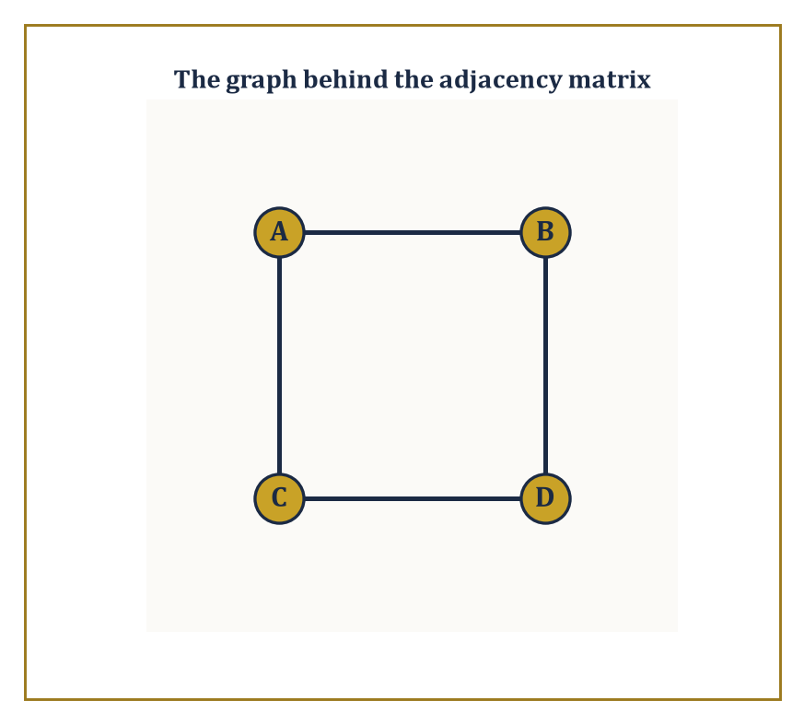
Figure 20.1 — The square graph behind the adjacency matrix of What a Matrix Is — four vertices, four edges, and a matrix that already knows every one of them.
An m×n matrix has m rows and n columns, and by convention (a convention worth memorizing now, because getting it backwards causes hours of quiet suffering later) rows are listed first: ‘m by n’ means m rows, n columns, in that order. The entry sitting in row i and column j is written aᵢⱼ, with the row index always first.
Think of a matrix as a spreadsheet with the headers stripped off: a single symbol, A, standing in for an entire grid of numbers that could otherwise take up half a page.
Numeric example — Consider the matrix:
 | A = |  | 2 | −1 | 5
 | A = |  | 0 | 3 | 7
This is a 2×3 matrix: two rows, three columns, six entries in total. Reading off individual entries by the aᵢⱼ convention:
a₁₁ = 2 (row 1, column 1), a₁₂ = −1, a₁₃ = 5, a₂₁ = 0, a₂₂ = 3, a₂₃ = 7
Note that A is not square — it has more columns than rows — and so, whatever else happens in this chapter, A itself will never possess an inverse; only square matrices are even eligible to apply.
Try it now — What size is [1 0 2; −1 3 1], and what is its (2, 3) entry? Answer →
Matrices earn their keep by showing up everywhere numbers need to be organized in two dimensions. They are the coefficient arrays of linear systems (the use that will occupy Row Reduction, Rank, and Solving Systems). They are tables of data — a spreadsheet of exam scores, rows for students and columns for subjects, is a matrix whether or not anyone in the room calls it one.
They are adjacency matrices of graphs, recording which vertices are joined to which. They represent linear transformations once a basis has been chosen (Matrices as Linear Maps). And in more advanced settings they act as discrete stand-ins for the integral kernels met a chapter ago — a matrix is, in a sense, what an integral operator looks like once you’ve chopped continuous space into finitely many pixels.
The arithmetic we are about to impose on matrices — addition, multiplication, the lot — is not handed down from on high; it is reverse-engineered from these uses, chosen because it makes each of these interpretations work correctly.
Numeric example — Consider four vertices A, B, C, D joined in a square: edges A-B, B-D, D-C, C-A (so that walking A to B to D to C to A traces the square). List the vertices in the order A, B, C, D and record a 1 in position (i,j) whenever vertex i is joined to vertex j, and 0 otherwise.
Vertex A is joined to B and C but not D, giving row (0,1,1,0). Vertex B is joined to A and D, giving (1,0,0,1). Vertex C is joined to A and D, giving (1,0,0,1). Vertex D is joined to B and C, giving (0,1,1,0).
The adjacency matrix is therefore:
 |  | 0 | 1 | 1 | 0
 |  | 1 | 0 | 0 | 1
 |  | 1 | 0 | 0 | 1
 |  | 0 | 1 | 1 | 0
- symmetric, as adjacency matrices of undirected graphs always are, since an edge from i to j is inescapably also an edge from j to i.
Each row sums to 2, which is the number of edges at that vertex; a matrix, it turns out, can recite the degree sequence of a graph without anyone having to draw a single picture.
Two matrices are equal exactly when they have the same size and every corresponding entry agrees; there is no partial credit; a matrix that is ‘almost’ equal to another is a different matrix.
The zero matrix, written 0 with size understood from context, has every entry zero and plays the role in matrix addition that the number 0 plays among ordinary numbers.
Square matrices — those with m = n — are the aristocracy of the subject: only a square matrix can be multiplied by itself, raised to a power, or hope to possess an inverse, and so almost everything in The Identity, Inverses, and Elementary Matrices, Determinants, and Eigenvalues and Eigenvectors is stated for square matrices specifically, with rectangular matrices left to make cameo appearances in systems of equations.
Numeric example — Consider the following three matrices:
 | A = |  | 1 | 2 |  | , B = |  | 1 | 2 |  | , C = |  | 1 | 2
 | A = |  | 3 | 4 |  | , B = |  | 3 | 4 |  | , C = |  | 3 | 5
Then, entry for entry:
A = B
But A is not equal to C, and it does not matter that they differ in only one place out of four — the (2,2) entries are 4 and 5 respectively, so C is a different matrix from A, full stop.
Meanwhile the 2×2 zero matrix is:
 |  | 0 | 0
 |  | 0 | 0
A + 0 = A
exactly as you’d hope; it is the null result of the addition operation we are about to define properly in the next section.
Here is the payoff for all this bookkeeping. A system of m linear equations in n unknowns can be written as the single matrix equation:
Ax = b
where A is the m×n coefficient matrix, x is the column of n unknowns, and b is the column of m constants. What used to be a paragraph of aligned equals signs becomes three symbols and a multiplication.
This is not merely typographical tidiness: once a system is a single equation Ax = b, questions about it — does a solution exist? is it unique? how does it change if b changes? — become questions about the matrix A, answerable by the machinery (determinants, rank, inverses) built over the rest of this chapter. Compression is not just convenient; it is the beginning of a new way of thinking about the problem.
Numeric example — Take the system:
x + 2y = 5, 3x − y = 1
In matrix form this is Ax = b with:
 | A = |  | 1 | 2 |  | , x = [x, y]ᵀ, b = [5,1]ᵀ
 | A = |  | 3 | −1 |  | , x = [x, y]ᵀ, b = [5,1]ᵀ
Solving by substitution in the usual way: from the first equation,
x = 5 − 2y
substituting into the second gives:
3(5 − 2y) − y = 1
15 − 6y − y = 1
15 − 7y = 1
y = 2
and then:
x = 5 − 2(2) = 1
Check directly against the matrix equation:
 | Ax = |  | 1 | 2 |  | · [1,2]ᵀ
 | Ax = |  | 3 | −1 |  | · [1,2]ᵀ
= [1·1+2·2, 3·1+(−1)·2]ᵀ = [1+4, 3−2]ᵀ = [5,1]ᵀ = b
The single symbol Ax = b really is hiding the pair of equations we started with, and this same matrix A will resurface in Determinants when we compute its determinant by a completely different route and get an answer that still, reassuringly, tells us this system had exactly one solution.
Keep only this · Section 20.1: What a Matrix Is
The idea. A matrix is a rectangular array; its size is rows × columns, and entry (i, j) sits in row i, column j.
Core.
an m × n matrix has m rows and n columns; entry aᵢⱼ is in row i, column j
Typical mistake. Swapping the roles of rows and columns when reading sizes or entries.
Minimal example. [1 2 3; 4 5 6] is 2 × 3 with a₂₃ = 6.
Practice. Easy to challenge; full worked answers, with the usual mistake, are in Answers to the Practice Sets at the back.
Easy — Size of [1 0; 2 5; 7 3], and its entry a₃₁? Answer →
Medium — Write the coefficient matrix of x + 2y = 5, 3x − y = 4. Answer →
Challenge — Write the 3 × 3 matrix with aᵢⱼ = i − j, and describe it. Answer →

Section 20.2: Matrix Arithmetic: Addition, Scalar Multiplication, Multiplication
Or: Why AB and BA Are Barely on Speaking Terms
CORE · about 15 minutes · later chapters build on this
A table of sales, with shops down the side and products across the top, is a matrix, and some of its arithmetic is obvious. Add last month’s table to this month’s, entry by entry, and you have the two-month totals; double every entry and you have the forecast for a month twice as busy. Multiplication is the surprise. Multiplying a table of quantities by a table of prices gives revenue, and the rule that does it pairs each row of the first table with each column of the second. Because rows and columns play different roles, swapping the order usually changes the answer, and sometimes makes the product meaningless. Matrices are the first numbers you meet that refuse to commute.
Definition — Addition and scalar multiplication are as unimaginative as you’d hope. Two matrices of the same size are added entrywise: the (i,j) entry of A + B is given by adding the corresponding entries.
(A + B)ᵢⱼ = aᵢⱼ + bᵢⱼ
Scalar multiplication multiplies every entry by the scalar.
(cA)ᵢⱼ = c · aᵢⱼ
These two operations, so simple they barely need announcing, are enough to make the set of all m×n matrices into a vector space in its own right — you can add matrices, scale them, and everything behaves just as vector addition and scaling ought to. Since an m×n matrix has mn entries, each free to be anything, this vector space has dimension mn: an m×n matrix is, structurally, nothing more than a list of mn numbers wearing a rectangular costume.
Numeric example — Let A = [1 2; 3 4] and B = [5 −1; 0 2].
 | A + B = |  | 1+5 | (2+(−1)) |  | = |  | 6 | 1
 | A + B = |  | 3+0 | 4+2 |  | = |  | 3 | 6
Entry by entry, no surprises.
 | 3A = |  | 3·1 | 3·2 |  | = |  | 3 | 6
 | 3A = |  | 3·3 | 3·4 |  | = |  | 9 | 12
Note that A is a 2×2 matrix, hence lives in a vector space of dimension 2·2 = 4 — and indeed A is entirely determined by the ordinary list of four numbers (1,2,3,4), read off row by row.
Try it now — Compute [1 2; 3 4][1; 1]. Answer →
Multiplication is where matrices stop being polite. The product AB is defined only when the number of columns of A equals the number of rows of B — an m×n matrix can only be multiplied on the right by an n×p matrix, and the result is m×p. The (i,j) entry of AB is the dot product of row i of A with column j of B: you march along a row and down a column simultaneously, multiplying corresponding entries and adding up.
This rule looks, on first encounter, like something a committee designed to be memorable rather than sensible. It is not arbitrary. It is the rule that makes the following true for every compatible column vector x:
(AB)x = A(Bx)
That is, multiplying by AB has precisely the same effect as multiplying by B first and then by A. Matrix multiplication is defined the way it is so that it corresponds to composing the linear maps that A and B represent: do B, then do A. Once you see multiplication as ‘do this, then do that’, the row-times-column formula stops being an arbitrary hoop and becomes the only formula that could possibly have worked.
Numeric example — Let A = [1 0 2; −1 3 1] (2×3) and B = [3 1; 2 1; 1 0] (3×2). Since A has 3 columns and B has 3 rows, AB is defined and will be 2×2.
Entry (1,1): row 1 of A, (1,0,2), dotted with column 1 of B, (3,2,1).
1·3 + 0·2 + 2·1 = 3+0+2 = 5
Entry (1,2): row 1 of A dotted with column 2 of B, (1,1,0).
1·1 + 0·1 + 2·0 = 1
Entry (2,1): row 2 of A, (−1,3,1), dotted with column 1 of B.
−1·3 + 3·2 + 1·1 = −3+6+1 = 4
Entry (2,2): row 2 of A dotted with column 2 of B.
−1·1 + 3·1 + 1·0 = −1+3+0 = 2
So:
 | AB = |  | 5 | 1
 | AB = |  | 4 | 2
Notice that BA would also be defined here (B is 3×2, A is 2×3, inner dimensions 2 and 2 match), and would come out 3×3 — a completely different shape from AB, which is your first hint that order matters rather a lot.
Matrix multiplication is associative and distributes over addition — both facts inherited directly from the composition-of-functions interpretation, since composing functions is always associative:
(AB)C = A(BC)
A(B+C) = AB+AC
What it is not, in general, is commutative: AB and BA need not be equal, and frequently are not even the same size.
Sitting among the square n×n matrices is the identity matrix Iₙ, with 1’s down the main diagonal and 0’s everywhere else, satisfying:
AI = IA = A
for every n×n matrix A. It is the matrix world’s answer to the number 1: multiplying by it changes nothing, which is why we shall spend The Identity, Inverses, and Elementary Matrices asking which matrices have a partner that undoes them.
Numeric example — Let A = [1 1; 0 1] and B = [1 0; 1 1] — both 2×2, so both products are defined and both come out 2×2, removing the easy excuse of mismatched shapes.
Computing AB entry by entry:
entry (1,1) = 1·1+1·1 = 2
entry (1,2) = 1·0+1·1 = 1
entry (2,1) = 0·1+1·1 = 1
entry (2,2) = 0·0+1·1 = 1
 | AB = |  | 2 | 1
 | AB = |  | 1 | 1
Now BA:
entry (1,1) = 1·1+0·0 = 1
entry (1,2) = 1·1+0·1 = 1
entry (2,1) = 1·1+1·0 = 1
entry (2,2) = 1·1+1·1 = 2
 | BA = |  | 1 | 1
 | BA = |  | 1 | 2
Same two matrices, same order of operations reversed, and AB is not equal to BA — they don’t even share a top-left entry. If multiplication were commutative here, the (1,1) entries would match; they are 2 and 1, and no amount of wishful thinking closes that gap.
For a square matrix A, powers are defined the obvious way — A² = A times A, A³ = A times A times A, and so on — and since matrix multiplication is associative, these behave as you’d expect powers to behave:
AᵐAⁿ = Aᵐ⁺ⁿ
Once powers exist, so do polynomials in A: an expression like the following is perfectly well-defined, obtained by computing the powers of A and combining them with scalar multiples of A and of the identity:
p(A) = A² − 2A + I
This might look like idle generalization, but polynomials in a matrix will turn out to be central later — the characteristic polynomial of Eigenvalues and Eigenvectors and the whole theory of the Jordan form (waiting one chapter later) are built entirely from this idea.
Numeric example — Let A = [2 1; 0 2]. Then A² = A times A, computed entry by entry:
entry (1,1) = 2·2+1·0 = 4
entry (1,2) = 2·1+1·2 = 4
entry (2,1) = 0·2+2·0 = 0
entry (2,2) = 0·1+2·2 = 4
 | A² = |  | 4 | 4
 | A² = |  | 0 | 4
Now evaluate p(A) = A² − 2A + I. We have:
 | 2A = |  | 4 | 2
 | 2A = |  | 0 | 4
 | I = |  | 1 | 0
 | I = |  | 0 | 1
 | p(A) = |  | 4−4+1 | 4−2+0 |  | = |  | 1 | 2
 | p(A) = |  | 0−0+0 | 4−4+1 |  | = |  | 0 | 1
Keep an eye on this particular A — it is going to reappear in Eigenvalues and Eigenvectors wearing a rather embarrassing secret: it has only one independent eigenvector, despite being 2×2, and this is the kind of matrix that keeps Jordan-form theorists in gainful employment.
Keep only this · Section 20.2: Matrix Arithmetic: Addition, Scalar Multiplication, Multiplication
The idea. Entry (i, j) of AB is row i of A dotted with column j of B; AB is defined only when A has as many columns as B has rows, and usually AB ≠ BA.
Core.
(AB)ᵢⱼ = row i of A · column j of B
(m × n)(n × p) = m × p
AB ≠ BA in general
Typical mistake. Assuming AB = BA, or multiplying entry by entry.
Minimal example. [1 2; 3 4][1; 1] = [3; 7].
Practice. Easy to challenge; full worked answers, with the usual mistake, are in Answers to the Practice Sets at the back.
Easy — Compute [1 2; 0 1][3; 4]. Answer →
Medium — With A = [1 1; 0 1] and B = [1 0; 1 1], compute AB and BA. Answer →
Challenge — Find a non-zero 2 × 2 matrix with A² = 0. Answer →

Section 20.3: The Identity, Inverses, and Elementary Matrices
Undoing What Has Been Done, When Possible
CORE · about 15 minutes · later chapters build on this
Some actions can be undone and some cannot. Rotate a photograph by 30 degrees and you can rotate it back; squash it flat onto a line and the lost detail is gone for good. Matrices describe actions like these, and the ones that can be undone are called invertible. The undoing matrix is the inverse, and an action followed by its inverse leaves everything exactly where it was, which is what the identity matrix does: the matrix version of multiplying by 1. For a stretch that doubles every length, the inverse halves every length. This section shows how to tell whether an inverse exists and how to compute it, one elementary step at a time.
Definition — A square matrix A is called invertible (or nonsingular) if there is some matrix A⁻¹ that undoes it, satisfying
AA⁻¹ = A⁻¹A = I
When such a matrix exists it is unique — if B and C both undid A, a short algebraic maneuver shows B = C, so there is never any ambiguity about which matrix is ‘the’ inverse:
B = BI = B(AC) = (BA)C = IC = C
Invertible matrices are the matrices that represent invertible linear maps: maps that can be run backwards without losing information.
Equivalently, A is invertible precisely when the system Ax = b has one and only one solution x for every possible b — invertibility is a statement about the matrix, but it is also, simultaneously, a statement about the solvability of an entire family of linear systems.
Not every square matrix qualifies, and this is worth dwelling on for a moment, because the temptation is to think of ‘inverse’ the way one thinks of reciprocals of ordinary numbers, where only zero misbehaves.
Among matrices the failure mode is more interesting: a matrix fails to be invertible whenever its rows (or columns) are not independent of one another — whenever one row can be written as a combination of the others, some information about the input vector is irretrievably thrown away by the map, and no amount of algebraic cleverness can build a machine to recover what was never recorded.
Numeric example — For a general 2×2 matrix A = [a b; c d], provided ad − bc is not zero, the inverse is given by swapping the diagonal entries, negating the off-diagonal ones, and dividing by the determinant (a quantity we shall meet properly next section, but which is already doing useful work here):
 | A⁻¹ = (1/(ad−bc)) · |  | d | −b
 | A⁻¹ = (1/(ad−bc)) · |  | −c | a
Take A = [2 1; 1 1]: here ad − bc = 2·1 − 1·1 = 1, so the inverse works out to
 | A⁻¹ = (1/1) · |  | 1 | −1 |  | = |  | 1 | −1
 | A⁻¹ = (1/1) · |  | −1 | 2 |  | = |  | −1 | 2
Check: AA⁻¹ = [2 1; 1 1] · [1 −1; −1 2]. Entry (1,1) = 2·1+1·(−1) = 1; entry (1,2) = 2·(−1)+1·2 = 0; entry (2,1) = 1·1+1·(−1) = 0; entry (2,2) = 1·(−1)+1·2 = 1. So:
 | AA⁻¹ = |  | 1 | 0 |  | = I
 | AA⁻¹ = |  | 0 | 1 |  | = I
exactly as promised.
Try it now — Invert [2 1; 5 3]. Answer →
Elementary matrices are a small, useful family: each is obtained from the identity matrix by performing exactly one elementary row operation — swap two rows, multiply a row by a nonzero scalar, or add a multiple of one row to another.
Every elementary matrix is invertible (each of the three operations is itself reversible: swap back, divide by the same scalar, subtract the same multiple back off), and the reason they matter is a small piece of magic: left-multiplying any matrix A by an elementary matrix E performs on A the exact row operation that was used to build E from the identity.
Row reduction, in other words, is secretly a sequence of matrix multiplications by elementary matrices, dressed up in more casual clothing.
Numeric example — The elementary matrix for ‘swap row 1 and row 2’ in the 2×2 setting is obtained by taking the identity and swapping its rows:
 | E = |  | 0 | 1
 | E = |  | 1 | 0
Apply it to A = [2 1; 1 1] by left multiplication: EA has entry (1,1) = 0·2+1·1 = 1; entry (1,2) = 0·1+1·1 = 1; entry (2,1) = 1·2+0·1 = 2; entry (2,2) = 1·1+0·1 = 1. So:
 | EA = |  | 1 | 1
 | EA = |  | 2 | 1
exactly A with its two rows swapped, as advertised, and no dot-product gymnastics were needed to see it coming.
Because every elementary row operation is achieved by left-multiplying by an elementary matrix, and because Gaussian elimination reduces any invertible matrix to the identity by a finite sequence of such operations, it follows that any invertible A can be written as a product of elementary matrices:
Eₖ ⋯ E₂ E₁ A = I
A⁻¹ = Eₖ ⋯ E₂ E₁
This is not just a structural curiosity — it hands us a genuine algorithm. If we apply the same sequence of row operations that reduces A to I to the identity matrix I sitting alongside it, we get A⁻¹ for free.
In practice this means: write the augmented block [A | I], row-reduce the left half to the identity, and read the inverse off the right half.
This is, in fact, the only sane way to invert anything bigger than a 3×3 matrix by hand; the cofactor-and-adjugate formula that generalizes the 2×2 shortcut of the previous example exists, technically, for every size of matrix, but its cost explodes so violently with n that nobody outside an examination hall has used it on a matrix larger than 3×3 in living memory.
Numeric example — Take the same A = [2 1; 1 1] as before, and confirm its inverse by the row-reduction method rather than the 2×2 formula, so the two routes can check each other. Start from the augmented block:
 | [A | I] = |  | 2 | 1 | 1 | 0
 | [A | I] = |  | 1 | 1 | 0 | 1
Operation 1: replace row 1 with row 1 minus row 2:
[2−1, 1−1 | 1−0, 0−1] = [1,0 | 1,−1]
The block is now [1 0 | 1 −1; 1 1 | 0 1]. Operation 2: replace row 2 with row 2 minus row 1:
[1−1, 1−0 | 0−1, 1−(−1)] = [0,1 | −1,2]
The block is now [1 0 | 1 −1; 0 1 | −1 2]. The left half is the identity, so the right half is the inverse:
 | A⁻¹ = |  | 1 | −1
 | A⁻¹ = |  | −1 | 2
what the formula gave a moment ago. The two methods agreeing is not a coincidence; it is the same fact, computed two different ways, which is the kind of consistency check a suspicious mathematician (that is, any competent one) should always perform.
Keep only this · Section 20.3: The Identity, Inverses, and Elementary Matrices
The idea. For [a b; c d] with ad − bc ≠ 0, the inverse is (1/(ad − bc))[d −b; −c a]; (AB)⁻¹ = B⁻¹A⁻¹.
Core.
[a b; c d]⁻¹ = (1/(ad − bc)) [d −b; −c a], ad − bc ≠ 0
(AB)⁻¹ = B⁻¹A⁻¹
Typical mistake. Writing (AB)⁻¹ = A⁻¹B⁻¹ in the original order.
Minimal example. [2 1; 1 1]⁻¹ = [1 −1; −1 2].
Practice. Easy to challenge; full worked answers, with the usual mistake, are in Answers to the Practice Sets at the back.
Easy — Invert [3 0; 0 2]. Answer →
Medium — Invert [1 2; 3 4]. Answer →
Challenge — Which elementary matrix adds 2 × row 1 to row 2 (3 × 3), and what is its inverse? Answer →

Section 20.4: Determinants
One Number That Somehow Knows Everything
CORE · about 15 minutes · later chapters build on this
A matrix transforms the plane, stretching, shearing and sometimes flipping it, and a single number tells you how much it scales areas. Send the two unit arrows along the axes to the arrows (3, 1) and (1, 2), and the unit square becomes a parallelogram of area 5; every shape in the plane has its area multiplied by 5 in the same move. That number is the determinant. When it is zero, the transformation has squashed the plane flat onto a line or a point, and nothing can undo it, which is why the determinant is the quickest test of whether a matrix has an inverse. Its sign records whether the transformation flips the plane over.
Definition — The determinant is a single scalar computed from a square matrix, written det(A) or |A|, with the crucial property that it detects singularity: it vanishes exactly when A is singular (non-invertible).
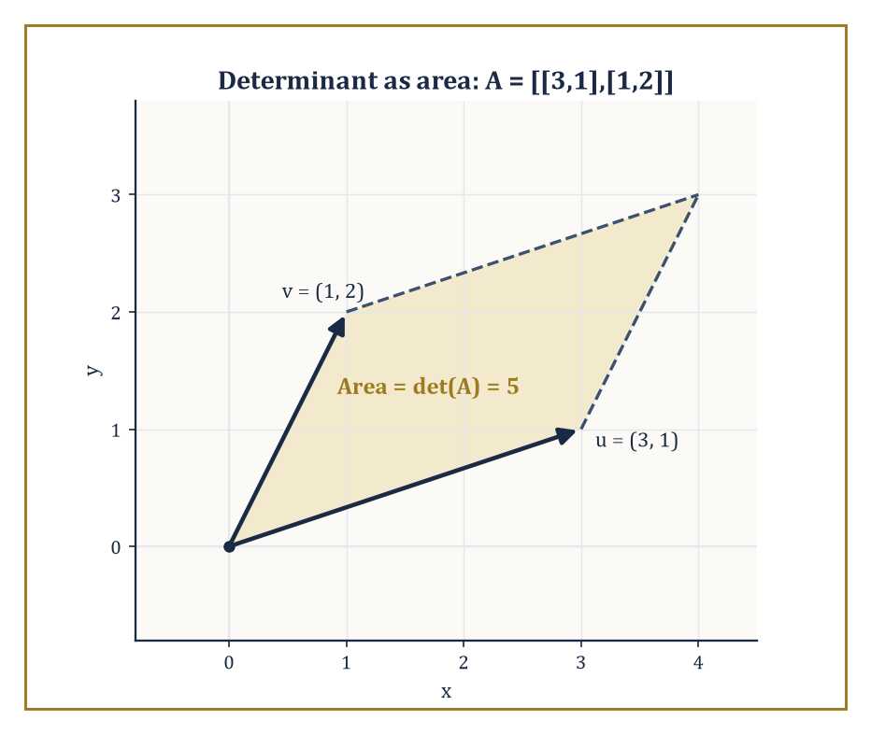
Figure 20.2 — The parallelogram spanned by u = (3,1) and v = (1,2), with area exactly 5 — the determinant caught in the act of measuring.
det(A) = 0 (exactly when A is singular)
It can be introduced in at least three equivalent ways: by the Leibniz formula, a signed sum over all n! permutations of {1, …, n}; by an axiomatic characterization as the unique function that is multilinear in the rows, alternates sign when two rows are swapped, and sends the identity to 1; or recursively, by cofactor expansion along any row or column, reducing an n×n determinant to a signed sum of (n−1) x (n−1) determinants.
All three definitions produce the same number; which one you reach for is a matter of taste, patience, and how many rows your matrix has.
Numeric example — Let M = [1 2 3; 0 1 4; 5 6 0]. Expand along the first row.
 | det(M) = 1·det |  | 1 | 4 |  | − 2·det |  | 0 | 4 |  | + 3·det |  | 0 | 1
 | det(M) = 1·det |  | 6 | 0 |  | − 2·det |  | 5 | 0 |  | + 3·det |  | 5 | 6
Each bracket is a 2×2 determinant, computed as (top-left times bottom-right) minus (top-right times bottom-left):
 | det |  | 1 | 4 |  | = 1·0 − 4·6 = −24
 | det |  | 6 | 0 |  | = 1·0 − 4·6 = −24
 | det |  | 0 | 4 |  | = 0·0 − 4·5 = −20
 | det |  | 5 | 0 |  | = 0·0 − 4·5 = −20
 | det |  | 0 | 1 |  | = 0·6 − 1·5 = −5
 | det |  | 5 | 6 |  | = 0·6 − 1·5 = −5
Substituting:
det(M) = 1·(−24) − 2·(−20) + 3·(−5) = −24 + 40 − 15 = 1
Since det(M) = 1, not zero, M is invertible — a fact we now know without doing a shred of row reduction.
Try it now — det [2 0 0; 5 3 0; 1 4 −1]? Answer →
Determinants obey a short, useful list of rules.
The determinant of a product is the product of the determinants, for any two square matrices of the same size — a fact that is far from obvious from the Leibniz formula but drops out cleanly from the axiomatic definition.
det(AB) = det(A) det(B)
The determinant of a triangular matrix (all entries above or below the diagonal zero) is the product of its diagonal entries — no expansion needed. Swapping two rows flips the sign of the determinant. Multiplying a single row by a scalar c multiplies the whole determinant by c.
These rules are what make Gaussian elimination a viable way to compute determinants of large matrices: track the sign flips from row swaps and the scalar factors from row scalings, reduce to triangular form, and multiply the diagonal.
Numeric example — Let A = [1 2; 0 1] and B = [2 0; 1 3]. Directly:
det(A) = 1·1 − 2·0 = 1
det(B) = 2·3 − 0·1 = 6
Now compute AB, entry by entry:
entry (1,1) = 1·2+2·1 = 4
entry (1,2) = 1·0+2·3 = 6
entry (2,1) = 0·2+1·1 = 1
entry (2,2) = 0·0+1·3 = 3
So AB = [4 6; 1 3], and:
det(AB) = 4·3 − 6·1 = 12 − 6 = 6
Compare with det(A) times det(B):
det(A) · det(B) = 1·6 = 6
They agree, as the product rule guarantees they must — for any pair of square matrices you care to try, not just this obliging one.
Geometrically, for a 2×2 matrix, |det(A)| is the area of the parallelogram spanned by its two columns (equivalently its two rows); for a 3×3 matrix, |det(A)| is the volume of the parallelepiped spanned by its three columns.
In higher dimensions the pattern continues: |det(A)| measures the factor by which the linear map x maps to Ax scales n-dimensional volume, and the sign of det(A) records whether the map preserves or reverses orientation (whether it flips the space over, like a reflection, or not).
A determinant of zero says the map squashes n-dimensional volume down to something lower-dimensional — a plane’s worth of area collapsed onto a line, say — which is the geometric reason a singular matrix cannot be inverted: you cannot un-squash a pancake back into a loaf.
Numeric example — Let u = (3,1) and v = (1,2) be the two columns of a matrix, so A = [3 1; 1 2].
det(A) = 3·2 − 1·1 = 6 − 1 = 5
So the parallelogram with sides u and v has area 5. As a sanity check by a completely different route: the parallelogram sits inside a 3-by-2 bounding rectangle of area 6, and a quick sketch confirms an area a little under 6 is entirely plausible — 5 passes the smell test, which is always worth doing before trusting an arithmetic answer.
Cramer’s rule expresses each coordinate of the solution to a nonsingular system Ax = b as a ratio of determinants, where Aᵢ is A with its i-th column replaced by b.
xᵢ = det(Aᵢ)/det(A)
It is an elegant formula and a genuinely poor algorithm — computing that many determinants costs far more arithmetic than Gaussian elimination once the system has more than three or four unknowns, so Cramer’s rule survives mainly as a theoretical tool and an exam question, rather than as something anyone runs on a computer.
One more fact worth banking now and cashing in Eigenvalues and Eigenvectors: the determinant is (up to sign) the constant term of the characteristic polynomial, and therefore equals the product of all the eigenvalues of A, counted with multiplicity — a single number that, remarkably, already knows the product of quantities we haven’t even defined yet.
Numeric example — Recall the system from What a Matrix Is: x + 2y = 5, 3x − y = 1, with A = [1 2; 3 −1] and b = [5,1]ᵀ.
det(A) = 1·(−1) − 2·3 = −1 − 6 = −7
For x, replace column 1 of A with b: A₁ = [5 2; 1 −1].
det(A₁) = 5·(−1) − 2·1 = −5 − 2 = −7
x = det(A₁)/det(A) = −7/−7 = 1
For y, replace column 2 of A with b: A₂ = [1 5; 3 1].
det(A₂) = 1·1 − 5·3 = 1 − 15 = −14
y = det(A₂)/det(A) = −14/−7 = 2
This matches x = 1, y = 2 as found by substitution back in What a Matrix Is — three different methods (substitution, matrix inversion in spirit, and now determinants) converging on the same answer, which is either deeply reassuring about the consistency of mathematics or a sign that we chose a suspiciously well-behaved example. Both, really.
Keep only this · Section 20.4: Determinants
The idea. det(AB) = det A det B, a row swap flips the sign, and |det A| is the factor by which A scales area or volume.
Core.
det [a b; c d] = ad − bc
det(AB) = det A · det B
|det A| = area or volume scale factor
Typical mistake. Forgetting the alternating signs + − + in cofactor expansion.
Minimal example. det [2 0; 0 3] = 6: areas grow by 6.
Practice. Easy to challenge; full worked answers, with the usual mistake, are in Answers to the Practice Sets at the back.
Easy — det [4 1; 2 3]. Answer →
Medium — det [1 2 0; 0 1 3; 0 0 2]. Answer →
Challenge — If det A = 3 for a 3 × 3 matrix A, find det(2A) and det(A⁻¹). Answer →

Section 20.5: Row Reduction, Rank, and Solving Systems
The Algorithm Underneath Everything Else in This Chapter
CORE · about 15 minutes · later chapters build on this
Key idea — Gaussian elimination reduces a matrix to row-echelon form — a staircase pattern where each row’s leading nonzero entry sits strictly to the right of the leading entry in the row above, and any all-zero rows sink to the bottom — using only the three elementary row operations from The Identity, Inverses, and Elementary Matrices.
Pushing further to eliminate entries above each leading entry as well (not just below) yields reduced row-echelon form, the process usually called Gauss-Jordan elimination.
Applying the same operations to the augmented matrix [A | b] simultaneously transforms both the coefficient matrix and the constants, so that at the end you can read off the solution to Ax = b directly.
Or you discover, from a row that reduces to the following, that no solution exists at all:
0 = (nonzero number)
Numeric example — Solve the following system of three equations in three unknowns:
x + y + z = 6, 2x − y + z = 3, x + 2y − z = 2
Written as an augmented matrix:
 | [A | b] = |  | 1 | 1 | 1 | 6
 | [A | b] = |  | 2 | −1 | 1 | 3
 | [A | b] = |  | 1 | 2 | −1 | 2
Eliminate the first column below row 1: row 2 becomes row 2 minus 2 times row 1, and row 3 becomes row 3 minus row 1.
row 2: [0,−3,−1|−9]
row 3: [0,1,−2|−4]
The augmented matrix is now:
 |  | 1 | 1 | 1 | 6
 |  | 0 | −3 | −1 | −9
 |  | 0 | 1 | −2 | −4
Swap rows 2 and 3 for a tidier leading entry:
 |  | 1 | 1 | 1 | 6
 |  | 0 | 1 | −2 | −4
 |  | 0 | −3 | −1 | −9
Eliminate below the new row 2: row 3 becomes row 3 plus 3 times row 2.
[0, −3+3, −1−6 | −9−12] = [0,0,−7|−21]
Back-substitute. From row 3:
−7z = −21, so z = 3
From row 2:
y − 2z = −4, so y = −4 + 2·3 = 2
From row 1:
x + y + z = 6, so x = 6 − 2 − 3 = 1
Check against all three original equations:
x+y+z = 1+2+3 = 6
2x-y+z = 2−2+3 = 3
x+2y-z = 1+4−3 = 2
All three check out correctly. The system has the unique solution (x,y,z) = (1,2,3).
Try it now — Rank and nullity of [1 2; 2 4]. Answer →
The rank of a matrix is the number of nonzero rows in its row-echelon form — equivalently, the dimension of its column space (the span of its columns) or of its row space (the span of its rows, which, remarkably, always has the same dimension as the column space, even though rows and columns are entirely different objects).
Rank does not change under elementary row operations, nor under transposition, which is precisely why ‘the number of nonzero rows after elimination’ is a safe and well-defined thing to count regardless of which sequence of legal row operations you happened to use to get there.
Rank is also connected to a theorem we shall only preview here and prove properly next chapter — the rank-nullity theorem — which says that for an n-column matrix:
rank + dim(null space) = n
Every dimension you ‘lose’ to a smaller rank shows up, without exception, as extra freedom in the null space.
Numeric example — Let N be the following matrix. Notice row 2 is exactly twice row 1 — a dependency that ought to cost the matrix a dimension of rank.
 | N = |  | 1 | 2 | 3
 | N = |  | 2 | 4 | 6
 | N = |  | 1 | 0 | 1
Row reduce: row 2 becomes row 2 minus 2 times row 1, and row 3 becomes row 3 minus row 1.
row 2: [0,0,0]
row 3: [0,−2,−2]
The echelon form is:
 |  | 1 | 2 | 3
 |  | 0 | −2 | −2
 |  | 0 | 0 | 0
(with the now-redundant all-zero row sitting at the bottom, where it belongs). There are two nonzero rows, so rank(N) = 2, not the full 3 you might have naively expected from a 3×3 matrix.
This matrix will turn out to have a one-dimensional null space, as the rank-nullity theorem predicts (3 columns minus rank 2 equals nullity 1), and we shall confirm that directly in the next section.
For a square n×n matrix, the following statements are all equivalent — each implies all the others, so any one of them is a complete test for invertibility:
A is invertible ⇔ rank(A) = n (full rank) ⇔ the reduced row-echelon form of A is the identity matrix ⇔ det(A) is not zero
Any one test failing means all of them fail simultaneously. In practice the determinant test is usually fastest for small matrices done by hand, while row reduction (which you’d often be doing anyway, to solve a system) is the practical test for anything larger.
It is worth pausing to notice how much weight this short list is carrying: a purely algebraic condition (a formula involving no geometry at all evaluates to a nonzero number), a purely computational condition (an algorithm terminates in a particular way), and a purely dimension-counting condition (a count of independent rows reaches its maximum possible value) all turn out to be exactly the same fact, seen through three different lenses.
Whenever one of them is easy to check and the others are not, you now have the right to check the easy one and trust the rest for free.
Numeric example — Compare A with B, defined as follows:
 | A = |  | 2 | 1 |  | , B = |  | 2 | 4
 | A = |  | 1 | 1 |  | , B = |  | 1 | 2
For A, compute the determinant:
det(A) = 2·1 − 1·1 = 1
This is not zero, and row-reducing A (row 1 minus row 2 gives [1,0]; row 2 stays [1,1], and further reduction confirms two independent nonzero rows) gives rank 2, full rank; A is invertible, consistent with The Identity, Inverses, and Elementary Matrices.
For B, compute the determinant:
det(B) = 2·2 − 4·1 = 4 − 4 = 0
Indeed row 2 = (1/2) times row 1, so row-reducing gives:
 |  | 2 | 4
 |  | 0 | 0
Only one nonzero row, so rank(B) = 1, less than 2. All three tests (determinant, rank, echelon form) agree that B is singular: there is no B⁻¹, and the system Bx = b will have either no solution or infinitely many, depending on b, but never exactly one.
Keep only this · Section 20.5: Row Reduction, Rank, and Solving Systems
The idea. Row reduce to echelon form; rank = number of pivots; nullity = number of columns − rank.
Core.
rank = number of pivots
Ax = b solvable ⇔ rank A = rank [A | b]
free variables = n − rank
Typical mistake. Counting non-zero rows of the original matrix rather than of the echelon form.
Minimal example. [1 2 | 3; 2 4 | 6] reduces to one pivot: infinitely many solutions.
Practice. Easy to challenge; full worked answers, with the usual mistake, are in Answers to the Practice Sets at the back.
Easy — Rank of [1 2; 2 4]. Answer →
Medium — Solve x + y + z = 3, x − y = 0, y + z = 2. Answer →
Challenge — For which k does x + 2y = 1, 2x + 4y = k have solutions? Answer →

Section 20.6: Matrices as Linear Maps
What A Actually Does to a Vector
CORE · about 15 minutes · later chapters build on this
Definition — Every m×n matrix A defines a function from ℝⁿ to ℝᵐ by the rule x maps to Ax — feed in a column vector with n entries, and matrix-vector multiplication (the one-column special case of the multiplication rule from Matrix Arithmetic) hands back a column vector with m entries.
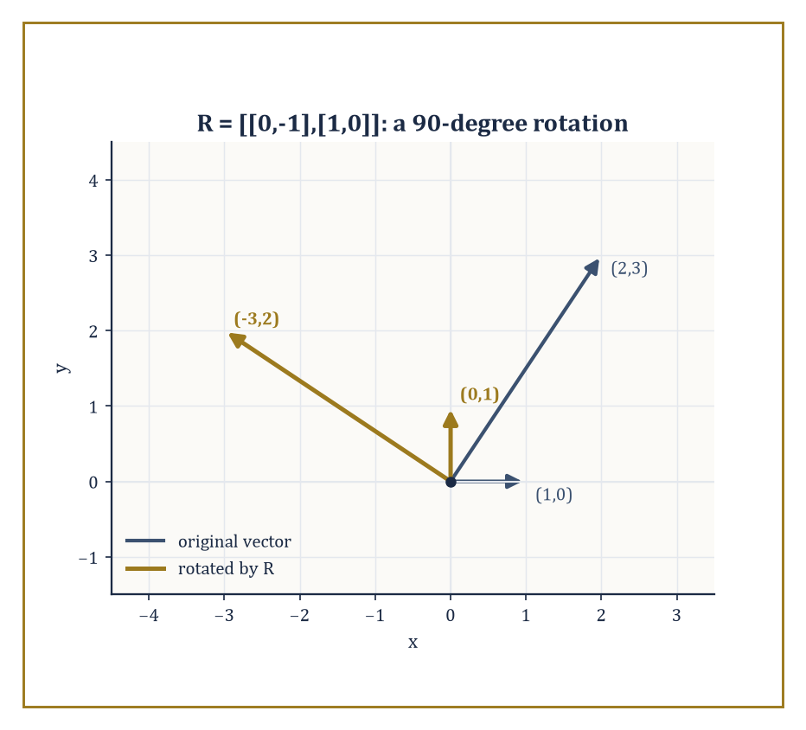
Figure 20.3 — R turning (1,0) into (0,1) and (2,3) into (−3,2) — the same quarter-turn, applied faithfully to every vector it meets.
This function is linear, both immediate from the distributive and scalar properties of matrix arithmetic:
A(x+y) = Ax + Ay
A(cx) = cAx
The converse also holds, once you fix bases for the source and target: every linear map between coordinate spaces arises from exactly one matrix.
And matrix multiplication, which looked like an arbitrary row-times-column rule when you first met it, now reveals its true purpose — AB corresponds to the composite map ‘first apply the map for B, then apply the map for A’, which is precisely why the formula had to be defined the way it was back in Matrix Arithmetic.
Numeric example — The matrix R = [0 −1; 1 0] represents a 90-degree counterclockwise rotation of the plane.
Apply it to (1,0):
R·(1,0)ᵀ = (0·1+(−1)·0, 1·1+0·0)ᵀ = (0,1)ᵀ
The point due east has rotated to due north, as a 90-degree turn should send it.
Apply it to (2,3):
R·(2,3)ᵀ = (0·2+(−1)·3, 1·2+0·3)ᵀ = (−3,2)ᵀ
Check this is a 90-degree rotation of (2,3) rather than some other transformation: the length is preserved (the square root of 2²+3² is the square root of 13, and the square root of (−3)²+2² is also the square root of 13), and the vector (−3,2) is indeed (2,3) turned a quarter-circle counterclockwise about the origin.
Try it now — Where does [0 −1; 1 0] send (2, 1)? Answer →
Two subspaces attached to A deserve names because they answer the two most natural questions about the map x maps to Ax: where can it land, and what does it destroy?
The column space of A — the span of its columns — is the range of the map, the set of all possible outputs Ax.
The null space of A is the set of all x with Ax = 0 — the kernel of the map, the vectors the map collapses to the origin.
Rank, defined in the previous section as a count of nonzero rows in echelon form, is simultaneously the dimension of the column space, i.e. of the range: a purely computational recipe (count the rows) and a purely geometric quantity (the dimension of where the map can land) turn out to be the same number, which is one of those small miracles linear algebra keeps producing once you look for them.
Numeric example — Recall N = [1 2 3; 2 4 6; 1 0 1] from Row Reduction, Rank, and Solving Systems, with rank 2 and echelon form [1 2 3; 0 −2 −2; 0 0 0].
Since N has 3 columns and rank 2, the rank-nullity theorem promises a null space of dimension 3 − 2 = 1: exactly one free direction of vectors that N crushes to zero.
Solve Nx = 0 using the echelon form: row 2 gives
−2x₂ − 2x₃ = 0
so x₂ = −x₃; set x₃ = 1, giving x₂ = −1.
Row 1 gives
x₁ + 2x₂ + 3x₃ = 0
x₁ = −2(−1) − 3(1) = 2 − 3 = −1
So x = (−1,−1,1) spans the null space.
Check directly against the original N.
row 1: 1(−1)+2(−1)+3(1) = −1−2+3 = 0
Correct.
row 2: 2(−1)+4(−1)+6(1) = −2−4+6 = 0
Correct.
row 3: 1(−1)+0(−1)+1(1) = −1+0+1 = 0
Correct.
The vector (−1,−1,1) really does vanish under N, and — because N has rank 2, not 3 — it is not alone; every scalar multiple of it vanishes too.
A single linear map can be written as many different matrices, depending on which basis you use to name your coordinates — the map itself doesn’t change, but its numerical description does.
If P is the change-of-basis matrix whose columns are the new basis vectors expressed in the old coordinates, then the matrix representing the same linear map with respect to the new basis is
P⁻¹ A P
This operation — sandwiching A between P⁻¹ and P — is called conjugation, and it is one of the most important formulas in the whole subject: two matrices related by
A′ = P⁻¹ A P
are called similar, they represent the same underlying map, and an enormous amount of the theory awaiting you next chapter (the search for the ‘nicest possible’ matrix representing a given map, culminating in the Jordan form and the spectral theorem) is really the search for a basis in which P⁻¹ A P looks as simple as possible.
Numeric example — Let A = [2 0; 0 3] (a map that stretches by 2 along one axis and by 3 along the other) and let P = [1 1; 0 1] describe a new basis whose vectors are (1,0) and (1,1) in the old coordinates.
First, P⁻¹: since
det(P) = 1·1 − 1·0 = 1
swapping-diagonal-negating-off-diagonal gives
 | P⁻¹ = |  | 1 | −1
 | P⁻¹ = |  | 0 | 1
Compute AP first:
entry (1,1) = 2·1+0·0 = 2; entry (1,2) = 2·1+0·1 = 2; entry (2,1) = 0·1+3·0 = 0; entry (2,2) = 0·1+3·1 = 3
 | AP = |  | 2 | 2
 | AP = |  | 0 | 3
Now P⁻¹(AP):
entry (1,1) = 1·2+(−1)·0 = 2; entry (1,2) = 1·2+(−1)·3 = −1; entry (2,1) = 0·2+1·0 = 0; entry (2,2) = 0·2+1·3 = 3
 | P⁻¹ A P = |  | 2 | −1
 | P⁻¹ A P = |  | 0 | 3
The underlying map — stretch by 2 in one direction, by 3 in another — hasn’t changed one iota, but its matrix has: diagonal in the old basis, no longer diagonal in the new one, because the new basis vectors aren’t aligned with the directions the map stretches along.
Choosing the right basis, as this example quietly demonstrates, is the difference between a matrix that explains itself at a glance and one that doesn’t.
Keep only this · Section 20.6: Matrices as Linear Maps
The idea. The columns of A are the images of the standard basis vectors; that determines the whole map.
Core.
columns of A are the images of the basis vectors
rotation by θ: [cos θ −sin θ; sin θ cos θ]
Typical mistake. Reading the rows instead of the columns as the images of e₁ and e₂.
Minimal example. [0 −1; 1 0] rotates by 90°: (1, 0) ↦ (0, 1).
Practice. Easy to challenge; full worked answers, with the usual mistake, are in Answers to the Practice Sets at the back.
Easy — Matrix of reflection in the x-axis. Answer →
Medium — Matrix of projection onto the x-axis, and its determinant. Answer →
Challenge — What does [1 k; 0 1] do, and why is its determinant 1? Answer →

Section 20.7: Eigenvalues and Eigenvectors: A First Look
Directions a Matrix Refuses to Bend
CORE · about 15 minutes · later chapters build on this
Open a photo in an editor and stretch it to twice its width. A horizontal arrow drawn on the photo stays horizontal and doubles in length. A vertical arrow stays vertical and keeps its length. A diagonal arrow, though, tilts: it gets wider but not taller, so it leans over toward the horizontal. Two directions came through unturned. Every other direction was bent.
For a stretch along the edges of the picture you can see those two directions without any calculation. Most matrices are not so considerate. Take A = [4 1; 2 3] and feed it some arrows, writing each as (across, up):
(1, 0) → (4, 2): turned
(0, 1) → (1, 3): turned
(1, 2) → (6, 8): turned
(1, 1) → (5, 5): same direction, 5 times as long
(1, −2) → (2, −4): same direction, 2 times as long
The first three come out pointing somewhere new. (1, 0) went in flat and came out climbing; (1, 2) went in climbing 2 for every 1 across and came out climbing 4 for every 3. But (1, 1) and (1, −2) came out along their own lines, only longer. For this matrix they play the role that the horizontal and vertical played for the photo stretch.
So the question is not ‘what does A do to an arrow’, which is a multiplication, but ‘which arrows does A leave pointing the way they were already pointing’?
Trying arrows one at a time is how the two above were found, and it is a poor method. There are infinitely many directions to try. A lucky guess does not tell you whether there are others. And for most matrices the special directions do not have whole-number coordinates to stumble on.
The way out is to stop searching and write down what you want. ‘A sends x to a multiple of x’ is an equation, Ax = λx, where the unknown stretch factor λ (the Greek letter lambda) is 5 for (1, 1) and 2 for (1, −2). Then let algebra find every solution at once.
Those special arrows are the eigenvectors of A, and their stretch factors are its eigenvalues; ‘eigen’ is German for ‘own’, a matrix’s own directions. The derivation below finds exactly the two in the table, (1, 1) with eigenvalue 5 and (1, −2) with eigenvalue 2, and shows that, apart from multiples of these two, there are no others.
Definition — An eigenvector of a square matrix A is a nonzero vector x satisfying the relation
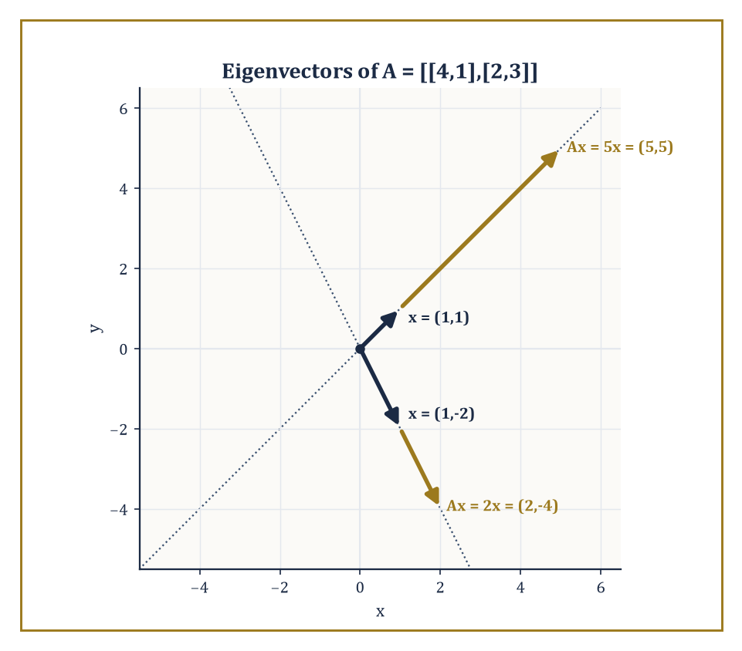
Figure 20.4 — The two eigenvector directions of A = [4 1; 2 3], each stretched in place — by 5 along (1,1), by 2 along (1,−2) — with no rotation anywhere in sight.
Ax = λ x
for some scalar λ, called the corresponding eigenvalue — a direction that the map doesn’t rotate or shear, only stretches or shrinks (and possibly flips, if λ is negative).
Rearranging, Ax = λ x means
(A − λ I)x = 0
so x is a nonzero solution of a homogeneous system, which by Section 20.5’s equivalences exists exactly when A − λ I is singular, i.e. when
det(A − λ I) = 0
This equation, expanded out, is a polynomial in λ called the characteristic polynomial of A; its roots are the eigenvalues.
For an n × n matrix the characteristic polynomial has degree n, so there are (counting complex roots and multiplicity) exactly n eigenvalues — though as we shall see shortly, ‘counting multiplicity’ hides a subtlety that will matter a great deal in the next chapter.
Numeric example — Let A = [4 1; 2 3]. The characteristic polynomial is
 | det(A − λ I) = det( |  | 4−λ | 1 |  | )
 | det(A − λ I) = det( |  | 2 | 3−λ |  | )
= (4−λ)(3−λ) − 1·2 = (12 − 4λ − 3λ + λ²) − 2 = λ² − 7λ + 10 = (λ − 5)(λ − 2)
So the eigenvalues are λ = 5 and λ = 2.
For λ = 5, solve (A − 5I)x = 0, where
 | A − 5I = |  | −1 | 1
 | A − 5I = |  | 2 | −2
The first row gives −x₁ + x₂ = 0, so x₂ = x₁; taking x₁ = 1 gives the eigenvector (1,1). Check:
A·(1,1)ᵀ = (4·1+1·1, 2·1+3·1)ᵀ = (5,5)ᵀ = 5·(1,1)ᵀ
correct. For λ = 2:
 | A − 2I = |  | 2 | 1
 | A − 2I = |  | 2 | 1
This gives 2x₁ + x₂ = 0, so x₂ = −2x₁; taking x₁ = 1 gives (1,−2). Check:
A·(1,−2)ᵀ = (4·1+1·(−2), 2·1+3·(−2))ᵀ = (2,−4)ᵀ = 2·(1,−2)ᵀ
correct. Two eigenvalues, two independent eigenvector directions — a thoroughly well-behaved matrix, of the sort eigenvalue theory was invented to describe.
Try it now — Eigenvalues of [3 1; 0 3]? Answer →
Eigenvalues and eigenvectors will be studied properly, with proofs and generality, in the next chapter; here we only reconnoiter. Even at this concrete stage, though, the geometric content is already visible: eigenvectors are the special directions along which a matrix acts by pure scaling, ignoring everything else the map might be doing elsewhere.
This turns out to matter enormously in practice — the stability of a dynamical system, the vibration modes of a bridge or a molecule, and the directions of greatest variance in a cloud of data (the starting point of principal component analysis) are all, underneath the application-specific language, questions about eigenvalues. Whenever a matrix gets applied to a vector repeatedly, it is the eigenvalue of largest magnitude that eventually dominates what happens — smaller eigenvalues get outrun.
Numeric example — Using the same A = [4 1; 2 3] with eigenvalues 5 and 2, start from an arbitrary vector v₀ = (1,0) and apply A repeatedly.
v₁ = A v₀ = (4,2)
v₂ = A v₁ = (4·4+1·2, 2·4+3·2) = (18,14)
v₃ = A v₂ = (4·18+1·14, 2·18+3·14) = (72+14, 36+42) = (86,78)
Look at the ratio of the two coordinates at each stage: 4/2 = 2, then 18/14 which is about 1.29, then 86/78 which is about 1.10 — steadily approaching 1, the ratio of the coordinates of the dominant eigenvector (1,1) found above. And the overall length is growing by roughly a factor of 5 at each step, converging on the dominant eigenvalue 5.
Repeated application of A is, quite literally, hunting down the eigenvector with the largest eigenvalue and ignoring everything else, a fact that entire numerical algorithms (power iteration, and its descendants used to rank web pages and search results) are built directly on top of.
For 2 × 2 and 3 × 3 matrices the characteristic polynomial can be written out explicitly and its roots found by the quadratic or cubic formula, or more often by inspection and a bit of luck with integer roots.
One subtlety is worth flagging now, even though its full resolution waits for the next chapter: the algebraic multiplicity of an eigenvalue (how many times it appears as a root of the characteristic polynomial) and its geometric multiplicity (the dimension of the corresponding eigenspace, i.e. how many independent eigenvectors it has) need not agree.
Geometric multiplicity can never exceed algebraic multiplicity, but it can fall short — and when it does, the matrix is called defective, and cannot be diagonalized. This discrepancy is the first hint of the Jordan form, the canonical shape that rescues defective matrices from being merely awkward.
Numeric example — Take A = [2 1; 0 2] — you may recognize this fellow from Matrix Arithmetic, where it was subjected to some perfectly innocent polynomial evaluation and gave no hint of the trouble brewing underneath. Its characteristic polynomial is
 | det(A − λ I) = det( |  | 2−λ | 1 |  | ) = (2−λ)² − 0 = (2−λ)²
 | det(A − λ I) = det( |  | 0 | 2−λ |  | ) = (2−λ)² − 0 = (2−λ)²
so λ = 2 is a root of multiplicity 2 — algebraic multiplicity 2, and it is the only eigenvalue. Now hunt for eigenvectors:
 | A − 2I = |  | 0 | 1
 | A − 2I = |  | 0 | 0
and (A−2I)x = 0 gives simply x₂ = 0, with x₁ completely free. The eigenspace is the span of (1,0) alone — a single independent direction, so geometric multiplicity 1, strictly less than the algebraic multiplicity of 2.
This matrix has only one eigen-direction to its name despite being 2 × 2, and no basis of eigenvectors exists for it; it is defective, and diagonalizing it is impossible. It will need the Jordan form to be tamed, which is the kind of unfinished business this chapter is content to leave dangling for the next one to pick up.
Keep only this · Section 20.7: Eigenvalues and Eigenvectors: A First Look
The idea. Eigenvalues solve det(A − λI) = 0; eigenvectors span the null space of A − λI for each λ.
Core.
Av = λv, v ≠ 0
det(A − λI) = 0
sum of eigenvalues = trace; product = det
Typical mistake. Accepting the zero vector as an eigenvector.
Minimal example. [2 0; 0 5]: eigenvalues 2 and 5, eigenvectors e₁ and e₂.
Practice. Easy to challenge; full worked answers, with the usual mistake, are in Answers to the Practice Sets at the back.
Easy — Eigenvalues of [3 1; 0 2]. Answer →
Medium — Eigenvalues and eigenvectors of [4 1; 2 3]. Answer →
Challenge — Show that a rotation by 90° has no real eigenvalues. Answer →

Section 20.8: Special Matrices and Factorizations
A Rogues’ Gallery of Well-Behaved Arrays
CORE · about 15 minutes · later chapters build on this
Definition — Diagonal matrices — nonzero entries only on the main diagonal, zero everywhere else — are the easiest matrices there are to work with.
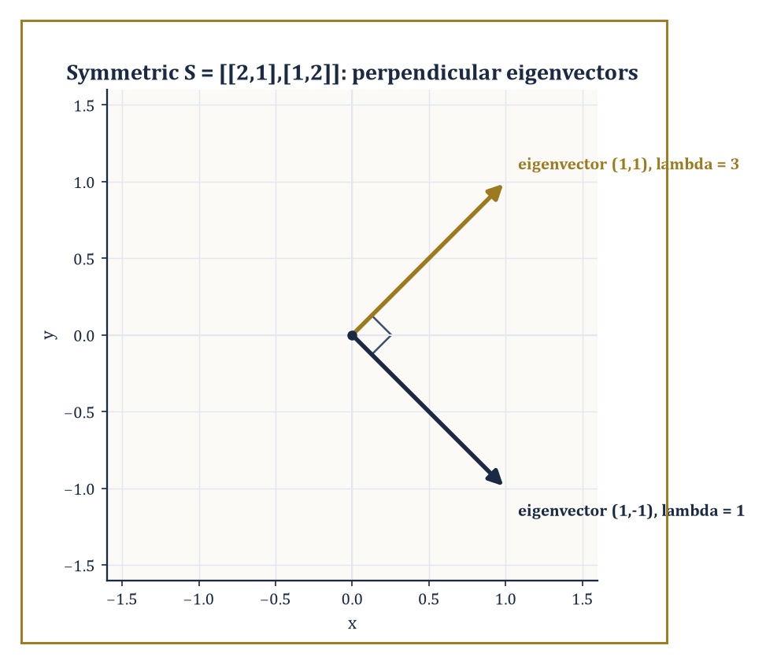
Figure 20.5 — The eigenvectors of symmetric S = [2 1; 1 2] meeting at a perfect right angle — the spectral theorem, glimpsed a chapter early.
Multiplying two diagonal matrices just multiplies corresponding diagonal entries; raising a diagonal matrix to a power just raises each diagonal entry to that power; and a diagonal matrix is invertible exactly when none of its diagonal entries is zero, with the inverse obtained by reciprocating each entry.
Much of the theory in the next chapter (diagonalization, the spectral theorem) is, at bottom, an elaborate scheme for finding a basis in which some more complicated matrix turns out to be secretly diagonal, precisely so that all this effortless arithmetic becomes available.
Numeric example — Let D = [2 0 0; 0 −1 0; 0 0 3]. Then D³ is obtained by cubing each diagonal entry:
 | D³ = |  | 2³ | 0 | 0 |  | = |  | 8 | 0 | 0
 | D³ = |  | 0 | (−1)³ | 0 |  | = |  | 0 | −1 | 0
 | D³ = |  | 0 | 0 | 3³ |  | = |  | 0 | 0 | 27
Compare the effort this took with what cubing a generic 3×3 matrix would require (two full matrix multiplications, each involving twenty-seven multiply-and-add operations) — diagonal matrices are, quite simply, cheating in the best possible way.
Try it now — Is [0.6 −0.8; 0.8 0.6] orthogonal? Answer →
Triangular matrices — upper triangular if every entry below the diagonal is zero, lower triangular if every entry above is — are the next best thing to diagonal.
Their determinant is the product of the diagonal entries (a special case of cofactor expansion always collapsing along the zero entries), and, more remarkably, their eigenvalues are their diagonal entries too, with no further computation required: the characteristic polynomial of a triangular matrix factors immediately into
(d₁ − λ)(d₂ − λ)⋯(dₙ − λ)
since det(A − λ I) of a triangular matrix is again triangular, hence again just a product of its diagonal entries.
Numeric example — Let U = [2 3 1; 0 −1 4; 0 0 5]. This is upper triangular, so det(U) is the product of the diagonal:
det(U) = 2·(−1)·5 = −10
And the eigenvalues of U can be read off in the same glance, with no characteristic-polynomial computation whatsoever: λ = 2, −1, 5 — the three diagonal entries. As a sanity check, the product of the eigenvalues should equal the determinant (a fact promised back in Determinants):
2·(−1)·5 = −10
matching det(U) exactly.
Symmetric matrices are those with
Aᵀ = A
meaning the matrix equals its own transpose (rows and columns swapped). They enjoy two remarkable properties that will be proved in full next chapter under the name of the spectral theorem: all their eigenvalues are real (no complex numbers sneak in, even though nothing in the definition rules them out a priori), and eigenvectors belonging to different eigenvalues are automatically orthogonal (perpendicular) to one another.
Orthogonal matrices are those satisfying
Aᵀ A = I
so that
Aᵀ = A⁻¹
They represent rigid motions: rotations, reflections, and their combinations. They preserve lengths and angles exactly, which is why they correspond to switching between two orthonormal bases (bases whose vectors are unit length and mutually perpendicular) without distorting the geometry along the way.
Numeric example — Let S = [2 1; 1 2], symmetric since it equals its own transpose by inspection. The characteristic polynomial is:
det(S − λ I) = (2−λ)² − 1 = 0
(2−λ)² = 1
2 − λ = ±1
so λ = 1 or λ = 3 — both real, as promised.
For λ = 3:
 | (S−3I) = |  | −1 | 1
 | (S−3I) = |  | 1 | −1
giving x₁ = x₂; take (1,1).
For λ = 1:
 | (S−I) = |  | 1 | 1
 | (S−I) = |  | 1 | 1
giving x₁ = −x₂; take (1,−1).
Check orthogonality:
(1,1) dot (1,−1) = 1·1 + 1·(−1) = 1 − 1 = 0
a dot product of exactly zero, confirming the two eigenvectors are perpendicular, exactly as the spectral theorem (still one chapter away from being proved, but already visibly true) predicts for any symmetric matrix.
Numeric example — Let R = [0.5 −0.8660; 0.8660 0.5], a rotation by 60 degrees (0.8660 approximates the square root of 3 divided by 2). Compute Rᵀ:
 | Rᵀ = |  | 0.5 | 0.8660
 | Rᵀ = |  | −0.8660 | 0.5
Check Rᵀ R entry by entry:
entry (1,1) = 0.5·0.5 + 0.8660·0.8660 = 0.25 + 0.75 = 1.00
entry (1,2) = 0.5·(−0.8660) + 0.8660·0.5 = −0.4330 + 0.4330 = 0
entry (2,1) = (−0.8660)·0.5 + 0.5·0.8660 = −0.4330+0.4330 = 0
entry (2,2) = (−0.8660)·(−0.8660) + 0.5·0.5 = 0.75+0.25 = 1.00
So:
 | Rᵀ R = |  | 1 | 0 |  | = I
 | Rᵀ R = |  | 0 | 1 |  | = I
to the precision shown, confirming R is orthogonal: applying it to any vector rotates it by 60 degrees without stretching or shrinking it by so much as a hair’s breadth.
The LU factorization writes a matrix A as a product
A = LU
of a lower-triangular matrix L (with 1’s on its diagonal, by convention) and an upper-triangular matrix U — possibly after first permuting rows, for matrices that need it. It is nothing more than Gaussian elimination recorded in matrix form: U is the row-echelon form you’d reach by elimination, and L records the multipliers used to get there.
The practical payoff is speed: once you have L and U for a given A, solving Ax = b for many different right-hand sides b becomes two easy triangular solves (forward-substitute for L, back-substitute for U) instead of redoing the entire elimination from scratch each time.
Numeric example — Let A = [4 3; 6 3]. Eliminate the (2,1) entry: the multiplier is 6/4 = 1.5, so row 2 becomes row 2 minus 1.5 times row 1, giving:
[6−1.5·4, 3−1.5·3] = [0, −1.5]
So U = [4 3; 0 −1.5], and L records the multiplier used: L = [1 0; 1.5 1]. Check LU entry by entry:
entry (1,1) = 1·4+0·0 = 4
entry (1,2) = 1·3+0·(−1.5) = 3
entry (2,1) = 1.5·4+1·0 = 6
entry (2,2) = 1.5·3+1·(−1.5) = 4.5−1.5 = 3
So:
 | LU = |  | 4 | 3 |  | = A
 | LU = |  | 6 | 3 |  | = A
exactly, and any future system with this same coefficient matrix A can now be solved twice as cheaply as before, for free.
Other factorizations — QR (a matrix as an orthogonal matrix times an upper triangular one), Cholesky (a symmetric positive-definite matrix as LLᵀ for a triangular L), and the singular value decomposition (which factors any matrix at all, square or not, invertible or not, into a product of two orthogonal matrices and a diagonal one) — will have to wait until inner-product spaces and orthogonality are on a firmer footing, next chapter.
What is already visible, even without the details, is the recurring strategic move: take a complicated matrix and rewrite it as a product of simpler, structured pieces — triangular, diagonal, orthogonal — each of which is individually easy to compute with. Factorization, in matrix algebra as in arithmetic, is how you turn a hard problem into several easy ones.
Keep only this · Section 20.8: Special Matrices and Factorizations
The idea. Symmetric matrices have real eigenvalues and orthogonal eigenvectors; orthogonal matrices satisfy QᵀQ = I; LU factorization records Gaussian elimination.
Core.
symmetric Aᵀ = A
orthogonal QᵀQ = I
A = LU, A = QR, A = QΛQᵀ (symmetric)
Typical mistake. Calling a matrix orthogonal because its columns are orthogonal but not of length 1.
Minimal example. [0 1; 1 0] is symmetric and orthogonal.
Practice. Easy to challenge; full worked answers, with the usual mistake, are in Answers to the Practice Sets at the back.
Easy — Is [1 2; 2 1] symmetric? Orthogonal? Answer →
Medium — Find the LU factorization of [2 1; 4 5]. Answer →
Challenge — Why is an orthogonal matrix’s determinant ±1? Answer →

Chapter 20 in One Page
A matrix is an array that acts on vectors. Matrix multiplication composes those actions, so it is associative but not commutative. Inverses undo a matrix when its determinant is non-zero. Row reduction solves systems and reveals rank, and rank plus nullity equals the number of columns. Eigenvectors are the directions a matrix only stretches, and diagonalizing a matrix means finding a basis of them.
Key definitions
• Matrix product: (AB)ᵢⱼ = Σₖ AᵢₖBₖⱼ.
• Inverse: AA⁻¹ = A⁻¹A = I.
• Rank: number of pivots after row reduction; nullity: dimension of the null space.
• Eigenvalue λ and eigenvector v ≠ 0 with Av = λv.
• Transpose Aᵀ, symmetric (Aᵀ = A), orthogonal (QᵀQ = I).
Key theorems, with their hypotheses
• Invertibility: A is invertible ⇔ det A ≠ 0 ⇔ rank A = n — hypothesis: A square, n × n.
• det(AB) = det A det B — hypothesis: A, B square of the same size.
• Rank–nullity: rank A + nullity A = n — hypothesis: A has n columns.
• Symmetric ⇒ real eigenvalues and orthogonal eigenvectors — hypothesis: real symmetric matrix.
Canonical example
• A = [4 1; 2 3]: det(A − λI) = (λ − 5)(λ − 2), eigenvectors (1, 1) and (1, −2), and P⁻¹AP = [5 0; 0 2] with P = [1 1; 1 −2].
Common errors
• Assuming AB = BA.
• Wrong signs in the 2 × 2 inverse.
• Counting rank before reducing.
• Taking v = 0 as an eigenvector.
Readiness checklist — you are ready for what comes next when you can:
□ multiply, transpose and invert small matrices
□ compute 3 × 3 determinants and use their properties
□ row-reduce a system and read off rank, nullity and solutions
□ find eigenvalues and eigenvectors of a 2 × 2 matrix
□ recognize symmetric, orthogonal and triangular matrices
Section 20.9 that follows is a preview, marked optional: it says where these ideas lead in later chapters and volumes. Nothing in it is needed for the exercises.

Section 20.9: Where This Goes Next (Optional): From Matrices to Linear Algebra
The Series Continues
PREVIEW — OPTIONAL · about 15 minutes · optional; read for orientation, nothing is examined
Overview — We have, over the last eight sections, acquired the working vocabulary of matrices: how to add, scale, and multiply them; how to invert them, and how elementary matrices make that inversion algorithmic; how to compress an entire matrix into the single revealing number that is its determinant; how to row-reduce, and how rank falls out of that process as both a computational count and a geometric dimension; how to read a matrix as a linear map, complete with a range, a kernel, and a change-of-basis formula; a first, careful look at eigenvalues and eigenvectors, complete with a warning about defective matrices; and a small museum of special matrices — diagonal, triangular, symmetric, orthogonal — together with the LU factorization that makes solving repeated systems cheap.
These tools are the concrete, computational foundation for the next chapter, Linear Algebra, which takes the same ideas and strips away the coordinates: vector spaces in place of ℝⁿ, abstract linear maps in place of matrices, and proofs — real, general proofs — of the spectral theorem, the Jordan form, and the theory of inner-product spaces and least squares that this chapter could only gesture toward. Nothing computed here becomes wasted effort.
Once bases are chosen, every abstract vector space collapses back down to ℝⁿ and every abstract linear map collapses back down to exactly the kind of matrix we have been multiplying, inverting, and eigen-decomposing throughout this chapter. The abstraction to come is not a replacement for this material; it is what this material looks like once you stop needing the coordinates as a crutch.
Every loose thread left dangling here has already been named: the discrepancy between algebraic and geometric multiplicity from Eigenvalues and Eigenvectors becomes the Jordan form; the orthogonality of eigenvectors noticed by hand in Special Matrices and Factorizations becomes the spectral theorem, proved for every symmetric matrix at once rather than checked example by example; and the LU factorization’s habit of breaking a matrix into simpler pieces becomes, in due course, QR and the singular value decomposition. None of this is new subject matter arriving from nowhere — it is this chapter’s half-finished sentences, finally allowed to finish.
The deeper lesson of this chapter, stripped of its arithmetic, is this: a rectangular array of numbers, once equipped with the right multiplication rule, stops being a mere table and becomes a precise, manipulable encoding of a linear relationship between spaces.
The algebra of these arrays — closed under addition, multiplication, and (when luck permits) inversion — turns out to be rich enough to solve any system of linear equations, to represent any linear transformation once coordinates are fixed, and, through the determinant and the eigenvalues, to reveal geometric facts (volumes, stretching factors, invariant directions) that were never explicitly written into the numbers to begin with.
Numeric example — A closing flourish. Recall the matrix A from Eigenvalues and Eigenvectors.
 | A = |  | 4 | 1
 | A = |  | 2 | 3
Its eigenvalues, 5 and 2, were found by solving the characteristic equation
det(A − λ I) = 0
Compute det(A) directly, the ordinary way:
det(A) = 4·3 − 1·2 = 12 − 2 = 10
Now compute the product of the eigenvalues:
5 times 2 = 10
They match exactly, confirming the fact flagged back in Determinants — the determinant is the product of the eigenvalues — using two completely independent calculations that have no right, on the face of it, to agree, and yet always do.
If a single closing image is wanted for everything this chapter has been about, it is this: determinant, eigenvalues, rank, invertibility, geometry — all different windows onto the same matrix, and all of them, when the arithmetic is done honestly, telling the same story.
Try it now — In the basis of eigenvectors (1, 1), (1, −2) of A = [4 1; 2 3], what matrix represents A? Answer →
It is worth remembering, as we leave this chapter, how much was accomplished with nothing more exotic than addition, multiplication, and a great deal of careful bookkeeping about rows and columns: no calculus, no topology, no infinite processes of the kind that gave earlier chapters their existential vertigo, just finite arithmetic performed correctly and interpreted geometrically. That restraint is what makes matrices such a reliable foundation to build on — there is nowhere for an error to hide in a finite grid of numbers, which is more than can be said for several chapters we have already worked through.
We have learned to multiply arrays. Whether the arrays know what we’ve done to them is a question the next chapter, mercifully, does not require us to answer.
Keep only this · Section 20.9: Where This Goes Next (Optional): From Matrices to Linear Algebra
The idea. Changing basis changes the matrix but not the map; Chapter 21 makes that the starting point.
Core.
vector space: add and scale
linear map: T(au + bv) = aT(u) + bT(v)
Typical mistake. Thinking linear algebra needs numbers in a grid; matrices are one way of writing linear maps.
Minimal example. Differentiation is linear on polynomials of degree ≤ 2, with matrix [0 1 0; 0 0 2; 0 0 0] in the basis 1, x, x².
Practice. Easy to challenge; full worked answers, with the usual mistake, are in Answers to the Practice Sets at the back.
Easy — Is T(x, y) = (x + 1, y) linear? Answer →
Medium — Matrix of d/dx on a + bx + cx² in the basis 1, x, x². Answer →
Challenge — Why does every linear map ℝⁿ → ℝᵐ have a matrix? Answer →

Check Your Understanding — Chapter 20
Answers are in the Answer Key at the back of the book — have a go before you look.
1. [Explain] The matrix A = [2 −1 5; 0 3 7] can never possess an inverse, no matter what its entries are. Why not?
See the answer →
2. [Explain] Why does matrix multiplication generally fail to be commutative (why can AB differ from BA)?
See the answer →
3. [Compute] For M = [1 2 3; 0 1 4; 5 6 0], compute det(M) by cofactor expansion along the first row, and say what the result tells you.
See the answer →
4. [Explain] Why can the eigenvalues of a triangular matrix be read directly off its diagonal, with no further calculation?
See the answer →

Fluency Drill — Chapter 20
Five minutes, no notes, before the harder problems. These are the moves the Problems assume are automatic; if one takes you more than a minute, reread the section it names. Worked answers, each with the usual slip, are in Answers to the Practice Sets.
1. [Compute] [2 0; 0 3][1 1; 1 1]. Answer →
2. [Compute] det [1 2; 3 4]. Answer →
3. [Compute] Rank and nullity of [1 1 1; 2 2 2; 0 0 1]. Answer →
4. [Compute] Rank and nullity of a 4 × 6 matrix of rank 4. Answer →
5. [Concept] A is 3 × 3 with det A = 0. How many solutions can Ax = 0 have? Answer →
6. [Compute] Inverse of [1 0; 3 1]. Answer →
7. [Compute] Eigenvalues of [2 0; 0 −5]. Answer →
8. [Compute] Is (1, −1) an eigenvector of [3 1; 1 3]? Answer →

Problems — Chapter 20
Matrices are the chapter where fluency is everything: the ideas are not deep, but the arithmetic must become automatic before Chapter 21 can do anything interesting with it. Twelve problems follow. Each problem carries a skill tag (Concept, Compute, Explain, Prove, Model or Challenge; see How to Use This Book) and a link to its full worked solution, which ends with the usual mistake.
Arithmetic and inverses
1. [Compute] For A = [1 2; 3 4] and B = [0 1; 1 0], compute AB and BA, and comment on the comparison. Solution →
2. [Compute] Find the inverse of A = [4 7; 2 6] and verify it. Solution →
3. [Explain] Explain why a matrix with a zero determinant cannot have an inverse, using the property det(AB) = det(A)det(B). Solution →
Determinants
4. [Compute] Compute the determinant of [2 0 1; 3 −1 2; 1 4 0] by cofactor expansion. Solution →
5. [Compute] Compute the determinant of the upper-triangular matrix [3 7 −2; 0 5 1; 0 0 4], and state the general rule. Solution →
6. [Prove] Show that if two rows of a square matrix are identical, its determinant is zero. Solution →
Systems, rank, and row reduction
7. [Compute] Solve the system x + y + z = 6, 2x − y + z = 3, x + 2y − z = 2 by row reduction. Solution →
8. [Compute] Find the rank of [1 2 3; 4 5 6; 7 8 9] and state how many solutions the corresponding homogeneous system has. Solution →
9. [Explain] A system of three equations in three unknowns has a coefficient matrix with determinant zero. State the two possibilities for its solution set and how to tell them apart. Solution →
Maps, eigenvalues, and structure
10. [Compute] The matrix R = [0 −1; 1 0] acts on ℝ². Describe its geometric effect, and find R⁴. Solution →
11. [Compute] Find the eigenvalues of [4 1; 2 3]. Solution →
12. [Challenge] The determinant is often introduced as a formula to be computed. What does it actually measure, and why does det(A) = 0 mean precisely that A is not invertible? Solution →

Math, Actually

Chapter 21

Linear Algebra
Vector Spaces, Linear Maps, and the Art of Seeing Structure Beneath Coordinates
The last chapter left you fluent in matrices — rectangular grids of numbers you could multiply, invert (sometimes), and coax into revealing eigenvalues after enough determined arithmetic. That fluency was hard-won and it is not wasted; nothing in this series is ever wasted, which is either its great virtue or its great cruelty depending on how the exam went. But a matrix, for all its usefulness, is secretly a costume. Underneath it is something wearing no coordinates at all: a linear map between two spaces of arrows, doing its business unannounced while the matrix takes the applause.
This chapter removes the costume. A vector space is any set in which you can add things together and scale them by numbers, obeying a short list of entirely unsurprising rules — the kind of rules you already believed about arrows, or polynomials, or functions, long before anyone wrote them down as axioms. A linear map is any function between two such sets that respects both operations. Once you have these two definitions, bases and dimension and rank and eigenvalues stop being properties of a particular grid of numbers and become properties of the underlying thing itself — true no matter which coordinate system you happen to be standing in when you look.
This is not abstraction for its own polish. The moment you stop insisting that a vector space must look like ℝⁿ, the same theorems start applying to spaces of polynomials, spaces of continuous functions, solution sets of differential equations, and the tangent spaces you will meet properly two chapters from now in analytic geometry. The matrix theory of Chapter 20 turns out to be the special case where the space happens to be ℝⁿ and someone has already chosen the standard basis for you. Most of life is not that considerate.
A small confession before we begin: the move from matrices to abstract vector spaces is, for a great many students, the first moment mathematics starts to feel like it is about symbols rather than about things. That feeling is real, and it is temporary. The symbols name relationships that were already sitting inside your matrix calculations, doing useful work in disguise; abstraction only removes the disguise. If matrices taught us to compute with linear maps, this chapter teaches us to understand them. Let us forget the bases — temporarily, and entirely on our own terms.
Before you begin — Chapter 21 · Core chapter
By the end of this chapter you will be able to:
1. Apply the subspace test and find a basis and the dimension of a subspace.
2. Write the matrix of a linear map in a given basis and change basis.
3. Compute rank and nullity and use the rank–nullity theorem.
4. Diagonalize a matrix, or show it cannot be diagonalized.
5. Compute projections and run Gram–Schmidt.
6. State, derive and apply the spectral theorem and the singular value decomposition, and say what the Jordan form adds.
Why it comes here. Chapter 20 did linear algebra with numbers. This chapter strips away the coordinates: vector spaces, linear maps, rank and nullity, and then the two great structure theorems — the spectral theorem for symmetric maps and the singular value decomposition for every matrix. Chapter 22 uses the spectral theorem to straighten out conics, and Volumes 3 and 4 use both constantly.
Required chapters. Matrices (Chapter 20).
Assumed skills. multiply matrices and compute 2 × 2 and 3 × 3 determinants; row-reduce a matrix and read off its rank; find eigenvalues and eigenvectors of a 2 × 2 matrix; work with complex numbers and their conjugates.
If you are rusty. Row Reduction, Rank, and Solving Systems; Eigenvalues and Eigenvectors: A First Look; Special Matrices and Factorizations.
Do not proceed until you can…
1. Row-reduce [1 2 3; 2 4 7] and give its rank. Answer →
2. Find the eigenvalues of [2 1; 1 2]. Answer →
3. Compute the conjugate and modulus of 3 − 4i. Answer →
Estimated study time. About 14–16 hours over two weeks; this is the longest chapter in the volume. Work every Try it now before reading on, finish each section’s Keep only this practice before starting the next, and do the Fluency Drill before the Problems.

Section 21.1: Vector Spaces and Subspaces
In Which Everything Becomes an Arrow, Whether It Looks Like One or Not
CORE · about 25 minutes · later chapters build on this
Arrows in the plane add tip to tail: draw one arrow from the origin to (1, 2), a second from the origin to (3, 1), slide the second so it starts where the first ends, and the sum, (1, 2) + (3, 1) = (4, 3), is where you land. Scaling an arrow by 3 makes it three times as long, pointing the same direction. None of that is new; it was already familiar from Chapter 13’s vector fields, and before that, from physics: forces and velocities have always behaved this way.
Polynomials add too, by exactly the same kind of rule, term by matching term: (x² + 1) + (2x − 3) = x² + 2x − 2, adding the constant terms, the x-terms, and the x²-terms separately, the same way the arrow’s two coordinates were added separately. Scaling a polynomial by 3 multiplies every coefficient by 3, exactly the way scaling an arrow multiplies every coordinate by 3.
A 2×3 matrix behaves the same way again: add two matrices entrywise, scale a matrix by multiplying every entry, and the arithmetic looks, cell for cell, exactly like the arrow’s arithmetic and the polynomial’s arithmetic. And yet a matrix looks nothing like an arrow either; nobody has ever tried to point a gradebook at a target, any more than they have tried to point a polynomial at one.
Here is the striking part: every property that gets used to prove something about arrows — addition is commutative, there is a zero element that changes nothing when added, every element has a negative that cancels it, scaling distributes over addition — turns out to hold, unchanged, word for word, for polynomials and for matrices too. A proof that uses only those properties, and never sneaks in anything specific to arrows — their length, their direction, their arrowhead — proves the same fact for all three objects at once, without ever choosing which one was meant.
So the question worth asking is not “what is special about arrows?” but “what is the smallest list of rules that makes addition and scaling behave the way they do, for arrows, for polynomials, for matrices, and for whatever unfamiliar object turns up a few chapters from now?” Anything obeying that list of rules, whatever it looks like on the page, earns the name vector space — and every fact proved from the rules alone, without reference to arrows, comes free of charge to every one of these objects, including ones nobody has thought of yet.
Definition — A vector space over a field F is a set V equipped with an addition (any two elements combine to give a third) and a scalar multiplication (any element can be scaled by a member of F), satisfying the axioms you would write down if someone handed you a pencil and asked you to formalize what arrows do: addition is associative and commutative, there is a zero vector that changes nothing, every vector has a negative, scalar multiplication distributes over both vector addition and scalar addition, and multiplying by the field’s own 1 does nothing.
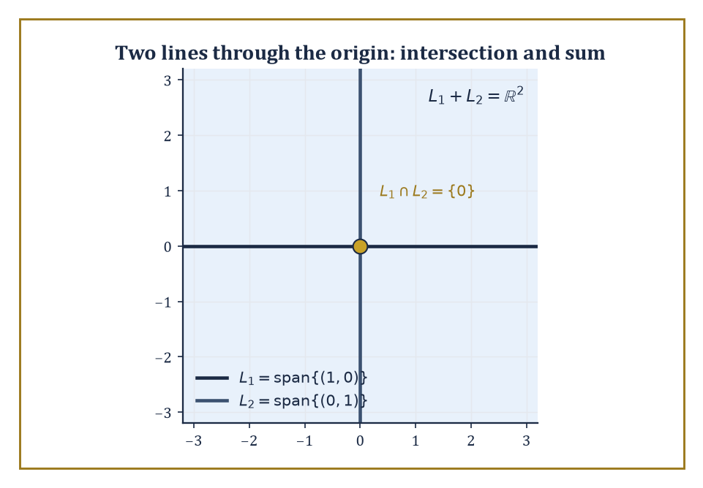
Figure 21.1 — Two lines through the origin: their intersection collapses to the point {0}, while their sum climbs back up to fill the entire plane.
The field F is usually ℝ or ℂ in this chapter, but nothing in the definition cares — the same axioms work over any field, a fact that will matter enormously two chapters hence, in the chapter on coding theory and finite fields, and not at all today.
Notice what has been deliberately left out of the definition: there is no mention of length, no mention of angle, no mention of coordinates. Those are luxuries, added later by an inner product (Inner-Product Spaces and Orthogonality) or a choice of basis (Linear Independence, Bases, and Dimension). A vector space, in its bare form, only knows how to add and how to scale. Everything else is decoration.
Numeric example — checking the axioms hold. Take u = (1, −2, 3), v = (0, 5, −1), and w = (4, 4, 4) in ℝ³, and check associativity of addition directly.
Left side: (u + v) + w. First compute u + v, then add w.
u + v = (1+0, −2+5, 3−1) = (1, 3, 2)
(u+v) + w = (1+4, 3+4, 2+4) = (5, 7, 6)
Right side: u + (v + w). First compute v + w, then add u.
v + w = (0+4, 5+4, −1+4) = (4, 9, 3)
u + (v+w) = (1+4, −2+9, 3+3) = (5, 7, 6)
Both sides equal (5, 7, 6) — associativity holds, as it must, since it holds coordinate-by-coordinate in ℝ and vector addition is just three copies of ordinary addition running in parallel.
Now check distributivity: 2(u + v) should equal 2u + 2v.
2(u + v) = 2(1,3,2) = (2,6,4)
2u + 2v = (2,−4,6) + (0,10,−2) = (2,6,4)
They match. This is the entire content of ‘the axioms hold’ for ℝⁿ — every one of them reduces to a true statement about real numbers, applied three (or n) times side by side.
Try it now — Subspace test: is {(x, y) : y = 2x} a subspace of ℝ²? Is {(x, y) : y = 2x + 1}? Answer →
A subspace of V is a subset that is itself a vector space using the same operations — which, since the axioms are automatic once you inherit them, reduces to a single practical check: is the subset closed under addition and scalar multiplication, and does it contain the zero vector?
Two structural facts follow almost immediately and get used constantly. First, the intersection of any collection of subspaces is again a subspace — if every vector in a set of subspaces is closed under the operations, so is anything lying in all of them at once.
Second, the sum of two subspaces U and W, meaning the set of all vectors u + w with u ∈ U and w ∈ W, is also a subspace — a new subspace built by letting the two originals mix freely.
The span of a set of vectors is the smallest subspace containing them: take every possible linear combination and you cannot get anything larger, nor is there any smaller subspace that still contains the original set.
Abstract example — the trace-zero matrices form a subspace. Let V be the space of all 2×2 real matrices, and let U be the subset of matrices whose trace (the sum of the diagonal entries) is zero.
Take M₁ = [1 2; 3 −1] and M₂ = [−2 0; 5 2], and check that both lie in U.
trace(M₁) = 1 + (−1) = 0
trace(M₂) = −2 + 2 = 0
Both lie in U. Now check closure under addition and scaling.
 | M₁ + M₂ = |  | −1 | 2 |  | , trace = −1 + 1 = 0
 | M₁ + M₂ = |  | 8 | 1 |  | , trace = −1 + 1 = 0
 | 3M₁ = |  | 3 | 6 |  | , trace = 3 + (−3) = 0
 | 3M₁ = |  | 9 | −3 |  | , trace = 3 + (−3) = 0
Both remain in U, and the zero matrix trivially has trace 0. So U is closed under addition and scalar multiplication and contains the zero matrix: it is a subspace of the 4-dimensional space of all 2×2 matrices, even though nobody drew you a picture of it as an arrow. This is the abstraction earning its keep — ‘subspace’ meant something purely algebraic here, with no geometric picture required to check it.
Span, intersection, and sum give you a small toolkit for building and combining subspaces, and it is worth seeing them work on something concrete before trusting the general theory.
Two distinct lines through the origin in ℝ² are each one-dimensional subspaces; their intersection is forced down to the single point {0} (two different lines can only cross at the origin), while their sum climbs back up to fill the whole plane, since any vector can be written as a combination of one vector from each line.
Span behaves more subtly when the input vectors are not independent — feeding in redundant vectors does not enlarge the span at all, a fact that becomes the entire subject of the next section.
Numeric example — intersection, sum, and a collapsing span. Let L₁ = span{(1, 0)} and L₂ = span{(0, 1)} in ℝ². Their intersection is forced down to the single point {0}, since a vector on the x-axis and on the y-axis simultaneously must be the origin.
L₁ ∩ L₂ = {(0,0)}
Their sum climbs back up to fill the whole plane, since any vector can be written as a combination of one vector from each line.
L₁ + L₂ = ℝ², since any (a, b) = a(1,0) + b(0,1)
Now consider span{(1,2,3), (2,4,6)} in ℝ³ — because the second vector is just twice the first,
(2,4,6) = 2·(1,2,3)
the second vector adds nothing new: every combination is just a multiple of (1,2,3).
c₁(1,2,3) + c₂(2,4,6) = (c₁ + 2c₂)(1,2,3)
So this span is only the line {t(1,2,3) : t ∈ ℝ} — a one-dimensional subspace, despite having been fed two vectors. Redundancy does not buy you extra dimensions; it only buys you extra typing.
The point of stating the axioms so sparsely is that an enormous zoo of objects satisfies them. ℝⁿ is the obvious example, but so is the space of all m×n matrices, the space of polynomials of degree at most n, the space of continuous real-valued functions on an interval, and — perhaps least expected — the solution set of a homogeneous linear differential equation.
That last example deserves a moment’s pause, because it is the one that makes the abstraction pay for itself immediately: if y₁ and y₂ both solve a homogeneous linear differential equation, so does any combination c₁y₁ + c₂y₂, by linearity of the derivative.
The solution set is therefore automatically a vector space, with no further checking required, purely because differentiation is a linear operation.
Few axioms, many examples — that ratio is the entire reason linear algebra shows up everywhere from quantum mechanics to search engines.
Worked example — the solution space of y′′ + y = 0. Consider the differential equation below.
y′′ + y = 0
It has general solution, for arbitrary constants A, B, given by the equation below — a fact from calculus, taken here as given.
y = A cos x + B sin x
The solution set is therefore a two-dimensional vector space with basis {cos x, sin x}: every solution is a coordinate pair (A, B) in disguise. Check linearity concretely with A = 3, B = −2, giving the solution below.
y = 3 cos x − 2 sin x
Differentiate twice.
y′ = −3 sin x − 2 cos x
y′′ = −3 cos x + 2 sin x = −(3 cos x − 2 sin x) = −y
So:
y′′ + y = −y + y = 0
This confirms this combination is indeed a solution — as the vector-space structure promised, without needing to solve the differential equation again from scratch for this particular combination. The abstract machinery did the work; the calculus only had to be done once, for the basis vectors.
Keep only this · Section 21.1: Vector Spaces and Subspaces
The idea. Subspace test: contains 0, closed under addition, closed under scalar multiplication. Any set failing one is not a subspace.
Core.
W ⊆ V is a subspace ⇔ 0 ∈ W, u + v ∈ W, cu ∈ W
Typical mistake. Calling a line or plane that misses the origin a subspace.
Minimal example. {(x, y, z) : z = 0} is a subspace of ℝ³; {z = 1} is not.
Practice. Easy to challenge; full worked answers, with the usual mistake, are in Answers to the Practice Sets at the back.
Easy — Is the set of polynomials p with p(0) = 0 a subspace? Answer →
Medium — Is {(x, y) : xy ≥ 0} a subspace of ℝ²? Answer →
Challenge — Show that the intersection of two subspaces is a subspace, but their union usually is not. Answer →

Section 21.2: Linear Independence, Bases, and Dimension
Counting What Cannot Be Canceled
CORE · about 15 minutes · later chapters build on this
A set of directions is only useful if none of them is redundant. Tell someone to walk east, then north-east, and you have given two genuinely different instructions; add “walk two east and one north-east” and the extra instruction tells them nothing new. Directions with no redundancy are called linearly independent, and an independent set that still reaches everywhere is a basis, a minimal toolkit for describing every position. With the arrows one unit east and one unit north-east, the point (5, 3) is reached by two steps of the first and three of the second. Every basis of a space has the same number of arrows, and that number is its dimension.
Definition — A set of vectors is linearly independent if the only linear combination of them that equals the zero vector is the trivial one — every coefficient zero.
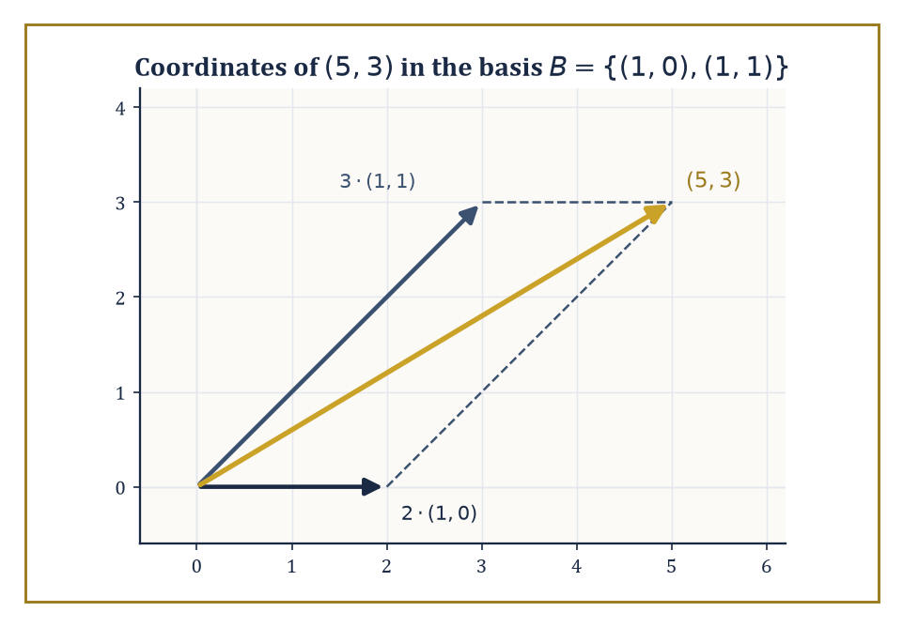
Figure 21.2 — The vector (5,3) as a parallelogram built from 2 copies of (1,0) and 3 copies of (1,1) — coordinates are just instructions for a walk.
c₁v₁ + ⋯ + cₙvₙ = 0 forces every cᵢ = 0
Equivalently, and more usefully in practice, no vector in the set can be written as a combination of the others; each one is pulling its own weight, contributing a new direction rather than freeloading off its neighbors.
This is worth internalizing as the real content of the definition, because the formal statement above can look like an arbitrary piece of algebra until you see it as ‘nobody here is redundant.’
Numeric example — catching a hidden dependence. Are (1,2,3), (4,5,6), (7,8,9) linearly independent in ℝ³? Try to find a nontrivial combination equaling zero — check whether the following holds.
(1,2,3) − 2(4,5,6) + (7,8,9) = 0
Work it out step by step.
2(4,5,6) = (8,10,12)
(1,2,3) − (8,10,12) = (−7,−8,−9)
(−7,−8,−9) + (7,8,9) = (0,0,0)
So the combination c₁ = 1, c₂ = −2, c₃ = 1 (not all zero) produces the zero vector — the three vectors are linearly dependent. Geometrically, the third row is exactly twice the second minus the first; the pattern was visible all along in the fact that each row’s entries increase by a constant step (the classic ‘arithmetic progression’ matrix), which always produces just this kind of dependency.
Try it now — Are (1, 2) and (2, 4) independent? Do (1, 0), (1, 1) form a basis of ℝ²? Answer →
A basis is a linearly independent set that also spans the whole space — independent enough that nothing is wasted, and large enough that nothing is missing.
Every vector space possessing a finite spanning set has a basis, and the deep and slightly surprising fact is that any two bases of the same space contain the same number of vectors.
That common number is the dimension of the space — a single, well-defined integer, not a property of whichever basis you happened to write down first.
Once a basis is fixed, every vector in the space acquires unique coordinates relative to it: a list of scalars telling you how much of each basis vector to add together.
Numeric example — finding coordinates in a non-standard basis. Take the basis B = {(1,0), (1,1)} for ℝ². Check independence first by seeing what forces the combination below to vanish.
c₁(1,0) + c₂(1,1) = 0
This gives c₁+c₂=0 and c₂=0, forcing c₁=c₂=0, so B is independent, and two independent vectors in a 2-dimensional space automatically span it.
Now find the coordinates of (5,3) relative to B by solving the equation below.
a(1,0) + b(1,1) = (5,3)
That is, a + b = 5 and b = 3. From the second equation b = 3, substituting into the first gives a = 2.
So (5,3) has coordinates (2,3) relative to B.
(5,3) = 2·(1,0) + 3·(1,1)
Check: 2(1,0) = (2,0), 3(1,1) = (3,3), and their sum is (5,3). Correct. The vector itself never changed; only the labels describing it did.
The Steinitz exchange lemma (also called the replacement theorem) is the piece of machinery that makes ‘dimension is well-defined’ more than wishful thinking: it says that if you have an independent set inside a spanning set, you can trade members of the independent set in for members of the spanning set one at a time, always keeping the result spanning, until the independent set has been fully absorbed.
Run the argument in both directions between two candidate bases and you find neither can be strictly larger than the other — hence they are the same size.
This chapter stays almost entirely within finite-dimensional spaces, where such arguments terminate cleanly; infinite-dimensional spaces, where a ‘basis’ has to be handled far more carefully, are held in reserve as the motivating puzzle for the functional analysis chapters much later in the series.
Abstract example — an exchange in ℝ³. Start with the standard spanning set {e₁, e₂, e₃} = {(1,0,0), (0,1,0), (0,0,1)} of ℝ³, and the independent set {(1,1,0), (0,1,1)}.
Exchange proposes replacing e₁ and e₂ with these two new vectors while keeping e₃, and claims the set below still spans ℝ³ — indeed forms a basis.
{(1,1,0), (0,1,1), (0,0,1)}
Check independence via the determinant of the matrix with these as rows.
 | det |  | 1 | 1 | 0
 | det |  | 0 | 1 | 1
 | det |  | 0 | 0 | 1
= 1·(1·1 − 1·0) − 1·(0·1 − 1·0) + 0 = 1·1 − 1·0 + 0 = 1
A nonzero determinant confirms independence, and three independent vectors in a 3-dimensional space automatically form a basis. The exchange succeeded exactly as promised: two members of the old spanning set were swapped out for two members of the new independent set, one survivor (e₃) held its ground, and the result still spans everything.
Once a basis is chosen, the abstract vector space and the coordinate space ℝⁿ (or ℂⁿ) become interchangeable — every vector is a list of numbers, and every linear map (as the next section shows) is a matrix.
This is the bridge back to Chapter 20: matrices were never a separate topic from vector spaces, only vector spaces observed through the particular lens of a chosen basis.
Change the basis and the same abstract object wears a different list of numbers, but the object itself never moved.
Numeric example — a polynomial’s coordinates. The space of polynomials of degree at most 2 has a natural basis {1, x, x²}.
p(x) = 3 − 2x + 5x²
This polynomial then has coordinate vector (3, −2, 5) relative to this basis — read straight off the coefficients.
This is not a metaphor for coordinates; it is literally the same bookkeeping as writing (5,3) for a vector in ℝ², once you accept that ‘polynomial’ and ‘arrow in the plane’ are just two costumes for the idea of a vector. Change the basis to {1, (x−1), (x−1)²} instead, and the same polynomial p would need entirely different coordinates — an exercise in substitution left for the reader with a free afternoon and a grudge against algebra.
Keep only this · Section 21.2: Linear Independence, Bases, and Dimension
The idea. A basis is an independent spanning set; every basis of a space has the same size, its dimension.
Core.
independent: c₁v₁ + … + cₖvₖ = 0 ⇒ all cᵢ = 0
basis = independent + spanning
dim = size of any basis
Typical mistake. Concluding independence by checking pairs only, for three or more vectors.
Minimal example. 1, x, x² is a basis of the polynomials of degree ≤ 2: dimension 3.
Practice. Easy to challenge; full worked answers, with the usual mistake, are in Answers to the Practice Sets at the back.
Easy — Are (1, 0, 0), (0, 1, 0), (1, 1, 0) independent? Answer →
Medium — Find the dimension of the span of (1, 2, 3), (2, 4, 6), (0, 1, 1). Answer →
Challenge — Why can four vectors in ℝ³ never be independent? Answer →

Section 21.3: Linear Maps and Matrices with Respect to Bases
Same Map, Different Disguise
CORE · about 15 minutes · later chapters build on this
Some transformations treat sums and scaled copies politely: transform two arrows and add the results, and you get the same as adding first and transforming afterwards. Rotations, reflections and stretches all behave this way, and they are called linear maps. Because they are so well behaved, a linear map is completely determined by what it does to a handful of basis arrows, and that information fits in a matrix. Reflect the plane in its diagonal line, for instance, and every point swaps its two coordinates, so (2, 5) lands on (5, 2); the east and north arrows trade places, and that fact alone pins down the whole map. Change the basis and the same map wears a different matrix.
Key idea — A linear map T: V → W is a function between vector spaces satisfying the two conditions below, for all vectors u, v and scalars λ.
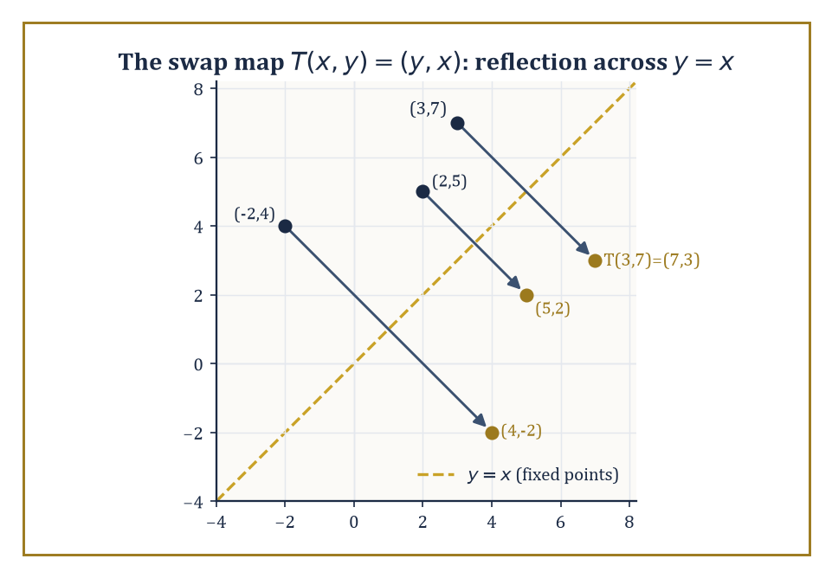
Figure 21.3 — The swap map T(x,y)=(y,x) is nothing more mysterious than a reflection across the line y=x, sending each point to its mirror image.
T(u + v) = T(u) + T(v)
T(λu) = λT(u)
It respects both of the operations a vector space has, and nothing more is asked of it.
Two subspaces travel with every linear map: the kernel (or null space), the set of vectors sent to zero, and the image (or range), the set of vectors actually hit.
Both are genuinely subspaces, not merely subsets — a fact worth checking once and trusting forever afterwards, since it follows in one line from linearity itself.
Composition of linear maps is again linear, and the identity map is linear, so linear maps between fixed spaces form their own well-behaved algebraic world.
Numeric example — the coordinate swap. Let T: ℝ² → ℝ² be the swap map defined below.
T(x, y) = (y, x)
Check linearity on specific vectors: compute the left- and right-hand sides of T((2,5) + (1,−3)) = T(2,5) + T(1,−3) separately.
T((2,5) + (1,−3)) = T(3, 2) = (2, 3)
T(2,5) + T(1,−3) = (5,2) + (−3,1) = (2,3)
They match, as linearity demands.
For the kernel, T(x,y) = (0,0) forces y = 0 and x = 0, so the kernel is {(0,0)} — nothing but the zero vector gets swapped away to nothing. The image is all of ℝ², since every (a,b) is T(b,a).
A map that is both injective (trivial kernel) and surjective (full image) between spaces of the same finite dimension — this is no coincidence, and Rank, Nullity, and the Fundamental Theorem explains why it never is.
Try it now — Write the matrix of T(x, y) = (x + y, 2y) in the standard basis. Answer →
Fix a basis of V and a basis of W. Then T is represented by a unique matrix A: the coordinate vector of T(v), relative to the chosen basis of W, equals A times the coordinate vector of v, relative to the chosen basis of V.
Constructing A is mechanical — the k-th column of A is the coordinate vector of T applied to the k-th basis vector of V.
This is the precise sense in which ‘a matrix is a linear map with a basis chosen’: change the basis and the matrix changes, but the map underneath does not.
Numeric example — building the matrix of the swap map. For T(x,y) = (y,x) with the standard basis {e₁, e₂} = {(1,0), (0,1)} on both sides, build the matrix column by column.
T(e₁) = T(1,0) = (0,1)
T(e₂) = T(0,1) = (1,0)
So the matrix is:
 | A = |  | 0 | 1
 | A = |  | 1 | 0
Check it reproduces T on a fresh vector, say (3,7).
A·(3,7)ᵀ = (0·3 + 1·7, 1·3 + 0·7) = (7,3)
And indeed T(3,7) = (7,3). The matrix and the map agree, as they must once the basis has been used to build the matrix in the first place.
Change the basis of V (and, for an endomorphism, use the same new basis on both sides) and the matrix of T transforms by conjugation, where P is the matrix whose columns are the new basis vectors expressed in the old coordinates.
new matrix = P⁻¹AP
This single formula is the concrete shadow of an abstract idea: two matrices A and B are similar exactly when they represent the same linear map with respect to two different bases.
B = P⁻¹AP (for some invertible P)
Similarity of matrices, which in Chapter 20 looked like an arbitrary algebraic relation worth checking by computation, turns out to mean something geometric: ‘these are the same transformation, photographed from two different angles.’
Numeric example — diagonalizing the swap map by choosing a better basis. The swap matrix A = [0 1; 1 0] looks unremarkable in the standard basis, but try the new basis {(1,1), (1,−1)}.
A·(1,1) = (1,1)
The vector (1,1) is unmoved — an eigenvalue-1 direction.
A·(1,−1) = (−1,1) = −1·(1,−1)
An eigenvalue-(−1) direction. Let P be the matrix whose columns are the new basis vectors.
 | P = |  | 1 | 1
 | P = |  | 1 | −1
Its determinant is 1·(−1) − 1·1 = −2, so:
 | P⁻¹ = (1/−2)· |  | −1 | −1 |  | = |  | 1/2 | 1/2
 | P⁻¹ = (1/−2)· |  | −1 | 1 |  | = |  | 1/2 | −1/2
Compute AP first: its columns are A·(1,1) = (1,1) and A·(1,−1) = (−1,1), so:
 | AP = |  | 1 | −1
 | AP = |  | 1 | 1
Now compute P⁻¹AP row by row.
row 1 = [1/2·1 + 1/2·1, 1/2·(−1) + 1/2·1] = [1, 0]
row 2 = [1/2·1 + (−1/2)·1, 1/2·(−1) + (−1/2)·1] = [0, −1]
 | P⁻¹AP = |  | 1 | 0
 | P⁻¹AP = |  | 0 | −1
Diagonal, with the two eigenvalues sitting plainly on the diagonal. Same map, dramatically simpler disguise.
Composition of linear maps corresponds to matrix multiplication once bases are fixed — the single fact that justifies defining matrix multiplication the peculiar way it is defined in the first place, back in Chapter 20.
This is the payoff of the whole coordinate-dependent machinery: abstract questions about maps become concrete questions about matrix arithmetic, and matrix computations become readable as statements about maps, translated freely in either direction.
Numeric example — composition as matrix multiplication. Let T₁(x,y) = (y,x) with matrix A₁ = [0 1; 1 0], and T₂(x,y) = (x+y, x−y) with matrix A₂ = [1 1; 1 −1].
T₂∘T₁(x,y) = T₂(y,x) = (y+x, y−x)
Its matrix should be A₂A₁ — compute row by row.
row 1 = [1·0 + 1·1, 1·1 + 1·0] = [1,1]
row 2 = [1·0 + (−1)·1, 1·1 + (−1)·0] = [−1,1]
 | A₂A₁ = |  | 1 | 1
 | A₂A₁ = |  | −1 | 1
Apply this to (x,y): first component x+y, second component −x+y — matching T₂(T₁(x,y)) = (y+x, y−x) computed directly. Matrix multiplication is composition of maps, no more and no less.
Everything so far has tacitly assumed the domain and codomain use the same basis before and after a change — fine for an endomorphism, but linear maps between spaces of different dimension need the more general formula.
If the domain’s basis changes via a matrix P and the codomain’s basis is left alone, the new matrix representing T is AP, with no inverse needed on either side, because only the input labeling has changed.
new matrix = AP
If the codomain’s basis also changes, via some matrix Q, the fully general rule is Q⁻¹AP — of which P⁻¹AP was only the special case where domain and codomain coincide and share a basis.
new matrix = Q⁻¹AP
Numeric example — changing only the domain’s basis. Let T(x,y,z) = (x+y, y+z), a map ℝ³ → ℝ², with standard-basis matrix below (the same matrix examined for its fundamental subspaces in Rank, Nullity, and the Fundamental Theorem).
 | A = |  | 1 | 1 | 0
 | A = |  | 0 | 1 | 1
Change the domain’s basis to B = {(1,0,0), (1,1,0), (1,1,1)}, keeping the codomain’s basis standard. The new matrix’s columns are T applied to each new basis vector, expressed in the unchanged codomain basis.
T(1,0,0) = (1,0)
T(1,1,0) = (1+1, 1+0) = (2,1)
T(1,1,1) = (1+1, 1+1) = (2,2)
So the new matrix is obtained as AP, where P = [1 1 1; 0 1 1; 0 0 1] has the new basis vectors as its columns.
 | new matrix = |  | 1 | 2 | 2
 | new matrix = |  | 0 | 1 | 2
Check one column directly.
A·(1,1,0)ᵀ = (1·1+1·1+0·0, 0·1+1·1+1·0) = (2,1)
This matches the second column above. No inverse was needed anywhere, because the codomain’s basis never moved.
Keep only this · Section 21.3: Linear Maps and Matrices with Respect to Bases
The idea. The j-th column of the matrix of T is the coordinate vector of T(bⱼ); a change of basis replaces A by P⁻¹AP.
Core.
column j of [T] = coordinates of T(bⱼ)
new basis: [T]_{B} = P⁻¹ [T] P
Typical mistake. Putting images in rows instead of columns.
Minimal example. T(x, y) = (y, x) has matrix [0 1; 1 0]; in the basis (1, 1), (1, −1) it is [1 0; 0 −1].
Practice. Easy to challenge; full worked answers, with the usual mistake, are in Answers to the Practice Sets at the back.
Easy — Matrix of T(x, y) = (2x, x + y). Answer →
Medium — Coordinates of (3, 1) in the basis (1, 1), (1, −1). Answer →
Challenge — Why do similar matrices P⁻¹AP and A have the same eigenvalues? Answer →

Section 21.4: Rank, Nullity, and the Fundamental Theorem
Where the Missing Dimensions Go
CORE · about 15 minutes · later chapters build on this
Definition — The rank of a linear map T is the dimension of its image — how much of the target space gets used.
Theorem — Rank–nullity
dim V = rank T + nullity T
Hypotheses — check each one before you use it:
□ T : V → W is linear
□ V is finite-dimensional (W may be anything)
□ “dim V” is the domain’s dimension, not the target’s
Why it matters. It turns questions about solutions of Ax = b into dimension counts, and it is why a map ℝ⁵ → ℝ³ cannot be one-to-one.
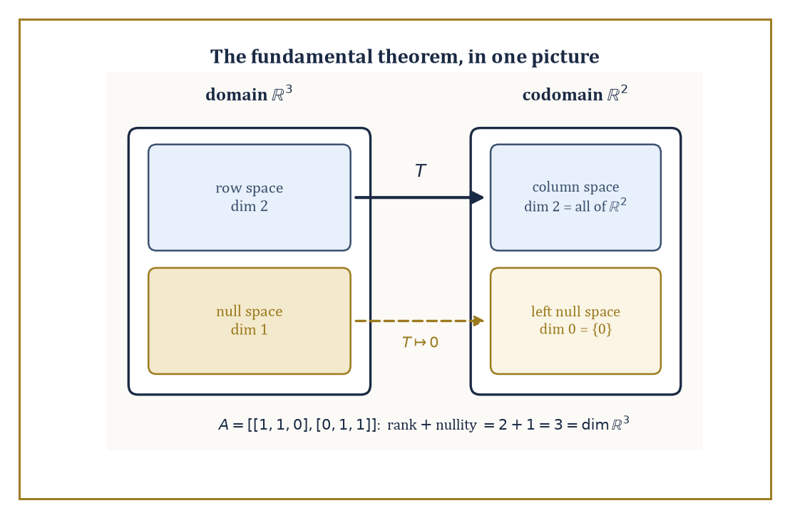
Figure 21.4 — The four fundamental subspaces of A = [1 1 0; 0 1 1]: the row space survives the trip intact, the null space collapses to zero.
The nullity is the dimension of its kernel — how much of the source space gets collapsed to zero.
The rank-nullity theorem states that, for any linear map T out of a finite-dimensional space V:
rank(T) + nullity(T) = dim V
Every dimension of the input either survives into the output (contributing to rank) or gets annihilated (contributing to nullity); there is nowhere else for it to go.
This is less a deep theorem than an accounting identity, but it is the accounting identity that makes the rest of linear algebra balance.
Numeric example — rank and nullity of a rank-deficient matrix. Let A = [1 2 3; 2 4 6], viewed as a map ℝ³ → ℝ². Row 2 is exactly twice row 1, so the two equations for the null space are really the same equation.
x+2y+3z = 0 and 2x+4y+6z = 0
For the rank: the image is spanned by the columns (1,2), (2,4), (3,6) — all multiples of (1,2) — so the image is the one-dimensional line span{(1,2)}.
rank(A) = 1
For the nullity, solve x + 2y + 3z = 0 for a basis of the null space. Set y=1, z=0.
x = −2, giving (−2,1,0); check: −2+2(1)+3(0) = 0
Set y=0, z=1.
x = −3, giving (−3,0,1); check: −3+2(0)+3(1) = 0
These two vectors are independent (neither is a multiple of the other), so:
nullity(A) = 2
Total:
rank + nullity = 1 + 2 = 3 = dim ℝ³
Just as the theorem demands.
Try it now — Rank and nullity of the map ℝ⁴ → ℝ² given by [1 0 1 0; 0 1 0 1]. Answer →
One striking corollary applies only to endomorphisms (linear maps from a finite-dimensional space to itself): such a map is injective if and only if it is surjective, if and only if it is bijective.
If the kernel is trivial (nullity 0), rank-nullity forces the rank to equal the full dimension, meaning the image is everything — injective forces surjective. Run the logic the other way and surjective forces injective too.
This collapse of three different properties into one is a finite-dimensional phenomenon; it fails the moment the space is infinite-dimensional, which is worth seeing go wrong at least once, if only so the finite-dimensional miracle is properly appreciated rather than taken for granted.
Abstract example — the collapse holds in ℝ², and fails in infinite dimensions. In ℝ², let A = [1 2; 3 4]. Compute its determinant.
det(A) = 1·4 − 2·3 = 4 − 6 = −2 ≠ 0
A nonzero determinant means the kernel is trivial (the only solution to Ax=0 is x=0), so A is injective; rank-nullity then forces rank 2, so A is also surjective, and hence bijective — as promised, checkable purely from one nonzero number.
Now consider the infinite-dimensional right-shift operator S on the space of all real sequences, defined below.
S(a₁, a₂, a₃, …) = (0, a₁, a₂, …)
S is injective: if S(a) is the zero sequence, every aᵢ must have been zero already. But S is not surjective: no sequence maps to (1, 0, 0, …), since the first output entry is always forced to be 0.
Injective without surjective, in flat contradiction of the finite-dimensional rule — because there is no finite dimension count to force the two properties to march together. The theorem needed finiteness, and here is the sequence space cheerfully doing without it.
Every matrix A carries four fundamental subspaces: the column space (span of the columns, equivalently the image of A), the row space (span of the rows), the null space (kernel of A), and the left null space (kernel of Aᵀ, equivalently vectors y with yᵀA = 0).
Rank-nullity relates their dimensions — column space and row space always share the same dimension, the rank, a fact that is far less obvious than it sounds until you have proved it once.
And, once an inner product is available (Inner-Product Spaces and Orthogonality), the row space and null space turn out to be orthogonal complements of each other inside the domain, as do the column space and left null space inside the codomain.
Numeric example — all four subspaces of a small matrix. Let A = [1 1 0; 0 1 1], a map ℝ³ → ℝ².
Row space: span{(1,1,0), (0,1,1)} ⊂ ℝ³, a 2-dimensional plane (the two rows are independent, since neither is a multiple of the other).
Column space: span of (1,0), (1,1), (0,1) in ℝ²; since the rows are independent the rank is 2, and a 2-dimensional subspace of ℝ² is all of ℝ².
Null space: solve x+y=0 and y+z=0, giving y=−x and z=−y=x.
(x,y,z) = x·(1,−1,1); check: 1·1+1·(−1) = 0, 1·(−1)+1·1 = 0
null space = span{(1,−1,1)}, dimension 1
Left null space: solve yᵀA = 0 for y=(y₁,y₂): from column 1, y₁·1=0 gives y₁=0; from column 3, y₂·1=0 gives y₂=0.
left null space = {(0,0)}, dimension 0
Check the bookkeeping.
row space (2) + null space (1) = 3 = dim ℝ³
column space (2) + left null space (0) = 2 = dim ℝ²
This machinery is precisely the theory behind solving Ax = b: the equation has a solution exactly when b lies in the column space of A.
When it does, the general solution is one particular solution plus anything from the null space — which is why an underdetermined system (positive nullity) has infinitely many solutions rather than one.
Existence lives in the column space; the shape of the solution set, if existence is granted, lives in the null space.
Numeric example — solvability via the column space. Using A = [1 1 0; 0 1 1] again, is Ax = (1,1) solvable? Since the column space of A is all of ℝ² (rank 2, computed above), yes automatically.
Find one solution: try z=0, then the second equation y+z=1 gives y=1, and the first equation x+y=1 gives x=0.
A·(0,1,0)ᵀ = (0+1, 1+0) = (1,1)
The general solution is (0,1,0) plus any multiple of the null space direction (1,−1,1) — for instance:
(0,1,0) + 2(1,−1,1) = (2,−1,2)
A·(2,−1,2)ᵀ = (2−1, −1+2) = (1,1)
A second, different solution to the same system, exactly as a nontrivial null space guarantees.
Keep only this · Section 21.4: Rank, Nullity, and the Fundamental Theorem
The idea. Rank–nullity: dim V = rank T + nullity T, with dim V the dimension of the domain.
Core.
dim V = rank T + nullity T
rank A = rank Aᵀ
Typical mistake. Using the dimension of the target instead of the domain.
Minimal example. A 3 × 5 matrix of rank 3 has nullity 2.
Practice. Easy to challenge; full worked answers, with the usual mistake, are in Answers to the Practice Sets at the back.
Easy — A map ℝ⁶ → ℝ⁴ has rank 4. Find its nullity. Answer →
Medium — Find a basis of the kernel of [1 1 0; 0 0 1]. Answer →
Challenge — Can a linear map ℝ³ → ℝ³ be injective but not surjective? Answer →

Section 21.5: Eigenvalues, Eigenvectors, and Diagonalization
Finding the Directions a Map Refuses to Bend
CORE · about 15 minutes · later chapters build on this
Stretch a sheet of rubber eastward and most arrows drawn on it change direction as well as length, tilting toward the east. A few do not. An arrow pointing exactly east only gets longer, and an arrow pointing exactly north, across the stretch, stays exactly as it was. Those special directions are eigenvectors, and the factor by which each one is stretched is its eigenvalue: 3 for the east arrow if the stretch triples lengths, 1 for the north arrow. Find these directions and a complicated transformation becomes simple, because along each of them it is just multiplication by a number. That is why eigenvalues sit underneath vibration analysis, population models and quantum mechanics.
Definition — An eigenvector of an endomorphism T is a nonzero vector v such that, for some scalar λ called the eigenvalue:
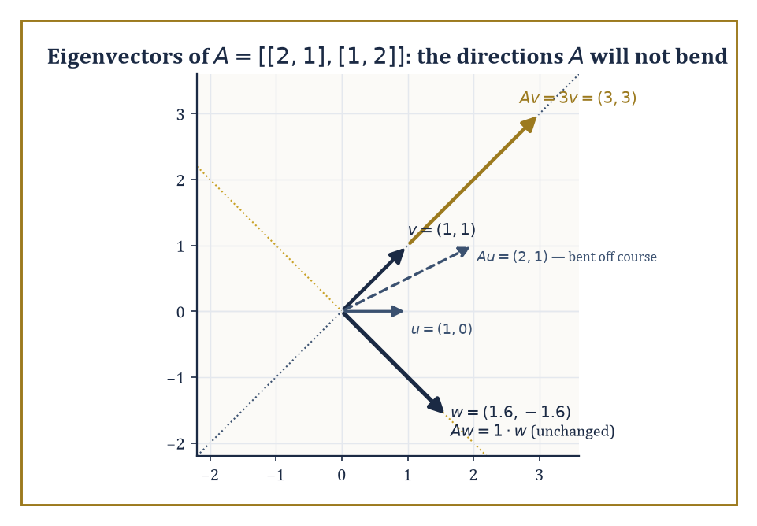
Figure 21.5 — Along the eigen-directions of A, the map only stretches; everywhere else, like the plain vector (1,0), it bends the arrow off its own line.
T(v) = λv
T does not rotate or shear v at all, only stretches or shrinks it along its own direction.
The eigenspace belonging to λ is the set of all vectors satisfying this, which is the kernel of T − λI, and is therefore automatically a subspace (Section 21.1’s closure facts, quietly at work again).
The characteristic polynomial det(T − λI) does not depend on which basis you use to compute the determinant — similar matrices, as Linear Maps and Matrices with Respect to Bases showed, share the same characteristic polynomial — and its roots are exactly the eigenvalues of T.
Numeric example — finding eigenvalues and eigenvectors by hand. Let A = [2 1; 1 2]. Find its characteristic polynomial.
 | det(A − λI) = det |  | 2−λ | 1 |  | = (2−λ)² − 1
 | det(A − λI) = det |  | 1 | 2−λ |  | = (2−λ)² − 1
Expand.
(2−λ)² = 4 − 4λ + λ²
λ² − 4λ + 4 − 1 = λ² − 4λ + 3 = (λ−1)(λ−3)
Roots: λ=1 and λ=3.
For λ=3, solve (A−3I)v=0.
 |  | −1 | 1 |  | v
 |  | 1 | −1 |  | v
= 0, giving −x+y=0, so y=x; eigenvector (1,1)
A·(1,1) = (2+1, 1+2) = (3,3) = 3·(1,1)
For λ=1, solve (A−I)v=0.
 |  | 1 | 1 |  | v
 |  | 1 | 1 |  | v
= 0, giving x+y=0, so y=−x; eigenvector (1,−1)
A·(1,−1) = (2−1, 1−2) = (1,−1) = 1·(1,−1)
Two eigenvalues, two eigenvector directions, both confirmed by direct substitution.
Try it now — Is [1 1; 0 2] diagonalizable? Answer →
T is diagonalizable if V has a basis consisting entirely of eigenvectors of T — equivalently, if the algebraic multiplicity (how many times an eigenvalue appears as a root of the characteristic polynomial) equals the geometric multiplicity (the dimension of its eigenspace) for every eigenvalue.
When this holds, T acts on the eigenbasis as nothing more complicated than independent scalings along each direction — arguably the simplest description any linear map can possibly have, which is why diagonalization is worth pursuing whenever it is available.
Numeric example — diagonalizing A = [2 1; 1 2]. Using the eigenvectors found above, let P have the eigenvectors as columns, ordered to match eigenvalues 3 then 1.
 | P = |  | 1 | 1
 | P = |  | 1 | −1
Its determinant is 1·(−1) − 1·1 = −2, so:
 | P⁻¹ = |  | 1/2 | 1/2
 | P⁻¹ = |  | 1/2 | −1/2
Compute AP: column 1 is A·(1,1) = (3,3); column 2 is A·(1,−1) = (1,−1).
 | AP = |  | 3 | 1
 | AP = |  | 3 | −1
Now compute P⁻¹AP row by row.
row 1 = [1/2·3 + 1/2·3, 1/2·1 + 1/2·(−1)] = [3, 0]
row 2 = [1/2·3 + (−1/2)·3, 1/2·1 + (−1/2)·(−1)] = [0, 1]
 | P⁻¹AP = |  | 3 | 0
 | P⁻¹AP = |  | 0 | 1
Diagonal, eigenvalues on the diagonal in the order chosen for P’s columns. Diagonalization achieved and independently verified, not merely asserted.
Not every matrix is diagonalizable, and the obstruction is a shortfall of eigenvectors: some eigenvalue’s algebraic multiplicity outruns its geometric multiplicity, meaning the characteristic polynomial promises more copies of an eigenvalue than there turn out to be independent eigenvector directions to match.
The size of that shortfall is measured by the Jordan block sizes of Jordan Form, SVD, and Canonical Forms; the discrepancy between the two multiplicities is the first, unmistakable warning sign that a matrix will need a more elaborate canonical form than a plain diagonal one.
Numeric example — a matrix that refuses to diagonalize. Let A = [1 1; 0 1]. Its characteristic polynomial is found using the fact that the matrix is upper triangular, so the determinant is the product of its diagonal entries.
 | det |  | 1−λ | 1 |  | = (1−λ)²
 | det |  | 0 | 1−λ |  | = (1−λ)²
So λ=1 is a root of multiplicity 2 (algebraic multiplicity 2) — the characteristic polynomial promises a two-dimensional eigenspace, if diagonalization is to succeed. Check the actual eigenspace by solving (A−I)v=0.
 |  | 0 | 1 |  | v = 0, which forces y=0 with x free
 |  | 0 | 0 |  | v = 0, which forces y=0 with x free
The eigenspace is span{(1,0)} — only one-dimensional (geometric multiplicity 1). Algebraic multiplicity 2 versus geometric multiplicity 1: the shortfall is exactly 1, and A cannot be diagonalized. No amount of clever basis-hunting produces a second independent eigenvector, because there isn’t one to find.
A preview worth planting now, to be harvested properly in Inner-Product Spaces and Orthogonality and The Spectral Theorem and Quadratic Forms: the eigenvectors of a symmetric matrix belonging to distinct eigenvalues are automatically orthogonal to each other, with no Gram-Schmidt cleanup required.
This is not a coincidence about the particular matrix used above; it is a theorem, and it is the single fact that makes the spectral theorem work.
Numeric example — orthogonality falling out for free. The eigenvectors found for A = [2 1; 1 2] were (1,1) for eigenvalue 3 and (1,−1) for eigenvalue 1. Check their dot product.
(1,1)·(1,−1) = 1·1 + 1·(−1) = 1 − 1 = 0
Orthogonal, with no adjustment needed. Contrast this with the earlier basis-change example in Linear Maps and Matrices with Respect to Bases, where a basis had to be chosen somewhat by inspection; here, for a symmetric matrix, the eigenvectors arrange themselves at right angles automatically, purely as a consequence of symmetry. The Spectral Theorem and Quadratic Forms explains precisely why.
Two cheap sanity checks are worth keeping in the back pocket whenever eigenvalues have just been computed by hand, since arithmetic slips are the second-most reliable cause of exam despair (the most reliable being a forgotten minus sign in a determinant).
The sum of the eigenvalues always equals the trace of the matrix (the sum of the diagonal entries), and the product of the eigenvalues always equals the determinant.
Both facts follow from expanding the characteristic polynomial and comparing coefficients, but they are far more useful as a quick arithmetic check than as anything requiring proof mid-calculation.
Numeric example — checking eigenvalues against trace and determinant. For A = [2 1; 1 2], the trace is:
trace(A) = 2 + 2 = 4
The eigenvalues found earlier were 1 and 3, summing to:
1 + 3 = 4
Matching. The determinant is:
det(A) = 2·2 − 1·1 = 4 − 1 = 3
And the product of the eigenvalues is:
1 · 3 = 3
Also matching. Had either check failed, it would have been a signal to go back and recheck the characteristic polynomial before trusting the eigenvectors built on top of it — a habit worth forming before the matrices get larger than 2×2 and the arithmetic stops being forgiving.
Keep only this · Section 21.5: Eigenvalues, Eigenvectors, and Diagonalization
The idea. A is diagonalizable exactly when it has a basis of eigenvectors; distinct eigenvalues are sufficient, not necessary.
Core.
A = PDP⁻¹ ⇔ n independent eigenvectors
distinct eigenvalues ⇒ diagonalizable
Typical mistake. Taking a repeated eigenvalue as proof that a matrix is not diagonalizable (the identity is a counterexample).
Minimal example. [1 1; 0 1] has the single eigenvalue 1 and only one eigenvector direction: not diagonalizable.
Practice. Easy to challenge; full worked answers, with the usual mistake, are in Answers to the Practice Sets at the back.
Easy — Is [2 0; 0 2] diagonalizable? Answer →
Medium — Diagonalize [1 2; 2 1]. Answer →
Challenge — Compute A¹⁰ for A = [1 2; 2 1]. Answer →

Section 21.6: Inner-Product Spaces and Orthogonality
Bringing Back the Angles We Pretended Not to Miss
CORE · about 15 minutes · later chapters build on this
Vector spaces as defined so far know how to add and scale, but nothing about length or angle. An inner product brings both back. It is a rule that takes two vectors and returns one number, with the ordinary dot product as the model: for the arrows (3, 4) and (4, −3) it gives 3 times 4 plus 4 times minus 3, which is zero, so the two arrows meet at a right angle. The same rule applied to an arrow and itself gives its length squared, here 25, so each arrow has length 5. With length and angle restored, we can build perpendicular coordinate systems in any such space, and perpendicular systems make almost every calculation easier.
Definition — An inner product on a real vector space is a positive-definite symmetric bilinear form — a rule ⟨u,v⟩ assigning a scalar to every pair of vectors, linear in each argument, symmetric, and positive on nonzero vectors; over ℂ the symmetry is replaced by conjugate-symmetry, giving a Hermitian form.
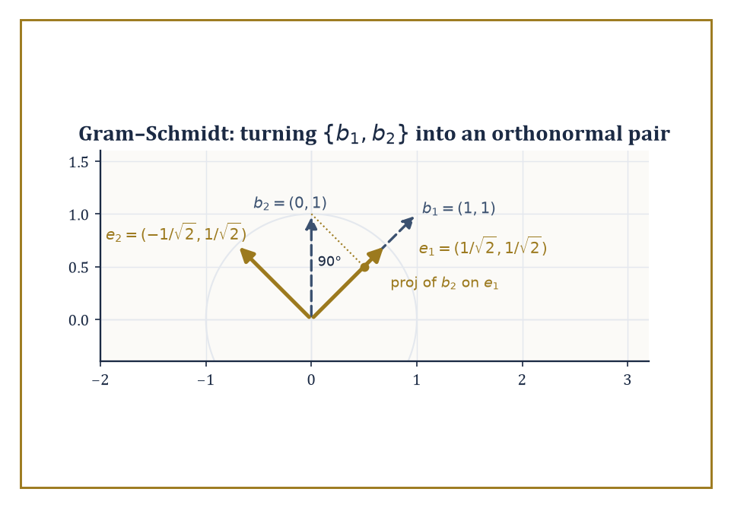
Figure 21.6 — Gram-Schmidt in action: subtract the projection of b₂ onto e₁, normalize what is left, and the result meets e₁ at a perfect right angle.
⟨u,v⟩ = ⟨v,u⟩ (symmetry); ⟨v,v⟩ > 0 unless v = 0 (positivity)
Once an inner product is chosen, length and angle return to the picture.
‖v‖ = √⟨v,v⟩
And two vectors are orthogonal exactly when ⟨u,v⟩=0.
The orthogonal complement of a subspace U, written U⊥, is the set of all vectors orthogonal to every vector in U — itself a subspace — and V splits as the direct sum of any subspace and its orthogonal complement: every vector decomposes uniquely into a piece inside U and a piece inside U⊥.
Numeric example — a plane and its orthogonal complement. In ℝ³ with the standard dot product, let U be the xy-plane, spanned by (1,0,0) and (0,1,0). Its orthogonal complement U⊥ is claimed to be the z-axis, spanned by (0,0,1) — check.
(1,0,0)·(0,0,1) = 0 and (0,1,0)·(0,0,1) = 0
So (0,0,1) is indeed orthogonal to everything in U, and no vector with a nonzero x or y component can be orthogonal to both (1,0,0) and (0,1,0) simultaneously, so U⊥ is just this line.
Every vector (a,b,c) decomposes uniquely, the first piece in U, the second in U⊥.
(a,b,c) = (a,b,0) + (0,0,c)
dim U (2) + dim U⊥ (1) = 3 = dim ℝ³
A direct sum — another instance of the additive bookkeeping this whole chapter keeps returning to.
Try it now — Project v = (3, 1) onto the line through u = (1, 1). Answer →
Orthonormal bases — bases whose vectors are mutually orthogonal and each of length 1 — are especially convenient, because the coordinate of a vector along a basis direction is its inner product with that basis vector; no linear system needs solving, as it did back in Linear Independence, Bases, and Dimension.
The Gram-Schmidt process converts any basis into an orthonormal one: take each basis vector in turn, subtract off its projection onto everything already processed, and normalize what remains.
Numeric example — Gram-Schmidt on two vectors in ℝ². Start with the basis {(1,1), (0,1)}. First, normalize (1,1): its norm is √(1²+1²) = √2, so:
e₁ = (1/√2, 1/√2)
Second, take (0,1) and subtract its projection onto e₁. The projection coefficient is:
⟨(0,1), e₁⟩ = 0·(1/√2) + 1·(1/√2) = 1/√2
So the projection itself is:
(1/√2)·e₁ = (1/√2)·(1/√2, 1/√2) = (1/2, 1/2)
Subtract:
(0,1) − (1/2,1/2) = (−1/2, 1/2)
Normalize: its norm is √((1/2)² + (1/2)²) = √(1/2) = 1/√2, so:
e₂ = (−1/2,1/2)/(1/√2) = (−1/√2, 1/√2)
Check orthonormality.
e₁·e₂ = (1/√2)(−1/√2) + (1/√2)(1/√2) = −1/2 + 1/2 = 0
Both e₁ and e₂ visibly have norm 1 by construction. {(1/√2,1/√2), (−1/√2,1/√2)} is the resulting orthonormal basis.
The adjoint of a linear map T is the unique linear map T* satisfying the relation below, for all v, w — the operator that can be legally moved from one side of the inner product to the other.
⟨T(v), w⟩ = ⟨v, T*(w)⟩
For a real matrix with the standard dot product, the adjoint is the transpose.
Three special families of operator are defined entirely in terms of their relationship to their own adjoint: self-adjoint (T = T*, symmetric matrices being the prototypical example), unitary (T* = T⁻¹, meaning T preserves lengths and angles exactly), and normal (TT* = T*T, the umbrella condition covering both of the previous two).
These three names are about to become the entire cast of the next section.
Numeric example — checking self-adjointness directly. Let A = [2 1; 1 2] again, with the standard inner product on ℝ², so the adjoint is the transpose — and A is symmetric (Aᵀ = A), so it should be self-adjoint. Verify the defining relation on specific vectors v=(1,0), w=(0,1).
Av = (2,1); ⟨Av,w⟩ = (2,1)·(0,1) = 0+1 = 1
Aw = (1,2); ⟨v,Aw⟩ = (1,0)·(1,2) = 1+0 = 1
Both sides equal 1, matching as the self-adjoint relation requires. This is not a coincidence of these particular vectors — it follows for every v,w whenever A is symmetric, using Aᵀ=A in the middle step.
⟨Av,w⟩ = (Av)ᵀw = vᵀAᵀw = vᵀAw = v·(Aw) = ⟨v,Aw⟩
Once a direction is normalized, the orthogonal projection of any vector onto it is given by a single clean formula, for a unit vector e.
proj(v) = ⟨v,e⟩·e
This is the algebraic heart of Gram-Schmidt (each step subtracts such a projection) and also the operation behind least-squares fitting and principal-component analysis, both of which reduce, at bottom, to projecting a high-dimensional vector onto a lower-dimensional subspace and asking how much was lost in the process.
Numeric example — projecting onto a unit vector. Let e = (1/√2, 1/√2), a unit vector along the line y=x, and project v=(2,3) onto it. The projection coefficient is:
⟨v,e⟩ = 2·(1/√2) + 3·(1/√2) = 5/√2
The projection itself is:
(5/√2)·e = (5/√2)·(1/√2,1/√2) = (5/2, 5/2)
Sanity check: the leftover vector should be orthogonal to e, since a projection is defined to leave behind the perpendicular remainder.
v − proj(v) = (2,3) − (5/2,5/2) = (−1/2, 1/2)
(−1/2)(1/√2) + (1/2)(1/√2) = −1/(2√2) + 1/(2√2) = 0
Confirmed orthogonal, as an honest projection requires.
It is worth being honest about what a choice of inner product costs you, since it is easy to mistake it for a free upgrade.
Fixing ⟨·,·⟩ singles out one particular notion of ‘right angle’ and ‘unit length’ among many that could have been chosen on the same underlying vector space — a different inner product on the same set V would declare a different pair of directions orthogonal, and a different set of vectors to have length 1.
The vector space itself, with its bare addition and scalar multiplication, is neutral on the question; the inner product is an extra structure laid on top, chosen because it is useful, not because the space demanded it.
Numeric example — orthogonality is relative to the inner product chosen. Under the standard dot product, (1,1) and (1,−1) are orthogonal, as Eigenvalues, Eigenvectors, and Diagonalization already checked.
1·1 + 1·(−1) = 0
Now define a different, equally legitimate inner product on the same ℝ², the weighted form below (positive-definite and symmetric, so it qualifies).
⟨u,v⟩ = 2u₁v₁ + u₂v₂
Recompute.
⟨(1,1),(1,−1)⟩ = 2·1·1 + 1·(−1) = 2 − 1 = 1 ≠ 0
The very same pair of vectors, sitting in the very same vector space ℝ², is orthogonal under one inner product and not under another. Orthogonality was never a property of the vectors alone; it was always a property of the vectors together with whichever inner product had been chosen to measure them.
Keep only this · Section 21.6: Inner-Product Spaces and Orthogonality
The idea. proj_{u} v = (⟨v, u⟩/⟨u, u⟩) u; Gram–Schmidt subtracts these projections to build an orthonormal basis.
Core.
proj_{u} v = (⟨v, u⟩/⟨u, u⟩) u
Gram–Schmidt: w₂ = v₂ − proj_{w}₁ v₂, then normalize
Typical mistake. Forgetting to normalize after subtracting projections, or dividing by |u| instead of |u|².
Minimal example. (1, 1) and (1, 0): w₂ = (1, 0) − (1/2)(1, 1) = (1/2, −1/2).
Practice. Easy to challenge; full worked answers, with the usual mistake, are in Answers to the Practice Sets at the back.
Easy — Are (1, 2) and (−2, 1) orthogonal? Answer →
Medium — Gram–Schmidt on (1, 1, 0), (1, 0, 1). Answer →
Challenge — Find the point of the line through 0 and (1, 2) nearest to (3, 1), and the distance. Answer →

Section 21.7: The Spectral Theorem and Quadratic Forms
Diagonal at Last, and Orthogonally So
CORE · about 15 minutes · later chapters build on this
Definition — The spectral theorem is the reward for everything built so far: every self-adjoint operator on a finite-dimensional inner-product space is diagonalizable by an orthonormal basis of eigenvectors — not merely diagonalizable in the loose sense of Eigenvalues, Eigenvectors, and Diagonalization, but diagonalizable using a basis that is also orthonormal, the best possible kind of basis to have.
Theorem — Spectral theorem (real symmetric form)
If A is a real symmetric n × n matrix, then ℝⁿ has an orthonormal basis of eigenvectors of A, and A = QΛQᵀ with Q orthogonal and Λ diagonal and real.
Hypotheses — check each one before you use it:
□ A is real and symmetric (Aᵀ = A); over ℂ, read “Hermitian” (A* = A)
□ the space is finite-dimensional with an inner product, and “symmetric” means with respect to that inner product
□ for unitary diagonalization over ℂ, normal (AA = AA) is enough
Why it matters. It says every symmetric matrix is a pure stretch along perpendicular axes. Quadratic forms, conics, Hessians, covariance matrices and the SVD all rest on it.
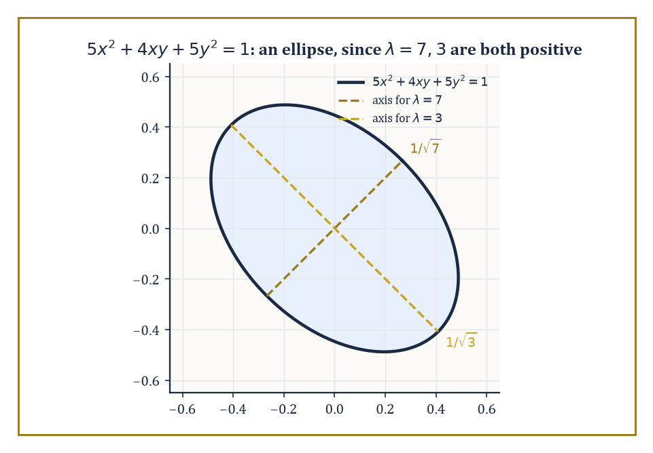
Figure 21.7 — The conic 5x²+4xy+5y²=1 is an ellipse whose axes point along the eigenvectors, with lengths 1/√λ set by the eigenvalues 7 and 3.
Over ℂ the same conclusion holds for the wider class of normal operators; the real, symmetric-matrix version is the one that shows up constantly in applications, precisely because so many matrices arising from physical or statistical problems (covariance matrices, moment-of-inertia tensors, Hessians at a critical point) are symmetric by construction.
Why the spectral theorem is true. The proof has three steps, and each uses symmetry once. Write ⟨x, y⟩ for the dot product, so that symmetry says ⟨Ax, y⟩ = ⟨x, Ay⟩.
Step 1: A has a real eigenvalue. Over ℂ the characteristic polynomial has a root λ with an eigenvector v ≠ 0 in ℂⁿ. Compute the number vAv two ways, where v is the conjugate transpose. First, vAv = v(λv) = λ(vv). Second, its conjugate is (vAv) = vAv = vAv, because A = Aᵀ = A for a real symmetric A; so vAv is real. Since vv = |v₁|² + … + |vₙ|² is real and positive, λ = vAv / v*v is real. Then A − λI is a real singular matrix, so it kills some real vector: there is a real unit eigenvector u₁.
Step 2: the perpendicular directions are left alone. Let W be the set of vectors perpendicular to u₁. If w is in W, then ⟨Aw, u₁⟩ = ⟨w, Au₁⟩ = λ⟨w, u₁⟩ = 0, so Aw is in W too. A maps the (n − 1)-dimensional space W into itself and is still symmetric there.
Step 3: induction. A symmetric map on a 1-dimensional space is multiplication by a number, so the theorem holds for n = 1. Assuming it for n − 1, W has an orthonormal basis u₂, …, uₙ of eigenvectors, and adding u₁ gives one for ℝⁿ. With Q = [u₁ … uₙ], AQ = QΛ, and since QᵀQ = I, A = QΛQᵀ.
The usual mistake is to think the proof needs distinct eigenvalues. It does not: Step 2 works for any eigenvector, so repeated eigenvalues cause no trouble.
Numeric example — the spectral theorem in action on A = [2 1; 1 2]. Eigenvalues, Eigenvectors, and Diagonalization found eigenvalues 3 and 1 for A = [2 1; 1 2], with eigenvectors (1,1) and (1,−1). Normalizing gives an orthonormal eigenbasis.
u₁ = (1/√2, 1/√2) (for eigenvalue 3)
u₂ = (1/√2, −1/√2) (for eigenvalue 1)
Check orthonormality.
u₁·u₂ = 1/2 − 1/2 = 0
Both have norm 1 by construction. This is the spectral theorem’s promise delivered concretely: because A is symmetric, its eigenvectors for distinct eigenvalues came out orthogonal automatically (as flagged at the end of Eigenvalues, Eigenvectors, and Diagonalization), and normalizing them costs nothing extra.
The matrix Q = [u₁ u₂] is then orthogonal, and the diagonalization is achieved by an orthogonal change of basis rather than merely an invertible one.
QᵀQ = I
QᵀAQ = diag(3,1)
Try it now — Classify q(x, y) = x² + 4xy + y². Answer →
A quadratic form is an expression built from a symmetric matrix, of the shape below.
Q(x,y) = ax² + bxy + cy² = vᵀAv
The spectral theorem diagonalizes quadratic forms by exactly the same orthonormal change of coordinates that diagonalizes the underlying symmetric matrix, eliminating all cross terms (the xy-type terms) and leaving a pure sum of squares weighted by the eigenvalues.
The signature of the form — the number of positive, negative, and zero eigenvalues — is an invariant of the form itself, unaffected by which orthonormal coordinates you use to view it, and it completely classifies the form up to change of orthonormal coordinates: positive definite (all eigenvalues positive), negative definite, indefinite, or degenerate, depending on the signs present.
Numeric example — diagonalizing a quadratic form. Let Q(x,y) = 2x² + 2xy + 2y², whose matrix is [2 1; 1 2] — check that it matches.
 | vᵀAv = [x y]· |  | 2 | 1 |  | · |  | x |  | = 2x²+xy+xy+2y² = 2x²+2xy+2y²
 | vᵀAv = [x y]· |  | 1 | 2 |  | · |  | y |  | = 2x²+xy+xy+2y² = 2x²+2xy+2y²
It matches Q exactly. Using the orthonormal eigenbasis from above, introduce new coordinates along the eigenvalue-3 and eigenvalue-1 directions.
u = (x+y)/√2, v = (x−y)/√2
The spectral theorem guarantees Q becomes the following in these coordinates, with the cross term gone entirely.
Q = 3u² + v²
Verify at the point (x,y)=(1,1). Directly:
Q(1,1) = 2+2+2 = 6
In the new coordinates:
u = (1+1)/√2 = √2, v = (1−1)/√2 = 0
3u²+v² = 3·2 + 0 = 6
Matching. Since both eigenvalues (3 and 1) are positive, the signature is (2 positive, 0 negative, 0 zero): Q is positive definite, meaning Q(x,y) > 0 for every nonzero (x,y).
This machinery underwrites some of the most-used tools in applied mathematics, generally without the tools themselves admitting it.
Principal-component analysis diagonalizes a data set’s covariance matrix to find the directions of greatest variance, which is a great deal more dignified a description than ‘finding out which way the cloud of points is leaning.’
The classification of conics and quadrics (ellipses, hyperbolas, and their higher-dimensional cousins, who rarely get invited to the introductory course) reduces to reading off the signature of a quadratic form after an orthonormal change of coordinates has removed the cross terms.
The stability analysis of an equilibrium in mechanics checks whether the Hessian of a potential energy function is positive definite at that point — the signature question above, applied to a matrix of second derivatives instead of a matrix of coefficients, and asked with rather higher stakes than a homework problem.
Numeric example — classifying a conic by its eigenvalues. Classify the curve below.
5x² + 4xy + 5y² = 1
Its matrix is A = [5 2; 2 5] (the cross-term coefficient 4 splits into 2 and 2 off the diagonal) — check.
vᵀAv = 5x²+2xy+2xy+5y² = 5x²+4xy+5y²
The characteristic polynomial:
 | det |  | 5−λ | 2
 | det |  | 2 | 5−λ
= (5−λ)² − 4 = λ² − 10λ + 25 − 4 = λ² − 10λ + 21
Factor.
λ² − 10λ + 21 = (λ−7)(λ−3)
Giving eigenvalues 7 and 3. Both positive, so the quadratic form is positive definite, and the curve is an ellipse — no further sketching required, the sign pattern of the eigenvalues has already settled the question.
The complex, normal-operator version of the spectral theorem is worth one concrete glance, if only so it does not remain a purely rhetorical extension of the real case.
A unitary operator (U* = U⁻¹, the complex analogue of an orthogonal matrix) is automatically normal, since the two possible orders of multiplication agree trivially once U* and U⁻¹ are literally the same matrix.
UU* = UU⁻¹ = I = U⁻¹U = U*U
Rotation matrices are the standard real example of this phenomenon: they preserve length and angle exactly, which is what being orthogonal (the real cousin of unitary) means.
Numeric example — a rotation matrix is orthogonal, hence normal. Let R be rotation by 90°.
 | R = |  | 0 | −1
 | R = |  | 1 | 0
Its transpose is:
 | Rᵀ = |  | 0 | 1
 | Rᵀ = |  | −1 | 0
Compute RᵀR row by row.
row 1 = [0·0 + 1·1, 0·(−1) + 1·0] = [1, 0]
row 2 = [−1·0 + 0·1, −1·(−1) + 0·0] = [0, 1]
RᵀR = I
R is orthogonal, meaning Rᵀ = R⁻¹, the real special case of unitary. Since R* (=Rᵀ here) equals R⁻¹, R is automatically normal by the argument above, and the complex spectral theorem applies to it even though, geometrically, all a rotation matrix does is turn the plane — no stretching along any real direction at all, which is exactly why its eigenvalues (i and −i, for this particular R) turn out to be complex rather than real: a pure rotation has no real eigenvector to diagonalize along, a fact the real spectral theorem quietly sidesteps by restricting itself to symmetric matrices in the first place.
Keep only this · Section 21.7: The Spectral Theorem and Quadratic Forms
The idea. A real symmetric matrix is QΛQᵀ with Q orthogonal: its eigenvectors are perpendicular axes, and the signs of its eigenvalues classify the quadratic form.
Core.
A = Aᵀ ⇒ A = QΛQᵀ, Q orthogonal, Λ real diagonal
q(x) = xᵀAx: all λ > 0 ⇔ positive definite
Typical mistake. Putting the full xy coefficient off the diagonal instead of half of it.
Minimal example. [2 1; 1 2]: eigenvalues 3, 1, positive definite.
Practice. Easy to challenge; full worked answers, with the usual mistake, are in Answers to the Practice Sets at the back.
Easy — Positive definite? [3 0; 0 −1]. Answer →
Medium — Write q = 2x² + 2xy + 2y² in principal axes. Answer →
Challenge — Show that eigenvectors of a symmetric matrix for different eigenvalues are orthogonal. Answer →

Section 21.8: Jordan Form, SVD, and Canonical Forms
The Last Word on What a Matrix Really Is
CORE · about 15 minutes · later chapters build on this
Key idea — Every endomorphism of a finite-dimensional complex vector space has a Jordan canonical form: a block-diagonal matrix whose blocks are Jordan blocks, each a square array with a single eigenvalue repeated down the diagonal and 1’s on the superdiagonal immediately above it.
The size of each block is fixed by the dimensions of the kernels of the successive powers of (T − λI); the Jordan form is unique up to reordering the blocks.
Where diagonalization fails, as it did for the matrix in Eigenvalues, Eigenvectors, and Diagonalization, Jordan form is the fallback: it is the closest any matrix can get to diagonal once the eigenvector shortage makes true diagonalization impossible.
Numeric example — the Jordan form of a non-diagonalizable matrix. Recall A = [1 1; 0 1] from Eigenvalues, Eigenvectors, and Diagonalization, with eigenvalue 1 (algebraic multiplicity 2) but only a one-dimensional eigenspace span{(1,0)}. Since A is already upper triangular with 1’s on the diagonal and a single 1 on the superdiagonal, it is already sitting in Jordan form: one Jordan block of size 2 for eigenvalue 1.
To see the generalized eigenvector that fills out the missing dimension, solve (A−I)v₂ = v₁ where v₁=(1,0) is the ordinary eigenvector.
 | (A−I) = |  | 0 | 1 |  | , so 0·x + 1·y
 | (A−I) = |  | 0 | 0 |  | , so 0·x + 1·y
= 1, giving y=1 with x free; choose v₂=(0,1)
The pair {(1,0), (0,1)} — here, unsurprisingly, the standard basis — is a genuine Jordan basis.
A(1,0) = (1,0) = 1·(1,0)
A(0,1) = (1,1) = 1·(0,1) + 1·(1,0)
This is the eigenvalue-plus-superdiagonal-1 pattern a Jordan block demands.
Try it now — Singular values of [3 0; 0 −2]? Answer →
The singular value decomposition writes an arbitrary m×n matrix A — square or not, diagonalizable or not — as the product below, where U and V are orthogonal (unitary), and Σ is diagonal with non-negative entries called the singular values.
A = UΣVᵀ (or UΣV* for complex matrices)
The singular values are the square roots of the eigenvalues of AᵀA, which is always symmetric and positive semi-definite, so those eigenvalues are always real and non-negative — the spectral theorem of The Spectral Theorem and Quadratic Forms guaranteeing the SVD’s existence behind the scenes.
Because the SVD makes no demand that A be square, self-adjoint, or even diagonalizable, it is the single most universally applicable matrix factorization in numerical linear algebra and data science.
Numeric example — a full SVD, reusing familiar eigenwork. Let A = [1 0; 1 1; 0 1], a 3×2 matrix. Compute AᵀA, where row 1 of Aᵀ is (1,1,0) and row 2 is (0,1,1).
(AᵀA)₁₁ = 1·1+1·1+0·0 = 2; (AᵀA)₁₂ = 1·0+1·1+0·1 = 1; (AᵀA)₂₁ = 1; (AᵀA)₂₂ = 0·0+1·1+1·1 = 2
 | AᵀA = |  | 2 | 1
 | AᵀA = |  | 1 | 2
This is the matrix diagonalized in Eigenvalues, Eigenvectors, and Diagonalization and The Spectral Theorem and Quadratic Forms, with eigenvalues 3 and 1 and orthonormal eigenvectors v₁=(1/√2,1/√2), v₂=(1/√2,−1/√2). The singular values are σ₁=√3, σ₂=1.
Compute u₁ = Av₁/σ₁.
Av₁ = (1·1/√2+0, 1/√2+1/√2, 0+1/√2) = (1/√2, √2, 1/√2)
u₁ = (1/√2, √2, 1/√2)/√3 = (1/√6, √(2/3), 1/√6)
Check its norm.
1/6 + 2/3 + 1/6 = 1/6+4/6+1/6 = 1
Compute u₂ = Av₂/σ₂.
Av₂ = (1/√2, 1/√2−1/√2, −1/√2) = (1/√2, 0, −1/√2), squared norm 1/2 + 0 + 1/2 = 1
A third vector u₃, orthogonal to both and spanning the leftover dimension of ℝ³ (since A has rank 2 but lands in a 3-dimensional space), works out to:
u₃ = (1/√3,−1/√3,1/√3)
Assembling the pieces:
 | U=[u₁ u₂ u₃], Σ = |  | √3 | 0 |  | , V=[v₁ v₂]
 | U=[u₁ u₂ u₃], Σ = |  | 0 | 1 |  | , V=[v₁ v₂]
 | U=[u₁ u₂ u₃], Σ = |  | 0 | 0 |  | , V=[v₁ v₂]
Multiplying UΣVᵀ back out reconstructs A exactly (row 1 gives (1,0), row 2 gives (1,1), row 3 gives (0,1)) — arithmetic best done slowly with a pencil, but it closes perfectly.
Notice what the SVD does that Jordan form cannot: it exists for every matrix, rectangular or square, diagonalizable or not, because it never asks for eigenvectors of A itself — only of the always-symmetric AᵀA.
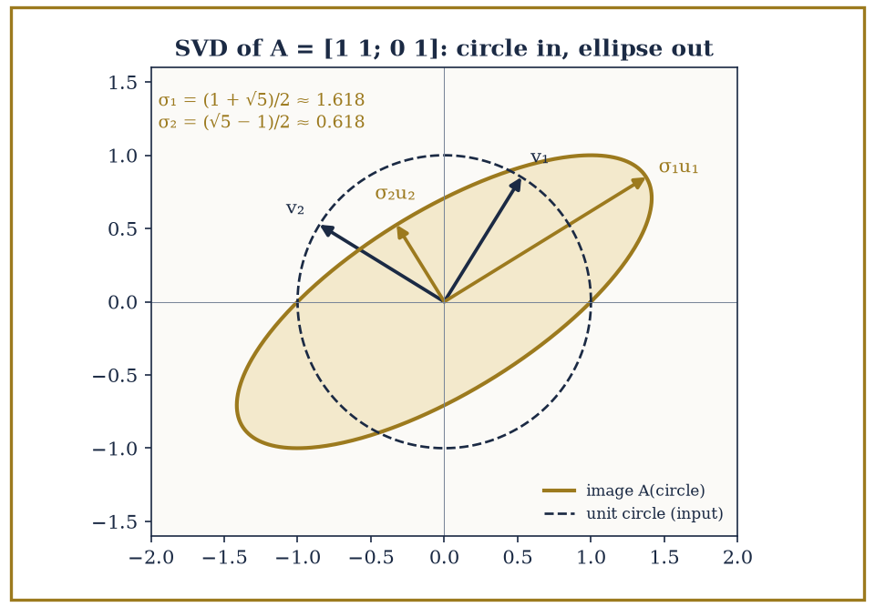
Figure 21.8 — The SVD of the stubbornly non-diagonalizable A = [1 1; 0 1]: the unit circle still becomes a perfectly respectable ellipse, with golden-ratio singular values.
Even the stubborn Jordan-block matrix [1 1; 0 1] from earlier in this section, which has no eigenbasis to speak of, has a perfectly respectable SVD, since AᵀA = [1 1; 1 2] is symmetric and positive definite regardless of A’s own eigenvector shortage.
Where the SVD comes from. Step 1: AᵀA is symmetric, and ⟨AᵀAx, x⟩ = ⟨Ax, Ax⟩ = |Ax|² ≥ 0, so its eigenvalues are real and non-negative. By the spectral theorem it has orthonormal eigenvectors v₁, …, vₙ with eigenvalues λ₁ ≥ … ≥ λₙ ≥ 0. Set σᵢ = √λᵢ.
Step 2: the images Avᵢ are automatically perpendicular. ⟨Avᵢ, Avⱼ⟩ = ⟨vᵢ, AᵀAvⱼ⟩ = λⱼ⟨vᵢ, vⱼ⟩, which is λᵢ when i = j and 0 otherwise. So |Avᵢ| = σᵢ, and for each σᵢ > 0 the vectors uᵢ = Avᵢ/σᵢ are orthonormal.
Step 3: complete the u’s to an orthonormal basis u₁, …, uₘ of ℝᵐ. Then Avᵢ = σᵢuᵢ for every i (for σᵢ = 0 both sides are 0, since |Avᵢ| = σᵢ). In matrix form AV = UΣ, and multiplying on the right by Vᵀ gives A = UΣVᵀ.
For A = [1 1; 0 1], AᵀA = [1 1; 1 2] has eigenvalues (3 ± √5)/2, so σ₁ = (1 + √5)/2 ≈ 1.618 and σ₂ = (√5 − 1)/2 ≈ 0.618. Their product is 1 = |det A|, as it must be, since the rotations U and V do not change area. The usual mistake is to take the eigenvalues of A itself (both equal to 1) as the singular values.
Theorem — Singular value decomposition
Every real m × n matrix A can be written A = UΣVᵀ, with U (m × m) and V (n × n) orthogonal and Σ (m × n) zero except for σ₁ ≥ σ₂ ≥ … ≥ 0 down its diagonal. The σᵢ are the square roots of the eigenvalues of AᵀA.
Hypotheses — check each one before you use it:
□ none on A: any size, any rank, diagonalizable or not
□ U and V are orthogonal; over ℂ, unitary, with A* in place of Aᵀ
□ the σᵢ are unique; U and V are unique only up to signs (and rotations within repeated σᵢ)
Why it matters. Every linear map is a rotation, a stretch along perpendicular axes, and another rotation: the best pair of orthonormal bases for input and output.
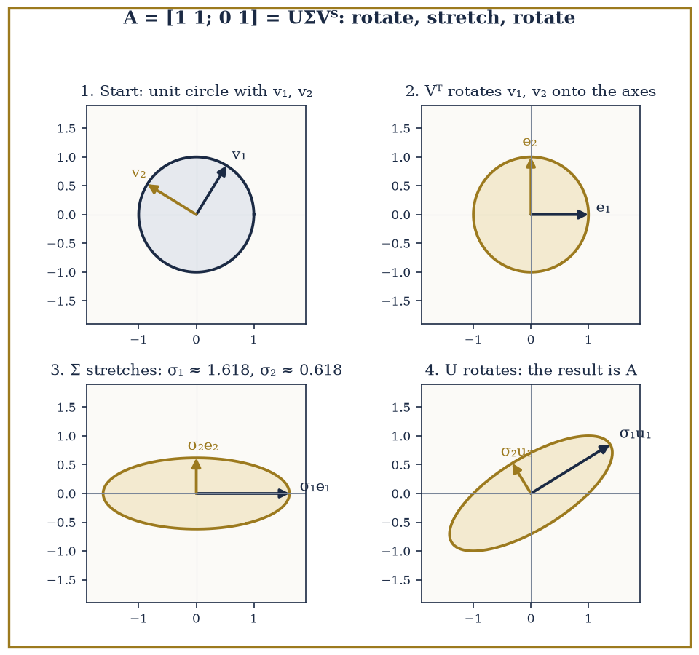
Figure 21.9 — The SVD of A = [1 1; 0 1] in four steps. Panel 1: the unit circle with the right singular vectors v₁, v₂. Panel 2: Vᵀ rotates them onto the coordinate axes. Panel 3: Σ stretches the axes by σ₁ ≈ 1.618 and σ₂ ≈ 0.618, making an upright ellipse. Panel 4: U rotates the ellipse into place; the result is exactly the image of the circle under A, with semi-axes σ₁u₁ and σ₂u₂.
Jordan form answers ‘what does this map look like in its own best basis?’ — a question that can have an ugly answer, or none at all outside ℂ. SVD answers ‘what does this map look like between its own best pair of orthonormal bases, one for input and one for output?’ — a question that always has a clean answer.
Together they complete the classification of linear maps: Jordan form up to ordinary change of basis, SVD up to orthonormal change of basis on each side.
Numeric example — SVD surviving where Jordan form struggles. For A = [1 1; 0 1], compute AᵀA. More carefully: Aᵀ = [1 0; 1 1], so:
 | AᵀA = |  | 1 | 0 |  | · |  | 1 | 1
 | AᵀA = |  | 1 | 1 |  | · |  | 0 | 1
Row by row:
row1 = [1·1+0·0, 1·1+0·1] = [1,1]
row2 = [1·1+1·0, 1·1+1·1] = [1,2]
 | AᵀA = |  | 1 | 1
 | AᵀA = |  | 1 | 2
Symmetric as required. Its characteristic polynomial:
(1−λ)(2−λ) − 1 = λ² − 3λ + 2 − 1 = λ² − 3λ + 1
With roots below — both positive, since their sum is 3 and their product is 1, both positive quantities forcing two positive roots.
λ = (3 ± √5)/2
So the singular values are:
σ = √((3±√5)/2)
These exist and are perfectly real, even though A itself, as Eigenvalues, Eigenvectors, and Diagonalization showed, has no eigenbasis at all. The SVD does not care that Jordan form was struggling next door.
One more fact worth carrying forward: the rank of a matrix equals the number of its nonzero singular values, since a zero singular value corresponds to an eigenvalue of AᵀA equal to zero — a direction that A collapses entirely, contributing nothing to the image.
This gives the SVD a second life as a rank-detector, and, in practice, as a rank-repairer: keeping only the largest few singular values and discarding the rest produces the best possible low-rank approximation to a matrix, which is the entire mathematical engine behind image compression and recommender systems.
Numeric example — rank read off from singular values. For A = [1 0; 1 1; 0 1], the singular values found earlier were √3 and 1 — both strictly positive, so all of them are nonzero. The rank of A is therefore 2, which matches direct inspection: the two columns (1,1,0) and (0,1,1) are independent (neither is a multiple of the other).
rank(A) = 2
As the singular-value count predicts. Had a third singular value existed and been zero, it would have signaled a hidden dependency among the columns worth hunting down directly.
Keep only this · Section 21.8: Jordan Form, SVD, and Canonical Forms
The idea. A = UΣVᵀ: rotate (Vᵀ), stretch along the axes (Σ), rotate (U). The σᵢ are the square roots of the eigenvalues of AᵀA.
Core.
A = UΣVᵀ (every matrix)
σᵢ = √λᵢ(AᵀA)
Jordan: A = PJP⁻¹ over ℂ
Typical mistake. Taking eigenvalues of A as singular values; they agree only for symmetric positive semi-definite A.
Minimal example. [1 1; 0 1]: σ₁ = (1 + √5)/2 ≈ 1.618 and σ₂ = (√5 − 1)/2 ≈ 0.618, with σ₁σ₂ = 1 = |det A|.
Practice. Easy to challenge; full worked answers, with the usual mistake, are in Answers to the Practice Sets at the back.
Easy — Singular values of [0 2; 0 0]. Answer →
Medium — Find the SVD of [3 0; 0 −2]. Answer →
Challenge — Why is the best rank-1 approximation of A equal to σ₁u₁v₁ᵀ? Answer →

Chapter 21 in One Page
A vector space is anything that can be added and scaled; subspaces are the subsets closed under both. Bases give coordinates and dimension. A linear map is fixed by what it does to a basis, and its matrix depends on the bases chosen. Rank plus nullity is the dimension of the domain. Eigenvectors diagonalize a map when there are enough of them. Inner products bring length, angle and projection. The spectral theorem diagonalizes every symmetric map in an orthonormal basis; Jordan form handles maps that cannot be diagonalized; the SVD writes every matrix as rotate, stretch, rotate.
Key definitions
• Subspace: contains 0, closed under addition and scalar multiplication.
• Basis and dimension.
• Kernel (null space), image, rank, nullity.
• Inner product ⟨·, ·⟩, orthogonal complement, projection.
• Self-adjoint (symmetric) map: ⟨Tv, w⟩ = ⟨v, Tw⟩.
• Singular values σᵢ = √(eigenvalues of AᵀA).
Key theorems, with their hypotheses
• Rank–nullity — hypotheses: T linear, domain finite-dimensional.
• Diagonalizability — hypothesis: a basis of eigenvectors exists (guaranteed by n distinct eigenvalues).
• Spectral theorem — hypotheses: real symmetric (or Hermitian; normal for unitary diagonalization), finite-dimensional inner-product space.
• Jordan form — hypothesis: complex scalars (the characteristic polynomial splits).
• SVD — no hypothesis on A.
Canonical example
• A = [2 1; 1 2]: eigenvalues 3 and 1, orthonormal eigenvectors (1, 1)/√2 and (1, −1)/√2, A = QΛQᵀ; the form 2x² + 2xy + 2y² becomes 3X² + Y² in the rotated axes.
Common errors
• Forgetting 0 in the subspace test.
• Images written as rows of the matrix.
• Rank–nullity with the target’s dimension.
• Eigenvalues of A taken as singular values.
Readiness checklist — you are ready for what comes next when you can:
□ apply the subspace test and find a basis and dimension
□ compute rank and nullity and check rank–nullity
□ diagonalize a 2 × 2 matrix or explain why it cannot be done
□ project a vector and run Gram–Schmidt on two vectors
□ state and use the spectral theorem and the SVD, with their hypotheses
Section 21.9 that follows is a preview, marked optional: it says where these ideas lead in later chapters and volumes. Nothing in it is needed for the exercises.

Section 21.9: Where This Goes Next (Optional): From Linear Algebra to Modules, Representations, and Functional Analysis
Packing the Toolbox for the Road Ahead
PREVIEW — OPTIONAL · about 15 minutes · optional; read for orientation, nothing is examined
Overview — Stand back and take stock of the equipment now in hand: vector spaces and subspaces, independence and dimension, linear maps and their matrices, rank-nullity, eigenvalues and diagonalization, inner products and orthogonality, the spectral theorem, and finally Jordan form and the SVD as the complete classification of what a linear map can look like.
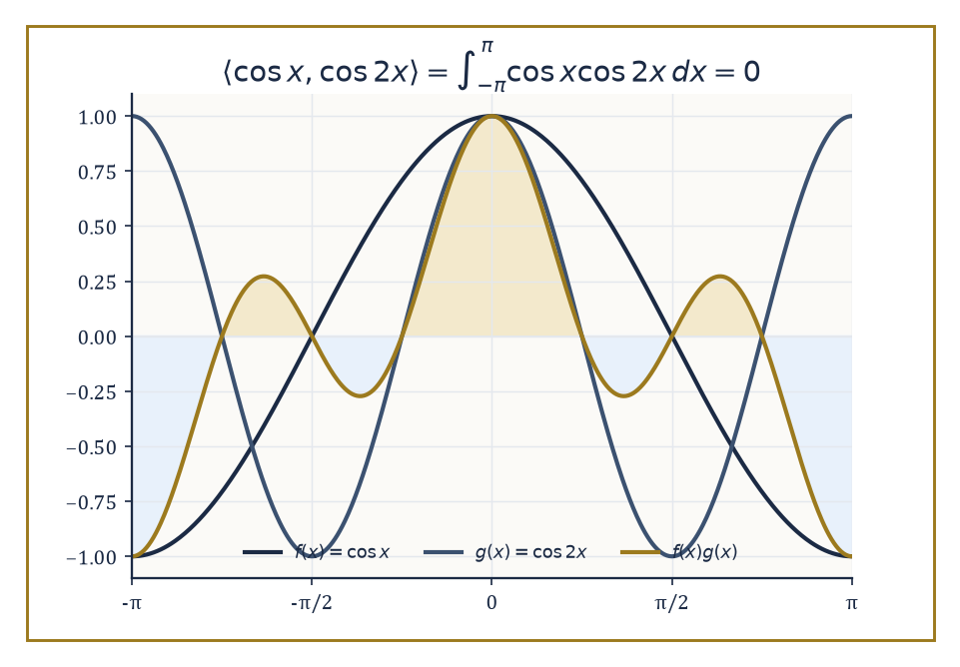
Figure 21.10 — cos x and cos 2x look nothing alike, but their product’s positive lobes (gold) and negative lobes (blue) balance out exactly — the seed of the Fourier basis.
It is a remarkably short list of ideas for how much weight it carries — which is, again, precisely the point of building a subject on few axioms and many examples.
These tools are not a self-contained destination; they are load-bearing walls for a great deal of what the series builds above this chapter.
Modules over rings generalize vector spaces by replacing the field of scalars with a mere ring — and the loss of division turns out to matter enormously.
Representation theory studies linear actions of groups on vector spaces, turning abstract group elements into concrete matrices that can be multiplied and diagonalized.
Functional analysis extends this entire theory to infinite-dimensional spaces of functions, where ‘basis’ and ‘orthonormal’ need considerably more care than they did here.
Quantum mechanics identifies physically observable quantities with self-adjoint operators — Section 21.6’s adjoint, doing genuine physical work.
And numerical linear algebra studies the stability and computational cost of the very algorithms — Gram-Schmidt, eigenvalue-finding, SVD — sketched by hand in this chapter but in practice run by machine, on matrices far too large for a human to diagonalize with a pencil.
Abstract example — why a module is not just a vector space with a different name. Consider ℤ as a module over itself (the ring ℤ acting on the set ℤ by ordinary multiplication). In a vector space over a field, you can always divide by a nonzero scalar; in the ℤ-module ℤ, you generally cannot. Is there an integer x with:
3x = 2
No — 2/3 is not an integer, so this simple equation, trivially solvable in any vector space over ℝ or ℚ, has no solution here.
Worse, consider ℤ/2ℤ = {0,1} as a ℤ-module, where 2 is congruent to 0 modulo 2, so:
2·1 = 0
In a vector space over a field, λv=0 with λ≠0 forces v=0 — but here 2≠0 (as a ring element) and 1≠0 (as a module element), yet 2·1=0 anyway.
This ‘torsion’ phenomenon has no counterpart in ordinary linear algebra; it is the first sign that modules are a harder and richer subject than their vector-space cousin, because rings, unlike fields, are allowed to have elements with no multiplicative inverse.
Try it now — Why can a ℤ-module fail to have a basis? Answer →
Abstract example — a first taste of representation theory. Let C₃ = {e, r, r²} be the cyclic group of order 3 (rotations by 0°, 120°, 240°). Represent it on ℝ² by rotation matrices.
R(e) = I
 | R(r) = |  | −1/2 | −√3/2
 | R(r) = |  | √3/2 | −1/2
 | R(r²) = |  | −1/2 | √3/2
 | R(r²) = |  | −√3/2 | −1/2
A representation must respect the group’s multiplication, so R(r)·R(r) should equal R(r²). Compute row by row.
row 1 = [(−1/2)(−1/2)+(−√3/2)(√3/2), (−1/2)(−√3/2)+(−√3/2)(−1/2)] = [1/4−3/4, √3/4+√3/4] = [−1/2, √3/2]
row 2 = [(√3/2)(−1/2)+(−1/2)(√3/2), (√3/2)(−√3/2)+(−1/2)(−1/2)] = [−√3/4−√3/4, −3/4+1/4] = [−√3/2, −1/2]
 | R(r)² = |  | −1/2 | √3/2 |  | = R(r²)
 | R(r)² = |  | −√3/2 | −1/2 |  | = R(r²)
Matching the group law r·r=r². The abstract group’s structure has been faithfully translated into matrix multiplication — the entire ambition of representation theory in one small, checkable example.
The deeper lesson beneath all the specific results is that linearity is an extraordinarily powerful simplifying assumption — powerful enough that an enormous amount of mathematics is built by first finding the linear approximation to a hard nonlinear problem (a tangent plane, a derivative, a linearized differential equation) and only afterward wrestling with what the linear picture leaves out.
The structure theory developed in this chapter — dimension, rank, eigenvalues, spectral decomposition — is both complete, in the precise sense that Jordan form and SVD leave nothing further to classify, and applicable far beyond the matrix setting where it was first discovered.
Abstract example — orthogonality surviving the leap to infinite dimensions. In the space of functions on [−π, π] with the inner product below, the functions {1, cos x, sin x, cos 2x, sin 2x, …} form an infinite orthogonal set — the Fourier basis, and the exact infinite-dimensional analogue of the Gram-Schmidt-built orthonormal bases of Inner-Product Spaces and Orthogonality.
⟨f,g⟩ = ∫[−π, π] f(x)g(x) dx
Check one instance.
⟨cos x, cos 2x⟩ = ∫[−π, π] cos x cos 2x dx
Using the product-to-sum identity below, the integral splits in two.
cos x cos 2x = ½[cos(x) + cos(3x)]
½∫cos x dx + ½∫cos 3x dx over [−π,π]
Both integrate to [sin(·)] evaluated at ±π.
∫[−π, π] cos x dx = sin π − sin(−π) = 0 − 0 = 0
∫[−π, π] cos 3x dx = (1/3)[sin 3x] from −π to π = (1/3)(sin 3π − sin(−3π)) = 0
So the whole integral is 0 — cos x and cos 2x are orthogonal, by exactly the same criterion (inner product zero) used throughout Inner-Product Spaces and Orthogonality, only now the ‘vectors’ are functions and the ‘dot product’ is an integral. This orthogonality is the seed from which the chapters on functional analysis, much later in the series, will grow an entire theory of Fourier series.
Numerical linear algebra, mentioned only in passing above, deserves one concrete warning before we leave it: solving a linear system on a computer is not the same problem as solving it on paper, because a computer’s arithmetic is rounded, and some matrices amplify rounding error catastrophically while others barely notice it.
The technical name for this sensitivity is conditioning, and a matrix that is ‘nearly singular’ — close to having a zero determinant, close to losing a dimension of rank — tends to be badly conditioned, however innocent it looks written down.
Numeric example — a matrix that looks harmless and is not. Compare A = [1 1; 1 1] (singular, columns identical) with B = [1 1; 1 1.0001] (technically invertible). Check their determinants.
det(A) = 1·1 − 1·1 = 0
det(B) = 1·1.0001 − 1·1 = 0.0001
B’s determinant is tiny but nonzero, so on paper it is perfectly solvable.
In practice, inverting B involves dividing by 0.0001, which multiplies any small input error by roughly 10,000 — meaning a rounding error of size 10⁻⁶ in the input data could produce an error of size 10⁻² in the computed solution, a hundred-fold amplification.
Nothing in the determinant’s bare nonzero-ness warns you of this; only the size of the determinant relative to the entries does. This is the kind of question — how much does a small input error get amplified — that numerical linear algebra exists to answer properly, and that the eigenvalue and SVD machinery of this chapter turns out to be the right language for measuring.
Linear algebra, in the end, is the backbone of modern mathematical science — not because linear problems are the interesting ones, but because they are the ones we know how to solve completely, and every harder problem gets attacked, sooner or later, by finding the linear structure hiding somewhere inside it.
The eigenvectors may now retire, at least for a chapter. Chapter 22 descends from this abstraction back into something you can genuinely sketch on paper: analytic geometry, where the plane and space of school mathematics — lines, circles, conics, and the angles between them — get re-derived properly, using coordinates chosen with intent rather than inherited by habit. Much of what felt like a leap of faith here (why should ‘inner product’ deserve the name it borrows from ordinary dot products; why should a quadratic form’s signature classify an ellipse) will turn out to have been just that dot product and that ellipse all along, merely wearing the more general clothing this chapter insisted on giving it first.
Going up into abstraction for a chapter and straight back down for the next is the honest shape of understanding anything properly — you go up to see the structure, and you come back down to remember what it was structure of. The series continues, and for once, the step back is part of the plan.
Keep only this · Section 21.9: Where This Goes Next (Optional): From Linear Algebra to Modules, Representations, and Functional Analysis
The idea. Modules, representations and Hilbert spaces each keep linear structure and change one assumption.
Core.
module = vector space over a ring
representation: a group acting by linear maps
Hilbert space: complete inner-product space
Typical mistake. Assuming every module behaves like a vector space and has a basis.
Minimal example. ℤ/6ℤ is a ℤ-module without a basis.
Practice. Easy to challenge; full worked answers, with the usual mistake, are in Answers to the Practice Sets at the back.
Easy — What changes when scalars come from ℤ instead of ℝ? Answer →
Medium — Give a two-dimensional representation of the group of rotations by multiples of 90°. Answer →
Challenge — Why does the spectral theorem need extra care in infinite dimensions? Answer →

Check Your Understanding — Chapter 21
Answers are in the Answer Key at the back of the book — have a go before you look.
1. [Explain] Why does the solution set of a homogeneous linear differential equation like y″ + y = 0 automatically form a vector space, with no further checking required?
See the answer →
2. [Compute] For A = [1 2 3; 2 4 6], viewed as a map ℝ³ → ℝ², compute the rank and nullity and verify the rank-nullity theorem.
See the answer →
3. [Explain] Why is the matrix [1 1; 0 1] not diagonalizable, even though it has a repeated eigenvalue?
See the answer →
4. [Explain] Why does the singular value decomposition exist for a matrix like [1 1; 0 1] that has no eigenbasis at all?
See the answer →

Fluency Drill — Chapter 21
Five minutes, no notes, before the harder problems. These are the moves the Problems assume are automatic; if one takes you more than a minute, reread the section it names. Worked answers, each with the usual slip, are in Answers to the Practice Sets.
1. [Concept] Subspace test: {(x, y, z) : x + y + z = 0} in ℝ³? Answer →
2. [Concept] Subspace test: the 2 × 2 matrices with determinant 0? Answer →
3. [Compute] Rank and nullity of [1 2 3; 2 4 6]. Answer →
4. [Compute] Rank and nullity of the identity on ℝ⁵, and of the zero map ℝ⁵ → ℝ². Answer →
5. [Compute] Project (2, 3) onto (1, 0). Answer →
6. [Compute] Project (1, 2, 2) onto (1, 1, 0). Answer →
7. [Compute] Orthonormalize (3, 4). Answer →
8. [Concept] Eigenvalues of a symmetric matrix are 4 and −1. Positive definite? Answer →

Problems — Chapter 21
Linear algebra rewards practice more than almost any chapter in this book, because its difficulty is not conceptual depth so much as fluency: the same half-dozen maneuvers, performed until they stop costing attention. Thirteen problems follow, grouped by the section that supplies the tool. Each problem carries a skill tag (Concept, Compute, Explain, Prove, Model or Challenge; see How to Use This Book) and a link to its full worked solution, which ends with the usual mistake.
Spaces, independence, and dimension
1. [Concept] Decide whether the set of all polynomials p(x) of degree at most 3 satisfying p(1) = 0 is a subspace of P₃. If it is, find its dimension. Solution →
2. [Compute] Determine whether the vectors (1, 2, 1), (2, 1, 0) and (1, −1, −1) in ℝ³ are linearly independent. Solution →
3. [Compute] Find a basis for the subspace of ℝ⁴ spanned by (1, 0, 1, 0), (0, 1, 1, 0), (1, 1, 2, 0) and (0, 0, 0, 1), and state its dimension. Solution →
Maps, rank, and nullity
4. [Compute] The matrix A = [1 2 3; 2 4 6; 1 1 1] represents a linear map ℝ³ → ℝ³. Find its rank and the dimension of its kernel, and check them against the rank–nullity theorem. Solution →
5. [Prove] Let T : V → W be linear with V finite-dimensional. Show that T is injective if and only if its kernel is the zero subspace. Solution →
6. [Challenge] A linear map from ℝ⁵ to ℝ³ can never be injective. Explain why in one sentence, using rank–nullity rather than any calculation, and state the general principle this illustrates. Solution →
Eigenvalues and diagonalization
7. [Compute] Find the eigenvalues and eigenvectors of A = [3 1; 0 2], and state whether A is diagonalizable. Solution →
8. [Compute] Find the eigenvalues of A = [2 1; 1 2] and an orthonormal basis of eigenvectors. Solution →
9. [Prove] Show that the matrix A = [2 1; 0 2] has a repeated eigenvalue but is not diagonalizable, and identify what obstruction is responsible. Solution →
Inner products, spectra, and canonical forms
10. [Compute] Apply the Gram–Schmidt process to the vectors (1, 1, 0) and (1, 0, 1) in ℝ³ with the standard inner product. Solution →
11. [Concept] Classify the quadratic form q(x, y) = 5x² + 4xy + 5y² as positive definite, negative definite or indefinite, by finding the eigenvalues of its symmetric matrix. Solution →
12. [Prove] Show that every eigenvalue of a real symmetric matrix is real. Solution →
13. [Challenge] The singular value decomposition exists for every matrix, including non-square and non-diagonalizable ones, while eigendecomposition does not. What does the SVD give up in exchange for that generality, and why is the trade worth making in practice? Solution →

Math, Actually

Chapter 22

Analytic Geometry
Coordinates, Curves, Surfaces, and the Art of Turning Geometry into Algebra
The previous chapter left us fluent in a language nobody speaks at dinner parties: vectors, matrices, eigenvalues, the whole grammar of linear structure. Fluency, however, is only interesting once you have somewhere to use it. This chapter is where the accent finally gets tested against something you can actually draw — lines, circles, cones, the whole geometric menagerie — and it turns out linear algebra was the native tongue all along.
Analytic geometry is, at bottom, a seventeenth-century bargain that has never stopped paying dividends: Descartes and Fermat noticed that if you nail down a coordinate grid, every point becomes a pair (or triple) of numbers, and every curve — however proud and geometrical it feels about itself — becomes an equation. A shape stops being a shape you contemplate and becomes a shape you can compute with. This is either the moment geometry became modern or the moment it became homework, depending on your temperament and how the last problem set went.
The plan of this chapter is to work up the second-degree ladder in an orderly fashion: coordinates for lines and planes first (the easy, load-bearing stuff), then distances and angles (still easy, marginally more fiddly), then circles and spheres, and finally the conic sections and their three-dimensional cousins the quadric surfaces — ellipsoids, hyperboloids, paraboloids, and a small zoo of degenerate cases where the equation gives up and becomes a point, a line, or nothing at all. Underneath almost all of it sits one recurring fact: classifying a quadratic equation is really just diagonalizing a symmetric matrix and reading off the eigenvalues. The spectral theorem, last seen doing honest work in Chapter 21, turns out to be the engine room of the entire subject.
A small confession before we begin: analytic geometry has a well-earned reputation as a subject that is ninety per cent memorizing which formula goes with which shape. That reputation is not entirely fair. Most of the formulas are the same formula, wearing a different coat, and by the end of this chapter the coats should stop fooling you.
Before you begin — Chapter 22 · Core chapter
By the end of this chapter you will be able to:
1. Write equations of lines and planes from points, directions and normals.
2. Compute distances and angles between points, lines and planes, and project vectors.
3. Complete the square to recognize circles, spheres and quadric surfaces.
4. Classify conics by eccentricity, by the discriminant and by eigenvalues, and remove a cross term by rotation.
5. Name the quadric surfaces from their equations.
6. Say which properties survive rigid, affine and projective transformations.
Why it comes here. After two chapters of abstraction, this one brings linear algebra back to things you can draw. Lines, planes, distances and projections use the dot product of Chapter 20; conics and quadric surfaces are quadratic forms, and the spectral theorem of Chapter 21 is exactly the tool that straightens a tilted ellipse. The step from the SVD to conics is therefore short: both are about finding the right perpendicular axes.
Required chapters. Matrices (Chapter 20); Linear Algebra (Chapter 21).
Assumed skills. compute dot and cross products in ℝ³; complete the square in one variable; find eigenvalues and unit eigenvectors of a symmetric 2 × 2 matrix.
If you are rusty. Quadratic Forms and the Spectral Theorem; Inner Product Spaces and Orthogonality.
Do not proceed until you can…
1. Complete the square: x² − 6x + 2. Answer →
2. Compute (1, 2, 2) · (2, 0, −1) and the cross product (1, 0, 0) × (0, 1, 0). Answer →
3. Write the symmetric matrix of 3x² + 6xy − y². Answer →
Estimated study time. About 8–10 hours over a week. Work every Try it now before reading on, finish each section’s Keep only this practice before starting the next, and do the Fluency Drill before the Problems.

Section 22.1: What Analytic Geometry Is
Or: Descartes, and the Point of Naming Points
CORE · about 15 minutes · later chapters build on this
A treasure map gives two instructions: walk twenty paces from the oak tree, then ten paces from the well. Follow them and you arrive at one specific spot — not roughly the right area, but the same exact spot every time, no matter who is holding the map, as long as the oak tree and the well have not moved.
That is already the whole idea behind graph paper. Fix an origin, fix two directions to measure along, and every point in the plane becomes a pair of numbers — an address, not merely a dot with no name. This system, under the name Cartesian coordinates, has been familiar since school; nothing about the coordinates themselves is new here.
What analytic geometry adds is not the coordinates — those are already in hand — but a promise about the relationship between a shape and an equation. Take the set of every point exactly 5 paces from the well: with the well placed at the origin, that condition can be written as x² + y² = 25 (the same Pythagorean-style rule that measures distance), and every point satisfying that equation lies on the circle, while every point that fails it lies somewhere else. The shape — a circle of radius 5 — and the equation — x² + y² = 25 — are, for every purpose that matters here, the same information written two different ways.
That reframes the whole question. Instead of answering geometric questions with geometric tools — compass, straightedge, careful drawing — a question about a shape can be turned into a question about an equation and answered with algebra instead; and a question about an equation can be pictured, rather than only computed, by drawing the shape it describes. Neither direction is the “real” one; the whole point of analytic geometry is that they are interchangeable.
This works because the plane, unlike a written description in words, has exactly two independent directions to measure along — length and width — and two numbers are exactly enough to pin down one point, no more and no fewer. Push the same idea to three perpendicular axes, and a point in space becomes an ordered triple; nothing about the method minds being extended that far, or further.
Definition — Analytic geometry studies geometric objects by means of coordinates and algebraic equations. It begins, as school mathematics always does, with the Cartesian plane: fix an origin, fix two perpendicular axes, and every point in the plane becomes an ordered pair (x, y) — a promise that the point is x units along the first axis and y units along the second.
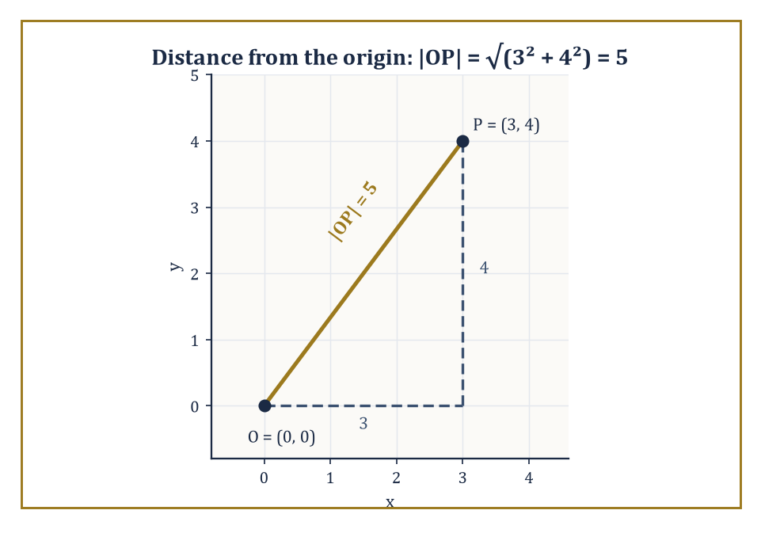
Figure 22.1 — The point P = (3, 4), its distance from the origin, and the 3-4-5 triangle doing the work underneath the square root.
The trick, once made, refuses to stay two-dimensional: add a third perpendicular axis and every point in space becomes an ordered triple (x, y, z), and nothing about the method minds being pushed to four coordinates, or four hundred, except our ability to draw a picture of it. The geometry does not become harder in higher dimensions so much as it becomes unillustrated.
Numeric example — Locate the point P = (3, 4) in the plane: three units along the x-axis, four along the y-axis. Its distance from the origin O = (0,0) is given by the Euclidean norm:
|OP| = √(3² + 4²) = √(9+16) = √25 = 5
— the famous 3-4-5 right triangle, now demoted to a special case of a coordinate formula. Extend to space: the point Q = (3, 4, 12) is at distance from the origin:
√(3²+4²+12²) = √(9+16+144) = √169 = 13
The method did not care that we added a dimension; it extended the sum under the square root.
Try it now — Distance from (1, 2) to (4, 6)? Answer →
The whole subject rests on one deliberate act of faith: that geometric statements and algebraic statements can be translated into each other without loss. ‘The point lies on the line’ becomes ‘the coordinates satisfy the linear equation’; ‘the curve is a circle’ becomes ‘the equation, once the squares are completed, has the form:
(x−h)² + (y−k)² = r²
This translation is exact — nothing is lost crossing from geometry to algebra and back — for every object elementary geometry studies, and it remains the working model for every more advanced geometry built on top of it.
Numeric example — Consider the line with equation 3x − y − 1 = 0. Does the point (1, 2) lie on it? Substitute:
3(1) − 2 − 1 = 3 − 2 − 1 = 0
The equation is satisfied, so yes — (1, 2) is on the line, purely as a matter of arithmetic, without any picture having been drawn. Now test (0, 0):
3(0) − 0 − 1 = −1 ≠ 0
so the origin is not on the line. Geometric incidence has become a one-line calculation.
Vectors and matrices supply the compact grammar for all of this. A plane through a point x₀ with normal vector n is the set of points x satisfying the condition that the vector from x₀ to x is perpendicular to n:
n · (x − x₀) = 0
The distance from a point to a line, in the plane or in space, comes out of a projection formula built from dot products (or, in three dimensions, a cross product); and the classification of conic sections — which of ellipse, parabola, or hyperbola a given quadratic equation describes — turns out to be nothing more exotic than applying the spectral theorem of Chapter 21 to a 2×2 symmetric matrix.
Analytic geometry is therefore not merely a subject in its own right; it is linear algebra, still warm from the previous chapter, put immediately to work.
Numeric example — Let the normal vector be n = (1, 2, 2) and let the plane pass through x₀ = (1, 0, 0). The condition n · (x − x₀) = 0 expands as:
1(x−1) + 2(y−0) + 2(z−0) = 0, i.e. x + 2y + 2z = 1
Check that x₀ itself satisfies it:
1 + 0 + 0 = 1 ✓
Now find another point on the plane by setting y = 1, z = 0: the equation gives
x + 2 = 1, so x = −1
and (−1, 1, 0) is a second point on the plane — found by pure algebra, with no ruler in sight.
There is a two-way benefit here worth pausing on. Geometry gives algebra something to picture — an otherwise abstract equation acquires a shape, a symmetry, a reason to be true.
Algebra gives geometry something to prove — a claim that looks obvious in a hand-drawn diagram (‘clearly these two lines meet at one point’) becomes a guaranteed fact once it is reduced to solving simultaneous equations, immune to the possibility that the diagram was drawn slightly wrong.
Every theorem in this chapter will be proved algebraically and explained geometrically, in that order of reliability if not of charm.
Numeric example — Sketch, freehand, the three lines x + y = 4, 2x − y = 2, and x − 2y = −5. On paper they can look as though they pass through a common point — freehand sketches are forgiving that way. Algebra is not: solving the first two simultaneously (add them):
3x = 6, so x = 2, then y = 2
gives the point (2, 2). Substitute (2, 2) into the third:
2 − 2(2) = 2 − 4 = −2, not −5
The third line misses the other two’s intersection point by a comfortable margin, a fact no amount of squinting at the sketch would have caught.
Keep only this · Section 22.1: What Analytic Geometry Is
The idea. Coordinates turn geometric questions into algebra: a curve is the solution set of an equation.
Core.
d(P, Q) = √((x₂ − x₁)² + (y₂ − y₁)²)
a curve = the solution set of an equation
Typical mistake. Mixing up the order of a point’s coordinates when substituting into an equation.
Minimal example. (1, 2) lies on 3x − y − 1 = 0, since 3 − 2 − 1 = 0.
Practice. Easy to challenge; full worked answers, with the usual mistake, are in Answers to the Practice Sets at the back.
Easy — Distance from (−1, 2) to (2, 6). Answer →
Medium — Is (2, 5) on the line through (0, 1) and (1, 3)? Answer →
Challenge — Show that (0, 0), (4, 0), (0, 3) form a right triangle using coordinates only. Answer →

Section 22.2: Lines and Planes in Coordinates
Four Ways to Write Down the Same Straight Idea
CORE · about 15 minutes · later chapters build on this
A straight line can be pinned down in several ways, and which one you use depends on what you are given. Two points will do; so will one point and a direction of travel; so will a slope and the place where the line crosses an axis. Each description leads to its own equation, and all of them describe the same set of points. Take the line through (1, 2) and (4, 8). Going from the first point to the second moves 3 across and 6 up, so every step of 1 across climbs 2: the direction (1, 2), or a slope of 2. Planes in space work the same way, with a second direction or a single perpendicular arrow.
Key idea — A line in the plane can be written in bewilderingly many equivalent ways, each suited to a different piece of given information.
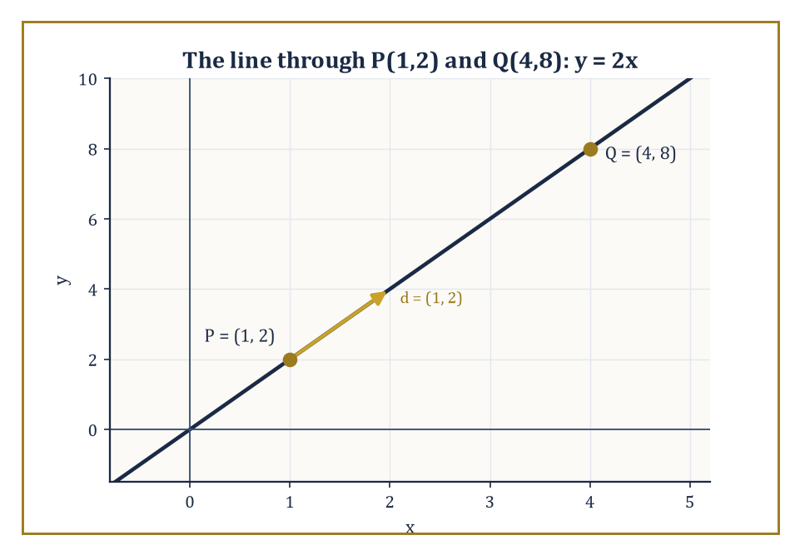
Figure 22.2 — The line through P(1,2) and Q(4,8), with its direction vector d = (1, 2) doing all the traveling.
In parametric form, a point moves along the line as the parameter t ranges over all real numbers, starting at x₀ and traveling in direction d.
x = x₀ + t d
In point-slope form, the line is pinned down by one point and a slope m.
y − y₀ = m(x − x₀)
In two-point form, the slope is computed from two given points before point-slope form is applied.
And in general linear form, the line is the level set of a linear function.
ax + by + c = 0
This is the form that generalizes most cleanly to planes and hyperplanes in higher dimensions.
Numeric example — Find the line through P = (1, 2) and Q = (4, 8).
The slope is computed from the two points:
m = (8−2)/(4−1) = 6/3 = 2
Using point-slope form at P:
y − 2 = 2(x − 1)
which rearranges to:
y = 2x
Check both points:
x = 1, y = 2(1) = 2 ✓; x = 4, y = 2(4) = 8 ✓
In general linear form this is:
2x − y = 0
In parametric form, starting at P with direction vector d = Q − P = (3, 6) (or the simplified (1,2)), the line is:
(x,y) = (1,2) + t(1,2)
At t = 3 this reaches Q, as it should:
(1+3, 2+6) = (4, 8) = Q
Try it now — Give a normal vector to 2x − y + 3z = 7 and one point on the plane. Answer →
In space, a single linear equation no longer pins down a line — it pins down a plane, since one equation in three unknowns leaves a two-parameter family of solutions.
A line in space is therefore best given parametrically, the same recipe as before with one more coordinate to carry:
x = x₀ + t d
A plane, meanwhile, can be specified either by a single linear equation:
ax + by + cz = d
or by a point x₀ together with two non-parallel direction vectors u and v lying in the plane, via:
x = x₀ + s u + t v
Numeric example — The line through (1, 0, −1) with direction (2, 1, 3) is:
(x, y, z) = (1+2t, t, −1+3t)
At t = 0 this is the starting point, at t = 1 it moves further along, and at t = −1 it moves the other way:
t = 0: (1, 0, −1); t = 1: (3, 1, 2); t = −1: (−1, −1, −4)
Three points, one formula, and the parameter t is doing all the work of ‘how far along’.
The normal vector to a plane ax + by + cz = d is read off without any work at all: it is the vector of coefficients,
n = (a, b, c)
Two planes are parallel exactly when their normals are parallel (scalar multiples of each other), and perpendicular exactly when their normals are perpendicular, i.e. their dot product vanishes.
This is one of the small mercies of the subject — an entire angular relationship between two infinite flat objects reduces to a question about two triples of numbers.
Numeric example — Take the planes x + y + z = 1 (normal n₁ = (1,1,1)) and x − 2y + z = 0 (normal n₂ = (1,−2,1)).
Their dot product is:
n₁ · n₂ = (1)(1) + (1)(−2) + (1)(1) = 1 − 2 + 1 = 0
so the planes are perpendicular.
Compare with x + y + z = 1 and 2x + 2y + 2z = 5: the second normal (2,2,2) is exactly 2n₁, so these two planes are parallel — and, since 2x+2y+2z=5 means x+y+z=2.5 rather than 1, they are distinct parallel sheets that never meet.
When two planes are not parallel, they meet in a line, and there are two equivalent ways to find it.
One can solve the two linear equations simultaneously, treating one variable as a free parameter.
Or — more elegantly — one can note that the direction of the intersection line must be perpendicular to both normals, and the cross product n₁ × n₂ is the vector perpendicular to both.
A single point on the line, found by solving the system for one convenient slice, then completes the description.
Numeric example — Take the planes x+y+z=6 and x−y+z=2, with normals n₁=(1,1,1) and n₂=(1,−1,1). The cross product is:
n₁ × n₂ = (1·1 − 1·(−1), 1·1 − 1·1, 1·(−1) − 1·1) = (1+1, 1−1, −1−1) = (2, 0, −2)
so the direction (1, 0, −1) will do (after halving).
For a point on the line, set z = 0: the equations become:
x+y=6 and x−y=2
Adding gives:
2x=8, so x=4 and y=2
giving the point (4, 2, 0). Check it satisfies both original planes:
4+2+0=6 ✓ and 4−2+0=2 ✓
The line of intersection is:
(x,y,z) = (4,2,0) + t(1,0,−1)
These descriptions are, by design, the easy end of the subject — first-year material dressed in slightly more formal clothing.
But they already demonstrate the method’s whole ambition: geometric incidence, parallelism, and perpendicularity, concepts that used to require a protractor and a certain amount of squinting, have all become linear algebra.
Keep only this · Section 22.2: Lines and Planes in Coordinates
The idea. A plane is n · (x − x₀) = 0; a line is x₀ + t d. The coefficients of a plane’s equation are its normal vector.
Core.
line: r = r₀ + t d
plane: n · (r − r₀) = 0
two planes’ intersection direction: n₁ × n₂
Typical mistake. Confusing a line’s direction vector with a plane’s normal vector.
Minimal example. Plane through (1, 0, 0) with normal (1, 2, 2): x + 2y + 2z = 1.
Practice. Easy to challenge; full worked answers, with the usual mistake, are in Answers to the Practice Sets at the back.
Easy — Parametrize the line through (1, 2, 3) and (2, 4, 7). Answer →
Medium — Plane through (1, 0, 0), (0, 1, 0), (0, 0, 1). Answer →
Challenge — Direction of the line where x + y + z = 6 and x − y + z = 2 meet. Answer →

Section 22.3: Distances, Angles, and Projections
Pythagoras, Generalized Until He Wouldn’t Recognize Himself
CORE · about 15 minutes · later chapters build on this
Distance, angle and shadow are what a ruler, a protractor and the midday sun measure, and vectors handle all three with the same few operations. The distance between two points is the length of the arrow joining them: from (1, 2, 3) to (4, 6, 3) the arrow runs three along, four across and nothing up, so the distance is 5, Pythagoras in three dimensions. The angle between two arrows comes from the dot product. The shadow, or projection, is the part of one arrow lying along another, the way a ladder casts a shadow on the ground, and the leftover part stands at right angles to it. Together they settle every nearest-point question in this section.
Definition — The distance between two points is the length — the Euclidean norm — of the vector joining them. If A and B are points with position vectors a and b, the distance is given by:
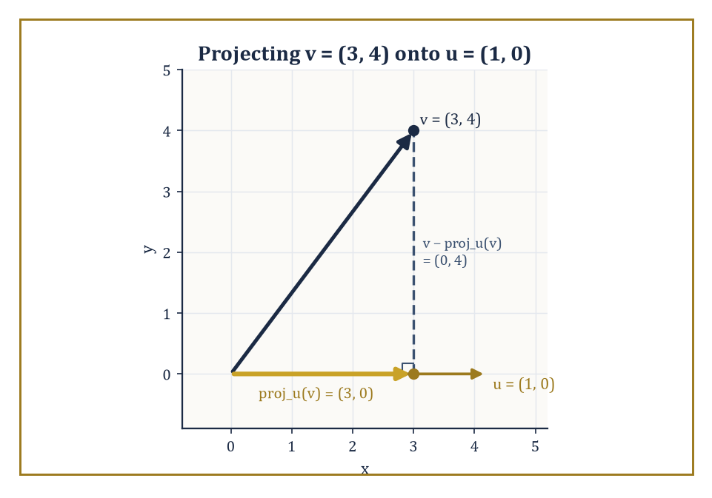
Figure 22.3 — The vector v = (3, 4) splits uniquely into its shadow along u and the perpendicular leftover — the whole subject in one picture.
|AB| = |b − a| = √((b−a)·(b−a))
In coordinates this is the familiar square-root-of-sum-of-squared-differences formula. It works identically in the plane, in space, or in as many dimensions as you have the nerve to write down.
Numeric example — Let A = (1,2,3) and B = (4,6,3). The difference vector is B − A = (3,4,0), and its length is:
|AB| = √(3² + 4² + 0²) = √(9+16) = √25 = 5
Note that the third coordinate contributed nothing here, since both points share z = 3 — the calculation automatically noticed that the real work was happening in a 3-4-5 triangle sitting inside the plane z = 3.
Try it now — Distance from (0, 0) to 3x + 4y − 10 = 0? Answer →
Distance from a point to a line or a plane is a slightly more interesting calculation. The idea is to take the vector from a known point on the line or plane to the external point, and project it onto the direction perpendicular to the line or plane (the ‘orthogonal complement’ of the line’s or plane’s own direction space). The length of that perpendicular component is the distance.
Worked out in coordinates, this collapses into a short formula: for a plane ax+by+cz=d and a point (x₀,y₀,z₀), the distance is:
distance = |ax₀+by₀+cz₀−d| / √(a²+b²+c²)
Numeric example — Find the distance from P=(1,1,1) to the plane x+2y+2z=9. Here a=1, b=2, c=2, d=9, so the formula gives:
|a x₀+b y₀+c z₀ − d| / √(a²+b²+c²) = |1+2+2−9| / √(1+4+4) = |−4| / 3 = 4/3
To check this directly: the foot of the perpendicular from P is P + t n where n=(1,2,2); substituting into the plane equation gives:
(1+t)+2(1+2t)+2(1+2t)=9, i.e. 5+9t=9, so t=4/9
The foot is (1+4/9, 1+8/9, 1+8/9) = (13/9, 17/9, 17/9). Its distance from P is:
|t|·|n| = (4/9)(3) = 4/3
This matches the formula exactly.
The angle between two lines is, by definition, the angle between their direction vectors (or its supplement, since a line has no preferred sense of travel); the angle between two planes is the angle between their normals; and the angle between a line and a plane is obtained from the angle between the line’s direction and the plane’s normal, then subtracted from a right angle, since direction and normal point in perpendicular senses when the line lies in the plane.
In every case the working formula is the same:
cos θ = (u · v)/(|u||v|)
Numeric example — Find the angle between the lines with direction vectors d₁=(1,1,0) and d₂=(1,0,1). Their dot product is:
d₁·d₂ = 1·1+1·0+0·1 = 1
Their lengths are:
|d₁| = √(1+1+0) = √2, |d₂| = √(1+0+1) = √2
So:
cos θ = 1/(√2·√2) = 1/2, giving θ = 60°
The two lines, though defined by rather arbitrary-looking direction vectors, meet at the angle of an equilateral triangle.
Orthogonal projection is the linear map doing all this work behind the scenes. The projection of a vector v onto a direction u is:
projᵤ(v) = ((v·u)/(u·u)) u
This is the ‘shadow’ v casts along u — and subtracting this shadow from v leaves the component of v perpendicular to u. Every vector splits uniquely into a piece parallel to a given direction and a piece perpendicular to it, and this decomposition is what the distance and angle formulas above are built from.
Numeric example — Project v=(3,4) onto u=(1,0). Compute:
projᵤ(v) = ((v·u)/(u·u)) u = ((3)/(1)) (1,0) = (3,0)
The perpendicular component is:
v − projᵤ(v) = (3,4) − (3,0) = (0,4)
Check the two pieces are perpendicular, and that they sum back to v:
(3,0)·(0,4) = 0 ✓, (3,0)+(0,4) = (3,4) = v ✓
In this simple case the projection is just ‘keep the x-coordinate, discard the y’, because u happened to point along the x-axis — the general formula reduces gracefully to the obvious answer when the obvious answer is available.
For the special case of a line meeting a plane, the natural angle to report is the one between the line and the plane itself, not between the line and the plane’s normal — and since a line lying in the plane is exactly perpendicular to the normal, the line-plane angle and the line-normal angle are complementary, so a small subtraction from 90° finishes the job.
Numeric example — Find the angle between the line with direction d=(1,0,1) and the plane z=0 (the xy-plane, normal n=(0,0,1)). First find the angle between d and n:
cos φ = (d·n)/(|d||n|) = (0+0+1)/(√2 · 1) = 1/√2, so φ = 45°
The angle between the line and the plane itself is:
90° − φ = 90° − 45° = 45°
In this particular case the two angles happen to coincide numerically, because 45° is its own complement — a coincidence of this example, not a general fact.
All of these quantities — distances, angles, the lengths of projected shadows — are invariant under rigid motions: rotate or translate the whole picture, and none of them change, precisely because rotations and translations preserve dot products. They are, in other words, the first worked examples in this chapter of a running theme: geometric invariants computed by linear algebra.
Keep only this · Section 22.3: Distances, Angles, and Projections
The idea. Distance from a point to a plane is |n · p − d|/|n|; the angle between a line and a plane is 90° minus the angle to the normal.
Core.
d(P, plane) = |n · P − d|/|n|
cos θ = (u · v)/(|u||v|)
Typical mistake. Dividing by |n|² rather than |n|.
Minimal example. Distance from (1, 1, 1) to x + 2y + 2z = 9: |5 − 9|/3 = 4/3.
Practice. Easy to challenge; full worked answers, with the usual mistake, are in Answers to the Practice Sets at the back.
Easy — Angle between (1, 0) and (1, 1). Answer →
Medium — Distance from (2, 1, 0) to 2x − y + 2z = 0. Answer →
Challenge — Distance from (0, 0) to the line through (1, 0) and (0, 1). Answer →

Section 22.4: Circles, Spheres, and Simple Quadric Surfaces
Completing the Square, One More Time, For Old Times’ Sake
CORE · about 15 minutes · later chapters build on this
A circle is the easiest shape there is to describe in words: every point at the same distance from a center. A compass draws one by holding that distance fixed. Coordinates turn the description straight into an equation, using the distance formula from the previous section. The circle with center (2, −3) and radius 5 passes through the point (5, 1), because that point lies 3 across and 4 up from the center, and 3, 4, 5 is a right triangle. A sphere is the same idea in three dimensions, and stretching a sphere by different amounts along each axis, or bending it open, produces the ellipsoids, paraboloids and saddles known as the simple quadric surfaces.
Definition — A circle with center (h,k) and radius r is the set of points at distance r from the center.
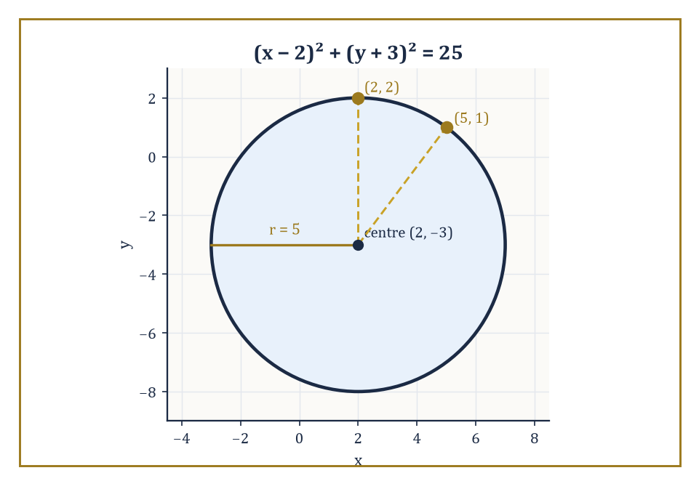
Figure 22.4 — The circle (x−2)² + (y+3)² = 25, with the two checked points sitting obediently on its rim.
(x−h)²+(y−k)²=r²
This is the distance formula from the previous section, squared to avoid an unnecessary square root, and set equal to a constant.
Numeric example — The circle with center (2,−3) and radius 5 has equation
(x−2)²+(y+3)²=25
Check the point (2,2):
(2−2)²+(2+3)²=0+25=25 ✓
so it lies on the circle. Check (5,1):
(5−2)²+(1+3)²=9+16=25 ✓
Also on the circle, and incidentally the same 3-4-5 triangle from What Analytic Geometry Is turning up again, this time as the radius itself rather than a chord.
Try it now — Center and radius of x² + y² + 2x − 4y = 4? Answer →
A circle rarely arrives pre-packaged in center-radius form; it more often turns up as a general equation
x²+y²+Dx+Ey+F=0
and the job of recovering the center and radius is completing the square in x and in y separately.
(x−h)²+(y−k)²=r²
The process either succeeds in producing this form with r²>0 (a genuine circle), or reveals r²=0 (the locus is a single point), or reveals r²<0 (the locus is empty — a circle of imaginary radius, which is a beautiful piece of algebra describing absolutely nothing in the real plane).
Numeric example — Take
x²+y²−4x+6y−3=0
Group and complete the square:
(x²−4x) + (y²+6y) = 3
Completing each square:
x²−4x+4=(x−2)², adding 4
y²+6y+9=(y+3)², adding 9
Add the same 4+9=13 to the right side:
(x−2)²+(y+3)² = 3+13 = 16
So the center is (2,−3) and the radius is √16=4 — the same center as the previous example, but a different circle.
Nothing about this procedure minds an extra variable. In three dimensions, the general equation
x²+y²+z²+Dx+Ey+Fz+G=0
completes the square in the same way to give
(x−h)²+(y−k)²+(z−l)²=r²
the equation of a sphere of radius r centered at (h,k,l).
Numeric example — Take
x²+y²+z²−2x+4y−6z+5=0
Complete each square:
x²−2x+1=(x−1)², adding 1
y²+4y+4=(y+2)², adding 4
z²−6z+9=(z−3)², adding 9
So the equation becomes
(x−1)²+(y+2)²+(z−3)² = −5+1+4+9 = 9
The center is (1,−2,3) and the radius is √9=3.
Some surfaces are best understood as something simpler dragged or spun through space. A cylinder is a plane curve extended uniformly along a perpendicular direction; the circular cylinder
x²+y²=r²
(with z left completely unconstrained) is the circle of radius r in the xy-plane, copied at every height.
A cone is obtained by joining every point of a curve to a fixed apex by straight lines; the right circular cone
x²+y²=z²
is generated by lines through the origin at a constant angle to the z-axis.
A surface of revolution, more generally, is formed by rotating a plane curve about an axis; slicing any of these surfaces with a well-chosen plane is precisely how the ancient Greeks first produced the conic sections, which is where the next section picks up the story.
Numeric example — Take the line z=y in the yz-plane (for y≥0) and rotate it about the z-axis. A point at parameter y=1 (so z=1) sweeps out, at rotation angle θ, the point (cos θ, sin θ, 1) — a circle of radius 1 at height 1. Check this lies on x²+y²=z²:
cos²θ+sin²θ = 1 = 1² ✓, for every θ
The rotated line has produced the cone x²+y²=z², regardless of which value of θ we chose — which is the whole point of a surface of revolution: every rotational copy of the generating curve satisfies the same equation.
Every horizontal slice of the cone x²+y²=z² is itself a circle, and it is worth checking how that circle’s radius depends on height, since exactly this kind of dependence is what will turn an oblique slice into an ellipse rather than a circle once the next section starts tilting the cutting plane.
Numeric example — At height z=k, the cone’s equation x²+y²=z² becomes
x²+y²=k², a circle of radius |k|
At z=3 this is
x²+y²=9, a circle of radius 3
at z=5 it is
x²+y²=25, a circle of radius 5
The radius grows in exact proportion to the height — double the height, double the radius — which is the straight-line widening that gives a cone its familiar shape, and the pattern that a tilted slicing plane will disturb in Conic Sections.
The circle equation’s completing-the-square procedure can also fail gracefully rather than producing a genuine circle, and it is worth watching both failure modes happen with the same coefficients D and E, varied only in the constant term F, to see how thin the line between ‘shape’ and ‘no shape at all’ really is.
Numeric example — Take
x²+y²−6x+8y+25=0
Complete the square:
(x−3)²−9+(y+4)²−16+25=0
i.e.
(x−3)²+(y+4)² = 9+16−25 = 0
A sum of two squares equal to zero forces both squares to be zero, so the only solution is the single point (3,−4) — a ‘circle’ of radius zero. Now change only the constant term to 30:
x²+y²−6x+8y+30=0
gives
(x−3)²+(y+4)² = 9+16−30 = −5
A sum of two real squares can never be negative, so this equation has no solutions at all — an empty locus, sometimes called an imaginary circle, produced by changing a single digit in the original equation.
A cylinder need not be built from a circle at all: take any plane curve and drag it uniformly along a perpendicular axis, and whatever the curve’s own equation happens to be becomes the cylinder’s equation unchanged, simply reinterpreted as living in one extra, unconstrained variable.
Numeric example — Take the parabola y=x² in the xy-plane and drag it freely along the z-axis to form a parabolic cylinder, with equation y=x² (z entirely unconstrained). Check the point (2,4,7):
y=x² requires 4=2²=4 ✓
and z=7 played no role whatsoever in the check — as it should not, since the cylinder contains the point (2,4,z) for every real z, not just z=7.
Keep only this · Section 22.4: Circles, Spheres, and Simple Quadric Surfaces
The idea. Complete the square in each variable to read off center and radius; quadric surfaces are named by their cross-sections.
Core.
(x − a)² + (y − b)² = r²
(x − a)² + (y − b)² + (z − c)² = r²
Typical mistake. Adding the squared terms to only one side when completing the square.
Minimal example. x² + y² − 4x = 0 ⇒ (x − 2)² + y² = 4.
Practice. Easy to challenge; full worked answers, with the usual mistake, are in Answers to the Practice Sets at the back.
Easy — Center and radius of x² + y² + 6y = 7. Answer →
Medium — Center and radius of the sphere x² + y² + z² − 2x + 4z = 4. Answer →
Challenge — Is x² + y² + 2x + 5 = 0 a circle? Answer →

Section 22.5: Conic Sections: Classification and Properties
Ellipse, Parabola, Hyperbola: A Discriminating Trio
CORE · about 15 minutes · later chapters build on this
Slice an ice-cream cone with a knife and the cut edge takes one of a few shapes. Cut at a gentle slant and you get an oval, an ellipse; tilt the knife until it runs parallel to the side of the cone and you get a parabola; tilt it further, on a double cone, and you cut both halves, getting the two branches of a hyperbola. Planets travel on ellipses, thrown balls on parabolas and some comets on hyperbolas. An ellipse 10 units long and 6 units wide has its two focal points 8 units apart, which makes it fairly elongated. This section shows how to tell the three curves apart from a single number computed from their equation.
Definition — A conic section is, classically, whatever curve results from slicing a double cone with a plane — a definition that is elegant, three-dimensional, and slightly awkward to compute with. The algebraic definition is more useful in practice: a conic is the locus of a second-degree equation
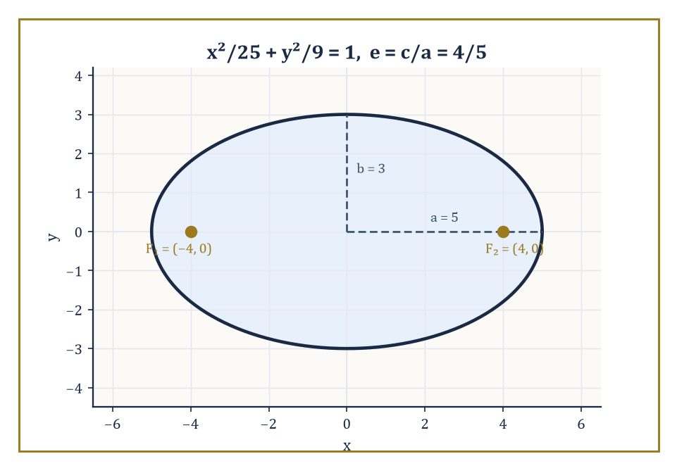
Figure 22.5 — The ellipse x²/25 + y²/9 = 1, with its two foci sitting safely inside — eccentricity 4/5, fairly elongated as ellipses go.
ax²+bxy+cy²+dx+ey+f=0
The type of curve this describes — ellipse, parabola, or hyperbola — is read off from the discriminant b²−4ac: negative for an ellipse, zero for a parabola, positive for a hyperbola (with a short list of degenerate cases — a point, a line, a pair of lines, or nothing at all — arising when the equation factors or otherwise fails to describe a proper curve).
Numeric example — Classify three curves by their discriminant. First, consider the curve
4x²+9y²−36=0
Here a=4, b=0, c=9, so
b²−4ac = 0−4(4)(9) = −144 < 0
an ellipse (indeed x²/9+y²/4=1, semi-axes 3 and 2). Second, consider
y²−4x=0
Here a=0 (no x² term), b=0, c=1, so
b²−4ac = 0−0 = 0
a parabola (this is the familiar y²=4x). Third, consider
x²−y²−1=0
Here a=1, b=0, c=−1, so
b²−4ac = 0−4(1)(−1) = 4 > 0
a hyperbola (the standard x²−y²=1).
Try it now — Eccentricity of x²/25 + y²/9 = 1? Answer →
Beyond the bare classification, each conic carries a geometric personality captured by its eccentricity e — the ratio, in the focus-directrix definition, of distance to a fixed point (the focus) over distance to a fixed line (the directrix).
Circles have e=0; ellipses have 0<e<1; parabolas sit at e=1; hyperbolas have e>1.
Each type also carries a reflective property that makes it useful rather than merely pretty: an ellipse reflects rays from one focus to the other (the principle behind whispering galleries), a parabola reflects rays parallel to its axis through a single focus (the principle behind satellite dishes and car headlights), and a hyperbola reflects rays aimed at one focus away from the other.
Numeric example — For the ellipse
x²/25+y²/9=1
we have a²=25 and b²=9, so a=5 and b=3. The focal distance satisfies
c²=a²−b²=25−9=16
so c=4. The eccentricity is
e=c/a=4/5=0.8
— fairly elongated, as ellipses go — and the foci sit at (±4,0), safely inside the ellipse, just as the focus-directrix definition requires.
Hyperbolas work the same way, save for a change of sign in the relationship between a, b, and c: since a hyperbola’s two arms flare outward forever rather than closing into a loop, the defining relation becomes
c²=a²+b²
rather than the ellipse’s c²=a²−b², and the eccentricity always comes out greater than 1.
Numeric example — For the hyperbola
x²/9−y²/16=1
we have a²=9 and b²=16, so a=3 and b=4. Here
c²=a²+b²=9+16=25
so c=5. The eccentricity is
e=c/a=5/3≈1.67
comfortably above 1, and the foci sit at (±5,0) — this time outside the curve’s own vertices at (±3,0), since a hyperbola’s foci lie beyond where the curve itself ever reaches.
When the cross term bxy is present, the conic’s axes are tilted relative to the coordinate axes, and a rotation of coordinates removes the tilt: choosing the rotation angle correctly makes the xy-term vanish in the new coordinates.
A subsequent translation, completing the square as in the previous section, then reduces the equation to one of the standard forms.
Both steps are, once again, linear algebra in disguise: the quadratic terms ax²+bxy+cy² correspond to a symmetric 2×2 matrix, the rotation that eliminates the cross term is exactly the orthogonal matrix that diagonalizes it, and the diagonal entries after rotation are its eigenvalues.
Numeric example — Consider the equation
xy=1
an equation with an obvious cross term and no x² or y² term at all. Rotate axes by 45°, substituting
x=(x′−y′)/√2 and y=(x′+y′)/√2
(the standard 45° rotation formulas). Then
xy = [(x′−y′)/√2]·[(x′+y′)/√2] = (x′²−y′²)/2
The equation xy=1 becomes
(x′²−y′²)/2=1, i.e. x′²−y′²=2
— a hyperbola in standard form, with its axes now aligned with the new x′ and y′ axes rather than sitting at 45° to them, as the original x and y axes were.
The focus-directrix definition is easiest to see in its purest form on a parabola, where there is only one focus and one directrix to keep track of, rather than the two of each that an ellipse or hyperbola requires.
Numeric example — The parabola
y²=4x
has focus (1,0) and directrix x=−1 (the standard form y²=4px has p=1 here). Take the point (1,2) on the curve — check it satisfies the equation:
2²=4=4(1) ✓
Its distance to the focus (1,0) is
√((1−1)²+(2−0)²) = √4 = 2
Its distance to the directrix x=−1 is the horizontal gap
1−(−1) = 2
The two distances agree, as the focus-directrix definition of a parabola requires — every point on the curve is equidistant from a fixed point and a fixed line.
The same threefold classification reappears well outside pure geometry: orbits under an inverse-square force (planets, comets, the occasional ambitious spacecraft) are always conic sections, with the type determined by the total energy of the orbit — negative energy gives an ellipse, zero gives a parabola, positive gives a hyperbola.
Perspective drawing, too, projects circles into ellipses as a matter of course, which is why a coin sketched at an angle always ends up looking suspiciously like an ellipse rather than a circle, no matter how carefully the artist rounds it.
Keep only this · Section 22.5: Conic Sections: Classification and Properties
The idea. Ellipse c² = a² − b²; hyperbola c² = a² + b²; eccentricity e = c/a sorts the conics.
Core.
ellipse x²/a² + y²/b² = 1, c² = a² − b², e = c/a < 1
parabola e = 1
hyperbola c² = a² + b², e > 1
Typical mistake. Using the hyperbola relation for an ellipse, or the reverse.
Minimal example. x²/9 − y²/16 = 1: c = 5, e = 5/3.
Practice. Easy to challenge; full worked answers, with the usual mistake, are in Answers to the Practice Sets at the back.
Easy — Classify x²/4 + y² = 1 and give its semi-axes. Answer →
Medium — Foci of x²/16 − y²/9 = 1. Answer →
Challenge — Focus and directrix of y = x²/8. Answer →

Section 22.6: The General Second-Degree Equation
One Matrix to Rule Them All (the 2×2 Kind, At Least)
CORE · about 15 minutes · later chapters build on this
Draw an ellipse at a slant and its equation acquires an awkward mixed term, a piece in which the two coordinates are multiplied together. The curve itself is perfectly ordinary; it has simply been rotated away from the axes. Tilt your head to line up with the curve’s own axes and the mixed term disappears, leaving an equation you can read at a glance. This section turns that head-tilt into a procedure. The tilted curve given by five x squared, plus four x times y, plus eight y squared, equal to 36, turns out to be an ellipse whose own half-axes are 3 and 2 long, once you look along the right directions.
Key idea — The previous section’s rotation trick generalizes into a full algorithm. Write the quadratic part ax²+bxy+cy² as the matrix expression xᵀAx, where x=(x,y) and A is the symmetric matrix
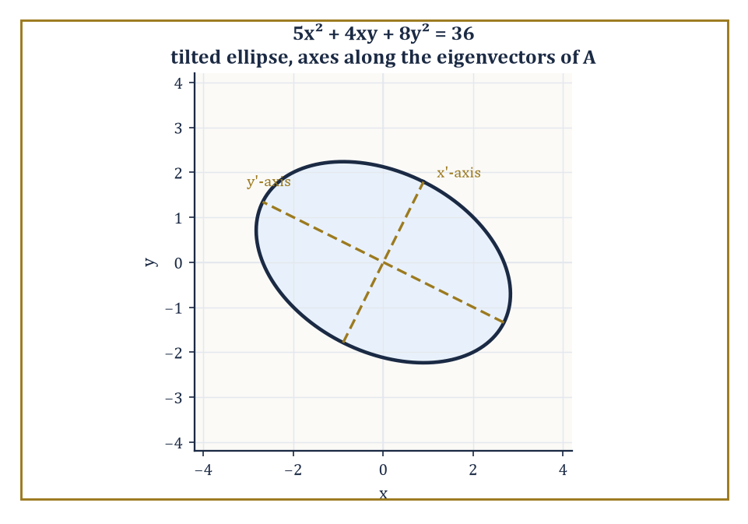
Figure 22.6 — 5x² + 4xy + 8y² = 36, tilted in the xy-plane but perfectly upright once you look along its own eigenvectors.
A = [a b/2; b/2 c]
Note the cross-term coefficient is split evenly between the two off-diagonal entries, so that the matrix is symmetric and xᵀAx correctly reproduces bxy when the off-diagonal contributions are added together. Since A is symmetric, the spectral theorem (Chapter 21, and not for the last time) guarantees it can be diagonalized by an orthogonal matrix — a rotation — whose columns are the eigenvectors of A.
In the rotated coordinates the cross term is gone, and the quadratic part becomes
λ₁x′² + λ₂y′²
for the eigenvalues λ₁,λ₂. A subsequent translation completes the square in each variable, exactly as before, to reach a standard form or a degenerate one.
Theorem — Principal axes theorem (conics)
Every conic ax² + bxy + cy² + dx + ey + f = 0 can be rotated and translated into λ₁x′² + λ₂y′² + (linear or constant terms) = 0. Here λ₁ and λ₂ are the eigenvalues of A = [a b/2; b/2 c], and the new axes point along its orthonormal eigenvectors.
Hypotheses — check each one before you use it:
□ the quadratic part is not identically zero
□ A is symmetric: the cross coefficient is split in half
□ the rotation is orthogonal (Q with QᵀQ = I), so lengths and angles survive
Why it matters. It is the spectral theorem of Chapter 21 drawn on paper: the eigenvectors are the axes of the quadratic form, and type follows from the eigenvalue signs (both the same, ellipse; opposite, hyperbola; one zero, parabola).
Numeric example — Classify the conic given by
5x²+4xy+8y²=36
The associated symmetric matrix is
 | A= |  | 5 | 2
 | A= |  | 2 | 8
since the cross-term coefficient 4 splits into 2 and 2. Its eigenvalues solve det(A−λI)=0, which expands as follows.
(5−λ)(8−λ)−4=0
40−13λ+λ²−4=0
λ²−13λ+36=0
By the quadratic formula,
λ=(13±√(169−144))/2=(13±√25)/2=(13±5)/2
giving λ=9 or λ=4. As a check: the trace of A is 5+8=13, and 9+4=13 ✓; the determinant of A is 5·8−2·2=36, and 9·4=36 ✓. In the rotated coordinates the equation becomes
9x′²+4y′²=36, i.e. x′²/4+y′²/9=1
an ellipse with semi-axes 2 and 3, its tilt in the original x,y coordinates now completely accounted for by the eigenvectors of A.
Try it now — Classify x² + 4xy + y² = 1 by the eigenvalues of its matrix. Answer →
The parabolic case corresponds to one of the two eigenvalues vanishing outright: the quadratic form is degenerate in one direction, which is why a parabola opens up indefinitely rather than closing into a bounded curve the way an ellipse does.
Numeric example — Rewrite y²=4x as
y²−4x=0
with a=0 (coefficient of x²), b=0, c=1 (coefficient of y²). The matrix is
 | A= |  | 0 | 0
 | A= |  | 0 | 1
already diagonal, with eigenvalues its diagonal entries, 0 and 1. The zero eigenvalue is the matrix-theoretic fingerprint of the parabolic type, agreeing with the discriminant test from Conic Sections:
b²−4ac=0−4(0)(1)=0
The pleasant surprise is that one need not perform the rotation to classify the conic. Certain combinations of the coefficients are invariant under rigid motions — they do not change when the coordinate axes are rotated or translated — and these invariants alone determine the type.
The trace and determinant of the 2×2 matrix A determine the eigenvalues (hence whether the conic is an ellipse, parabola, or hyperbola), while the determinant of the full 3×3 matrix built from all the coefficients (quadratic, linear, and constant) determines whether the conic is degenerate.
The same program — bigger matrices, same idea — classifies quadric surfaces in space, which is where the next section is headed.
Numeric example — For
5x²+4xy+8y²−36=0
(no linear terms, for simplicity), the full 3×3 matrix, with rows and columns ordered (x,y,1), is
 |  | 5 | 2 | 0
 |  | 2 | 8 | 0
 |  | 0 | 0 | −36
Its determinant, expanding along the bottom row, is
 | (−36)·det |  | 5 | 2 |  | = (−36)·(40−4) = (−36)(36) = −1296
 | (−36)·det |  | 2 | 8 |  | = (−36)·(40−4) = (−36)(36) = −1296
which is nonzero — confirming the conic is non-degenerate, consistent with the genuine ellipse found in the previous example. Had this determinant come out to be zero, the equation would have described a degenerate conic — a point, a line, or a pair of lines — rather than a proper curve.
It is worth seeing a degenerate case up close, since the classification machinery handles it just as gracefully as it handles honest curves.
When the second-degree equation factors into two linear expressions, the ‘conic’ is nothing but a pair of intersecting (or parallel, or coincident) lines — a limiting case the ancient Greeks would have politely declined to call a conic section at all, but which the algebra cannot help producing.
Numeric example — Take
x²−4y²=0
This factors directly.
x²−4y² = (x−2y)(x+2y)
So the equation
(x−2y)(x+2y)=0
holds exactly when x−2y=0 or x+2y=0 — two straight lines through the origin, y=x/2 and y=−x/2. Checking with the matrix machinery:
 | A= |  | 1 | 0
 | A= |  | 0 | −4
already diagonal, no rotation needed, with eigenvalues 1 and −4 — one positive, one negative, which is the ellipse/hyperbola-type signature, except that the constant term is zero, so the ‘hyperbola’ has degenerated to its own pair of asymptotes. The invariant test (the 3×3 determinant, here built from A and a zero constant row) comes out to zero, correctly flagging degeneracy.
The full invariant test can even distinguish a genuine ellipse from its empty, purely imaginary twin — a distinction the eigenvalues alone cannot make, since two equations can share identical quadratic terms, and hence identical eigenvalues, while describing entirely different loci.
The difference lives in the sign of the constant term relative to those eigenvalues, which is just what the diagonalized form makes transparent.
Numeric example — Compare
5x²+4xy+8y²=36
diagonalized earlier to
9x′²+4y′²=36, i.e. x′²/4+y′²/9=1
a genuine ellipse — with the equation
5x²+4xy+8y²=−36
which has the same quadratic part and hence the same eigenvalues 9 and 4. Diagonalized, this becomes
9x′²+4y′²=−36
But the left-hand side, a sum of two non-negative terms (since 9 and 4 are both positive and squares are non-negative), can never be negative. The equation has no real solutions whatsoever: an empty locus produced by nothing more than flipping the sign of the constant term.
Keep only this · Section 22.6: The General Second-Degree Equation
The idea. The quadratic part is xᵀAx with A symmetric; the eigenvectors of A are the axes of the conic and the signs of its eigenvalues give its type.
Core.
ax² + bxy + cy² ↦ A = [a b/2; b/2 c]
eigenvalues: same sign ellipse, opposite hyperbola, one zero parabola
discriminant b² − 4ac
Typical mistake. Forgetting to halve the cross-term coefficient when building A.
Minimal example. 5x² + 4xy + 8y² = 36 ⇒ 9x′² + 4y′² = 36.
Practice. Easy to challenge; full worked answers, with the usual mistake, are in Answers to the Practice Sets at the back.
Easy — Discriminant type of 3x² + 2xy + y² = 1. Answer →
Medium — Remove the cross term of xy = 2. Answer →
Challenge — For which k is x² + kxy + y² = 1 an ellipse? Answer →

Section 22.7: Quadric Surfaces in Space
The Conic Sections Grow Up and Move to Three Dimensions
CORE · about 15 minutes · later chapters build on this
Definition — A quadric surface is the three-dimensional generalization of a conic section: the locus of a second-degree equation in three variables.
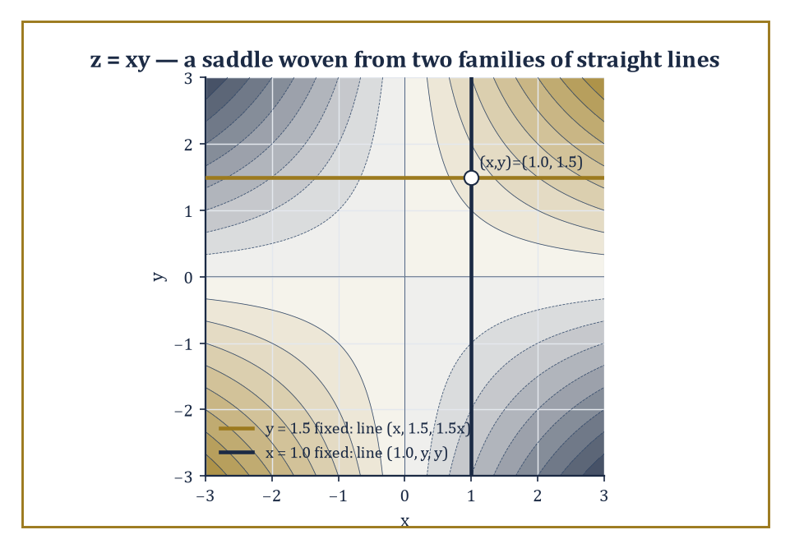
Figure 22.7 — z = xy shown as a contour map, with the two straight generating lines through one point — a curved saddle built from nothing but straight beams.
The standard catalog — every non-degenerate quadric is, after a suitable rotation and translation, one of these — comprises the ellipsoid, the hyperboloid of one sheet, the hyperboloid of two sheets, the elliptic paraboloid, the hyperbolic paraboloid, the (elliptic) cone, and the various cylinders.
Each has a normal form reached as in the planar case: rotate coordinates to diagonalize the quadratic part, then translate to simplify or eliminate the linear terms.
Numeric example — Consider the ellipsoid below, which has semi-axes 2, 3, and 4 along the x, y, and z directions respectively.
x²/4+y²/9+z²/16=1
Check the point (2,0,0):
4/4+0+0=1 ✓
the ‘tip’ of the ellipsoid along the x-axis. Check (0,3,0):
0+9/9+0=1 ✓
the tip along the y-axis. Now check that (2,3,4) is NOT on the surface, despite being made of exactly the three semi-axis lengths:
4/4+9/9+16/16=1+1+1=3≠1
— a useful reminder that the semi-axes are where the ellipsoid meets each axis individually, not a point you can combine freely.
Try it now — Name x² + y² − z² = 1 and x² + y² − z² = −1. Answer →
The hyperboloids differ from the ellipsoid by a single sign, with dramatic consequences for their shape.
A hyperboloid of one sheet is a single connected surface that pinches in toward a waist and flares outward in both directions along the z-axis — think of a power-station cooling tower.
x²/a²+y²/b²−z²/c²=1
A hyperboloid of two sheets is the opposite: two separate bowl-shaped surfaces, one for x≥a and one for x≤−a, with a genuine gap between them where no real points exist at all.
x²/a²−y²/b²−z²/c²=1
Numeric example — Consider the one-sheet hyperboloid below.
x²/4+y²/9−z²/16=1
Check the point (2,0,0):
4/4+0−0=1 ✓
on the surface. At height z=4, the equation becomes:
x²/4+y²/9=1+16/16=2
an ellipse of larger size than the waist ellipse at z=0 — confirming the surface flares outward, but never breaks into two pieces, as z ranges over all real numbers. Now consider the two-sheet hyperboloid:
x²/4−y²/9−z²/16=1
At x=0, the equation reads:
−y²/9−z²/16=1
impossible for real y,z since the left side is never positive — confirming there are no points with x=0, i.e. a genuine gap. At x=2, it reads:
1−y²/9−z²/16=1
forcing y=z=0 — the single point (2,0,0), the very tip of the nearer sheet.
The elliptic paraboloid is a bowl:
z=x²/a²+y²/b²
The hyperbolic paraboloid is the celebrated saddle shape, curving upward in one direction and downward in the perpendicular direction:
z=x²/a²−y²/b²
Two members of this catalog carry a further surprise: the hyperboloid of one sheet and the hyperbolic paraboloid are ruled surfaces, meaning that despite their curved appearance, they are entirely covered by straight lines — a fact exploited by architects, who can build a curved-looking roof out of nothing but straight beams.
Abstract example — Take the hyperbolic paraboloid below (a rescaled version of the standard form).
z=xy
Fix x at a constant value a: the equation becomes:
z=ay
which — as y varies with x held fixed at a — traces out the straight line {(a, y, ay) : y∈ℝ} in three-dimensional space. Check this satisfies z=xy:
z=ay and xy=a·y=ay ✓
for every y. Symmetrically, fixing y=b gives the line {(x, b, bx) : x∈ℝ}, since:
z=bx=xy when y=b
Through every point of the surface there pass two such straight lines — one from each family — which is exactly why a hyperbolic paraboloid can be built from a lattice of straight steel beams and still look like a saddle.
The classification of a quadric proceeds as for conics, with one dimension added throughout: the eigenvalues of the 3×3 symmetric matrix of quadratic terms determine which of the standard shapes is present, and the rank of the full 4×4 matrix (quadratic, linear, and constant terms together) determines whether the quadric is degenerate.
Quadric surfaces are not merely a museum exhibit, either: they appear as wave fronts in physics, as equipotential surfaces around charge distributions, and — perhaps most usefully for anyone destined for later chapters on optimization and statistics — as the level sets of quadratic functions, where a positive-definite matrix of second derivatives produces an ellipsoid (a well-behaved bowl with a single minimum) and an indefinite matrix produces a saddle-shaped hyperbolic paraboloid (a stationary point that is neither a maximum nor a minimum, and considerably more annoying to optimize near).
Numeric example — Consider the function:
f(x,y)=2x²+3y²
Its matrix of second derivatives (Hessian) is [4 0; 0 6], with eigenvalues 4 and 6, both positive — a positive-definite matrix — and the level sets f(x,y)=k for k>0 are ellipses:
2x²+3y²=k
nested around the single minimum at the origin, f(0,0)=0. Contrast this with:
g(x,y)=x²−y²
Hessian [2 0; 0 −2], eigenvalues 2 and −2 (one of each sign, an indefinite matrix): the origin is a saddle point, g increases as x moves away from 0 but decreases as y moves away from 0, and the level sets g(x,y)=k are hyperbolas for k≠0 — the same shape catalog from conic sections, now doing useful work diagnosing whether a stationary point is a comfortable minimum or a treacherous saddle.
Keep only this · Section 22.7: Quadric Surfaces in Space
The idea. A quadric is classified by the signs of the eigenvalues of its 3 × 3 symmetric matrix and by its constant.
Core.
signs of the eigenvalues of the 3 × 3 symmetric matrix, plus the constant, name the quadric
Typical mistake. Counting sheets by the number of minus signs without checking the constant’s sign.
Minimal example. x²/4 + y²/9 + z²/16 = 1: ellipsoid with semi-axes 2, 3, 4.
Practice. Easy to challenge; full worked answers, with the usual mistake, are in Answers to the Practice Sets at the back.
Easy — Name z = x² − y². Answer →
Medium — Name x² − y² − z² = 1. Answer →
Challenge — Classify x² + y² + z² + 2xy = 1 using the eigenvalues of its matrix. Answer →

Section 22.8: Transformations and Invariants
What Survives the Trip: A Traveler’s Guide to Invariants
CORE · about 15 minutes · later chapters build on this
Key idea — Rigid motions — rotations, translations, reflections, and their combinations — act on an equation by substitution: replace x by its expression in the new coordinates, and the equation transforms accordingly.
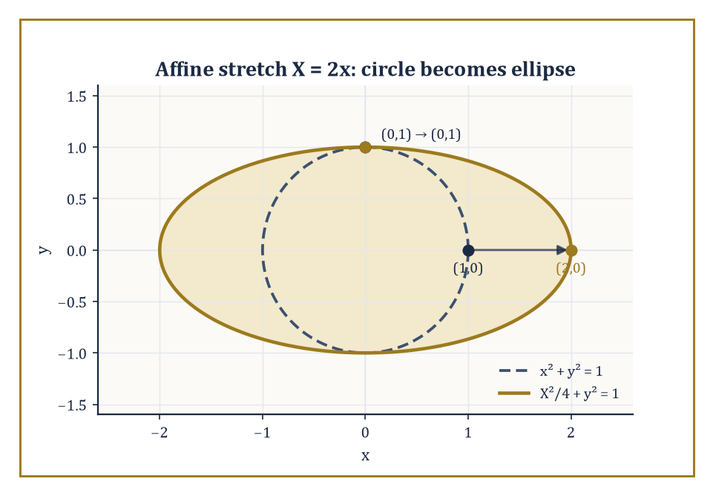
Figure 22.8 — An affine stretch turns the unit circle into an ellipse — roundness lost, but the shape’s status as a bounded conic survives the trip.
Because rigid motions preserve distances and angles, they preserve the geometric character of a locus outright: a circle stays a circle, an ellipse stays an ellipse of the same shape (though possibly relocated and reoriented).
This preserved character is just what the invariants of The General Second-Degree Equation and Quadric Surfaces in Space — the trace, determinant, and rank of the associated matrices — are built to detect, without needing to watch the transformation happen.
Numeric example — Consider the circle
x²+y²=25
centered at the origin with radius 5. Translate it by (3,−2) — substitute x→x−3, y→y+2 to shift the center to (3,−2) — giving
(x−3)²+(y+2)²=25
Check a point: (5,0) was on the original circle since
5²+0²=25
Its translated image is (5+3, 0−2)=(8,−2); check
(8−3)²+(−2+2)²=5²+0²=25 ✓
confirming the point moved rigidly with the whole curve, radius and shape completely unchanged.
Try it now — Does a rotation change the eccentricity of an ellipse? Does a stretch x ↦ 2x? Answer →
Affine transformations are a notch more general still than rigid motions — they allow stretching along the axes as well as rotating and translating — and they preserve straightness and parallelism, though no longer distances or angles.
A circle need not stay a circle under an affine transformation, but it always becomes an ellipse, since the transformation remains linear on the quadratic part of the equation.
Numeric example — Apply the stretch that doubles every x-coordinate and leaves y alone,
X=2x
to the circle
x²+y²=1
Substituting x=X/2 gives
(X/2)²+y²=1, i.e. X²/4+y²=1
an ellipse with semi-axes 2 and 1. Check the point (1,0) on the original circle: it maps to X=2(1)=2, giving (2,0); substitute into
X²/4+y²=4/4+0=1 ✓
Check (0,1): it maps to X=2(0)=0, giving (0,1); substitute:
0+1=1 ✓
The circle’s roundness did not survive the stretch, but its status as a bounded, closed conic did.
Rigid motions are a fairly conservative group of transformations — they cannot turn an ellipse into a hyperbola, since the discriminant’s sign is a rigid-motion invariant.
Enlarge the group to include projective transformations, however, and the distinctions start to dissolve: every non-degenerate conic — ellipse, parabola, hyperbola alike — becomes projectively equivalent to every other.
The tool that makes this precise is homogeneous coordinates: represent the point (x,y) by the triple [x:y:1], and more generally identify any two triples [X:Y:Z] and [λX:λY:λZ] (λ≠0) as the same point.
The projective plane becomes, in effect, the vector space ℝ³ with scaling forgotten — and linear algebra, once again, supplies the entire language.
Abstract example — Homogenize the circle
x²+y²=1
by substituting x=X/Z, y=Y/Z and clearing denominators:
X²+Y²=Z²
At infinity, where Z=0, this forces
X²+Y²=0
whose only real solution is X=Y=0 — not a valid projective point (the triple [0:0:0] is excluded by definition), so the circle has no real points at infinity at all.
Now homogenize the hyperbola
x²−y²=1
the same way:
X²−Y²=Z²
At infinity, Z=0 gives
X²=Y², so X=±Y
— two genuine points at infinity, [1:1:0] and [1:−1:0]. These are the directions of the hyperbola’s two asymptotes, y=x and y=−x, now revealed as the points where the curve ‘reaches’ infinity.
The ellipse and the hyperbola, so different as real curves, are distinguished projectively only by how many real points of the line at infinity they happen to pass through — none for the ellipse, two for the hyperbola.
A quick check would show the same for the parabola
y²=4x
whose homogenization is
Y²=4XZ, giving Y²=0 at Z=0
a single repeated point [1:0:0] — exactly one, with multiplicity two, for the parabola sitting on the boundary between the two cases.
Two further projective notions round out the picture and will resurface, transformed almost beyond recognition, much later in the series: the cross ratio, a numerical quantity attached to four collinear points that survives projective transformations even though individual distances and ratios of distances do not.
And poles and polars, a duality that pairs points with lines relative to a given conic, exchanging incidence for incidence in a way that turns every theorem about points into a theorem about lines, free of charge.
Together with the projective classification of quadric surfaces — which follows the same rank-and-signature logic as Quadric Surfaces in Space, now up to the larger projective group — these ideas form a natural bridge toward algebraic geometry, the subject of higher-degree curves and surfaces that Chapter 22 has spent its whole length preparing the ground for.
Numeric example — For four collinear points A, B, C, D with coordinates a, b, c, d measured along the line, the cross ratio is defined as
(A,B;C,D) = [(c−a)(d−b)] / [(c−b)(d−a)]
Take a=0, b=1, c=3, d=6.
(c−a)=3, (d−b)=5
so the numerator is
3·5=15
and
(c−b)=2, (d−a)=6
so the denominator is
2·6=12
The cross ratio is
15/12 = 5/4
This single number — 5/4 — depends only on how the four points sit relative to one another, and it is a theorem of projective geometry (the details of which take more machinery than fits in this section) that it stays exactly 5/4 under any projective transformation of the line, however drastically the individual gaps between the points are stretched or shrunk in the process.
Numeric example — For the circle
x²+y²=9
(radius 3), the polar line of the external point P=(5,0) is found by the standard substitution rule
x·5+y·0=9, i.e. x=9/5
This vertical line is the polar of P; geometrically, it passes through the two points where the tangent lines from P touch the circle. Check it is sensible: the point (9/5, y) lies on the circle when
(9/5)²+y²=9
i.e.
y²=9−81/25=(225−81)/25=144/25, so y=±12/5
— two real touching points, as expected since P=(5,0) lies outside the circle (distance 5 from the center, greater than the radius 3).
Keep only this · Section 22.8: Transformations and Invariants
The idea. Rigid motions preserve lengths, angles, eccentricity and the discriminant; affine maps preserve only conic type and parallelism.
Core.
rigid: lengths, angles
affine: parallelism, ratios along a line, conic type
projective: cross ratio, incidence
Typical mistake. Expecting distances to survive affine or projective maps.
Minimal example. The stretch x ↦ 2x turns the unit circle into an ellipse with semi-axes 2 and 1.
Practice. Easy to challenge; full worked answers, with the usual mistake, are in Answers to the Practice Sets at the back.
Easy — Does a translation change the discriminant of a conic? Answer →
Medium — Cross ratio of 0, 1, 2, 3 with (a, b; c, d) = ((c − a)(d − b))/((c − b)(d − a)). Answer →
Challenge — Why can a projective map turn an ellipse into a parabola, but no affine map can? Answer →

Chapter 22 in One Page
Lines and planes are linear equations; distances and angles come from dot products and projections. Circles, spheres and quadrics come from completing the square. Every conic is a quadratic form plus linear terms: rotating to the eigenvectors of its symmetric matrix removes the cross term, and the eigenvalue signs classify it. Invariants such as the discriminant and determinant classify without rotating. Rigid, affine and projective maps preserve successively less.
Key definitions
• Normal vector of a plane; direction vector of a line.
• Conic, eccentricity, foci, directrix.
• Symmetric matrix of a quadratic form, A = [a b/2; b/2 c].
• Quadric surface; ellipsoid, hyperboloids, paraboloids, cones and cylinders.
• Invariant of a class of transformations.
Key theorems, with their hypotheses
• Point–plane distance formula — hypothesis: n ≠ 0.
• Principal axes theorem — hypotheses: real symmetric A, orthogonal change of axes.
• Discriminant test — hypothesis: a non-degenerate conic (the 3 × 3 determinant is non-zero).
Canonical example
• 5x² + 4xy + 8y² = 36: A = [5 2; 2 8], eigenvalues 9 and 4, so x′²/4 + y′²/9 = 1, an ellipse with semi-axes 2 and 3 along the eigenvectors (1, 2)/√5 and (2, −1)/√5.
Common errors
• Not halving the cross term.
• Using |n|² in the distance formula.
• Hyperbola relation used for an ellipse.
• Calling an empty equation such as 9x′² + 4y′² = −36 an ellipse.
Readiness checklist — you are ready for what comes next when you can:
□ write the equation of a plane from a point and a normal, and of a line from two points
□ compute point–line and point–plane distances
□ complete the square to find centers and radii
□ classify a conic with a cross term by eigenvalues and by the discriminant
□ name a quadric from its equation
Section 22.9 that follows is a preview, marked optional: it says where these ideas lead in later chapters and volumes. Nothing in it is needed for the exercises.

Section 22.9: Where This Goes Next (Optional): From Analytic Geometry to Differential Geometry and Algebraic Geometry
The View From the End of This Chapter
PREVIEW — OPTIONAL · about 15 minutes · optional; read for orientation, nothing is examined
Overview — We have now acquired the basic vocabulary of analytic geometry: coordinate descriptions of lines and planes, distance and angle formulas built from dot products, circles and spheres from completed squares, conic sections and quadric surfaces classified by the eigenvalues of a symmetric matrix, and — in the last section — a first glimpse of the projective plane, where even the difference between an ellipse and a hyperbola becomes a question of how many points at infinity one is willing to count.
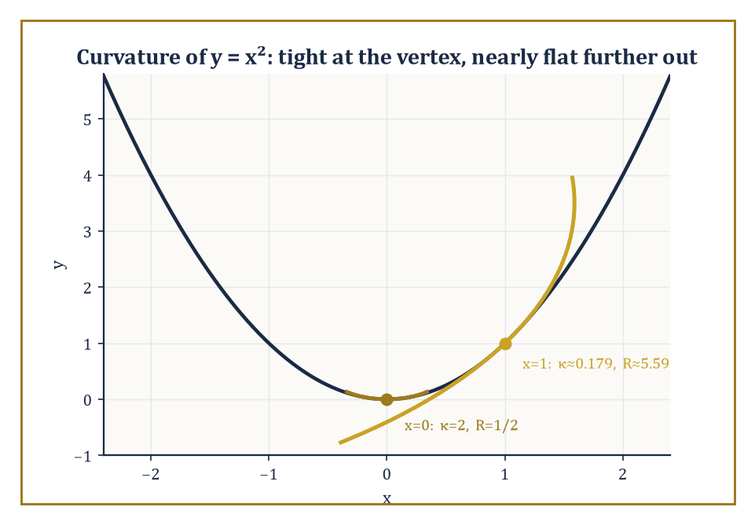
Figure 22.9 — The parabola y = x², hugged by two osculating circles — tightly curved at the vertex, almost forgetting it is curved at all further along.
These tools are the foundation of later geometric subjects, and it is worth naming the two most direct descendants. Differential geometry, first, replaces the global algebraic equation of a curve or surface with a local parametrization — a description of the surface piece by piece, as the image of a map from a flat parameter domain.
It studies differential invariants such as curvature (how sharply a curve bends) and torsion (how much a space curve twists out of its own osculating plane) that no single algebraic equation captures directly.
Numeric example — A circle of radius r has constant curvature at every point — the sharper the bend, the smaller the circle, the larger the curvature.
κ=1/r
Take r=2:
κ=1/2
This holds everywhere on the circle, with no exceptions. Contrast this with the parabola y=x², whose curvature at a point is given by
κ=|y″|/(1+y′²)^{3/2}
with y′=2x and y″=2. At the vertex x=0:
κ=2/(1+0)^{1.5}=2/1=2
At x=1: y′=2, so
κ=2/(1+4)^{1.5}=2/5^{1.5}=2/(5√5)≈2/11.18≈0.179
The parabola’s curvature has dropped by more than a factor of ten between these two points — it is sharply curved at its vertex and flattens out rapidly further along, a local piece of information that the single global equation y=x² does not display without this extra calculation. This is precisely the kind of quantity — varying from point to point rather than fixed for the whole curve — that differential geometry is built to track.
Try it now — Curvature of a circle of radius 4? Answer →
Algebraic geometry, second, keeps the coordinate method of this chapter but drops the restriction to degree two. A conic meets a line in at most two points (count them with multiplicity, over the complex numbers, and it is always exactly two); a cubic curve — degree three — meets a line in up to three points, a quartic in up to four, and so on, a pattern formalized by Bézout’s theorem.
The zoo of shapes available at degree three alone (nodes, cusps, and the elliptic curves that underpin large parts of modern cryptography) already dwarfs the three-item catalog — ellipse, parabola, hyperbola — that occupied most of this chapter.
Abstract example — Take the cubic curve y²=x³−x and intersect it with the line y=0. Setting y=0 gives
0=x³−x=x(x²−1)=x(x−1)(x+1)
with three roots x=0,1,−1 — three real intersection points, (0,0), (1,0), (−1,0), matching the degree of the cubic exactly. Compare with a conic, say the circle x²+y²=4 intersected with the line y=0:
x²=4, giving only x=±2
— two points, matching the conic’s degree of two. The pattern (degree of curve = number of intersection points with a generic line) is Bézout’s theorem in its simplest instance, and it is the organizing principle of the entire subject that algebraic geometry becomes once the degree is allowed to climb past two.
Computational geometry, a third and more recent descendant, takes the same objects — points, lines, circles, polygons — and asks not what their equations are but how efficiently a computer can decide questions about them: does this point lie inside that polygon, do these two line segments cross, what is the smallest convex shape containing a given cloud of points.
The algebra developed in this chapter — the sign of a determinant deciding which side of a line a point falls on, for instance — is the machinery such algorithms are built from underneath their loops and data structures.
Numeric example — To decide whether a point C=(x₃,y₃) lies to the left or right of the directed line through A=(x₁,y₁) and B=(x₂,y₂), compute the sign of the determinant
D = (x₂−x₁)(y₃−y₁) − (y₂−y₁)(x₃−x₁)
Take A=(0,0), B=(4,0), C=(2,3):
D = (4−0)(3−0) − (0−0)(2−0) = 12 − 0 = 12 > 0
so C lies to the left of the directed line from A to B (traveling along the positive x-axis, ‘left’ means positive y, which C indeed has). This one-line determinant test, run millions of times per second, is the entire basis of computational-geometry routines for convex hulls, polygon triangulation, and line-segment intersection — the algebra of this chapter, doing manual labor.
The deeper lesson, buried under all the formulas, is that geometry and algebra are two languages for the same underlying relationships, and that fluency in both is considerably more powerful than fluency in either alone — a geometric picture supplies intuition an equation alone would not volunteer, and an algebraic derivation supplies certainty a picture alone cannot guarantee.
There is a pleasing symmetry in where the series goes next. This chapter took the plane ℝ² — two independent real coordinates, dutifully kept apart, one for x and one for y — and taught it to carry circles, conics, and quadratic forms. Chapter 23 takes the very same plane and performs a small act of arithmetic sorcery: it declares that the second coordinate is not a second number at all, but an imaginary partner to the first, glued on by i² = −1, and that the resulting single complex number z = x + iy can be differentiated, integrated, and reasoned about with a rigidity that real functions of two variables can only envy. Coordinates got us this far by brute algebraic force; complex analysis is about to show what happens when geometry and algebra stop merely cooperating and start conspiring.
Onward, then — same plane, new rules, considerably stranger consequences.
Keep only this · Section 22.9: Where This Goes Next (Optional): From Analytic Geometry to Differential Geometry and Algebraic Geometry
The idea. Differential geometry studies curvature; algebraic geometry studies curves as solution sets of polynomials.
Core.
curvature of a circle = 1/r
algebraic curve = zero set of a polynomial
Typical mistake. Thinking curvature is a property of the parametrization; it depends only on the curve.
Minimal example. y² = x³ − x meets y = 0 at x = −1, 0, 1.
Practice. Easy to challenge; full worked answers, with the usual mistake, are in Answers to the Practice Sets at the back.
Easy — Curvature of a line. Answer →
Medium — Where does y² = x³ − x meet the x-axis? Answer →
Challenge — Sign test: is (1, 3) left or right of the directed line from (0, 0) to (2, 2)? Answer →

Check Your Understanding — Chapter 22
Answers are in the Answer Key at the back of the book — have a go before you look.
1. [Compute] The planes x+y+z=1 and x−2y+z=0 are given. Are they perpendicular, and how can you tell from the equations alone without drawing anything?
See the answer →
2. [Explain] When finding the angle between a line and a plane, why does the formula take 90° minus the angle between the line’s direction and the plane’s normal, rather than just using that angle directly?
See the answer →
3. [Compute] Classify the conic 5x²+4xy+8y²=36 and give its standard form.
See the answer →
4. [Explain] Why is the hyperbolic paraboloid z=xy called a ‘ruled surface,’ and why does that matter to architects?
See the answer →

Fluency Drill — Chapter 22
Five minutes, no notes, before the harder problems. These are the moves the Problems assume are automatic; if one takes you more than a minute, reread the section it names. Worked answers, each with the usual slip, are in Answers to the Practice Sets.
1. [Compute] Project v = (2, 1) onto u = (3, 4). Answer →
2. [Compute] Scalar projection of (1, 1, 1) on the normal (0, 0, 2). Answer →
3. [Compute] Distance from (1, 0, 0) to the plane x + y + z = 4. Answer →
4. [Compute] Plane through (0, 0, 1) with normal (1, 1, 1). Answer →
5. [Compute] Center and radius of x² + y² − 8y = 0. Answer →
6. [Concept] Type of x² − xy + y² = 1 by the discriminant. Answer →
7. [Concept] Type of 4xy = 1 by eigenvalues. Answer →
8. [Concept] Name z = x² + y² and z² = x² + y². Answer →

Problems — Chapter 22
Analytic geometry is the chapter where the abstraction of Chapters 20 and 21 comes back down to things you can draw. These twelve problems are deliberately concrete — but several ask you to notice the linear algebra underneath. Solutions are in the appendix.
Lines, planes, distances
1. [Compute] Find the distance from the point (3, 4) to the line 3x + 4y − 10 = 0. Solution →
2. [Compute] Find the equation of the plane through (1, 0, 2) with normal vector (2, −1, 3). Solution →
3. [Compute] Find the angle between the planes x + y + z = 1 and x − y = 0. Solution →
Circles, spheres, quadrics
4. [Compute] Find the center and radius of the circle x² + y² − 6x + 4y − 12 = 0. Solution →
5. [Concept] Describe the surface x²/4 + y²/9 + z²/1 = 1, name it, and state the lengths of its three semi-axes. Solution →
6. [Compute] Find where the line (x, y, z) = (1, 1, 1) + t(1, 2, 2) meets the sphere x² + y² + z² = 9. Solution →
Conics and the general second-degree equation
7. [Compute] Identify the conic 4x² + 9y² − 36 = 0 and give its semi-axes and eccentricity. Solution →
8. [Prove] Show that the general conic Ax² + Bxy + Cy² + … represents an ellipse, parabola or hyperbola according to the sign of the discriminant B² − 4AC, and identify 2x² + 4xy + 5y² = 1. Solution →
9. [Explain] Explain why classifying a conic is an eigenvalue problem, using the symmetric matrix of its quadratic part. Solution →
Transformations and invariants
10. [Compute] A rotation by 45° is applied to the hyperbola xy = 1. Find its equation in the new coordinates. Solution →
11. [Explain] Under a rigid motion, which features of a conic change and which do not? Give two of each. Solution →
12. [Challenge] Descartes’ insight was that geometry could be done with coordinates. But coordinates are arbitrary — you chose the axes. How does geometry survive that arbitrariness, and what is the general name for the things that do survive? Solution →

Math, Actually

Chapter 23

Complex Analysis
Holomorphic Functions, Contours, and the Art of Calculus in the Complex Plane
The last chapter left us bending lines into ellipses and teaching coordinates to gossip about angles, all the while confined to the real line’s dreary, one-dimensional honesty. We now do something reckless: we invent a number whose entire personality is that it is the square root of −1, bolt it onto the real numbers, and see what happens. What happens, it turns out, is one of the most astonishing plot twists in the whole series. On the real line, being differentiable is a fairly modest achievement — smooth enough not to have a corner, roughly speaking. On the complex plane, the same-looking definition turns out to be almost absurdly demanding, and a function that satisfies it is rewarded with an entire cascade of miracles it did nothing to deserve.
That is the theme of this chapter, so let us state it plainly before we start proving anything: a function that is complex-differentiable just once, at every point of an open set, is automatically differentiable infinitely often there, equals its own Taylor series near every point, integrates to zero around every closed loop it bounds, and has its values on the interior of a region entirely determined by its values on the boundary. None of this is true for real-differentiable functions, which can be as badly behaved as they like the moment you look away. Complex analysis is the chapter in which a mathematician first gets the distinct, slightly suspicious feeling that a theory is too good to be true. The feeling is half right. The theorems really are that strong. But they are also, provably, entirely true — the rigidity is forced by the geometry of the plane, not smuggled in by a hopeful author.
We will travel from the algebra of complex numbers and the geometry of the plane, through the Cauchy–Riemann equations that define holomorphic (complex-differentiable) functions, into contour integration and Cauchy’s theorem — the single fact from which nearly everything else in this chapter descends like obedient dominoes. From there: power series, Laurent series, singularities, residues, and the practical business of using all this machinery to evaluate real integrals that resist every method from earlier chapters. We finish with conformal mapping, harmonic functions, and a glance up the stairwell toward Riemann surfaces.
Before you begin — Chapter 23 · Core chapter
By the end of this chapter you will be able to:
1. Compute with complex numbers in Cartesian and polar form, including powers and roots.
2. Test holomorphy with the Cauchy–Riemann equations.
3. Evaluate contour integrals by parametrization, Cauchy’s theorem and the Cauchy integral formula.
4. Classify isolated singularities from Laurent series and compute residues.
5. Apply the residue theorem, with the six-step checklist, to contour integrals and real integrals.
6. Decide where a map is conformal, state the Riemann mapping theorem, and verify harmonicity.
Why it comes here. Chapter 22 ended with conics as the zero sets of quadratic polynomials. This chapter moves from the real plane to the complex plane and asks for one thing only: that a function have a derivative in the complex sense. That single demand forces power series, Cauchy’s theorem, residues and conformal maps. Residues also pay back Chapters 16–18: real integrals and inverse transforms that resist ordinary calculus become finite sums.
Required chapters. Partial Derivatives and The Chain Rule in Several Variables (Chapter 13); Green’s Theorem (Chapter 14); Power Series and Radius of Convergence (Chapter 16).
Assumed skills. complex arithmetic, modulus, conjugate and polar form; partial derivatives of functions of x and y; line integrals along a parametrized curve; geometric series and partial fractions.
If you are rusty. Vector Fields and Line Integrals; Green’s Theorem; Taylor and Maclaurin Series.
Do not proceed until you can…
1. Write 1 + i in polar form and compute (1 + i)². Answer →
2. For u(x, y) = x² − y², compute u_{x} and u_{y}. Answer →
3. Split 1/((z − 1)(z − 3)) into partial fractions. Answer →
Estimated study time. About 14–16 hours over two weeks. Work every Try it now before reading on, finish each section’s Keep only this practice before starting the next, and do the Fluency Drill before the Problems.

Section 23.1: Complex Numbers and the Complex Plane
In which we invent a number whose only job is to be its own negative square root
CORE · about 20 minutes · later chapters build on this
The equation x² + 1 = 0 looks perfectly ordinary until you try to solve it. Rearranging gives x² = −1, and then x = ±√(−1) — and there the process stops cold, because every real number, positive, negative, or zero, squares to something zero or greater. Nothing on the real number line can possibly square to −1, so, working only with the numbers used everywhere else in this book so far, the equation has no solution at all.
For a long time, that was taken as the end of the matter: some quadratics have no roots at all, and one moves on. But suppose the objection is set aside for one paragraph, and the troublesome quantity is given a name anyway: declare a new symbol, i, and decree that i² = −1 — not derived from anything already known, only asserted, the way 0 was once asserted into existence to fill a gap nothing else could fill. Then x = i and x = −i both become candidates for solving x² = −1, and checking one of them is ordinary algebra: i² = −1, so substituting x = i into x² + 1 gives (i)² + 1 = −1 + 1 = 0, exactly as required.
The same trick handles harder equations too. Solving x² − 2x + 5 = 0 with the ordinary quadratic formula gives x = (2 ± √(4−20))/2 = (2 ± √(−16))/2 = (2 ± 4i)/2 = 1 ± 2i. Substitute x = 1 + 2i back into the original equation to check it: (1+2i)² − 2(1+2i) + 5 = (1 + 4i − 4) − 2 − 4i + 5 = 0, exactly as the formula promised. Treating i as an ordinary number under the ordinary rules of algebra — nothing more exotic than that — produces an answer that checks out by direct substitution, for an equation that was never, on the face of it, about square roots of negative numbers at all.
So the question worth asking is not “does √(−1) exist among the numbers already in hand?” — plainly, it does not — but “what happens if a new number is allowed anyway, obeying i² = −1 and every ordinary rule of algebra otherwise, and is the resulting system still consistent, still trustworthy, still a number system worth using?”
It is — consistent, trustworthy, and, as later sections on this chapter show, indispensable well beyond solving equations with negative discriminants. The numbers built this way, of the form a + bi with a and b ordinary real numbers, are called complex numbers, and the rest of this section makes precise what “ordinary algebra” is allowed to mean for them.
Definition — A complex number is an expression a + bi, where a and b are ordinary real numbers and i is a new symbol obeying the rule
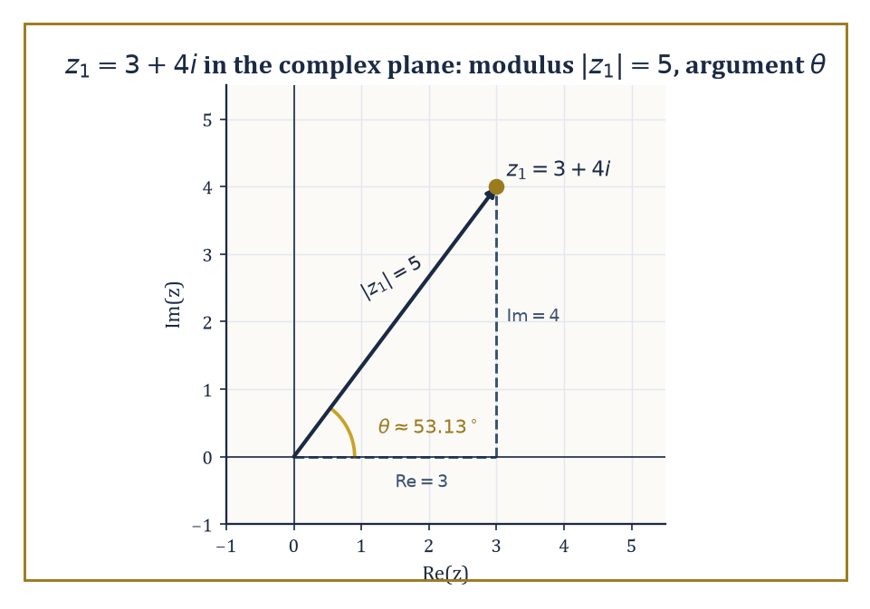
Figure 23.1 — z₁ = 3 + 4i plotted with its modulus, argument, and the 3-4-5 triangle hiding underneath the algebra.
i² = −1
Descartes coined the word ‘imaginary’ for such numbers, meaning it as an insult; the name stuck, rather unfairly, because these numbers turned out to be indispensable to nearly every branch of mathematics and physics that came after him.
The set of complex numbers, written ℂ, forms a field: you can add, subtract, multiply, and divide (by anything nonzero) using the ordinary rules of algebra, with the single extra fact i² = −1 thrown in whenever it’s needed.
Addition is done componentwise:
(a + bi) + (c + di) = (a + c) + (b + d)i
Multiplication follows the distributive law and then simplifies using i² = −1:
(a + bi)(c + di) = (ac − bd) + (ad + bc)i
A complex number a + bi is visualized as the point (a, b) in a plane — the real part a is the horizontal coordinate, the imaginary part b the vertical one — so ℂ is, geometrically, just the ordinary Cartesian plane with a multiplication rule bolted on.
Numeric example — arithmetic in ℂ. Let z₁ = 3 + 4i and z₂ = 1 − 2i.
Addition:
z₁ + z₂ = (3 + 1) + (4 − 2)i = 4 + 2i
Multiplication:
z₁z₂ = (3 + 4i)(1 − 2i) = 3(1) + 3(−2i) + 4i(1) + 4i(−2i) = 3 − 6i + 4i − 8i²
Since i² = −1, the last term −8i² becomes +8, giving:
3 + 8 − 6i + 4i = 11 − 2i
The modulus of z₁, written |z₁|, is its distance from the origin:
|z₁| = √(3² + 4²) = √25 = 5
— the classic 3-4-5 triangle, hiding in plain sight inside the algebra. The argument of z₁, written arg(z₁), is the angle its position vector makes with the positive real axis:
arg(z₁) = arctan(4/3) ≈ 53.13°
Try it now — Compute (3 + 4i)/(1 − 2i) and |3 + 4i|. Answer →
Because a complex number is a point in the plane, it is often more useful to describe it by distance and direction rather than by horizontal and vertical offset — exactly as you might give directions as ‘200 meters, north-east’ rather than ‘140 meters east and 140 meters north’.
This is the polar form, abbreviated using Euler’s notation as:
z = r(cos θ + i sin θ) = reⁱᶿ
where r = |z| is the modulus and θ = arg(z) is the argument.
The payoff of polar form is that it converts the fiddly business of complex multiplication into simple addition: multiplying two complex numbers multiplies their moduli and adds their arguments.
Raising a complex number to a whole-number power n, then, just multiplies the argument by n and raises the modulus to the n-th power — this is De Moivre’s theorem:
(r eⁱᶿ)ⁿ = rⁿ eⁱⁿᶿ
and it turns what looks like a tedious repeated multiplication into a single rotation-and-rescaling.
Numeric example — De Moivre’s theorem. Compute (1 + i)⁴.
First find polar form:
|1 + i| = √(1² + 1²) = √2
arg(1 + i) = 45° = π/4
(since the point (1, 1) sits on the diagonal). So:
1 + i = √2 · exp(iπ/4)
By De Moivre:
(1 + i)⁴ = (√2)⁴ · exp(i·4·(π/4)) = 4 · exp(iπ) = 4(cos π + i sin π) = 4(−1 + 0i) = −4
Check by direct multiplication:
(1 + i)² = 1 + 2i + i² = 1 + 2i − 1 = 2i
(2i)² = 4i² = −4
The two routes agree, as they must — but the polar route needed no expansion of brackets at all, only one multiplication of angles.
The most important holomorphic function in the entire chapter — indeed in most of mathematics — is the complex exponential eᶻ, defined for z = x + iy by:
eᶻ = eˣ(cos y + i sin y)
which is Euler’s formula smuggled into a definition. Two consequences are worth sitting with.
First, eᶻ is periodic with period 2πi: adding 2πi to z leaves eᶻ unchanged, because cosine and sine have period 2π. The real exponential function has no periodicity whatsoever; the complex one is compelled to repeat itself forever along vertical strips, purely because rotating by a full turn gets you back where you started.
Second, eᶻ maps horizontal lines (constant y, varying x) to rays from the origin — since the argument y is fixed and the modulus eˣ sweeps through all positive reals — and maps vertical lines (constant x, varying y) to circles of radius eˣ centered at the origin, since now the modulus is fixed and the argument sweeps around. A rectangular grid goes in; a polar grid of rays and circles comes out.
Numeric example — values of eᶻ. Compute exp(iπ/2). Using Euler’s formula with x = 0, y = π/2:
exp(iπ/2) = cos(π/2) + i sin(π/2) = 0 + i(1) = i
So raising e to a purely imaginary power π/2 lands you on i — a quarter-turn around the unit circle.
Compute exp(1+iπ). Here x = 1, y = π:
exp(1+iπ) = e¹(cos π + i sin π) = e(−1 + 0i) = −e ≈ −2.71828
This is the complex form of the identity sometimes called (with a straight face, remarkably) the most beautiful equation in mathematics:
exp(iπ) + 1 = 0
here with an extra factor of e along for the ride.
Before we can talk about differentiating functions on regions of the plane, we need the vocabulary for describing those regions, mostly borrowed and lightly modified from the topology you’ll meet properly several chapters from now.
An open set is one where every point has a little disk of wiggle-room around it still inside the set (so no boundary points included). A domain is a connected open set — one piece, no islands.
A path is a continuous journey through the plane, and a domain is simply connected if every closed loop drawn inside it can be shrunk continuously down to a point without ever leaving the domain — informally, the domain has no holes.
It’s worth adding one point at infinity to the plane, obtained by letting |z| → ∞ from every direction simultaneously and calling the result a single point ∞; the result is the Riemann sphere, on which even a function like f(z) = 1/z, badly behaved at the origin in the plane, becomes a perfectly continuous map (it just sends 0 to ∞ and back again).
Abstract example — simply connected or not?. Take the open unit disk:
D = {z : |z| < 1}
Any closed loop drawn inside D can be shrunk continuously to a point (say, the center) while staying inside D the whole time — just shrink it radially. So D is simply connected.
Now take the annulus:
A = {z : 1 < |z| < 2}
a ring-shaped region with a hole punched through its middle. A loop that winds once around the inner boundary — for instance the circle |z| = 1.5 traversed once — cannot be shrunk to a point without at some stage crossing the missing disk |z| ≤ 1, which isn’t part of A. So A is not simply connected.
This distinction looks like topological housekeeping now; by Contour Integrals and Cauchy’s Theorem it will decide, quite literally, whether a contour integral is forced to vanish or is free to be anything it likes.
Keep only this · Section 23.1: Complex Numbers and the Complex Plane
The idea. ℂ is the plane with a multiplication: multiplying by r·exp(iθ) scales by r and rotates by θ.
Core.
z = x + iy = r exp(iθ)
zw: multiply moduli, add arguments
z̄ = x − iy, |z|² = z z̄
Typical mistake. Writing |a + bi| = a + b, or √(a² − b²).
Minimal example. (1 + i)⁴ = (√2)⁴ exp(iπ) = −4.
Practice. Easy to challenge; full worked answers, with the usual mistake, are in Answers to the Practice Sets at the back.
Easy — Compute (2 + i)(3 − i). Answer →
Medium — Find all square roots of −4i. Answer →
Challenge — Show that |zw| = |z||w| using conjugates. Answer →

Section 23.2: Holomorphic Functions and the Cauchy–Riemann Equations
Where differentiability becomes an extremely exclusive members’ club
CORE · about 15 minutes · later chapters build on this
Definition — A function f, defined on an open subset of ℂ, is holomorphic at a point z (the words complex-differentiable and analytic are used interchangeably, and we shall not apologize for the redundancy) if the limit f′(z) exists, where h is itself a complex number allowed to approach 0 from any direction whatsoever.
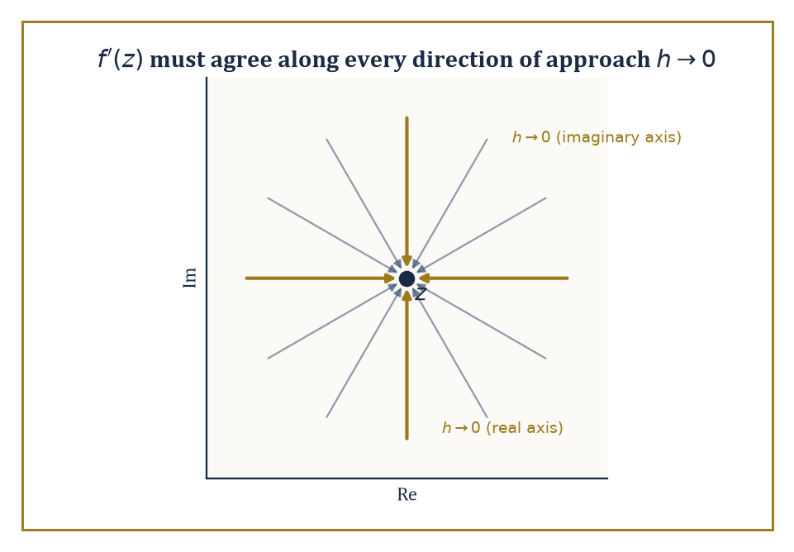
Figure 23.2 — The limit defining f′(z) has to agree along every one of infinitely many directions of approach — not just the two the real line ever bothers to offer.
f′(z) = lim[h→0] [f(z + h) − f(z)] / h
That last clause is the entire story. On the real line, h can only sneak up on 0 from the left or the right, so ‘the limit exists’ means those two one-sided limits agree — already a meaningful constraint, but only a two-way negotiation.
In the plane, h can approach 0 along any of infinitely many directions — straight in from the east, spiraling in like a moth, anything — and the definition demands the same answer from every single one of them.
It is not obvious that any non-trivial function could survive such a demand. Remarkably, an enormous and useful class of functions does.
Writing f(z) = u(x, y) + iv(x, y), where z = x + iy and u, v are the real and imaginary parts of f (each an ordinary real-valued function of two real variables), we can extract the consequence of that all-directions requirement by testing just two directions and insisting they agree.
f(z) = u(x, y) + iv(x, y)
Approach along the real axis (h real, h → 0): the difference quotient tends to u_{x} + iv_{x}, where the subscript denotes partial derivative. Approach along the imaginary axis (h = ik, k real, k → 0): the difference quotient tends to −iu_{y} + v_{y} (the extra factor of i in the denominator flips a sign when you divide it out).
For f′(z) to exist, these two must be equal:
u_{x} + iv_{x} = v_{y} − iu_{y}
Matching real and imaginary parts separately gives the Cauchy–Riemann equations:
u_{x} = v_{y} and u_{y} = −v_{x}
These two partial differential equations are the real-variable translation of ‘complex-differentiable’, and they are ferociously restrictive — two ordinary real functions u and v, chosen independently, will essentially never satisfy them both.
Numeric example — verifying the Cauchy–Riemann equations. Let f(z) = z². Writing z = x + iy, we expand:
z² = (x + iy)² = x² + 2ixy + i²y² = (x² − y²) + i(2xy)
So u(x, y) = x² − y² and v(x, y) = 2xy.
Compute the four partials:
u_{x} = 2x, u_{y} = −2y, v_{x} = 2y, v_{y} = 2x
Check Cauchy–Riemann:
u_{x} = v_{y} becomes 2x = 2x ✓
u_{y} = −v_{x} becomes −2y = −2y ✓
Both equations hold at every point, so f(z) = z² is holomorphic everywhere (it is entire, meaning holomorphic on the whole plane).
At the specific point z = 1 + 2i (so x = 1, y = 2): u_{x} = 2, v_{y} = 2, and the derivative works out to:
f′(z) = uₓ + ivₓ = 2x + i(2y) = 2(x + iy) = 2z
At z = 1 + 2i this gives:
f′(1 + 2i) = 2 + 4i
This is what you’d get by the ordinary power rule (z²)′ = 2z, computed the naive way. The Cauchy–Riemann machinery and the familiar calculus rule agree, as they must, since z² was always going to be holomorphic; the machinery earns its keep on functions where the answer isn’t obvious in advance.
Try it now — Is f(z) = z² + z holomorphic? Check Cauchy–Riemann. Answer →
Holomorphic functions behave, on the whole, just as one hopes: sums, products, and compositions of holomorphic functions are holomorphic, quotients are holomorphic wherever the denominator is nonzero, and all the familiar differentiation rules (product rule, chain rule, and so on) carry over unchanged from real calculus.
What doesn’t carry over is how rare holomorphic functions turn out to be once you go looking for them. A non-constant holomorphic function is an open map, meaning it sends open sets to open sets — it cannot, for instance, squash a whole disk down onto a line segment or a single point, the way (x, y) ↦ x can in ordinary two-variable calculus.
It also obeys the maximum-modulus principle: |f(z)| cannot attain a maximum at an interior point of a domain unless f is constant there — the modulus can only peak on the boundary, rather as a soap film stretched over a wire frame can only bulge as far as the frame allows.
And the zeros of a non-constant holomorphic function are isolated: you cannot have a whole little disk’s worth of points where f vanishes without f vanishing everywhere.
Abstract example — a function that fails Cauchy–Riemann everywhere. Let f(z) = z̄, complex conjugation:
z̄ = x − iy
Here u(x, y) = x and v(x, y) = −y.
Compute the partials:
u_{x} = 1, v_{y} = −1
Cauchy–Riemann requires u_{x} = v_{y}, i.e.
1 = −1
which is false at every single point of the plane. So z̄ is nowhere complex-differentiable, despite being about as innocuous and continuous a function as you could hope to meet — it just reflects the plane in the real axis, no drama involved in the real-variable picture at all.
This is the crucial lesson of the section: differentiability as a function of two real variables (which z̄ certainly has — u and v are both perfectly smooth) is a completely different, much weaker condition than complex-differentiability.
The extra requirement — that the limit agree from every direction of approach, not just along two axes independently — rules out almost every function you could write down using x and y separately.
It does not, however, rule out functions built purely from z itself (no bare x, y, or z̄ allowed) using addition, multiplication, and composition; those survive by construction, which is why z² sailed through the previous example while z̄ crashes here.
The rigidity promised in this chapter’s opening pages is already visible. A holomorphic function on a connected domain is completely determined by its values on any subset that has a limit point inside the domain — even an infinite sequence of points converging to a single point is enough to pin the function down everywhere (this is the identity theorem, which we will meet properly once power series are available, in The Cauchy Integral Formula and Power Series).
A real-differentiable function of two variables enjoys no such privilege whatsoever: you can build a perfectly smooth real function that is zero on an entire disk and nonzero just outside it (the so-called bump functions, beloved of physicists and analysts alike), and no amount of real differentiability prevents this.
Complex differentiability, imposed at every point of an open set, forbids any such localized misbehavior. One demand — the limit must agree from every direction — and an entire zoo of pathological functions is banished from the premises.
Abstract example — pinned down by a sequence. Let f and g both be holomorphic on the open disk D = {z : |z| < 1}, and suppose f(1/n) = g(1/n) for every positive integer n = 1, 2, 3, ….
The points 1/n accumulate at 0, which lies inside D — so they have a limit point inside the domain, exactly the hypothesis the identity theorem asks for.
Set h(z) = f(z) − g(z), itself holomorphic on D.
Then h(1/n) = 0 for every n, and by continuity:
h(0) = lim[n→∞] h(1/n) = 0
So h vanishes at 0 and at every point of a sequence converging to 0 — a limit point of zeros inside the domain. The identity theorem says this forces h to vanish identically on all of D.
Hence f = g everywhere on D, not merely at the points 1/n where we happened to check.
Contrast this with the real-variable version of the same setup: a smooth real function can vanish at every point 1/n and at 0 itself while being nonzero everywhere else on (−1, 1) (a suitably sculpted bump function manages this).
No such freedom exists once you insist on complex differentiability — agreement on a mere sequence with a limit point is already enough to force agreement everywhere.
Keep only this · Section 23.2: Holomorphic Functions and the Cauchy–Riemann Equations
The idea. Holomorphic means complex-differentiable on an open set: u_{x} = v_{y} and u_{y} = −v_{x}, with continuous partials.
Core.
f = u + iv holomorphic ⇒ u_{x} = v_{y}, u_{y} = −v_{x}
f′ = uₓ + ivₓ
Typical mistake. Checking only one of the two Cauchy–Riemann equations.
Minimal example. exp(z): u = eˣ cos y, v = eˣ sin y satisfy CR, and f′ = exp(z).
Practice. Easy to challenge; full worked answers, with the usual mistake, are in Answers to the Practice Sets at the back.
Easy — Check CR for f(z) = 3z. Answer →
Medium — Where is f(z) = |z|² complex-differentiable? Answer →
Challenge — Find v so that f = u + iv is holomorphic with u = x² − y² + 2x. Answer →

Section 23.3: Contour Integrals and Cauchy’s Theorem
The one fact from which almost everything else in this chapter descends
CORE · about 15 minutes · later chapters build on this
Key idea — To integrate a complex-valued function along a curve, parametrize the curve by a real variable and integrate the resulting complex-valued function of that real variable, exactly as you would integrate a vector field along a path in ordinary multivariable calculus. Concretely: if γ is a curve traced out by z(t) for t running from a to b, the contour integral of f along γ is defined as follows, where the right-hand side is an ordinary integral (split into real and imaginary parts if you like, and integrate each separately):
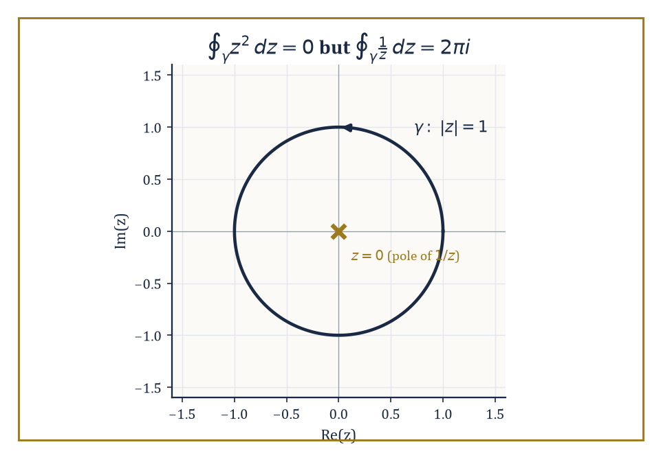
Figure 23.3 — The same unit circle gives 0 for z² and 2πi for 1/z — the entire difference between having a singularity inside and not.
∫ᵧ f(z) dz = ∫ₐᵇ f(z(t)) z′(t) dt
Two basic facts are worth having ready: the value of the integral does not depend on which parametrization you choose for the curve, only on the curve itself and its direction of travel; and reversing the direction of travel along γ negates the integral, as reversing the limits of an ordinary definite integral does.
Numeric example — a contour integral along a line segment. Let f(z) = z, and let γ be the straight segment from 0 to 1 + i. Parametrize z(t) = t(1 + i) for t ∈ [0, 1], so z′(t) = 1 + i.
∫ᵧ z dz = ∫₀¹ t(1 + i) · (1 + i) dt = (1 + i)² ∫₀¹ t dt = (1 + i)² · [t²/2]₀¹ = (1 + i)² · (1/2)
We already computed (1 + i)² = 2i in Complex Numbers and the Complex Plane. So the integral is 2i · (1/2) = i.
Sanity check: since z is entire and has the antiderivative z²/2 (just as in real calculus, where (x²/2)′ = x, so here F(z) = z²/2 satisfies F′(z) = z), the Fundamental Theorem of Calculus for contour integrals gives:
∫ᵧ z dz = F(1 + i) − F(0) = (1 + i)²/2 − 0 = 2i/2 = i
This matches exactly — confirming that for a holomorphic function with a known antiderivative, the integral only cares about the endpoints, not the path taken between them.
Try it now — Compute ∮ z̄ dz around the unit circle counterclockwise. Answer →
Cauchy’s theorem is the load-bearing wall of the entire subject: if f is holomorphic throughout a simply connected domain, and γ is any closed contour lying inside that domain, then:
∫ᵧ f(z) dz = 0
The standard route to proving it starts, perhaps surprisingly, with triangles: Goursat showed that the integral of a holomorphic function around the boundary of any triangle inside the domain is zero, by repeatedly quartering the triangle into four smaller similar triangles and showing the error can be squeezed to nothing as the pieces shrink. Since any polygon can be triangulated, and any closed contour can be approximated as closely as you like by a polygon, the triangle case bootstraps its way up to the general statement.
A useful corollary, homotopy invariance, falls out immediately: if two closed contours can be continuously deformed into one another without ever leaving the domain on which f is holomorphic, their integrals of f agree — deforming the path costs nothing, provided you never cross a point where f misbehaves.
Numeric example — zero versus 2πi, and why the difference matters. First take f(z) = z² (holomorphic everywhere) and let γ be the unit circle |z| = 1, traversed once counterclockwise. Since z² is entire and the disk |z| ≤ 1 is simply connected, Cauchy’s theorem guarantees the following without any computation at all:
∮ᵧ z² dz = 0
Indeed, using the antiderivative z³/3, the integral over any closed loop is F(start) − F(start) = 0 automatically.
Now take f(z) = 1/z and the same contour γ, the unit circle traversed once counterclockwise. Parametrize z = eⁱᶿ, dz = ieⁱᶿ dθ, θ running from 0 to 2π:
∮ᵧ (1/z) dz = ∫[0, 2π] (1/eⁱᶿ) · i eⁱᶿ dθ = ∫[0, 2π] i dθ = i · 2π = 2πi
This is emphatically not zero, and it is not a mistake: 1/z is holomorphic everywhere except at z = 0, and z = 0 lies inside the contour, and the punctured disk {0 < |z| < 1} is not simply connected in the sense that matters — you cannot shrink the unit circle to a point without passing through the very singularity where f blows up. Cauchy’s theorem doesn’t apply here, because one of its hypotheses (holomorphic throughout, including the interior) fails.
The size of the discrepancy, 2πi, is not an accident either — it is the first sighting of the residue, the star of Laurent Series and Singularities and The Residue Theorem and Applications.
It’s hard to overstate how much of the rest of this chapter is just Cauchy’s theorem wearing different hats. The Cauchy integral formula (next section) follows by applying the theorem to a cleverly chosen contour with a small circle cut out around a singularity. The residue theorem (The Residue Theorem and Applications) follows by applying the same trick to several singularities at once.
Even the fact that holomorphic functions are infinitely differentiable and equal their own Taylor series — the single most surprising claim in the whole chapter — is, at bottom, a consequence of Cauchy’s theorem plus a little bookkeeping. If you remember only one theorem from this chapter when you’re revising at three in the morning before an exam, make it this one; everything else can, in principle, be rederived from it, though your examiner will not thank you for doing so under time pressure.
Keep only this · Section 23.3: Contour Integrals and Cauchy’s Theorem
The idea. ∫ᵧ f dz = ∫ f(z(t)) z′(t) dt; for f holomorphic on a simply connected domain, every closed contour integral is 0.
Core.
∫ᵧ f dz = ∫[a, b] f(z(t)) z′(t) dt
∮ (z − a)ⁿ dz = 2πi if n = −1, else 0 (circle around a)
Typical mistake. Applying Cauchy’s theorem when a singularity lies inside the contour.
Minimal example. ∮ dz/z = 2πi around |z| = 1.
Practice. Easy to challenge; full worked answers, with the usual mistake, are in Answers to the Practice Sets at the back.
Easy — ∫ z dz along the segment from 0 to 2. Answer →
Medium — ∮ dz/(z − 3) around |z| = 1. Answer →
Challenge — ∮ dz/z² around |z| = 1. Answer →

Section 23.4: The Cauchy Integral Formula and Power Series
In which the inside of a region turns out to be a hostage of its boundary
CORE · about 20 minutes · later chapters build on this
Definition — The Cauchy integral formula is the precise statement of a claim that sounds too strong to be true: the value of a holomorphic function at any interior point of a domain is completely determined by its values on the boundary.
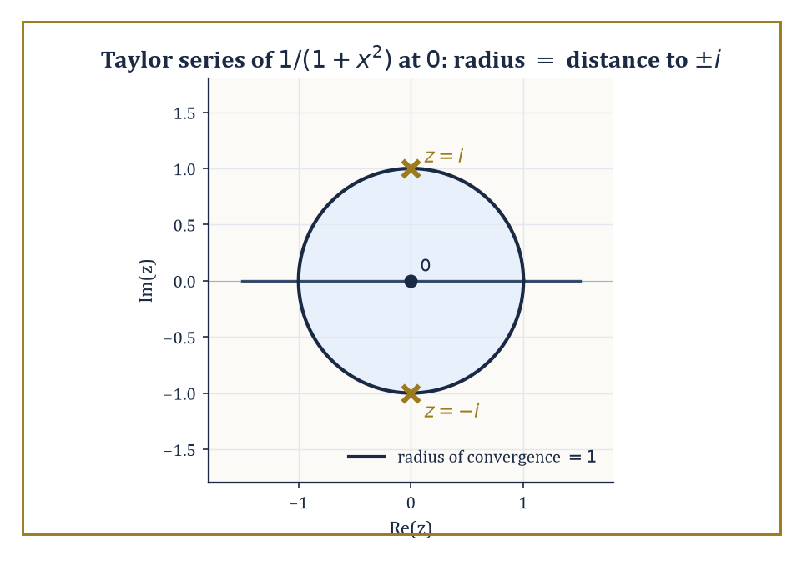
Figure 23.4 — 1/(1+x²) looks perfectly innocent on the real line, but its Taylor series stalls at radius 1 because ±i are lurking just off-stage.
Formally, if f is holomorphic on and inside a simply connected region and γ is a closed contour winding once counterclockwise around a point a inside that region, then:
f(a) = (1/(2πi)) ∮ᵧ f(z)/(z − a) dz
The proof is a direct application of Cauchy’s theorem from the previous section: cut a small circular disk of radius ε out of the region around a, apply Cauchy’s theorem to the resulting region (which no longer contains the troublesome point z = a, since 1/(z − a) blows up there), and then shrink ε to 0, using the fact that f is continuous at a to show the small-circle contribution converges to f(a) times 2πi.
The upshot is remarkable: knowing f only on some encircling curve γ, you can recover its value at any point strictly inside — the interior has no freedom the boundary hasn’t already spent.
Numeric example — applying the Cauchy integral formula. Let f(z) = z² (entire, hence holomorphic everywhere), and let γ be the circle |z| = 2 traversed once counterclockwise. Take a = i, which satisfies |i| = 1 < 2, so a lies inside γ.
The Cauchy integral formula says f(a) = (1/(2πi)) ∮ᵧ f(z)/(z − a) dz — that is, for this particular f, a, and γ:
∮ᵧ z²/(z − i) dz = 2πi · f(i)
Compute:
f(i) = i² = −1
So the contour integral equals:
2πi · (−1) = −2πi
Notice what just happened: we evaluated a contour integral — the kind of object that, in Contour Integrals and Cauchy’s Theorem, required parametrizing and grinding through a real integral — by plugging a into f and multiplying by 2πi. This is the computational payoff the formula is famous for: contour integrals of the shape ∮ f(z)/(z − a) dz, with f holomorphic and a inside the contour, are read off almost by inspection.
Try it now — Evaluate ∮ cos z/(z − π) dz around |z| = 4, counterclockwise. Answer →
Differentiating the Cauchy integral formula under the integral sign (a maneuver that is entirely legitimate here, though it would need justifying carefully in other settings) produces formulas for every derivative of f, not just its value:
f⁽ⁿ⁾(a) = (n!/(2πi)) ∮ᵧ f(z)/(z − a)ⁿ⁺¹ dz
Since the right-hand side is manifestly well-defined for every n = 0, 1, 2, 3, …, we get the single most startling structural fact in the whole chapter for free: a function that is complex-differentiable just once on an open set is automatically differentiable infinitely often there.
There is no such thing as a complex function that is differentiable but not twice-differentiable, or twice but not three-times, the way there routinely is on the real line (|x|³ is twice but not three-times differentiable at 0, for instance — a whole industry of counterexamples like this exists in real analysis and has no complex-analytic counterpart).
Once through the door marked ‘holomorphic’, you get every subsequent derivative thrown in as a free upgrade.
Numeric example — recovering a derivative from a contour integral. Let f(z) = eᶻ, and let γ be the unit circle |z| = 1. We know directly, from ordinary calculus, that f″(z) = eᶻ (differentiating eᶻ twice just gives eᶻ back), so:
f″(0) = e⁰ = 1
Cauchy’s derivative formula with n = 2, a = 0 reads:
f″(0) = (2!/(2πi)) ∮ᵧ eᶻ/z³ dz
Substituting f″(0) = 1:
1 = (2/(2πi)) ∮ᵧ eᶻ/z³ dz
∮ᵧ eᶻ/z³ dz = 2πi/2 = πi
So without ever parametrizing the unit circle or grinding through a real integral of eᶜᵒˢᶿ(cos(sin θ) + i sin(sin θ)) — which is the mess a direct parametrization would produce — the derivative formula hands us the exact value πi, purely from knowing that eᶻ differentiates to itself.
This is the formula’s real value: it turns fearsome-looking contour integrals into ordinary calculus problems about the numerator function.
Because a holomorphic function equals its own Taylor series near every point of its domain, it is natural to ask how far that series can be trusted — the answer is the radius of convergence, and it has an unexpectedly clean geometric description: the radius of convergence of the Taylor series of f centered at a is the distance from a to the nearest point where f fails to be holomorphic (a singularity).
Inside that radius the series converges to f exactly; on or beyond it, convergence is not guaranteed.
This single fact resolves a puzzle left dangling since early chapters on real calculus, where the Taylor series of a perfectly smooth real function was sometimes observed to have an oddly small radius of convergence for no visible reason.
The reason was invisible because it was hiding off the real line, in the complex plane, all along.
Numeric example — radius of convergence via distance to the nearest singularity. Take f(z) = 1/(1 − z). This has a single singularity, at z = 1 (where the denominator vanishes). Expanded as a Taylor series about z = 0:
f(z) = 1 + z + z² + z³ + …
(the familiar geometric series), and its radius of convergence is the distance from 0 to the singularity at 1, namely 1 — matching the well-known fact that the geometric series converges for |z| < 1.
Now take f(z) = 1/(1 + x²), thought of as a real function of x with a perfectly innocent-looking graph — smooth, bounded, no visible bumps or corners anywhere on the real line.
Viewed as a complex function f(z) = 1/(1 + z²), it has singularities where 1 + z² = 0, i.e. at z = i and z = −i, each at distance 1 from the origin.
So the Taylor series of 1/(1 + x²) about x = 0 has radius of convergence exactly 1, even though the real function itself shows no sign of trouble at x = ±1 or anywhere else on the real line.
The instability was there all along; it was positioned a unit’s distance off the real axis, invisible to anyone who insisted on only ever looking along it.
Two famous consequences round off the section. Liouville’s theorem states that a bounded entire function (holomorphic on the whole plane, with |f(z)| ≤ M for some constant M and all z) must be constant — intuitively, a Taylor series valid on the whole plane with bounded coefficients has nowhere left to hide any nontrivial variation, and the Cauchy derivative formula, applied on ever-larger circles, forces every derivative beyond the zeroth to vanish.
From Liouville’s theorem the Fundamental Theorem of Algebra falls out almost as an afterthought: every non-constant polynomial has a root in ℂ.
And the identity theorem, promised in Holomorphic Functions and the Cauchy–Riemann Equations, now has its proof: two holomorphic functions that agree on a set with a limit point inside a connected domain must agree everywhere on that domain, because agreement on such a set forces every Taylor coefficient at the limit point to match, and the Taylor series determines the function completely nearby, and nearby propagates to everywhere by a connectedness argument.
Abstract example — proving the Fundamental Theorem of Algebra from Liouville. Claim: every non-constant polynomial p(z) has a root in ℂ. Suppose, for contradiction, that p(z) has no root anywhere — so p(z) ≠ 0 for every z.
Then define:
g(z) = 1/p(z)
This g is defined and holomorphic on the whole plane (entire), since its only possible singularities would be at roots of p, and there are none by assumption.
Because p is a non-constant polynomial, |p(z)| → ∞ as |z| → ∞ (the highest-degree term eventually dominates and swamps everything else). So:
|g(z)| = 1/|p(z)| → 0 as |z| → ∞
meaning g is bounded on the whole plane — certainly bounded near infinity, and bounded on any fixed large disk too, since g is continuous there.
By Liouville’s theorem, a bounded entire function must be constant. So g is constant, hence p = 1/g is constant too — contradicting the assumption that p is non-constant.
The contradiction shows no such root-free polynomial can exist: every non-constant polynomial has at least one root in ℂ.
It’s a curious feature of this proof that it establishes the existence of a root without ever exhibiting one — very much in the spirit of the whole chapter, where existence statements routinely arrive long before anyone can compute anything.
Keep only this · Section 23.4: The Cauchy Integral Formula and Power Series
The idea. f(a) = (1/(2πi)) ∮ f(z)/(z − a) dz: interior values are fixed by boundary values, and holomorphic functions are power series.
Core.
f(a) = (1/(2πi)) ∮ f(z)/(z − a) dz
f⁽ⁿ⁾(a) = (n!/(2πi)) ∮ f(z)/(z − a)ⁿ⁺¹ dz
Typical mistake. Forgetting the factor 2πi, or using it when a lies outside the contour.
Minimal example. ∮ exp(z)/z dz = 2πi around |z| = 1.
Practice. Easy to challenge; full worked answers, with the usual mistake, are in Answers to the Practice Sets at the back.
Easy — ∮ z²/(z − 1) dz around |z| = 2. Answer →
Medium — ∮ exp(z)/z³ dz around |z| = 1. Answer →
Challenge — Radius of the Taylor series of 1/(z² + 4) about z = 1. Answer →

Section 23.5: Laurent Series and Singularities
A taxonomy of the ways a function can misbehave at a point
CORE · about 15 minutes · later chapters build on this
Key idea — Taylor series describe a holomorphic function on a disk, but plenty of interesting functions have a nasty point right in the middle of the region we care about — 1/z at the origin, say. On an annulus (a ring-shaped region r < |z − a| < R around the point a, avoiding the trouble spot entirely), a function holomorphic throughout the annulus admits a Laurent series, a two-sided generalization of the Taylor series, where negative powers of (z − a) are allowed alongside the usual non-negative ones:
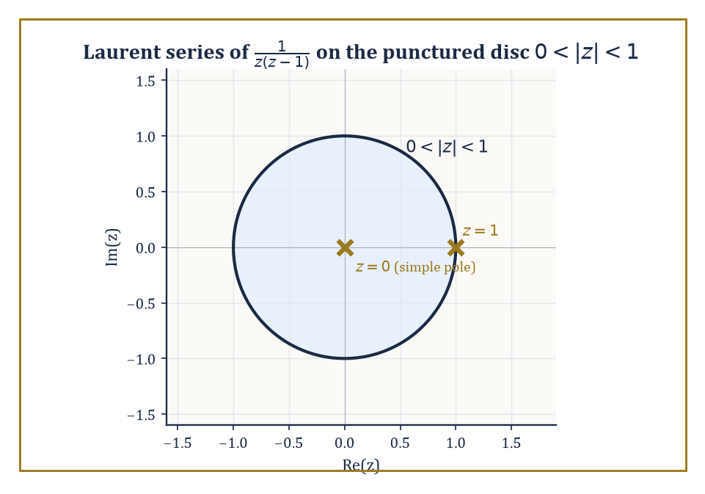
Figure 23.5 — The punctured disk 0 < |z| < 1, home to the Laurent series of 1/(z(z−1)), with its pole at the center and its excluded neighbor at z = 1.
f(z) = Σ[−∞ < n < ∞] cₙ(z − a)ⁿ
The terms with negative exponent are called the principal part of the series, and it is the principal part alone that encodes how badly f misbehaves at the missing center a — the non-negative-power part behaves exactly like an ordinary Taylor series and contributes nothing pathological.
Numeric example — finding a Laurent series by partial fractions. Let f(z) = 1/(z(z − 1)), and find its Laurent series on the punctured disk 0 < |z| < 1 (avoiding both z = 0 and z = 1, the two places f is undefined).
Partial fractions: write 1/(z(z − 1)) = A/z + B/(z − 1). Clearing denominators:
A(z − 1) + Bz = 1
Setting z = 0: −A = 1, so A = −1. Setting z = 1: B = 1. So:
f(z) = −1/z + 1/(z − 1)
Now expand 1/(z − 1) as a series valid for |z| < 1, using the geometric series (valid since |z| < 1):
1/(z − 1) = −1/(1 − z) = −(1 + z + z² + z³ + …)
Combining:
f(z) = −1/z − (1 + z + z² + z³ + …) = −1/z − 1 − z − z² − z³ − …
The principal part is the single term −1/z; every other term has a non-negative power. This tells us immediately, by the classification below, that f has a simple pole at z = 0 with residue −1 (the coefficient of the 1/z term).
Try it now — Order of the pole of 1/(z²(z + 1)) at 0 and at −1. Answer →
The principal part sorts isolated singularities — points where f is holomorphic on a punctured neighborhood but not defined (or not holomorphic) at the center — into exactly three types.
If the principal part is entirely zero (no negative powers at all), the singularity is removable: f simply forgot to be defined at that one point, and extending it by its limiting value there patches the hole with no loss of holomorphy, a fact formalized as Riemann’s removable singularity theorem.
If the principal part is a finite sum ending at (z − a)⁻ᵐ for some positive integer m (that is, the lowest power appearing is −m), the singularity is a pole of order m — f blows up to infinity there, in a controlled, polynomial-like way, roughly like 1/(z − a)ᵐ near a.
If the principal part has infinitely many nonzero negative-power terms, the singularity is essential — and essential singularities are where complex analysis stops being polite.
Picard’s Great Theorem states that near an essential singularity, f takes every complex value, with at most one exception, infinitely often in any punctured neighborhood, however small — a function near such a point is not just badly behaved, it is behaved with a kind of manic, unbounded enthusiasm.
Numeric example — classifying three singularities at z = 0. 1) f(z) = sin(z)/z. Using the Taylor series sin(z) = z − z³/3! + z⁵/5! − …, dividing by z gives:
sin(z)/z = 1 − z²/6 + z⁴/120 − …
There are no negative powers at all — the principal part is zero — so z = 0 is a removable singularity, and defining f(0) = 1 (matching the well-known limit lim[z→0] sin(z)/z = 1) makes f entire.
2) f(z) = 1/z³. This is already its own Laurent series, with a single term at power −3 and nothing else. The lowest power is −3, so z = 0 is a pole of order 3.
3) f(z) = exp(1/z). Substituting w = 1/z into the exponential series eʷ = Σ[n ≥ 0] wⁿ/n! gives:
exp(1/z) = Σ[n ≥ 0] (1/z)ⁿ/n! = 1 + 1/z + 1/(2z²) + 1/(6z³) + …
Every negative power of z appears, with no stopping point — infinitely many nonzero terms in the principal part. So z = 0 is an essential singularity: the kind of point where Picard’s theorem applies and exp(1/z) takes on (almost) every complex value infinitely often in any neighborhood of 0, no matter how small you make it.
The coefficient c₋₁ — the coefficient of the (z − a)⁻¹ term in the Laurent expansion — is singled out with its own name, the residue of f at a, written Res[z=a] f.
It earns the special treatment because it is the only coefficient in the entire Laurent series that survives integration around a small circle centered at a: every other power (z − a)ⁿ with n ≠ −1 has an antiderivative that is single-valued on the circle and so integrates to zero around a closed loop, while (z − a)⁻¹ alone integrates to 2πi (the computation we did by hand for 1/z in Contour Integrals and Cauchy’s Theorem).
This single surviving coefficient is about to become the entire content of the residue theorem in the next section, so it pays to get comfortable computing it.
Numeric example — computing two residues. Residue of exp(1/z) at z = 0: from the expansion above, exp(1/z) = 1 + 1/z + 1/(2z²) + …, the coefficient of the 1/z term is 1. So:
Res[z=0] exp(1/z) = 1
Residue of f(z) = 1/(z²(z − 1)) at z = 0 (a pole of order 2, so the direct series trick needs slightly more care than a simple pole): near z = 0, expand 1/(z − 1) as a series:
1/(z − 1) = −1/(1 − z) = −(1 + z + z² + …)
f(z) = (1/z²) · [−(1 + z + z² + …)] = −1/z² − 1/z − 1 − z − …
Reading off the coefficient of the 1/z term:
Res[z=0] f = −1
As a check, the standard formula for a pole of order m at a is:
Res[z=a] f = (1/(m−1)!) · lim[z→a] dᵐ⁻¹/dzᵐ⁻¹ [(z − a)ᵐ f(z)]
Here m = 2, a = 0, so:
Res = lim[z→0] d/dz [z² f(z)] = d/dz [1/(z − 1)] = −1/(z − 1)²
Evaluated at z = 0:
Res = −1/(−1)² = −1/1 = −1
Both methods agree.
Keep only this · Section 23.5: Laurent Series and Singularities
The idea. Removable: no negative powers. Pole of order m: lowest power (z − a)⁻ᵐ. Essential: infinitely many negative powers. The residue is the coefficient of (z − a)⁻¹.
Core.
f = Σ cₙ(z − a)ⁿ over all n ∈ ℤ, on an annulus r < |z − a| < R
Res[z = a] f = c₋₁
Typical mistake. Taking the residue to be the coefficient of the highest negative power.
Minimal example. exp(1/z) = 1 + 1/z + 1/(2z²) + …: essential at 0, residue 1.
Practice. Easy to challenge; full worked answers, with the usual mistake, are in Answers to the Practice Sets at the back.
Easy — Classify the singularity of (1 − cos z)/z² at 0. Answer →
Medium — Laurent series of 1/(z(1 − z)) for 0 < |z| < 1, and its residue at 0. Answer →
Challenge — Residue of z/(z² + 1) at i. Answer →

Section 23.6: The Residue Theorem and Applications
Turning contour integrals into a finite shopping list of coefficients
CORE · about 15 minutes · later chapters build on this
Some integrals along the real line resist every technique from first-year calculus, yet give way after a detour through the complex plane. The idea is to close the path into a loop and use a remarkable fact: the integral around a loop depends only on the troublesome points trapped inside it, each of which contributes a single number called its residue. An integral over a whole curve shrinks to a short sum. The classic case is the area under the curve one over one plus x squared, across the entire real line. Closing the path with a huge semicircle traps just one troublesome point, at i, and the answer, pi, drops out in a couple of lines.
Definition — The residue theorem is the payoff for all the bookkeeping in the previous section: if f is holomorphic on and inside a closed contour γ except for finitely many isolated singularities a₁, …, aₖ inside γ, then
∮ᵧ f(z) dz = 2πi Σⱼ₌₁ᵏ Res[z=a_{j}] f
In words: instead of parametrizing the contour and grinding through a real integral, you locate the singularities trapped inside the loop, compute the residue at each one (a purely local, algebraic calculation, as the previous section demonstrated), add them up, and multiply by 2πi.
An integral over an entire curve has been reduced to a finite sum of numbers, each computed by looking only at a single point.
Cauchy’s theorem is the special case where there happen to be no singularities inside γ at all — the empty sum is zero, matching what we already knew.
Theorem — The residue theorem
Let f be holomorphic on an open set containing a simple closed contour γ and its interior, except at finitely many isolated singularities a₁, …, aₖ inside γ (none on γ). If γ is traversed once counterclockwise, then
∮ᵧ f(z) dz = 2πi Σ Res[z = aⱼ] f
Hypotheses — check each one before you use it:
□ f is holomorphic on and inside γ apart from finitely many isolated singularities
□ no singularity lies on γ itself
□ γ is simple, closed, and traversed once counterclockwise (clockwise reverses the sign)
□ only the singularities inside γ are summed
Why it matters. It is the central computational tool of complex analysis: an integral over a whole curve becomes a finite sum of local coefficients. Real integrals, inverse Laplace transforms and series sums all reduce to it.
The residue checklist (use it every time)
1. List every singularity of f: the zeros of each denominator, and any points where log, square roots or exp(1/z) misbehave.
2. Decide which singularities the contour encloses: compare each one’s distance from the center with the radius, and look at a sketch.
3. Check the orientation: counterclockwise counts +, clockwise −. A contour that winds twice counts twice.
4. Find the order of each enclosed pole, or recognize a removable or essential singularity.
5. Compute each residue: lim (z − a)f(z) for a simple pole; (1/(m − 1)!) lim dᵐ⁻¹/dzᵐ⁻¹ [(z − a)ᵐ f(z)] for order m; or read the coefficient of (z − a)⁻¹ from the Laurent series.
6. Multiply the sum by 2πi. For a real integral over the line, also prove the arc contribution tends to 0: |∫ over the arc| ≤ πR · max |f| on the arc, so you need R · max |f| → 0.
Why it matters. Almost every wrong residue calculation skips step 2 or step 4.
Numeric example — applying the residue theorem. Let f(z) = 1/(z²(z − 1)), and let γ be the circle |z| = 2, traversed once counterclockwise, which encloses both singularities of f: z = 0 (pole of order 2) and z = 1 (simple pole), since both |0| = 0 < 2 and |1| = 1 < 2.
From the previous section, Res[z=0] f = −1. For the simple pole at z = 1, use the formula for a simple pole:
Res[z=1] f = lim[z→1] (z − 1) f(z) = lim[z→1] 1/z² = 1/1² = 1
Sum of residues:
−1 + 1 = 0
By the residue theorem:
∮ᵧ f(z) dz = 2πi · 0 = 0
This is a genuinely useful sanity check on the method: two singularities, each individually contributing a nonzero residue, can still conspire to make the total contour integral vanish. Nothing in the calculation was wasted — you still needed both residues to discover that they cancel.
Worked example — the checklist on a three-pole function. Evaluate ∮ dz/(z²(z − 1)(z − 3)) around |z| = 2, counterclockwise.
Steps 1–3: the singularities are 0, 1 and 3. The circle |z| = 2 encloses 0 and 1; 3 is outside, since |3| > 2. The orientation is counterclockwise.
Step 4: z = 0 is a pole of order 2; z = 1 is simple.
Step 5: at 0, multiply by z² and differentiate once: g(z) = 1/((z − 1)(z − 3)) = 1/(z² − 4z + 3), g′(z) = −(2z − 4)/(z² − 4z + 3)², so Res[z = 0] = g′(0) = 4/9. At 1: Res[z = 1] = lim[z → 1] 1/(z²(z − 3)) = 1/(1 · (−2)) = −1/2.
Step 6:
∮ = 2πi (4/9 − 1/2) = 2πi · (−1/18) = −πi/9
Check: the residue at the excluded pole is Res[z = 3] = 1/(9 · 2) = 1/18, and the three residues sum to 0, as they must for a rational function whose denominator has degree at least 2 more than its numerator. Including the pole at 3 by mistake would give 0.
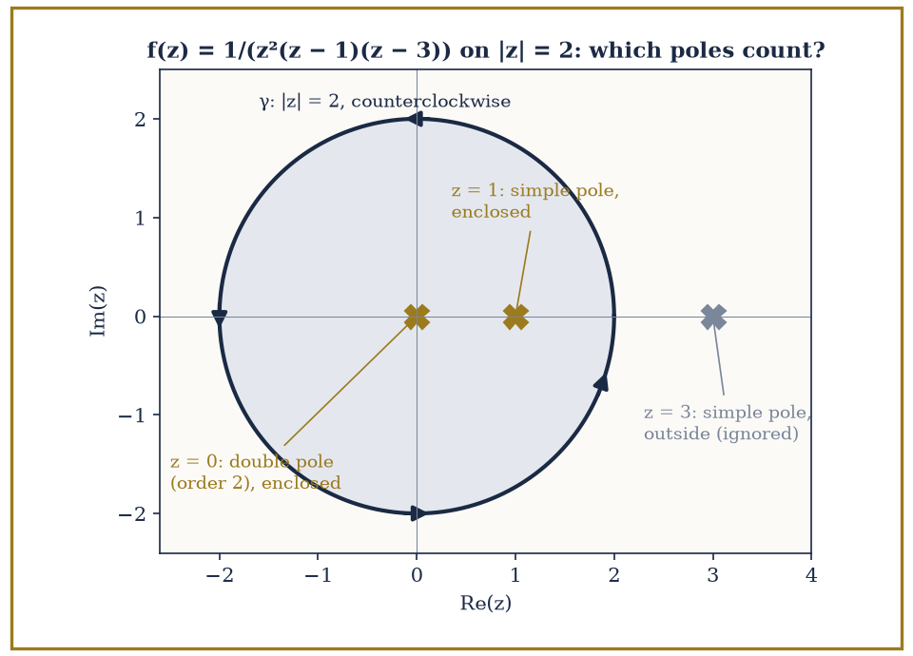
Figure 23.6 — The contour |z| = 2, traversed counterclockwise (arrows), for f(z) = 1/(z²(z − 1)(z − 3)). The poles at 0 (order 2) and 1 (simple) lie inside and contribute residues 4/9 and −1/2; the pole at 3 lies outside and contributes nothing. The integral is 2πi(4/9 − 1/2) = −πi/9.
Try it now — Does the circle |z − 1| = 1 enclose the pole of 1/(z − 2.5)? And of 1/(z − 1.5)? Answer →
The most celebrated practical use of the residue theorem is evaluating certain real definite integrals that resist every technique from ordinary calculus — typically integrals over the whole real line of a rational function, or of a rational function multiplied by a trigonometric or exponential factor.
The trick is to view the real integral as one piece of a closed contour: run along the real axis from −R to R, then close the loop with a large semicircular arc in the upper (or lower) half-plane back to the starting point.
If the integrand decays fast enough at infinity, the contribution from the arc vanishes as R → ∞, leaving the real integral equal to 2πi times the sum of residues trapped inside the closed semicircle — which, for large enough R, means every pole in the upper half-plane.
Numeric example — evaluating a real integral by residues. Evaluate the following integral by contour methods (the answer is known from ordinary calculus to be π, via arctan, so this is a good test case for the machinery):
I = ∫[−∞, ∞] dx/(1 + x²)
Let f(z) = 1/(1 + z²) = 1/((z − i)(z + i)), which has simple poles at z = i and z = −i. Close the real-axis integral with a large semicircular arc in the upper half-plane; only the pole at z = i lies inside this closed contour (z = −i is in the lower half-plane, outside).
Residue at z = i:
Res[z=i] f = lim[z→i] (z − i) f(z) = lim[z→i] 1/(z + i) = 1/(2i)
On the large semicircular arc, |f(z)| behaves like 1/R² while the arc’s length grows only like R, so the arc’s contribution to the integral shrinks like 1/R and vanishes as R → ∞ — this is the standard estimate that justifies discarding the arc.
By the residue theorem, the closed contour integral equals:
2πi · Res[z=i] f = 2πi · 1/(2i) = π
Since the arc contributes nothing in the limit, the real-axis piece alone must account for the whole answer:
∫[−∞, ∞] dx/(1 + x²) = π
This exactly matches the arctan calculation from ordinary calculus — a satisfying handshake between two entirely different chapters’ worth of technique.
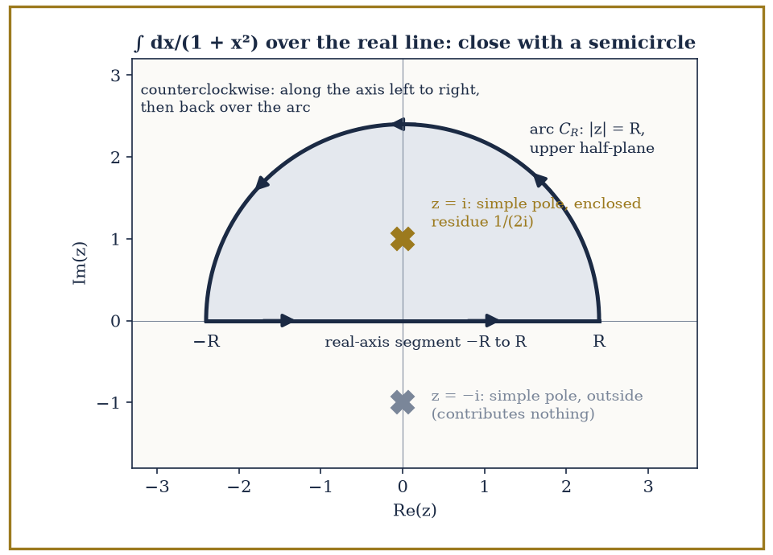
Figure 23.7 — The closed contour for ∫ dx/(1 + x²) over the whole real line: the real-axis segment from −R to R, closed by the semicircular arc |z| = R in the upper half-plane, traversed counterclockwise (arrows). The simple pole z = i lies inside the half-disk and contributes residue 1/(2i); the pole z = −i lies outside and contributes nothing. The arc’s contribution shrinks like 1/R, so the real integral equals 2πi · 1/(2i) = π.
Context — The argument principle and Rouché’s theorem are enrichment (optional reading)
Rouché’s theorem and the argument principle are not needed later in this volume and can be skipped on a first reading. They are included because they show the residue theorem counting zeros instead of computing integrals, and because the root-location example below is a model of a clean inequality argument: bound |g| from above and |f| from below on the contour, with |g(z)| < |f(z)| strictly at every point of γ.
Two further tools round out the toolkit. The argument principle states the following relation between a contour integral and a count of zeros and poles:
(1/(2πi)) ∮ᵧ f′(z)/f(z) dz = (number of zeros of f inside γ) − (number of poles of f inside γ)
Each zero and pole is counted with multiplicity. It works because f′/f has a simple pole at every zero and every pole of f, with residue equal to +m at a zero of order m and −m at a pole of order m, so the residue theorem turns the count into a contour integral.
Rouché’s theorem is the practical cousin of this fact: if f and g are holomorphic inside and on a closed contour γ, and |g(z)| < |f(z)| for every z on γ, then f and f + g have the same number of zeros inside γ.
Intuitively, g is too small on the boundary to ever perturb f enough to create or destroy a zero — the boundary comparison controls the interior count, which is the whole chapter’s leitmotif turning up once more.
Abstract example — locating roots with Rouché’s theorem. Claim: every root of p(z) = z⁴ + 6z + 3 lies inside the circle |z| = 2.
Split p as f(z) + g(z) with f(z) = z⁴ and g(z) = 6z + 3. On the circle |z| = 2, bound each piece separately, using the triangle inequality for g:
|f(z)| = |z|⁴ = 2⁴ = 16
|g(z)| = |6z + 3| ≤ 6|z| + 3 = 6(2) + 3 = 15
Since 15 < 16, we have |g(z)| < |f(z)| everywhere on |z| = 2, so Rouché’s theorem applies: p = f + g has the same number of zeros inside |z| < 2 as f alone.
The function f(z) = z⁴ has a single zero, z = 0, of multiplicity 4 — so f has 4 zeros (counted with multiplicity) inside |z| < 2.
Therefore p(z) = z⁴ + 6z + 3 also has exactly 4 zeros inside |z| < 2, counted with multiplicity.
Since p has degree 4, that accounts for all of its roots — every root of this particular quartic lies inside the disk of radius 2, a fact we’ve now established without solving the quartic, or indeed finding a single root explicitly.
Keep only this · Section 23.6: The Residue Theorem and Applications
The idea. ∮ f dz = 2πi × (sum of residues inside), counterclockwise. Work through the six-step checklist every time.
Core.
∮ᵧ f dz = 2πi Σ Res (inside, counterclockwise)
simple pole: Res = lim (z − a)f(z) = p(a)/q′(a) for f = p/q
Typical mistake. Including poles outside the contour, or forgetting the minus sign for a clockwise contour.
Minimal example. ∫[−∞, ∞] dx/(1 + x²) = π.
Practice. Easy to challenge; full worked answers, with the usual mistake, are in Answers to the Practice Sets at the back.
Easy — ∮ dz/(z(z − 2)) around |z| = 1. Answer →
Medium — ∫[−∞, ∞] dx/(x² + 4). Answer →
Challenge — ∫[−∞, ∞] dx/(1 + x²)². Answer →

Section 23.7: Conformal Mapping and the Riemann Mapping Theorem
Angle-preserving maps, and the astonishing claim that almost every shape is secretly a disk
CORE · about 15 minutes · later chapters build on this
Definition — A holomorphic function f with f′(z) ≠ 0 at a point is conformal there: it preserves angles between curves crossing at that point, and it preserves orientation (it doesn’t flip things into a mirror image).
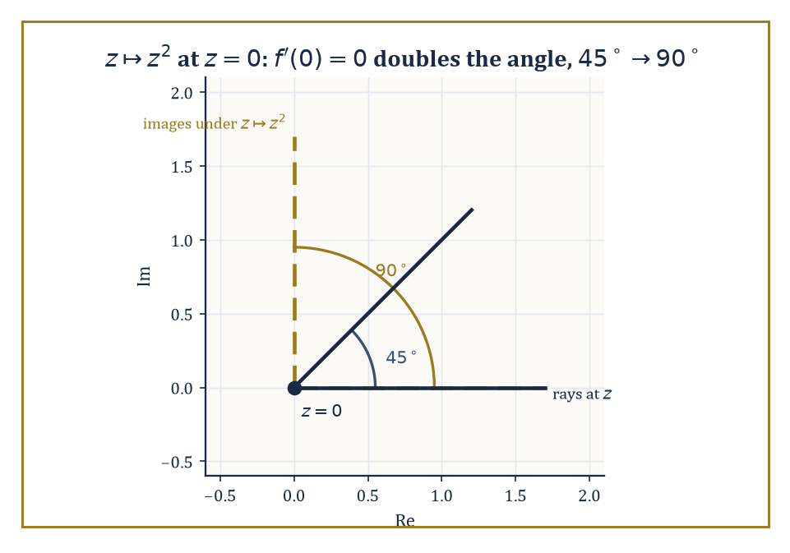
Figure 23.8 — At the one point where f′ vanishes, z ↦ z² stops being polite: a 45° angle walks in and a 90° angle walks out.
The geometric reason is close to the algebra of Holomorphic Functions and the Cauchy–Riemann Equations: locally, near a point where f′(z₀) ≠ 0, f behaves almost like multiplication by the complex number f′(z₀) — which, as we saw with polar form back in Complex Numbers and the Complex Plane, is a rotation (by arg f′(z₀)) combined with a uniform rescaling (by |f′(z₀)|).
Rotating and rescaling uniformly preserves the angle between any two crossing curves, since both curves get rotated by the same amount.
Infinitesimally small circles around z₀ get mapped to infinitesimally small circles around f(z₀) — squashed or stretched, perhaps, but not sheared into ellipses, which is what makes conformal maps the natural change of coordinates for any problem built on Laplace’s equation, as Harmonic Functions and Boundary-Value Problems will exploit directly.
Numeric example — conformal except where the derivative vanishes. Let f(z) = z², with derivative f′(z) = 2z.
At z = 1, the derivative is nonzero, so f is conformal there:
f′(1) = 2 ≠ 0
Consider two rays leaving z = 1: one along the positive real direction (angle 0) and one at 45° to it.
Locally, f acts like multiplication by f′(1) = 2 — a pure rescaling by factor 2 with zero rotation — so the 45° angle between the two rays is preserved at the image point f(1) = 1.
Now look at z = 0, where the derivative vanishes — conformality’s hypothesis fails, and indeed the conclusion fails too:
f′(0) = 2(0) = 0
Take the ray at angle 0 (the positive real axis) and the ray at angle π/4 (45°), both leaving the origin.
Under the squaring map, a ray at angle θ maps to a ray at angle 2θ:
f(z) = z² = r²eⁱ²ᶿ
The angle-0 ray maps to the angle-0 ray, and the angle-π/4 ray maps to the angle-π/2 ray:
2 × 0 = 0
2 × π/4 = π/2
The original 45° angle between the two rays has become a 90° angle between their images — doubled, not preserved.
This is just what the vanishing derivative warns you about:
f′(0) = 0
At a point where the derivative vanishes, the local rotation-and-rescaling picture breaks down, and angles are free to distort.
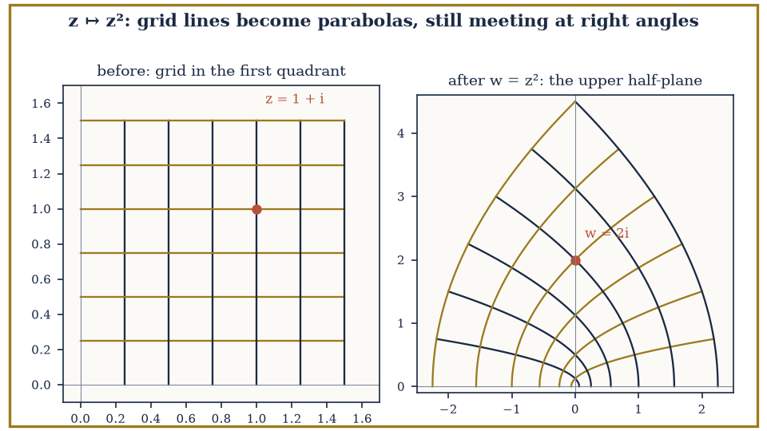
Figure 23.9 — The map w = z² applied to a square grid in the first quadrant. Left: the grid lines x = constant and y = constant. Right: their images, two families of parabolas that still cross at right angles wherever z ≠ 0. At the origin, where f′(0) = 0, the right angle between the axes is doubled to a straight angle.
Try it now — Where is f(z) = z³ not conformal? Answer →
The Riemann mapping theorem is one of the most quietly astonishing existence statements in classical analysis: every simply connected domain in the plane, other than the whole plane itself, is conformally equivalent to the open unit disk — meaning there exists a holomorphic bijection between the two, with a holomorphic inverse, that preserves angles throughout.
Stop and register how strong this is: a domain shaped like a jagged, five-pointed star, or a long thin crescent, or the inside of a maple leaf, is — provided it’s simply connected and not the entire plane — secretly, conformally, just a disk wearing a costume.
Theorem — Riemann mapping theorem (stated and motivated, not proved)
If D ⊂ ℂ is open, connected and simply connected, and D ≠ ℂ, then there is a bijective holomorphic map f : D → {|w| < 1}. Fixing a point z₀ ∈ D, it can be chosen with f(z₀) = 0 and f′(z₀) > 0, and then it is unique.
Hypotheses — check each one before you use it:
□ D is open and connected (a domain)
□ D is simply connected: no holes
□ D is not all of ℂ (Liouville rules that out: a bounded entire function is constant)
Why it matters. Every hole-free proper domain is, conformally, the disk. A problem on an awkward domain (for example Laplace’s equation) can be solved on the disk and carried back. The proof uses normal families and lies beyond this book.
The theorem, as usually proved, is non-constructive: it guarantees the map exists without necessarily telling you a formula for it.
But for a great many domains that actually arise in practice, explicit conformal maps are known and computable: Möbius transformations (ratios of linear expressions) for disks, half-planes, and circles; power maps z ↦ zⁿ for wedge-shaped sectors; and the Schwarz–Christoffel formula for polygons of any shape.
Abstract example — an explicit conformal map, half-plane to disk. Claim: the Möbius transformation below maps the upper half-plane {z : Im(z) > 0} conformally onto the open unit disk {w : |w| < 1}, sending the real axis to the unit circle.
w = (z − i) / (z + i)
First check the center: z = i (a point comfortably in the upper half-plane) maps to the center of the disk — a promising sign:
w = (i − i)/(i + i) = 0/(2i) = 0
Now check that real points land on the unit circle. For any real x, the distances to i and to −i are equal, since conjugating x − i (which is x + i, as x is real) doesn’t change the modulus:
|x − i| = √(x² + 1) and |x + i| = √(x² + 1)
So the whole real axis maps onto the unit circle:
|w| = |x − i|/|x + i| = 1 for every real x
Spot-check two points. At x = 0:
w = (0 − i)/(0 + i) = −i/i = −1
and indeed |−1| = 1. At x = 1, multiply numerator and denominator by the conjugate (1 − i):
w = (1 − i)/(1 + i) = (1 − i)²/((1 + i)(1 − i)) = (1 − 2i + i²)/(1 − i²) = (1 − 2i − 1)/(1 + 1) = −2i/2 = −i
And indeed |−i| = 1. Both boundary points check out, and since z = i (interior) maps to w = 0 (interior), the map sends the upper half-plane’s interior to the disk’s interior, as claimed — a single algebraic formula, and an entire half-plane’s worth of geometry has been folded losslessly onto a disk.
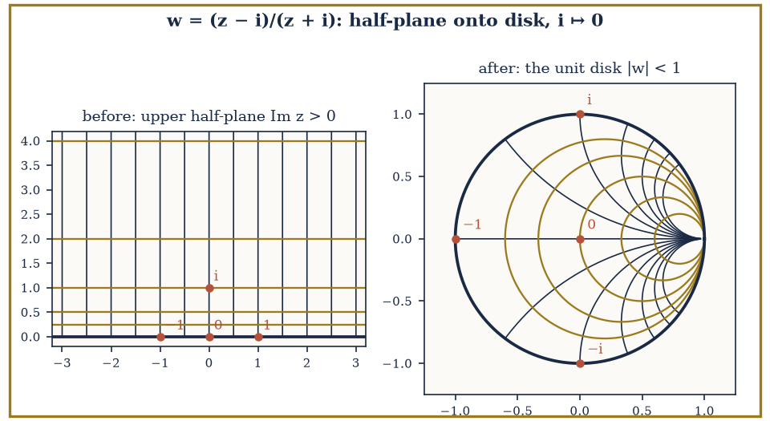
Figure 23.10 — The Möbius map w = (z − i)/(z + i) sends the upper half-plane (left) onto the unit disk (right). The real axis becomes the unit circle, with i ↦ 0, 0 ↦ −1, 1 ↦ −i and −1 ↦ i. Horizontal lines become circles tangent at w = 1, the image of the point at infinity.
The practical value of all this is that conformal maps let you relocate a hard problem to easier ground.
Many boundary-value problems — solving Laplace’s equation subject to prescribed values on a boundary, for instance — are difficult on an awkwardly-shaped domain but have clean, well-understood solutions on the unit disk or the upper half-plane (via the Poisson kernel or Fourier series, which we’ll meet properly in Harmonic Functions and Boundary-Value Problems).
The strategy is: conformally map your awkward domain to the disk, transport the boundary data across using the map, solve the easy problem on the disk, and map the solution back.
Since conformal maps preserve the structure that Laplace’s equation cares about (this is not a coincidence — it follows from the fact that harmonic functions are the real and imaginary parts of holomorphic functions, our very next topic), the solution translates back faithfully, angle-preservation and all.
Keep only this · Section 23.7: Conformal Mapping and the Riemann Mapping Theorem
The idea. Where f′ ≠ 0 a holomorphic map preserves angles. Every simply connected open domain other than ℂ can be mapped conformally onto the unit disk.
Core.
f′(a) ≠ 0 ⇒ f preserves angles at a
Möbius maps (az + b)/(cz + d) send circles and lines to circles and lines
Typical mistake. Calling a map conformal at a critical point, where f′ = 0.
Minimal example. w = (z − i)/(z + i) maps the upper half-plane onto the unit disk.
Practice. Easy to challenge; full worked answers, with the usual mistake, are in Answers to the Practice Sets at the back.
Easy — Is exp(z) conformal everywhere? Answer →
Medium — Image of the circle |z| = 2 under w = z². Answer →
Challenge — Why can no conformal bijection map ℂ onto the unit disk? Answer →

Section 23.8: Harmonic Functions and Boundary-Value Problems
Laplace’s equation, and the unreasonable usefulness of splitting a function into two halves
CORE · about 15 minutes · later chapters build on this
A metal plate held at fixed temperatures around its edge settles, after a while, into a steady pattern of temperature inside. That pattern has a striking property: the temperature at any point is exactly the average of the temperatures on any circle drawn around it, so the hottest and coldest spots can only lie on the edge, never in the interior. Functions with this averaging property are called harmonic, and they also describe electric potential in empty space. The real part of any well-behaved complex function is harmonic. For the saddle that comes from squaring a complex number, the average round any circle centered at the origin is zero, its value at the center.
Definition — A twice-differentiable real function u(x, y) is harmonic if it satisfies Laplace’s equation — the sum of its two second partial derivatives vanishes everywhere.
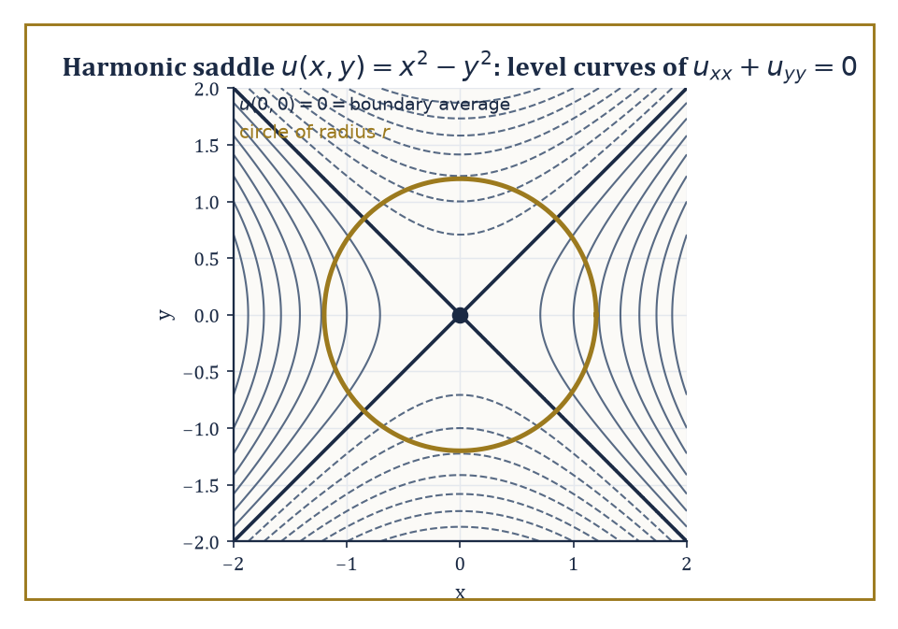
Figure 23.11 — The saddle u = x² − y², real part of z², with a circle drawn round the origin to check that its boundary average really is the center value: zero.
u_{xx} + u_{yy} = 0
Laplace’s equation shows up constantly in physics (steady-state heat distribution, electrostatic potential, the shape of a stretched membrane at rest), which is reason enough to care about it, but the connection to this chapter is direct and startling: the real part and the imaginary part of any holomorphic function are each individually harmonic.
This follows almost immediately from the Cauchy–Riemann equations of Holomorphic Functions and the Cauchy–Riemann Equations.
u_{x} = v_{y}
u_{y} = −v_{x}
Differentiate the first equation with respect to x and the second with respect to y, and (using the fact that holomorphic functions have continuous partial derivatives of every order, from The Cauchy Integral Formula and Power Series) the mixed partials of v cancel, leaving the following.
u_{xx} + u_{yy} = 0
The converse holds too, on a simply connected domain: every harmonic function u is the real part of some holomorphic function f = u + iv, where v (called the harmonic conjugate of u) can be recovered from u by integrating the Cauchy–Riemann equations.
Numeric example — verifying harmonicity and finding a conjugate. Let u be the function given below.
u(x, y) = x² − y²
Compute uₓₓ: first differentiate once,
uₓ = 2x
then differentiate again.
uₓₓ = 2
Compute u_{yy} the same way: first differentiate once,
u_{y} = −2y
then differentiate again.
u_{yy} = −2
Sum the two:
u_{xx} + u_{yy} = 2 + (−2) = 0
✓ — u is harmonic.
To find its harmonic conjugate v, use Cauchy–Riemann. From v_{y} = u_{x}, we have the following.
v_{y} = u_{x} = 2x
Integrate with respect to y.
v = 2xy + g(x)
for some function g(x) depending only on x (the ‘constant’ of integration with respect to y can depend on x). Differentiate this v with respect to x.
vₓ = 2y + g′(x)
The other Cauchy–Riemann equation says the following.
v_{x} = −u_{y} = −(−2y) = 2y
So g′(x) = 0, meaning g is a genuine constant; take it to be 0 for simplicity. So:
v(x, y) = 2xy
Reconstruct f = u + iv.
f = u + iv = (x² − y²) + i(2xy)
Compare with z².
z² = (x + iy)² = x² + 2ixy + i²y² = (x² − y²) + i(2xy)
Exactly the same expression. So u = x² − y² is, unsurprisingly given where we plucked it from, the real part of f(z) = z², and its harmonic conjugate is v = 2xy, the imaginary part of the same function.
Try it now — Is u = x³ − 3xy² harmonic? Answer →
Because harmonic functions inherit their good behavior directly from holomorphic ones, several of the chapter’s earlier theorems translate over almost word for word. The mean-value property holds: the value of a harmonic function at the center of a disk equals the average of its values around the boundary circle (this follows from applying the Cauchy integral formula to the associated holomorphic function and taking real parts).
The maximum principle holds too: a non-constant harmonic function attains no interior maximum or minimum — its extreme values live entirely on the boundary of its domain, just like the maximum-modulus principle from Holomorphic Functions and the Cauchy–Riemann Equations.
And on the unit disk specifically, there is an explicit reconstruction formula, the Poisson integral formula, expressing the value of a harmonic function at any interior point as a weighted average of its boundary values, with weights (the Poisson kernel) that concentrate more heavily near the interior point in question and fall off elsewhere.
Numeric example — the mean-value property in action. Take u(x, y) = x² − y², already confirmed harmonic in the previous example, and check the mean-value property on the circle of radius r centered at the origin.
u(0, 0) = 0² − 0² = 0
Parametrize the circle as x = r cos θ, y = r sin θ, θ running from 0 to 2π. Then:
u = r² cos²θ − r² sin²θ = r²(cos²θ − sin²θ) = r² cos(2θ)
using the double-angle identity. The average value around the circle is the following.
(1/2π) ∫[0, 2π] r² cos(2θ) dθ
Since cos(2θ) completes exactly two full periods as θ runs from 0 to 2π, it integrates to zero over the interval.
∫[0, 2π] cos(2θ) dθ = [sin(2θ)/2]₀^{2π} = 0 − 0 = 0
So the average is:
r² · 0 = 0
The boundary average, 0, matches the center value u(0, 0) = 0 exactly, for every radius r — the mean-value property confirmed on a concrete example, without needing to invoke the Cauchy integral formula that proves it in general.
These facts combine into a practical method for solving Dirichlet problems — find a harmonic function on a domain that matches prescribed values on the boundary — on domains that are not themselves the disk.
If your domain D can be conformally mapped to the unit disk (and, by the Riemann mapping theorem of the previous section, essentially any simply connected domain other than the whole plane can), the recipe is: map D to the disk, carry the boundary data across using the same map, solve the now-easy Dirichlet problem on the disk using the Poisson integral formula, and map the solution back to D using the inverse map.
Because conformal maps preserve harmonicity (a fact easiest to see via holomorphic functions: if h is holomorphic and u is harmonic, then u composed with h is again harmonic, essentially because composing with a holomorphic map preserves the ‘is the real part of a holomorphic function’ property), the transported solution is guaranteed to be harmonic on D and to match the prescribed boundary values, solving the original problem exactly.
Abstract example — solving a Dirichlet problem by transport. Suppose we want a harmonic function on the upper half-plane matching some prescribed values on the real axis (its boundary). Direct solution on the half-plane is possible but fiddly; instead, use the map from Conformal Mapping and the Riemann Mapping Theorem, which sends the upper half-plane conformally to the unit disk and the real axis to the unit circle.
w = (z − i)/(z + i)
Step 1: transport the boundary data. Every real point x on the boundary of the half-plane corresponds, via the map, to a specific point on the unit circle; carry the prescribed boundary value at x over to that corresponding circle point.
Step 2: solve the easy problem. On the disk, with boundary data now sitting on the unit circle, the Poisson integral formula hands you an explicit harmonic function U(w) matching that data — no further cleverness required, just an integral against the Poisson kernel.
Step 3: pull back. Define u(z) = U(w(z)), i.e. compose U with the map below.
w = (z − i)/(z + i)
Because composing a harmonic function with a holomorphic map yields another harmonic function, u is harmonic on the upper half-plane; and because the map sends each boundary point x to the corresponding circle point where U already matches the transported data, u matches the original prescribed boundary values on the real axis.
The hard problem on the half-plane has been solved entirely by solving an easy problem on the disk and translating the answer back — conformal mapping doing the heavy lifting so that Poisson’s formula never has to leave its comfort zone.
Keep only this · Section 23.8: Harmonic Functions and Boundary-Value Problems
The idea. Real and imaginary parts of holomorphic functions are harmonic, and harmonic functions satisfy the mean-value property.
Core.
u_{xx} + u_{yy} = 0
u = Re f with f holomorphic
u(center) = average of u on any circle in the domain
Typical mistake. Forgetting that a harmonic conjugate is fixed only up to an additive constant.
Minimal example. u = Re(z²) = x² − y² is harmonic, with conjugate v = 2xy.
Practice. Easy to challenge; full worked answers, with the usual mistake, are in Answers to the Practice Sets at the back.
Easy — Is u = eˣ sin y harmonic? Answer →
Medium — Find a harmonic conjugate of u = 2xy. Answer →
Challenge — A harmonic u on the disk |z| < 2 equals 5 everywhere on the circle |z| = 1. What is u(0)? Answer →

Chapter 23 in One Page
Complex differentiability is one demand with large consequences. Through the Cauchy–Riemann equations it forces Cauchy’s theorem: closed integrals of holomorphic functions vanish. The Cauchy integral formula then shows that holomorphic functions are power series, determined inside by their boundary values. Laurent series classify isolated singularities, and the residue theorem turns contour integrals and many real integrals into sums of residues. Where f′ ≠ 0 holomorphic maps are conformal, and the Riemann mapping theorem says every hole-free proper domain is conformally a disk. Harmonic functions are their real parts.
Key definitions
• Holomorphic (complex-differentiable on an open set).
• Contour integral ∫ᵧ f(z) dz.
• Laurent series, removable singularity, pole of order m, essential singularity.
• Residue: the coefficient of (z − a)⁻¹.
• Conformal map; harmonic function.
Key theorems, with their hypotheses
• Cauchy–Riemann — hypothesis: f complex-differentiable (conversely, continuous partials satisfying CR).
• Cauchy’s theorem — hypotheses: f holomorphic on a simply connected domain containing γ.
• Cauchy integral formula — hypotheses: f holomorphic on and inside γ, a inside γ, γ counterclockwise.
• Residue theorem — hypotheses: finitely many isolated singularities inside γ, none on γ.
• Riemann mapping — hypotheses: open, connected, simply connected, not ℂ.
Canonical example
• ∫[−∞, ∞] dx/(1 + x²) = 2πi · Res[z = i] 1/(1 + z²) = 2πi/(2i) = π, closing in the upper half-plane, where the arc contributes O(1/R).
Common errors
• Summing residues of poles outside the contour.
• Simple-pole formula used at a double pole.
• Forgetting the arc estimate for real integrals.
• Calling z̄ holomorphic because it is smooth.
Readiness checklist — you are ready for what comes next when you can:
□ check the Cauchy–Riemann equations
□ compute a contour integral by parametrization and by Cauchy’s formula
□ find the order of a pole and its residue
□ run the six-step residue checklist on a real integral
□ test conformality and state the Riemann mapping theorem with its hypotheses
Section 23.9 that follows is a preview, marked optional: it says where these ideas lead in later chapters and volumes. Nothing in it is needed for the exercises.

Section 23.9: Where This Goes Next (Optional): From Complex Analysis to Riemann Surfaces and Several Complex Variables
At the end of the chapter, several unmarked doors leading onward
PREVIEW — OPTIONAL · about 15 minutes · optional; read for orientation, nothing is examined
Overview — We have, in eight sections, acquired the core of classical complex analysis: what it means for a function to be holomorphic, why that one demand (agreement of a limit from every direction) forces an entire cascade of consequences — Cauchy’s theorem, the Cauchy integral formula, infinite differentiability and Taylor series, Laurent series and the classification of singularities, the residue theorem and its very concrete uses for evaluating real integrals and counting roots, conformal mapping and the Riemann mapping theorem, and finally the bridge to harmonic functions and boundary-value problems.
It is worth pausing, before we go further, to notice how much of this was really one idea worked out in exhaustive, satisfying detail: complex differentiability is a far more exclusive club than real differentiability, and everything else in the chapter is a description of exactly how generous the club is to the functions lucky enough to get in.
Several doors lead onward from here, none of which we’ll walk through in this chapter, but each worth naming so you know where to look later in the series.
The most immediate is the theory of Riemann surfaces — the natural habitat for multi-valued functions like the square root or the logarithm, which cannot be made single-valued on the punctured plane no matter how you try, but become perfectly single-valued, holomorphic functions once you replace the plane with a more elaborate surface built specifically to accommodate them.
Abstract example — the Riemann surface of the square root. Consider the function
f(z) = √z
This is a headache on ℂ \ {0}, because every nonzero z has two square roots, and there’s no way to choose one consistently all the way around a loop that encircles the origin.
For instance, start at z = 1 with √1 = 1, walk once counterclockwise around the origin back to z = 1, and continuous tracking of the square root brings you back to −1, not 1 — the two branches have swapped.
The fix is to stop insisting on a single copy of the plane. Take two copies of ℂ \ {0}, slit each one open along the positive real axis, and glue the top edge of the slit in copy one to the bottom edge of the slit in copy two, and vice versa (top of two to bottom of one) — a bit like taping two sheets of paper together so that walking off the edge of one lands you on the other.
The result is a single connected surface, wrapping around the origin twice before closing up on itself, on which √z is now perfectly well-defined and holomorphic at every point: what looked like a two-valued function on the plane is a single-valued function on this doubled-up surface.
This is the smallest possible taste of Riemann surface theory — the general theory builds such surfaces for arbitrarily complicated multi-valued functions, and the resulting objects turn out to be deeply entangled with algebraic geometry and topology, since the surface’s shape (how many handles it has, essentially) turns out to control which functions can live on it.
Try it now — Why does √z need a two-sheeted surface? Answer →
Several complex variables — functions of more than one complex variable simultaneously — turns out not to be a straightforward generalization but a different subject, with phenomena that have no single-variable analogue at all.
Hartogs’ phenomenon, for instance, shows that a function holomorphic near the boundary of certain regions in several variables is automatically forced to extend holomorphically into the interior too, whether it likes it or not — there is no several-variable equivalent of a function like 1/z that can be holomorphic on an annulus without extending across the hole, and the whole notion of a domain of holomorphy (a region that is, so to speak, maximally resistant to such forced extension) becomes a subtle and interesting question in its own right.
Complex dynamics, meanwhile, studies what happens when you iterate a holomorphic map — apply it, then apply it again to the result, and again, forever — and produces two of the most recognizable objects in all of mathematics, the intricately fractal Julia sets and the Mandelbrot set, both built from nothing more exotic than repeatedly squaring a complex number and adding a constant.
And the theory of modular forms and special functions, which underlies deep results in number theory (including, famously, the proof of Fermat’s Last Theorem), leans on complex-analytic techniques — holomorphicity, growth estimates, contour integration — at nearly every step.
The deeper lesson of this chapter, if it must be compressed into a single sentence before we move on, is this: an apparently modest local requirement — that a limit exist and agree from every direction of approach — imposes a global structure of extraordinary rigidity, reaching from the humble arithmetic of a + bi all the way to the shape of fractal sets and the proofs of centuries-old number-theoretic conjectures.
Complex analysis is at once a formidable computational engine (ask any physicist who has ever evaluated an integral by closing a contour in the upper half-plane and thanking a pole for its trouble) and one of the purest, most satisfying demonstrations in the whole series that algebra, geometry, and analysis are, deep down, telling the same story in three different accents.
The next chapter descends rather sharply from continuity into its opposite: Discrete Mathematics trades the smooth, infinitely-divisible plane we have just spent nine sections exploring for a world of counting, graphs, and objects that come one at a time, with no meaningful notion of ‘in between’ at all. It will feel, for a section or two, like leaving a well-appointed concert hall for a gravel car park. Bear with it — the gravel, it turns out, has its own extraordinary architecture, and a rather large fraction of the computers reading this very sentence (metaphorically speaking, since none of them can read yet) run on nothing but discrete mathematics underneath the hood.
The series continues. Mind the step; the handrail on this next flight is, appropriately enough, made of integers.
Keep only this · Section 23.9: Where This Goes Next (Optional): From Complex Analysis to Riemann Surfaces and Several Complex Variables
The idea. Riemann surfaces make multi-valued functions single-valued; several complex variables behave very differently from one.
Core.
multi-valued functions become single-valued on Riemann surfaces
Hartogs: in two or more variables, isolated singularities are removable
Typical mistake. Treating a branch cut as a property of the function rather than a choice made to define one branch.
Minimal example. log z needs infinitely many sheets, one for each value of 2πik added.
Practice. Easy to challenge; full worked answers, with the usual mistake, are in Answers to the Practice Sets at the back.
Easy — How many values does z^{1/3} have at z = 8? Answer →
Medium — What happens to log z after one counterclockwise loop around 0? Answer →
Challenge — Why is there no Riemann mapping theorem in two complex variables? Answer →

Check Your Understanding — Chapter 23
Answers are in the Answer Key at the back of the book — have a go before you look.
1. [Explain] Why does complex conjugation, f(z) = z̄, fail to be holomorphic at every single point of the plane, even though it’s a perfectly smooth function of x and y?
See the answer →
2. [Compute] Compute ∮ᵧ (1/z) dz around the unit circle traversed once counterclockwise, and explain why Cauchy’s theorem does not force this integral to vanish.
See the answer →
3. [Compute] Use the residue theorem to evaluate ∫[−∞, ∞] dx/(1+x²), and say which pole of 1/(1+z²) contributes.
See the answer →
4. [Compute] Verify the mean-value property for the harmonic function u(x,y) = x² − y² on a circle of radius r centered at the origin, and explain in one line why the property has to hold.
See the answer →

Fluency Drill — Chapter 23
Five minutes, no notes, before the harder problems. These are the moves the Problems assume are automatic; if one takes you more than a minute, reread the section it names. Worked answers, each with the usual slip, are in Answers to the Practice Sets.
1. [Compute] Order of the pole of 1/(z − 2)³ at 2, and of z/(z² + 1) at i. Answer →
2. [Compute] Order of the pole of sin z/z⁴ at 0. Answer →
3. [Compute] Residue of 1/((z − 1)(z + 2)) at 1. Answer →
4. [Compute] Residue of exp(z)/z² at 0. Answer →
5. [Concept] Does |z| = 1 enclose the poles of 1/(z² − 4)? Of 1/(z² + 1/4)? Answer →
6. [Concept] Which of 0, 3i and 1 + i lie inside the circle |z − i| = 1.5? Answer →
7. [Concept] The unit circle is traversed clockwise around a simple pole with residue 3. What is the integral? Answer →
8. [Compute] ∮ dz/z around |z| = 5 traversed twice counterclockwise. Answer →

Problems — Chapter 23
Complex analysis is the chapter where a computation you were dreading turns out to be a single residue, and the reader who has not practiced will not believe it. Thirteen problems follow, from arithmetic in the plane up to contour integration. Each problem carries a skill tag (Concept, Compute, Explain, Prove, Model or Challenge; see How to Use This Book) and a link to its full worked solution, which ends with the usual mistake.
The plane and its arithmetic
1. [Compute] Write z = 1 + i√3 in polar form, and use it to compute z⁶. Solution →
2. [Compute] Find all three cube roots of 8i and plot their positions on the circle of radius 2. Solution →
3. [Explain] Show that |eᶻ| = eᴿᵉᶻ for every complex z, and explain what this says about where the complex exponential is large. Solution →
Holomorphy and the Cauchy–Riemann equations
4. [Compute] Use the Cauchy–Riemann equations to verify that f(z) = z² is holomorphic everywhere. Solution →
5. [Prove] Show that f(z) = z̄ satisfies the Cauchy–Riemann equations nowhere, and hence is holomorphic nowhere, despite being smooth as a map ℝ² → ℝ². Solution →
6. [Challenge] A real-differentiable function of two variables has two independent partial derivatives. A complex-differentiable function has, in effect, only one derivative. Why does requiring the limit to be the same from every direction impose so much more than real differentiability, and what famous consequence follows? Solution →
Integration and Cauchy’s theorem
7. [Compute] Evaluate ∮[C] dz/z where C is the unit circle traversed once counterclockwise. Solution →
8. [Compute] Evaluate ∮[C] z² dz where C is any closed contour, and justify the answer in one sentence. Solution →
9. [Compute] Use the Cauchy integral formula to evaluate ∮[C] eᶻ/(z − 1) dz where C is the circle |z| = 2. Solution →
Singularities and residues
10. [Explain] Classify the singularity of f(z) = sin z / z at z = 0, and justify the classification from the Laurent series. Solution →
11. [Compute] Find the residue of f(z) = 1/((z − 1)(z − 3)) at z = 1, and evaluate ∮[C] f(z) dz for C the circle |z| = 2. Solution →
12. [Prove] Show that the residue of f(z) = z/((z − 2)²) at z = 2 equals 1. Solution →
13. [Challenge] The residue theorem converts an integral around a closed curve into a finite sum of local data at isolated points. What is it about holomorphic functions that makes such a drastic reduction possible, and why does nothing comparable exist for smooth real functions? Solution →

Math, Actually

Chapter 24

Counting Carefully
Counting, Graphs, Logic, and the Art of Reasoning About Finite Structures
The previous chapter left us in the company of holomorphic functions — objects so rigid that knowing one on a thimbleful of the plane determines it everywhere else, forever, whether it likes it or not. It was, in its way, a chapter about infinite generosity: an analytic function cannot help but tell you everything it knows. This chapter has rather a different temperament. Here we deal with objects that owe you nothing beyond what you can count, and the first rule of this chapter is that you are not permitted to wave a limit at a problem and hope it embarrasses itself into submission. If you want the answer, you count it.
Discrete mathematics studies structures that are, unsurprisingly, discrete: sets, graphs, integers, propositions, finite machines — things you could in principle list one by one, even if the list would outlast your career, your pension, and quite possibly the heat death of the universe. There is no differentiating, no integrating, no ε trailing nervously after δ in the small hours. There is only counting, deciding, and building — and counting, it turns out, is a great deal harder than it sounds once the quantities involved have more digits than you have fingers, toes, and complaining colleagues combined.
This is also, not coincidentally, the mathematics underneath your laptop. Every algorithm is a discrete object — a finite recipe of finitely many steps — and every claim that an algorithm works, or works quickly, is a discrete mathematics proof wearing a lab coat. Over the sections ahead we shall count things properly (Counting Principles and Generating Functions), watch sequences define themselves in terms of their own past selves (24.3), draw pictures of dots and lines that turn out to encode entire transport networks, molecules, and family trees (24.4–24.5), learn to argue with the icy precision the rest of mathematics only pretends to have (24.6), tidy up what a “relation” and a “function” really are once infinity is barred from the premises (24.7), and finish by totting up what all this counting and arguing actually costs to carry out on a machine (24.8) — which is, as it happens, most of what a computer scientist is paid to lie awake worrying about.
One warning, delivered now so it cannot later claim to have been sprung on you: in Logic, Proofs, and Boolean Algebra we shall need a small trick called diagonalization, invented by a gentleman arguing about lists that stubbornly refuse to be made complete. Here it looks like a parlor trick — a neat way to show that no clever enumeration scheme quite catches everything. In the next chapter, Set Theory & Logic, the very same trick is turned loose on infinity itself, and infinity does not survive the encounter with its dignity fully intact. Consider this a preview. Discrete mathematics, for all its scrupulous finitude, keeps one foot wedged in the door to the infinite next door. We shall walk through properly, and with considerably less caution, very soon. For now: let us count carefully.
Before you begin — Chapter 24 · Core chapter
By the end of this chapter you will be able to:
1. Count arrangements and selections with the product rule, permutations, combinations, inclusion–exclusion and stars and bars.
2. Solve linear recurrences by characteristic roots or generating functions, and divide-and-conquer recurrences.
3. Run BFS and DFS, test bipartiteness, find matchings and colourings, and use Euler’s formula.
4. Build truth tables, negate quantified statements and write induction and loop-invariant proofs.
5. Work with equivalence relations, partial orders and Hasse diagrams, and count functions.
6. Compare growth rates with O, Ω and Θ, and state P, NP and NP-completeness precisely.
Why it comes here. After the continuous mathematics of Chapters 13–23, this chapter turns to objects that can be counted: arrangements, recurrences, graphs, logical formulas and algorithms. The jump from residues to graphs is smaller than it looks. Generating functions continue the power series of Chapter 16, recurrences are discrete differential equations, and graph eigenvalues use Chapter 21. Chapter 25 then examines the logic and set theory underneath everything.
Required chapters. Power Series and Radius of Convergence (Chapter 16); Eigenvalues, Eigenvectors, and Diagonalization (Chapter 21).
Assumed skills. proof by induction (Volume 1); factorials and binomial coefficients; solving quadratic equations; reading simple pseudocode.
If you are rusty. Generating functions; Operations on Power Series.
Do not proceed until you can…
1. Compute C(6, 2) and 5!/3!. Answer →
2. Prove by induction that 1 + 2 + … + n = n(n + 1)/2 — just state the inductive step. Answer →
3. Solve x² = x + 1. Answer →
Estimated study time. About 12–14 hours over two weeks. Work every Try it now before reading on, finish each section’s Keep only this practice before starting the next, and do the Fluency Drill before the Problems.

Section 24.1: What Discrete Mathematics Is
In Which We Put Away the Ruler
CORE · about 15 minutes · later chapters build on this
A pizza place offers 4 sizes, 3 crusts, and 12 possible toppings, any number of which — including none, or all twelve — can be added to a single pizza. Counting how many different pizzas that allows sounds as though it might require listing every one of them, but it does not: choosing a size (4 ways), then a crust (3 ways), then independently deciding yes-or-no for each of the 12 toppings (2 choices per topping, so 2¹² = 4096 ways to choose a topping combination) multiplies together to 4 × 3 × 4096 = 49152 distinct pizzas — an exact, finite number, reached without listing a single one of them by hand.
Nowhere in that calculation did a derivative, an integral, or a limit put in an appearance, and that is not an accident. A pizza either has pepperoni on it or it does not; there is no “half a topping” sitting between “no pepperoni” and “one serving of pepperoni” for a rate of change to describe. Every quantity in the pizza-counting problem is separate and listable, even when the list is too long to write out by hand.
Every chapter so far in this series has asked some version of the same question: how does this quantity change as the input varies smoothly, continuously, by an amount that can be made as small as you like? Counting problems refuse that question outright. They ask how many distinct somethings there are, full stop — not how fast something is changing, because nothing here is changing in the continuous sense at all.
That shift — from measuring to counting, from continuous quantities to discrete, separate ones — is the shift this chapter is built around, and it needs its own toolkit, almost entirely unlike the one built up over the last twelve chapters. Multiplying possibilities together, the way the pizza count did, is only the beginning; harder counting problems need cleverer tools, and “I am fairly confident that is the right count” has to be replaceable, eventually, by an actual proof that it is the right count.
The objects under study change too. Instead of real numbers and smooth curves, this chapter spends its time with graphs of vertices and edges, finite sets, and step-by-step procedures guaranteed to stop after finitely many steps rather than sneaking up on an answer through a limiting process the way Chapter 10 (Volume 1)’s limits did. Nothing here is a lesser version of calculus; it is a different kind of mathematics, built for a different kind of question.
Definition — Discrete mathematics is the study of structures that are fundamentally discrete rather than continuous — objects to be counted rather than measured, relations that are finite rather than infinitesimal, algorithms that terminate after finitely many steps rather than sneaking up on an answer through a limiting process. Where the continuous chapters behind us asked “how does this quantity change as we nudge the input by an infinitesimal amount?”, this chapter asks “how many of these things are there, and can you list them without dying of old age first?”
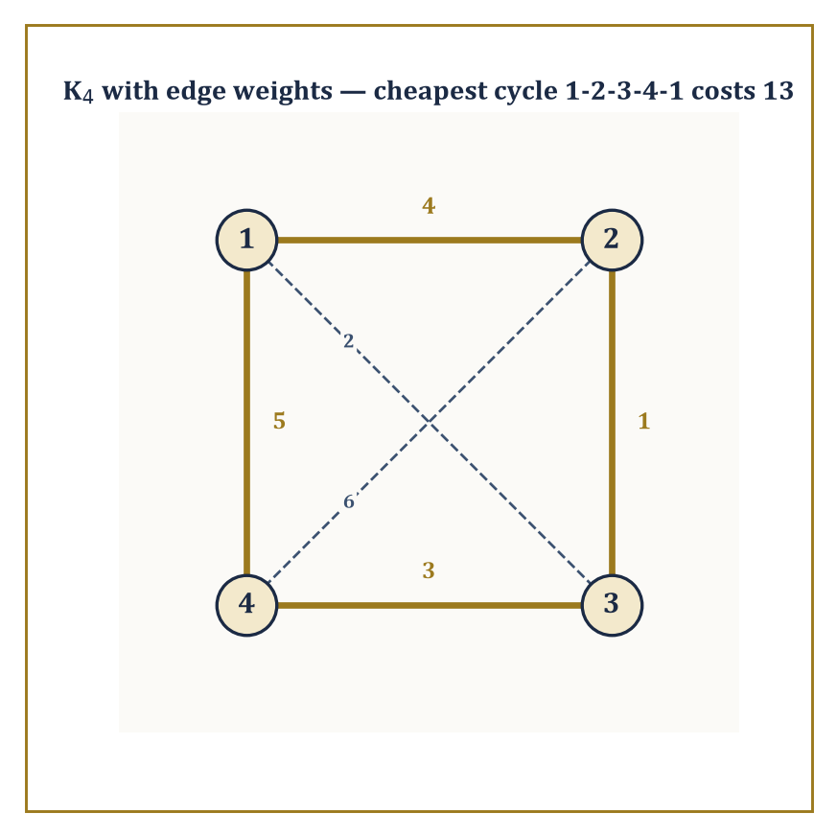
Figure 24.1 — Four weighted routes through K4; gold traces the cheapest tour, at a total cost of 13 — the humble ancestor of the Traveling Salesman Problem.
It sounds like a modest ambition. It is not. Exact counting, done honestly, is one of the more unforgiving disciplines in mathematics, because there is nowhere to hide an error behind an “approximately.”
Numeric example — counting handshakes. Suppose five people arrive at a rather small party and everyone shakes hands with everyone else exactly once. How many handshakes occur? Each handshake corresponds to an unordered pair of people, so we want the number of 2-element subsets of a 5-element set, written C(5,2).
C(n,k) = n! / (k!(n−k)!)
C(5,2) = 5! / (2!·3!) = (5·4·3·2·1) / (2·6) = 120/12 = 10
Direct check: label the guests A, B, C, D, E. The pairs are AB, AC, AD, AE, BC, BD, BE, CD, CE, DE — count them: that is exactly ten. No calculus was harmed in the production of this answer, and none was needed.
Try it now — How many handshakes happen when 6 people each shake hands with everyone else once? Answer →
The subject organizes itself around four recurring questions, and it is worth naming them once, cleanly, because they will recur under different disguises for the rest of the chapter.
Enumeration asks how many objects of a given kind exist. Existence asks merely whether at least one exists — a much weaker and sometimes much harder question, since proving something exists without producing it is a peculiar art in itself.
Construction asks whether we can build an example, efficiently, rather than merely proving one is out there somewhere sulking. Optimization asks, among all the objects that exist, which is best by some measure of cost or value.
A single problem can be attacked from all four angles, and doing so is usually the fastest way to understand it properly.
Abstract example — one graph, four questions. Take the complete graph K4 on four vertices {1,2,3,4}, where every pair of vertices is joined by an edge, and ask about Hamiltonian cycles — cycles that visit every vertex exactly once and return to the start.
Existence: does one exist? Trivially yes, since K4 has every possible edge available.
Construction: exhibit one — the cycle 1→2→3→4→1 works, since edges 1-2, 2-3, 3-4, 4-1 are all present.
Enumeration: how many distinct such cycles are there? For Kₙ the count is (fixing a starting vertex to kill rotational duplicates, then dividing by 2 for the two directions round the same cycle):
(n−1)!/2
For n=4 that is:
3!/2 = 6/2 = 3
Listing them confirms it: 1-2-3-4-1, 1-2-4-3-1, and 1-3-2-4-1 — three different cycles.
Optimization: now weight the edges — say 1-2:4, 1-3:2, 1-4:5, 2-3:1, 2-4:6, 3-4:3 — and ask for the cheapest cycle.
Cycle 1-2-3-4-1 costs 4+1+3+5 = 13
Cycle 1-2-4-3-1 costs 4+6+3+2 = 15
Cycle 1-3-2-4-1 costs 2+1+6+5 = 14
The cheapest is the first, at 13 — which is, incidentally, a miniature and entirely honest instance of the Traveling Salesman Problem, a question so innocuous-looking that entire university departments have built careers on failing to answer it quickly for large n.
The methods that answer these four questions form the working toolkit of the whole chapter, and it is worth having their names in advance even before we have earned the right to use them properly: induction (prove a statement for all natural numbers by proving it for the first one and showing each case drags the next one along with it), bijection (prove two sets have the same size by pairing their elements off perfectly, with nobody left over), and inclusion–exclusion (count a union by adding the pieces and then correcting for double-counting the overlaps).
The remaining methods are generating functions (encode an entire infinite sequence of counts as a single algebraic object and let algebra do the counting for you), recurrence relations (define a sequence in terms of its own earlier values), and algorithm analysis (count not objects but operations, to work out how expensive a computation will be).
Every one of these gets a proper section to itself before this chapter is done.
Numeric example — a bijection in miniature. Here is the bijection method doing real work on the smallest possible scale. Claim: a set of 3 elements has just this many subsets:
2³ = 8
Proof by bijection: pair each subset of {1,2,3} with a binary string of length 3, where position i is 1 if element i is included and 0 otherwise. The pairing is:
∅↔000, {1}↔100, {2}↔010, {3}↔001, {1,2}↔110, {1,3}↔101, {2,3}↔011, {1,2,3}↔111
Every subset gets exactly one string and every string gets exactly one subset — a perfect pairing, with nothing left over on either side.
Since there are 2³ = 8 binary strings of length 3 (two choices per position, three positions), there must be exactly 8 subsets too.
No subset was directly counted; the count was borrowed, honestly, from an easier problem next door. This is the entire strategy of bijective counting in one paragraph, and we shall lean on it constantly.
Keep only this · Section 24.1: What Discrete Mathematics Is
The idea. Discrete mathematics counts, arranges and connects finite structures; a good bijection often replaces a long calculation.
Core.
count, construct, decide
bijection: equal sizes without counting either
Typical mistake. Counting ordered pairs when the question is about unordered ones.
Minimal example. Subsets of {1, …, n} ↔ binary strings of length n: 2ⁿ of each.
Practice. Easy to challenge; full worked answers, with the usual mistake, are in Answers to the Practice Sets at the back.
Easy — How many edges does K₇ have? Answer →
Medium — Give a bijection showing that subsets of {1, 2, 3} with an even number of elements are as many as those with an odd number. Answer →
Challenge — How many Hamiltonian cycles does K₅ have (as undirected cycles)? Answer →

Section 24.2: Counting Principles and Generating Functions
Or: How Many Ways Can This Possibly Go
CORE · about 25 minutes · later chapters build on this
Counting sounds like the easiest thing in mathematics until the things being counted are arrangements rather than objects. How many meals can be ordered from a short menu, how many eight-character passwords exist, how many ways can a committee of three be chosen from ten people? Listing them soon becomes hopeless: there are 120 possible committees, and the passwords run to hundreds of trillions once capitals, small letters and digits are allowed. A few principles do the work instead. Multiply when choices are made one after another, add when they are alternatives, and divide out orderings you do not care about. Generating functions, at the end of the section, pack a whole counting problem into a single expression.
A small restaurant offers 3 starters and 2 desserts. How many different two-course meals, one starter and one dessert, can you order? List them, calling the starters S1, S2 and S3 and the desserts D1 and D2:
S1 D1, S1 D2
S2 D1, S2 D2
S3 D1, S3 D2
Six meals, in three rows of two. The list has that shape because every starter goes with every dessert: 3 rows with 2 in each, and 3 × 2 = 6. A diner who wants only one course, a starter or a dessert, has 3 + 2 = 5 choices. Multiplying answers ‘this and then that’; adding answers ‘this or that’.
Listing stops being practical very quickly. Add 4 mains, and the three-course meals number 3 × 4 × 2 = 24, which nobody wants to write out. Multiplying can also overcount. Put 3 of your 5 books on a shelf, left to right, and there are 5 × 4 × 3 = 60 arrangements. Choose 3 of the 5 to take on holiday, where order means nothing, and the answer is not 60. Each holiday choice, say books A, B and C, appears on the shelf in 3 × 2 × 1 = 6 orders: ABC, ACB, BAC, BCA, CAB and CBA. So the holiday count is 60 ÷ 6 = 10.
That is most of this section in miniature: multiply for independent choices, add for separate alternatives, and divide out the orders you did not mean to count. The worked examples below use this restaurant and these five books, then build the same habits into binomial coefficients, inclusion–exclusion and generating functions.
Definition — The two founding rules of counting are almost embarrassingly simple to state and endlessly useful to apply.
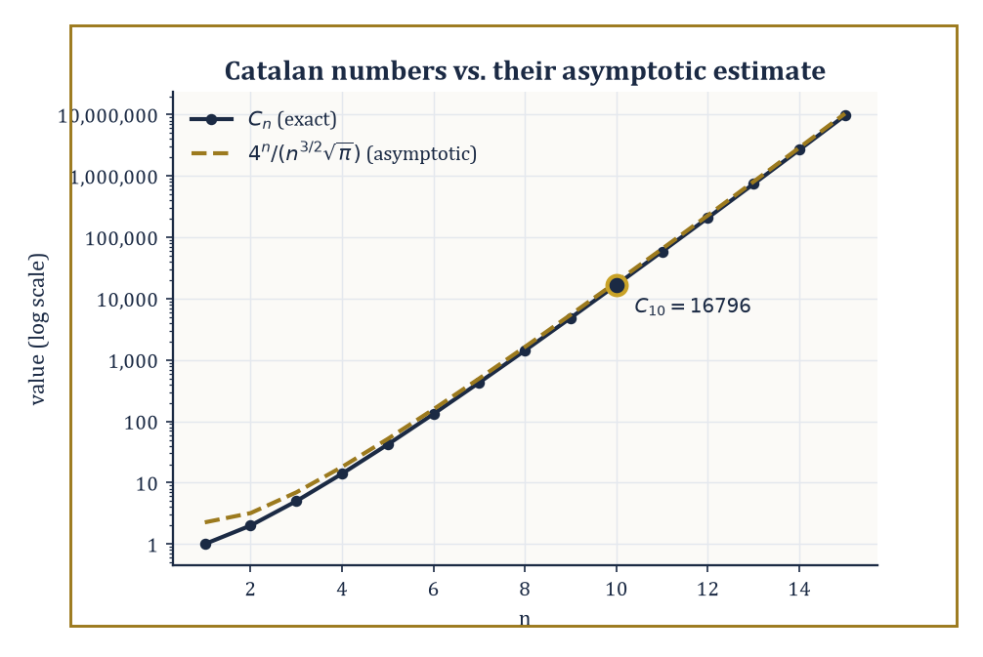
Figure 24.2 — The exact Catalan numbers and their asymptotic estimate, agreeing rather smugly once n reaches double digits.
The sum rule: if a choice can be made in one of two mutually exclusive ways, offering m options and n options respectively, the total number of options is m + n.
The product rule: if a compound choice consists of an independent first choice with m options followed by a second choice with n options, the total number of combined outcomes is m × n.
Almost every counting argument in this section is these two rules, dressed up and applied repeatedly.
Numeric example — a set menu. A restaurant offers 3 starters, 4 mains, and 2 desserts.
By the product rule, a full three-course meal (one from each) can be chosen in the following number of ways — each independent choice multiplies the possibilities:
3 × 4 × 2 = 24
Now suppose instead a diner in a hurry wants just one course, either a starter or a dessert (never both, and the two lists share no dishes).
By the sum rule, that is:
3 + 2 = 5
Notice the rules answer different questions: product rule for “this AND that AND that,” sum rule for “this OR that,” with the crucial proviso that the “or” options must be genuinely mutually exclusive, or you will double-count and a pedant (or an examiner) will notice.
Try it now — How many 3-letter strings can be made from A–E with no repeats? How many 3-element subsets? Answer →
A permutation is an ordered arrangement of r objects chosen from n distinct objects, counted by:
P(n,r) = n!/(n−r)!
A combination is an unordered selection of r objects from n, counted by:
C(n,r) = n!/(r!(n−r)!)
The relationship between them is an overcounting correction: every combination of r objects can be arranged in r! different orders, so:
P(n,r) = C(n,r) × r!
Dividing by r! is how one recovers C(n,r) from P(n,r).
Numeric example — shelving versus selecting. You own 5 distinct books but only 3 slots on a display shelf, and order on the shelf matters (leftmost is most prominent).
The number of ways to fill the shelf is:
P(5,3) = 5!/(5−3)! = 5!/2!
5!/2! = (5·4·3·2·1)/(2·1) = 120/2 = 60
Equivalently, directly: 5 choices for the first slot, 4 remaining for the second, 3 remaining for the third —
5×4×3 = 60
matching exactly.
Now suppose instead you are choosing 3 of the 5 books to take on holiday, with no shelf and no order. That is:
C(5,3) = 5!/(3!·2!) = 120/(6·2)
120/(6·2) = 120/12 = 10
Check the relationship:
P(5,3)/3! = 60/6 = 10 = C(5,3)
This holds as the theory promises, since each of the 10 unordered trios can be arranged on the shelf in 3! = 6 different orders, and 10 × 6 = 60.
The binomial theorem states:
(x+y)ⁿ = Σₖ₌₀ⁿ C(n,k) xᵏ yⁿ⁻ᵏ
The coefficients C(n,k) obey Pascal’s recurrence:
C(n,k) = C(n−1,k−1) + C(n−1,k)
This is a fact with a lovely combinatorial proof rather than merely an algebraic one: a k-element subset of an n-element set either contains a fixed element (choose the remaining k−1 from the other n−1) or does not (choose all k from the other n−1), and these two cases are exhaustive and non-overlapping, so the counts add.
Numeric example — expanding (x+y)⁴. Row four of Pascal’s triangle is 1, 4, 6, 4, 1 (each entry the sum of the two above it: 4 = 1+3, 6 = 3+3, from row three’s 1,3,3,1).
So:
(x+y)⁴ = x⁴ + 4x³y + 6x²y² + 4xy³ + y⁴
As a sanity check, set x = y = 1: the left side is
2⁴ = 16
and the right side is
1+4+6+4+1 = 16
They agree, which is no accident, since setting x=y=1 counts every subset of a 4-element set by size, and there are 2⁴ subsets in total.
The principle of inclusion–exclusion corrects the sum rule for the case where the “or” categories overlap:
|A ∪ B| = |A| + |B| − |A ∩ B|
The general pattern — add the singles, subtract the pairwise overlaps, add back the triple overlaps, and so on, alternating sign — extends to any number of sets.
Numeric example — divisible by 3 or by 5. How many integers from 1 to 100 are divisible by 3 or by 5?
Let A be those divisible by 3:
|A| = ⌊100/3⌋ = 33
Let B be those divisible by 5:
|B| = ⌊100/5⌋ = 20
The overlap A∩B is those divisible by both, i.e. by 15:
|A∩B| = ⌊100/15⌋ = 6
By inclusion–exclusion:
|A∪B| = 33 + 20 − 6 = 47
Naively adding 33+20 = 53 would have double-counted the 6 multiples of 15 (such as 15, 30, 45, ...) — inclusion–exclusion is the bookkeeping that removes that double-count exactly once, no more, no less.
Stars and bars counts the number of ways to distribute k indistinguishable objects into n distinguishable bins:
C(k+n−1, n−1)
The trick is to represent the distribution as a row of k stars (the objects) separated by n−1 bars (the bin dividers); any arrangement of k stars and n−1 bars corresponds to exactly one distribution, so the count reduces to choosing which k of the k+n−1 positions in the row hold stars — a bijection, once again, turning a hard-looking problem into an easy one.
Numeric example — sweets for three children. Ten identical sweets are to be distributed among three children (some may get none).
Here k=10 objects, n=3 bins, so the count is:
C(10+3−1, 3−1) = C(12,2) = 12!/(2!·10!) = (12·11)/2 = 66
As a spot check on a tiny case: distributing 2 sweets among 2 children should give:
C(2+2−1,2−1) = C(3,1) = 3
And indeed the possibilities are (2,0), (1,1), (0,2), which is exactly three ways. The formula scales correctly.
Certain counting problems recur so often that their answers have been given names and studied as sequences in their own right.
The Catalan numbers count, among many equivalent things, the number of ways to correctly balance n pairs of parentheses:
Cₙ = C(2n,n)/(n+1)
The Stirling numbers count partitions of a set into a given number of non-empty blocks (Stirling numbers of the second kind) or permutations by cycle structure (first kind).
What makes these sequences worth naming is that wildly different-looking problems — balanced parentheses, binary tree shapes, triangulations of a polygon, paths that never cross a diagonal — all turn out to be secretly the same problem, and hence share the same answer.
Numeric example — balancing three pairs of parentheses. How many ways can 3 pairs of parentheses be validly balanced (never a closing bracket with no matching open bracket to its left)?
By the formula:
C₃ = C(6,3)/(3+1) = 20/4 = 5
Listing them by hand to check: ()()(), (())(), ()(()), (()()), ((())) — five valid strings, and no others work (try, for instance, )(()( — invalid immediately at the first character). The formula and the exhaustive list agree.
A generating function encodes an entire sequence a₀, a₁, a₂, ... as the coefficients of a single formal power series:
A(x) = Σₙ aₙxⁿ
The word “formal” is doing real work here: we never actually plug in a value of x and worry about convergence — the series is a clothes-line on which to hang the sequence, one term per peg.
Its power is that combinatorial constructions translate directly into algebraic operations on generating functions: a disjoint union of structures corresponds to adding generating functions; independently combining two structures corresponds to multiplying them; and “zero or more copies of a structure” corresponds to the geometric-series operation 1/(1−f(x)).
Worked example — the generating function for subsets. Consider (1+x)ⁿ as the generating function that tracks subsets of an n-element set by size: the coefficient of xᵏ is C(n,k), the number of k-element subsets.
For n=3:
(1+x)³ = 1 + 3x + 3x² + x³
Read off the coefficients: 1 subset of size 0 (the empty set), 3 of size 1, 3 of size 2, 1 of size 3 (the whole set) — matching the subsets of {a,b,c} exactly: ∅; {a},{b},{c}; {a,b},{a,c},{b,c}; {a,b,c}.
The algebraic operation “multiply out (1+x)(1+x)(1+x)” has silently performed the combinatorial operation “for each of the three elements, independently decide in or out” — which is precisely the product rule, wearing algebra as a disguise.
A close cousin, the exponential generating function (EGF), replaces xⁿ with xⁿ/n! and is the natural tool when the objects being arranged are labeled and distinguishable — permutations, labeled trees, and the like — because division by n! is the correction needed to account for the n! ways of ordering n labels.
Beyond enumeration, generating functions have an asymptotic superpower: the growth rate of a combinatorial sequence is governed by the location of the nearest singularity of its generating function to the origin — a startling bridge back to the complex analysis of the previous chapter, where “singularity” meant a point where a function misbehaves.
Here it means the same thing, and it tells you, almost for free, how fast your sequence grows.
Numeric example — Catalan growth from a singularity. The Catalan generating function has a singularity at x = 1/4, and the resulting asymptotic estimate is:
Cₙ ≈ 4ⁿ / (n^{3/2}·√π)
Test it at n=10, where the true value is C₁₀ = 16796 (the Catalan sequence runs 1, 1, 2, 5, 14, 42, 132, 429, 1430, 4862, 16796, ...).
The estimate proceeds step by step:
4¹⁰ = 1,048,576
n^{3/2} = 10^{1.5} ≈ 31.62
√π ≈ 1.772
denominator ≈ 31.62 × 1.772 ≈ 56.05
estimate ≈ 1,048,576 / 56.05 ≈ 18,710
Compared to the true 16,796, the estimate is about 11% high — respectable but not exact, exactly as expected from an asymptotic formula at a modest n=10; the relative error shrinks steadily as n grows, and the formula is provably exact in the limit.
The singularity at x=1/4 is precisely why the base of the exponential growth is 4 — a fact you would be hard-pressed to extract by staring at balanced parentheses alone.
Keep only this · Section 24.2: Counting Principles and Generating Functions
The idea. Product rule for successive choices; divide by the orderings you do not care about; inclusion–exclusion for overlaps; stars and bars for identical objects.
Core.
P(n, k) = n!/(n − k)!
C(n, k) = n!/(k!(n − k)!)
|A ∪ B| = |A| + |B| − |A ∩ B|
stars and bars: C(n + k − 1, k − 1)
Typical mistake. Forgetting the overlap term in inclusion–exclusion.
Minimal example. 3 starters, 4 mains, 2 desserts: 24 menus.
Practice. Easy to challenge; full worked answers, with the usual mistake, are in Answers to the Practice Sets at the back.
Easy — In how many ways can first, second and third place be filled from 10 runners? Answer →
Medium — How many integers in 1–60 are divisible by 4 or 6? Answer →
Challenge — How many solutions in non-negative integers has x + y + z = 7? Answer →

Section 24.3: Recurrence Relations
Sequences That Look Back Before Moving Forward
CORE · about 15 minutes · later chapters build on this
Key idea — A recurrence relation expresses each term of a sequence in terms of one or more earlier terms, together with enough initial conditions to get the whole thing started. It is the discrete cousin of a differential equation — instead of relating a function to its instantaneous rate of change, a recurrence relates a term to its immediate predecessors — and, pleasingly, many of the solution techniques carry straight over with only cosmetic changes.
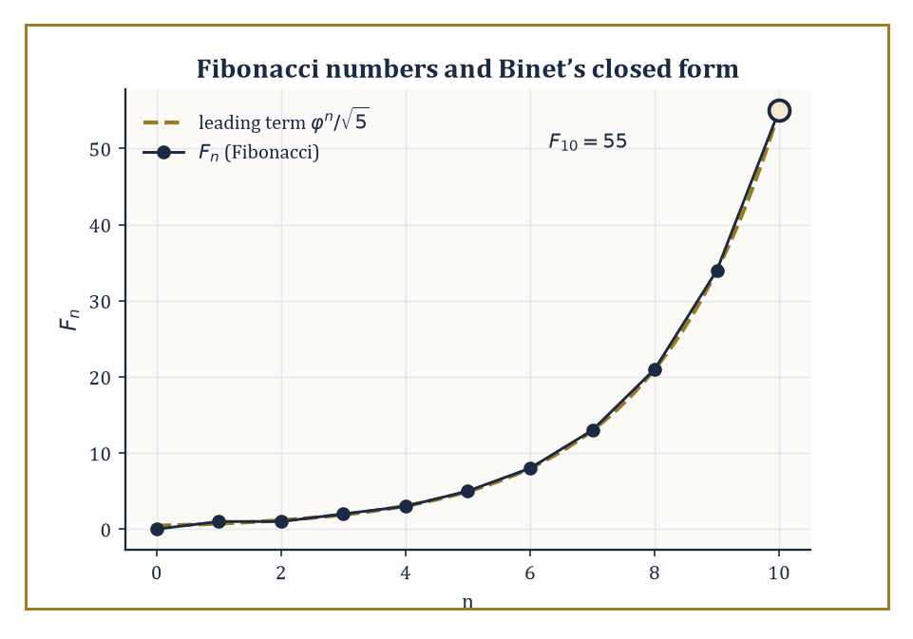
Figure 24.3 — Fibonacci’s stepped growth against the smooth exponential curve it was obeying all along.
Numeric example — the simplest possible recurrence. Let aₙ be defined by the recurrence
aₙ = 2aₙ₋₁, a₀ = 1
Unrolling it:
a₁ = 2·1 = 2
a₂ = 2·2 = 4
a₃ = 2·4 = 8
a₄ = 2·8 = 16
a₅ = 2·16 = 32
The pattern aₙ = 2ⁿ is obvious by now and easily confirmed by induction.
base case: a₀ = 2⁰ = 1 ✓
inductive step: if aₖ = 2ᵏ then aₖ₊₁ = 2·2ᵏ = 2ᵏ⁺¹ ✓
Trivial, yes — but every technique in this section is ultimately a more industrial-strength version of this unrolling process.
Try it now — Solve aₙ = 2aₙ₋₁, a₀ = 5. Answer →
For a linear recurrence with constant coefficients — one where each term is a fixed linear combination of a bounded number of predecessors — the standard method is the characteristic equation: guess a solution of the form aₙ = rⁿ, substitute into the recurrence, and the exponents cancel, leaving a plain polynomial equation in r. Solve that polynomial for its roots, and a general solution is a linear combination of rⁿ for each root r (with a little extra care if a root repeats). This is the method used to solve linear differential equations with constant coefficients — same idea, discrete clothing.
Numeric example — Fibonacci via the characteristic equation. The Fibonacci recurrence Fₙ = Fₙ₋₁ + Fₙ₋₂, with F₀=0, F₁=1, gives the characteristic equation:
r² = r + 1, i.e. r² − r − 1 = 0
By the quadratic formula, r = (1 ± √5)/2, giving:
φ = (1+√5)/2 ≈ 1.6180339887, ψ = (1−√5)/2 ≈ −0.6180339887
Fitting the initial conditions yields Binet’s formula:
Fₙ = (φⁿ − ψⁿ)/√5
Test it at n=10, using the identity xⁿ = Fₙ·x + Fₙ₋₁ (valid for any root x of the characteristic equation, since the recurrence itself supplies it):
φ¹⁰ = F₁₀·φ + F₉
We don’t know F₁₀ yet — that is what we are solving for — so instead compute directly, using the same identity with F₅=5, F₄=3:
φ⁵ = 5φ+3 ≈ 5(1.6180339887)+3 = 8.0901699435+3 = 11.0901699435
φ¹⁰ = (φ⁵)² ≈ 122.9918693729
Similarly:
ψ⁵ = 5ψ+3 ≈ 5(−0.6180339887)+3 = −3.0901699435+3 = −0.0901699435
ψ¹⁰ = (ψ⁵)² ≈ 0.0081306135
Then:
Fₙ = (φ¹⁰ − ψ¹⁰)/√5 ≈ (122.9918693729 − 0.0081306135)/2.2360679845 ≈ 122.9837387594/2.2360679845 ≈ 55.0000
Direct iteration confirms it: 0,1,1,2,3,5,8,13,21,34,55 — the tenth Fibonacci number (starting the count at F₀=0) is indeed 55. A formula built entirely from irrational numbers conspires, term by term, to output a perfect integer — which is either beautiful or deeply suspicious, depending on how much sleep you have had.
Generating functions offer a second route to the same destination, and one that scales more gracefully to recurrences the characteristic-equation method finds awkward: multiply the recurrence by xⁿ, sum over all valid n, and the resulting equation involves only the generating function A(x) itself — algebra, not a case-by-case unrolling.
After which solving for A(x) and expanding it as a power series reads off the closed form directly from the coefficients.
Numeric example — solving aₙ = 3aₙ₋₁ by generating function. Consider the recurrence aₙ = 3aₙ₋₁ for n≥1, with a₀=2, and set the generating function:
A(x) = Σ[n ≥ 0] aₙxⁿ
Then:
A(x) − a₀ = Σ[n ≥ 1] aₙxⁿ = Σ[n ≥ 1] 3aₙ₋₁xⁿ = 3x·Σ[n ≥ 1] aₙ₋₁xⁿ⁻¹ = 3x·A(x)
So:
A(x) − 2 = 3x·A(x)
A(x)(1−3x) = 2
A(x) = 2/(1−3x)
Recognizing 1/(1−3x) as the geometric series Σ(3x)ⁿ, we get:
A(x) = 2·Σ(3x)ⁿ = Σ 2·3ⁿ xⁿ
so:
aₙ = 2·3ⁿ
Check at n=3: formula gives 2·27 = 54; direct iteration gives a₀=2, a₁=6, a₂=18, a₃=54 — matches exactly.
Divide-and-conquer algorithms — the ones that split a problem into smaller copies of itself, solve those, and stitch the results together — obey recurrences of the shape:
T(n) = a·T(n/b) + f(n)
where a is the number of subproblems, n/b is their size, and f(n) is the cost of splitting and recombining.
The Master theorem reads off the growth rate of T(n) by comparing f(n) against n^{log}_{b} ª: if f(n) grows strictly slower, the recursive calls dominate; if strictly faster, the combining step dominates; and if they match (up to logarithmic factors), the two contributions balance and contribute equally.
Numeric example — merge sort’s recurrence. Merge sort splits an array in two, recursively sorts each half, then merges in linear time:
T(n) = 2T(n/2) + n
Here a=2, b=2, so:
n^{log}_{b} ª = n^{log₂2} = n¹ = n
This matches f(n) = n — the Master theorem’s balanced case — giving:
T(n) = Θ(n log n)
Tracing actual values with base case T(1)=1:
T(2) = 2T(1)+2 = 2·1+2 = 4
T(4) = 2T(2)+4 = 2·4+4 = 12
T(8) = 2T(4)+8 = 2·12+8 = 32
Compare against n·log₂n at n=8:
8·3 = 24
T(8)=32 is not equal to 24 — Θ describes matching order of growth, not an exact value, and the gap is entirely explained by the constant baked in by the base case T(1)=1. The ratio T(n)/(n log n) stays bounded as n grows, which is all Θ ever promised.
The Fibonacci recurrence is not merely a famous curiosity; the identical recurrence relation governs several outwardly unrelated counting problems, and recognizing the shared skeleton is often the whole trick to solving a new problem instantly.
Numeric example — tiling a 2×n strip with dominoes. How many ways can a 2×n rectangular strip be tiled with 1×2 dominoes (placed either horizontally or vertically)? Let T(n) be the count.
The rightmost column is either covered by a single vertical domino (leaving a 2×(n−1) strip to tile in T(n−1) ways) or by two horizontal dominoes stacked, covering the last two columns together (leaving a 2×(n−2) strip in T(n−2) ways).
These two cases are exhaustive and disjoint, so:
T(n) = T(n−1) + T(n−2)
This is the Fibonacci recurrence exactly, with base cases T(1)=1 (one vertical domino) and T(2)=2 (two verticals, or two horizontals stacked).
T(3) = T(2)+T(1) = 2+1 = 3
T(4) = T(3)+T(2) = 3+2 = 5
T(5) = T(4)+T(3) = 5+3 = 8
A 2×5 strip can be tiled in exactly 8 ways — and the number is a Fibonacci number purely because the case-split has the identical shape as rabbits breeding, with no rabbits, breeding, or biology involved anywhere.
Numeric example — the Euclidean algorithm’s worst case. The Euclidean algorithm finds gcd(a,b) by repeated division with remainder. It is a classical fact (Lamé’s theorem) that consecutive Fibonacci numbers force the algorithm to take its maximum possible number of steps for numbers of that size.
Trace gcd(55,34), where 55=F₁₀ and 34=F₉:
55 = 1·34 + 21
34 = 1·21 + 13
21 = 1·13 + 8
13 = 1·8 + 5
8 = 1·5 + 3
5 = 1·3 + 2
3 = 1·2 + 1
2 = 2·1 + 0
That is 8 division steps before the remainder hits zero, giving gcd(55,34) = 1. Notice the remainders themselves — 21, 13, 8, 5, 3, 2, 1 — are the Fibonacci sequence marching downward.
Every step but the last produces a quotient of exactly 1 — the smallest quotient a division with remainder can produce without terminating outright, and so the slowest possible way to shrink the pair — with only the final, terminating division (2 = 2·1 + 0) breaking the pattern, which is why consecutive Fibonacci numbers are the algorithm’s nemesis.
Keep only this · Section 24.3: Recurrence Relations
The idea. For aₙ = c₁aₙ₋₁ + c₂aₙ₋₂, solve r² = c₁r + c₂ and fit the initial values; divide-and-conquer recurrences give n log n.
Core.
aₙ = c₁aₙ₋₁ + c₂aₙ₋₂ ⇒ r² = c₁r + c₂, aₙ = Ar₁ⁿ + Br₂ⁿ
repeated root: (A + Bn)rⁿ
T(n) = 2T(n/2) + n ⇒ Θ(n log n)
Typical mistake. Fitting the general solution to the wrong initial index (a₁ in place of a₀).
Minimal example. aₙ = 5aₙ₋₁ − 6aₙ₋₂: roots 2, 3.
Practice. Easy to challenge; full worked answers, with the usual mistake, are in Answers to the Practice Sets at the back.
Easy — Solve aₙ = 4aₙ₋₁, a₀ = 3. Answer →
Medium — Solve aₙ = 4aₙ₋₁ − 4aₙ₋₂, a₀ = 1, a₁ = 4. Answer →
Challenge — Solve T(n) = T(n/2) + 1, T(1) = 0, for n a power of 2. Answer →

Section 24.4: Graph Theory: Basics, Paths, and Trees
Dots, Lines, and the Networks They Secretly Are
CORE · about 20 minutes · later chapters build on this
Strip a road map down to its essentials and you are left with towns and the roads between them. Strip down a social network and you have people and friendships; a molecule, atoms and bonds; a project plan, tasks and dependencies. In every case the useful information is simply which things are connected to which, and that is all a graph records: dots, called vertices, and lines between them, called edges. The geometry is thrown away, so the same tools work for all of them. Finding the fewest roads from one town to every other, for example, is done by spreading outward from the start one step at a time, and the roads used form a tree.
Definition — A graph consists of a set V of vertices and a set E of edges, each edge joining a pair of vertices.
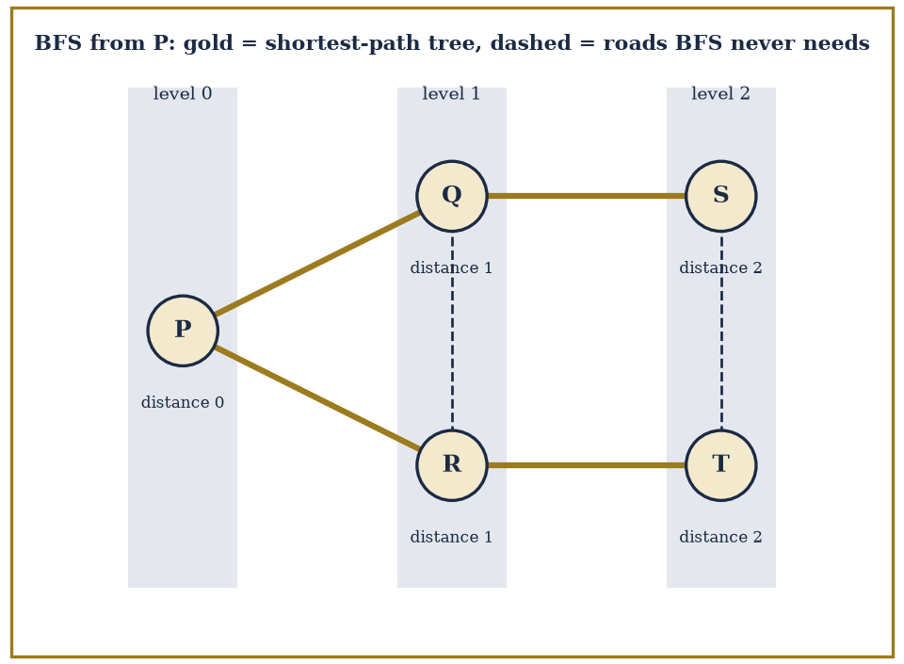
Figure 24.4 — BFS from town P on the six roads PQ, PR, QR, QS, RT, ST: the gold roads form the shortest-path tree, levels 0, 1, 2 are the distances from P, and the two dashed roads (Q–R inside level 1, S–T inside level 2) are never needed to reach anything sooner.
G = (V,E)
That is the entire definition, and its very sparseness is the source of its power: a graph can equally well represent a road network, a social network, a molecule’s bonds, a project’s task dependencies, or a city’s subway lines, because all these situations reduce to “some things, and some pairwise connections between them,” with everything else stripped away as irrelevant detail.
Variants enlarge the vocabulary as needed: directed graphs give edges a direction (an arrow, not a line), weighted graphs attach a number — distance, cost, capacity — to each edge, and multigraphs permit more than one edge between the same pair of vertices.
Numeric example — a small road network. Five towns P, Q, R, S, T are connected by roads P–Q, P–R, Q–R, Q–S, R–T, S–T (six roads in total).
The maximum conceivable number of roads, if every pair of towns were directly connected, would be:
C(5,2) = 10
This network uses 6 of those 10 possible connections, making it a fairly well-connected but not complete graph. This same five-town map will serve as our running example for the rest of the section.
A walk is any route through a graph that follows edges, possibly revisiting vertices or edges. A path is a walk that never revisits a vertex. A cycle is a path that returns to its starting vertex (with no other repeats along the way).
Two graphs on the same vertices can look wildly different depending purely on which walks happen to close up into cycles and which do not, and this single structural fact — cyclic or acyclic — turns out to be the fork in the road that separates “graph” from “tree,” as we shall see shortly.
Numeric example — a path and a cycle in the same map. In the P–Q–R–S–T road network above, P–Q–R–P is a cycle: the edges P–Q, Q–R, and R–P (the same road as P–R) are all present, and it returns to its start without repeating any other vertex.
Meanwhile P–Q–S–T is a path: the edges P–Q, Q–S, and S–T are all present, no vertex repeats, and it does not close up into a loop.
Incidentally, this graph has the following degree sequence:
deg(P)=2, deg(Q)=3, deg(R)=3, deg(S)=2, deg(T)=2
sum = 12 = 2×6 edges
as it must, since every edge contributes exactly 2 to the total degree count. Exactly two vertices, Q and R, have odd degree — a fact that will matter enormously in the very next paragraph.
An Eulerian circuit is a closed walk using every edge exactly once; an Eulerian path does the same without needing to return to the start.
Euler’s own theorem (from the famous Königsberg bridges problem, arguably the founding puzzle of graph theory) says a connected graph has an Eulerian circuit exactly when every vertex has even degree, and an Eulerian path exactly when the number of odd-degree vertices is 0 or 2.
A Hamiltonian circuit, by contrast, visits every vertex exactly once rather than every edge, and there is no equally tidy criterion for its existence — deciding whether one exists is, in general, believed to be computationally hard, a fact we will return to with some relish in Introduction to Algorithms and Complexity.
Numeric example — the Königsberg bridges, honestly. The original puzzle: the city of Königsberg had two riverbanks and two islands, joined by seven bridges, and the question was whether a walker could cross every bridge exactly once.
Modeling the four land masses as vertices, the degree sequence works out to 5, 3, 3, 3 (one land mass had five bridges touching it, the other three had three apiece), summing as follows:
14 = 2×7 bridges
as required. All four vertices have odd degree.
Since an Eulerian circuit needs zero odd-degree vertices and an Eulerian path needs exactly two, and here there are four, neither exists — no route crosses every bridge exactly once, however cleverly you plan the walk.
Euler proved this in 1736 by just this counting argument, without drawing a single diagram of the city, which remains one of the great early demonstrations that graph theory is about structure, not geography.
A tree is a connected graph with no cycles.
This single definition secretly packs in several equivalent characterizations that are worth knowing simultaneously: a tree is the minimal connected graph on its vertex set (delete any edge and it falls apart into two pieces), the maximal acyclic graph on its vertex set (add any edge and you create a cycle), and — most usefully for counting — a tree on n vertices has exactly n−1 edges, no more, no less.
A spanning tree of a connected graph G is a tree using all of G’s vertices but only some of its edges — a minimal “skeleton” that still holds everything together.
Cayley’s formula gives a strikingly clean count of how many spanning trees the complete graph Kₙ possesses:
nⁿ⁻²
Numeric example — spanning trees of K4. By Cayley’s formula, K4 (four vertices, all six possible edges present) has:
4⁴⁻² = 4² = 16 distinct spanning trees
Each spanning tree uses exactly 4−1 = 3 of the 6 available edges and must connect all 4 vertices without forming a cycle.
As a partial check: the total number of ways to choose 3 edges out of 6 is:
C(6,3) = 20
and of those 20 triples of edges, some form a cycle (e.g. the three edges of a triangle on 3 of the 4 vertices, leaving the fourth vertex disconnected — not spanning at all) and are therefore excluded, leaving fewer than 20 valid spanning trees; the formula tells us the exact surviving count is 16, sparing us the tedium of checking all 20 by hand.
Breadth-first search (BFS) and depth-first search (DFS) are the two fundamental algorithms for systematically exploring a graph, and between them they underpin almost every other graph algorithm you will ever meet.
BFS explores level by level from a starting vertex — visiting all neighbors first, then all neighbors of neighbors, and so on — using a queue, and the resulting BFS tree has the property that distance from the root in the tree exactly equals the shortest-path distance in the original graph (a fact provable by a clean induction on the level number).
DFS instead plunges as deep as possible before backtracking, using a stack (or recursion, which is a stack in disguise), and the resulting DFS tree instead reveals the graph’s cycle structure through its characteristic “back edges.”
Numeric example — BFS on the road network. Run BFS on the P–Q–R–S–T network (edges P–Q, P–R, Q–R, Q–S, R–T, S–T) starting from P. Level 0: {P}.
Visit P’s unvisited neighbors Q and R — both go into level 1.
Process Q: its neighbors are P (visited), R (visited), S (unvisited) — S enters level 2.
Process R: its neighbors are P (visited), Q (visited), T (unvisited) — T enters level 2.
Process S and T: all their neighbors are already visited, so nothing new is added.
Final levels:
P=0, Q=1, R=1, S=2, T=2
These level numbers are the shortest-path distances from P in an unweighted graph — for instance, the shortest route from P to T is 2 edges (P–R–T), not 1, since P and T share no direct road.
Worked example — DFS on the same network. Run depth-first search from P on the network with roads P–Q, P–R, Q–R, Q–S, R–T, S–T, always trying neighbours in alphabetical order.
From P, go to the first unvisited neighbour, Q. From Q (neighbours P, R, S), go to R. From R (neighbours P, Q, T), go to T. From T (neighbours R, S), go to S. From S, both neighbours Q and T are visited, so backtrack all the way to P: everything has been reached.
visit order P, Q, R, T, S; tree edges P–Q, Q–R, R–T, T–S
Every road not in the tree, here P–R and Q–S, joins a vertex to one of its ancestors in the tree. A non-tree edge found by DFS in an undirected graph is always a back edge like this, and finding one proves the graph has a cycle.
Compare with BFS: DFS gave S depth 4 in its tree, but its true distance from P is 2. DFS trees do not measure distance, which is the usual mistake.
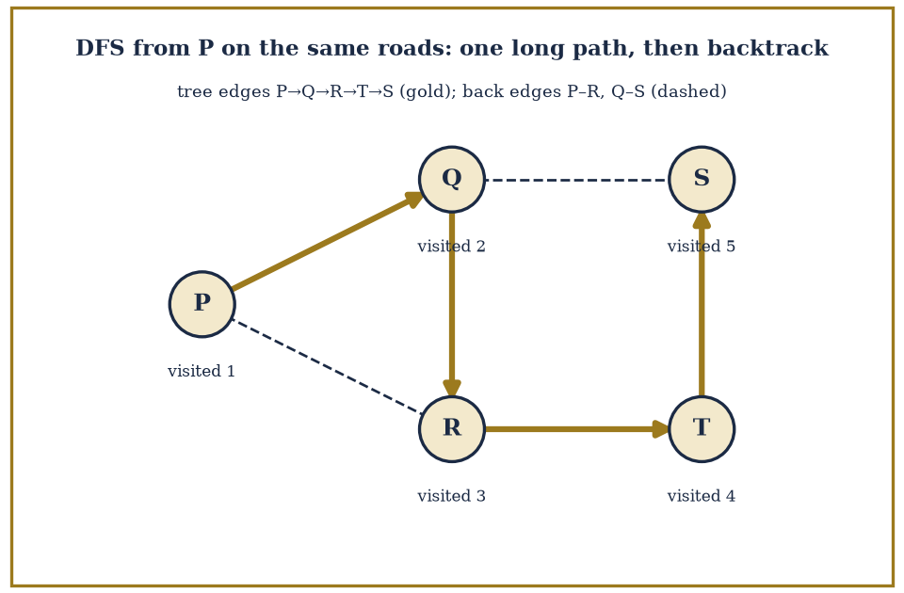
Figure 24.5 — Depth-first search from P with neighbours taken in alphabetical order. The solid gold edges P–Q, Q–R, R–T, T–S form the DFS tree, with the visit order 1–5 marked. The dashed edges P–R and Q–S are back edges, each joining a vertex to an ancestor, so the graph has cycles.
Try it now — In the road network, BFS from S: give each town’s level. Answer →
Keep only this · Section 24.4: Graph Theory: Basics, Paths, and Trees
The idea. BFS explores in layers and finds shortest paths in unweighted graphs; DFS goes deep and backtracks; a tree on n vertices has n − 1 edges.
Core.
Σ deg v = 2E
tree: connected, acyclic, n − 1 edges
BFS: layers = distances; DFS: tree + back edges
Typical mistake. Using DFS order as shortest-path distance.
Minimal example. A path on 5 vertices: 4 edges, a tree.
Practice. Easy to challenge; full worked answers, with the usual mistake, are in Answers to the Practice Sets at the back.
Easy — A graph has degrees 3, 3, 2, 2, 2. How many edges? Answer →
Medium — Run BFS from vertex 1 on the 6-cycle 1–2–3–4–5–6–1. Give the levels. Answer →
Challenge — Why does every connected graph have a spanning tree? Answer →

Section 24.5: Connectivity, Colorings, and Matchings
How Robust, How Colorful, How Well Matched
CORE · about 15 minutes · later chapters build on this
Definition — The connectivity of a graph — how many vertices (or edges) must be removed to disconnect it — measures how robust a network is against failure, and is worth caring about for the reasons an engineer or an epidemiologist would guess: it tells you how many simultaneous failures a network can survive before falling apart.
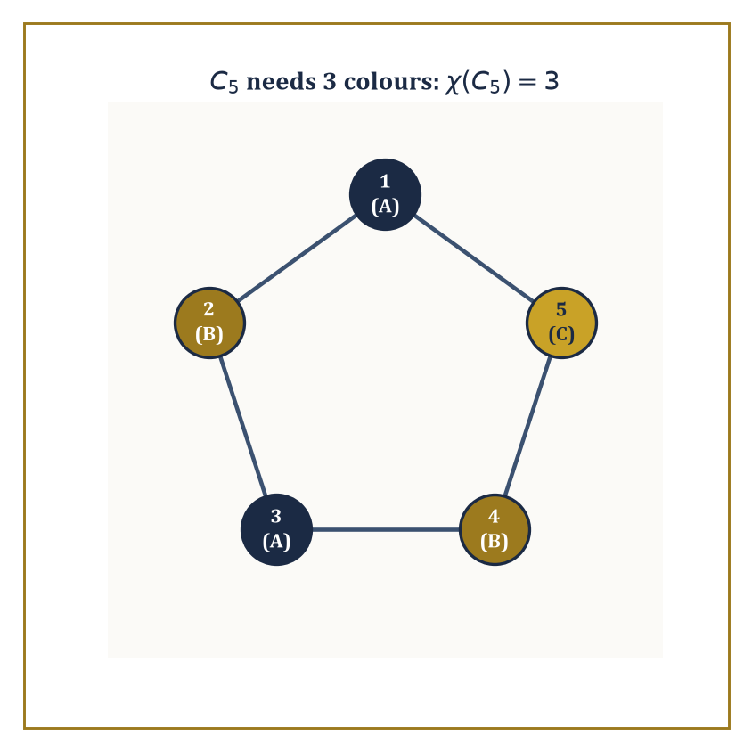
Figure 24.6 — Three colors, no shortcuts: C5 flatly refuses to be tamed by two.
Menger’s theorem supplies the deep reason connectivity is the right measure: the minimum number of vertices needed to separate two non-adjacent vertices equals the maximum number of vertex-disjoint paths that can be found between them. Robustness and redundancy, it turns out, are the same quantity viewed from two directions.
Numeric example — connectivity of a 5-cycle. Take the 5-cycle C₅ on vertices 1-2-3-4-5-1. Removing any single vertex leaves a path on the remaining four, which is still connected — so one removal never disconnects it.
Removing two non-adjacent vertices, say 1 and 3: the surviving edges are only 4–5 (since edges 1-2, 2-3, 3-4, 5-1 all touch a removed vertex), leaving vertex 2 isolated from vertices 4 and 5 — disconnected.
So the connectivity of C₅ is exactly 2: some pair of removals disconnects it, and no single removal does. Menger’s theorem predicts this should match the maximum number of vertex-disjoint paths between two non-adjacent vertices, say 1 and 3: indeed there are exactly two — the direct route 1-2-3, and the long way round 1-5-4-3 — sharing no intermediate vertices. Two disjoint paths, connectivity 2: theorem and direct check agree.
Try it now — Is the 6-cycle bipartite? Is the 5-cycle? Answer →
A planar graph is one that can be drawn in the plane with no edges crossing. For any connected planar graph drawn this way, Euler’s formula relates vertices, edges, and the faces the drawing carves the plane into (where F includes the single unbounded outer face):
V − E + F = 2
Kuratowski’s theorem then characterizes planarity completely: a graph is planar if and only if it contains no subdivision of K5 (the complete graph on 5 vertices) or K3,3 (the complete bipartite graph on two sets of 3) as a subgraph — those two small graphs are, in a precise sense, the only fundamental obstructions to being drawable without crossings.
Numeric example — Euler’s formula on a cube. The graph of a cube’s vertices and edges (as drawn, say, flattened onto the plane as a planar projection) has V=8 vertices, E=12 edges, and F=6 faces (the six square faces of the cube). Check:
V − E + F = 8 − 12 + 6 = 2
As Euler’s formula demands. This is no coincidence restricted to cubes — every convex polyhedron, when its edge-graph is drawn as a planar graph, satisfies the identical relation, a fact Euler noticed for polyhedra centuries before graph theory existed as a separate subject.
Abstract example — why K3,3 refuses to be planar. K3,3, the “utility graph” (three houses, three utilities, each utility connected to each house), has V=6 and E=9 (each of 3 vertices on one side connects to all 3 on the other):
3×3 = 9 edges
For any planar bipartite graph (no odd cycles, hence no triangular faces), a consequence of Euler’s formula bounds the edge count by E ≤ 2V − 4. Here:
2V − 4 = 2(6) − 4 = 8
But E = 9 > 8, violating the bound outright. Therefore K3,3 cannot be drawn in the plane without a crossing — no amount of clever rearranging will ever route three houses to three utilities without at least one pipe crossing another, a fact many a frustrated puzzle-solver has rediscovered the hard way.
Graph coloring assigns colors to vertices so that no edge joins two vertices of the same color, and the chromatic number χ(G) is the fewest colors needed to do this. A simple greedy argument shows χ(G) ≤ Δ(G) + 1, where Δ(G) is the largest vertex degree (color the vertices in any order, and each vertex always has at least one color left over from its at most Δ neighbors).
For planar graphs specifically, the celebrated four-color theorem — proved in 1976 with the aid of a computer checking an enormous number of cases, to the considerable discomfort of mathematicians who prefer their proofs to fit on a napkin — asserts that four colors always suffice, however intricate the map.
Context — The four-colour theorem (optional reading)
Every planar map can be coloured with four colours so that neighbouring regions differ. Appel and Haken proved it in 1976 by reducing it to 1,936 configurations checked by computer; Robertson, Sanders, Seymour and Thomas simplified the proof in 1996, and Gonthier verified it in the Coq proof assistant in 2005. The proof is beyond this book and is not needed later. What you need is the easy part: five colours always suffice (a planar graph has a vertex of degree ≤ 5), and C₅ shows that two can fail.
Numeric example — coloring an odd cycle. Return to C₅ (the 5-cycle 1-2-3-4-5-1). Try to 2-color it by alternating: 1=A, 2=B, 3=A, 4=B, and now vertex 5 is adjacent to both vertex 4 (color B) and vertex 1 (color A) — every remaining color is already forbidden by a neighbor, so 2 colors are not enough.
This is not a failure of cleverness; it is structural: any odd cycle cannot be 2-colored, because 2-colorability is equivalent to bipartiteness, and an odd cycle is famously not bipartite.
Three colors do work: 1=A, 2=B, 3=A, 4=B, 5=C. Check every edge: 1-2 (A,B) fine, 2-3 (B,A) fine, 3-4 (A,B) fine, 4-5 (B,C) fine, 5-1 (C,A) fine.
So χ(C₅) = 3, consistent with the greedy bound χ ≤ Δ+1 = 2+1 = 3 (each vertex of C₅ has degree 2), and this bound happens to be tight here.
A matching is a set of edges no two of which share a vertex — pairing things up with no double-booking. Hall’s marriage theorem gives a clean existence criterion for a perfect matching in a bipartite graph: one exists if and only if, for every subset S of one side, the set of vertices it connects to on the other side (its neighborhood) is at least as large as S itself — no group of “suitors” may collectively be interested in fewer “partners” than their own number.
König’s theorem then connects matching to another quantity entirely: in a bipartite graph, the size of the maximum matching equals the size of the minimum vertex cover (a smallest set of vertices touching every edge) — a useful equivalence, since one of these quantities is often far easier to compute than the other, and Tutte’s theorem extends the existence question to general, non-bipartite graphs.
Numeric example — assigning workers to jobs. Three workers W1, W2, W3 are qualified for jobs as follows: W1 can do J1 or J2; W2 can only do J1; W3 can do J2 or J3. Check Hall’s condition for every subset of workers:
{W1}→{J1,J2}, size 2≥1 ✓
{W2}→{J1}, size 1≥1 ✓
{W3}→{J2,J3}, size 2≥1 ✓
{W1,W2}→{J1,J2}, size 2≥2 ✓
{W1,W3}→{J1,J2,J3}, size 3≥2 ✓
{W2,W3}→{J1,J2,J3}, size 3≥2 ✓
{W1,W2,W3}→{J1,J2,J3}, size 3≥3 ✓
Every subset’s neighborhood is large enough, so a perfect matching exists by Hall’s theorem.
Constructing it: W2 has only one option, so W2 must take J1. That forces W1 away from J1, leaving W1 to take J2. That in turn forces W3 away from J2, leaving W3 to take J3.
Final matching: W1–J2, W2–J1, W3–J3 — every worker placed, every job filled, no conflicts, exactly as Hall’s theorem promised it must be possible.
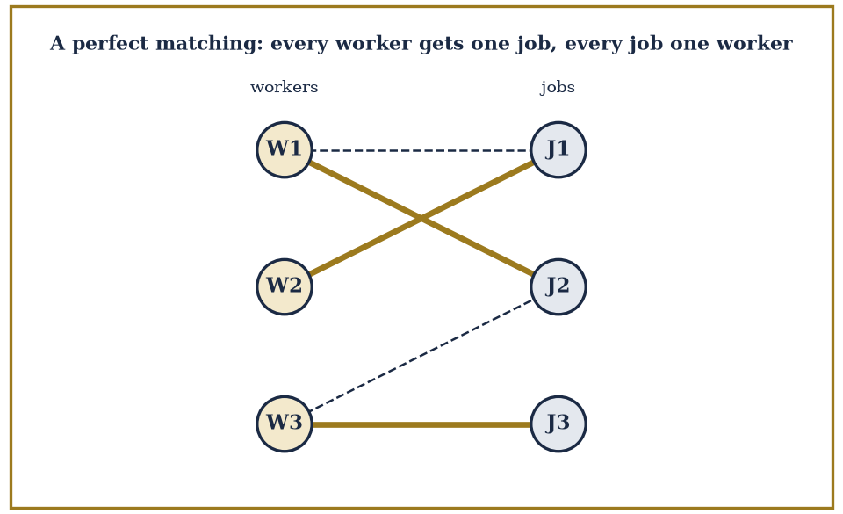
Figure 24.7 — Workers W1–W3 and jobs J1–J3, with an edge for each qualification. The perfect matching W1–J2, W2–J1, W3–J3 is drawn in gold. W2 has only one option, J1, which forces the rest.
Keep only this · Section 24.5: Connectivity, Colorings, and Matchings
The idea. A graph is bipartite exactly when it has no odd cycle; Euler’s formula V − E + F = 2 limits planar graphs; Hall’s condition decides perfect matchings.
Core.
bipartite ⇔ no odd cycle
planar: V − E + F = 2, E ≤ 3V − 6
Hall: |N(S)| ≥ |S| for every S
Typical mistake. Checking Hall’s condition only for single vertices rather than every subset.
Minimal example. K₃,₃: E = 9 > 2V − 4 = 8 (triangle-free), so not planar.
Practice. Easy to challenge; full worked answers, with the usual mistake, are in Answers to the Practice Sets at the back.
Easy — Chromatic number of K₄. Answer →
Medium — Use E ≤ 3V − 6 to show K₅ is not planar. Answer →
Challenge — Workers A, B, C; A can do 1; B can do 1; C can do 1, 2, 3. Perfect matching? Answer →

Section 24.6: Logic, Proofs, and Boolean Algebra
The Grammar of Certainty
CORE · about 15 minutes · later chapters build on this
Key idea — Propositional logic studies compound statements built from simpler ones by connectives: ∧ (and), ∨ (or), ¬ (not), → (implies), and ↔ (if and only if).
A truth table lists every possible combination of truth values for the component propositions and records the resulting truth value of the whole compound statement — a small, exhaustive, and entirely mechanical way to settle any question of logical validity, since there are only finitely many rows to check.
Numeric example — the truth table for implication. For p→q (“p implies q”), the truth table has four rows, one per combination of p and q:
p=T,q=T gives T
p=T,q=F gives F
p=F,q=T gives T
p=F,q=F gives T
The only row making the whole statement false is p true and q false — “p implies q” fails when p happens but q does not, and is (perhaps counterintuitively at first) considered true whenever p itself is false, since a promise about a hypothetical that never arises is never broken.
This is the famous “vacuous truth,” and yes, it does mean “if pigs fly, then 2+2=5” is a logically true statement, in the sense that matters for proofs.
Try it now — Negate “for every x there is a y with y > x”. Answer →
Two statements are logically equivalent if they share the same truth table — the same truth value on every row, regardless of the underlying propositions’ actual meaning. De Morgan’s laws are the workhorse equivalences for rewriting statements into normal forms (conjunctive normal form, a big AND of ORs, or disjunctive normal form, a big OR of ANDs):
¬(p∧q) ≡ ¬p∨¬q
¬(p∨q) ≡ ¬p∧¬q
Every Boolean formula can be rewritten into either form — a fact that underlies both automated theorem proving and the design of digital circuits.
Numeric example — checking De Morgan by exhaustion. Verify ¬(p∧q) ≡ ¬p∨¬q across all four rows.
p=T,q=T: p∧q=T so ¬(p∧q)=F; and ¬p=F, ¬q=F, so ¬p∨¬q=F. Match.
p=T,q=F: p∧q=F so ¬(p∧q)=T; ¬p=F, ¬q=T, so ¬p∨¬q=T. Match.
p=F,q=T: p∧q=F so ¬(p∧q)=T; ¬p=T, ¬q=F, so ¬p∨¬q=T. Match.
p=F,q=F: p∧q=F so ¬(p∧q)=T; ¬p=T, ¬q=T, so ¬p∨¬q=T. Match.
All four rows agree, so the equivalence holds — proved not by cleverness but by refusing to leave any case unchecked, which is rather the point of a truth table.
Predicate logic extends propositional logic with quantifiers: ∀x P(x) (“for all x, P(x) holds”) and ∃x P(x) (“there exists an x for which P(x) holds”).
The order in which quantifiers are nested is not a stylistic nicety — it changes the meaning entirely, and mixing up ∀∃ with ∃∀ is one of the most common and most consequential logical errors a student (or, let it be whispered, an occasional don) can make.
Numeric example — quantifier order changes everything. Let P(x,y) mean “y > x” over the integers.
Consider ∀x ∃y P(x,y): for every integer x, does some larger integer y exist? Yes — given any x, take y=x+1, and y>x always holds. The statement is true.
Now consider ∃y ∀x P(x,y): does a single integer y exist that is larger than every integer x? No — the integers are unbounded above, so for any candidate y, taking x=y itself (or larger) breaks the claim. The statement is false.
Swapping merely the order of two symbols flipped a true statement into a false one — the ∀∃ version allows the witness y to depend on x (a new, larger y for each x), while the ∃∀ version demands one fixed y that dominates every x simultaneously, which is a vastly stronger and here impossible requirement.
The standard proof techniques of discrete mathematics are worth naming explicitly, since half the difficulty of writing a proof is choosing the right shape for it before you start.
Direct proof assumes the hypothesis and derives the conclusion by a chain of valid steps.
Proof by contrapositive proves “not Q implies not P” instead of “P implies Q” — logically identical, but sometimes far easier to work with.
Proof by contradiction assumes the conclusion is false and derives an absurdity.
Mathematical induction proves a statement for all natural numbers by establishing a base case and an inductive step that carries truth from n to n+1 (or, in strong induction, from all values up to n).
Diagonalization constructs an object that provably differs from every item on a proposed complete list, thereby proving the list cannot have been complete after all.
Numeric example — induction proves the sum formula. Claim:
1+2+3+...+n = n(n+1)/2 for every positive integer n
Base case, n=1: left side is 1; right side is
1·2/2 = 1
They match. Inductive step: assume the formula holds for some k, i.e.
1+2+...+k = k(k+1)/2 (the inductive hypothesis)
Then for k+1:
1+2+...+k+(k+1) = k(k+1)/2 + (k+1) = (k+1)[k/2 + 1] = (k+1)(k+2)/2
which is exactly the formula evaluated at n=k+1. Since the base case holds and each case drags the next one along, the formula holds for every positive integer n — not merely the ones we happened to check by hand, but literally all of them, an infinite claim proved in two finite steps.
As a spot check at n=6: formula gives
6·7/2=21
and direct addition
1+2+3+4+5+6=21
Matches.
Abstract example — diagonalization, in miniature. Suppose someone claims to have listed every infinite sequence of 0s and 1s, as an infinite list s₁, s₂, s₃, s₄, .... To see the list must be missing something, build a new sequence t by flipping the n-th digit of the n-th sequence:
t’s n-th digit is 1 minus sₙ’s n-th digit
As a concrete taste, suppose the list begins:
s₁=0110..., s₂=1011..., s₃=0001..., s₄=1100...
The diagonal digits are s₁’s 1st digit (0), s₂’s 2nd digit (0), s₃’s 3rd digit (0), s₄’s 4th digit (0); flipping each gives
t = 1111...
By construction t differs from s₁ in position 1, from s₂ in position 2, from s₃ in position 3, and from s₄ in position 4 — and this pattern continues no matter how far down the (infinite) list you look, since t’s n-th digit is defined specifically to disagree with sₙ’s n-th digit. So t cannot equal any sequence on the list, however the list was constructed, proving the list was never complete to begin with.
This is a small, contained taste of an argument that becomes considerably more consequential — and considerably more unsettling — in the very next chapter.
Boolean algebra is the algebraic structure of truth values themselves, with operations ∧, ∨, ¬ obeying laws — commutativity, associativity, distributivity, De Morgan’s laws, absorption — that are, symbol for symbol, identical to the laws of set algebra (∩, ∪, complement) and to the laws governing switching circuits (AND gates, OR gates, NOT gates).
This is not a superficial analogy dressed up to look profound: all three are models of the same abstract algebraic structure, which is precisely why a circuit designer, a logician, and a set theorist can, and regularly do, borrow each other’s simplification tricks without needing to translate anything.
Numeric example — simplifying a Boolean circuit. Simplify:
(A∧B)∨(A∧¬B)
By the distributive law this factors as
A∧(B∨¬B)
and since B∨¬B is always true (a tautology — one of B or ¬B must hold), the whole expression collapses to simply A. Check by exhaustive truth table:
A=1,B=1: (1∧1)∨(1∧0) = 1∨0 = 1 = A ✓
A=1,B=0: (1∧0)∨(1∧1) = 0∨1 = 1 = A ✓
A=0,B=1: (0∧1)∨(0∧0) = 0∨0 = 0 = A ✓
A=0,B=0: (0∧0)∨(0∧1) = 0∨0 = 0 = A ✓
All four rows confirm the simplification. In circuit terms, this means a circuit built from two AND gates and one OR gate, wired this way, can be replaced by a single wire carrying A — one gate’s worth of hardware doing the work three gates were previously doing, which is the kind of saving that keeps circuit designers, and their budgets, cheerful.
Keep only this · Section 24.6: Logic, Proofs, and Boolean Algebra
The idea. Negation flips ∀ and ∃ and negates the inside; the order of quantifiers matters; induction proves statements for all n.
Core.
p → q ≡ ¬p ∨ q
¬(p ∧ q) ≡ ¬p ∨ ¬q
¬∀x P(x) ≡ ∃x ¬P(x)
loop invariant = induction on iterations
Typical mistake. Treating p → q as false whenever p is false.
Minimal example. Sum loop: invariant s = 1 + … + i after iteration i.
Practice. Easy to challenge; full worked answers, with the usual mistake, are in Answers to the Practice Sets at the back.
Easy — Truth value of “if 2 + 2 = 5 then the moon is cheese”. Answer →
Medium — Negate ∀ε > 0 ∃δ > 0 ∀x (|x| < δ → |f(x)| < ε). Answer →
Challenge — State the loop invariant that proves a loop computing m = max(a₁, …, aᵢ) is correct. Answer →

Section 24.7: Sets, Relations, and Functions (Discrete View)
Tidying Up Before the Infinite Arrives
CORE · about 15 minutes · later chapters build on this
Definition — Finite sets are counted either directly, by inclusion–exclusion when categories overlap, or — most elegantly — by exhibiting a bijection with some other set whose size is already known, as we practiced back in What Discrete Mathematics Is. A very ordinary but genuinely useful counting fact concerns divisors: if a positive integer n has prime factorization
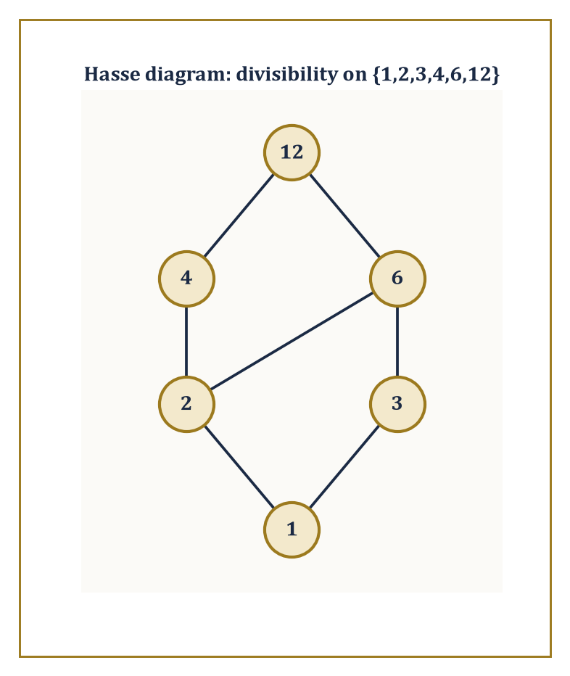
Figure 24.8 — The divisibility order on {1,2,3,4,6,12}, with every edge that transitivity already implies tactfully left off the picture.
n = p₁^{a₁} · p₂^{a₂} · ... · pₖ^{aₖ}
the number of positive divisors of n is
(a₁+1)(a₂+1)...(aₖ+1)
because choosing a divisor amounts to independently choosing, for each prime, how many copies of it (from 0 up to aᵢ) to include, and that is the product rule again, running the show unannounced.
Numeric example — counting the divisors of 60. Factorize 60.
60 = 2² · 3¹ · 5¹
The divisor-count formula gives
(2+1)(1+1)(1+1) = 3·2·2 = 12
divisors. Listing them directly to check:
1, 2, 3, 4, 5, 6, 10, 12, 15, 20, 30, 60
— twelve numbers, and each one does divide 60 evenly.
60/4=15, 60/6=10, 60/12=5, 60/15=4, 60/20=3, 60/30=2
— all exact. The formula and the exhaustive list agree, and the formula would remain just as fast even if 60 were replaced by a number with forty digits, which the listing approach very much would not.
Try it now — How many functions are there from {1, 2} to {a, b, c}? How many injective ones? Answer →
A relation on a set S is a set of ordered pairs from S×S — a formal way of saying “these elements are related, and those are not.” Relations are classified by which structural properties they satisfy: reflexive (every element relates to itself), symmetric (if a relates to b, then b relates to a), transitive (if a relates to b and b relates to c, then a relates to c), and antisymmetric (if a relates to b and b relates to a, then a=b — no distinct pair relates both ways).
A relation that is reflexive, symmetric, and transitive is called an equivalence relation, and equivalence relations are important because of what they do to a set, described in the next paragraph.
Numeric example — congruence mod 3 is an equivalence relation. Define a ~ b on {0,1,2,...,8} to mean “a and b leave the same remainder when divided by 3.” Reflexive: a always has the same remainder as itself. Symmetric: if a and b share a remainder, so do b and a — trivially. Transitive: if a and b share a remainder, and b and c share a remainder, then a and c share that same remainder too.
All three properties hold, so ~ is an equivalence relation. Grouping the nine elements by shared remainder gives three classes:
{0,3,6} (remainder 0), {1,4,7} (remainder 1), {2,5,8} (remainder 2)
This is not a coincidence specific to remainders: every equivalence relation on a set partitions that set into disjoint, non-empty classes (its equivalence classes) whose union is the whole set, and conversely every partition of a set defines an equivalence relation (“related” meaning “in the same block”).
The two notions — equivalence relation and partition — are, in fact, the same idea described in two different vocabularies, a small but useful piece of intellectual economy.
Numeric example — the partition, counted. Continuing the mod-3 example: the three equivalence classes {0,3,6}, {1,4,7}, {2,5,8} are pairwise disjoint (no element sits in two classes at once) and their union recovers the whole original set {0,1,...,8}. As a count:
3+3+3 = 9
matching the original set’s size exactly — every element accounted for precisely once, which is the defining feature of a genuine partition.
A partial order is a relation that is reflexive, antisymmetric, and transitive — like an equivalence relation’s stricter, less forgiving cousin, one that organizes a set into a hierarchy rather than into flat, interchangeable clusters. Divisibility on the positive integers is a classic example: a ≤ b meaning “a divides b.” A Hasse diagram draws only the covering relations — the direct “one level up” connections, omitting anything implied by transitivity — giving an economical picture of the whole order at a glance.
Abstract example — the divisibility Hasse diagram on {1,2,3,4,6,12}. Check every pair for a covering relation (a covers b if b|a with nothing dividing strictly between them). 1 covers 2 (nothing between 1 and 2 in the divisibility order) and 1 covers 3, similarly. 2 covers 4 (divisors of 4 are 1,2,4 — nothing strictly between 2 and 4) and 2 covers 6 (divisors of 6 touching 2 are just 2 and 6 itself). 3 covers 6 by the same reasoning. 4 covers 12 (no divisor of 12 sits strictly between 4 and 12) and 6 covers 12 likewise.
Note that 1 does NOT directly cover 4 in the diagram, even though 1 divides 4, because 2 sits strictly in between
1|2|4
that relation is implied by transitivity and so is left off the picture. The resulting diagram has three levels: {1} at the bottom, {2,3} above it, {4,6} above that, and {12} at the top, joined by the covering edges just listed — a compact, uncluttered map of an order relation that, drawn in full with every implied pair, would have needed far more ink.
A function f: A→B assigns each element of A exactly one element of B. It is injective (one-to-one) if distinct inputs always give distinct outputs; surjective (onto) if every element of B is hit by something; and bijective if both hold at once — the strongest and most useful condition, since a bijection is precisely a perfect pairing, the very tool we relied on throughout What Discrete Mathematics Is.
Numeric example — counting injections. How many injective functions are there from {1,2,3} to {a,b,c,d}? Each element of the domain needs a distinct image: 4 choices for f(1), then 3 remaining choices for f(2) (it must differ from f(1)), then 2 remaining for f(3) — giving
4×3×2 = 24
total, which is P(4,3) from Section 24.2’s permutation formula:
P(4,3) = 4!/(4−3)! = 24/1 = 24
None of these 24 functions can be surjective, incidentally, since the domain has only 3 elements to cover a codomain of 4 — one element of {a,b,c,d} is always left unhit, which brings us directly to the next, rather more forceful, observation.
The pigeonhole principle states, with almost insulting simplicity, that if more than n objects are placed into n boxes, some box contains more than one object — equivalently, no injection can exist from a strictly larger finite set into a smaller one.
Simple to state, yet it proves results that feel far too strong to have come from something so obvious; the generalized version sharpens this to: distributing N objects into n boxes forces some box to contain at least ⌈N/n⌉ objects.
Numeric example — birthdays, guaranteed. Among any 13 people, at least two must share a birth month, since there are only 12 months and 13 > 12 — the basic pigeonhole principle applied directly.
Now sharpen it: among 25 people and 12 months, the generalized pigeonhole principle guarantees some month contains at least ⌈25/12⌉ people. Compute:
25/12 ≈ 2.083
and rounding up gives
⌈25/12⌉ = 3
So at least 3 of the 25 people were born in the same month — not a probability, not a likelihood, but a mathematical certainty, guaranteed purely by counting, with no need to know anything at all about how birthdays are distributed.
Keep only this · Section 24.7: Sets, Relations, and Functions (Discrete View)
The idea. Equivalence relations partition a set; partial orders are drawn as Hasse diagrams; |B|^{|A|} functions from A to B.
Core.
equivalence: reflexive, symmetric, transitive
partial order: reflexive, antisymmetric, transitive
|B|^{|A|} functions A → B
Typical mistake. Drawing the edges implied by transitivity in a Hasse diagram.
Minimal example. Divisors of 12 under | form the Hasse diagram 1 < 2, 3 < 4, 6 < 12.
Practice. Easy to challenge; full worked answers, with the usual mistake, are in Answers to the Practice Sets at the back.
Easy — Is “has the same birthday as” an equivalence relation? Answer →
Medium — How many divisors does 72 = 2³ · 3² have? Answer →
Challenge — List the covering pairs (edges of the Hasse diagram) of the divisors of 18 under divisibility. Answer →

Section 24.8: Introduction to Algorithms and Complexity
What All This Counting Costs
CORE · about 15 minutes · later chapters build on this
Definition — An algorithm is a finite, deterministic procedure that transforms an input into an output in a bounded number of steps.
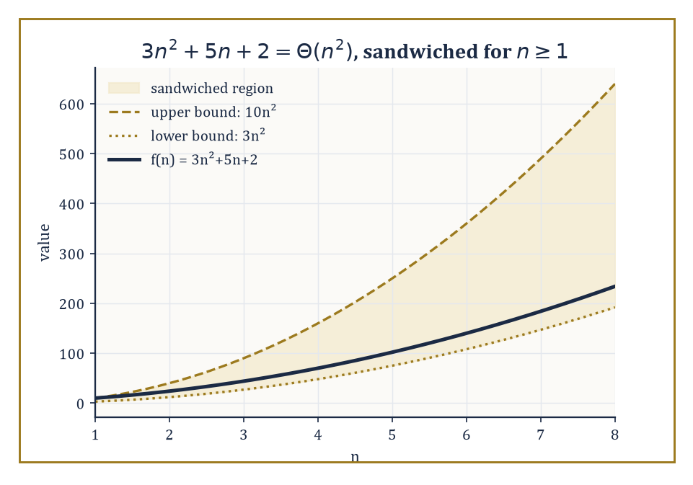
Figure 24.9 — 3n²+5n+2 kept honestly between two straight-faced multiples of n² — that is all Θ(n²) has ever promised.
Correctness is established not by running it and hoping, but by proving a loop invariant — a statement that is true before the process begins, remains true after every step, and, once the process finishes, implies the desired result.
This is induction again, wearing yet another disguise: the invariant is the inductive hypothesis, and each step of the algorithm is the inductive step.
Numeric example — linear search, traced and verified. Search for the value 7 in the array [3, 9, 7, 1, 5] by checking each element in order.
Index 0: compare 3 to 7 — no match (1 comparison so far). Index 1: compare 9 to 7 — no match (2 comparisons). Index 2: compare 7 to 7 — match, return index 2 (3 comparisons total).
The loop invariant here is “the target has not been found among the elements examined so far,” which trivially holds before the loop starts (nothing examined yet), is preserved by each failed comparison, and — the moment it is violated by a successful comparison — immediately hands us the correct answer.
Three comparisons were needed for a five-element array; in the worst case (target absent, or in the last position), linear search on n elements needs exactly n comparisons.
Try it now — Order by growth for large n: 100n, n log₂ n, n²/100. Answer →
Running time is measured as a function of input size n, and to avoid drowning in irrelevant detail, we describe it up to constant factors and lower-order terms using asymptotic notation.
f(n) = O(g(n))
This means f is eventually bounded above by some constant multiple of g.
f(n) = Ω(g(n))
This means f is bounded below similarly.
f(n) = Θ(g(n))
This means both at once — f and g grow at the same rate, up to a constant.
Numeric example — proving 3n² + 5n + 2 is Θ(n²). We need constants c₁, c₂ > 0 and a threshold n₀ such that the following sandwich holds for all n ≥ n₀.
c₁n² ≤ 3n²+5n+2 ≤ c₂n²
Lower bound: since 5n+2 ≥ 0 for all n ≥ 0, we always have 3n²+5n+2 ≥ 3n², so c₁=3 works for every n₀ ≥ 0.
Upper bound: we need 5n+2 ≤ (c₂−3)n² for n ≥ n₀; trying c₂=10 means checking whether the following holds.
5n+2 ≤ 7n²
At n=1: left side 5+2=7, right side 7·1=7 — equality holds. For n≥1 the quadratic term grows faster than the linear one, so the inequality only strengthens as n increases (at n=2: left=12, right=28).
3n² ≤ 3n²+5n+2 ≤ 10n²
So with c₁=3, c₂=10, n₀=1, this sandwich holds for all n≥1, confirming the following.
3n²+5n+2 = Θ(n²)
The “+5n+2” is, from the point of view of asymptotic growth, entirely beneath our notice.
Comparison-based sorting algorithms — those that decide the final order purely by pairwise comparisons — face an unavoidable lower bound.
Model every possible sequence of comparisons as a binary decision tree: each internal node is one comparison, each leaf is one possible sorted output.
Since there are n! possible orderings of n distinct elements, the tree needs at least n! leaves, and a binary tree with n! leaves must have depth at least the following.
depth ≥ ⌈log₂(n!)⌉
That means any correct comparison sort needs at least that many comparisons in the worst case, for every algorithm, no matter how cleverly written.
Numeric example — the comparison lower bound for 5 elements. For n=5, there are the following number of possible orderings.
5! = 120
We need ⌈log₂(120)⌉. Since
2⁶ = 64 and 2⁷ = 128
log₂(120) lies strictly between 6 and 7 (closer to 7), so
⌈log₂(120)⌉ = 7
No comparison-based algorithm can correctly sort 5 arbitrary elements using fewer than 7 comparisons in the worst case — and this bound is not merely theoretical throat-clearing, either: it is a known, tight result that exactly 7 comparisons both suffice and are necessary to sort 5 elements optimally. The theoretical floor and the best achievable algorithm meet exactly, which happens far less often in complexity theory than one might hope.
Graph traversal algorithms such as BFS and DFS (Graph Theory) run in the following time.
O(V+E)
That means visiting every vertex once and examining every edge once — which is as fast as any algorithm could possibly be, since it must at minimum read its own input.
Numeric example — counting the work in a traversal. Take a graph with V=6 vertices and E=7 edges: {1,2,3,4,5,6} with edges 1-2, 1-3, 2-4, 3-4, 4-5, 5-6, 3-6.
A BFS or DFS from any starting vertex performs work proportional to the following.
V+E = 6+7 = 13
That means visiting each of the 6 vertices once and inspecting each of the 7 edges (in an appropriate representation) at most twice, once from each endpoint, which is still a constant factor and so still counted as O(V+E), not something worse.
Doubling the graph’s size (12 vertices, 14 edges, say, by attaching a similar structure) roughly doubles the running time — linear behavior, the best a traversal algorithm could possibly hope for.
The deepest open question in the whole of computer science is whether P equals NP. P is the class of problems solvable in time polynomial in the input size. NP is the class of problems whose proposed solutions can be verified in polynomial time, even if finding a solution from scratch might take vastly longer.
Every problem in P is trivially in NP (if you can solve it quickly, you can certainly check a solution quickly), but whether the reverse holds — whether easy verification always implies easy solving — remains unresolved, with a rather large prize attached to whoever settles it convincingly.
SAT (Boolean satisfiability), the clique problem, vertex cover, and the Hamiltonian cycle problem from What Discrete Mathematics Is are all NP-complete: each is in NP, and each is at least as hard as every other problem in NP, so that a fast algorithm for any one of them would instantly yield a fast algorithm for all of them, collapsing the entire question at a stroke.
Definition — P, NP and NP-complete, carefully. A decision problem asks a yes-or-no question about an input of size n bits. It is in P if some algorithm answers it in at most C·nᵏ steps for fixed C and k. It is in NP if every yes-instance has a certificate of polynomial length that a polynomial-time verifier accepts, while no certificate makes the verifier accept a no-instance. For SAT the certificate is a satisfying assignment. A polynomial-time reduction from A to B turns every instance of A into an instance of B with the same answer. B is NP-complete if B is in NP and every NP problem reduces to it (Cook–Levin: SAT is NP-complete). P ⊆ NP is clear. Whether P = NP is open: no proof either way is known, and it is one of the Clay Millennium Problems. “NP” means nondeterministic polynomial time, not “not polynomial”.
Abstract example — verifying, versus finding, a SAT solution. Consider the 3-SAT formula (x₁∨x₂∨¬x₃) ∧ (¬x₁∨x₃) ∧ (x₂∨¬x₃), and the proposed assignment x₁=False, x₂=True, x₃=True.
Verification is fast.
clause 1: x₁∨x₂∨¬x₃ = F∨T∨F = T ✓ (since ¬x₃=¬True=False)
clause 2: ¬x₁∨x₃ = T∨T = T ✓ (since ¬x₁=¬False=True)
clause 3: x₂∨¬x₃ = T∨F = T ✓
All three clauses are satisfied, confirmed in three quick checks — polynomial-time verification, just as NP membership requires.
Finding this assignment in the first place, though, without being handed it, is a different matter: with 3 boolean variables there are only the following number of possible assignments to check.
2³ = 8
That is entirely manageable by brute force here — but for a formula with, say, 100 variables, brute force means checking up to the following number of possibilities.
2¹⁰⁰
That is about 1.3 × 10³⁰. A computer checking a billion subsets every second would need about 4 × 10¹³ years, some three thousand times the present age of the universe.
That gulf — trivial to check, ruinous to search — is the entire content of the P versus NP question, and it is a question this series, for all its many chapters, is not going to settle today.
Keep only this · Section 24.8: Introduction to Algorithms and Complexity
The idea. O, Ω and Θ compare growth up to constant factors for large n; P is polynomial-time solvable, NP is polynomial-time verifiable, and whether P = NP is open.
Core.
f = O(g): f ≤ Cg for n ≥ n₀
Θ: both O and Ω
BFS/DFS O(V + E); merge sort O(n log n)
P ⊆ NP; P = NP? open
Typical mistake. Saying NP means “not polynomial”.
Minimal example. 3n² + 5n + 2 ≤ 10n² for n ≥ 1, so it is O(n²).
Practice. Easy to challenge; full worked answers, with the usual mistake, are in Answers to the Practice Sets at the back.
Easy — Is 2ⁿ⁺¹ = O(2ⁿ)? Is 4ⁿ = O(2ⁿ)? Answer →
Medium — Show n log₂ n = O(n²). Answer →
Challenge — Why does showing a problem is NP-complete matter in practice? Answer →

Chapter 24 in One Page
Counting rests on the product rule, division by symmetries, inclusion–exclusion and bijections. Generating functions turn sequences into power series. Linear recurrences are solved through their characteristic roots, and divide-and-conquer recurrences give n log n. Graphs model networks: BFS finds distances, DFS finds structure and cycles, trees have n − 1 edges, bipartite means no odd cycle, and Hall’s condition decides matchings. Logic gives the rules of proof, with loop invariants as induction over iterations. Asymptotic notation compares algorithms, and P versus NP asks whether checking is genuinely easier than finding.
Key definitions
• Permutation, combination, multiset coefficient.
• Recurrence relation and characteristic equation.
• Graph, path, cycle, tree, bipartite graph, matching, chromatic number.
• Tautology, logical equivalence, quantifiers.
• Equivalence relation, partial order, Hasse diagram.
• O, Ω, Θ; P, NP, NP-complete.
Key theorems, with their hypotheses
• Inclusion–exclusion — hypothesis: finite sets.
• Handshake lemma — any finite graph: Σ deg = 2E.
• Tree edge count — hypotheses: connected and acyclic, n vertices.
• Euler’s formula V − E + F = 2 — hypothesis: connected planar graph.
• Hall’s theorem — hypothesis: finite bipartite graph.
• Comparison-sorting lower bound ⌈log₂ n!⌉ — hypothesis: only comparisons are used.
Canonical example
• aₙ = aₙ₋₁ + aₙ₋₂: r² = r + 1, r = (1 ± √5)/2, so Fₙ = (φⁿ − ψⁿ)/√5.
Common errors
• Ordered versus unordered counts.
• Missing the overlap in inclusion–exclusion.
• Negating only one quantifier.
• Reading O as “exactly”, or NP as “not polynomial”.
Readiness checklist — you are ready for what comes next when you can:
□ count with permutations, combinations and inclusion–exclusion
□ solve a second-order linear recurrence
□ run BFS and DFS and test bipartiteness
□ negate quantified statements and build truth tables
□ prove a Θ bound with explicit constants and define P and NP
Section 24.9 that follows is a preview, marked optional: it says where these ideas lead in later chapters and volumes. Nothing in it is needed for the exercises.

Section 24.9: Where This Goes Next (Optional): From Discrete Mathematics to Combinatorics, Graph Theory, and Theoretical CS
The View From Here
PREVIEW — OPTIONAL · about 15 minutes · optional; read for orientation, nothing is examined
Overview — We have now acquired the working vocabulary of discrete mathematics: counting, recurrences, graphs, logic, relations, and a first taste of what algorithms cost to run.
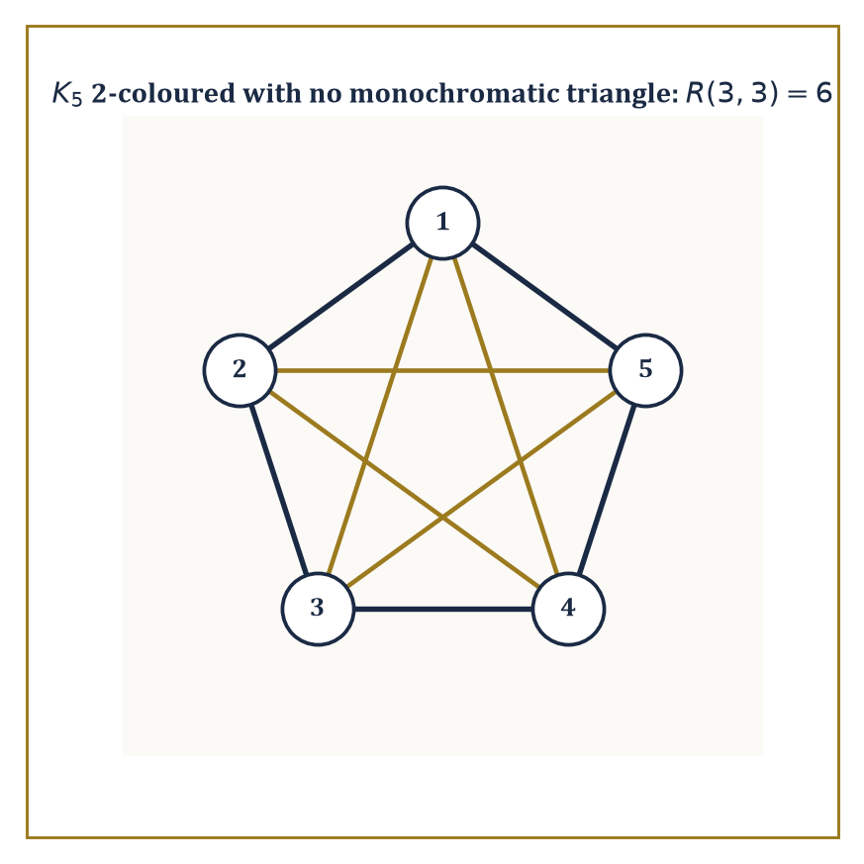
Figure 24.10 — One pentagon, one pentagram, zero monochromatic triangles — a sixth vertex would have made this picture impossible to draw.
Each of these threads runs well past the point where this chapter stops, and it is useful to know roughly where each one leads.
Enumerative combinatorics takes the counting toolbox of Counting Principles and Generating Functions and pushes it much further, into partitions, symmetric functions, and species theory.
Extremal and probabilistic combinatorics ask a subtly different question: not “how many exactly,” but “how large or small can a structure with a given property possibly be,” and they answer it with startling arguments that mix counting with probability.
Numeric example — a taste of Ramsey theory. The Ramsey number R(3,3) is a classic extremal result: color every edge of the complete graph K₆ either red or blue, in absolutely any way you like, and a monochromatic triangle (three vertices, all three connecting edges the same color) is unavoidable — guaranteed to appear, with no possible clever coloring scheme dodging it.
Yet K₅ can be 2-colored to avoid one entirely (color the edges of one pentagon red and the edges of the complementary five-pointed star blue, and check: no triangle is monochromatic). So 6 is the exact threshold — five vertices can escape, six cannot — which is why R(3,3) is defined as follows.
R(3,3) = 6
Ramsey theory’s general slogan, of which this is the founding example, is that complete disorder is impossible: past a certain size, structure is forced to appear whether you want it or not.
Try it now — What does R(3, 3) = 6 say about 6 people? Answer →
Algebraic graph theory links graphs to linear algebra by studying a graph’s adjacency matrix and its eigenvalues, which turn out to encode an astonishing amount of structural information — connectivity, bipartiteness, even how quickly a random walk on the graph mixes — inside a purely algebraic object.
Numeric example — eigenvalues of a 4-cycle. For the cycle graph Cₙ, the adjacency matrix eigenvalues are known in closed form.
λₖ = 2cos(2πk/n), for k = 0, 1, ..., n−1
For C₄ (n=4), compute each eigenvalue in turn.
λ₀ = 2cos(0) = 2
λ₁ = 2cos(π/2) = 2×0 = 0
λ₂ = 2cos(π) = 2×(−1) = −2
λ₃ = 2cos(3π/2) = 2×0 = 0
The eigenvalues are {2, 0, 0, −2}.
2 + 0 + 0 − 2 = 0
Notice they sum to zero, which must hold for any graph’s adjacency matrix, since the diagonal of the adjacency matrix — the trace, which equals the sum of eigenvalues — is entirely zero (no vertex is adjacent to itself, absent unusual conventions). A structural fact about the drawing (no self-loops) forced an algebraic fact about the eigenvalues, without either side needing to consult the other directly.
Formal languages and automata theory systematize the notion of computation itself, starting from finite-state machines — tiny devices with a handful of states and simple transition rules — and building upward through increasingly powerful models.
Numeric example — a finite automaton that computes remainders. Build a 3-state machine with states S₀, S₁, S₂ (representing “remainder 0, 1, 2 mod 3 so far”), reading a binary number one bit at a time from the most significant end, with the following transition rule: on reading bit b in state s, move to a new state.
new state = (2s + b) mod 3
This works because appending a bit to a binary number doubles the number and adds the bit, so the remainder mod 3 updates the same way. Trace the binary string 110 (which represents the decimal number 6): start at S₀.
Read ‘1’: (2×0+1) mod 3 = 1 → move to S₁
Read ‘1’: (2×1+1) mod 3 = 3 mod 3 = 0 → move to S₀
Read ‘0’: (2×0+0) mod 3 = 0 → stay at S₀
The machine ends in state S₀, correctly signaling that 6 is divisible by 3 — a tiny, entirely mechanical device with only three internal states has just computed a remainder, with no arithmetic circuitry beyond the three transition rules themselves.
Cryptography and coding theory, meanwhile, lean heavily on finite fields and the discrete logarithm problem — the fact that computing xʸ mod p is fast, while recovering y from xʸ mod p (given only x and the result) is believed to be extraordinarily hard for suitably large primes p, an asymmetry that much of modern secure communication is quietly built on top of.
Numeric example — a discrete logarithm, small enough to solve by hand. Work in the integers mod 7, using base 3. Compute successive powers.
3¹ = 3
3² = 9 ≡ 2 (mod 7)
3³ ≡ 3×2 = 6 (mod 7)
3⁴ ≡ 3×6 = 18 ≡ 4 (mod 7)
3⁵ ≡ 3×4 = 12 ≡ 5 (mod 7)
3⁶ ≡ 3×5 = 15 ≡ 1 (mod 7)
The powers cycle through {3,2,6,4,5,1} — all six nonzero residues mod 7 — before repeating, which makes 3 a “primitive root” mod 7. Suppose someone hands you the value 6 and asks: what power of 3, mod 7, gives 6? Scanning the table above, 3³ ≡ 6 (mod 7), so the discrete logarithm of 6 base 3 (mod 7) is 3.
For a modulus this small, scanning the whole table by hand takes seconds. For a modulus hundreds of digits long, the equivalent table has more entries than there are atoms to write them on, and no faster method than essentially exhaustive search is publicly known — which is the gap that keeps this small, symmetric-looking arithmetic exercise underpinning a great deal of the world’s encrypted traffic.
The deeper lesson threading through this entire chapter is that finite structures admit a rich, precise theory of their own, every bit as deep as anything in the continuous world we left behind two chapters ago — and that the same theory underpins both pure combinatorial mathematics and the design and analysis of every algorithm that has ever run on a computer.
Discrete mathematics is the mathematics of the finite, and the finite, as it happens, is where computation lives.
But scrupulous finitude was never going to be the whole story, and by now you have almost certainly noticed the loose thread we kept tugging at and refusing to pull all the way: diagonalization, back in Logic, Proofs, and Boolean Algebra, dressed up as a modest trick for showing a list of binary strings could not be complete. That trick did not stay modest for long. In the next chapter, Set Theory & Logic, the very same argument is aimed squarely at infinity itself, and it turns out that not all infinities are the same size — that there are, in a perfectly rigorous sense, more real numbers than there are counting numbers, and stranger sizes still above those. Sets, which this chapter treated as tame, countable, list-it-and-be-done objects, are about to become considerably less tame, and considerably more interesting.
The series continues. Mind the step — the next one is rather larger than it looks.
Keep only this · Section 24.9: Where This Goes Next (Optional): From Discrete Mathematics to Combinatorics, Graph Theory, and Theoretical CS
The idea. Ramsey theory, spectral graph theory, automata and cryptography continue this chapter.
Core.
R(3, 3) = 6
adjacency eigenvalues of Cₙ: 2 cos(2πk/n)
finite automata recognize regular languages
Typical mistake. Thinking each advanced topic is unrelated to this chapter; they reuse its counting, graphs and logic.
Minimal example. C₄: eigenvalues 2, 0, −2, 0.
Practice. Easy to challenge; full worked answers, with the usual mistake, are in Answers to the Practice Sets at the back.
Easy — Eigenvalues of the adjacency matrix of K₂. Answer →
Medium — A 3-state automaton tracks n mod 3 while reading binary digits. From state r, reading bit b, where does it go? Answer →
Challenge — Compute 3ᵏ mod 7 for k = 1, …, 6 and solve 3ᵏ ≡ 6 (mod 7). Answer →

Check Your Understanding — Chapter 24
Answers are in the Answer Key at the back of the book — have a go before you look.
1. [Compute] Using inclusion–exclusion, how many integers from 1 to 100 are divisible by 3 or by 5?
See the answer →
2. [Model] Why does the Königsberg bridges graph have neither an Eulerian circuit nor an Eulerian path?
See the answer →
3. [Explain] Why is a statement like ‘if pigs fly, then 2+2=5’ logically true?
See the answer →
4. [Explain] Why can no comparison-based sorting algorithm sort 5 distinct elements in fewer than 7 comparisons in the worst case?
See the answer →

Fluency Drill — Chapter 24
Five minutes, no notes, before the harder problems. These are the moves the Problems assume are automatic; if one takes you more than a minute, reread the section it names. Worked answers, each with the usual slip, are in Answers to the Practice Sets.
1. [Concept] Bipartite test: is a square with one diagonal (vertices 1–2–3–4–1 plus 1–3) bipartite? Answer →
2. [Concept] Bipartite test: is a tree bipartite? Answer →
3. [Concept] Bipartite test: is the cube graph (8 vertices, 12 edges) bipartite? Answer →
4. [Compute] For n = 1024, compare n, n log₂ n and n². Answer →
5. [Concept] An algorithm takes 1 s on n = 1000. Estimate the time on n = 2000 for O(n), O(n log n), O(n²). Answer →
6. [Concept] True or false: 5n² + 100n = O(n²); n² = O(n log n); n log n = O(n²). Answer →
7. [Compute] Number of arrangements of the letters of LEVEL. Answer →
8. [Compute] Solve aₙ = aₙ₋₁ + 2aₙ₋₂, a₀ = 0, a₁ = 3. Answer →

Problems — Chapter 24
Discrete mathematics rewards the reader who actually counts things, and punishes the one who reasons vaguely about them. Twelve problems follow, several with small enough numbers to check by brute force — which you should do, because catching your own off-by-one is the skill being trained. Solutions are in the appendix.
Counting
1. [Compute] How many distinct arrangements are there of the letters of the word BANANA? Solution →
2. [Compute] How many 5-card hands from a standard 52-card deck contain exactly two aces? Solution →
3. [Compute] Use inclusion–exclusion to count the integers from 1 to 100 divisible by 2, 3 or 5. Solution →
Recurrences and generating functions
4. [Compute] Solve the recurrence aₙ = 3aₙ₋₁ − 2aₙ₋₂ with a₀ = 1, a₁ = 3. Solution →
5. [Model] A staircase has n steps and may be climbed one or two at a time. Find the recurrence for the number of ways, and identify the sequence. Solution →
Graphs
6. [Compute] A simple graph has 7 vertices and every vertex has degree 4. How many edges does it have? Verify with the handshake lemma. Solution →
7. [Explain] Explain why no graph can have exactly one vertex of odd degree. Solution →
8. [Compute] Determine whether K₅ and K₃,₃ are planar, and state the theorem that settles it. Solution →
9. [Prove] Show that a tree on n vertices has exactly n − 1 edges. Solution →
Logic, algorithms, complexity
10. [Compute] Construct the truth table for (p → q) ∧ (q → p) and state what connective it is equivalent to. Solution →
11. [Prove] Show that 3n² + 5n + 2 is Θ(n²) by exhibiting explicit constants. Solution →
12. [Challenge] Sorting by comparisons cannot beat n log n in the worst case, and this is a theorem rather than a failure of imagination. What is the argument, and why does it not apply to counting sort? Solution →

Math, Actually

Chapter 25

Set Theory & Logic
Foundations, Infinite Sets, and the Art of Reasoning About Reasoning
The last chapter left us rather pleased with ourselves. We had spent it reasoning cleanly about finite structures — graphs, counting arguments, algorithms that always terminate — the sort of mathematics you could, in principle, verify by hand, given enough hands and an unreasonable amount of patience. This chapter asks a ruder question, the kind a small child asks and a career mathematician spends decades trying to stop being asked: what, precisely, is a ‘thing’? And once we have things, what does it mean to reason about them correctly at all?
Every mathematical object met on the journey so far — numbers, functions, spaces, the graphs of the last chapter — can be formalized inside set theory, a subject built from a single primitive relation (membership, ∈) and a handful of careful rules about which collections are allowed to exist. Logic, its constant companion, supplies the grammar: the connectives and quantifiers and inference rules that let one sentence follow validly from another, and that let a proof be checked rather than merely admired. Together they are not the mathematics anyone does day to day — nobody visualizes their theorem as a chain of set-builder notation — but they are the guarantee sitting quietly underneath every other chapter of this series: if a proof is ever pushed hard enough, it can be cashed out in these terms, all the way down to the empty set.
A small confession, before we start: set theory and logic can feel remote from the concrete calculation of earlier chapters, all those clean numeric answers replaced by talk of infinities and inference rules. The remoteness is only apparent. The cardinality that classifies infinite sets in this chapter is the same cardinality that separated countable from uncountable bases many chapters back; the quantifiers ∀ and ∃ that structure predicate logic are the very quantifiers buried inside every ε-δ definition of a limit; the inductive constructions that build the natural numbers here are the same technique, one chapter removed, that built the formulas of every formal language since.
If the last chapter taught us to reason about finite, countable structures with total confidence, this one teaches us to reason about the infinite, and about the act of reasoning itself, with the same rigor. Let’s begin, as one always must in this subject, with the empty set.
Before you begin — Chapter 25 · Core chapter
By the end of this chapter you will be able to:
1. Build numbers and ordered pairs from sets, and explain Russell’s paradox and how ZFC avoids it.
2. Compute set operations, test relations and functions, and prove set identities by double inclusion.
3. Prove countability by bijections and uncountability by diagonal arguments, and state Cantor’s theorem.
4. State the axiom of choice and two equivalents, and explain where it is needed.
5. Compute simple ordinal sums and products and describe transfinite induction.
6. Check tautologies, negate quantified formulas, and state soundness, completeness and incompleteness with their hypotheses.
Why it comes here. Every chapter so far has used sets, functions, quantifiers and proofs without asking what they are. This last chapter asks. It makes precise the “for every ε there is a δ” logic of Volume 1, the infinite sums of Chapter 16 and the counting of Chapter 24, then shows where the foundations stop: some true statements cannot be proved, and some well-posed questions cannot be decided by any algorithm.
Required chapters. Logic, Proofs, and Boolean Algebra (Chapter 24); Sets, Relations, and Functions (Discrete View) (Chapter 24).
Assumed skills. truth tables and the connectives ∧, ∨, ¬, →; reading and negating quantified statements; proof by induction and by contradiction; injective, surjective and bijective functions.
If you are rusty. Logic, Proofs, and Boolean Algebra; Sets, Relations, and Functions (Discrete View).
Do not proceed until you can…
1. Negate “every student passed some exam”. Answer →
2. Is f(n) = 2n a bijection from ℕ to ℕ? From ℕ to the even numbers? Answer →
3. Show by contradiction that √2 is irrational — state the key step. Answer →
Estimated study time. About 10–12 hours over a week and a half. Work every Try it now before reading on, finish each section’s Keep only this practice before starting the next, and do the Fluency Drill before the Problems.

Section 25.1: What Set Theory and Logic Actually Are
In which we build the number three out of nothing at all
CORE · about 20 minutes · later chapters build on this
Ask what the number 3 actually is — not how to compute with it, not 3+4=7, but what kind of thing it is, stripped of any particular collection of objects being counted — and most people run out of an answer surprisingly quickly. “Three apples” is a claim about apples; “three”, on its own, with no apples anywhere in sight, is harder to point at.
This is not merely a philosophical curiosity to be waved away. So much of the mathematics built over the previous twenty-four chapters — counting, ordering, the real numbers constructed back in Chapter 1 (Volume 1) — quietly assumes that numbers are some kind of well-defined object, not merely a word everyone happens to have agreed on the meaning of. If that assumption were never checked, the whole series would be resting on a foundation nobody had actually inspected.
Set theory inspects it, and the answer it gives is stranger than expected: build the number 3 out of nothing but the empty set — the set with nothing in it at all — and one single operation, membership, applied a handful of times. Nothing “numerical” is assumed anywhere in the construction; only collections, and which collections happen to belong to which other collections.
So this chapter does not ask “how do you calculate with numbers, sets, and logical statements?” — every chapter before this one already assumed you could do that perfectly well. It asks something more basic: what are these things actually built from underneath, and what are the ground rules by which one true statement is allowed to produce another, so that a proof is a proof and not merely a persuasive story?
Answering both questions — what things are built from, and what reasoning is allowed — means starting from almost nothing at all: one relation, membership, written ∈, and a small number of rules for combining true statements into other true statements without ever smuggling in a falsehood along the way.
It is a strange place to spend a chapter of a mathematics book — closer to philosophy than to computation, at first glance — but it is also the chapter that makes precise every assumption the previous twenty-four chapters were quietly relying on without ever stating it outright.
Definition — Set theory is the study of collections of objects — called sets — together with the single relation that matters most in mathematics: membership, written ∈. From membership alone, an entire universe can be built: pairs, functions, numbers, spaces, the lot.
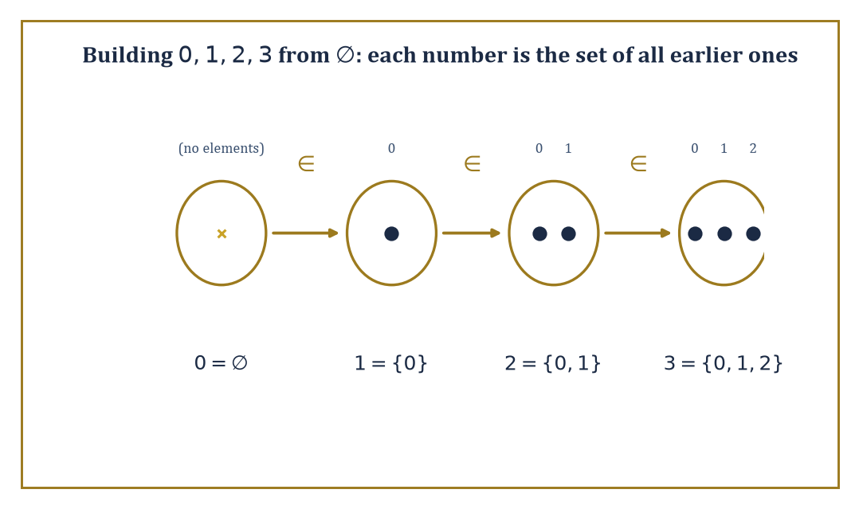
Figure 25.1 — Four sets, one membership chain: 0∈1∈2∈3, built from ∅ using nothing but Pairing and Union.
Mathematical logic, meanwhile, is the study of formal languages and the rules by which one sentence may be validly obtained from others. Where set theory asks ‘what exists?’, logic asks ‘what follows?’ — and mathematics, as a going concern, needs answers to both.
Numeric example — Building the numbers 0-3 from nothing. Set theory’s boldest party trick is manufacturing the natural numbers out of the empty set ∅ and nothing else, defining each successor as ‘the set of everything built so far.’
0 = ∅
1 = {∅} = {0}
2 = {∅,{∅}} = {0,1}
3 = {∅,{∅},{∅,{∅}}} = {0,1,2}
Here 0 is the set with no elements, 1 a set containing one element, 2 a set containing two elements, and 3 a set containing three elements. Two things are worth checking, and both are true: first, each number genuinely has as many elements as its name suggests — 3 has exactly three elements, 0, 1, and 2 — so ‘size’ falls straight out of the construction. Second, membership tracks order:
0∈1∈2∈3
and in fact 0∈3, 1∈3, 2∈3 as well, since each later number contains all the earlier ones. The number 4 is built the same way, and so on forever — the entire edifice of arithmetic (Chapters 1–3 (Volume 1) of this series) can, if you insist, be re-derived from these bare sets. Nobody does this in daily practice, for the same reason nobody derives their morning coffee from the standard model of particle physics — but the fact that one could is the point of a foundation.
Try it now — Write the von Neumann ordinal 3 as a set. Answer →
None of this works without care, though. The naive idea that ‘any description you can state carves out a set’ cannot be maintained without contradiction — Naive Set Theory will watch it collapse in real time — so the working axioms of set theory, Zermelo–Fraenkel with Choice (ZFC), replace unrestricted set-formation with a short, narrowly worded list of construction permits: an empty set exists; the pair of any two existing sets exists; the union of any existing collection exists; the subset of an existing set carved out by a formula exists; and a handful more in the same bureaucratic spirit.
It looks like paperwork. It is paperwork. It is also the only reason the rest of this series is standing on solid ground rather than quietly resting on Russell’s paradox.
Abstract example — The Pairing axiom, at work. ZFC’s Pairing axiom licenses exactly one move: for any two sets a and b, the set {a,b} exists. This single narrow permission is doing more work than it looks.
Given only ∅, Pairing produces {∅,∅}, which — since a set cannot list the same element twice — is {∅}, precisely the number 1 from the construction above:
{∅,∅} = {∅} = 1
Feed Pairing the two existing sets ∅ and {∅}, and it produces {∅,{∅}} directly — already exactly 2, no further assembly required, because 2 happens to be built from precisely two existing sets and Pairing’s whole job is producing sets from precisely two:
{∅,{∅}} = 2
Building 3 needs one more ingredient, because Pairing only ever hands you a set of one or two elements, never three: apply Pairing once more to get the singleton {2}:
{2} = {{∅,{∅}}}
then apply the Union axiom to merge 2 = {∅,{∅}} with {2}, producing:
{∅,{∅},{∅,{∅}}} = 3
as promised. Every step of the numeral construction above is licensed this way, by a specific, named axiom — Pairing to combine two known sets, Union to merge collections when more than a pair is needed, and so on — never by the unrestricted ‘any property you can state defines a set’ that gets Russell’s paradox off the ground. The numbers are built entirely legally, one permit at a time, and that, in miniature, is what an axiomatic foundation buys over a naive one.
This is what it means to say set theory and logic form a foundation: every mathematical object — numbers, functions, groups, manifolds — can in principle be coded as a set, and every mathematical proof can in principle be rewritten as a formal derivation obeying explicit rules of inference.
The foundation is not how mathematicians think from day to day (nobody visualizes a topologist’s manifold as a von Neumann ordinal in disguise), but it is the guarantee underlying everything else, unremarked: if a proof is ever challenged closely enough, it can be cashed out in these terms.
Abstract example — From an ordinary claim to a formal one. Take the everyday fact ‘the sum of two even numbers is even.’ In predicate logic, with Even(x) standing for ‘x is even’, this becomes:
∀x ∀y (Even(x) ∧ Even(y) → Even(x+y))
Nothing has been added mathematically — but everything has been made explicit: the universal quantifiers ∀x∀y say which objects are being generalized over, the connective ∧ says both hypotheses must hold, and → says the conclusion follows.
A proof of this sentence in a formal system would spell out, symbol by symbol, exactly how Even(x+y) follows from Even(x) and Even(y) via the definitions:
x=2m, y=2n, so x+y=2(m+n)
— the same proof you’d give informally, merely with every appeal to intuition converted into a licensed rule of inference. This translation step, tedious as it looks, is what makes automated proof-checking possible: a computer cannot follow intuition, but it can follow ∀, ∧, and →.
The subject is not merely infrastructure for everything else, however; it produces its own headline results, several of which are among the most celebrated theorems of the twentieth century. Cantor proved that no set can be put in bijection with its own power set — so there is no largest infinity, ever, at any scale (Infinite Sets, Cardinality, and Cantor’s Theorems).
Gödel and Cohen together showed that the continuum hypothesis, Cantor’s guess about how much bigger the reals are than the naturals, can be neither proved nor refuted from the standard axioms — it is independent of them, floating free.
And Gödel’s incompleteness theorems (Incompleteness and Undecidability) show that any formal system strong enough to do ordinary arithmetic must leave some true statements about the natural numbers forever unprovable within itself. These are not obscure curiosities; they are the moments when mathematics turned around, looked at itself, and discovered its own edges.
Numeric example — A finite rehearsal of Cantor’s theorem. The full argument (Infinite Sets, Cardinality, and Cantor’s Theorems) works for infinite sets, but its shape is visible already in the finite case. Let S = {a, b, c}, a set with |S| = 3 elements. Its power set 𝒫(S) — the set of all subsets of S — is:
𝒫(S) = {∅, {a}, {b}, {c}, {a,b}, {a,c}, {b,c}, {a,b,c}}
Count them: that’s 8 subsets, and indeed
2³ = 8
So
|𝒫(S)| = 8 > 3 = |S|
the power set is strictly bigger than the set, for the boring reason that 2ⁿ > n for every natural number n. Cantor’s theorem is the statement that this inequality survives even when ‘n’ stops being a number you can count to — that the power set of an infinite set is a strictly bigger infinity than the set itself. The finite case is arithmetic; the infinite case is where the theorem earns its keep.
Keep only this · Section 25.1: What Set Theory and Logic Actually Are
The idea. Set theory builds all mathematical objects from sets and membership; logic says what counts as a proof.
Core.
0 = ∅, n + 1 = n ∪ {n}
extensionality: sets with the same members are equal
Typical mistake. Confusing ∅ with {∅}: the first has no elements, the second has one.
Minimal example. 2 = {∅, {∅}} has exactly 2 elements.
Practice. Easy to challenge; full worked answers, with the usual mistake, are in Answers to the Practice Sets at the back.
Easy — How many elements do ∅, {∅} and {∅, {∅}} have? Answer →
Medium — Use Pairing to build {{∅}, ∅}. Is it equal to {∅, {∅}}? Answer →
Challenge — Formalize “the sum of two even numbers is even”. Answer →

Section 25.2: Naive Set Theory: Operations, Relations, Functions
In which everything turns out to be a set, including, unfortunately, the things that shouldn’t be
CORE · about 15 minutes · later chapters build on this
A class of eight students, numbered 1 to 8, has a choir and a chess club. The choir list is {1, 2, 3, 4}. The chess list is {3, 4, 5, 6}. Students 7 and 8 belong to neither.
Four questions come up as soon as there are two lists. Who is in at least one club? Read both lists and keep everyone once: 1, 2, 3, 4, 5 and 6. Who is in both? Only 3 and 4. Who sings but does not play chess? 1 and 2. Who is not in the choir at all? 5, 6, 7 and 8.
Notice that every answer is a list again. Nothing had to be added up or measured. Each question about lists gives back another list, so the answers can be fed straight into further questions. Who is in neither club? Take the students in at least one, 1 to 6, and ask who in the class is left out: 7 and 8.
That is the whole content of the first half of this section. The lists are sets, the class is the universal set U = {1, …, 8}, and the four questions are union, intersection, difference and complement. The figure draws these same two lists, and the second half of the section uses the same habit of building new sets out of old ones to define relations and functions.
Key idea — Sets combine by four basic operations.
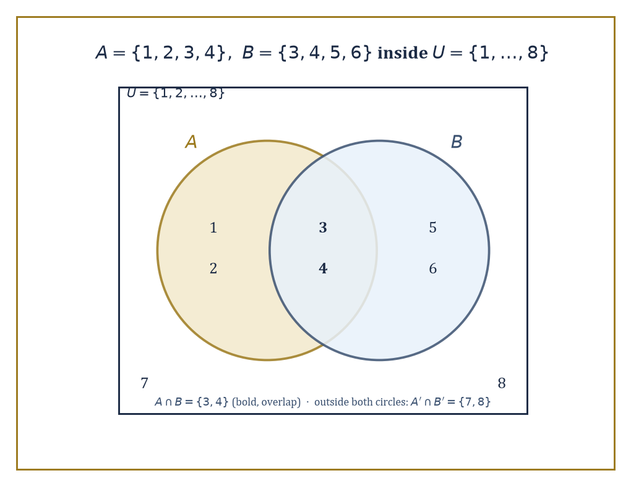
Figure 25.2 — A∪B, A∩B, and the rest, drawn out for A={1,2,3,4} and B={3,4,5,6} inside U={1,…,8}.
The union A∪B collects everything in A or B (or both); the intersection A∩B keeps only what’s in both; the difference A\B keeps what’s in A but not B; and, relative to some fixed universal set U, the complement keeps everything outside A:
A′ = U\A
The power set 𝒫(A) — met already in What Set Theory and Logic Actually Are — is the set of all subsets of A, including ∅ and A itself.
Numeric example — The four operations, computed. Let A = {1,2,3,4} and B = {3,4,5,6}, both subsets of a universe U = {1,2,...,8}.
A∪B = {1,2,3,4,5,6}
everything in either.
A∩B = {3,4}
only the overlap.
A\B = {1,2}
in A, kicked out because it’s also in B: 3 and 4 leave.
B\A = {5,6}
the symmetric idea, the other way.
A′ = U\A = {5,6,7,8}
everything in U not in A.
𝒫(A∩B) = 𝒫({3,4}) = {∅, {3}, {4}, {3,4}}
a set of 4 = 2² elements, since A∩B itself has 2 elements. Every one of these is a fact you could, if pressed, verify by literally checking each of the eight elements of U against each set — tedious, finite, and completely rigorous.
Try it now — With A = {1, 2}, B = {2, 3}, compute A ∪ B, A ∩ B, A \ B and A × B. Answer →
Sets alone cannot express order — {1,2} and {2,1} are the same set — so ordered pairs need a separate trick. The standard device, due to Kuratowski, defines the ordered pair as:
(a,b) := {{a},{a,b}}
From ordered pairs, the Cartesian product is defined as:
A×B := {(a,b) : a∈A, b∈B}
collecting all pairs with first coordinate from A and second from B. A relation between A and B is any subset of A×B — a rule for which pairs ‘count’ as related. Functions are the special case of relations that are single-valued and total: for every input in A there is exactly one related output in B.
Numeric example — Pairs that remember their order. Check that Kuratowski’s trick distinguishes (1,2) from (2,1). By the definition:
(1,2) = {{1},{1,2}}
(2,1) = {{2},{1,2}}
These are different sets, because {1} ∈ (1,2) but {1} ∉ (2,1) — the set {{2},{1,2}} contains only {2} and {1,2}, neither of which equals {1}. So the ordered pair encodes which coordinate came first, using nothing but braces and membership.
For the product: with A = {1,2} and B = {x,y}:
A×B = {(1,x), (1,y), (2,x), (2,y)}
exactly
|A|·|B| = 2·2 = 4
pairs, as expected.
Not every relation is a function, and the distinction matters enormously — it is, for instance, exactly the difference between ‘a rule that assigns each student one grade’ and ‘a rule that assigns some students several grades and others none.’
Numeric example — Function or merely a relation? Let A = {1,2,3} and B = {a,b}. Consider the relation:
R = {(1,a), (2,b), (3,a)} ⊆ A×B
R is a function: every element of A appears as a first coordinate exactly once (1 pairs only with a, 2 only with b, 3 only with a), so each input gets exactly one output.
Contrast:
R′ = {(1,a), (1,b), (2,a)}
here 1 appears twice, paired with both a and b — R′ is a perfectly good relation (a subset of A×B), but it is not a function, since it fails to assign 1 a single, unambiguous value.
R″ = {(1,a), (2,b)}
R″ is single-valued but not total (3 has no output at all) — also not a function on all of A. A function needs both properties: exactly one output, for every input, no exceptions.
Two further structures deserve names. An equivalence relation ~ on a set is one that is reflexive, symmetric, and transitive; it partitions the set into disjoint equivalence classes, and the set of these classes is the quotient set, written A/~.
A partial order, by contrast, need not relate every pair of elements, but where it does relate them, it does so consistently (reflexively, antisymmetrically, transitively) — producing a hierarchy rather than a partition. Both constructions are used constantly throughout mathematics, frequently without anyone pausing to remark that a quotient set is, underneath, nothing more than the set of equivalence classes defined above.
Numeric example — Congruence mod 3 chops nine numbers into three piles. Let S = {0,1,2,3,4,5,6,7,8} and define x ~ y iff x and y leave the same remainder on division by 3 (equivalently, 3 divides x−y). Check the three axioms hold: reflexive, since x−x=0 is divisible by 3; symmetric, since if 3 | x−y then 3 | y−x; and transitive, since if 3 | x−y and 3 | y−z then 3 | x−z, because (x−y)+(y−z)=x−z. So this is a genuine equivalence relation.
The equivalence classes are:
[0] = {0,3,6}
[1] = {1,4,7}
[2] = {2,5,8}
These three classes are disjoint and their union is all of S — a partition, as promised. The quotient set:
S/~ = {[0],[1],[2]}
has just 3 elements, even though S itself had 9; this three-element quotient is, in fact, the set usually written ℤ/3ℤ once S is extended to all the integers. ‘Clock arithmetic’ on a three-hour clock is nothing more exotic than this quotient set.
All of this — unions, products, relations, quotients — is ‘naive’ set theory: intuitive, unrestricted, and, as it turns out, dangerous if pushed too far.
The trouble is unrestricted comprehension: the assumption that any property you can state defines a set (the set of all x such that [property]). Bertrand Russell noticed in 1901 that this assumption collapses under its own weight.
Abstract example — Russell’s paradox, in full. Suppose, naively, that for any property you can define, there is a set of the things with that property. Consider the property ‘x is not a member of itself,’ and let R be the resulting set:
R = {x : x∉x}
Now ask the innocent question: is R a member of itself? Case one: suppose R∈R. Then, by R’s defining property, R must satisfy x∉x — that is:
R∉R
Contradiction. Case two: suppose R∉R. Then R does satisfy the defining property ‘x∉x’, so by definition of R:
R∈R
Contradiction again. Either answer refutes itself; R can be neither a member of itself nor not a member of itself, which is absurd for something that is supposed to be a well-defined set. The fault lies not with logic but with the assumption that every property carves out a set — an assumption axiomatic set theory (ZFC) repairs by replacing unrestricted comprehension with more careful, restricted axioms (Separation, Replacement, and friends) that build new sets only from ones already known to exist. It is, in a phrase, the mathematical equivalent of realizing you cannot declare a barber who shaves everyone who does not shave themselves, and then ask who shaves the barber.
Keep only this · Section 25.2: Naive Set Theory: Operations, Relations, Functions
The idea. Union is “or”, intersection is “and”, complement is “not”; a function is a relation giving each input exactly one output.
Core.
A ∪ B, A ∩ B, A \ B, Aᶜ
(a, b) = {{a}, {a, b}}
function: each a has exactly one image
Typical mistake. Accepting a relation as a function when some input has two outputs or none.
Minimal example. A = {1, 2, 3, 4}, B = {3, 4, 5, 6}: A ∩ B = {3, 4}.
Practice. Easy to challenge; full worked answers, with the usual mistake, are in Answers to the Practice Sets at the back.
Easy — With U = {1, …, 6} and A = {1, 2}, find Aᶜ. Answer →
Medium — Is R = {(1, a), (2, a), (3, b)} a function from {1, 2, 3} to {a, b}? Injective? Surjective? Answer →
Challenge — Show that (A ∪ B)ᶜ = Aᶜ ∩ Bᶜ. Answer →

Section 25.3: Infinite Sets, Cardinality, and Cantor’s Theorems
In which some infinities turn out to be more infinite than others
CORE · about 20 minutes · later chapters build on this
Definition — Two sets have the same cardinality — the same ‘size’, even if both are infinite — if there is a bijection between them: a function that is one-to-one and onto, pairing every element of one set with exactly one element of the other and leaving nothing unpaired on either side. This single idea is what lets us compare infinities at all.
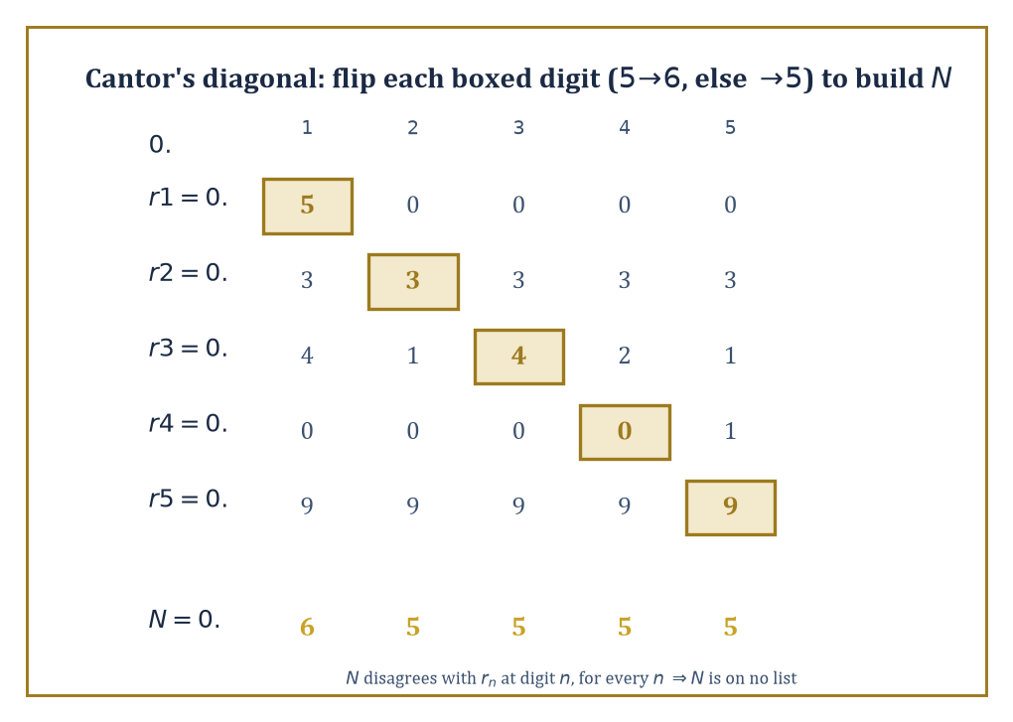
Figure 25.3 — The diagonal argument on the section’s own five rows: flip each boxed digit to build a number no list could have contained.
A set is called infinite, in fact, when it can be put in bijection with a proper subset of itself — a property no finite set can have (you cannot pair five items with four of them and leave none out), but which every infinite set has in abundance.
Numeric example — The naturals and the integers are the same size. It looks obvious that ℤ = {...,−2,−1,0,1,2,...} should be ‘twice as big’ as ℕ = {0,1,2,3,...}, since ℕ is missing all the negative numbers. Cardinality disagrees. Define f: ℕ→ℤ by:
f(n) = n/2 if n is even, and f(n) = -(n+1)/2 if n is odd
Compute the first few values:
f(0)=0, f(1)=−1, f(2)=1, f(3)=−2, f(4)=2, f(5)=−3, f(6)=3
The outputs march through ℤ as 0, −1, 1, −2, 2, −3, 3, ... — every integer appears exactly once, positive and negative alike, zig-zagging outward. This f is a bijection: injective (no output repeats, checked by working through the even/odd cases separately) and surjective (every integer k≥0 is hit by n=2k, every integer k<0 is hit by n=−2k−1). So |ℕ| = |ℤ|, despite the strong intuitive pull the other way. This common size is called ℵ₀ (aleph-null), the smallest infinite cardinal, and any set in bijection with ℕ is called countably infinite.
Try it now — Give an explicit bijection ℕ → ℤ (ℕ = {0, 1, 2, …}). Answer →
Not every infinite set is countable, and the proof that some are not is one of the great pieces of mathematical theater: Cantor’s diagonal argument. It shows that the real numbers cannot be listed off against the naturals — there are, in a precise sense, strictly more reals than naturals.
Numeric example — Cantor’s diagonal argument, digit by digit. Suppose, for contradiction, someone hands you a complete list of all real numbers between 0 and 1, enumerated as r₁, r₂, r₃, .... Say the list begins:
r₁ = 0.50000..., r₂ = 0.33333..., r₃ = 0.41421..., r₄ = 0.00001..., r₅ = 0.99999...
Read off the diagonal digit from each row — the 1st digit of r₁, the 2nd digit of r₂, the 3rd digit of r₃, and so on: here, 5, 3, 4, 0, 9. Now build a new number N by changing every diagonal digit according to one fixed rule (to dodge decimal-representation ambiguities like 0.4999...=0.5000...): if the diagonal digit is 5, write 6; otherwise write 5. Applied to 5,3,4,0,9 this gives new digits 6,5,5,5,5, so:
N = 0.65555...
Check that N differs from every row on the list:
N ≠ r₁, N ≠ r₂, N ≠ r₃, N ≠ r₄, N ≠ r₅
— disagreeing respectively at digit 1 (6 vs 5), digit 2 (5 vs 3), digit 3 (5 vs 4), digit 4 (5 vs 0), and digit 5 (5 vs 9). Continuing this recipe down an infinite list produces a real number N ∈ [0,1] that disagrees with row n at digit n for every single n — so N cannot equal any r on the list, no matter how the list was drawn up. But N was supposed to be in [0,1], and the list was supposed to contain every real number in [0,1]. Contradiction: no such complete list can exist. The reals are uncountable.
Cantor’s theorem generalizes the diagonal trick from ℝ to every set whatsoever: the power set of any set S is strictly larger than S itself:
|𝒫(S)| > |S|
with no exceptions — not for finite sets (What Set Theory and Logic Actually Are checked 2³>3), and, this is the point, not for infinite ones either. Since 𝒫(ℕ) turns out to have the same cardinality as ℝ (via representing subsets as binary digit-sequences), this is really the same argument as the diagonal proof above, dressed differently.
Theorem — Cantor’s theorem
For every set S there is no surjection S → P(S). Hence |S| < |P(S)|.
Hypotheses — check each one before you use it:
□ S is any set: finite, countable or larger
□ P(S) is the set of all subsets of S
□ the proof uses the diagonal set D = {x ∈ S : x ∉ f(x)} and no axiom of choice
Why it matters. It produces an endless ladder of infinities, |ℕ| < |P(ℕ)| = |ℝ| < |P(ℝ)| < …, and its diagonal trick returns in Russell’s paradox, Gödel’s theorem and the halting problem.
Abstract example — Cantor’s theorem, in general. Suppose, for contradiction, that some set S did have a bijection f: S → 𝒫(S) matching each element to a subset of S. Define the ‘diagonal set’:
D = {x ∈ S : x ∉ f(x)}
the set of elements that are not members of their own assigned subset. Since f is supposed to be onto, D = f(a) for some a ∈ S. Now ask: is a ∈ D?
If a ∈ D, then by D’s definition a ∉ f(a) = D — contradiction. If a ∉ D, then a ∉ f(a), which is D’s membership condition, so a ∈ D — contradiction again.
Either way, disaster: no such a can consistently exist, so f cannot have been onto after all, and no bijection S → 𝒫(S) exists. Compare this argument, element by element, to Russell’s paradox in Naive Set Theory: ‘x ∉ f(x)’ is playing the role that ‘x ∉ x’ played there. This is not a coincidence — Russell’s paradox is Cantor’s theorem applied to the (illegal) ‘set of all sets’, with f taken to be the identity.
Iterating the power-set operation — ℕ, then 𝒫(ℕ), then 𝒫(𝒫(ℕ)), and so on forever — produces an endless, strictly increasing tower of infinite cardinals, with no largest one at any stage (Cantor’s theorem forbids it).
Cardinal arithmetic — addition, multiplication, exponentiation of these sizes — turns out to be strangely simple once the axiom of choice (The Axiom of Choice and Its Equivalents) is assumed: for infinite cardinals κ and λ:
κ+λ = κ·λ = max(κ,λ)
It is exponentiation, 2^{κ}, that stays mysterious — mysterious enough that the question of exactly where 2^{ℵ₀} sits in the hierarchy (the continuum hypothesis) is independent of the usual axioms altogether.
Worked example — Cardinal addition and multiplication collapse to the max. Check the rule κ+λ = κ·λ = max(κ,λ) on the smallest infinite cardinal, κ=λ=ℵ₀.
For addition, ℵ₀+ℵ₀ is the size of two disjoint copies of ℕ combined; send the first copy to the even numbers 0,2,4,... and the second copy to the odds 1,3,5,..., and this is a bijection from (copy 1 ⊔ copy 2) onto ℕ itself — so:
ℵ₀+ℵ₀ = ℵ₀ = max(ℵ₀,ℵ₀)
For multiplication, ℵ₀·ℵ₀ is the size of ℕ×ℕ, the full grid of pairs (m,n); the same zig-zagging-along-the-diagonals idea used on the rationals below (or the closed-form Cantor pairing function
(m,n) ↦ (m+n)(m+n+1)/2 + n
lists every pair off against a single natural number, so:
ℵ₀·ℵ₀ = ℵ₀ = max(ℵ₀,ℵ₀)
Both answers land on the rule. Exponentiation refuses to cooperate: 2^{ℵ₀} is not ℵ₀ at all, but the strictly larger cardinality of ℝ — the very fact the diagonal argument earlier in this section spent an entire example proving. Addition and multiplication of infinities are almost insultingly tame; exponentiation is where all the actual difficulty in the subject lives.
Countable sets — those of cardinality at most ℵ₀ — are more plentiful than the diagonal argument might suggest. The rational numbers ℚ are countable, despite being dense (between any two rationals sits another); so are the algebraic numbers (roots of polynomials with integer coefficients); so is the set of all finite binary strings.
Once you leave this discrete, listable realm, though, uncountability becomes the rule rather than the exception: ℝ, 𝒫(ℕ), the set of all functions ℕ→ℕ, the set of all subsets of ℝ — all uncountable, all strictly bigger than ℵ₀, and mostly bigger than each other.
Numeric example — Listing the rationals without missing any. It looks impossible to enumerate ℚ, since between any two rationals there are infinitely many more. Cantor’s fix: arrange the positive rationals p/q in a grid, rows indexed by numerator p, columns by denominator q, and read off the grid along its diagonals (constant p+q), skipping any fraction not already in lowest terms (to avoid, say, counting both 1/1 and 2/2).
The diagonal with p+q=2 contributes:
1/1
The diagonal p+q=3 contributes:
1/2, 2/1
The diagonal p+q=4 contributes (2/2 skipped, already counted as 1/1):
1/3, 3/1
The diagonal p+q=5 contributes:
1/4, 2/3, 3/2, 4/1
Strung together, the enumeration begins:
1/1, 1/2, 2/1, 1/3, 3/1, 1/4, 2/3, 3/2, 4/1, ...
Every positive rational appears exactly once, eventually, at some finite position in this list (interleave in 0 and the negatives, by the same zig-zag trick as the ℤ example above, to get all of ℚ). A set that looked hopelessly dense turns out to be as countable as ℕ itself.
Keep only this · Section 25.3: Infinite Sets, Cardinality, and Cantor’s Theorems
The idea. Same size means a bijection exists; ℕ, ℤ and ℚ are countable; ℝ is not; |S| < |P(S)| for every set S.
Core.
countable: bijection with ℕ (or finite)
diagonal argument: [0, 1] is uncountable
|S| < |P(S)|
κ + λ = κ · λ = max(κ, λ) (infinite)
Typical mistake. Concluding a set is uncountable because one attempted listing missed something.
Minimal example. ℕ → ℤ: 0, −1, 1, −2, 2, …
Practice. Easy to challenge; full worked answers, with the usual mistake, are in Answers to the Practice Sets at the back.
Easy — Is the set of even natural numbers countable? Answer →
Medium — Show that ℕ × ℕ is countable. Answer →
Challenge — Show that there is no surjection f : S → P(S). Answer →

Section 25.4: The Axiom of Choice and Its Equivalents
In which we agree to pick one sock from every pair, no questions asked
EXTENSION · about 15 minutes · enrichment; nothing later depends on it
Key idea — The axiom of choice (AC) says: given any family of nonempty sets, however large or however alien, there exists a function that selects one element from each set simultaneously — a ‘choice function’.
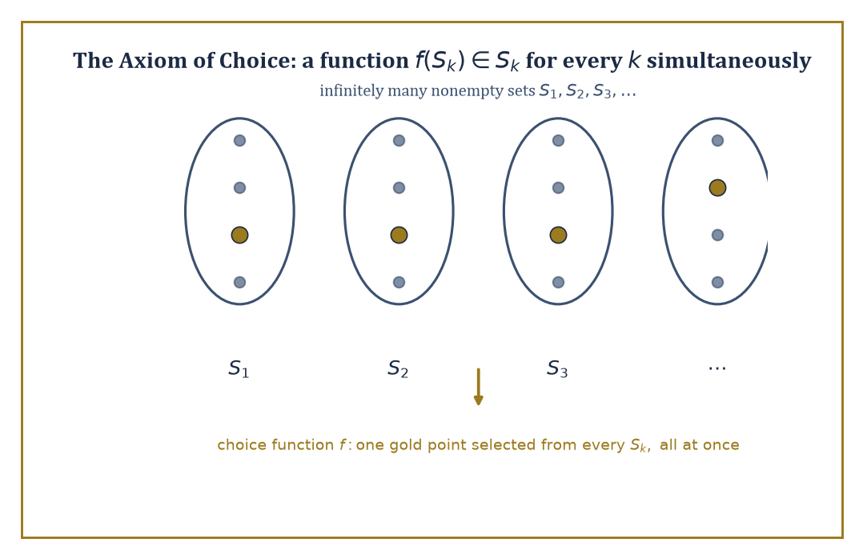
Figure 25.4 — A choice function in action: one gold representative plucked from every one of infinitely many sets, all at once, no rule supplied.
Stated baldly like that, it sounds too obvious to deserve a name, let alone a century of controversy. The trouble is entirely about infinite families with no rule for choosing.
Abstract example — Russell’s shoes and socks. Suppose you own infinitely many pairs of shoes, and infinitely many pairs of socks, and must pick one shoe and one sock from every pair, all at once.
For the shoes, no axiom is needed: declare ‘always pick the left one’ — a single explicit rule that works uniformly across every pair, because left and right shoes are distinguishable.
For the socks, assumed identical within each pair, no such rule exists; there is nothing that says ‘pick this one, not that one’ for a pair of indistinguishable socks.
You can certainly imagine having made a selection from each pair — but imagining infinitely many independent, unjustified selections all at once, with no rule to justify any of them, is the content of the axiom of choice. It is the difference between an explicit algorithm and a bare assertion that a choice is possible.
Try it now — Why does choosing one shoe from each of infinitely many pairs not need the axiom of choice? Answer →
AC is independent of the other axioms of ZFC — it can be neither proved nor disproved from them — yet a striking number of theorems mathematicians would be reluctant to give up turn out to depend on it without saying so: every vector space (including infinite-dimensional ones) has a basis; every product of compact topological spaces is compact (Tychonoff’s theorem); every surjective function has a right inverse (a ‘section’, undoing the surjection on some chosen preimage of each output).
Abstract example — A basis for an infinite-dimensional space, via Zorn’s Lemma. Zorn’s Lemma — logically equivalent to AC — says: if every chain (totally ordered subset) in a partially ordered set has an upper bound within the set, then the set has a maximal element.
Apply it to build a basis for a vector space V (say, V = ℝ as a vector space over ℚ, an infinite-dimensional space with no obvious finite list of ‘axes’). Let P be the collection of all linearly independent subsets of V, partially ordered by inclusion ⊆.
Take any chain — a family of linearly independent sets totally ordered by inclusion — and let its union U be the proposed upper bound. Is U linearly independent? Any finite subset of U consists of finitely many vectors, each drawn from some set in the chain; since the chain is totally ordered, the largest of those finitely many sets contains all the others, so the whole finite subset already sits inside one linearly-independent set from the chain — hence it is linearly independent.
So U is linearly independent, and Zorn’s Lemma applies: P has a maximal element B. If B failed to span V, some vector v ∉ span(B) could be added, and B∪{v} would still be linearly independent (standard linear algebra) — contradicting B’s maximality. So B spans V and is linearly independent: a basis.
No one has ever written down an explicit basis of ℝ over ℚ (a ‘Hamel basis’), nor ever will; Zorn’s Lemma guarantees one exists without supplying so much as a hint of what it looks like. This is the flavor of every AC-powered proof: existence without exhibition.
AC comes in many logically equivalent disguises — Zorn’s Lemma above, the well-ordering theorem (every set can be well-ordered, Ordinals, Well-Ordering, and Transfinite Induction), the statement that every ring with identity has a maximal ideal — each more convenient than the others in different corners of mathematics.
The price of admission is non-constructivity, and, occasionally, outright pathology: the Vitali set (choose one representative from each coset of ℚ inside [0,1] under the equivalence x~y iff x−y∈ℚ) turns out to be non-measurable — it cannot be assigned any sensible notion of length at all. The Banach–Tarski theorem goes further still, showing a solid ball can be split into finitely many pieces and reassembled, using only rotations, into two solid balls each the same size as the original. Both constructions require AC essentially; without it, such monstrosities cannot be built.
Abstract example — Why the Vitali set has no length. Build a Vitali set V by AC: partition [0,1) into equivalence classes under x~y iff x−y∈ℚ, and choose — via AC, since there is no rule for preferring one representative over another — exactly one point from each class, collecting the choices into V.
List the rationals in [0,1) as q₀,q₁,q₂,... (Infinite Sets, Cardinality, and Cantor’s Theorems showed such a list exists) and form the translated copies:
Vₙ = {v+qₙ mod 1 : v∈V}
for each n. These copies are pairwise disjoint — two of them sharing a point would put two points of V in the same equivalence class, contradicting how V was built to hold exactly one representative per class — and their union is all of [0,1), since every x there equals v+q mod 1 for v the representative of x’s class and q the appropriate rational.
Suppose, for contradiction, V has some well-defined length m (a Lebesgue measure); every translate Vₙ has the same length m, since sliding a set along the line cannot change its length. Summing the countably many disjoint pieces must reproduce the length of the whole:
1 = Σₙ m
But a countable sum of one constant m, added to itself over and over, is either 0 (if m=0) or infinite (if m>0) — never exactly 1. No value of m survives the check, so V has no length at all: a set too pathological for ordinary geometry to measure, built by AC and unbuildable without it.
One theorem so ordinary it barely feels like a theorem exposes just how invisibly AC gets used: ‘a countable union of countable sets is countable.’ It is assumed constantly, and it does require a choice principle — not the full-strength axiom, but a weaker cousin called countable choice — because proving it means simultaneously selecting an enumeration for each of the countably many sets involved, and nothing but a choice principle licenses infinitely many simultaneous, unjustified selections like that.
Abstract example — Why the union needs a choice, not just a listing. Suppose A₁, A₂, A₃, ... is a countably infinite family of countable sets, and the goal is to show their union ⋃ₙ Aₙ is countable, by listing its elements off against ℕ.
Each Aₙ, being countable, does have some enumeration — some bijection (or surjection) ℕ→Aₙ. But ‘does have’ is not ‘has been handed to you’; for each n there are typically many different valid enumerations of Aₙ, and nothing in the hypothesis ‘Aₙ is countable’ picks out one over another.
To build a single enumeration of the whole union — interleave enumeration 1 of A₁, enumeration 2 of A₂, and so on, in the same zig-zag style as Section 25.3’s rationals argument — requires first selecting one enumeration per Aₙ, simultaneously, out of infinitely many equally valid candidates with no distinguishing rule between them: precisely a choice function on an infinite family, and precisely what countable choice supplies.
Deny yourself even this weak form of AC, and it becomes logically consistent that ℝ itself is a countable union of countable sets — a statement that sounds like nonsense (it would make the uncountability proof of Infinite Sets, Cardinality, and Cantor’s Theorems collapse) and is exactly the sort of thing set theorists mean when they warn that AC’s absence does not just remove convenience, it lets in new pathologies of its own.
Most working mathematicians accept AC without a second thought — the convenience is too large to refuse, and the pathologies it enables (Vitali sets, Banach–Tarski) are safely non-constructive curiosities rather than everyday hazards.
The finer question of which theorems genuinely need AC, and which survive without it, is a specialized pursuit belonging to set theorists rather than to the rest of us — a bit like asking which structural beams a building could, in principle, do without. Best left to people who enjoy load calculations.
Keep only this · Section 25.4: The Axiom of Choice and Its Equivalents
The idea. AC: every family of non-empty sets has a choice function. It is equivalent to Zorn’s lemma and the well-ordering theorem.
Core.
AC: every family of non-empty sets has a choice function
AC ⇔ Zorn’s lemma ⇔ well-ordering theorem
Typical mistake. Using AC where an explicit rule would do, or overlooking a hidden use of it.
Minimal example. Every vector space has a basis (by Zorn).
Practice. Easy to challenge; full worked answers, with the usual mistake, are in Answers to the Practice Sets at the back.
Easy — Do you need AC to choose an element from each of finitely many non-empty sets? Answer →
Medium — Name a consequence of AC that is surprising. Answer →
Challenge — Why does choosing an element from each non-empty subset of ℕ not need AC? Answer →

Section 25.5: Ordinals, Well-Ordering, and Transfinite Induction
In which counting keeps going long after the numbers run out
EXTENSION · about 15 minutes · enrichment; nothing later depends on it
Definition — An ordinal is the order type of a well-ordered set — a set equipped with a total order in which every nonempty subset has a least element (so there are no infinite descending chains). The finite ordinals are just the natural numbers 0,1,2,3,..., but well-ordering does not stop there: after every finite ordinal comes ω, the order type of ℕ itself — the first infinite ordinal, standing for ‘the whole endless queue of finite numbers, viewed as a single completed object.’
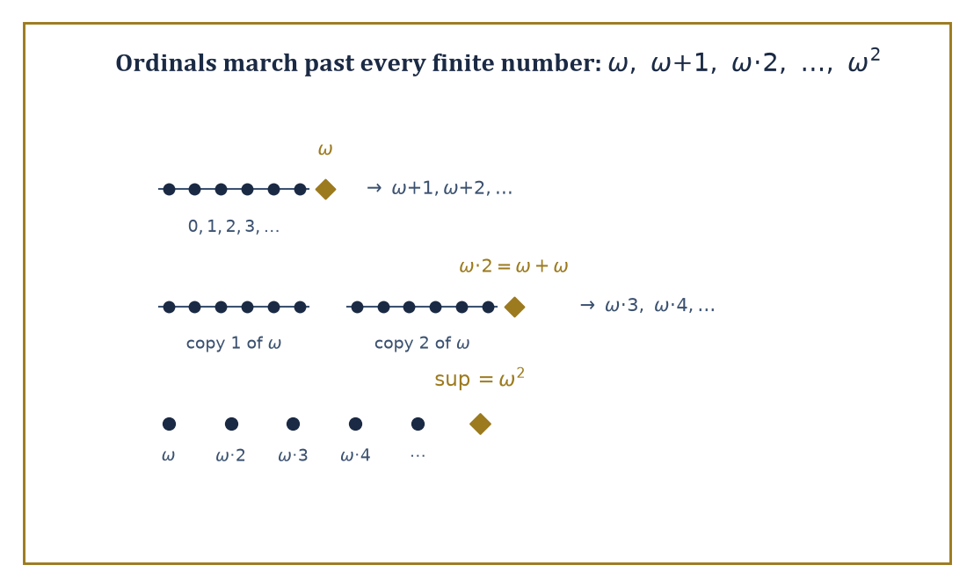
Figure 25.5 — Counting past infinity: ω, then ω+1, then two copies of ω laid end to end, then the whole tower’s supremum ω².
Beyond ω come ω+1, ω+2, ..., then ω·2 (two copies of ω back to back), then ω·3, and so on to
ω·ω = ω²
then ω³, and eventually ω^{ω}, and further still, all the way to ω₁, the first ordinal too big to be reached by any countable process at all — the first uncountable ordinal.
Worked example — Ordinal addition and multiplication do not commute. In ordinary arithmetic 1+ω would just be another name for ω+1, and 2·ω the same as ω·2. Ordinals disagree, because addition means ‘lay one order after the other’ — order matters.
Compute 1+ω: put a single new point before the usual ω-sequence 0,1,2,3,.... The result — one point, then infinitely many more, none of them a top element — is order-isomorphic to ω itself (just relabel: the new point becomes position 0, old position n becomes position n+1). So:
1+ω = ω
Now compute ω+1: put a single new point after the ω-sequence. The result has a top element — something greater than every one of 0,1,2,3,... — and ω itself has no such maximum. So:
ω+1 ≠ ω
it is a strictly larger ordinal, ω with one more rung.
Multiplication shows the same asymmetry. ω·2 means two copies of ω laid end to end: 0,1,2,...,then 0,1,2,... again — this equals ω+ω, which (like ω+1) has infinitely many elements with infinitely many predecessors, so:
ω·2 ≠ ω
strictly bigger. But 2·ω means ω copies of the 2-element order {0,1}, laid end to end: 0,1,0,1,0,1,.... Every element here still has only finitely many predecessors (the element in the n-th copy, at position 2n or 2n+1, has just that many predecessors — always a finite number), so this whole arrangement is order-isomorphic to ω after all:
2·ω = ω
Conclusion:
2·ω = ω, but ω·2 = ω+ω ≠ ω
multiplication depends on which side the multiplier sits, and the two answers are not even close.
Try it now — Compute 2 + ω and ω + 2. Are they equal? Answer →
Transfinite induction and transfinite recursion extend ordinary induction and recursive definition past ω, to any well-ordered index set.
Transfinite induction proves a statement holds for every ordinal by handling three cases: the base case (0), the successor case (assuming it holds at α, prove it at α+1), and — the new ingredient — the limit case (if it holds at every ordinal below a limit ordinal λ, prove it holds at λ itself, with no single ‘previous step’ to appeal to). Transfinite recursion defines objects the same way, stage by stage, taking limits at limit stages.
Worked example — Building ω² by transfinite recursion. Define a sequence of ordinals by recursion:
a₀ = ω, and aₙ₊₁ = aₙ + ω for each finite n
Unwind it:
a₀ = ω
a₁ = a₀+ω = ω+ω = ω·2
(matching the previous example)
a₂ = a₁+ω = ω·2+ω = ω·3
In general aₙ = ω·(n+1) — each step tacks on one more copy of ω. At the limit stage (n reaching ω itself, the recursion’s first limit ordinal), the natural definition is:
a_{ω} = sup{aₙ : n<ω} = sup{ω, ω·2, ω·3, ...} = ω·ω = ω²
This single small recursion, run past its first limit stage, has just manufactured ω² out of nothing but ω and repeated addition — the pattern (successor steps building, limit steps collecting) that every transfinite construction in this series ultimately follows.
Every well-ordered set, however exotic, is order-isomorphic to exactly one ordinal — ordinals are, in this sense, the complete catalog of possible well-orderings, one representative of each ‘shape’. And the axiom of choice (The Axiom of Choice and Its Equivalents) turns out to be logically equivalent to the well-ordering theorem: the assertion that every set whatsoever — including ℝ, including 𝒫(ℝ) — can be well-ordered by some relation, even sets whose usual order is nothing like a well-order.
Numeric example — Well-ordering ℤ, the sneaky way. The integers ℤ, under their usual order ..., −2, −1, 0, 1, 2, ..., are not well-ordered: the whole set has no least element (for any candidate least element k, k−1 is smaller still). Yet the well-ordering theorem insists ℤ can be well-ordered somehow — and here it costs nothing to exhibit the somehow explicitly, because ℤ is countable.
Reuse the zig-zag bijection from Section 25.3’s ℕ-to-ℤ example:
0,−1,1,−2,2,−3,3,...
Define a brand new order ≺ on ℤ by declaring that whichever integer appears earlier in this list counts as smaller:
0 ≺ −1 ≺ 1 ≺ −2 ≺ 2 ≺ −3 ≺ 3 ≺ ...
Under ≺, every nonempty subset of ℤ has a ≺-least element (namely, whichever of its elements appears earliest in the zig-zag list) — so (ℤ, ≺) is a well-order, with order type ω, even though (ℤ, <) manifestly is not a well-order at all.
For a countable set like ℤ this reordering trick is easy and entirely explicit. For an uncountable set like ℝ, the well-ordering theorem still guarantees such a reordering exists — but no one has ever written one down, nor (it can be shown) could anyone ever write one down explicitly using the usual rules of construction. It is existence by decree, courtesy of AC, with the details permanently classified.
Keep only this · Section 25.5: Ordinals, Well-Ordering, and Transfinite Induction
The idea. Ordinals extend counting past the finite; transfinite induction proves statements for all ordinals by handling 0, successors and limits.
Core.
ordinals: 0, 1, …, ω, ω + 1, …, ω · 2, …, ω²
1 + ω = ω ≠ ω + 1
transfinite induction: 0, successor, limit
Typical mistake. Forgetting the limit case in a transfinite induction.
Minimal example. ω · 2 = ω + ω, but 2 · ω = ω.
Practice. Easy to challenge; full worked answers, with the usual mistake, are in Answers to the Practice Sets at the back.
Easy — Is ω + 1 a limit or a successor ordinal? Answer →
Medium — Compute (ω + 1) + ω. Answer →
Challenge — Give a well-ordering of ℤ. Answer →

Section 25.6: Propositional and Predicate Logic
In which sentences get truth tables, and truth gets sentences
CORE · about 15 minutes · later chapters build on this
Definition — Propositional logic studies truth-functional combinations of atomic propositions — statements like p (‘it is raining’) and q (‘the match is canceled’) combined via connectives: ¬ (not), ∧ (and), ∨ (or), → (implies), ↔ (if and only if).
A formula’s truth value is completely determined, mechanically, by the truth values of its atoms via a truth table listing every possible combination. A tautology is a formula that comes out true on every row of its truth table — true no matter what the atoms mean, purely by its logical shape.
Numeric example — Checking a tautology, row by row. Verify that (p→q) ↔ (¬p∨q) is a tautology — a well-known identity that rewrites ‘implies’ using only ‘or’ and ‘not’. There are four rows, one for each combination of p,q ∈ {True, False}.
Row 1, p=T, q=T:
p→q = T; ¬p∨q = F∨T = T; (T)↔(T) = T
true implies true is true. Row 2, p=T, q=F:
p→q = F; ¬p∨q = F∨F = F; (F)↔(F) = T
true cannot imply false. Row 3, p=F, q=T:
p→q = T; ¬p∨q = T∨T = T; (T)↔(T) = T
false implies anything. Row 4, p=F, q=F:
p→q = T; ¬p∨q = T∨F = T; (T)↔(T) = T
Every row lands on T, so the biconditional holds regardless of p and q’s actual truth values: it is a tautology, and p→q and ¬p∨q are logically interchangeable everywhere. (This identity, incidentally, is why ‘if pigs fly, I’m the Pope’ is not a promise to check the sky: with p false, p→q is automatically true, whatever nonsense q happens to be.)
Try it now — Is (p ∧ q) → p a tautology? Answer →
Truth tables are correct but do not scale — a formula with 20 atoms needs a table with 2²⁰ rows, well over a million, which is a poor way to spend an afternoon.
Practical tools instead convert formulas into normal forms — conjunctive normal form (CNF), an AND of ORs of (possibly negated) atoms — and hunt for contradictions using resolution: from two clauses containing a literal and its negation, resolution cancels that literal and merges what remains into a single new, shorter clause.
Numeric example — Resolution finds a contradiction. Take three clauses in CNF:
(p∨q), (¬p∨q), (¬q)
and ask whether they can all be true at once (satisfiability). Resolve the first two on p: (p∨q) and (¬p∨q) contain p positively and negatively respectively, so cancel p and merge the remainders — q from one side, q from the other, which collapse into a single copy — leaving the new clause:
(q)
Now resolve this derived unit clause (q) with the third original clause (¬q): both are single-literal clauses on the same variable, so canceling q leaves nothing behind on either side — the empty clause, a clause with no literals left at all, which stands for an outright contradiction. Deriving the empty clause proves the original three clauses cannot be satisfied simultaneously by any assignment of p and q.
(Check directly if in doubt: working through all 4 rows of a truth table for p,q confirms no row makes (p∨q), (¬p∨q), and (¬q) all true together — resolution just established this in two mechanical cancellations instead of four table rows, which is exactly the scalability resolution is for.)
Predicate logic extends this by adding quantifiers (∀ ‘for all’, ∃ ‘there exists’), variables ranging over some domain, and predicates (relations like Prime(x) or properties like Even(x)) applied to them.
The semantics is given by a structure: a chosen domain of objects together with an interpretation telling you exactly what each predicate and function symbol means on that domain. A sentence is satisfied in a structure if it comes out true once its symbols are interpreted there; it is valid if it comes out true in every structure whatsoever, and a logical consequence of a set of sentences if it is true in every structure where those sentences are true.
Worked example — Formalizing, and checking, Goldbach’s conjecture. Formalize ‘every even number greater than 2 is the sum of two primes’ in predicate logic:
∀n (n>2 ∧ Even(n) → ∃p ∃q (Prime(p) ∧ Prime(q) ∧ n=p+q))
interpreted in the structure ℕ with the usual meanings of Even, Prime, +, and >. Check the sentence’s inner claim on a few concrete instances, the way any structure’s satisfaction relation is checked one case at a time:
n=4: 2+2=4
witnessed by p=q=2, since 2 is prime.
n=6: 3+3=6
witnessed by p=q=3, since 3 is prime.
n=8: 3+5=8
witnessed by p=3, q=5, since 3 and 5 are both prime. Each individual instance checks out, cheaply, by exhibiting explicit primes. What nobody has ever managed — this is Goldbach’s actual, still-open conjecture — is a proof (or refutation) that the universally quantified sentence holds for every even n>2 at once; the ∀ at the front is doing infinite work that no finite list of checked instances, however long, can discharge. This is the recurring gap between ‘true in every case I’ve tried’ and ‘valid’ in the strict logical sense — a gap first-order logic is built to keep visible.
First-order logic’s expressive power is calibrated, and precisely limited. It cannot, with a single sentence, directly say ‘there are infinitely many x such that...’ — quantifiers only ever range over individual elements, never over ‘how many’ in bulk.
And, more surprisingly, it cannot distinguish infinite cardinalities at all: the Löwenheim–Skolem theorems show that any first-order theory with an infinite model has models of every infinite cardinality, so no first-order sentence can pin down ‘the model has ℵ₀ elements’ versus ‘exactly 2^{ℵ₀}’. Higher-order logics (quantifying over sets or functions, not just individuals) and infinitary logics (allowing infinitely long formulas) buy back this expressive power — at the cost of the completeness theorem itself (Formal Proofs, Completeness, and Soundness), which holds for first-order logic and fails, in general, for its more powerful cousins.
Abstract example — Saying ‘infinite’ without saying it. No single first-order sentence directly asserts ‘the domain is infinite’ — yet infinity can still be forced indirectly, through infinitely many finite sentences working together. For each n, let φₙ be the sentence:
φₙ = ∃x₁...∃xₙ ⋀ᵢ<ⱼ xᵢ≠xⱼ
(‘there exist at least n distinct elements’). No individual φₙ says anything about infinity — each just demands a finite lower bound on the domain’s size. But consider the infinite theory:
T = {φ₁, φ₂, φ₃, ...}
all at once. Any model satisfying every φₙ simultaneously must have at least n elements for every n — and a set that has at least n elements for every natural number n is, by definition, infinite. So T’s models are forced to be infinite, even though the route there passed through nothing but finite, individually modest sentences. This is the seed of compactness, the tool that makes the trick fully rigorous — the subject of Formal Proofs, Completeness, and Soundness.
Keep only this · Section 25.6: Propositional and Predicate Logic
The idea. A formula is a tautology if it is true in every row; predicate logic adds quantifiers ∀, ∃ over a domain.
Core.
p → q ≡ ¬p ∨ q
CNF and resolution
∀, ∃ over a domain; ¬∀ ≡ ∃¬
Typical mistake. Reading ∀x∃y as ∃y∀x.
Minimal example. Resolution on (p ∨ q), (¬p ∨ q), (¬q) derives q and then the empty clause.
Practice. Easy to challenge; full worked answers, with the usual mistake, are in Answers to the Practice Sets at the back.
Easy — Truth value of p → q when p is false and q is true. Answer →
Medium — Is ((p → q) ∧ (q → r)) → (p → r) a tautology? Answer →
Challenge — Formalize Goldbach: every even number greater than 2 is the sum of two primes. Answer →

Section 25.7: Formal Proofs, Completeness, and Soundness
In which proof and truth shake hands, formally
EXTENSION · about 15 minutes · enrichment; nothing later depends on it
Key idea — A formal proof system fixes a stock of axioms (formulas accepted without proof) and a small set of inference rules (ways of producing a new formula from earlier ones). A derivation is a finite sequence of formulas, each one either an axiom or the output of a rule applied to earlier formulas in the sequence; the last formula in the sequence is the thing derived.
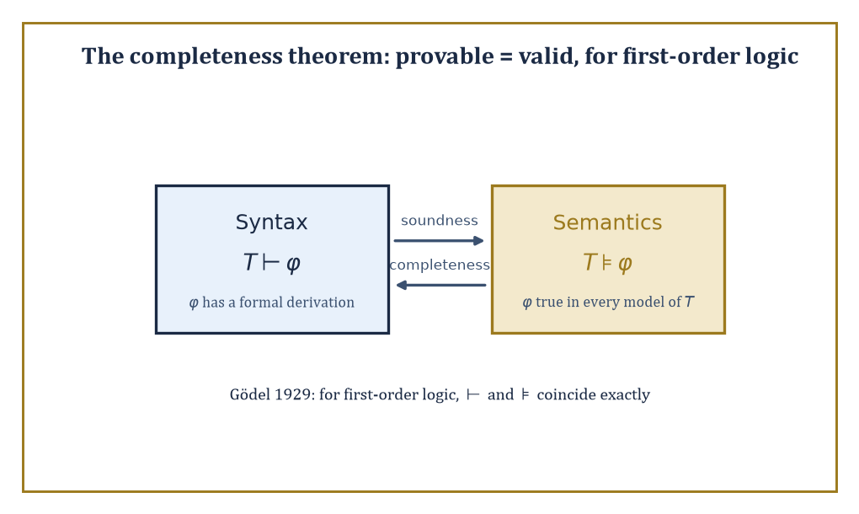
Figure 25.6 — Soundness carries truth from syntax to semantics; completeness carries it back — for first-order logic, the two arrows meet.
Two properties matter above all others: soundness (every formula the system can derive really is valid — true in every structure) and completeness (every formula that really is valid can, in fact, be derived by the system). Soundness without completeness leaves truths unreachable; completeness without soundness lets falsehoods through.
A good proof system needs both, in the same way a good witness needs both to know things and to tell the truth about them — a system with only one of the two virtues is, if anything, worse than a system with neither, since at least the useless one is honestly useless.
Abstract example — A short derivation, step by step. Derive p→r from the premises p→q and q→r, using only modus ponens (from X and X→Y, derive Y) and the standard technique of conditional proof (to derive X→Y, temporarily assume X, derive Y, then discharge the assumption).
Line 1: p (temporary hypothesis, to be discharged)
Line 2: p→q (given premise)
Line 3: q, by modus ponens from lines 1 and 2
Line 4: q→r (given premise)
Line 5: r, by modus ponens from lines 3 and 4
Line 6: p→r, discharging the assumption from line 1
since assuming p led to r, this conclusion no longer depends on the temporary assumption. Six lines, two premises, one rule applied twice, and the classical ‘hypothetical syllogism’ p→q, q→r ⊢ p→r drops out mechanically — no cleverness required, just faithful bookkeeping. This is what ‘formal proof’ buys over informal argument: every step is checkable by a machine with no understanding of what p, q, and r actually mean.
Try it now — Is the rule “from p → q and q, infer p” sound? Answer →
Soundness is checked first, always, for good reason: a proof system’s derivations are only trustworthy once soundness is nailed down, and an unsound system is worse than no system at all, since it can manufacture confident-looking ‘proofs’ of statements that are simply false.
Abstract example — An unsound rule, and the nonsense it licenses. Suppose someone proposes a shiny new inference rule: from ∃x P(x) (‘some x has property P’), derive P(c), where c is any constant already in use elsewhere in the proof (‘so the particular thing named c has property P’). It looks like harmless existential instantiation, done a little carelessly.
Apply it to a genuine, true premise:
∃x Prime(x)
true of ℕ, since (say) 7 is prime. Suppose the constant c already in play elsewhere in the proof happens to name 4, which is not prime. The flawed rule cheerfully licenses deriving:
Prime(4)
manifestly false, obtained from a true premise, via a single plausible-looking line of inference.
The actual, sound version of existential instantiation adds one crucial restriction: c must be a brand-new constant, never previously used for anything else in the proof, to block this leak — a fresh name cannot smuggle in a false assumption about who it secretly refers to.
The moral: an inference rule is not innocent until proven guilty. Every rule in a formal system has to earn its soundness by an actual argument; ‘looks reasonable’ is not such an argument, and the gap between the two is where unsound systems go to hide.
Gödel’s completeness theorem (1929, his other, considerably more reassuring theorem) proves that the standard proof systems for first-order logic really are complete with respect to the usual structure-based semantics: syntax (derivability) and semantics (truth in every structure) coincide exactly.
A powerful corollary, compactness, follows almost for free: a set of sentences has a model if and only if every finite subset of it has a model. Compactness sounds like a technicality but is one of the sharpest tools in the box for building models with deliberately engineered properties — including, as glimpsed in Propositional and Predicate Logic, models that are forced to be infinite by nothing but finite pieces of evidence.
Abstract example — Building a nonstandard model of arithmetic, via compactness. Let T be the true first-order theory of the natural numbers (all first-order sentences true in ℕ, including the ordinary axioms of arithmetic). Extend the language with a brand-new constant symbol c, and add infinitely many new axioms:
c>0, c>1, c>2, c>3, ...
(one axiom c>n for every natural number n). Call the combined theory T’. Check compactness’s hypothesis: does every finite subset of T′ have a model? Any finite subset mentions only finitely many of the new axioms, say up to c>k for some largest k; interpret c as the standard number k+1 (or larger) inside ℕ itself, and every sentence in that finite subset is satisfied — so yes, every finite subset has a model.
Compactness then guarantees the full, infinite theory T′ has a model too — call it ℕ*. In ℕ*, the element interpreting c must be greater than 0, greater than 1, greater than every single standard natural number simultaneously (since ℕ* satisfies every one of the infinitely many axioms c>n at once). No such number exists inside ordinary ℕ; ℕ* is therefore a different, ‘nonstandard’ model of arithmetic, containing an entire extra layer of infinite numbers that first-order arithmetic cannot tell apart from the standard ones using any single sentence. Compactness conjured a new mathematical universe from nothing but a consistency check on finite fragments.
The completeness theorem is, in the end, the fundamental theorem of first-order logic: it is the bridge guaranteeing that ‘provable’ (a syntactic, mechanical, checkable notion) and ‘true in every structure’ (a semantic, conceptual notion) are one and the same thing, for this particular logic.
It is worth savoring, because Incompleteness and Undecidability is about to show that its cousin for arithmetic — ‘every truth about the natural numbers is provable within a single fixed system’ — is false. Completeness holds for the logic; it fails for the theory. The distinction is the entire content of the next section.
Keep only this · Section 25.7: Formal Proofs, Completeness, and Soundness
The idea. Soundness: what is provable is true. Completeness (Gödel 1929): what is true in every model is provable in first-order logic.
Core.
soundness: ⊢ φ ⇒ ⊨ φ
completeness: ⊨ φ ⇒ ⊢ φ
compactness: every finite subset has a model ⇒ the whole set has one
Typical mistake. Confusing completeness of a logic with completeness of a theory.
Minimal example. From p → q, q → r and p, modus ponens twice gives r.
Practice. Easy to challenge; full worked answers, with the usual mistake, are in Answers to the Practice Sets at the back.
Easy — Derive q from p and p → q. Answer →
Medium — Why does soundness of a proof system guarantee that it never proves p ∧ ¬p? Answer →
Challenge — Use compactness to explain why there are non-standard models of arithmetic. Answer →

Section 25.8: Incompleteness and Undecidability
In which mathematics discovers its own edges
EXTENSION · about 15 minutes · enrichment; nothing later depends on it
Definition — Gödel’s first incompleteness theorem (1931) is the sobering counterpart to the completeness theorem of Formal Proofs, Completeness, and Soundness: it states that any consistent, sufficiently strong, effectively axiomatized theory of arithmetic — one that can express and prove basic facts about + and × — is necessarily incomplete. There exist sentences in the language of arithmetic that the theory can neither prove nor disprove, true or not.
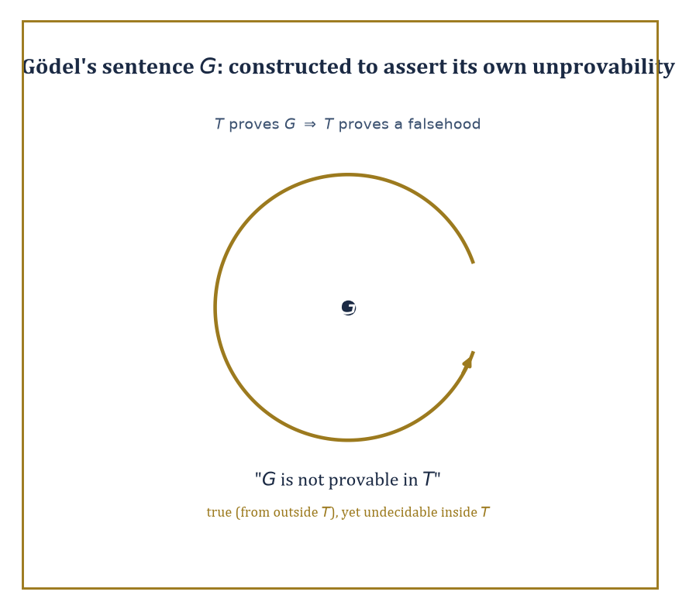
Figure 25.7 — Gödel’s sentence G, chasing its own tail: engineered to say exactly one true thing — that T cannot prove it.
The second incompleteness theorem sharpens the blow: such a theory cannot even prove its own consistency, using only its own resources — it would need to step outside itself to vouch for itself, and nothing can do that.
Theorem — Gödel’s incompleteness theorems
First: if T is consistent, effectively axiomatized and interprets enough arithmetic, then some sentence G is neither provable nor refutable in T. Second: such a T cannot prove its own consistency statement Con(T).
Hypotheses — check each one before you use it:
□ T is consistent
□ T is effectively axiomatized: its axioms can be listed by an algorithm
□ T interprets elementary arithmetic (Robinson arithmetic is enough for the first theorem; the second needs a little more, such as Peano arithmetic)
Why it matters. It marks the limit of the axiomatic method: no single computable set of axioms captures all arithmetic truths. It does not say mathematics is inconsistent or that truth is relative.
Abstract example — The sentence that talks about itself. Gödel’s method (heavily compressed, and the technical machinery genuinely does deserve an entire chapter to itself, not a paragraph) assigns every formula and every proof in a formal theory T a unique natural number — a ‘Gödel number’ — so that T’s own arithmetic can talk about T’s own sentences and proofs as numbers.
Using this coding, Gödel constructs a specific sentence G, cleverly engineered so that G asserts, in effect, ‘G is not provable in T.’
Now reason about G assuming T is consistent. If T could prove G, then (since G says it’s unprovable) T would be proving something false about itself — deeply suspicious for a consistent theory, and in fact ruled out by the careful version of the argument.
If T could prove ¬G instead, T would be asserting that G is provable — while G, if unprovable as ¬G claims it’s provable, creates its own tangle that a fully rigorous treatment resolves in T’s disfavor.
Either way, provided T is consistent, T can prove neither G nor its negation: G is undecidable within T, despite being — from outside T, looking in — recognizably true (it truthfully reports its own unprovability).
I am eliding a genuine technical hypothesis or two here, of the sort that has filled entire careers; readers wanting the full, watertight argument should consult a dedicated text on proof theory, and readers wanting the takeaway without the scar tissue should trust that the construction works.
Try it now — Does incompleteness mean some arithmetic statements are neither true nor false? Answer →
A close cousin of incompleteness, discovered independently by Turing, is the undecidability of the halting problem: there is no algorithm that, given an arbitrary computer program and input, always correctly decides whether the program eventually halts or runs forever.
A related result, Church’s theorem, shows there is likewise no algorithm deciding, for an arbitrary first-order sentence, whether it is valid. Both are undecidability results in the strict technical sense: not ‘nobody has found the algorithm yet’, but ‘no algorithm can possibly exist, ever, for anyone.’
Abstract example — Turing’s diagonal proof that halting is undecidable. Suppose, for contradiction, some program H(P, I) exists that always correctly decides whether program P halts on input I, outputting ‘halts’ or ‘loops’.
Build a new program D that, on input P, runs H(P,P): if H reports ‘halts’, D deliberately loops forever; if H reports ‘loops’, D immediately halts. D is a perfectly legitimate program, built entirely out of the (assumed) H.
Now ask the fatal question: what does D do when run on itself, i.e. what is D(D)?
If D(D) halts, then by D’s own construction that only happens when H(D,D) reported ‘loops’ — meaning H predicted D would loop on itself. But D(D) halted. H was wrong.
If D(D) loops forever, then by D’s construction that only happens when H(D,D) reported ‘halts’ — meaning H predicted D would halt on itself. But D(D) loops. H was wrong again.
Either outcome contradicts H’s assumed perfect reliability. So no such H can exist: the halting problem is undecidable, by an argument that is, move for move, structurally the same diagonal trick as Cantor’s argument in Infinite Sets, Cardinality, and Cantor’s Theorems and Gödel’s self-referential sentence above — swap ‘is a member of’ for ‘halts on’, and the three proofs become the same proof wearing different coats.
Gödel’s own G is a strange, self-referential construction, seemingly invented purely to break the system — which invites a natural worry that incompleteness might just be a logician’s parlor trick, of no consequence to ordinary mathematics.
It isn’t. Concrete, mathematically meaningful statements exist that are true of the natural numbers yet unprovable in Peano Arithmetic (the standard first-order axioms for arithmetic), with no explicit self-reference in sight.
Abstract example — Goodstein sequences: ordinary-looking, secretly transfinite. A Goodstein sequence starts from a number, writes it in ‘hereditary base 2’ (base 2, with the exponents themselves also written in base 2, and so on all the way down), then repeatedly bumps the base up by one and subtracts 1, re-expanding in hereditary form at each new base.
Goodstein’s theorem states that every such sequence, however wildly the base-bumping makes the intermediate numbers balloon — and they balloon spectacularly, starting from numbers as small as 4 or 5 and climbing, before they finally turn around, to values with far more digits than there are atoms in the observable universe — eventually reaches 0.
The theorem is true: it has a proof, but the proof requires transfinite induction up the ordinal ε₀, a limit ordinal built by the very successor-and-limit recursion of Ordinals, Well-Ordering, and Transfinite Induction, only very much further out than the ω² of that section’s worked example.
And here is the sting: Goodstein’s theorem is provably unprovable within Peano Arithmetic itself (Kirby and Paris, 1982) — PA is too weak, as a formal system, to formalize the transfinite induction its own proof needs. This is Gödel’s phenomenon exactly, dressed in ordinary natural-number clothing rather than in a sentence engineered to talk about itself: proof that incompleteness is not a curiosity confined to logicians’ self-referential toys, but a genuine limitation with genuine mathematical casualties.
None of this — incompleteness, undecidability — means mathematics is unreliable, still less that ‘2+2 might secretly equal 5 somewhere.’ It means something more precise and, properly understood, rather beautiful: no single formal system, however carefully built, can capture the entirety of mathematical truth about even so modest an object as the natural numbers. Truth outruns provability.
These are the edges of formalization, discovered by formalization’s own tools — mathematics, quite late in its career, turned its most powerful method upon itself, and the method reported back, honestly, that it has limits. Few subjects manage to prove their own boundaries; set theory and logic did, in the space of about two years, in the early 1930s, and mathematics has been living with the news ever since — mostly by getting on with its work, since almost none of the sentences one needs to prove turn out to be Gödel sentences in disguise.
Keep only this · Section 25.8: Incompleteness and Undecidability
The idea. A consistent, effectively axiomatized theory containing enough arithmetic has true but unprovable sentences (Gödel) and cannot prove its own consistency; the halting problem is undecidable (Turing).
Core.
Gödel I: true but unprovable sentences
Gödel II: T ⊬ Con(T)
halting is undecidable
Typical mistake. Stating incompleteness without its hypotheses.
Minimal example. Goodstein’s theorem is true but unprovable in Peano arithmetic.
Practice. Easy to challenge; full worked answers, with the usual mistake, are in Answers to the Practice Sets at the back.
Easy — Can a program decide, for every program and input, whether it halts? Answer →
Medium — Sketch Turing’s proof that halting is undecidable. Answer →
Challenge — Does Gödel’s theorem apply to the theory of real closed fields (the first-order theory of (ℝ, +, ·, <))? Answer →

Chapter 25 in One Page
Sets and membership build everything: numbers as ordinals, ordered pairs, relations and functions. Unrestricted comprehension gives Russell’s paradox, which ZFC avoids. Cardinality compares sizes by bijections: ℕ, ℤ and ℚ are countable, ℝ is not, and Cantor’s theorem gives an unending ladder of infinities. Choice, ordinals and transfinite induction extend counting and induction beyond the finite. Logic makes proof precise: first-order logic is sound and complete, yet arithmetic is incomplete and the halting problem is undecidable.
Key definitions
• Set, subset, power set, Cartesian product.
• Relation, function, equivalence relation, partition.
• Countable and uncountable; cardinality.
• Axiom of choice; Zorn’s lemma; well-ordering.
• Ordinal, successor, limit ordinal.
• Tautology, model, soundness, completeness, consistency, decidability.
Key theorems, with their hypotheses
• Cantor’s theorem — any set S.
• Schröder–Bernstein — injections both ways give a bijection.
• Completeness (Gödel 1929) — first-order logic.
• Incompleteness — consistent, effectively axiomatized, enough arithmetic.
• Undecidability of halting — Turing machines (any general model of computation).
Canonical example
• The diagonal argument: from any list s₁, s₂, … of binary sequences, flip the diagonal to get a sequence differing from every sₖ at place k.
Common errors
• ∅ versus {∅}.
• A failed listing taken as proof of uncountability.
• Quantifier order swapped.
• Incompleteness stated without hypotheses, or read as “mathematics is inconsistent”.
Readiness checklist — you are ready for what comes next when you can:
□ compute set operations and check whether a relation is a function
□ prove two sets equal by double inclusion
□ give a bijection for a countable set and run the diagonal argument
□ compute simple ordinal sums
□ state soundness, completeness and incompleteness with their hypotheses
Section 25.9 that follows is a preview, marked optional: it says where these ideas lead in later chapters and volumes. Nothing in it is needed for the exercises.

Section 25.9: Where This Goes Next (Optional): From Foundations to Category Theory, Model Theory, and Beyond
In which the reflective core reflects on itself, one last time
PREVIEW — OPTIONAL · about 15 minutes · optional; read for orientation, nothing is examined
Overview — We have, over the last eight sections, acquired the basic vocabulary of set theory and logic: sets and their operations, cardinality and Cantor’s hierarchy of infinities, the axiom of choice and its many disguises, ordinals and transfinite induction, propositional and predicate logic, the completeness theorem, and — the sobering capstone — incompleteness and undecidability.
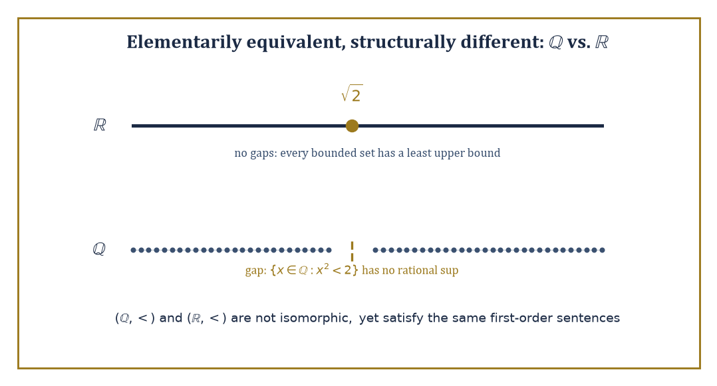
Figure 25.8 — ℝ has no gaps and ℚ has a gap right at √2 — yet no first-order sentence about < alone can tell the two orders apart.
It is, by some distance, the most self-referential chapter in the series so far: a subject that spent much of its energy examining its own foundations, and came away with results about itself rather than merely about numbers or shapes. We began the chapter with nothing but ∅; we end it with an entire strictly-increasing universe of infinities, a hierarchy of formal systems none of which can fully certify itself, and a toolkit sturdy enough to build every remaining chapter of this series upon.
These tools underwrite the rest of mathematics, but they also open directly onto further foundational subjects, each of which could easily have been its own chapter. Model theory studies the relationship between formal languages and the structures that interpret them — asking, for instance, which properties a structure can and cannot ‘see’ using only first-order sentences.
Proof theory analyses the internal structure of formal proofs themselves, as combinatorial objects worth studying independently of what they prove. Category theory offers an entirely different foundation for mathematics, organized around morphisms (structure-preserving maps) rather than membership — a perspective some mathematicians find more natural than sets, and which reappears throughout the later chapters of this series. Set-theoretic topology and the study of large cardinal axioms push further still into the higher reaches of the set-theoretic universe, well past anything this chapter has had room to touch.
Abstract example — A glimpse of model theory: two orders that agree on everything sayable. The rational numbers (ℚ, <) and the real numbers (ℝ, <) are not isomorphic as orders — ℝ has no ‘gaps’ (it is complete: every bounded set has a least upper bound) while ℚ is riddled with them:
{x∈ℚ : x²<2} has no rational least upper bound, since √2 is irrational
Yet remarkably, (ℚ,<) and (ℝ,<) satisfy the same first-order sentences in the language of order — they are what model theorists call elementarily equivalent. No first-order sentence about < alone can tell them apart, because ‘completeness’ (every bounded set has a least upper bound) is a statement about arbitrary subsets, and first-order logic, as Propositional and Predicate Logic showed, cannot quantify over subsets at all — only over individual elements.
It takes second-order logic, quantifying over sets of elements, to state completeness and finally distinguish the two orders. This single example is model theory’s entire opening question in miniature: just what can, and cannot, a formal language see?
Try it now — What do (ℚ, <) and (ℝ, <) have in common that first-order logic cannot tell apart? Answer →
Abstract example — Measuring a proof’s strength in ordinals. Proof theory does not just check whether a proof exists; it measures how much proof-theoretic strength a formal system has — often, remarkably, in ordinals. Peano Arithmetic’s proof-theoretic strength is calibrated by the ordinal ε₀, the very same ordinal that appeared in Section 25.8’s Goodstein sequences as the transfinite induction PA cannot perform.
Stronger theories are calibrated by larger ordinals still, each one a further stop along Section 25.5’s tower of ω, ω², ω^{ω}, and beyond; each step up that ordinal hierarchy corresponds to a step up in what a formal theory can prove.
Proof theory, in other words, takes Section 25.5’s abstract tower of ordinals and Section 25.8’s abstract account of unprovability and turns them into a genuine measuring instrument — a single ordinal that tells you how strong a formal system is, and hence how far its arithmetic can reach before it, too, meets a Gödel sentence of its own.
Abstract example — A group with no elements: category theory’s alternative. Category theory’s alternative to sets-and-membership is arrows-and-composition: a category consists of objects and morphisms between them, composable and associative, with an identity morphism at each object — nothing here mentions what the objects ‘contain’.
Remarkably, an entire familiar structure can be recovered from arrows alone: take a category with exactly one object •, and suppose every morphism •→• is invertible (has a two-sided inverse under composition).
The collection of morphisms, with composition as the operation, is then a group — composition serves as the group operation, the identity morphism serves as the identity element, and invertibility supplies inverses; the group axioms (associativity, identity, inverses) are the category axioms, read off directly.
A group, ordinarily defined as a set with a binary operation satisfying certain equations, has just been redefined with no reference to a ‘set’ or an ‘element’ in sight — purely as a pattern of arrows. This is category theory’s founding move, generalized across the whole of mathematics: describe a structure by how it relates to everything around it, rather than by what, internally, it is made of.
The deeper lesson of this chapter is that mathematics can turn around and examine its own foundations — and that the examination produces both reassuring theorems (first-order logic is complete; syntax and semantics agree) and sobering ones (arithmetic is incomplete; some truths will always sit just out of formal reach).
Set theory and logic are the reflective core of mathematics — the chapter where the series pauses for a moment and inspects its own foundations, chapter by chapter, with a torch and a slightly worried expression. We have learned to reason about the infinite (there is always a bigger infinity; there is no view from the top) and about reasoning itself (there is always a true sentence just out of reach; there is no system that proves everything about itself). Both facts are, on reflection, oddly comforting: an infinite hierarchy of infinities means the mathematician’s job security is, at minimum, transfinite; and a theory that cannot prove its own consistency is, when you think about it, in exactly the same position as everyone applying for tenure.
The series continues, and rather more concretely from here. Chapter 26 (Volume 3) returns to quantities that change: ordinary differential equations, then equations whose present value remembers their past. It stands on the real line as the completed continuum this chapter has only gestured at, and it uses tools already built — the Laplace transform of Chapter 18, and the eigenvalues of Chapters 20 and 21. What it does not inherit is a finished account of when a solution exists, and when there is only one. The first section of that chapter builds the account, and finds that continuity of the right-hand side is enough for a solution to exist, but not enough to keep a second solution from leaving the same starting point.
We came up from the empty set. We leave with a universe of infinities, stacked one atop the next, forever, and the sober knowledge that no chain of reasoning — not even this one, not even at chapter fifty — could ever prove everything true about it. Onward, undaunted, to equations that move.
Keep only this · Section 25.9: Where This Goes Next (Optional): From Foundations to Category Theory, Model Theory, and Beyond
The idea. Model theory, proof theory and category theory each take one part of the foundations further.
Core.
model theory: structures and the sentences they satisfy
proof theory: strength measured by ordinals (PA: ε₀)
category theory: objects and arrows
Typical mistake. Thinking category theory replaces sets everywhere; it changes the questions asked, not the need for foundations.
Minimal example. (ℚ, <) and (ℝ, <) satisfy the same first-order sentences.
Practice. Easy to challenge; full worked answers, with the usual mistake, are in Answers to the Practice Sets at the back.
Easy — Which ordinal measures the strength of Peano arithmetic? Answer →
Medium — In category theory, what replaces the elements of a group? Answer →
Challenge — Why can no first-order sentence say “the domain is finite”? Answer →

Check Your Understanding — Chapter 25
Answers are in the Answer Key at the back of the book — have a go before you look.
1. [Explain] Why does the assumption ‘any property you can state defines a set’ collapse into contradiction, and how does ZFC repair it?
See the answer →
2. [Explain] The rational numbers are dense — between any two there’s always another — so why are they still countable?
See the answer →
3. [Explain] In Russell’s shoes-and-socks illustration, why does picking one shoe from each pair need no axiom, while picking one sock does — and what does that illustrate about the axiom of choice?
See the answer →
4. [Explain] Why does the fact that Goodstein’s theorem is unprovable in Peano Arithmetic matter, rather than being just a logician’s curiosity like Gödel’s self-referential sentence G?
See the answer →

Fluency Drill — Chapter 25
Five minutes, no notes, before the harder problems. These are the moves the Problems assume are automatic; if one takes you more than a minute, reread the section it names. Worked answers, each with the usual slip, are in Answers to the Practice Sets.
1. [Concept] Translate “every number has a larger prime” into symbols. Answer →
2. [Concept] Negate ∀x ∃y (x + y = 0). Answer →
3. [Concept] Over ℕ, is ∃x ∀y (x ≤ y) true? Over ℤ? Answer →
4. [Concept] Is ∀x (P(x) ∨ ¬P(x)) a logical truth? Is ∀x P(x) ∨ ∀x ¬P(x)? Answer →
5. [Compute] |P({1, 2, 3, 4})| and the number of subsets of size 2. Answer →
6. [Compute] Is |ℕ × ℕ| = |ℕ|? Give the reason. Answer →
7. [Compute] Compute ω + ω and 2 · ω (ordinal operations). Answer →
8. [Concept] Is “this sentence is false” a statement Gödel uses? Answer →

Problems — Chapter 25
The last chapter of this volume asks what mathematical objects are and what proof can achieve. Its problems are less computational than the rest of the book, but no less exact — and the reader who works them will find the incompleteness theorems considerably less mystical afterwards. Twelve problems follow. Solutions are in the appendix.
Sets and functions
1. [Compute] List all subsets of {a, b, c}, and state |P(S)| for a set S with n elements. Solution →
2. [Explain] Explain why the empty set is a subset of every set, including itself. Solution →
3. [Prove] Show that A ∩ (B ∪ C) = (A ∩ B) ∪ (A ∩ C). Solution →
Cardinality
4. [Compute] Show that the integers are countable by exhibiting an explicit bijection with the natural numbers. Solution →
5. [Explain] Show that the rationals are countable, and explain why the obvious “order them by size” approach fails. Solution →
6. [Prove] Show by Cantor’s diagonal argument that the set of infinite binary sequences is uncountable. Solution →
7. [Explain] State Cantor’s theorem and explain why it implies there is no largest cardinal. Solution →
Choice, ordinals, and induction
8. [Concept] State the axiom of choice and give two statements equivalent to it. Solution →
9. [Compute] Show that ordinal addition is not commutative by computing 1 + ω and ω + 1. Solution →
Logic and its limits
10. [Compute] Show that ¬(p ∧ q) is equivalent to ¬p ∨ ¬q using a truth table, and name the law. Solution →
11. [Explain] Distinguish the completeness theorem for first-order logic from the incompleteness theorems for arithmetic. Why is there no contradiction? Solution →
12. [Challenge] Gödel’s second incompleteness theorem says a sufficiently strong consistent theory cannot prove its own consistency. Does this mean we have no reason to believe arithmetic is consistent? Answer carefully. Solution →

Epilogue — Between Volumes
This is a pause, not the end. The book continues in Volume 3.
You have now read twenty-five chapters. Calculus has been taken into many dimensions, linear algebra has turned systems of equations into geometry, complex analysis has shown how much a single derivative can know, and the last chapter dug down to the logic underneath all of it. That is the toolkit almost every later chapter will reach for.
Before going on, consider rereading the chapter that resisted you. Linear algebra in particular repays a second pass more generously than almost anything else in mathematics.
When you are ready, Volume 3, From Differential Equations to Abstract Algebra, opens with differential equations — calculus put to work on change itself — and moves through optimization, geometry, analysis, and measure theory to abstract algebra.

Answer Key
Answers to every “Check Your Understanding” question, grouped by chapter and in the same order they were asked.
Chapter 13: Multi-Variable Functions
1. No. Checking straight lines y = mx only rules out straight-line approaches; it can never rule out a curved path. Along the parabola x = y², f(y², y) = y⁴/(2y⁴) = 1/2 for every y ≠ 0, a different value from the straight-line result of 0. Since two paths give different values, the limit does not exist at all.
Usual mistake. testing every straight line, getting 0 each time, and concluding the limit is 0.
← Back to question
2. f_{x} = 2xy³, so f_{xy} = ∂/∂y(2xy³) = 6xy². f_{y} = 3x²y², so f_{yx} = ∂/∂x(3x²y²) = 6xy². Both mixed partials equal 6xy² (and both equal 12 at the point (2,1)), confirming that for this smooth polynomial the order of differentiation doesn’t matter.
Usual mistake. mixing up the order: f_{xy} means differentiate in x first, then in y.
← Back to question
3. Set F(x,y) = x² + y² − 25 = 0. Then F_{x} = 2x = 6 and F_{y} = 2y = 8, so dy/dx = −F_{x}/F_{y} = −6/8 = −3/4. This only required two partial derivatives and a division, rather than solving explicitly for y = √(25 − x²) and differentiating that — a shortcut that matters far more once F is messier than a circle.
Usual mistake. solving for y = √(25 − x²) and losing the sign information on the lower half of the circle.
← Back to question
4. The only critical point is (0,0). The second partials are g_{xx} = 2, g_{yy} = −2, g_{xy} = 0, giving Hessian determinant D = (2)(−2) − 0² = −4, which is negative. A negative Hessian determinant means the point is a saddle — matching the level-curve picture, where the level set at c = 0 degenerates into two crossing lines (y = x and y = −x) rather than a closed loop.
Usual mistake. calling −4 the “Hessian”: it is the Hessian determinant D, and its negative sign means saddle.
← Back to question
Chapter 14: Multi-Variable Calculus
1. The limits of integration are meant to describe the actual shape of D, so they can only be trusted once you can see the boundary curves, where they intersect, and which curve bounds the region from above versus below for the chosen order. In the area-between-curves example, sketching showed the line y = x sits above the parabola y = x² on [0,1], which is what justified integrating y from x² to x; getting this backwards computes the wrong region entirely, however correct the arithmetic afterward.
Usual mistake. copying limits from a similar-looking problem; the limits belong to this region’s boundary curves.
← Back to question
2. By linearity, M = ∭x² dV + ∭y² dV + ∭z² dV, and by the symmetry of the cube all three integrals are equal, so only one needs computing: ∭x² dV = (∫₀¹x²dx)(∫₀¹dy)(∫₀¹dz) = 1/3. Summing three copies gives M = 1/3 + 1/3 + 1/3 = 1 gram, saving two-thirds of the direct work.
Usual mistake. computing three separate integrals instead of using symmetry, then adding wrongly.
← Back to question
3. Apply the curl test: compute ∂P/∂y = 2x and ∂Q/∂x = 2x; since they are equal, F is conservative. Integrating P with respect to x and matching the y-derivative against Q gives the potential f(x,y) = x²y + 3x − 2y² (up to an arbitrary constant).
Usual mistake. forgetting the −2y² term when matching the y-derivative of the potential to Q.
← Back to question
4. Green’s theorem says ∮[C] P dx + Q dy = ∬[D] (∂Q/∂x − ∂P/∂y) dA for a positively oriented boundary C of region D. A conservative field satisfies ∂P/∂y = ∂Q/∂x everywhere, so the integrand ∂Q/∂x − ∂P/∂y is identically zero, making the double integral zero for any region D whatsoever — and hence the closed-loop line integral around its boundary is forced to be zero too, for every possible closed curve, not just the ones you happen to check.
Usual mistake. saying Green’s theorem needs only continuity of P and Q; it needs continuous first partials on the whole region.
← Back to question
Chapter 15: Vector Calculus
1. Divergence measures local expansion, and a spinning disk of fluid neither inflates nor deflates as it spins, so div F = 0. Curl measures local spin, and this field rotates about the z-axis at 1 radian per second, so curl F = ⟨0,0,2⟩ (magnitude twice the angular speed), pointing along the axis of rotation by the right-hand rule.
Usual mistake. thinking a rotating fluid must be compressing somewhere; rotation and expansion are independent.
← Back to question
2. F is conservative with potential φ(x,y) = x²y + y³ (found by integrating ∂φ/∂x = 2xy and matching ∂φ/∂y against x² + 3y²). Since the field is conservative, the integral equals φ(1,1) − φ(0,0) = (1 + 1) − 0 = 2, regardless of the path taken.
Usual mistake. integrating along a specific path when the potential makes the path irrelevant.
← Back to question
3. Stokes’ theorem states that the circulation ∮[C] F · dr around a closed curve C equals the flux of curl F through any oriented surface S bounded by C. For F = ⟨−y, x, 0⟩ with S the unit disk and C its boundary circle, the flux of curl F = ⟨0,0,2⟩ through the disk is 2π, and the circulation computed directly around the circle is also 2π, so both sides match exactly.
Usual mistake. forgetting that the surface can be any surface bounded by the loop, not just the flat disk.
← Back to question
4. The field’s magnitude falls off as 1/R² while the sphere’s surface area grows as R², so the two effects cancel in the flux integral. For q = 2 this gives a flux of 8π through spheres of any radius, matching Gauss’s law’s prediction 4πkq = 8π (with k = 1, as in the section’s example) — the inverse-square law restated as a flux computation.
Usual mistake. expecting a larger sphere to catch more flux.
← Back to question
Chapter 16: Series
1. Compare Σ1/n to ∫[1, ∞] dx/x = [ln x]₁∞, which diverges to infinity because ln x has no ceiling. Since the integral diverges, so does the series — the terms shrink, but not fast enough for the running total to settle down.
Usual mistake. arguing from the terms shrinking instead of comparing the partial sums with the integral.
← Back to question
2. No. At x = 1/3 the terms become 1/n, the divergent harmonic series. At x = −1/3 the terms become (−1)ⁿ/n, which converges conditionally by Leibniz’s test. So the interval is [−1/3, 1/3): closed on the left, open on the right — the radius formula alone cannot reveal this, the endpoints must be checked by hand.
Usual mistake. assuming both endpoints behave the same way.
← Back to question
3. Every derivative of f at 0 works out to 0, because the exponential decay of exp(−1/x²) crushes any polynomial-in-1/x factor as x → 0. Plugging these all-zero derivatives into the Taylor formula gives the identically zero series, which converges everywhere to the constant 0 — but f(x) is strictly positive for every x ≠ 0. The series exists and converges, just not to the function that produced it, which is precisely why ‘smooth’ and ‘analytic’ are different words.
Usual mistake. concluding the Taylor series diverges; it converges, but to the wrong function.
← Back to question
4. The computation gives bₙ = (2/(nπ))[1 − cos(nπ)]. Since cos(nπ) = (−1)ⁿ, the bracket equals 2 when n is odd and 0 when n is even. So only the odd harmonics (bₙ = 4/(nπ) for odd n) carry any of the square wave — the even ones contribute nothing at all.
Usual mistake. forgetting that cos nπ = (−1)ⁿ.
← Back to question
Chapter 17: Fourier Transforms and FFT
1. Because the complex exponential exp(2πixξ) is an eigenfunction of d/dx with eigenvalue 2πiξ — differentiating it just rescales it without changing its shape. Since any well-behaved signal is built from these exponentials, differentiation acts the same way on every frequency component, which is why constant-coefficient differential equations turn into algebra once transformed.
Usual mistake. forgetting the factor 2π that comes with the ordinary-frequency convention.
← Back to question
2. Using cₖ = Σⱼ aⱼbₖ₋ⱼ gives c₀=1, c₁=1×1+2×1=3, c₂=2×1+3×1=5, c₃=3×1=3, so c = [1, 3, 5, 3]. This is the behavior of a length-2 moving-average (smoothing) filter, each output being the sum of a pair of neighboring input entries.
Usual mistake. multiplying entry by entry instead of sliding and summing.
← Back to question
3. It splits the length-n DFT into two half-length DFTs (over the even- and odd-indexed inputs), each of which is recursively split again, bottoming out after log₂n levels. Combining two half-length results into a full-length one costs only O(n) work (a handful of twiddle-factor multiplications), so the total across all levels is n operations times log₂n levels, i.e. O(n log n).
Usual mistake. saying the FFT is faster because it approximates; it is exact.
← Back to question
4. The Nyquist frequency for a 5 kHz sampling rate is 2.5 kHz, and the true 3 kHz component lies above it, so it cannot be represented faithfully. It reflects around 2.5 kHz to 2×2.5−3 = 2 kHz, so the sampled data shows an indistinguishable 2 kHz tone — a permanent, unrecoverable misidentification called aliasing, which is why anti-aliasing filters are placed before analog-to-digital conversion.
Usual mistake. reflecting about the sampling rate instead of the Nyquist frequency.
← Back to question
Chapter 18: Laplace Transform
1. The Laplace transform only integrates over t ≥ 0 and multiplies f(t) by the decaying weight e⁻ˢᵗ. Choosing s larger than the function’s growth rate makes the exponential decay beat the growth, so the integral converges; this works for any function ‘of exponential order’ (growth bounded by some Meᶜᵗ). Fourier’s kernel has no such freedom and insists on integrability over the whole real line, which eᵗ fails.
Usual mistake. saying the Laplace transform converges for every s; it converges only for s greater than the growth rate.
← Back to question
2. The derivative rule L{f′(t)} = sF(s) − f(0) (and its second-derivative version) folds the initial values into the algebraic equation the instant a derivative is transformed. So by the time you’ve transformed the whole differential equation, the initial conditions are already built into the coefficients of the equation for Y(s) — there is no separate constant-fitting stage as there is in the classical general-solution-then-substitute method.
Usual mistake. substituting the initial conditions a second time at the end.
← Back to question
3. Solving gives Y(s) = e⁻ˢ/(s+1), which inverts via the second shifting theorem to y(t) = u₁(t) e⁻⁽ᵗ⁻¹⁾: the solution is 0 for t < 1, jumps to 1 at t = 1, then decays as e⁻⁽ᵗ⁻¹⁾. The jump size (1) matches the delta function’s unit strength, since a first-order equation forced by an impulse responds with a jump in the solution itself.
Usual mistake. expecting the impulse to produce a spike in y; for a first-order equation it produces a jump.
← Back to question
4. Yes: both poles (s = −1 and s = −2) have negative real part, so the free response is a sum of decaying terms e⁻ᵗ and e⁻²ᵗ that settle to zero. If a pole moved to s = +1, the free response would include a term proportional to eᵗ, which grows without bound as t increases, making the system unstable.
Usual mistake. judging stability from the zeros instead of the poles.
← Back to question
Chapter 19: Integral Geometry
1. A rotation of the plane by 45° sends slope m to (m+1)/(1−m), a map whose derivative is far from 1 almost everywhere, so equal-width slope intervals get stretched or squashed unevenly by rotation — the measure secretly favors near-vertical or near-horizontal lines depending on setup. dp∧dφ, by contrast, has Jacobian determinant exactly 1 under both rotations (p,φ)↦(p,φ+α) and translations, so it is invariant under every rigid motion.
Usual mistake. saying slopes are “not uniform” without naming the transformation that distorts them.
← Back to question
2. For direction φ the segment’s projection onto the line’s normal has length 7|cos φ|, so the inner integral over p equals 7|cos φ|. Integrating over φ gives 7 × 2 = 14, and applying the formula’s constant of ½ gives L = ½ × 14 = 7 — the segment’s own length.
Usual mistake. forgetting the factor 1/2 and reporting 14.
← Back to question
3. An n×n grid has n² unknowns but at most 2n−1 independent constraints from its row and column sums (one equation is always redundant, since both totals equal the grand sum), and n² outstrips 2n−1 for every n ≥ 2, with the gap widening as n grows. Section 19.7’s 3×3 cycle-swap example shows two genuinely different grids sharing identical row and column sums, which is exactly why real scanners gather projections from hundreds of angles rather than settling for a tidy pair of perpendicular ones: more angles aren’t mere refinement, they can be the difference between a unique reconstruction and an ambiguous one.
Usual mistake. counting 2n equations instead of 2n − 1 independent ones.
← Back to question
4. The theoretical probability is p = 2ℓ/(πd) = 2(1)/(π·2) = 1/π ≈ 0.3183. Inverting the formula gives π ≈ 2ℓN/(d × crossings); for N = 1000 drops with 316 observed crossings, π̂ = 2000/632 ≈ 3.1646 — a noisy but unbiased estimate, since the experiment is literally the Cauchy–Crofton formula of The Cauchy–Crofton Formula run with real needles instead of a symbolic integral.
Usual mistake. inverting the formula as π = 2ℓC/(dN).
← Back to question
Chapter 20: Matrices
1. Only square matrices are even eligible to have an inverse. A is 2×3 — two rows, three columns — so it is not square, and that fact alone rules out invertibility regardless of what specific numbers fill the grid.
Usual mistake. computing a determinant for a non-square matrix.
← Back to question
2. Matrix multiplication is defined to mirror composition of linear maps — AB means ‘do B, then do A’ — and composing functions in one order need not give the same result as the other order. Concretely, with A = [1 1; 0 1] and B = [1 0; 1 1], AB = [2 1; 1 1] while BA = [1 1; 1 2], which don’t even agree in their top-left entry.
Usual mistake. answering “because the entries are different”; the reason is that composition depends on order.
← Back to question
3. Expanding gives det(M) = 1·(−24) − 2·(−20) + 3·(−5) = −24+40−15 = 1. Since det(M) = 1 is nonzero, M is invertible — known without doing any row reduction.
Usual mistake. forgetting the minus sign on the middle cofactor.
← Back to question
4. For a triangular matrix, A − λI is again triangular, and the determinant of a triangular matrix is the product of its diagonal entries. So det(A − λI) factors immediately as (d₁−λ)(d₂−λ)⋯(dₙ−λ), meaning the roots of the characteristic polynomial — the eigenvalues — are exactly the diagonal entries d₁,...,dₙ themselves.
Usual mistake. claiming only diagonal matrices work; triangular is enough.
← Back to question
Chapter 21: Linear Algebra
1. Because differentiation is a linear operation, any linear combination c₁y₁ + c₂y₂ of two solutions is itself a solution. That closure under addition and scalar multiplication (plus containing the trivial solution y=0) is what a subspace requires, so the solution set is a vector space purely as a consequence of linearity, not by coincidence.
Usual mistake. checking only one solution instead of arbitrary linear combinations.
← Back to question
2. Since row 2 is exactly twice row 1, the image is the one-dimensional line span{(1,2)}, so rank(A) = 1. The null space is spanned by (−2,1,0) and (−3,0,1), so nullity(A) = 2. Then rank + nullity = 1 + 2 = 3 = dim ℝ³, just as the theorem requires.
Usual mistake. counting the nullity as the number of rows minus the rank.
← Back to question
3. Its characteristic polynomial gives eigenvalue 1 with algebraic multiplicity 2, but solving (A−I)v=0 shows the eigenspace is only span{(1,0)}, i.e. geometric multiplicity 1. Diagonalization needs a full basis of eigenvectors, and here there simply is not a second independent eigenvector to complete one, so the algebraic-geometric shortfall blocks diagonalization.
Usual mistake. thinking a repeated eigenvalue alone rules out diagonalization.
← Back to question
4. The SVD never needs eigenvectors of A itself — only of AᵀA, which is always symmetric and positive semi-definite no matter what A looks like, guaranteeing real, non-negative eigenvalues and hence real singular values. That is why SVD applies to every matrix, square or rectangular, diagonalizable or not, even one Jordan form struggles with.
Usual mistake. saying the SVD uses eigenvectors of A.
← Back to question
Chapter 22: Analytic Geometry
1. Yes. The normal vectors are n₁=(1,1,1) and n₂=(1,−2,1); their dot product is 1(1)+1(−2)+1(1)=1−2+1=0. Two planes are perpendicular exactly when their normal vectors have a zero dot product, so no picture is needed — just the arithmetic.
Usual mistake. testing the planes’ equations instead of their normal vectors.
← Back to question
2. The natural angle between a line’s direction and a plane’s normal is measured from the normal, but a line lying entirely in the plane is perpendicular to the normal (angle 90°), not aligned with it (angle 0°). So the angle ‘between the line and the plane itself’ is the complement of the angle to the normal, and subtracting from 90° converts one into the other.
Usual mistake. using the angle to the normal as the angle to the plane.
← Back to question
3. The associated symmetric matrix is A=[5 2; 2 8] (the cross-term 4 splits evenly). Its eigenvalues solve λ²−13λ+36=0, giving λ=9 and λ=4 (check: trace 5+8=13=9+4, det 5·8−2·2=36=9·4). Since both eigenvalues are positive, the conic is an ellipse; in rotated coordinates it becomes 9x′²+4y′²=36, i.e. x′²/4+y′²/9=1, an ellipse with semi-axes 2 and 3.
Usual mistake. using 4 rather than 2 in the off-diagonal entries.
← Back to question
4. Fixing x at a constant value a turns z=xy into z=ay, which traces a straight line as y varies; fixing y=b likewise traces another straight line as x varies. Through every point on the surface pass two such straight lines, one from each family, so despite its curved saddle appearance the whole surface is covered by straight lines — which is why architects can build a curved-looking roof out of nothing but straight steel beams.
Usual mistake. thinking “ruled” means only that the surface has one straight line on it.
← Back to question
Chapter 23: Complex Analysis
1. Writing z̄ = x − iy gives u = x and v = −y, so u_{x} = 1 and v_{y} = −1. The Cauchy–Riemann equation u_{x} = v_{y} demands 1 = −1, which is false everywhere. Smoothness in x and y separately is a much weaker condition than complex-differentiability, which requires the difference-quotient limit to agree from every direction of approach at once.
Usual mistake. saying z̄ is holomorphic because u and v are smooth.
← Back to question
2. Parametrizing z = eⁱᶿ for θ from 0 to 2π gives ∮ᵧ (1/z) dz = ∫[0, 2π] i dθ = 2πi. Cauchy’s theorem doesn’t apply here because its hypothesis fails: 1/z is not holomorphic throughout the region enclosed by γ, since it blows up at z = 0, which lies inside the contour.
Usual mistake. concluding 0 from Cauchy’s theorem, whose hypothesis fails at z = 0.
← Back to question
3. Close the contour with a large semicircular arc in the upper half-plane; only the pole at z = i lies inside (z = −i is in the lower half-plane). Its residue is 1/(2i), so the closed contour integral is 2πi · 1/(2i) = π. Since the arc’s contribution vanishes as R → ∞, the real integral equals π, matching the ordinary arctan calculation.
Usual mistake. including the pole at −i, which lies in the lower half-plane.
← Back to question
4. The center value is u(0,0) = 0. On the circle, u = r²cos(2θ), and its average over θ from 0 to 2π is (1/2π)∫[0, 2π] r²cos(2θ) dθ = 0, matching the center value for every r. The property holds in general because u is the real part of the holomorphic function z², and the Cauchy integral formula applied to that function forces its value at the center to equal the average of its values on any surrounding circle.
Usual mistake. expecting the average to be the value on the circle rather than at its center.
← Back to question
Chapter 24: Counting Carefully
1. Let A be multiples of 3 (|A|=33) and B be multiples of 5 (|B|=20); their overlap A∩B is multiples of 15 (|A∩B|=6). By inclusion–exclusion, |A∪B| = 33 + 20 − 6 = 47. Adding 33+20 would have double-counted the 6 multiples of 15.
Usual mistake. adding 33 and 20 without subtracting the 6 multiples of 15.
← Back to question
2. Modeling the four land masses as vertices gives degrees 5, 3, 3, 3 — all four vertices have odd degree. Euler’s theorem requires zero odd-degree vertices for a circuit and exactly two for a path; with four odd-degree vertices, neither condition is met, so no route can cross every bridge exactly once.
Usual mistake. counting bridges rather than the degrees at each land mass.
← Back to question
3. The implication p→q is false only in the single case where p is true and q is false; whenever p itself is false, p→q is automatically true, a fact called vacuous truth. Since ‘pigs fly’ is false, the implication holds regardless of what q says — a promise about a hypothetical that never arises is never broken.
Usual mistake. thinking a false hypothesis makes an implication false.
← Back to question
4. There are 5! = 120 possible orderings of 5 elements, and modeling every comparison sequence as a binary decision tree means the tree needs at least 120 leaves (one per possible output). A binary tree with 120 leaves must have depth at least ⌈log₂(120)⌉ = 7, so any correct comparison sort needs at least 7 comparisons in the worst case — and this bound is in fact tight.
Usual mistake. computing log₂ 120 and rounding down instead of up.
← Back to question
Chapter 25: Set Theory & Logic
1. Let R = {x : x∉x}. Asking whether R∈R leads to a contradiction either way: R∈R forces R∉R by R’s own defining property, and R∉R forces R∈R the same way. ZFC blocks this by dropping unrestricted comprehension in favor of a short list of named axioms (Pairing, Union, Separation, Replacement, and friends) that only ever build new sets out of sets already known to exist.
Usual mistake. stopping after one direction of the contradiction.
← Back to question
2. Cantor arranges the positive rationals p/q in a grid (rows by numerator, columns by denominator) and reads them off diagonal by diagonal (constant p+q), skipping any fraction not already in lowest terms. This produces an explicit list, 1/1, 1/2, 2/1, 1/3, 3/1, ..., in which every rational eventually appears at some finite position — density doesn’t prevent a complete enumeration against ℕ.
Usual mistake. counting equal fractions such as 1/2 and 2/4 twice.
← Back to question
3. Left and right shoes are distinguishable, so a single explicit rule (‘always take the left one’) selects one from every pair with no special principle required. The two socks in a pair are identical, so no rule can single one out; asserting that a selection nonetheless exists, simultaneously, across infinitely many indistinguishable pairs, is the non-constructive content the axiom of choice adds.
Usual mistake. saying socks need choice because there are infinitely many pairs; the issue is the lack of a rule.
← Back to question
4. Gödel’s first incompleteness theorem says any consistent, sufficiently strong theory of arithmetic has sentences it can neither prove nor disprove. Goodstein’s theorem is an ordinary-looking statement about natural numbers, with no built-in self-reference, that is nonetheless true and yet provably unprovable in PA (Kirby and Paris, 1982) — its proof needs transfinite induction up to the ordinal ε₀, which PA is too weak to formalize. That shows incompleteness has genuine mathematical casualties, not just engineered logical curiosities.
Usual mistake. thinking Goodstein’s theorem is false because the numbers grow enormous at first.
← Back to question

Solutions to the Problems
Worked solutions to the end-of-chapter problem sets. Every result here has been checked by hand; where a check is cheap — an initial value, a substitution back into the original equation — it is shown, because verifying your own answer is a skill worth more than any single problem.

Chapter 13 — Multi-Variable Functions
Problem 1. [Concept] ← Back to problem
The logarithm needs a strictly positive argument, so the domain is the set where 4 − x² − y² > 0, that is x² + y² < 4: the open disk of radius 2, boundary excluded.
The level set f = 0 requires ln(4 − x² − y²) = 0, so 4 − x² − y² = 1, giving x² + y² = 3 — the circle of radius √3, comfortably inside the domain.
Usual mistake. including the boundary circle x² + y² = 4, where the logarithm of 0 is undefined.
Problem 2. [Compute] ← Back to problem
The limit is 0. Switch to polar coordinates: x = r cos θ, y = r sin θ. Then
(x²y)/(x² + y²) = (r²cos²θ · r sin θ)/r² = r cos²θ sin θ
The trigonometric factor is bounded in absolute value by 1, so the whole expression is bounded by r, which goes to 0 as r → 0 regardless of θ.
That bound is what makes this a proof rather than a survey of directions. A uniform bound tending to zero settles existence; checking paths never can.
Usual mistake. checking a few lines, finding 0, and stopping; only the bound by r proves the limit.
Problem 3. [Prove] ← Back to problem
Strategy: to disprove a limit you need two approach routes giving different values. Straight lines through the origin are the cheapest family to try.
The pivot is choosing lines rather than axes. Along the axes this function is identically 0, which is why testing only x = 0 and y = 0 misleads. Substitute y = mx instead and simplify — the x² factors cancel and you are left with an expression in m alone, with no dependence on how close you are to the origin.
Along y = mx with x ≠ 0: xy/(x² + y²) = x·mx/(x² + m²x²) = mx²/(x²(1 + m²)) = m/(1 + m²).
This value depends on m but not on x, so along each line the function is constant: 0 along m = 0 and 1/2 along m = 1.
Two lines, two different values, so no limit exists. Worth noting the contrast with the previous problem: there the polar form retained a factor of r and was squeezed to zero; here it does not, and the angle survives.
Usual mistake. testing only the axes, where the function is identically 0, and concluding the limit is 0.
Problem 4. [Compute] ← Back to problem
Differentiate treating the other variable as constant.
f_{x} = 3x²y − 4y², f_{y} = x³ − 8xy
At (1, 2): f_{x} = 3(1)(2) − 4(4) = 6 − 16 = −10, and f_{y} = 1 − 8(1)(2) = 1 − 16 = −15.
∇f(1, 2) = (−10, −15)
Usual mistake. differentiating the constant 7, or dropping the y² factor when differentiating −4xy² in x.
Problem 5. [Compute] ← Back to problem
First the gradient: f_{x} = 2x + 3y and f_{y} = 3x, so at (2, 1), ∇f = (4 + 3, 6) = (7, 6).
The direction must be a unit vector: |(3, 4)| = 5, so û = (3/5, 4/5).
D_{û} f = ∇f · û = 7(3/5) + 6(4/5) = 21/5 + 24/5 = 45/5 = 9
Forgetting to normalize is the standard error here, and it would have given 45 — five times too large, because the answer would then scale with the arbitrary length of the direction vector.
Usual mistake. using (3, 4) instead of the unit vector (3/5, 4/5), which gives 45 instead of 9.
Problem 6. [Explain] ← Back to problem
The level sets of f = x² + y² are the circles x² + y² = c. The gradient is ∇f = (2x, 2y) = 2(x, y), which points radially outward from the origin.
A circle centered at the origin has tangent direction perpendicular to the radius at every point. Since the gradient is parallel to the radius, it is perpendicular to the tangent — that is, perpendicular to the level curve.
At (3, 4): ∇f = (6, 8). The tangent to the circle x² + y² = 25 there has direction (−4, 3). Their dot product is 6(−4) + 8(3) = −24 + 24 = 0. Perpendicular, as claimed.
This is general, not a feature of circles: moving along a level set does not change f, so the directional derivative along it is zero, and a zero dot product with the gradient is exactly perpendicularity.
Usual mistake. checking perpendicularity against the radius direction instead of the tangent direction.
Problem 7. [Compute] ← Back to problem
Chain rule: dz/dt = (∂z/∂x)(dx/dt) + (∂z/∂y)(dy/dt).
∂z/∂x = 2xy, ∂z/∂y = x², dx/dt = −sin t, dy/dt = cos t.
At t = π/2: x = cos(π/2) = 0 and y = sin(π/2) = 1. So ∂z/∂x = 0, ∂z/∂y = 0, and both terms vanish.
dz/dt = 0 at t = π/2
Sanity check directly: z = cos²t · sin t, which is 0 at t = π/2 and stays small nearby, since cos²t has a double zero there. A stationary point, as the chain rule reported.
Usual mistake. substituting t = π/2 before differentiating x(t) and y(t).
Problem 8. [Compute] ← Back to problem
The gradient gives the plane. f_{x} = 2x and f_{y} = 2y, so at (1, 2) these are 2 and 4.
z = f(1,2) + f_{x}(1,2)(x − 1) + f_{y}(1,2)(y − 2) = 5 + 2(x − 1) + 4(y − 2)
Simplifying: z = 2x + 4y − 5.
Check the point: 2(1) + 4(2) − 5 = 5 ✓.
Usual mistake. writing the plane with partials evaluated at (x, y) instead of at (1, 2).
Problem 9. [Model] ← Back to problem
Let f(x, y) = √(x² + y²), and approximate near (3, 4) where f = 5 exactly.
f_{x} = x/√(x²+y²) = 3/5, and f_{y} = y/√(x²+y²) = 4/5.
With Δx = 0.1 and Δy = −0.1:
f ≈ 5 + (3/5)(0.1) + (4/5)(−0.1) = 5 + 0.06 − 0.08 = 4.98
True value: √(9.61 + 15.21) = √24.82 = 4.98196… The estimate is low by about 0.002, or 0.04% — respectable for a first-order approximation, and the error is second order in the step size, which is why halving the step would quarter it.
Usual mistake. expanding around (3.1, 3.9) instead of the nearby point (3, 4) where everything is exact.
Problem 10. [Compute] ← Back to problem
Set both partials to zero. f_{x} = 2x − 4 = 0 gives x = 2; f_{y} = 2y + 6 = 0 gives y = −3. One critical point, at (2, −3).
Second derivatives: f_{xx} = 2, f_{yy} = 2, f_{xy} = 0. The discriminant is D = f_{xx} f_{yy} − f_{xy}² = 4 > 0, and f_{xx} = 2 > 0.
So (2, −3) is a local minimum. Completing the square confirms it globally: f = (x − 2)² + (y + 3)² − 13, a paraboloid with minimum value −13.
Usual mistake. stopping at the critical point without classifying it.
Problem 11. [Prove] ← Back to problem
Strategy: solve ∇f = 0 for the critical points, then apply the second-derivative test.
The gradient is (2x, −2y), which vanishes only at the origin — so there is exactly one critical point, and that part needs no test.
The pivot is the sign structure of the second derivatives. Compute f_{xx}, f_{yy} and f_{xy} and form D = f_{xx} f_{yy} − f_{xy}². The key observation is that f_{xx} and f_{yy} have opposite signs here, which forces their product negative, and f_{xy} contributes nothing.
f_{xx} = 2, f_{yy} = −2 and f_{xy} = 0, so D = (2)(−2) − 0² = −4 < 0. A negative D is the saddle condition, and (0, 0) is a saddle.
The geometry matches: along the x-axis f = x² curves upward, along the y-axis f = −y² curves downward. The origin is a minimum in one direction and a maximum in another, which is what a saddle is.
Usual mistake. stopping at “f_{xx} > 0” and calling the point a minimum without forming D.
Problem 12. [Challenge] ← Back to problem
The rule that does the work is that D = 0 means the quadratic approximation is degenerate — flat in some direction — so second derivatives simply do not decide the question.
A minimum with D = 0: take f(x, y) = x⁴ + y⁴. All second partials vanish at the origin, so D = 0, yet f > 0 everywhere except at the origin, which is plainly a strict minimum. The curvature is there, it is just fourth order, and a second-order test cannot see it.
A saddle with D = 0: take f(x, y) = x⁴ − y⁴. Again every second partial vanishes and D = 0, but f is positive along the x-axis and negative along the y-axis, so the origin is a saddle.
Where you should land: D = 0 is not a weak verdict, it is no verdict. The test is a statement about the quadratic term, and when that term vanishes the answer lives in higher-order behavior that must be examined directly.
Usual mistake. concluding from D = 0 that the point is a saddle.

Chapter 14 — Multi-Variable Calculus
Problem 1. [Compute] ← Back to problem
Inner integral first, treating x as constant:
∫₀² (x + 2y) dy = [xy + y²]₀² = 2x + 4
Then the outer integral: ∫₀¹ (2x + 4) dx = [x² + 4x]₀¹ = 1 + 4 = 5.
Usual mistake. integrating in x first while the inner differential is dy.
Problem 2. [Concept] ← Back to problem
The curves meet where x² = 2x, so x = 0 and x = 2, giving intersection points (0, 0) and (2, 4). Between them, 2x lies above x².
Order dy dx: x runs 0 to 2, and for each x, y runs from x² up to 2x:
∫₀² ∫[x², 2x] f(x, y) dy dx
Order dx dy: y runs 0 to 4, and for each y, x runs from y/2 across to √y (since y = 2x gives x = y/2, and y = x² gives x = √y, with √y ≥ y/2 on this range):
∫₀⁴ ∫[y/2, √y] f(x, y) dx dy
Area, using the first form with f = 1: ∫₀² (2x − x²) dx = [x² − x³/3]₀² = 4 − 8/3 = 4/3.
Usual mistake. getting the curves the wrong way round: on 0 ≤ x ≤ 2, the line y = 2x lies above the parabola y = x².
Problem 3. [Compute] ← Back to problem
The solid is the tetrahedron with vertices at the origin and the three unit points on the axes. Limits: x from 0 to 1; for each x, y from 0 to 1 − x; for each (x, y), z from 0 to 1 − x − y.
∫₀¹∫₀¹⁻ˣ∫₀¹⁻ˣ⁻ʸ dz dy dx = ∫₀¹∫₀¹⁻ˣ (1 − x − y) dy dx
The inner integral is [(1−x)y − y²/2]₀¹⁻ˣ = (1−x)² − (1−x)²/2 = (1−x)²/2.
Then ∫₀¹ (1−x)²/2 dx = [−(1−x)³/6]₀¹ = 1/6.
This is the familiar volume of a tetrahedron: (1/3)(base area)(height) = (1/3)(1/2)(1).
Usual mistake. using limits 0 to 1 for all three variables, which gives the cube’s volume 1 instead of 1/6.
Problem 4. [Compute] ← Back to problem
In polar coordinates the integrand becomes exp(−r²) and the area element is r dr dθ.
∫[0, 2π]∫₀¹ exp(−r²) r dr dθ
The r from the Jacobian is what makes this elementary: substitute u = r², du = 2r dr, so the inner integral is (1/2)∫₀¹ e⁻ᵘ du = (1/2)(1 − e⁻¹).
Multiplying by the 2π from θ: π(1 − e⁻¹) ≈ 1.986.
Without that r the integral would have no elementary antiderivative at all — the same obstruction that makes the Gaussian integral hard in Cartesian coordinates and easy in polar.
Usual mistake. forgetting the factor r, which leaves ∫exp(−r²) dr with no elementary antiderivative.
Problem 5. [Prove] ← Back to problem
Strategy: the Jacobian is the determinant of the matrix of partial derivatives of (x, y) with respect to (r, θ). Compute the four partials and take the determinant.
The four entries are ∂x/∂r, ∂x/∂θ, ∂y/∂r, ∂y/∂θ. Two of them carry a factor of r and two do not, which is where the answer comes from.
The partials are ∂x/∂r = cos θ, ∂x/∂θ = −r sin θ, ∂y/∂r = sin θ, ∂y/∂θ = r cos θ. So
J = det [cos θ −r sin θ; sin θ r cos θ] = r cos²θ + r sin²θ = r(cos²θ + sin²θ) = r.
Since r ≥ 0, |J| = r, and dA = r dr dθ.
What goes wrong without it: the factor r is the local area magnification. A polar rectangle dr × dθ is not a rectangle of area dr dθ — it is a curved wedge whose width grows with distance from the origin, and its area is r dr dθ. Omit the r and you weight every ring equally regardless of circumference, which undercounts the outer regions badly. In the previous problem it would also have left you with ∫exp(−r²) dr, which has no elementary closed form.
Usual mistake. omitting the absolute value, or expanding the determinant as a sum of products.
Problem 6. [Compute] ← Back to problem
Parametrize the segment: r(t) = (t, 2t) for t from 0 to 1, so dr = (1, 2) dt.
Along the path F = (y, x) = (2t, t), so F · dr = 2t(1) + t(2) = 4t.
∫₀¹ 4t dt = 2
Worth noticing: F = (y, x) is the gradient of xy, so the integral should be xy|_{1,2} − xy|_{0,0} = 2 − 0 = 2. It agrees, and the path never mattered.
Usual mistake. parametrizing with t from 0 to 2, which stretches the path.
Problem 7. [Compute] ← Back to problem
Test for conservativeness: ∂/∂y(2xy) = 2x and ∂/∂x(x²) = 2x. They agree, and the domain is all of ℝ², which is simply connected, so F is conservative.
Find the potential: φ must satisfy φ_{x} = 2xy, so φ = x²y + g(y). Then φ_{y} = x² + g′(y), and this must equal x², forcing g′ = 0. So φ = x²y, up to a constant.
The line integral is then just the change in potential:
∫F · dr = φ(2, 3) − φ(0, 0) = (4)(3) − 0 = 12
Any path gives 12 — which is the entire practical point of finding a potential.
Usual mistake. integrating along a particular path when the potential gives f(2, 3) − f(0, 0) = 12 directly.
Problem 8. [Prove] ← Back to problem
Strategy: two separate computations. First show the curl (in the plane, the scalar ∂Q/∂x − ∂P/∂y) vanishes; then exhibit a closed loop on which the circulation is not zero, which is incompatible with conservativeness.
For the first part, differentiate P = −y/(x²+y²) and Q = x/(x²+y²) using the quotient rule. Both partials come out to the same expression, (y² − x²)/(x² + y²)², so the curl is zero everywhere the field is defined.
On the unit circle take r(t) = (cos t, sin t), 0 ≤ t ≤ 2π. There x² + y² = 1, so F = (−sin t, cos t), and r′(t) = (−sin t, cos t). Then
∮ F · dr = ∫[0, 2π] (sin²t + cos²t) dt = ∫[0, 2π] 1 dt = 2π.
The circulation is 2π, not 0, so F cannot be the gradient of any function on the punctured plane.
So the field has zero curl but non-zero circulation around a loop. The resolution is the domain: the punctured plane is not simply connected, and the unit circle cannot be shrunk to a point without crossing the missing origin. Zero curl implies conservative only on simply connected domains — this field is the standard example proving the hypothesis cannot be dropped.
Usual mistake. concluding “zero curl, so conservative” without checking that the domain is simply connected.
Problem 9. [Compute] ← Back to problem
Green’s theorem converts the circulation into a double integral over the enclosed disk:
∮(P dx + Q dy) = ∬(∂Q/∂x − ∂P/∂y) dA
With P = x²y and Q = xy²: ∂Q/∂x = y² and ∂P/∂y = x², so the integrand is y² − x².
Over a disk centered at the origin, ∬y² dA and ∬x² dA are equal by symmetry, so the difference integrates to 0.
The answer is 0 — obtained without evaluating a single integral, purely from symmetry.
Usual mistake. getting the sign of ∂P/∂y wrong: P = x²y gives ∂P/∂y = x².
Problem 10. [Compute] ← Back to problem
div F = ∂x/∂x + ∂y/∂y + ∂z/∂z = 3.
By the divergence theorem the flux equals the integral of the divergence over the enclosed ball:
Flux = ∭ 3 dV = 3 · (4/3)π(2)³ = 3 · (32π/3) = 32π
The field F = (x, y, z) is the position field, which flows radially outward at unit rate per unit distance, so a constant divergence of 3 is exactly what one dimension per coordinate should give.
Usual mistake. dividing by the surface area or forgetting that div F = 3, not 1.
Problem 11. [Explain] ← Back to problem
div F = 2x + 2y + 2z.
curl F = (∂(z²)/∂y − ∂(y²)/∂z, ∂(x²)/∂z − ∂(z²)/∂x, ∂(y²)/∂x − ∂(x²)/∂y) = (0, 0, 0).
What they say: the curl vanishing everywhere means the field has no local rotational tendency — a small paddle wheel placed anywhere would not spin. The divergence, being non-constant, means the field has sources where 2x + 2y + 2z > 0 and sinks where it is negative, with the plane x + y + z = 0 separating them.
Because the curl vanishes on all of ℝ³, which is simply connected, F is conservative — and indeed F = ∇φ for φ = (x³ + y³ + z³)/3.
Usual mistake. computing the curl of (x², y², z²) as non-zero; each component depends only on its own variable.
Problem 12. [Challenge] ← Back to problem
The rule that does the work is the generalized Stokes theorem: ∫[M] dω = ∫[∂M] ω.
All three are the same statement at different dimensions. Each says that integrating a derivative over a region equals integrating the original object over that region’s boundary — which is the Fundamental Theorem of Calculus, promoted. Green’s theorem is the case of a 2-dimensional region in the plane; Stokes’ is a surface in space; the divergence theorem is a solid region in space. Even the ordinary FTC is the case of an interval, whose boundary is two points, with the “integral” over that boundary being the difference of endpoint values.
What differs between them is only the dimension of M and the degree of the form ω. Gradient, curl and divergence — which look like three unrelated operators — are the exterior derivative d acting on 0-forms, 1-forms and 2-forms respectively. The identities curl(grad f) = 0 and div(curl F) = 0 are both the single fact d² = 0.
Where you should land: you have not learned three theorems in this chapter. You have learned one theorem three times, in the dimensions where it can be written without differential forms. Where This Goes Next: Differential Forms, Manifolds, and Beyond and Chapter 34 (Volume 3) supply the language that says it once.
Usual mistake. treating the theorems as three unrelated formulas to memorize.

Chapter 15 — Vector Calculus
Problem 1. [Compute] ← Back to problem
∇f = (∂f/∂x, ∂f/∂y, ∂f/∂z) = (2xy, x² + z³, 3yz²).
At (1, 2, 1): (2·1·2, 1 + 1, 3·2·1) = (4, 2, 6).
Usual mistake. forgetting the z-derivative of yz³, which is 3yz².
Problem 2. [Compute] ← Back to problem
div F = ∂(xy)/∂x + ∂(yz)/∂y + ∂(zx)/∂z = y + z + x.
curl F = (∂(zx)/∂y − ∂(yz)/∂z, ∂(xy)/∂z − ∂(zx)/∂x, ∂(yz)/∂x − ∂(xy)/∂y)
= (0 − y, 0 − z, 0 − x) = (−y, −z, −x).
Usual mistake. mixing up the order in the curl components and getting the signs of all three wrong.
Problem 3. [Explain] ← Back to problem
For F = (x, 0, 0): div F = 1. For F = (−y, x, 0): div F = 0 + 0 + 0 = 0.
The first field points along x with strength growing in x, so more flows out of any small box on the right face than flows in on the left: material is being created inside. A positive divergence everywhere means every point is a source.
The second field circulates around the z-axis. Whatever flows into a small box on one side flows out the other as the fluid goes round; nothing accumulates and nothing is created. Zero divergence is the statement that the flow is incompressible — it can spin material, but it cannot manufacture it. Its curl, by contrast, is (0, 0, 2), which is where all its interesting behavior lives.
Usual mistake. saying (−y, x, 0) has a source because the arrows get longer away from the axis.
Problem 4. [Prove] ← Back to problem
Strategy: write out one component of curl(∇f) and read what it says.
The x-component of curl(∇f) is ∂(f_{z})/∂y − ∂(f_{y})/∂z, that is f_{zy} − f_{yz}.
The pivot is Clairaut’s theorem: for f twice continuously differentiable, mixed partial derivatives are equal regardless of order, so f_{zy} = f_{yz} and the component vanishes.
Writing ∇f = (f_{x}, f_{y}, f_{z}), the three components of curl ∇f are
(f_{zy} − f_{yz}, f_{xz} − f_{zx}, f_{yx} − f_{xy}).
Each is a difference of the same mixed partial taken in the two orders, and Clairaut’s theorem makes each difference 0 for a twice continuously differentiable f. So curl(∇f) = 0.
Note where the hypothesis bites: without continuity of the second derivatives, mixed partials need not commute, and the identity can fail. The smoothness assumption is not decoration.
Usual mistake. arguing from one example instead of the general components.
Problem 5. [Prove] ← Back to problem
Strategy: expand div(curl F) fully and count terms.
div(curl F) = ∂/∂x(R_{y} − Q_{z}) + ∂/∂y(P_{z} − R_{x}) + ∂/∂z(Q_{x} − P_{y}), writing F = (P,Q,R).
The pivot: expanding gives six second-derivative terms, and they pair off — R_{yx} against R_{xy}, Q_{xz} against Q_{zx}, P_{zy} against P_{yz} — with opposite signs in each pair.
Expanding, div(curl F) = (R_{yx} − Q_{zx}) + (P_{zy} − R_{xy}) + (Q_{xz} − P_{yz}).
The six terms pair off: R_{yx} with −R_{xy}, Q_{xz} with −Q_{zx}, and P_{zy} with −P_{yz}. By Clairaut each pair cancels, so div(curl F) = 0.
Both this and the previous identity are, in the language of Where This Goes Next: Differential Forms, Manifolds, and Beyond, the single statement d² = 0. Two proofs here, one fact underneath.
Usual mistake. forgetting that it is Clairaut that makes the six terms cancel in pairs.
Problem 6. [Compute] ← Back to problem
Left side: fF = x(y, z, x) = (xy, xz, x²), so
div(fF) = ∂(xy)/∂x + ∂(xz)/∂y + ∂(x²)/∂z = y + 0 + 0 = y.
Right side: div F = ∂y/∂x + ∂z/∂y + ∂x/∂z = 0, so f div F = 0. And ∇f = (1, 0, 0), so ∇f · F = 1·y + 0·z + 0·x = y.
Right side total: 0 + y = y. Both sides equal y ✓.
Usual mistake. forgetting the ∇f · F term in the product rule.
Problem 7. [Compute] ← Back to problem
Parametrize: r(t) = (cos t, sin t, 0), so dr = (−sin t, cos t, 0) dt.
On the circle F = (−sin t, cos t, 0), so F · dr = sin²t + cos²t = 1.
∮ F · dr = ∫[0, 2π] 1 dt = 2π
Cross-check with Stokes: curl F = (0, 0, 2), and the flux of that through the unit disk is 2 · π(1)² = 2π. Agreement.
Usual mistake. traversing the circle clockwise and getting −2π.
Problem 8. [Compute] ← Back to problem
div F = ∂(0)/∂x + ∂(0)/∂y + ∂(z)/∂z = 1.
By the divergence theorem the outward flux is the integral of the divergence over the cube: ∭ 1 dV = 1.
Directly, as a check: the field is vertical, so only the top and bottom faces contribute. On the top, z = 1 and the outward normal is +ẑ, giving flux 1 × area = 1. On the bottom, z = 0 so the field is zero there. Total 1 ✓.
Usual mistake. forgetting the bottom face, where z = 0 and the flux is 0, or the sign of the normal there.
Problem 9. [Explain] ← Back to problem
Any closed surface S bounds a solid region V. By the divergence theorem the flux of a field through S equals the integral of its divergence over V. For a curl field, div(curl G) = 0 identically — the identity proved two problems ago — so the integral is zero and hence the flux is zero. This holds for every closed surface and every field G.
Verification: G = (0, 0, xy) gives curl G = (∂(xy)/∂y − 0, 0 − ∂(xy)/∂x, 0) = (x, −y, 0).
Its divergence is ∂x/∂x + ∂(−y)/∂y = 1 − 1 = 0, so the flux through the unit sphere is ∭ 0 dV = 0, as predicted.
The geometric reading: a closed surface has no boundary curve, so by Stokes there is no circulation for the flux to equal. A field that is entirely circulation has nothing to push through a sealed container.
Usual mistake. computing the surface integral directly when div curl = 0 gives 0 at once.
Problem 10. [Model] ← Back to problem
curl v = (∂(0)/∂y − ∂(ωx)/∂z, ∂(−ωy)/∂z − ∂(0)/∂x, ∂(ωx)/∂x − ∂(−ωy)/∂y) = (0, 0, 2ω).
The curl points along the axis of rotation, by the right-hand rule, and its magnitude is 2ω — exactly twice the angular speed.
The factor of two is not an accident of this example: for any rigid rotation, the curl is twice the angular velocity vector. It is why the curl is sometimes called the vorticity, and why half the curl, not the curl itself, is the local angular velocity of a fluid element.
Usual mistake. reporting curl v = (0, 0, ω) instead of (0, 0, 2ω).
Problem 11. [Compute] ← Back to problem
Write r = (x² + y² + z²)^{1/2}, so F = (x, y, z)/r³.
For the x-component: ∂/∂x (x r⁻³) = r⁻³ + x·(−3r⁻⁴)(x/r) = r⁻³ − 3x²r⁻⁵.
The y and z components give the same with y² and z². Summing all three:
div F = 3r⁻³ − 3(x² + y² + z²) r⁻⁵ = 3r⁻³ − 3r² r⁻⁵ = 3r⁻³ − 3r⁻³ = 0
So the inverse-square field is divergence-free everywhere except the origin, where it is undefined.
Usual mistake. differentiating (x² + y² + z²)^{−3/2} without the chain rule factor 2x.
Problem 12. [Challenge] ← Back to problem
The rule that does the work is that the divergence theorem requires the field to be defined and differentiable throughout the enclosed region — and here it is not.
There is no contradiction because the two statements are about different sets. The divergence vanishes on the punctured space, where the field lives. But a sphere centered at the origin encloses the origin, which is exactly the point the field is missing, so the divergence theorem does not apply to that region and cannot force the flux to zero. Compute the flux directly and it is 4π, independent of the radius — the r² growth of surface area cancels the 1/r² decay of the field precisely.
The consistency check that makes this convincing: take any closed surface that does NOT enclose the origin. There the theorem does apply, and the flux is indeed 0.
Where you should land: all the flux originates at the single excluded point. In physics this is Gauss’s law, and the resolution is to say the divergence is not really zero but a delta function at the origin, 4πδ³(r) — a point source of exactly the right strength. The mathematical content is the same as the curl-free but non-conservative field of Line Integrals and Conservative Fields: puncture a domain and the global theorems acquire exceptions, which is topology making itself felt in analysis.
Usual mistake. concluding that the divergence theorem fails; it needs the field defined throughout the solid.

Chapter 16 — Series
Problem 1. [Compute] ← Back to problem
Σ 1/n² converges; Σ 1/n diverges. Both are settled by the integral test, and both are instances of the p-series rule: Σ 1/nᵖ converges if and only if p > 1.
For p = 2: ∫[1, ∞] dx/x² = [−1/x]₁∞ = 1, finite, so the series converges. (Its value is π²/6, which Problem 10 derives by a quite different route.)
For p = 1: ∫[1, ∞] dx/x = [ln x]₁∞ diverges, so the harmonic series diverges — famously slowly, but it does.
Usual mistake. using the ratio test, whose limit is 1 for both series and so decides nothing.
Problem 2. [Compute] ← Back to problem
Ratio test: with aₙ = n!/nⁿ,
aₙ₊₁/aₙ = [(n+1)!/(n+1)ⁿ⁺¹] · [nⁿ/n!] = (n+1)·nⁿ/(n+1)ⁿ⁺¹ = nⁿ/(n+1)ⁿ = 1/(1 + 1/n)ⁿ
As n → ∞ the denominator tends to e, so the ratio tends to 1/e ≈ 0.368.
Since 1/e < 1, the series converges absolutely.
Usual mistake. simplifying (n + 1)!/n! wrongly; it is n + 1, and the ratio tends to 1/e.
Problem 3. [Explain] ← Back to problem
The phenomenon is conditional convergence: the series converges, but the series of absolute values does not.
What it costs you is unconditional arithmetic. In an absolutely convergent series you may reorder the terms freely and the sum is unchanged. In a conditionally convergent one you may not — the Riemann rearrangement theorem says the terms can be reordered to converge to any real number you like, or to diverge.
So Σ (−1)ⁿ⁺¹/n = ln 2, but only in the order written. Rearranged, the same terms can be made to sum to 5, or to −17, or to nothing at all. Convergence here is a property of the sequence of partial sums, not of the collection of terms.
Usual mistake. thinking conditional convergence is a weaker kind of convergence with no consequences; rearrangements can change the sum.
Problem 4. [Compute] ← Back to problem
Ratio test on |xⁿ/n|: the ratio is |x|·n/(n+1) → |x|. Convergence for |x| < 1, so the radius is R = 1.
At x = 1: Σ 1/n, the harmonic series — diverges.
At x = −1: Σ (−1)ⁿ/n, alternating with terms decreasing to zero — converges by the alternating series test.
Interval of convergence: [−1, 1). The endpoints genuinely differ, which is why they must always be checked separately rather than assumed to match.
Usual mistake. forgetting that x = −1 gives the convergent alternating harmonic series.
Problem 5. [Compute] ← Back to problem
eˣ = 1 + x + x²/2! + x³/3! + x⁴/4! + … = 1 + x + x²/2 + x³/6 + x⁴/24 + …
At x = 0.1, the first four terms give
1 + 0.1 + 0.005 + 0.000166667 = 1.105166667
True value: exp(0.1) = 1.105170918… The error is about 4.2 × 10⁻⁶, which is roughly the size of the first omitted term x⁴/24 = 4.17 × 10⁻⁶ — as it should be for an alternating-free series with rapidly shrinking terms.
Usual mistake. stopping too early or adding the x⁴ term with the wrong factorial.
Problem 6. [Compute] ← Back to problem
The geometric series: 1/(1 − x) = 1 + x + x² + x³ + … , valid for |x| < 1.
For 1/(1 + x²), substitute −x² in place of x:
1/(1 + x²) = 1 − x² + x⁴ − x⁶ + … , valid for |x| < 1.
Worth noticing: the function 1/(1+x²) is perfectly smooth on the whole real line with no visible trouble at x = ±1, yet its series stops converging there. The reason is invisible from the real axis — the singularities sit at x = ±i, at distance 1 from the origin. Chapter 23 is where that becomes obvious rather than mysterious.
Usual mistake. stating the series for all x instead of |x| < 1.
Problem 7. [Prove] ← Back to problem
Strategy: show by induction that every derivative has the form (a rational function of x) × exp(−1/x²) for x ≠ 0, then take the limit at 0.
The pivot is the limit itself, and it is the only real content here: as x → 0, exp(−1/x²) → 0 faster than any rational function of x blows up. Exponential decay beats polynomial growth, so every such product tends to 0. Substituting t = 1/x² turns the question into whether tᵏ e⁻ᵗ → 0 as t → ∞, which it does for every k.
Claim: for x ≠ 0, f⁽ⁿ⁾(x) = pₙ(1/x) exp(−1/x²) with pₙ a polynomial. For n = 0 take p₀ = 1. If it holds for n, differentiating gives f⁽ⁿ⁺¹⁾(x) = [−pₙ′(1/x)/x² + 2pₙ(1/x)/x³] exp(−1/x²), again a polynomial in 1/x times exp(−1/x²).
At the origin use the definition. If f⁽ⁿ⁾(0) = 0, then f⁽ⁿ⁺¹⁾(0) = lim[h → 0] f⁽ⁿ⁾(h)/h = lim (1/h) pₙ(1/h) exp(−1/h²) = 0, since a polynomial in 1/h times exp(−1/h²) tends to 0. By induction f⁽ⁿ⁾(0) = 0 for every n.
Consequence to state: the Maclaurin series is therefore 0 + 0x + 0x² + … , the zero series. It converges everywhere, and it converges to the zero function — which agrees with f only at the single point x = 0.
The moral is worth carrying forward: smooth is not analytic. Real functions can have every derivative and still not be recoverable from them. In Chapter 23 you will find that complex differentiability, once, forbids this entirely.
Usual mistake. forgetting to compute f⁽ⁿ⁺¹⁾(0) from the limit definition rather than from the formula for x ≠ 0.
Problem 8. [Compute] ← Back to problem
For an odd extension of period 2π, only sine terms appear, with
bₙ = (2/π) ∫[0, π] x sin(nx) dx
Integrating by parts with u = x, dv = sin(nx) dx gives
∫[0, π] x sin(nx) dx = [−x cos(nx)/n]₀^{π} + (1/n)∫[0, π] cos(nx) dx = −π cos(nπ)/n + 0
Since cos(nπ) = (−1)ⁿ, this is −π(−1)ⁿ/n = π(−1)ⁿ⁺¹/n.
So bₙ = (2/π)·π(−1)ⁿ⁺¹/n = 2(−1)ⁿ⁺¹/n, and
x = 2 Σ[n≥1] (−1)ⁿ⁺¹ sin(nx)/n on (0, π)
Check at x = π/2: the right side is 2(1 − 1/3 + 1/5 − …) = 2(π/4) = π/2 ✓ — and the Leibniz series drops out as a bonus.
Usual mistake. forgetting the alternating sign (−1)ⁿ⁺¹ in bₙ = 2(−1)ⁿ⁺¹/n.
Problem 9. [Explain] ← Back to problem
The effect is the Gibbs phenomenon.
Near a jump discontinuity the partial sums overshoot the true value by roughly 9% of the jump height, and adding terms does not reduce the overshoot — it only narrows the region in which it occurs, sliding the spike closer to the discontinuity.
The reason is that Fourier partial sums converge to the function pointwise away from the jump, and in the mean-square sense overall, but not uniformly across the jump. Uniform convergence would forbid a persistent overshoot; mean-square convergence does not, because the overshoot occupies an ever-shrinking interval and so contributes ever less energy.
Practically it matters: any attempt to reconstruct a square edge from finitely many harmonics — in audio, in image compression, in signal filtering — will ring. The ringing is not a bug in the algorithm but a property of the expansion.
Usual mistake. saying the overshoot disappears in the limit; it moves closer to the jump but keeps its height.
Problem 10. [Compute] ← Back to problem
Parseval for a sine series on (0, π) states
(2/π) ∫[0, π] f(x)² dx = Σ bₙ²
Left side with f = x: (2/π)·(π³/3) = 2π²/3.
Right side with bₙ = 2(−1)ⁿ⁺¹/n: Σ 4/n².
Equating: 4 Σ 1/n² = 2π²/3, so
Σ 1/n² = π²/6 ≈ 1.644934
This is the Basel problem, solved here almost as a by-product. Numerically the first 1000 terms give 1.643935 — converging, slowly, toward π²/6 as claimed.
Usual mistake. forgetting the factor 1/π on the left side of Parseval’s identity.
Problem 11. [Compute] ← Back to problem
Expand G(x) = x/(1 − x − x²) as a power series. Write G(x) = Σ aₙxⁿ; then x = G(x)(1 − x − x²), and comparing coefficients gives a₁ = 1 and aₙ = aₙ₋₁ + aₙ₋₂ for n ≥ 2 — the Fibonacci recurrence itself, with a₀ = 0.
Expanding directly: x/(1 − (x + x²)) = x[1 + (x+x²) + (x+x²)² + (x+x²)³ + …]
= x[1 + x + x² + x² + 2x³ + x⁴ + x³ + … ] = x + x² + 2x³ + 3x⁴ + 5x⁵ + …
So the coefficients are 1, 1, 2, 3, 5 — the Fibonacci numbers, as claimed.
This is what a generating function does: it packs an entire integer sequence into one function, and turns a recurrence into an algebraic identity that can be manipulated by ordinary calculus.
Usual mistake. multiplying out to fewer terms than the x⁵ coefficient needs.
Problem 12. [Challenge] ← Back to problem
The rule that does the work is where the coefficients come from: Taylor coefficients are derivatives at a single point; Fourier coefficients are integrals over the whole interval.
The consequence is that a Taylor series knows only what is happening infinitesimally near its center. If the function misbehaves elsewhere — a singularity, a corner, a jump — the series either stops converging there or, worse, converges to something else, as Problem 7 showed. A Fourier series samples the entire interval, so no single point can mislead it, and it tolerates discontinuities happily: it will converge in the mean, and pointwise to the midpoint of a jump.
For a function with a corner, reach for Fourier. A Taylor series centered at the corner does not exist, since the function is not differentiable there, and one centered anywhere else can describe the function at best up to the corner: for |x| centered at 1 the Taylor series is the line x, which converges everywhere and is wrong for every x < 0. Fourier has no such difficulty — it will represent a sawtooth or a square wave without complaint, at the price of the Gibbs ringing of Problem 9.
Where you should land: Taylor is a microscope and Fourier is a survey. Choosing between them is choosing what you are willing to be ignorant of.
Usual mistake. reaching for Taylor at a corner, where there is no derivative to expand.

Chapter 17 — Fourier Transforms and FFT
Problem 1. [Compute] ← Back to problem
F(ω) = ∫₋ₐᵃ exp(−iωt) dt = [exp(−iωt)/(−iω)]₋ₐᵃ
= (exp(−iωa) − exp(iωa))/(−iω) = (exp(iωa) − exp(−iωa))/(iω) = 2 sin(aω)/ω
At ω = 0 the expression is indeterminate but the limit is 2a, which is the area of the pulse — as the transform at zero frequency always is.
This is the sinc function, and it is the single most important transform pair in signal processing: a sharp edge in time produces slowly decaying oscillation in frequency.
Usual mistake. forgetting that the integral runs from −a to a, which gives half the answer.
Problem 2. [Explain] ← Back to problem
As a shrinks, the first zero of 2 sin(aω)/ω, which sits at ω = π/a, moves outward. The central lobe widens and the transform spreads over an ever-larger band of frequencies. In the limit a → 0 with the area held fixed, the pulse becomes a delta function and the transform becomes flat — every frequency present in equal measure.
The principle is the time–frequency uncertainty relation: narrowing a signal in time necessarily broadens it in frequency, and the product of the two spreads is bounded below. You cannot localize sharply in both domains at once, and this is a mathematical fact about the transform, not a limitation of instruments.
Usual mistake. thinking a narrower pulse has a narrower spectrum.
Problem 3. [Compute] ← Back to problem
The shifting property: F{f(t − t₀)}(ω) = exp(−iωt₀) F(ω).
The factor exp(−iωt₀) has modulus 1 for every real ω, so |exp(−iωt₀)F(ω)| = |F(ω)|. The magnitude spectrum is completely unchanged; the entire effect of the delay lives in the phase, which acquires a term linear in ω.
This is why magnitude-only spectral displays cannot tell you when something happened — they discard exactly the information that encodes timing.
Usual mistake. writing exp(+iωt₀) with the wrong sign.
Problem 4. [Prove] ← Back to problem
Strategy: split the transform integral into its cosine and sine parts using exp(−iωt) = cos ωt − i sin ωt, then use the symmetry of f to kill one of them.
The pivot is the parity argument on the second integral. With f real and even, the product f(t) sin(ωt) is even × odd = odd, and the integral of an odd function over a symmetric interval (−∞, ∞) vanishes. That is what removes the imaginary part; nothing else in the argument does any work.
Since f(t) sin(ωt) is odd, its integral vanishes and F(ω) = ∫ f(t) cos(ωt) dt. The integrand is a product of real functions, so F(ω) is real.
Replacing ω by −ω gives ∫ f(t) cos(−ωt) dt = ∫ f(t) cos(ωt) dt = F(ω), because cosine is even. So F is real and even.
Worth noting the companion result, provable the same way: a real odd function transforms to something purely imaginary and odd. Symmetry in one domain is always symmetry in the other.
Usual mistake. forgetting to use that f(t) sin(ωt) is odd, which is what kills the imaginary part.
Problem 5. [Explain] ← Back to problem
The convolution theorem: F{f ∗ g} = F(ω)·G(ω). Convolution in time becomes ordinary pointwise multiplication in frequency.
Why this makes filtering practical: a filter acts by convolving the signal with the filter’s impulse response, and direct convolution of two length-N sequences costs O(N²) operations. Via the theorem you instead transform both (O(N log N) with the FFT), multiply pointwise (O(N)), and transform back (O(N log N)). The total is O(N log N).
For N = 10⁶ that is the difference between about 10¹² operations and about 2 × 10⁷ — the difference between impossible and instant. Essentially all practical digital filtering is done this way.
Usual mistake. stating the theorem without saying why multiplication is cheaper than convolution.
Problem 6. [Compute] ← Back to problem
Plancherel: ∫|f(t)|² dt = (1/2π) ∫|F(ω)|² dω.
Left side: ∫[−∞, ∞] exp(−2a|t|) dt = 2∫[0, ∞] e⁻²ᵃᵗ dt = 2·(1/2a) = 1/a.
Right side: (1/2π) ∫ [2a/(a² + ω²)]² dω = (4a²/2π) ∫ dω/(a² + ω²)².
Equating: 1/a = (2a²/π) ∫ dω/(a² + ω²)², so
∫[−∞, ∞] dω/(a² + ω²)² = π/(2a³)
Sanity check at a = 1: the claim is π/2 ≈ 1.5708. Numerical integration of 1/(1 + ω²)² over the line gives 1.570796 ✓.
Usual mistake. forgetting the factor 1/(2π) of Plancherel in the ω convention.
Problem 7. [Challenge] ← Back to problem
The rule that does the work is that the transform of a Gaussian of width σ is a Gaussian of width 1/σ — the widths are reciprocal, so their product is fixed.
The general principle is the uncertainty principle for the Fourier transform: for any function, the product of its spread in time and its spread in frequency is bounded below by a constant. No signal can be arbitrarily concentrated in both domains, and the Gaussian is the extremal case that achieves the bound with equality — which is why it keeps appearing wherever optimal localization is wanted.
In physics this is the Heisenberg uncertainty principle. That is not an analogy or a coincidence of terminology: position and momentum wavefunctions are Fourier transforms of one another, so Heisenberg’s relation is this mathematical theorem applied to that pair. The physics supplies ħ; the mathematics supplies the inequality.
Where you should land: the uncertainty principle is a statement about waves, not about measurement clumsiness. It would hold in a universe of perfect instruments.
Usual mistake. treating the uncertainty principle as a limit of measurement.
Problem 8. [Compute] ← Back to problem
The 4-point DFT is X[k] = Σₙ₌₀³ x[n] exp(−2πikn/4) = Σ x[n](−i)ᵏⁿ.
With x = (1, 0, −1, 0), only n = 0 and n = 2 contribute:
X[k] = 1 + (−1)·(−i)²ᵏ = 1 − (−1)ᵏ
X[0] = 1 − 1 = 0; X[1] = 1 − (−1) = 2; X[2] = 1 − 1 = 0; X[3] = 1 + 1 = 2.
X = (0, 2, 0, 2). The sequence is cos(πn/2), one full cycle across the four samples, so all its energy sits at k = 1 and its mirror k = 3 (the fastest alternation four samples can carry is (1, −1, 1, −1), at k = 2) — and X[3] = conj(X[1]), as Problem 11 requires for a real input.
Usual mistake. ordering the four-point roots of unity wrongly, which scrambles X₁ and X₃.
Problem 9. [Explain] ← Back to problem
The structural fact is that the DFT of a length-N sequence can be written in terms of two DFTs of length N/2 — one over the even-indexed samples, one over the odd — combined with N multiplications by twiddle factors.
That gives the recurrence T(N) = 2T(N/2) + O(N). Unwinding it, the problem halves log₂N times and each level costs O(N), so the total is O(N log N).
The reason the decomposition works is that the exponentials exp(−2πikn/N) are highly redundant: the same root-of-unity values recur throughout the sum, and the naive O(N²) algorithm recomputes them over and over. The FFT is not a numerical approximation or a different transform — it is the same DFT, with the arithmetic reorganized so that no value is computed twice.
Usual mistake. saying the FFT skips terms; it reuses them.
Problem 10. [Model] ← Back to problem
The Nyquist frequency is half the sampling rate: 500 Hz.
A 700 Hz component is above Nyquist and cannot be represented. It aliases — it is indistinguishable, in the samples, from a lower frequency. The alias appears at |1000 − 700| = 300 Hz.
So the 700 Hz tone shows up in the spectrum as a spurious 300 Hz tone, and no amount of later processing can separate it from a genuine 300 Hz component. The information is destroyed at the moment of sampling, which is why anti-aliasing filters go before the converter and not after it.
Usual mistake. aliasing 700 Hz to 700 − 500 = 200 Hz instead of 1000 − 700 = 300 Hz.
Problem 11. [Prove] ← Back to problem
Strategy: write down X[N − k] from the definition and manipulate the exponent until the expression matches the conjugate of X[k].
X[N − k] = Σ x[n] exp(−2πi(N−k)n/N) = Σ x[n] exp(−2πin) exp(2πikn/N).
The pivot is the factor exp(−2πin): for integer n this is exactly 1, so it disappears entirely. That is the only step that uses N being the transform length, and once it is gone you are left with Σ x[n] exp(+2πikn/N) — the same sum as X[k] but with the sign of the exponent flipped.
X[N − k] = Σ x[n] exp(−2πi(N − k)n/N) = Σ x[n] exp(−2πin) exp(2πikn/N) = Σ x[n] exp(2πikn/N), because exp(−2πin) = 1.
Since each x[n] is real, this is the complex conjugate of Σ x[n] exp(−2πikn/N) = X[k]. So X[N − k] = conj(X[k]). For even N, X[0] and X[N/2] are real and the rest pair off, leaving N/2 + 1 independent values (N real numbers in all, as many as went in).
How many independent values: the second half of the spectrum is determined by the first, so for real input of length N there are about N/2 + 1 independent complex values — specifically N/2 + 1 for even N, counting the purely real X[0] and X[N/2]. Real FFT routines exploit exactly this to halve both the work and the storage.
Usual mistake. conjugating x[n] as well, which is allowed only because x is real.
Problem 12. [Challenge] ← Back to problem
The rule that does the work is that the DFT implicitly assumes the finite record repeats periodically forever.
If the record does not contain a whole number of cycles, the assumed periodic extension has a discontinuity at the seam where the end meets the beginning. That artificial jump is not in the signal, but the transform faithfully reports it — as a broad smear of spurious frequencies. This is spectral leakage, and it can bury a genuine small peak entirely beneath the skirts of a large one.
A window tapers the record smoothly to zero at both ends, so the periodic extension has no seam. The cost is real: tapering discards information near the edges and broadens every genuine peak, so resolution worsens. But the leakage a window removes is an artifact of arbitrary record length, while the broadening it introduces is predictable and quantified for each window shape.
Where you should land: you are trading an unpredictable, signal-dependent error for a known, bounded one. Without a window you do not avoid distortion — you merely fail to control it, and lose the ability to tell which peaks are real.
Usual mistake. thinking no window means no distortion; the rectangular window is still a window.

Chapter 18 — The Laplace Transform
Problem 1. [Compute] ← Back to problem
Linearity over three table entries. L{4} = 4/s. L{e⁵ᵗ} = 1/(s − 5). L{t⁴} = 4!/s⁵ = 24/s⁵. Combining with the coefficients:
F(s) = 4/s − 3/(s − 5) + 48/s⁵
Usual mistake. L{t⁴} = 4/s⁵ instead of 4!/s⁵ = 24/s⁵.
Problem 2. [Compute] ← Back to problem
First shifting. The undamped function sin 5t transforms to 5/(s² + 25). Multiplying by e²ᵗ replaces s by s − 2 throughout:
F(s) = 5 / ((s − 2)² + 25)
Usual mistake. shifting to s + 2 instead of s − 2.
Problem 3. [Compute] ← Back to problem
Either the tⁿeᵃᵗ entry with n = 2, a = −1, or first shifting applied to L{t²} = 2/s³. Both give:
F(s) = 2 / (s + 1)³
Usual mistake. differentiating once instead of twice for t².
Problem 4. [Explain] ← Back to problem
Each step is the t-shift rule applied to f = 1, whose transform is 1/s. So u(t − 1) gives e⁻ˢ/s and u(t − 3) gives e⁻³ˢ/s, and by linearity:
F(s) = (e⁻ˢ − e⁻³ˢ) / s
Why two steps: a single u(t − 1) switches the function on at t = 1 and leaves it on forever. Nothing in it knows about t = 3. The second step is what switches the first back off — subtracting an identical staircase that begins two seconds later. Every finite-duration input enters the s-domain this way, as a difference of steps, and the two exponentials in the answer are the on-switch and the off-switch respectively.
Usual mistake. subtracting the transforms in the wrong order, which gives a negative pulse.
Problem 5. [Prove] ← Back to problem
Strategy: the multiplication-by-t rule says L{t f(t)} = −F′(s). Here f(t) = cos 3t, so F(s) = s/(s² + 9), and the whole problem reduces to differentiating that quotient and negating it.
The pivotal step is recognizing that the rule turns a harder transform into an easier derivative — you are not integrating anything. Apply the quotient rule to s/(s² + 9); the numerator of the derivative is (s² + 9)·1 − s·(2s).
−d/ds [s/(s² + 9)] = −[(s² + 9) − s · 2s]/(s² + 9)² = −(9 − s²)/(s² + 9)² = (s² − 9)/(s² + 9)².
This matches the table entry L{t cos ωt} = (s² − ω²)/(s² + ω²)² with ω = 3.
For the confirmation: the table entry is (s² − ω²)/(s² + ω²)². Substitute ω = 3 and check it matches what you derived. Two independent routes agreeing is how you know neither was a fluke.
Usual mistake. forgetting the minus sign in L{t f(t)} = −F′(s).
Problem 6. [Compute] ← Back to problem
Straight off the eᵃᵗ entry with a = −4, scaled by 7:
f(t) = 7 e⁻⁴ᵗ
Usual mistake. writing 7e^{4t}; the pole is at s = −4.
Problem 7. [Compute] ← Back to problem
Split into the cosine and sine shapes. 3s/(s² + 16) is 3 cos 4t. For the second piece the table wants a numerator of 4, so write −2/(s² + 16) = −(1/2)·4/(s² + 16):
f(t) = 3 cos 4t − (1/2) sin 4t
Usual mistake. inverting −2/(s² + 16) as −2 sin 4t without the factor 1/4.
Problem 8. [Compute] ← Back to problem
Partial fractions with two simple poles: 1/((s + 1)(s + 4)) = A/(s + 1) + B/(s + 4), so 1 = A(s + 4) + B(s + 1). Setting s = −1 gives A = 1/3; setting s = −4 gives B = −1/3.
f(t) = (1/3)(e⁻ᵗ − e⁻⁴ᵗ)
Check at t = 0: (1/3)(1 − 1) = 0, consistent with F(s) decaying like 1/s².
Usual mistake. getting the partial-fraction coefficients the wrong sign; they are 1/3 and −1/3.
Problem 9. [Prove] ← Back to problem
Strategy: an irreducible quadratic in the denominator means a damped oscillation, so the route is complete the square, then force the numerator to speak in the same shifted variable.
The pivot is the second half of that. Completing the square gives s² + 6s + 13 = (s + 3)² + 4, so a = −3 and ω = 2 — but the numerator 2s + 5 is still written in s. Rewrite it in terms of (s + 3). That single rearrangement is what makes both table entries visible; everything after it is bookkeeping.
Write the numerator in terms of s + 3: 2s + 5 = 2(s + 3) − 1. With s² + 6s + 13 = (s + 3)² + 4,
F(s) = 2 · (s + 3)/((s + 3)² + 4) − (1/2) · 2/((s + 3)² + 4).
The first term inverts to 2e^{−3t} cos 2t and the second to (1/2)e^{−3t} sin 2t, so f(t) = 2e^{−3t} cos 2t − (1/2)e^{−3t} sin 2t.
Self-check: at t = 0 your answer must equal 2, and the initial value theorem agrees — s F(s) = (2s² + 5s)/(s² + 6s + 13) → 2 as s → ∞.
Usual mistake. forgetting to rewrite the numerator in terms of s + 3 before reading off the table.
Problem 10. [Compute] ← Back to problem
Transform both sides, using L{y″} = s²Y − s y(0) − y′(0) = s²Y − 2s:
s²Y − 2s + 4Y = 0 ⟹ Y(s² + 4) = 2s ⟹ Y = 2s/(s² + 4)
That is the cosine entry with ω = 2, scaled by 2:
y(t) = 2 cos 2t
The initial conditions were consumed by the transform itself. No general solution was written down and no constants fitted afterwards — which is the whole argument for the method.
Usual mistake. forgetting the −s y(0) term and getting y = 0.
Problem 11. [Model] ← Back to problem
First the time constant: RC = (1000 Ω)(0.001 F) = 1 s. The equation is v′ + v = 5 with v(0) = 0. Transforming, sV − 0 + V = 5/s, so
V(s) = 5 / (s(s + 1))
Partial fractions give 5(1/s − 1/(s + 1)), and inverting termwise:
v(t) = 5(1 − e⁻ᵗ) volts
After one time constant, t = 1 s, this is 5(1 − e⁻¹) = 5(0.632) ≈ 3.16 V — the familiar 63% of the final value. Notice the final value theorem gets the endpoint with no inversion at all: s·V(s) = 5/(s + 1) → 5 as s → 0. The capacitor charges toward the supply and never overshoots it, because there is only one pole and it is real.
Usual mistake. using RC = 1 ms; 1 kΩ × 1 mF = 1 s.
Problem 12. [Model] ← Back to problem
Strategy: transform, solve the resulting algebraic equation for X(s), factor the denominator, and invert term by term.
The pivot is remembering that both initial conditions enter through the derivative rules — L{x″} = s²X − s x(0) − x′(0) = s²X − 2s, and L{x′} = sX − 2. Substituting those and collecting terms gives X(s² + 4s + 3) = 2s + 8. Miss the −2s or the −2 and everything downstream is wrong, which is why this is the step worth slowing down for.
s² + 4s + 3 = (s + 1)(s + 3). Cover-up gives A = (2(−1) + 8)/(−1 + 3) = 3 at s = −1 and B = (2(−3) + 8)/(−3 + 1) = −1 at s = −3, so X(s) = 3/(s + 1) − 1/(s + 3) and x(t) = 3e^{−t} − e^{−3t}.
Check: x(0) = 3 − 1 = 2 and x′(0) = −3 + 3 = 0, as required.
On oscillation: the answer is no, and the reason is visible before you invert anything. The discriminant of s² + 4s + 3 is 16 − 12 = 4 > 0, so the poles are real and negative and the solution is a sum of decaying exponentials — the overdamped case. Oscillation requires a complex-conjugate pair, which requires a negative discriminant. You can answer the qualitative question from the denominator alone.
Usual mistake. calling the motion oscillatory; both poles are real, so it is overdamped.
Problem 13. [Challenge] ← Back to problem
The rule that does the work is integration by parts, and the whole difference lies in where the limits sit.
Both transforms differentiate by parts. What survives is the boundary term. Laplace integrates from 0 to ∞, so the lower boundary lands exactly on t = 0 and leaves −f(0) behind. Fourier integrates over the whole line, where a decaying function contributes nothing at either end, so no boundary term survives at all.
That single asymmetry decides what each transform is for. Laplace absorbs initial conditions automatically, which makes it the natural instrument for initial-value problems: systems that are switched on, struck, or released at a definite moment. Fourier assumes the whole history from −∞ and returns the steady state, which makes it the natural instrument for signals with no beginning — a tone, a spectrum, a filter response.
Where you should land: the −f(0) is not an inconvenience in the Laplace rule, it is the feature. It is the transform charging you for the privilege of starting the clock somewhere.
Usual mistake. saying Fourier has no initial-value term because it is “less accurate”; it integrates over all time, so there is no starting point to report.

Chapter 19 — Integral Geometry
Problem 1. [Explain] ← Back to problem
The measure dp dφ is the unique one (up to a constant multiple) invariant under all rigid motions of the plane — rotations and translations. That invariance is the whole requirement: a measure on lines that is to give geometric answers must not care where you placed your origin or how you oriented your axes.
A measure weighting lines by distance from the origin would fail immediately. It would make the answer depend on the arbitrary choice of origin, so the same curve would be assigned different lengths by two observers who had set up coordinates differently. Every formula in this chapter would become coordinate-dependent and therefore useless.
This invariant measure descends from the Haar measure of the group of rigid motions acting on the space of lines, as Invariant Measures on Spaces of Lines and Planes sets out.
Usual mistake. arguing for dp dφ only by convenience; the point is invariance under rigid motions.
Problem 2. [Compute] ← Back to problem
A line at distance p from the center meets a circle of radius R in two points when p < R, and in none when p > R. So n(p, φ) = 2 on the strip |p| < R, independent of φ.
L = (1/2) ∫[0, π] ∫[−R, R] 2 dp dφ = (1/2) ∫[0, π] 4R dφ = (1/2)(4R)(π) = 2πR
The circumference, as required. Note that the answer emerged from counting intersections alone — no arc length was parametrized and no square root was integrated.
Usual mistake. forgetting that each line meeting the circle crosses it twice.
Problem 3. [Compute] ← Back to problem
For a convex region, almost every line that meets it crosses the boundary exactly twice, so n = 2 on the set of lines meeting the square and 0 elsewhere. The formula therefore reduces to L = (1/2)·2·(measure of lines meeting the square) = the measure of that set.
For a convex set, the measure of lines meeting it equals its perimeter — which is the content of Cauchy’s formula. For the unit square that gives L = 4.
Equivalently, and as a check: the mean width of a convex set integrated over all directions gives the perimeter, and for the unit square the width at angle φ is |cos φ| + |sin φ|. Then ∫[0, π] (|cos φ| + |sin φ|) dφ = 2 + 2 = 4 ✓.
Usual mistake. ignoring the lines through corners, which have measure zero and do not matter.
Problem 4. [Explain] ← Back to problem
Buffon’s needle counts intersections between a fixed family of lines and a randomly placed curve. Cauchy–Crofton counts intersections between a fixed curve and a randomly placed family of lines. By the invariance of the measure it makes no difference which you regard as moving — the two set-ups are the same integral read from opposite sides.
Concretely, the expected number of crossings is proportional to the length of the needle and to nothing else about its shape. That is exactly the Crofton statement: length is recoverable from an intersection count. It is why the needle can be bent into any shape at all and the expected crossing count stays proportional to its length — a variant known as Buffon’s noodle, which is much easier to see from the Crofton side than from the probabilistic one.
Usual mistake. treating the needle as a random line rather than a random segment meeting fixed lines.
Problem 5. [Model] ← Back to problem
P = 2ℓ/(πd) = 2(3)/(π·5) = 6/(5π) ≈ 0.381972
Expected crossings in 1000 drops: 1000 × 0.381972 ≈ 382.
The check that ℓ ≤ d holds here (3 ≤ 5), which matters — for a longer needle the formula changes, because multiple crossings become possible.
Usual mistake. forgetting to multiply the probability by 1000 drops, or using ℓ/d without 2/π.
Problem 6. [Prove] ← Back to problem
Strategy: the probability formula contains π, so solving it for π turns an experiment into an estimator.
Set-up: drop the needle N times and observe C crossings. The empirical frequency C/N estimates the probability P = 2ℓ/(πd).
The pivot is rearranging that relation to isolate π rather than P — the experiment measures a frequency, and π is the only unknown in the expression it estimates. Do the rearrangement and substitute C/N for P.
From C/N ≈ P = 2ℓ/(πd), solve for π: π ≈ 2ℓ/(d · (C/N)), so the estimator is π̂ = 2ℓN/(dC).
By the law of large numbers C/N → P as N → ∞, so π̂ → π: the experiment estimates π consistently.
Worth registering how bad it is in practice. The estimate converges like 1/√N, and with ℓ = 1, d = 2 the standard error of the estimate of π after N drops is about 4.6/√N: about 0.15, or 5%, after 1000 drops, so three correct decimal places (error below 0.0005) need roughly a hundred million drops. Buffon’s needle is a beautiful theorem and a terrible way to compute π — which is a useful lesson about the difference between the two.
Usual mistake. swapping C and N in the estimator.
Problem 7. [Concept] ← Back to problem
The Radon transform of f is the function Rf(p, φ) = ∫[L] f ds, the integral of f along the line L determined by (p, φ). It replaces a function on the plane by the collection of all its line integrals.
In a CT scanner it is the attenuation measurement. An X-ray beam sent along a line arrives weakened by everything it passed through, and the logarithm of the intensity ratio is precisely the integral of the tissue’s attenuation coefficient along that line. The scanner rotates, collecting these integrals for many angles φ and offsets p, and what it records is a sampled Radon transform.
The patient is the function f. The scan is Rf. Reconstruction is inverting R.
Usual mistake. describing Rf as an image rather than as a collection of line integrals.
Problem 8. [Compute] ← Back to problem
A line at perpendicular distance p from the center of the unit disk cuts a chord. Half the chord, the radius and the distance p form a right triangle with hypotenuse 1, so the half-chord is √(1 − p²).
Rf(p, φ) = 2√(1 − p²) for |p| ≤ 1, and 0 for |p| > 1.
It is independent of φ, as it must be for a rotationally symmetric object. The profile is a semi-ellipse: maximum 2 through the center, falling to zero at the edge with infinite slope — the vertical tangent at p = ±1 being the tell-tale of a sharp boundary, and the reason edges are the hardest thing for a reconstruction to get right.
Usual mistake. forgetting the factor 2 in the chord length 2√(1 − p²).
Problem 9. [Explain] ← Back to problem
The Fourier slice theorem says that transforming a single projection Rf(·, φ) in one dimension gives you the values of the 2-D Fourier transform of f along a line through the origin at angle φ.
Why reconstruction follows: collecting projections at every angle fills in the 2-D Fourier transform of f along every line through the origin — that is, the whole plane. Once the full 2-D transform is known, f is recovered by a 2-D inverse transform. So the scan determines the patient uniquely, and does so through operations that are computationally cheap.
The theorem also explains two practical facts. Coverage is polar rather than Cartesian, so samples crowd near the origin and thin out at high frequency — which is why fine detail is the first thing lost. And a missing range of angles leaves a wedge of the Fourier plane unmeasured, producing the characteristic streak artifacts of limited-angle tomography.
Usual mistake. saying the slice theorem gives the image directly; it gives its Fourier transform, slice by slice.
Problem 10. [Model] ← Back to problem
The estimated volume fraction is 0.23.
The principle is the Delesse relation: for a statistically homogeneous, isotropic material, the expected area fraction on a random plane section equals the volume fraction of the phase. Written V_{V} = A_{A}.
It is a genuinely surprising result — a two-dimensional measurement estimating a three-dimensional quantity with no model of the particle shapes at all — and it is the foundation of quantitative microscopy. The catch is in the hypotheses: sections must be random and the material statistically uniform, and a biased sampling plane will give a biased answer no matter how carefully the area is measured.
Usual mistake. quoting 23% as a lower bound rather than an estimate.
Problem 11. [Explain] ← Back to problem
Lay a grid of points over the section and count what fraction fall on the phase of interest. Each point is an independent sample of the section, and the probability that a uniformly placed point lands on the phase is exactly the area fraction. So the observed hit fraction is an unbiased estimator of A_{A}, which by Delesse estimates V_{V}.
It is the cheapest method because counting is all it requires — no tracing of boundaries, no planimetry, no image segmentation. Counting a few hundred points by eye gives a useful estimate in minutes, and the standard error is governed by the number of hits rather than by the complexity of the shapes.
The chain is worth appreciating: counting points estimates area, area estimates volume, and neither step needed to know what the particles look like.
Usual mistake. confusing point counting with line counting.
Problem 12. [Challenge] ← Back to problem
The rule that does the work is invariance: integrating over a space of geometric objects with an invariant measure produces quantities that do not depend on how the object was placed.
What the reversal buys you is access. Ordinary integration requires knowing the integrand throughout the region — you must already have the function to integrate it. Integral geometry requires only aggregate measurements taken along whole lines or planes, and turns a collection of such aggregates into the thing itself. Length from intersection counts, volume fraction from a single slice, an interior from its shadows.
That is exactly the situation in tomography. Nobody can measure the attenuation at a point inside a living patient; opening them up to do so defeats the purpose. But a beam can be sent through, and what arrives is a line integral. Integral geometry says those line integrals, gathered over enough angles, determine the interior uniquely — so the measurement you can take substitutes completely for the one you cannot.
Where you should land: this chapter is not an exotic corner of geometry. It is the mathematics of inferring an inside from an outside, and it earns its place in the series because that problem is everywhere.
Usual mistake. answering only “it averages”; the point is that line data are what can be measured from outside.

Chapter 20 — Matrices
Problem 1. [Compute] ← Back to problem
AB = [1 2; 3 4]·[0 1; 1 0] = [2 1; 4 3].
BA = [0 1; 1 0]·[1 2; 3 4] = [3 4; 1 2].
They differ. Matrix multiplication is not commutative, and this is the cheapest possible demonstration: B here simply swaps columns when applied on the right and swaps rows when applied on the left, which are different operations.
Usual mistake. concluding from one example that AB and BA always differ; for some pairs they agree.
Problem 2. [Compute] ← Back to problem
det A = (4)(6) − (7)(2) = 24 − 14 = 10, which is non-zero, so the inverse exists.
For a 2×2 matrix, A⁻¹ = (1/det)·[d −b; −c a]:
A⁻¹ = (1/10)·[6 −7; −2 4] = [0.6 −0.7; −0.2 0.4]
Verify: [4 7; 2 6]·[0.6 −0.7; −0.2 0.4] = [(2.4−1.4) (−2.8+2.8); (1.2−1.2) (−1.4+2.4)] = [1 0; 0 1] ✓
Usual mistake. forgetting the factor 1/det = 1/10.
Problem 3. [Explain] ← Back to problem
Suppose A had an inverse B, so AB = I. Taking determinants and using the product rule:
det(A)·det(B) = det(I) = 1
If det(A) = 0 the left side is 0 regardless of B, and 0 ≠ 1. So no such B can exist.
The argument is short but complete, and it shows the obstruction is not computational difficulty but arithmetic impossibility. Geometrically, det(A) = 0 means A collapses space onto something lower-dimensional, and no map can un-collapse it — information genuinely destroyed cannot be restored.
Usual mistake. saying det A = 0 means A is the zero matrix.
Problem 4. [Compute] ← Back to problem
Expand along the first row:
det = 2·det [−1 2; 4 0] − 0·det [3 2; 1 0] + 1·det [3 −1; 1 4]
= 2·((−1)(0) − (2)(4)) + 1·((3)(4) − (−1)(1))
= 2·(−8) + 1·(13) = −16 + 13 = −3
Expanding along the first row was the efficient choice because of the zero in the middle entry, which removed one of the three 2×2 determinants entirely.
Usual mistake. expanding along a row with the wrong sign pattern.
Problem 5. [Compute] ← Back to problem
det = 3 × 5 × 4 = 60.
The general rule: the determinant of a triangular matrix — upper or lower — is the product of its diagonal entries. Everything off the diagonal is irrelevant.
This is why row reduction to triangular form is the practical method for larger determinants: reduce first, then multiply the diagonal, tracking sign changes from row swaps and factors pulled out of scaled rows.
Usual mistake. adding the diagonal entries instead of multiplying them.
Problem 6. [Prove] ← Back to problem
Strategy: use the fact that swapping two rows multiplies the determinant by −1.
The pivot is to swap the two identical rows. The matrix is completely unchanged by that swap, since the rows are the same — but the swap rule says its determinant must have changed sign.
Adding det(A) to both sides of det(A) = −det(A) gives 2 det(A) = 0, so det(A) = 0.
One caveat worth registering: the final step divides by 2, which requires that 2 ≠ 0 in the underlying field. Over a field of characteristic 2 this proof fails, and the result has to be established differently — a technicality that never arises over the reals but matters in Chapter 37 (Volume 3).
Usual mistake. claiming det A = −det A implies nothing; it forces 2 det A = 0.
Problem 7. [Compute] ← Back to problem
Augmented matrix: [1 1 1 | 6; 2 −1 1 | 3; 1 2 −1 | 2].
R2 − 2R1 → (0, −3, −1 | −9). R3 − R1 → (0, 1, −2 | −4).
From the second row: −3y − z = −9, so z = 9 − 3y. Substituting into the third: y − 2(9 − 3y) = −4, giving 7y = 14, so y = 2.
Then z = 9 − 6 = 3, and from the first row x = 6 − y − z = 6 − 2 − 3 = 1.
Solution: (x, y, z) = (1, 2, 3). Check in the second equation: 2 − 2 + 3 = 3 ✓.
Usual mistake. an arithmetic slip during elimination; always check the answer (1, 2, 3) in all three equations.
Problem 8. [Compute] ← Back to problem
Row-reduce: R2 − 4R1 → (0, −3, −6); R3 − 7R1 → (0, −6, −12). The third row is exactly twice the second, so it reduces to zero.
Two non-zero rows remain, so the rank is 2.
For the homogeneous system Ax = 0: the nullity is 3 − 2 = 1, so the solution set is a one-dimensional line through the origin — infinitely many solutions, all multiples of a single vector, here (1, −2, 1).
Usual mistake. reading rank 3 from three non-zero rows of the unreduced matrix.
Problem 9. [Explain] ← Back to problem
A zero determinant means the coefficient matrix is singular, so the system does not have a unique solution. The two possibilities are: no solution at all (inconsistent), or infinitely many (a line or plane of solutions).
To tell them apart, row-reduce the augmented matrix and compare ranks. If rank(A) = rank(A|b), the system is consistent and has infinitely many solutions, with n − rank(A) free parameters. If rank(A|b) > rank(A) — that is, reduction produces a row reading 0 = non-zero — the system is inconsistent and has none.
Geometrically: three planes that share a common line, versus three planes arranged so that no point lies on all of them.
Usual mistake. forgetting the “no solution” case.
Problem 10. [Compute] ← Back to problem
R is rotation by 90° counterclockwise: it sends (1,0) to (0,1) and (0,1) to (−1,0).
Four such rotations make a full turn, so R⁴ should be the identity. Confirming: R² = [−1 0; 0 −1] = −I, and R⁴ = (R²)² = (−I)² = I.
R⁴ = [1 0; 0 1]
Note also det R = 1 and RᵀR = I, so R is orthogonal with unit determinant — exactly the algebraic signature of a rotation.
Usual mistake. computing R⁴ by multiplying four times and making a sign error, instead of noting four quarter-turns make a full turn.
Problem 11. [Compute] ← Back to problem
Characteristic polynomial: det(A − λI) = (4 − λ)(3 − λ) − (1)(2)
= 12 − 7λ + λ² − 2 = λ² − 7λ + 10 = (λ − 2)(λ − 5)
Eigenvalues: λ = 2 and λ = 5.
Quick check: the trace 4 + 3 = 7 should equal the sum of eigenvalues, 2 + 5 = 7 ✓; and det A = 12 − 2 = 10 should equal their product, 2 × 5 = 10 ✓. Both checks cost seconds and catch most arithmetic slips.
Usual mistake. writing the characteristic polynomial as λ² − 7λ + 12, using ad instead of ad − bc.
Problem 12. [Challenge] ← Back to problem
The rule that does the work is that the determinant is the signed volume scaling factor of the linear map.
Apply A to the unit cube and you get a parallelepiped; det(A) is its volume, with a sign recording whether orientation was preserved or reversed. In two dimensions it is the area of the image of the unit square. Every algebraic property follows from this reading: det(AB) = det(A)det(B) because applying two maps scales volume twice over; a row swap flips the sign because it reverses orientation; adding a multiple of one row to another leaves it unchanged because shearing a shape does not alter its volume.
And det(A) = 0 means the image has zero volume — the cube has been flattened into something of lower dimension. A whole line of inputs has been collapsed to a single output point, so the map cannot be undone: there is no rule that could decide which of those inputs to return.
Where you should land: singularity is not a numerical accident to be checked for, it is geometric collapse. The determinant is the instrument that detects it, and the formula you were taught to compute is merely one way of measuring that volume.
Usual mistake. describing the determinant only as a formula.

Chapter 21 — Linear Algebra
Problem 1. [Concept] ← Back to problem
It is a subspace. The zero polynomial satisfies 0(1) = 0, so the set is non-empty; and if p(1) = q(1) = 0 then (ap + bq)(1) = a·0 + b·0 = 0, so it is closed under linear combination. Evaluation at a point is a linear functional, and the set is its kernel — kernels are always subspaces, which is the quick way to see it.
Dimension: P₃ has dimension 4, and the condition p(1) = 0 is one non-trivial linear constraint, so the subspace has dimension 3. Concretely, {x − 1, x² − 1, x³ − 1} is a basis: each vanishes at x = 1, and they are independent because their degrees differ.
Usual mistake. forgetting that the zero polynomial must satisfy p(1) = 0 (it does) before claiming a subspace.
Problem 2. [Compute] ← Back to problem
Form the matrix with these as rows and reduce. Subtracting twice the first row from the second gives (0, −3, −2); subtracting the first from the third gives (0, −3, −2) as well. The second and third rows are identical, so the rows are dependent.
Explicitly: (1, 2, 1) + (1, −1, −1) = (2, 1, 0), so the second vector is the sum of the other two. They are linearly dependent, and they span only a plane in ℝ³.
Usual mistake. stopping at “no two are multiples” without checking all three together.
Problem 3. [Compute] ← Back to problem
Note first that the third vector is the sum of the first two: (1,0,1,0) + (0,1,1,0) = (1,1,2,0). So it contributes nothing. The remaining three — (1,0,1,0), (0,1,1,0), (0,0,0,1) — are independent: the fourth has a 1 where the others have 0, and the first two are independent by inspection of their first two coordinates.
A basis is {(1,0,1,0), (0,1,1,0), (0,0,0,1)}, and the dimension is 3.
Usual mistake. keeping (1, 1, 2, 0), which is the sum of the first two.
Problem 4. [Compute] ← Back to problem
Row two is exactly twice row one, so it vanishes under reduction. That leaves (1,2,3) and (1,1,1), which are independent. So rank A = 2.
Rank–nullity: dim ker = 3 − 2 = 1.
Check by finding the kernel directly. Solving x + 2y + 3z = 0 together with x + y + z = 0: subtracting gives y + 2z = 0, so y = −2z, and then x = −y − z = z. The kernel is spanned by (1, −2, 1) — one dimension, as predicted.
Usual mistake. using rank 3 because no row is zero before reducing.
Problem 5. [Prove] ← Back to problem
Strategy: this is an “if and only if”, so two directions, and each is one line once you use linearity.
The pivot, and the only place linearity does real work: T(u) = T(v) is equivalent to T(u − v) = 0. That single rearrangement converts a statement about two vectors colliding into a statement about one vector lying in the kernel, and both directions fall out of it immediately.
Forward: suppose T is injective and v ∈ ker T. Then T(v) = 0 = T(0), and injectivity gives v = 0, so ker T = {0}.
Backward: suppose ker T = {0} and T(u) = T(v). Then T(u − v) = 0, so u − v ∈ ker T = {0} and u = v; T is injective. Neither direction used dim V < ∞.
Usual mistake. proving only one direction of the “if and only if”.
Problem 6. [Challenge] ← Back to problem
The rule that does the work is rank–nullity: dim ker T = dim V − rank T.
The rank of T is at most 3, because the image sits inside ℝ³ and cannot have dimension greater than 3. So the kernel has dimension at least 5 − 3 = 2, which is more than zero, so T kills something non-zero and cannot be injective.
The general principle: you cannot inject a larger-dimensional space into a smaller one by a linear map. Dimension is a genuine obstruction, not merely an inconvenience — which is why it is a linear-algebraic invariant rather than a bookkeeping convention. Where you should land: linear maps can lose information but never manufacture room.
Usual mistake. answering with a calculation instead of the one-line rank–nullity argument.
Problem 7. [Compute] ← Back to problem
A is upper triangular, so the eigenvalues sit on the diagonal: λ = 3 and λ = 2.
For λ = 3: (A − 3I)v = 0 gives [0 1; 0 −1]v = 0, so the second coordinate is 0 and v = (1, 0).
For λ = 2: (A − 2I)v = 0 gives [1 1; 0 0]v = 0, so v₁ + v₂ = 0 and v = (1, −1).
Two distinct eigenvalues in a 2×2 matrix give two independent eigenvectors, so A is diagonalizable: A = PDP⁻¹ with P = [1 1; 0 −1] and D = diag(3, 2).
Usual mistake. missing that distinct eigenvalues already guarantee diagonalizability.
Problem 8. [Compute] ← Back to problem
The characteristic polynomial is (2 − λ)² − 1 = λ² − 4λ + 3 = (λ − 1)(λ − 3), so the eigenvalues are 1 and 3.
For λ = 3: (A − 3I)v = [−1 1; 1 −1]v = 0 gives v = (1, 1). For λ = 1: (A − I)v = [1 1; 1 1]v = 0 gives v = (1, −1).
These are orthogonal — as the spectral theorem guarantees for a symmetric matrix with distinct eigenvalues — so normalizing gives the orthonormal basis {(1,1)/√2, (1,−1)/√2}.
Usual mistake. giving eigenvectors that are orthogonal but not normalized.
Problem 9. [Prove] ← Back to problem
Strategy: compute the eigenvalue, then count eigenvectors and compare with the multiplicity. Diagonalizability fails exactly when the count comes up short.
The eigenvalue is immediate: A is upper triangular with both diagonal entries 2, so λ = 2 with algebraic multiplicity 2.
(A − 2I)v = 0 with A − 2I = [0 1; 0 0] says (y, 0) = (0, 0) for v = (x, y): y = 0 and x is free. The eigenspace is spanned by (1, 0) alone, which is one-dimensional, although the matrix is not the zero matrix.
So the geometric multiplicity is 1 while the algebraic multiplicity is 2. The obstruction is exactly that deficit: diagonalization needs a full set of independent eigenvectors, and this matrix supplies only one. A is a Jordan block, and Jordan Form, SVD, and Canonical Forms is where such matrices are given their proper canonical form.
Usual mistake. concluding non-diagonalizable from the repeated eigenvalue without counting eigenvectors.
Problem 10. [Compute] ← Back to problem
Take u₁ = (1, 1, 0). Normalizing, e₁ = (1, 1, 0)/√2.
Now subtract from v = (1, 0, 1) its component along e₁. The inner product is ⟨v, u₁⟩ = 1, and ⟨u₁, u₁⟩ = 2, so the projection is (1/2)(1, 1, 0).
u₂ = (1, 0, 1) − (1/2)(1, 1, 0) = (1/2, −1/2, 1).
Its norm is √(1/4 + 1/4 + 1) = √(3/2), so e₂ = (1/2, −1/2, 1)/√(3/2), or equivalently (1, −1, 2)/√6.
Check orthogonality: (1)(1) + (1)(−1) + (0)(2) = 0. Correct.
Usual mistake. normalizing before subtracting the projection, with the wrong length.
Problem 11. [Concept] ← Back to problem
The symmetric matrix of the form is A = [5 2; 2 5] — the off-diagonal entries are half the cross-term coefficient, which is the step most often got wrong.
Characteristic polynomial: (5 − λ)² − 4 = λ² − 10λ + 21 = (λ − 3)(λ − 7). The eigenvalues are 3 and 7.
Both are strictly positive, so the form is positive definite: q(x, y) > 0 for every non-zero (x, y). Geometrically the level sets q = c are ellipses, with axes along the eigenvectors (1,1) and (1,−1) and semi-axis lengths governed by 1/√7 and 1/√3.
Usual mistake. using 4 instead of 2 for the off-diagonal entries of the symmetric matrix.
Problem 12. [Prove] ← Back to problem
Strategy: the standard argument works over ℂ, using the conjugate transpose, and gets its force from computing one quantity two different ways.
Set-up: let A be real symmetric, and suppose Av = λv with v a non-zero complex vector. Consider the scalar v*Av, where v* is the conjugate transpose.
The pivot is evaluating that single scalar twice. Read one way, using Av = λv, it equals λ(v*v). Read the other way, using the symmetry and realness of A to move it across, it equals the conjugate of the same thing. Since v*v is a positive real number, the two readings force a conclusion about λ.
First reading: v*Av = v*(λv) = λ(v*v). Second reading: since A is real and symmetric, A* = A, so (v*Av)* = v*A*v = v*Av; a number equal to its own conjugate is real. Hence λ(v*v) is real.
Since v ≠ 0, vv = |v₁|² + … + |vₙ|² is real and positive, so λ = (vAv)/(v*v) is real, that is, λ = λ̄.
Worth noticing afterwards: realness of the entries is essential. A complex symmetric matrix need not have real eigenvalues at all — it is Hermitian symmetry, not symmetry alone, that does the work.
Usual mistake. using the transpose instead of the conjugate transpose for a complex eigenvector.
Problem 13. [Challenge] ← Back to problem
The rule that does the work is that the SVD diagonalizes with two different bases, while eigendecomposition insists on one.
Eigendecomposition writes A = PDP⁻¹: the same basis P is used in the domain and the codomain. That is a strong demand, and plenty of matrices cannot meet it — the Jordan block of Problem 9 being the standard witness. The SVD writes A = UΣVᵀ with U and V different orthogonal bases, and because it is allowed to change basis on each side, it always exists.
What is given up is the dynamical reading. Eigenvectors are the directions a map preserves, which is what makes them the right tool for iteration, differential equations and stability — Aⁿ is easy precisely because the basis does not move. Singular vectors are not preserved: V-directions are sent to U-directions, so you cannot iterate an SVD the way you iterate an eigendecomposition.
Where you should land: the trade is worth it whenever the question is about size rather than dynamics — approximation, compression, conditioning, least squares, rank. For “what does repeated application do?”, eigenvalues remain the only honest answer.
Usual mistake. saying the SVD loses nothing; it gives up a single basis and the information about repeated application.

Chapter 22 — Analytic Geometry
Problem 1. [Compute] ← Back to problem
Distance from (x₀, y₀) to ax + by + c = 0 is |ax₀ + by₀ + c|/√(a² + b²).
= |3(3) + 4(4) − 10|/√(9 + 16) = |9 + 16 − 10|/5 = 15/5 = 3
Usual mistake. forgetting the absolute value or dividing by 25 instead of 5.
Problem 2. [Compute] ← Back to problem
A plane with normal (a, b, c) through (x₀, y₀, z₀) is a(x−x₀) + b(y−y₀) + c(z−z₀) = 0.
2(x − 1) − 1(y − 0) + 3(z − 2) = 0
2x − y + 3z = 8
Check: 2(1) − 0 + 3(2) = 8 ✓
Usual mistake. writing 2x − y + 3z = 0, forgetting the constant 2·1 + 3·2 = 8.
Problem 3. [Compute] ← Back to problem
The angle between planes is the angle between their normals: n₁ = (1,1,1) and n₂ = (1,−1,0).
cos θ = (n₁·n₂)/(|n₁||n₂|) = (1 − 1 + 0)/(√3·√2) = 0
The normals are orthogonal, so θ = 90°. The planes are perpendicular.
Usual mistake. using the cosine of the normals without the absolute value, giving an obtuse angle.
Problem 4. [Compute] ← Back to problem
Complete the square in both variables:
(x² − 6x) + (y² + 4y) = 12 → (x − 3)² − 9 + (y + 2)² − 4 = 12
(x − 3)² + (y + 2)² = 25
Center (3, −2), radius 5.
Usual mistake. getting the center with the wrong signs, (−3, 2).
Problem 5. [Concept] ← Back to problem
It is an ellipsoid — the three-dimensional analogue of an ellipse, with all three signs positive and the right side equal to 1.
Semi-axes: a = 2 along x, b = 3 along y, c = 1 along z. So it is elongated in the y-direction and flattened in z.
Had one sign been negative it would be a hyperboloid — of one sheet for one negative sign, of two sheets for two. The signature of the quadratic form, which is to say the signs of its eigenvalues, is what determines the type; the coefficients only set the scale.
Usual mistake. giving the full axes 4, 6, 2 instead of the semi-axes 2, 3, 1.
Problem 6. [Compute] ← Back to problem
Substitute the parametrization into the sphere equation:
(1+t)² + (1+2t)² + (1+2t)² = 9
1 + 2t + t² + 1 + 4t + 4t² + 1 + 4t + 4t² = 9
9t² + 10t + 3 = 9 → 9t² + 10t − 6 = 0
t = [−10 ± √(100 + 216)]/18 = (−10 ± √316)/18
√316 ≈ 17.776, so t ≈ 0.4320 and t ≈ −1.5431.
Two real roots, so the line is a secant, cutting the sphere at approximately (1.432, 1.864, 1.864) and (−0.543, −2.086, −2.086).
Usual mistake. solving the quadratic in t and forgetting to substitute back to get the points.
Problem 7. [Compute] ← Back to problem
Divide by 36: x²/9 + y²/4 = 1. An ellipse with a = 3 along x and b = 2 along y.
c² = a² − b² = 9 − 4 = 5, so c = √5.
Eccentricity e = c/a = √5/3 ≈ 0.745.
The foci sit at (±√5, 0), and e < 1 confirms an ellipse.
Usual mistake. using c² = a² + b², which is the hyperbola relation.
Problem 8. [Prove] ← Back to problem
Strategy: the type of a conic is decided entirely by its quadratic part, and the discriminant is the invariant that reads it off.
The pivot: B² − 4AC is unchanged by rotation of axes. To see why, note that B² − 4AC = −4 det M, where M = [A B/2; B/2 C] is the symmetric matrix of the quadratic part. A rotation x = Qx′, with Q orthogonal and det Q = 1, replaces M by QᵀMQ, and det(QᵀMQ) = det Qᵀ · det M · det Q = det M. So the discriminant is the same in every rotated frame.
Now rotate to the eigenvectors of M, so that the quadratic part becomes λ₁x′² + λ₂y′² and the discriminant becomes −4λ₁λ₂. It is negative when λ₁ and λ₂ have the same sign (an ellipse), positive when they have opposite signs (a hyperbola), and zero when one is zero (a parabola). This assumes the conic is non-degenerate.
Apply it to 2x² + 4xy + 5y² = 1: A = 2, B = 4, C = 5, so B² − 4AC = 16 − 40 = −24 < 0, and the curve is an ellipse (a real one, since the right-hand side 1 is positive).
Confirm it independently if you like: the symmetric matrix is [2 2; 2 5], whose eigenvalues are 1 and 6 — both positive, an ellipse, with axes in the eigenvector directions and semi-axes 1/√1 and 1/√6.
Usual mistake. stating the discriminant test without saying why rotation does not change it.
Problem 9. [Explain] ← Back to problem
Write the quadratic part as xᵀMx with M the symmetric matrix [A B/2; B/2 C] — the off-diagonal entries being half the cross-term coefficient, which is the step most often got wrong.
By the spectral theorem M has real eigenvalues and an orthonormal basis of eigenvectors. Rotating coordinates to that basis diagonalizes M, which is exactly the rotation that eliminates the xy term. In the new coordinates the equation reads λ₁u² + λ₂v² = const.
So the classification is read straight off the eigenvalues: both the same sign gives an ellipse, opposite signs a hyperbola, one of them zero a parabola. The eigenvectors give the directions of the axes, and the eigenvalues their lengths.
This is why Chapter 21 had to come first. Classifying conics is not a separate technique to memorize — it is the spectral theorem applied to a 2×2 matrix.
Usual mistake. treating the tilt as the only information in the matrix and forgetting the eigenvalue signs.
Problem 10. [Compute] ← Back to problem
Rotation by 45°: x = (u − v)/√2 and y = (u + v)/√2.
Then xy = (u − v)(u + v)/2 = (u² − v²)/2.
So xy = 1 becomes (u² − v²)/2 = 1, that is
u²/2 − v²/2 = 1
The cross term is gone and the hyperbola now sits in standard position with its axes along the new coordinate directions and semi-axes √2. The rotation did not change the curve — only the description of it.
Usual mistake. rotating the wrong way, getting y′² − x′² = 2 instead of x′² − y′² = 2 (both are fine if the rotation direction is stated).
Problem 11. [Explain] ← Back to problem
Unchanged: the type (ellipse, parabola, hyperbola), the eccentricity, the lengths of the axes, the area enclosed, and the distances between foci. Rigid motions preserve all metric properties.
Changed: the coefficients in the equation, the position of the center, the orientation of the axes, and the presence or absence of a cross term.
The distinction is the whole point of Transformations and Invariants. What changes is description; what stays is geometry. A classification scheme is only worth having if it depends on the second kind of thing, which is why the discriminant — invariant under rotation — is the right classifier and the individual coefficients are not.
Usual mistake. listing the position of the center as an invariant.
Problem 12. [Challenge] ← Back to problem
The rule that does the work is invariance under change of coordinates.
Geometry survives the arbitrariness because the statements it cares about are the ones unchanged when the axes move. Choose different axes and every coefficient in your equation changes, but the curve does not, and neither does its type, its eccentricity, or the distance between two of its points. Coordinates are a language; geometry is what survives translation between languages.
The general name for the things that survive is invariants. Each group of allowed transformations has its own: under rigid motions, lengths and angles are invariant; under similarities, angles and ratios but not lengths; under affine maps, parallelism and ratios along a line; under projective maps, only incidence and the cross-ratio. Shrink the group and more survives; enlarge it and less does.
Where you should land: Klein’s Erlangen program made this the definition rather than an observation — a geometry IS a group of transformations together with its invariants. Descartes made geometry computable by adding coordinates; Klein made it coherent again by identifying what a change of coordinates is not allowed to alter.
Usual mistake. saying that nothing survives; invariants are exactly what survives.

Chapter 23 — Complex Analysis
Problem 1. [Compute] ← Back to problem
Modulus: |z| = √(1 + 3) = 2. Argument: the point (1, √3) lies in the first quadrant with tan θ = √3, so θ = π/3. Hence z = 2exp(iπ/3).
By de Moivre, z⁶ = 2⁶ exp(i6·π/3) = 64 exp(i2π) = 64.
The answer is real, and that is not a coincidence: raising to the sixth power multiplies the argument by six, and π/3 × 6 is a full turn back to the positive real axis.
Usual mistake. arguing in degrees and then mixing in radians for the sixth power.
Problem 2. [Compute] ← Back to problem
Write 8i in polar form: modulus 8, argument π/2, so 8i = 8exp(i(π/2 + 2πk)).
Cube roots have modulus 8^{1/3} = 2 and arguments (π/2 + 2πk)/3 for k = 0, 1, 2, giving π/6, 5π/6 and 3π/2.
So the roots are 2exp(iπ/6) = √3 + i, 2exp(i5π/6) = −√3 + i, and 2exp(i3π/2) = −2i.
They sit on the circle of radius 2, spaced 120° apart — as the n roots of any complex number always are, forming the vertices of a regular n-gon.
Usual mistake. giving one root only, or forgetting that the moduli are 2.
Problem 3. [Explain] ← Back to problem
Write z = x + iy. Then eᶻ = eˣ⁺ⁱʸ = eˣ·eⁱʸ. The second factor has modulus 1 for every real y, since |eⁱʸ| = |cos y + i sin y| = √(cos²y + sin²y) = 1.
Therefore |eᶻ| = eˣ = eᴿᵉᶻ.
What it says: the size of eᶻ depends only on the real part; the imaginary part controls only the direction. So eᶻ is large far to the right, tiny far to the left, and of constant modulus along any vertical line. This is also why eᶻ has no zeros — eˣ is never zero — and why it is periodic with period 2πi rather than decaying: moving vertically only rotates.
Usual mistake. writing |exp(z)| = exp(|z|).
Problem 4. [Compute] ← Back to problem
With z = x + iy, z² = (x² − y²) + i(2xy), so u = x² − y² and v = 2xy.
Partial derivatives: u_{x} = 2x, u_{y} = −2y, v_{x} = 2y, v_{y} = 2x.
Cauchy–Riemann requires u_{x} = v_{y} and u_{y} = −v_{x}. Here 2x = 2x ✓ and −2y = −2y ✓. Both hold at every point, and the partials are continuous, so f is holomorphic on all of ℂ — it is entire.
Usual mistake. checking only u_{x} = v_{y}.
Problem 5. [Prove] ← Back to problem
Strategy: write the function in terms of u and v, then test the two Cauchy–Riemann equations and see where they can hold.
Set-up: z̄ = x − iy, so u(x, y) = x and v(x, y) = −y.
The pivot is the first equation. Compute u_{x} and v_{y}: one is +1 and the other is −1, and they are constants. So u_{x} = v_{y} demands 1 = −1, which fails at every point of the plane — there is no exceptional set where it might hold, because nothing here depends on x or y at all.
The second equation: u = x does not depend on y, so u_{y} = 0; v = −y does not depend on x, so v_{x} = 0. Hence u_{y} = 0 = −v_{x} holds everywhere. The second equation is satisfied identically, so the failure of the first, 1 = −1, is the whole obstruction.
Conclusion to reach: z̄ is holomorphic nowhere. Yet as a map ℝ² → ℝ² it is a reflection — linear, smooth, invertible, and about as well behaved as a map can be. Holomorphy is strictly stronger than real smoothness, and conjugation is the standard example proving the gap is real.
Usual mistake. stopping after the first equation without stating where (nowhere) both could hold.
Problem 6. [Challenge] ← Back to problem
The rule that does the work is that the complex limit must be independent of the direction of approach.
A real-differentiable map ℝ² → ℝ² has a 2×2 Jacobian: four independent real numbers, and the map can stretch differently along different directions. Complex differentiability demands that the same Jacobian act as multiplication by a single complex number — and multiplication by a complex number can only rotate and scale uniformly. That collapses four free parameters to two, and the two constraints thrown off are precisely the Cauchy–Riemann equations.
The famous consequence: holomorphic functions are infinitely differentiable and equal to their own Taylor series, from the mere assumption of one derivative. Nothing remotely like this holds in the real case, where a function can be once differentiable and no more.
Where you should land: complex differentiability is not the two-dimensional analogue of real differentiability — it is a rigidity condition, and the entire richness of the chapter descends from it.
Usual mistake. saying that a complex function has two derivatives, one for each of x and y.
Problem 7. [Compute] ← Back to problem
Parametrize: z = eⁱᶿ for θ from 0 to 2π, so dz = i eⁱᶿ dθ and 1/z = e⁻ⁱᶿ.
The integrand becomes e⁻ⁱᶿ·i eⁱᶿ dθ = i dθ, and the integral is i·2π.
∮[C] dz/z = 2πi
This single result is the seed of the whole residue calculus: the function 1/z is the one that fails to have an antiderivative on a punctured disk, and 2πi is the exact size of that failure.
Usual mistake. giving 2π, forgetting the i.
Problem 8. [Compute] ← Back to problem
The answer is 0.
z² is entire — holomorphic everywhere, with antiderivative z³/3 — so by Cauchy’s theorem its integral around any closed contour vanishes.
Usual mistake. claiming the result depends on the contour.
Problem 9. [Compute] ← Back to problem
The Cauchy integral formula says ∮[C] f(z)/(z − a) dz = 2πi·f(a) whenever f is holomorphic inside and on C and a lies inside.
Here f(z) = eᶻ, which is entire, and a = 1, which lies inside |z| = 2.
∮[C] eᶻ/(z − 1) dz = 2πi·e¹ = 2πie
No integration was performed. The value of the function at one interior point determined the whole contour integral — which is the formula’s real content.
Usual mistake. using exp(0) instead of exp(1) because the circle is centered at 0.
Problem 10. [Explain] ← Back to problem
Expand the numerator: sin z = z − z³/3! + z⁵/5! − … , so
sin z / z = 1 − z²/6 + z⁴/120 − …
The Laurent series has no negative powers at all. The singularity is therefore removable: defining f(0) = 1 makes the function holomorphic at the origin.
The classification is decided entirely by the principal part. No negative powers means removable; finitely many means a pole; infinitely many means essential. Here the division by z is exactly canceled by the z that sin z contributes, so nothing survives below the constant term.
Usual mistake. calling z = 0 a pole because the denominator vanishes there.
Problem 11. [Compute] ← Back to problem
At z = 1 the pole is simple, so the residue is the limit of (z − 1)f(z) as z → 1:
Res(f, 1) = 1/(1 − 3) = −1/2
For the integral, note that C: |z| = 2 encloses z = 1 but not z = 3. So the residue theorem gives
∮[C] f(z) dz = 2πi·(−1/2) = −πi
Usual mistake. including the pole at 3, which lies outside |z| = 2.
Problem 12. [Prove] ← Back to problem
Strategy: the pole is double, so the simple-pole shortcut does not apply. The rule for a pole of order m at a is to multiply by (z − a)ᵐ, differentiate m − 1 times, and take the limit.
Here m = 2, so the pivot is: multiply f by (z − 2)², which leaves just z, then differentiate once before taking the limit. Skipping the differentiation is the standard error, and it would give 2 instead of 1.
Carry it out: (z − 2)² f(z) = z, whose derivative is 1. So Res[z = 2] f = (1/1!) lim[z → 2] d/dz [z] = 1, as stated.
Cross-check by Laurent expansion: write z = (z − 2) + 2, so f(z) = 1/(z − 2) + 2/(z − 2)². The coefficient of (z − 2)⁻¹ is 1. Two routes, one answer.
Usual mistake. using the simple-pole formula at a double pole, which gives 2 instead of 1.
Problem 13. [Challenge] ← Back to problem
The rule that does the work is analyticity: a holomorphic function is determined, on any disk, by a single power series.
Because of that rigidity, all the information a holomorphic function carries near an isolated singularity is packed into its Laurent coefficients — and of those, only one, the coefficient of (z − a)⁻¹, survives integration around a small loop. Every other power integrates to zero, since every other power has an antiderivative on the punctured disk. The contour integral cannot see anything else, so the global integral collapses to a finite sum of these local numbers.
Nothing comparable exists for smooth real functions because they have no such rigidity. A smooth function can be altered on a tiny region without affecting it anywhere else — bump functions exist — so local data near a few points constrains a global integral not at all. Holomorphic functions admit no bump functions; changing one anywhere changes it everywhere.
Where you should land: the residue theorem is not a clever integration trick. It is the accounting consequence of holomorphic functions being unable to keep secrets.
Usual mistake. saying the reduction works for every smooth function.

Chapter 24 — Counting Carefully
Problem 1. [Compute] ← Back to problem
BANANA has 6 letters: one B, three A’s, two N’s.
Arrangements = 6!/(3!·2!·1!) = 720/12 = 60
Dividing by the factorials of the repeat counts is what removes the arrangements that differ only by permuting identical letters.
Usual mistake. dividing by 3! for the A’s only and forgetting the 2! for the N’s.
Problem 2. [Compute] ← Back to problem
Choose which two of the four aces: C(4,2) = 6. Choose the other three cards from the 48 non-aces: C(48,3) = 17296.
Total = 6 × 17296 = 103776
The restriction to non-aces for the remaining three is essential — drawing from all 48 rather than all 50 is what makes it “exactly two” rather than “at least two”.
Usual mistake. choosing the 3 non-aces from all 52 cards instead of the 48 non-aces.
Problem 3. [Compute] ← Back to problem
|A₂| = 50, |A₃| = 33, |A₅| = 20.
Pairs: |A₆| = 16, |A₁₀| = 10, |A₁₅| = 6.
Triple: |A₃₀| = 3.
Inclusion–exclusion: 50 + 33 + 20 − 16 − 10 − 6 + 3 = 74
So 74 of the first 100 integers are divisible by at least one of 2, 3, 5 — and 26 are coprime to all three.
Usual mistake. forgetting the term for multiples of 30.
Problem 4. [Compute] ← Back to problem
Characteristic equation: r² = 3r − 2, so r² − 3r + 2 = 0, giving (r−1)(r−2) = 0 and roots r = 1, 2.
General solution: aₙ = A(1)ⁿ + B(2)ⁿ = A + B·2ⁿ.
From a₀ = 1: A + B = 1. From a₁ = 3: A + 2B = 3. Subtracting gives B = 2, then A = −1.
aₙ = 2ⁿ⁺¹ − 1
Check: a₀ = 2 − 1 = 1 ✓, a₁ = 4 − 1 = 3 ✓, a₂ = 8 − 1 = 7, and directly 3(3) − 2(1) = 7 ✓
Usual mistake. using the roots 1 and 2 but fitting the constants to a₁ and a₂.
Problem 5. [Model] ← Back to problem
To reach step n you arrived either from step n−1 (taking one) or from step n−2 (taking two), and those routes are disjoint and exhaustive. So
sₙ = sₙ₋₁ + sₙ₋₂
with s₁ = 1 and s₂ = 2. The sequence is 1, 2, 3, 5, 8, 13, … — the Fibonacci numbers, offset by one position from the usual indexing.
The recurrence came from a case split on the last move, which is the standard way to find recurrences: ask what the final step could have been, and count the ways to have got to where it started.
Usual mistake. starting the sequence at the wrong index, which shifts the Fibonacci numbers by one.
Problem 6. [Compute] ← Back to problem
Handshake lemma: the sum of all degrees equals twice the number of edges.
Sum of degrees = 7 × 4 = 28, so edges = 28/2 = 14.
The count is consistent because 28 is even — which it must be, since it is twice an integer. Had the problem said 7 vertices of degree 3, the degree sum would be 21, odd, and no such graph could exist.
Usual mistake. giving 28 by multiplying 7 · 4 without halving.
Problem 7. [Explain] ← Back to problem
The sum of all degrees is twice the edge count, hence even. Vertices of even degree contribute an even amount to that sum, so the odd-degree vertices must together contribute an even amount too — which requires there to be an even number of them.
One odd-degree vertex would make the total odd, contradicting that it equals 2|E|. So odd-degree vertices always come in pairs, and exactly one is impossible.
This is the handshake lemma’s corollary, and it generalizes the observation that at any party the number of people who have shaken an odd number of hands is even.
Usual mistake. proving it for one example instead of from the handshake lemma.
Problem 8. [Compute] ← Back to problem
Neither is planar.
Kuratowski’s theorem settles it: a graph is planar if and only if it contains no subdivision of K₅ or K₃,₃. These two ARE those graphs, so neither can be drawn in the plane without crossings.
Euler’s formula gives an independent check. For a simple planar graph with n ≥ 3, e ≤ 3n − 6. For K₅, n = 5 and e = 10, but 3(5) − 6 = 9 < 10 — contradiction. For K₃,₃, which is bipartite and so has no triangles, the sharper bound e ≤ 2n − 4 applies: n = 6 and e = 9, but 2(6) − 4 = 8 < 9 — contradiction again.
Usual mistake. calling K₅ planar because one drawing seems close.
Problem 9. [Prove] ← Back to problem
Strategy: induction on the number of vertices, using the fact that every finite tree has a leaf.
Base case: a tree on 1 vertex has 0 edges, and 1 − 1 = 0 ✓.
The pivot for the inductive step is the existence of a leaf — a vertex of degree 1. A finite tree must have one, because a graph with every vertex of degree ≥ 2 contains a cycle, and trees are acyclic by definition. That existence claim is the only place acyclicity is used, and the rest of the argument is bookkeeping.
Inductive step: let T be a tree on n ≥ 2 vertices and let v be a leaf, with its single edge e. Removing v and e leaves a graph T′ on n − 1 vertices. T′ is connected, because a path between two vertices of T′ never passed through v (a path entering a leaf cannot leave it). T′ is acyclic, because removing edges cannot create a cycle. So T′ is a tree, and by the inductive hypothesis it has n − 2 edges. Adding e back gives n − 1 edges, which completes the induction.
Note both hypotheses earn their keep. Connectedness forces at least n − 1 edges; acyclicity forbids more.
Usual mistake. removing an arbitrary vertex, which can disconnect the tree; it must be a leaf.
Problem 10. [Compute] ← Back to problem
p q | p→q | q→p | conjunction
T T | T | T | T
T F | F | T | F
F T | T | F | F
F F | T | T | T
The conjunction is true exactly when p and q have the same truth value, so it is equivalent to the biconditional p ↔ q.
This is the formal content of the phrase “if and only if”: two implications, one in each direction — which is why proving an iff always means proving two things.
Usual mistake. calling (p → q) ∧ (q → p) “implies” rather than “if and only if”.
Problem 11. [Prove] ← Back to problem
Θ requires constants c₁, c₂ > 0 and n₀ with c₁n² ≤ 3n² + 5n + 2 ≤ c₂n² for all n ≥ n₀.
Lower bound: 3n² + 5n + 2 ≥ 3n² for all n ≥ 0, so c₁ = 3 works.
Upper bound: for n ≥ 1 we have 5n ≤ 5n² and 2 ≤ 2n², so 3n² + 5n + 2 ≤ 10n². Take c₂ = 10 and n₀ = 1.
With c₁ = 3, c₂ = 10, n₀ = 1 the definition is satisfied, so 3n² + 5n + 2 = Θ(n²).
Check at n = 1: 3 ≤ 10 ≤ 10 ✓. The constants are not unique — any valid triple proves the claim.
Usual mistake. choosing constants that work only for large n without stating n₀.
Problem 12. [Challenge] ← Back to problem
The rule that does the work is a counting argument on decision trees, not any fact about particular algorithms.
A comparison sort learns about its input only through yes/no comparisons, so its execution is a path down a binary decision tree. There are n! possible orderings of the input, and the algorithm must be able to distinguish all of them, so the tree needs at least n! leaves. A binary tree with n! leaves has depth at least log₂(n!), and by Stirling log₂(n!) is Θ(n log n). The depth is the worst-case number of comparisons. No cleverness can help, because the bound constrains any algorithm restricted to that information channel.
Counting sort escapes because it does not use comparisons. It reads the keys themselves and indexes an array with them, which is a different and more powerful operation — one comparison yields one bit, but reading a key from a known range of size k yields log₂k bits at once. The decision-tree model simply does not describe it, so its bound does not apply. The price is the assumption that keys are integers in a bounded range, which is a real restriction and not always available.
Where you should land: lower bounds are always statements about a model of computation. “Impossible” in complexity theory means impossible within stated rules, and the productive question when you meet one is which rule to break.
Usual mistake. saying the bound applies to counting sort, which does not compare elements.

Chapter 25 — Set Theory & Logic
Problem 1. [Compute] ← Back to problem
The eight subsets are: ∅, {a}, {b}, {c}, {a,b}, {a,c}, {b,c}, {a,b,c}.
In general |P(S)| = 2ⁿ for |S| = n. The reason is a bijection with binary strings: each subset is determined by n independent yes/no decisions, one per element.
Here 2³ = 8 ✓
Usual mistake. forgetting ∅ and the whole set, and getting 6 instead of 8.
Problem 2. [Explain] ← Back to problem
“A ⊆ B” means every element of A is also in B. For A = ∅ there are no elements to check, so the condition holds vacuously — there is no possible counterexample, because a counterexample would be an element of ∅ lying outside B, and ∅ has no elements at all.
This includes ∅ ⊆ ∅, which is fine: subset does not mean proper subset.
Readers often resist vacuous truth as a trick. It is not — it is what makes the definition usable. If ∅ were not a subset of everything, then intersections could fail to be subsets of their operands, and the whole algebra of sets would need special cases bolted on.
Usual mistake. arguing that ∅ has no elements “so it cannot be a subset”.
Problem 3. [Prove] ← Back to problem
Strategy: prove set equality by double inclusion — show each side is a subset of the other — chasing an arbitrary element through the definitions.
The pivot is that the set operations mirror the logical connectives exactly: ∩ is “and”, ∪ is “or”. So the statement to be proved is the distributive law of ∧ over ∨, wearing different notation, and every step is just that law applied to membership.
Take x ∈ A ∩ (B ∪ C). Then x ∈ A, and x ∈ B or x ∈ C. If x ∈ B, then x ∈ A ∩ B; if x ∈ C, then x ∈ A ∩ C. Either way x ∈ (A ∩ B) ∪ (A ∩ C).
Conversely, take x ∈ (A ∩ B) ∪ (A ∩ C). If x ∈ A ∩ B, then x ∈ A and x ∈ B ⊆ B ∪ C; if x ∈ A ∩ C, then x ∈ A and x ∈ C ⊆ B ∪ C. Either way x ∈ A ∩ (B ∪ C).
Each side is a subset of the other, so the two sets have the same members and are equal, by extensionality.
Usual mistake. proving only one inclusion.
Problem 4. [Compute] ← Back to problem
Interleave the non-negative and negative integers so that every integer appears exactly once:
f(n) = n/2 for even n, and f(n) = −(n+1)/2 for odd n.
So 0↦0, 1↦−1, 2↦1, 3↦−2, 4↦2, 5↦−3, … Every integer is hit exactly once, so f is a bijection ℕ → ℤ.
The lesson is that a proper subset of an infinite set can be put in bijection with the whole — ℕ is a proper subset of ℤ, yet they have the same cardinality. Far from being a paradox, Dedekind took this property as the definition of infinite.
Usual mistake. listing all non-negatives first, which never reaches the negatives.
Problem 5. [Explain] ← Back to problem
Arrange the positive rationals in a grid with numerator along one axis and denominator along the other, then traverse it along diagonals: 1/1, 1/2, 2/1, 1/3, 2/2, 3/1, … skipping any fraction not in lowest terms. Every positive rational appears exactly once, so this is a bijection with ℕ. Extend to negatives and zero by the interleaving of the previous problem.
Why ordering by size fails: between any two distinct rationals there is another — the rationals are densely ordered. So no rational has a well-defined “next” one, and a list in increasing order cannot even be started, let alone completed. Countability requires some enumeration, not an order-preserving one, and the diagonal traversal supplies one at the cost of abandoning size order entirely.
Usual mistake. ordering by size, which has no “next” rational.
Problem 6. [Prove] ← Back to problem
Strategy: assume such an enumeration exists and construct a sequence it cannot contain.
Set-up: suppose s₁, s₂, s₃, … lists every infinite binary sequence. Write them as rows of an infinite table, so sᵢ has entries sᵢ₁, sᵢ₂, sᵢ₃, …
The pivot is the diagonal. Define a new sequence d whose nth entry is the opposite of sₙₙ — flip the diagonal. That single definition is the whole idea: d is built to disagree with s₁ in position 1, with s₂ in position 2, and in general with sₙ somewhere.
d is a legitimate infinite binary sequence: each entry dₙ = 1 − sₙₙ is 0 or 1, and one is defined for every n. Suppose d = sₖ for some k. Compare position k: dₖ = 1 − sₖₖ, but d = sₖ means dₖ = sₖₖ. So sₖₖ = 1 − sₖₖ, that is, 2sₖₖ = 1, which no 0 or 1 satisfies. This is a contradiction, so d is not on the list.
Conclude that no enumeration can be complete, so the set is uncountable. Notice what the proof does not do: it does not fail to find a listing, it proves no listing can exist — the argument works against any proposed enumeration whatsoever.
Usual mistake. flipping the digits of only finitely many rows.
Problem 7. [Explain] ← Back to problem
Cantor’s theorem: for every set S, there is no surjection from S onto its power set P(S). Hence |S| < |P(S)| strictly, for every S — finite or infinite.
Why no largest cardinal: suppose κ were the largest. Take a set S with |S| = κ. Then P(S) has cardinality strictly greater than κ, contradicting maximality. So no largest cardinal exists, and iterating the power-set operation produces an endless increasing hierarchy ℵ₀ < 2^{ℵ₀} < 2^{2ℵ₀} < …
The proof of Cantor’s theorem is the diagonal argument again, in more general dress: given any f : S → P(S), the set {x ∈ S : x ∉ f(x)} is not in the image.
Usual mistake. thinking Cantor’s theorem only applies to infinite sets.
Problem 8. [Concept] ← Back to problem
The axiom of choice: for any collection of non-empty sets, there is a function selecting one element from each — even when the collection is infinite and no rule for choosing is specified.
Two equivalent statements: Zorn’s lemma (a partially ordered set in which every chain has an upper bound contains a maximal element), and the well-ordering theorem (every set can be well-ordered).
Others in common use: every vector space has a basis; every surjection has a right inverse; any product of compact spaces is compact (Tychonoff). The equivalences are genuine theorems of ZF, not restatements — proving Zorn from choice is real work.
The price is non-constructive existence. AC hands you a basis for ℝ over ℚ without any means of writing one down, and it yields the Banach–Tarski decomposition. Most working mathematicians accept it; the study of what survives without it is a subject in itself.
Usual mistake. stating a consequence of AC as an equivalent.
Problem 9. [Compute] ← Back to problem
1 + ω = ω, but ω + 1 > ω. They are different, so ordinal addition is not commutative.
For 1 + ω: place one element before a copy of ℕ. The result is •, 0, 1, 2, 3, … which is order-isomorphic to ℕ itself — just relabel. Prepending one item to an infinite queue changes nothing about its order type.
For ω + 1: place one element after a copy of ℕ, giving 0, 1, 2, 3, …, •. Now there is a last element, and ℕ has no last element, so the two cannot be order-isomorphic. This is a strictly larger ordinal.
The asymmetry is real and not a notational quirk: appending at the end of an infinite sequence is visible, prepending at the start is not.
Usual mistake. writing ω + 1 = ω.
Problem 10. [Compute] ← Back to problem
p q | p∧q | ¬(p∧q) | ¬p | ¬q | ¬p∨¬q
T T | T | F | F | F | F
T F | F | T | F | T | T
F T | F | T | T | F | T
F F | F | T | T | T | T
The final two columns agree in all four rows, so the formulas are equivalent.
This is De Morgan’s law. Its companion is ¬(p ∨ q) ≡ ¬p ∧ ¬q, and together they say that negation swaps conjunction and disjunction — which is why negating “for all x, P(x)” gives “there exists x with ¬P(x)”.
Usual mistake. getting one row of the table wrong and calling the law false.
Problem 11. [Explain] ← Back to problem
They are about different things, which is the whole resolution.
The completeness theorem is about first-order logic itself: every sentence true in all models of a set of axioms is derivable from those axioms. The proof system misses nothing that follows logically.
The incompleteness theorems are about particular theories: any consistent, effectively axiomatized theory strong enough to encode arithmetic has sentences neither provable nor refutable from its axioms. Such a sentence is not a logical consequence of the axioms, so completeness is not violated — it is true in some models of the axioms and false in others.
The slogan version: completeness says the logic is adequate; incompleteness says the axioms are not. Gödel proved both, within a year of each other, and they are consistent because “true in all models” and “true in the intended model” are different conditions. Arithmetic has unintended models, and that is where the independent sentences differ.
Usual mistake. thinking completeness contradicts incompleteness.
Problem 12. [Challenge] ← Back to problem
The rule that does the work is that the theorem is conditional and internal: IF PA is consistent, THEN PA cannot prove its own consistency.
It does not say arithmetic is inconsistent, and it does not say we have no evidence. What it forbids is a particular kind of evidence — a proof of consistency carried out inside the theory whose consistency is at issue. And such a proof would have been close to worthless anyway: an inconsistent theory proves everything, including its own consistency, so a self-certification is precisely the assurance that carries no information.
The reasons for believing PA consistent are real but external. Gentzen proved its consistency in 1936 using transfinite induction up to ε₀ — a genuine proof, using a principle PA itself cannot verify. Stronger set theories prove it routinely. And there is the empirical fact of a century of hard use without contradiction, plus the informal but weighty consideration that we have a clear picture of the natural numbers and PA is evidently true of it.
Where you should land: the second theorem is a statement about the limits of self-certification, not about the trustworthiness of arithmetic. Every foundation must be justified from somewhere further out, and no system escapes that by pulling on its own bootstraps. That is a constraint on the architecture of justification — the same lesson the note on foundations in the front matter draws about where foundations sit.
Usual mistake. concluding we have no reason to believe arithmetic is consistent.

Answers to the Practice Sets
Worked answers to every chapter-opening diagnostic question, every Try it now check, every Keep only this practice question and every Fluency Drill item, chapter by chapter. Each answer shows the reasoning and names the mistake the question most often provokes. Follow “← Back” to return to the question.
Chapter 13: Multi-Variable Functions
Before you begin — question 1. g′(t) = 2t sin(3t) + 3t² cos(3t) — product rule, then the chain rule on sin(3t). The usual slip is forgetting the factor 3 from the inner function. ← Back
Before you begin — question 2. Length 5, so the unit vector is (3/5, 4/5); the dot product is 1·3 + 2·4 = 11. The usual slip is dividing by 7 (adding the components) instead of by √(3² + 4²) = 5. ← Back
Before you begin — question 3. h′(x) = 3x² − 3 = 0 at x = ±1, and h″(1) = 6 > 0, so x = 1 is a local minimum (value −2). The usual slip is reading h″ > 0 as a maximum. ← Back
Try it now — Section 13.1. f(2, 1) = 6 − 1 = 5 and f(1, 2) = 3 − 4 = −1. The input is an ordered pair, so swapping the coordinates gives a different point and, in general, a different output. Usual mistake: treating (2, 1) and (1, 2) as the same input. ← Back
Section 13.1 — Easy. f(1, 3) = 1 − 6 = −5 and f(3, 1) = 9 − 2 = 7. Common mistake: treating (1, 3) and (3, 1) as the same input; the order of the coordinates matters. ← Back
Section 13.1 — Medium. V(2r, h/2) = π(4r²)(h/2) = 2πr²h = 2V: the volume doubles. Common mistake: concluding the changes cancel; r enters squared, h only to the first power. ← Back
Section 13.1 — Challenge. For example f(x, y) = x² + y², or any g(√(x² + y²)). Its level sets f = c are circles centered at the origin (a point for c = 0, empty for c < 0). Common mistake: offering x + y, whose level sets are lines, not circles. ← Back
Try it now — Section 13.2. 1 − 1 − 1 = −1 < 0, so no: (1, 1) is outside the domain. The level curve f = 0 is 1 − x² − y² = 0, the unit circle x² + y² = 1. Usual mistake: setting x² + y² = 0 instead of solving √(1 − x² − y²) = 0. ← Back
Section 13.2 — Easy. All (x, y) with x ≠ y: the plane minus the line y = x. Common mistake: excluding only the origin. ← Back
Section 13.2 — Medium. y = x² + c: three upward parabolas, shifted up by 1, not shifted, and shifted down by 1. Common mistake: drawing circles because the formula has a square. ← Back
Section 13.2 — Challenge. g = c > 0: hyperboloids of one sheet; c = 0: a double cone; c < 0: hyperboloids of two sheets. Common mistake: calling all of them cones; only c = 0 gives a cone. ← Back
Try it now — Section 13.3. Along y = x: x²/(2x²) = 1/2. Along y = 0: 0. Two paths, two values, so the limit at (0, 0) does not exist. Usual mistake: testing one path, getting a number, and declaring that number the limit. ← Back
Section 13.3 — Easy. The function is a polynomial, hence continuous: 1 + 2 = 3. Common mistake: looking for paths when direct substitution is legitimate. ← Back
Section 13.3 — Medium. Along y = 0 the value is 1; along x = 0 it is −1. Two paths give different limits. Common mistake: testing only lines y = mx and then claiming the limit exists when they all agree. ← Back
Section 13.3 — Challenge. Along y = mx it is mx³/(x⁴ + m²x²) = mx/(x² + m²) → 0. Along y = x² it is x⁴/(2x⁴) = 1/2. So there is no limit, although every line gives 0. Common mistake: concluding the limit is 0 from lines alone. ← Back
Try it now — Section 13.4. f_{x} = 2xy = 4 and f_{y} = x² + 3y² = 1 + 12 = 13. Usual mistake: differentiating the y³ term when computing f_{x}; with y held fixed it is a constant and contributes 0. ← Back
Section 13.4 — Easy. f_{x} = 5 + y, f_{y} = x − 2y. Common mistake: f_{x} = 5 + xy, differentiating as if y were also a variable of x. ← Back
Section 13.4 — Medium. f_{x} = eˣ sin y, f_{y} = eˣ cos y; f_{xx} = eˣ sin y, f_{yy} = −eˣ sin y, f_{xy} = f_{yx} = eˣ cos y. Common mistake: f_{yy} = eˣ sin y, dropping the sign from differentiating cos y. ← Back
Section 13.4 — Challenge. u_{xx} = −sin(x − 3t), u_{tt} = −9 sin(x − 3t) = 9u_{xx}. Common mistake: forgetting the chain-rule factor −3 twice, so u_{tt} comes out equal to u_{xx}. ← Back
Try it now — Section 13.5. ∇f = (6, 8). In the unit direction (1, 0) the rate is 6. The maximum rate is |∇f| = 10, in the direction (3/5, 4/5). Usual mistake: forgetting that the direction must be a unit vector before dotting with ∇f. ← Back
Section 13.5 — Easy. ∇f = (2xy, x²) = (6, 1). Common mistake: (2x, x²), forgetting the y in 2xy. ← Back
Section 13.5 — Medium. ∇f = (2x + y, x) = (3, 1). Unit direction (3/5, 4/5). D_{u} f = 9/5 + 4/5 = 13/5. Common mistake: using (3, 4) unnormalized and getting 13. ← Back
Section 13.5 — Challenge. If r(t) runs along the level curve, f(r(t)) = c, so by the chain rule ∇f · r′(t) = 0: the gradient is perpendicular to every tangent vector of the curve. Common mistake: arguing from a single picture instead of from the chain rule. ← Back
Try it now — Section 13.6. dz/dt = y·(2t) + x·3 = 3·2 + 1·3 = 9 at t = 1. Directly, z = 3t³ and dz/dt = 9t² = 9. Usual mistake: dropping one of the two branches of the chain rule. ← Back
Section 13.6 — Easy. dz/dt = 1·1 + 2y·2t = 1 + 4t³. Directly z = t + t⁴, dz/dt = 1 + 4t³. Common mistake: omitting the dy/dt factor. ← Back
Section 13.6 — Medium. ∂z/∂s = y·1 + x·1 = 2s; ∂z/∂t = y·1 + x·(−1) = −2t. Check: z = s² − t². Common mistake: losing the minus sign in ∂y/∂t. ← Back
Section 13.6 — Challenge. g_{θ} = f_{x}(−r sin θ) + f_{y}(r cos θ). Common mistake: forgetting the factor r, which comes from differentiating r cos θ in θ. ← Back
Try it now — Section 13.7. f_{x} = y = 3, f_{y} = x = 2, so z ≈ 6 + 3(x − 2) + 2(y − 3). At (2.1, 2.9): 6 + 0.3 − 0.2 = 6.1; the true value is 6.09. Usual mistake: using f_{x} and f_{y} at the new point instead of the base point. ← Back
Section 13.7 — Easy. f_{x} = 2, f_{y} = 3: z = 4 + 2(x − 1) + 3(y − 1). Common mistake: using the value 4 in place of a slope. ← Back
Section 13.7 — Medium. f = 4, f_{x} = y/(2√(xy)) = 1/2, f_{y} = 1/2. Estimate 4 + 0.05 − 0.05 = 4. True value √15.99 ≈ 3.99875. Common mistake: evaluating the partials at (4.1, 3.9) instead of the base point. ← Back
Section 13.7 — Challenge. Plane: 1 + h + k. True value: 1 + h + k + hk. Error hk, second order in the step. Common mistake: expecting the error to be proportional to h + k. ← Back
Try it now — Section 13.8. f_{x} = 2x − 2 = 0 and f_{y} = 6y = 0 give (1, 0). f_{xx} = 2, f_{yy} = 6, f_{xy} = 0, so D = 12 > 0 with f_{xx} > 0: a local minimum, value −1. Usual mistake: forgetting the f_{xy}² term in D, which happens to be zero here but rarely is. ← Back
Section 13.8 — Easy. ∇f = (−2x, −2y) = 0 at (0, 0). f_{xx} = −2, f_{yy} = −2, f_{xy} = 0, D = 4 > 0, f_{xx} < 0: a local maximum (value 4). Common mistake: reading D > 0 alone as a minimum. ← Back
Section 13.8 — Medium. f_{x} = 3x² − 3 = 0, f_{y} = 2y = 0: (1, 0) and (−1, 0). f_{xx} = 6x, f_{yy} = 2, f_{xy} = 0. At (1, 0): D = 12 > 0, min. At (−1, 0): D = −12 < 0, saddle. Common mistake: calling (−1, 0) a maximum because f_{xx} < 0 there; D < 0 overrides. ← Back
Section 13.8 — Challenge. f ≥ 0 everywhere and f(0, 0) = 0, so the origin is a (global) minimum. Common mistake: concluding “saddle” or “no extremum” from D = 0; the test simply gives no verdict. ← Back
Try it now — Section 13.9. ∇f(3, 4) = (6, 8); step to (3, 4) − 0.1(6, 8) = (2.4, 3.2). f falls from 25 to 16. Usual mistake: adding the gradient, which climbs instead of descending. ← Back
Section 13.9 — Easy. 5 − 0.25 · 10 = 2.5. Common mistake: adding the gradient instead of subtracting. ← Back
Section 13.9 — Medium. The map is x ↦ (1 − 2η)x; it converges when |1 − 2η| < 1, that is 0 < η < 1. Common mistake: assuming any positive η works; η = 1.5 gives x ↦ −2x, which diverges. ← Back
Section 13.9 — Challenge. Its eigenvalues tell how the function curves in each principal direction: all positive means a bowl (a minimum), mixed signs mean a saddle. This generalizes the D test, and it is why Chapter 21’s spectral theorem returns in optimization. Common mistake: thinking the diagonal entries alone decide. ← Back
Fluency drill — 1. f_{x} = 3x²y², f_{y} = 2x³y. Usual slip: differentiating both factors in each partial. ← Back
Fluency drill — 2. f_{x} = 2x − y = 3, f_{y} = −x = −1, so ∇f = (3, −1). Usual slip: sign error on −xy differentiated in y. ← Back
Fluency drill — 3. (1/√2, 1/√2). Usual slip: using (1, 1) itself. ← Back
Fluency drill — 4. Ellipses x² + 4y² = c for c > 0 (a point for c = 0, empty for c < 0). Usual slip: calling them circles. ← Back
Fluency drill — 5. The half-plane x > y. Usual slip: including the line x = y, where ln 0 is undefined. ← Back
Fluency drill — 6. A saddle. Usual slip: reading a negative D as a maximum. ← Back
Fluency drill — 7. dz/dt = 1·1 + 2y·2t = 1 + 4 = 5. Usual slip: forgetting dy/dt = 2t. ← Back
Fluency drill — 8. f ≈ 2 + 2(0.1) + 1(0) = 2.2 (exact: 2.2, since f is linear in x). Usual slip: using f_{x} = x instead of f_{x} = y. ← Back
Chapter 14: Multi-Variable Calculus
Before you begin — question 1. With u = 1 + x², du = 2x dx: (1/2)∫₁⁵ √u du = (1/3)(5^{3/2} − 1) ≈ 3.39. Usual slip: forgetting to change the limits to u = 1 and u = 5. ← Back
Before you begin — question 2. 3·4 − 1·2 = 10. Usual slip: adding the cross term instead of subtracting it. ← Back
Before you begin — question 3. Circle: (cos t, sin t), 0 ≤ t ≤ 2π. Segment: (t, 2t), 0 ≤ t ≤ 1. Usual slip: using (sin t, cos t), which runs clockwise. ← Back
Try it now — Section 14.1. Inner: ∫₀¹ (x + y) dy = x + 1/2. Outer: ∫₀¹ (x + 1/2) dx = 1/2 + 1/2 = 1. Usual mistake: integrating the inner integral in x when its differential is dy. ← Back
Section 14.1 — Easy. Inner: x + 1/2. Outer: 1/2 + 1/2 = 1. Common mistake: integrating y as if it were a constant, giving x + 1 in the inner step. ← Back
Section 14.1 — Medium. ∫[0, 1] ∫[0, x] x dy dx = ∫[0, 1] x² dx = 1/3. Common mistake: using constant limits 0 to 1 for y, which integrates over the square. ← Back
Section 14.1 — Challenge. Region 0 ≤ y ≤ x ≤ 1. Reversed: ∫[0, 1] ∫[0, x] exp(x²) dy dx = ∫[0, 1] x exp(x²) dx = (e − 1)/2. Common mistake: keeping the original order, in which exp(x²) has no elementary antiderivative. ← Back
Try it now — Section 14.2. ∭ 1 dV = 2·3·1 = 6. Usual mistake: forgetting that the integrand 1 gives volume, and integrating z or xyz instead. ← Back
Section 14.2 — Easy. (1/2)³ = 1/8. Common mistake: 3/2, adding instead of multiplying the three factors. ← Back
Section 14.2 — Medium. ∫[0, 1] ∫[0, 1−x] (1 − x − y) dy dx = ∫[0, 1] (1 − x)²/2 dx = 1/6. Common mistake: using a constant upper limit 1 for y. ← Back
Section 14.2 — Challenge. Mass ∭ x dV = 1/2. Moment ∭ x² dV = 1/3. x̄ = (1/3)/(1/2) = 2/3. Common mistake: x̄ = 1/2, ignoring that the density is heavier on the right. ← Back
Try it now — Section 14.3. ∂(x, y)/∂(u, v) = det [2 0; 0 3] = 6, so the unit square maps to a 2 × 3 rectangle of area 6. Usual mistake: using the Jacobian of the inverse map, which gives 1/6. ← Back
Section 14.3 — Easy. |det [2 0; 0 3]| = 6. Common mistake: 5, adding the scale factors. ← Back
Section 14.3 — Medium. ∫[0, 2π] ∫[0, 1] exp(−r²) r dr dθ = 2π · (1 − e⁻¹)/2 = π(1 − 1/e). Common mistake: dropping the factor r. ← Back
Section 14.3 — Challenge. ∫[0, 2π] ∫[0, π] ∫[0, a] ρ² sin φ dρ dφ dθ = 2π · 2 · a³/3 = 4πa³/3. Common mistake: φ running to 2π, which doubles the result. ← Back
Try it now — Section 14.4. r(t) = (3t, 4t), r′ = (3, 4), F · r′ = 3, so the integral is ∫₀¹ 3 dt = 3. Usual mistake: using the length 5 of the segment instead of the component of F along it. ← Back
Section 14.4 — Easy. F · r′ = (1, 0) · (1, 1) = 1; integral 1. Common mistake: using |r′| = √2 as in a scalar arc-length integral. ← Back
Section 14.4 — Medium. r = (t, t²), r′ = (1, 2t), F = (t², t). F · r′ = t² + 2t² = 3t²; integral 1. Common mistake: forgetting the 2t in r′. ← Back
Section 14.4 — Challenge. The tangent vector r′ reverses, so F · r′ changes sign; arc length ds = |r′| dt is always positive. Common mistake: thinking both are orientation-free. ← Back
Try it now — Section 14.5. ∂P/∂y = 1 = ∂Q/∂x, so yes on the plane; f = xy + y works, since f_{x} = y and f_{y} = x + 1. Usual mistake: forgetting the “+ g(y)” when integrating P in x, which loses the y term. ← Back
Section 14.5 — Easy. ∂P/∂y = 1 = ∂Q/∂x: yes, f = xy. Common mistake: f = x² + y², which has gradient (2x, 2y). ← Back
Section 14.5 — Medium. ∂P/∂y = 1 and ∂Q/∂x = −1 differ: no. Common mistake: comparing ∂P/∂x with ∂Q/∂y. ← Back
Section 14.5 — Challenge. The test implies a potential only on a simply connected domain; the plane minus the origin has a hole. Common mistake: concluding the curl test is wrong. ← Back
Try it now — Section 14.6. The unit normal is (0, 0, 1), F · n = 2, and the area is 1, so the flux is 2. Usual mistake: forgetting that the orientation (up or down) fixes the sign. ← Back
Section 14.6 — Easy. F · n = 3, area 4π: flux 12π. Common mistake: using the radius 2 in place of the area. ← Back
Section 14.6 — Medium. On the sphere F · n = |r| = 2, area 16π: flux 32π. Common mistake: using area 4π (the unit sphere). ← Back
Section 14.6 — Challenge. r = (x, y, g): r_{x} = (1, 0, g_{x}), r_{y} = (0, 1, g_{y}), and the cross product is (−g_{x}, −g_{y}, 1). Common mistake: reversing the order of the cross product and getting the downward normal. ← Back
Try it now — Section 14.7. ∂Q/∂x − ∂P/∂y = 1 − (−1) = 2, so the integral is 2 × area = 2 · 4π = 8π. Usual mistake: using area π, the unit circle’s, instead of 4π. ← Back
Section 14.7 — Easy. ∂Q/∂x − ∂P/∂y = 2; times area π gives 2π. Common mistake: 0, from subtracting in the wrong order. ← Back
Section 14.7 — Medium. ∂Q/∂x − ∂P/∂y = y − 0; ∬ y dA = 1/2. Common mistake: including the x² term, whose ∂/∂y is 0. ← Back
Section 14.7 — Challenge. (1/2)∫[0, 2π] (ab cos² t + ab sin² t) dt = πab. Common mistake: traversing clockwise and getting −πab. ← Back
Try it now — Section 14.8. div F = 1, so the flux is the volume, 1. Usual mistake: computing all six faces by hand and forgetting the inward-pointing normals on three of them. ← Back
Section 14.8 — Easy. ∇ · F = 1, volume 1: flux 1. Common mistake: summing only over the top face. ← Back
Section 14.8 — Medium. ∇ × F = (0, 0, 2); with S the unit disk and n = (0, 0, 1): 2π. Common mistake: choosing the downward normal and getting −2π. ← Back
Section 14.8 — Challenge. F is not defined (not smooth) at the origin, which lies inside, so the hypothesis fails. Common mistake: concluding the theorem is false. ← Back
Try it now — Section 14.9. The divergence theorem (Gauss). Usual mistake: naming Stokes, which turns a surface integral of the curl into a line integral. ← Back
Section 14.9 — Easy. Green’s theorem. Common mistake: Stokes’ theorem — correct only in the sense that Green is its flat special case. ← Back
Section 14.9 — Medium. The unit sphere; the sphere has no boundary (it is empty). Common mistake: “the equator”. ← Back
Section 14.9 — Challenge. By the divergence theorem, ∭ ∇ · (∇ × F) dV is the flux of ∇ × F through a closed surface, and by Stokes that equals a circulation around the boundary of a closed surface, which is empty. So the integral vanishes over every region, and the integrand must vanish. Common mistake: proving it by one example. ← Back
Fluency drill — 1. 2 — the area of a 1 × 2 rectangle. Usual slip: swapping limits between variables. ← Back
Fluency drill — 2. ∫₀¹∫_{y}¹ f dx dy (the triangle 0 ≤ y ≤ x ≤ 1). Usual slip: keeping 0 to x as the inner limits. ← Back
Fluency drill — 3. r: dA = r dr dθ. Usual slip: writing dr dθ. ← Back
Fluency drill — 4. det [1 1; 1 −1] = −2, so |J| = 2. Usual slip: using −2 as an area factor. ← Back
Fluency drill — 5. f(1, 3) − f(0, 0) = 3. Usual slip: integrating along a path when the endpoints suffice. ← Back
Fluency drill — 6. No: ∂Q/∂x − ∂P/∂y = 2 ≠ 0. Usual slip: checking ∂P/∂x instead of ∂P/∂y. ← Back
Fluency drill — 7. div F = 0; curl F = (0, 0, −2). Usual slip: a sign error in the k-component, ∂Q/∂x − ∂P/∂y = −1 − 1. ← Back
Fluency drill — 8. div F = 3, so 3 · (4/3)π = 4π. Usual slip: using the surface area 4π times 3. ← Back
Chapter 15: Vector Calculus
Before you begin — question 1. (0, 0, 1): i × j = k. Usual slip: getting the sign wrong, which gives −k (that is j × i). ← Back
Before you begin — question 2. ∂/∂y(2xy³) = 6xy². Usual slip: differentiating x²y³ twice in the same variable. ← Back
Before you begin — question 3. ∫₀³ 2x dx = 9. Usual slip: using F at the endpoint times the length, 6 · 3 = 18. ← Back
Try it now — Section 15.1. F(1, 2, 3) = (6, −1, 1). Usual mistake: substituting the coordinates in the wrong slots. ← Back
Section 15.1 — Easy. (2, 3, 1). Common mistake: (2, 3, 9), squaring z instead of x. ← Back
Section 15.1 — Medium. x′ = x, y′ = y: x = aeᵗ, y = beᵗ, rays leaving the origin. Common mistake: circles, confusing it with (−y, x). ← Back
Section 15.1 — Challenge. Undefined at the origin; |F| = 1/r, pointing radially outward and weakening with distance. Common mistake: |F| = 1/r², which is the three-dimensional inverse-square law. ← Back
Try it now — Section 15.2. div F = 1 + 1 + 0 = 2; curl F = (0, 0, ∂y/∂x − ∂x/∂y) = (0, 0, 0). Usual mistake: thinking a field that spreads out must also rotate. ← Back
Section 15.2 — Easy. 2x + 2y + 2z. Common mistake: a vector (2x, 2y, 2z); divergence is a scalar. ← Back
Section 15.2 — Medium. (0 − 0, 0 − 0, 1 − (−1)) = (0, 0, 2). Common mistake: (0, 0, 0), from computing Q_{x} − P_{y} as 1 − 1. ← Back
Section 15.2 — Challenge. (−y, x, 0): div 0, curl (0, 0, 2). (x, y, z): div 3, curl 0. Common mistake: believing a non-zero field must have non-zero divergence. ← Back
Try it now — Section 15.3. ∇f = (y, x, 0); curl = (0, 0, ∂x/∂x − ∂y/∂y) = (0, 0, 0). Usual mistake: computing ∂y/∂x − ∂x/∂y as 1 − 1 in the wrong order and getting −2 or 2. ← Back
Section 15.3 — Easy. 0, by the identity, for every smooth F. Common mistake: computing a non-zero answer through an arithmetic slip; the identity is a check. ← Back
Section 15.3 — Medium. fF = (x², xy, 0), divergence 2x + x = 3x. Right side: (1, 0, 0) · (x, y, 0) + x · 2 = 3x. Common mistake: forgetting the ∇f · F term. ← Back
Section 15.3 — Challenge. ∇(1/r) = −r/r³ and ∇ · (r/r³) = 0 for r ≠ 0, so ∇²(1/r) = 0 away from the origin. Common mistake: using the two-dimensional result, in which 1/r is not harmonic. ← Back
Try it now — Section 15.4. F = ∇(x² + y²), and both endpoints have x² + y² = 1, so the integral is 0. Usual mistake: computing along a path when the endpoints decide. ← Back
Section 15.4 — Easy. Curl 0: f = xy + z. Common mistake: f = xy, forgetting the z-component. ← Back
Section 15.4 — Medium. f = x² + y² + z²: f(1, 2, 2) − f(0) = 9. Common mistake: parametrizing a path — correct but unnecessary. ← Back
Section 15.4 — Challenge. f = xyz + x (+ const). Check: f_{y} = xz, f_{z} = xy. Common mistake: adding the integrals of all three components, which gives 3xyz + x. ← Back
Try it now — Section 15.5. F · n = 3 and the area is 4π, so the flux is 12π. Usual mistake: using the radius 2 in place of the area. ← Back
Section 15.5 — Easy. F · n = 3, area 1: flux 3. Common mistake: 6, adding all components. ← Back
Section 15.5 — Medium. By symmetry or divergence: ∇ · F = 1, flux = 4π/3. Common mistake: 4π, using the surface area. ← Back
Section 15.5 — Challenge. The strip has only one side, so no continuous unit normal exists and “through” has no consistent sign. Common mistake: computing it anyway with a local normal. ← Back
Try it now — Section 15.6. div F = 3, volume 1, so the flux is 3. Usual mistake: forgetting the faces at x = 0, y = 0, z = 0, which contribute 0 here but not in general. ← Back
Section 15.6 — Easy. The divergence (Gauss) theorem. Common mistake: Stokes, which needs a surface with a boundary curve. ← Back
Section 15.6 — Medium. ∇ · F = 6; flux 6 · 4π/3 = 8π. Common mistake: 6 · 4π, using surface area. ← Back
Section 15.6 — Challenge. Each equals ∮_{C} F · dr by Stokes, provided both normals induce the same orientation on C. Common mistake: forgetting to match the orientations, which flips a sign. ← Back
Try it now — Section 15.7. A = (−y/2, x/2, 0) works: curl A = (0, 0, 1/2 + 1/2) = (0, 0, 1). Usual mistake: forgetting that A is not unique; adding any gradient gives another. ← Back
Section 15.7 — Easy. (x, y, 0) = ∇((x² + y²)/2) is curl-free; (−y, x, 0) is divergence-free. Common mistake: calling the whole field curl-free. ← Back
Section 15.7 — Medium. φ = −(x² + y² + z²)/2. Common mistake: dropping the minus sign. ← Back
Section 15.7 — Challenge. One can add ∇h with h harmonic to the gradient part and subtract it from the curl part, since ∇h is both curl-free and divergence-free. Common mistake: thinking the parts are always unique. ← Back
Try it now — Section 15.8. div u = 0, so incompressible; curl u = (0, 0, 1 − 1) = 0, so irrotational. Usual mistake: computing ∂u₁/∂x for the curl. ← Back
Section 15.8 — Easy. There are no magnetic monopoles: the net magnetic flux out of every closed surface is zero. Common mistake: “B is zero”. ← Back
Section 15.8 — Medium. ∇²u = 0, Laplace’s equation. Common mistake: ∇u = 0, which would force u to be constant. ← Back
Section 15.8 — Challenge. By symmetry E is radial with constant size on the sphere of radius r: E · 4πr² = q/ε₀, so E = q/(4πε₀r²). Common mistake: using the surface area 2πr. ← Back
Try it now — Section 15.9. df = 2xy dx + x² dy — the gradient written as a 1-form. Usual mistake: writing d(x²y) = 2x dx. ← Back
Section 15.9 — Easy. ∇ × (∇f) = 0. Common mistake: ∇ · (∇f) = 0, which is false in general. ← Back
Section 15.9 — Medium. dx ∧ dy. Common mistake: 0, treating x as a constant. ← Back
Section 15.9 — Challenge. Green, Stokes and Gauss are ∫[M] dω = ∫[∂M] ω for forms of degree 1 on a surface in the plane, 1 on a surface in space, and 2 on a solid. Common mistake: listing them as unrelated facts. ← Back
Fluency drill — 1. 2x + 2y + 2z = 6. Usual slip: adding the components instead of differentiating them. ← Back
Fluency drill — 2. (∂x/∂y − 0, 0 − ∂x/∂x, 0) = (0, −1, 0). Usual slip: a sign error in the middle component, P_{z} − R_{x}. ← Back
Fluency drill — 3. 2 + 2 + 2 = 6. Usual slip: stopping at the gradient (2x, 2y, 2z). ← Back
Fluency drill — 4. A rotation: div = 0, curl = (0, 0, −2) (clockwise). Usual slip: reading the minus sign as a sink. ← Back
Fluency drill — 5. The gradient. Usual slip: naming the divergence, which goes the other way. ← Back
Fluency drill — 6. φ = xy + x. Usual slip: φ = xy, which misses the +1 in the first component. ← Back
Fluency drill — 7. 0, by the divergence theorem and div curl F = 0. Usual slip: computing a surface integral by hand. ← Back
Fluency drill — 8. Field strength 1/R² times area 4πR² is 4π for every R. Usual slip: expecting the flux to grow with the sphere. ← Back
Chapter 16: Series
Before you begin — question 1. 1/2. Usual slip: answering 1 by cancelling n + 1 with n. ← Back
Before you begin — question 2. (1 − (1/3)⁶)/(1 − 1/3) = (3/2)(1 − 1/729) = 364/243 ≈ 1.498. Usual slip: using the infinite-sum formula 3/2. ← Back
Before you begin — question 3. By parts: [−x cos x]₀^{π} + ∫[0, π] cos x dx = π + 0 = π. Usual slip: a sign error on −x cos x at x = π. ← Back
Try it now — Section 16.1. A geometric series with first term 2 and ratio 1/3: 2/(1 − 1/3) = 3. Usual mistake: starting the formula at n = 1 and getting 1. ← Back
Section 16.1 — Easy. 1/(1 − 1/3) = 3/2. Common mistake: 1/3 ÷ (1 − 1/3) = 1/2, which starts at n = 1. ← Back
Section 16.1 — Medium. Its terms tend to 1, not 0, so it diverges. Common mistake: comparing with 1/n and getting lost; the term test settles it. ← Back
Section 16.1 — Challenge. 1/(n(n + 1)) = 1/n − 1/(n + 1); the sum telescopes to 1. Common mistake: concluding divergence because it looks like 1/n². ← Back
Try it now — Section 16.2. aₙ₊₁/aₙ = 2/(n + 1) → 0 < 1, so the series converges (its sum is e² − 1). Usual mistake: forgetting that a limit equal to 1 decides nothing. ← Back
Section 16.2 — Easy. Yes: a p-series with p = 1.01 > 1. Common mistake: “no, it is essentially the harmonic series”. ← Back
Section 16.2 — Medium. aₙ₊₁/aₙ = (n + 1)/10 → ∞: diverges. Common mistake: concluding convergence because 10ⁿ grows fast. ← Back
Section 16.2 — Challenge. Alternating with decreasing terms → 0: converges (to −ln 2). Σ 1/n diverges, so convergence is conditional. Common mistake: “absolutely”. ← Back
Try it now — Section 16.3. |cₙ₊₁/cₙ| = 1/2, so R = 2; at x = ±2 the terms do not tend to 0, so the interval is (−2, 2). Usual mistake: forgetting to test the endpoints. ← Back
Section 16.3 — Easy. |cₙ₊₁/cₙ| = 1/2, so R = 2. Common mistake: R = 1/2. ← Back
Section 16.3 — Medium. R = 1, center 3; at both ends Σ 1/n² or Σ(−1)ⁿ/n² converges: [2, 4]. Common mistake: forgetting to test the endpoints. ← Back
Section 16.3 — Challenge. First: ratio (n + 1)|x| → ∞ unless x = 0, so R = 0. Second: |x|/(n + 1) → 0, so R = ∞. Common mistake: swapping them. ← Back
Try it now — Section 16.4. 1 − x²/2 + x⁴/24; at 0.2: 1 − 0.02 + 0.0000667 = 0.9800667 (true 0.9800666). Usual mistake: including odd powers; cos is even. ← Back
Section 16.4 — Easy. 1 − x²/2 + x⁴/24. Common mistake: signs all positive, as for cosh x. ← Back
Section 16.4 — Medium. 1 + 0.1 + 0.005 = 1.105. Remainder ≤ exp(0.1)(0.1)³/6 < 1.2 × 0.001/6 = 0.0002. True value 1.10517. Common mistake: bounding with M = 1, since exp(0.1) > 1. ← Back
Section 16.4 — Challenge. All derivatives at 0 are 0, so the series is identically 0, yet the function is positive for x ≠ 0. Smooth does not imply analytic. Common mistake: assuming every smooth function equals its Taylor series. ← Back
Try it now — Section 16.5. Σ n xⁿ⁻¹ = 1/(1 − x)² for |x| < 1. Usual mistake: forgetting that the n = 0 term disappears and shifting the index wrongly. ← Back
Section 16.5 — Easy. Σ nxⁿ⁻¹ = 1/(1 − x)² for |x| < 1. Common mistake: Σ nxⁿ. ← Back
Section 16.5 — Medium. Integrate Σ (−x)ⁿ: x − x²/2 + x³/3 − …, |x| < 1. Common mistake: forgetting the constant (ln 1 = 0 makes it zero here, but check it). ← Back
Section 16.5 — Challenge. Σ nxⁿ = x/(1 − x)²; at x = 1/2: (1/2)/(1/4) = 2. Common mistake: using 1/(1 − x)² without the extra factor x. ← Back
Try it now — Section 16.6. Even, so every bₙ = 0 and only the cosine terms a₀, aₙ survive. Usual mistake: computing all the bₙ by hand only to get zero. ← Back
Section 16.6 — Easy. All bₙ, because f(x) sin nx is odd. Common mistake: all aₙ. ← Back
Section 16.6 — Medium. 0: distinct sines are orthogonal on [−π, π]. Common mistake: π, the value for equal frequencies. ← Back
Section 16.6 — Challenge. Odd, so aₙ = 0. bₙ = (2/π)∫[0, π] sin nx dx = (2/(nπ))(1 − (−1)ⁿ): 4/(nπ) for odd n, 0 for even n. Common mistake: dropping the factor 2 from symmetry. ← Back
Try it now — Section 16.7. The average of the one-sided limits, (1 + (−1))/2 = 0. Usual mistake: expecting 1 or −1. ← Back
Section 16.7 — Easy. The midpoint of −1 and 1, which is 0. Common mistake: 1 or −1. ← Back
Section 16.7 — Medium. No: its height stays about 9% of the jump; it only narrows toward the jump. Common mistake: expecting it to shrink to zero. ← Back
Section 16.7 — Challenge. (1/π)∫[−π, π] x² dx = 2π²/3, and Σ bₙ² = Σ 4/n². So 4Σ1/n² = 2π²/3 and Σ 1/n² = π²/6. Common mistake: forgetting the 1/π normalization. ← Back
Try it now — Section 16.8. Multiply out: c₀ = 1, c₁ = 1, c₂ = 2 (Fibonacci numbers shifted by one). Usual mistake: forgetting the cross term when matching x² coefficients. ← Back
Section 16.8 — Easy. aₙ = 3ⁿ. Common mistake: aₙ = 3n. ← Back
Section 16.8 — Medium. aₙ = 2ⁿ − 1 (0, 1, 3, 7, …). Check: 2(2ⁿ⁻¹ − 1) + 1 = 2ⁿ − 1. Common mistake: 2ⁿ, forgetting the +1 drift. ← Back
Section 16.8 — Challenge. Σ (n + 1)xⁿ: aₙ = n + 1. Common mistake: aₙ = n. ← Back
Try it now — Section 16.9. It tends to 0: the comb of frequencies fills in to a continuum, which is the Fourier transform. Usual mistake: thinking the frequencies themselves shrink. ← Back
Section 16.9 — Easy. The transform. Common mistake: the series, which forces periodicity. ← Back
Section 16.9 — Medium. Spacing 1/(2L) → 0, so the frequencies become a continuum. Common mistake: thinking the spacing grows. ← Back
Section 16.9 — Challenge. L²[−π, π], with ⟨f, g⟩ = ∫[−π, π] f(x) ḡ(x) dx. Common mistake: claiming pointwise convergence for every L² function. ← Back
Fluency drill — 1. Yes, a p-series with p = 1.01 > 1. Usual slip: treating it as the harmonic series. ← Back
Fluency drill — 2. 1. Usual slip: 2, which is the sum from n = 0. ← Back
Fluency drill — 3. R = 1, since (n + 1)/n → 1. Usual slip: R = ∞ because “n grows slowly”. ← Back
Fluency drill — 4. −1/6. Usual slip: +1/6, forgetting the alternating signs. ← Back
Fluency drill — 5. Conditionally: Leibniz gives convergence, but Σ 1/√n diverges. Usual slip: “absolutely”, because the alternating series converges. ← Back
Fluency drill — 6. (1/π)∫[−π, π] x sin x dx = (1/π)(2π) = 2. Usual slip: forgetting the factor 1/π. ← Back
Fluency drill — 7. All aₙ (including a₀). Usual slip: saying the bₙ vanish. ← Back
Fluency drill — 8. 1, since f is continuous there with value 1. Usual slip: the midpoint 0, which applies only at jumps. ← Back
Chapter 17: Fourier Transforms and FFT
Before you begin — question 1. exp(iπ/2) = i and exp(−iπ) = −1. Usual slip: exp(−iπ) = 1, mixing it up with exp(−2πi). ← Back
Before you begin — question 2. 1/2. Usual slip: −1/2, from evaluating the antiderivative −exp(−2t)/2 in the wrong order. ← Back
Before you begin — question 3. All the cosine coefficients aₙ (and a₀). Usual slip: saying the sine coefficients vanish. ← Back
Try it now — Section 17.1. 1/4. As T grows the spacing 1/T shrinks toward 0. Usual mistake: answering 4, the period itself. ← Back
Section 17.1 — Easy. 1/10. Common mistake: 10. ← Back
Section 17.1 — Medium. cₙ = (1/T)∫ f exp(−2πinx/T) dx, and the integral stays bounded since the pulse occupies a fixed width, so the 1/T factor shrinks them. Common mistake: thinking the coefficients stay the same size and the sum blows up. ← Back
Section 17.1 — Challenge. With ξₙ = n/T and Δξ = 1/T, cₙ ≈ f̂(ξₙ)Δξ, so the sum is a Riemann sum Σ f̂(ξₙ) exp(2πixξₙ)Δξ, which tends to the integral. Common mistake: dropping the Δξ and losing the integral. ← Back
Try it now — Section 17.2. exp(−6πiξ) sinc(ξ): a shift multiplies by a phase and leaves |f̂| unchanged. Usual mistake: shifting the transform to sinc(ξ − 3), which is modulation, not translation. ← Back
Section 17.2 — Easy. ∫ f(x) dx, the total area. Common mistake: f(0). ← Back
Section 17.2 — Medium. ∫[0, ∞] exp(−x(1 + 2πiξ)) dx = 1/(1 + 2πiξ). Common mistake: 1/(1 − 2πiξ), a sign slip in the exponent. ← Back
Section 17.2 — Challenge. If g(x) = f(ax) then ĝ(ξ) = (1/a) f̂(ξ/a); so the answer is (1/a) exp(−πξ²/a²). Common mistake: forgetting the 1/a, so the area is wrong. ← Back
Try it now — Section 17.3. 1, by Plancherel: the transform preserves energy. Usual mistake: computing the integral of sinc instead of sinc². ← Back
Section 17.3 — Easy. Only the sign of the exponent: +2πixξ instead of −2πixξ (no extra constant with this convention). Common mistake: inserting a 1/(2π), which belongs to the ω convention. ← Back
Section 17.3 — Medium. By Plancherel it equals ∫ exp(−2πx²) dx = 1/√2. Common mistake: computing ∫ f̂ instead of ∫ |f̂|². ← Back
Section 17.3 — Challenge. f̂(ξ) = ∫ f(x) cos(2πxξ) dx: real and even. Common mistake: “purely imaginary”, which is the case for real odd f. ← Back
Try it now — Section 17.4. [1, 2, 1]: (1·1), (1·1 + 1·1), (1·1). Usual mistake: multiplying entrywise to get [1, 1]. ← Back
Section 17.4 — Easy. (sin(πξ)/(πξ))². Common mistake: 2 sin(πξ)/(πξ), adding instead of multiplying. ← Back
Section 17.4 — Medium. ∫ f(y) f(−y) dy = 1. Common mistake: 0, thinking the overlap vanishes at the center. ← Back
Section 17.4 — Challenge. It replaces each value by a weighted average of nearby values; with a symmetric bump the average is centered, so features stay in place but lose sharpness. Its transform is close to 1 near ξ = 0 and falls off at high frequency. Common mistake: thinking blur adds energy at high frequency. ← Back
Try it now — Section 17.5. ω = −1: X₀ = 1 + 1 = 2, X₁ = 1 − 1 = 0. Usual mistake: using ω = exp(+2πi/n) and changing the sign convention midway. ← Back
Section 17.5 — Easy. X = (4, 0, 0, 0). Common mistake: (1, 1, 1, 1), confusing it with the impulse. ← Back
Section 17.5 — Medium. X_{k} = Σ (−1)ⁿ exp(−πikn/2); only k = 2 survives: X = (0, 0, 4, 0). Common mistake: putting the peak at k = 1. ← Back
Section 17.5 — Challenge. X_{N−k} = conj(X_{k}). So only about half the coefficients carry independent information. Common mistake: X_{N−k} = X_{k}. ← Back
Try it now — Section 17.6. About n log₂ n = 1024 · 10 ≈ 10⁴, against n² ≈ 10⁶ — roughly 100 times fewer. Usual mistake: comparing n log n with n and calling the saving small. ← Back
Section 17.6 — Easy. log₂ 1024 = 10. Common mistake: 512. ← Back
Section 17.6 — Medium. N² ≈ 1.1 × 10¹²; N log₂ N ≈ 2.1 × 10⁷: about 50 000 times faster. Common mistake: using log₁₀ and understating the gain. ← Back
Section 17.6 — Challenge. Each step halves the length, so it must divide evenly down to 1. Otherwise pad with zeros or use mixed-radix or Bluestein algorithms. Common mistake: thinking other lengths cannot be transformed quickly at all. ← Back
Try it now — Section 17.7. As exp(−4π²ξ²t) in the ξ convention: high frequencies die fastest. Usual mistake: exp(−ξt), forgetting that the second derivative brings down a square. ← Back
Section 17.7 — Easy. The highest, since the factor exp(−4π²kξ²t) falls fastest for large |ξ|. Common mistake: the lowest. ← Back
Section 17.7 — Medium. Multiplies it by 2πiξ. Common mistake: dividing by 2πiξ, which is integration. ← Back
Section 17.7 — Challenge. Its impulse response is the inverse transform of a rectangle, a sinc, which oscillates and decays slowly; convolving a jump with it gives ripples (the Gibbs effect). Common mistake: expecting a sharp cut in frequency to give a clean result in time. ← Back
Try it now — Section 17.8. The Nyquist frequency is 500 Hz; 900 Hz folds to 1000 − 900 = 100 Hz. Usual mistake: answering 400 Hz by reflecting about 500 the wrong way. ← Back
Section 17.8 — Easy. It gets wider. Common mistake: it gets narrower too. ← Back
Section 17.8 — Medium. A finite record is an abrupt rectangular cut whose transform, sinc, has large side lobes; a smooth window tapers the ends and has much smaller side lobes. Common mistake: thinking a window adds information. ← Back
Section 17.8 — Challenge. Gaussians (modulated and shifted). Common mistake: the rectangular pulse, which has infinite frequency spread in the variance sense. ← Back
Try it now — Section 17.9. A real decay factor exp(−σt), so s = σ + iω, which lets it handle growing signals and initial conditions. Usual mistake: thinking it replaces the oscillation exp(−iωt) rather than adding to it. ← Back
Section 17.9 — Easy. The Laplace transform. Common mistake: the Fourier transform. ← Back
Section 17.9 — Medium. Its Fourier transform at ξ. Common mistake: thinking the two are unrelated. ← Back
Section 17.9 — Challenge. Localization in time and frequency together, so a short event in a long signal can be located. Common mistake: thinking wavelets break the uncertainty principle. ← Back
Fluency drill — 1. [1, 1, 1, 1]. Usual slip: [1, 0, 0, 0], confusing the DFT with the identity. ← Back
Fluency drill — 2. [4, 0, 0, 0]. Usual slip: dividing by 4, which belongs to the inverse in this convention. ← Back
Fluency drill — 3. [1, 1, −2]. Usual slip: [1, −2], forgetting the middle cross terms. ← Back
Fluency drill — 4. Nothing: it multiplies f̂ by a phase of modulus 1. Usual slip: saying the spectrum shifts. ← Back
Fluency drill — 5. 4 kHz. Usual slip: 16 kHz, doubling instead of halving. ← Back
Fluency drill — 6. 10⁶, about 2 × 10⁷ (log₂ 10⁶ ≈ 20), and 10¹². Usual slip: treating n log n as close to n². ← Back
Fluency drill — 7. wider: compressing in x stretches in ξ. Usual slip: also narrower. ← Back
Fluency drill — 8. 2/(1 + ω²). Usual slip: 1/(1 + ω²), using only half the line. ← Back
Chapter 18: Laplace Transform
Before you begin — question 1. (1/3)/(s − 1) − (1/3)/(s + 2). Usual slip: forgetting the minus sign on the second coefficient. ← Back
Before you begin — question 2. (s + 2)² + 9. Usual slip: (s + 2)² + 13, forgetting to subtract 4. ← Back
Before you begin — question 3. By parts: 1. Usual slip: 0, dropping the boundary term analysis and the remaining integral. ← Back
Try it now — Section 18.1. ∫₀∞ exp(−(s − 2)t) dt = 1/(s − 2), valid for s > 2. Usual mistake: forgetting the condition s > 2, without which the integral diverges. ← Back
Section 18.1 — Easy. ∫[0, ∞] exp(−(s − 3)t) dt = 1/(s − 3), for s > 3. Common mistake: 1/(s + 3). ← Back
Section 18.1 — Medium. Integrate by parts: ∫ t exp(−st) dt = [−t exp(−st)/s] + (1/s)∫ exp(−st) dt = 0 + 1/s². Common mistake: 1/s, forgetting the second integration. ← Back
Section 18.1 — Challenge. exp(t² − st) → ∞ for every s, so the integral diverges. Common mistake: thinking a large enough s always works; it works only for at-most-exponential growth. ← Back
Try it now — Section 18.2. L{cos 2t} = s/(s² + 4); shift s → s + 1: (s + 1)/((s + 1)² + 4). Usual mistake: shifting the wrong way, to s − 1. ← Back
Section 18.2 — Easy. 3/s + 4/s³. Common mistake: 2/s³ for t², forgetting the 2!. ← Back
Section 18.2 — Medium. (s + 1)/((s + 1)² + 4). Common mistake: shifting to s − 1. ← Back
Section 18.2 — Challenge. L{f″} = sL{f′} − f′(0) = s²F − sf(0) − f′(0). Common mistake: forgetting the s on f(0). ← Back
Try it now — Section 18.3. 3e^{−2t} − t. Usual mistake: inverting 1/s² as 1 instead of t. ← Back
Section 18.3 — Easy. 5 exp(2t). Common mistake: 5 exp(−2t). ← Back
Section 18.3 — Medium. A/(s + 1) + B/(s + 2) with A = 2, B = −1: 2 exp(−t) − exp(−2t). Check: at t = 0 this gives 1, and sF(s) → 1 as s → ∞, as the initial-value rule requires. Common mistake: A = −2 from a sign slip in the cover-up. ← Back
Section 18.3 — Challenge. s² + 2s + 5 = (s + 1)² + 4, so the inverse is exp(−t) cos 2t. Common mistake: trying to factor over the reals. ← Back
Try it now — Section 18.4. sY − 3 + Y = 0, Y = 3/(s + 1), y = 3e^{−t}. Usual mistake: transforming y′ as sY and losing the initial value. ← Back
Section 18.4 — Easy. sY − 1 − 3Y = 0, Y = 1/(s − 3), y = exp(3t). Common mistake: dropping the −y(0) term. ← Back
Section 18.4 — Medium. s²Y − 1 + Y = 0, Y = 1/(s² + 1), y = sin t. Common mistake: Y = s/(s² + 1), giving cos t, by mixing up the two initial conditions. ← Back
Section 18.4 — Challenge. sY + 2Y = 4/s, Y = 4/(s(s + 2)) = 2/s − 2/(s + 2), y = 2 − 2 exp(−2t). Common mistake: forgetting to transform the constant 4 as 4/s. ← Back
Try it now — Section 18.5. e^{−2s}/s. Usual mistake: 1/(s − 2), confusing a delay with an exponential factor. ← Back
Section 18.5 — Easy. exp(−3s)/s. Common mistake: exp(3s)/s. ← Back
Section 18.5 — Medium. (t − 2)u(t − 2): a ramp switched on at t = 2. Common mistake: t u(t − 2), without shifting the t. ← Back
Section 18.5 — Challenge. Y = exp(−s)/(s + 1), y = exp(−(t − 1))u(t − 1): zero until t = 1, then a jump to 1 and decay. Common mistake: a continuous solution; an impulse makes y jump. ← Back
Try it now — Section 18.6. 1/s ↔ 1 and 1/(s + 1) ↔ e^{−t}, so f = 1 ∗ e^{−t} = ∫₀ᵗ e^{−τ} dτ = 1 − e^{−t}. Usual mistake: multiplying the inverses to get e^{−t}. ← Back
Section 18.6 — Easy. ∫[0, t] (t − τ) dτ = t²/2; also 1/s · 1/s² = 1/s³ ↦ t²/2. Common mistake: t². ← Back
Section 18.6 — Medium. 1 ∗ sin t = ∫[0, t] sin τ dτ = 1 − cos t. Common mistake: cos t − 1, a sign slip. ← Back
Section 18.6 — Challenge. A linear time-invariant system responds to an impulse at time τ with h(t − τ); the input f is a superposition of impulses f(τ)dτ, so the output is ∫ f(τ)h(t − τ)dτ. Common mistake: multiplying f(t)h(t) pointwise. ← Back
Try it now — Section 18.7. s² + s − 2 = (s + 2)(s − 1) has a pole at s = 1 in the right half-plane, so no. Usual mistake: judging stability from the coefficients’ signs without factoring. ← Back
Section 18.7 — Easy. 1/(s² + 3s + 2) = 1/((s + 1)(s + 2)). Common mistake: s² + 3s + 2. ← Back
Section 18.7 — Medium. Poles (1 ± i√3)/2 have real part 1/2 > 0: unstable. Common mistake: “stable because the poles are complex”. ← Back
Section 18.7 — Challenge. |H(i)| = 1/√2 and arg H(i) = −π/4: y ≈ (1/√2) sin(t − π/4). Common mistake: using H(1) = 1/2 instead of H(i). ← Back
Try it now — Section 18.8. lim sF(s) = lim 2/(s + 4) = 1/2 as s → 0. Usual mistake: applying the theorem when sF(s) has poles on the imaginary axis. ← Back
Section 18.8 — Easy. F = 1/(s − 1), −F′ = 1/(s − 1)². Common mistake: −1/(s − 1)². ← Back
Section 18.8 — Medium. sF = 3/(s + 2) → 3/2. Indeed f = (3/2)(1 − exp(−2t)). Common mistake: evaluating F, not sF, at 0. ← Back
Section 18.8 — Challenge. sF → 0, but f = sin t has no limit; the theorem needs all poles of sF in the left half-plane. Common mistake: trusting the formula without checking hypotheses. ← Back
Try it now — Section 18.9. 6s/(s² + 9)². Usual mistake: reading the t cos ωt row instead. ← Back
Section 18.9 — Easy. 6/s⁴ = 3!/s⁴ ↦ t³. Common mistake: 6t³. ← Back
Section 18.9 — Medium. exp(t) sin 2t. Common mistake: 2 exp(t) sin 2t, leaving the numerator 2 outside. ← Back
Section 18.9 — Challenge. With b = 2: s/(s² + 4)² = (1/4) · 4s/(s² + 4)² ↦ (t sin 2t)/4. Common mistake: forgetting the factor 1/4. ← Back
Try it now — Section 18.10. The Fourier transform F(ω) = ∫₀∞ f(t) exp(−iωt) dt, when it exists. Usual mistake: thinking the two transforms are unrelated. ← Back
Section 18.10 — Easy. It decays like exp(−5t). Common mistake: grows, misreading the sign. ← Back
Section 18.10 — Medium. Differentiation becomes multiplication by s (with initial values), as in the operator view of differential equations. Common mistake: integration becomes multiplication by s; it is division by s. ← Back
Section 18.10 — Challenge. They contribute exp((−1 ± 3i)t) = exp(−t)(cos 3t ± i sin 3t), which combine into exp(−t) times a sinusoid of frequency 3. Common mistake: treating the imaginary part as growth. ← Back
Fluency drill — 1. 5/s. Usual slip: 5. ← Back
Fluency drill — 2. 3!/s⁴ = 6/s⁴. Usual slip: 3/s⁴. ← Back
Fluency drill — 3. sin 4t. Usual slip: 4 sin 4t, ignoring that the numerator is already ω. ← Back
Fluency drill — 4. cos 3t. Usual slip: sin 3t. ← Back
Fluency drill — 5. s²Y − s − 2. Usual slip: s²Y − 1 − 2s, with the initial values swapped. ← Back
Fluency drill — 6. u(t − 3). Usual slip: e^{−3t}. ← Back
Fluency drill — 7. Stable (real part −1) and oscillating (imaginary part 2): e^{−t} times sines and cosines of 2t. Usual slip: “unstable” because of the imaginary part. ← Back
Fluency drill — 8. ∫₀ᵗ 1 dτ = t. Usual slip: 1. ← Back
Chapter 19: Integral Geometry
Before you begin — question 1. 2: the integral of cos φ over [0, π/2] is 1, and symmetry doubles it. Usual slip: 0, forgetting the absolute value. ← Back
Before you begin — question 2. 1/2. Usual slip: 1/π, dividing by the wrong side. ← Back
Before you begin — question 3. ∫[0, 2π]∫[0, 2] r dr dθ = 2π · 2 = 4π. Usual slip: 2π · 2 · 2 = 8π, forgetting the 1/2 from integrating r. ← Back
Try it now — Section 19.1. The length of the chord, 1. Usual mistake: answering the area 1 for the wrong reason, or 1/2 (the height of the line). ← Back
Section 19.1 — Easy. The chord length √2. Common mistake: 1, the side length. ← Back
Section 19.1 — Medium. Otherwise probabilities would depend on where the axes were put; the answer to a geometric question must not change when the whole picture is moved. Common mistake: choosing slope and intercept uniformly, which is not invariant. ← Back
Section 19.1 — Challenge. The unit disk and the region 0 ≤ y ≤ 2√(1 − x²) have the same vertical chord at every x, namely 2√(1 − x²), yet they are different shapes. One direction records only how much lies on each line, not where. Common mistake: thinking one direction of data determines a shape; tomography needs many directions. ← Back
Try it now — Section 19.2. p ranges over [0, 2] for each φ in [0, 2π), so 2 · 2π = 4π, the disk’s perimeter. Usual mistake: using p ∈ [−2, 2] with φ ∈ [0, 2π), which counts every line twice. ← Back
Section 19.2 — Easy. The segment’s width in direction φ is 3|cos φ|, and ∫[0, π] 3|cos φ| dφ = 6. Common mistake: 3π, using the length for every direction. ← Back
Section 19.2 — Medium. Its perimeter, 8. Common mistake: 4, the area. ← Back
Section 19.2 — Challenge. (p, φ) ↦ (p, φ + α): a shift in φ, which preserves dp dφ. Common mistake: thinking p changes under a rotation about the origin. ← Back
Try it now — Section 19.3. For each φ the lines crossing the segment fill a p-interval of length 3|cos φ|, so the measure is ∫[0, π] 3|cos φ| dφ = 6, and the formula’s factor 1/2 gives 3. Usual mistake: forgetting the 1/2 and getting 6. ← Back
Section 19.3 — Easy. n = 1 on an interval of p of length 5|cos φ|: L = ½ · 5 · 2 = 5. Common mistake: forgetting the ½ and getting 10. ← Back
Section 19.3 — Medium. Length is proportional to the integral of n, so L = 2 · 2π = 4π. Common mistake: 2π + 2. ← Back
Section 19.3 — Challenge. Average number of crossings is proportional to length; for a circle of diameter d (length πd) it is exactly 2. So a needle of length l crosses on average 2l/(πd) times, and since it crosses at most once, this is the probability. Common mistake: l/d, ignoring the angle. ← Back
Try it now — Section 19.4. 2R, since every direction gives the same width; and perimeter = π × mean width = 2πR. Usual mistake: averaging the radius instead of the width. ← Back
Section 19.4 — Easy. Perimeter/π = 10π/π = 10. Common mistake: 5, the radius. ← Back
Section 19.4 — Medium. 4/π ≈ 1.27, between 1 and √2. Common mistake: 1, the width in the axis directions only. ← Back
Section 19.4 — Challenge. For each fixed φ, ∫ chord length dp is the area (Cavalieri), and integrating over φ ∈ [0, π) multiplies by π. Common mistake: dividing by 2π, as if φ ran over a full turn. ← Back
Try it now — Section 19.5. 5 + 4 − 2 = 7. Usual mistake: 9, forgetting the overlap. ← Back
Section 19.5 — Easy. 2π(π + 4π) + (2π)(4π) = 10π² + 8π² = 18π². Common mistake: forgetting the perimeter product. ← Back
Section 19.5 — Medium. Area of center positions π · 3² = 9π, times 2π for rotations: 18π². Common mistake: forgetting the factor 2π for rotations. ← Back
Section 19.5 — Challenge. 2π(π + 0) + 2 · 2π = 2π² + 4π. Common mistake: using perimeter 1 for the segment; a segment counted as a degenerate convex set has perimeter twice its length. ← Back
Try it now — Section 19.6. The chord length 2√(1 − 0.36) = 1.6. Usual mistake: √(1 − 0.36) = 0.8, half the chord. ← Back
Section 19.6 — Easy. 2√(1 − 0.36) = 1.6. Common mistake: 0.8, forgetting the factor 2. ← Back
Section 19.6 — Medium. The line ℓ_{p,φ} passes through (a, 0) when p = a cos φ. Common mistake: a straight line, because the source is a point. ← Back
Section 19.6 — Challenge. For fixed φ, integrating the line integrals over all parallel lines gives ∬ f dA, which does not depend on φ. Common mistake: expecting it to vary with the shape’s orientation. ← Back
Try it now — Section 19.7. [1 2; 3 4] and [2 1; 2 5]. Usual mistake: assuming the sums determine the grid. ← Back
Section 19.7 — Easy. At each point it adds up the projection values of all lines through that point. Common mistake: thinking it inverts the transform by itself. ← Back
Section 19.7 — Medium. Polar sampling crowds low frequencies near the origin; |ξ| is the polar Jacobian that compensates. Common mistake: thinking it only removes noise; in fact it amplifies high-frequency noise. ← Back
Section 19.7 — Challenge. By projection-slice each angle gives one line of f̂; too few lines leave gaps in frequency space and streak artefacts. Common mistake: thinking two perpendicular views suffice. ← Back
Try it now — Section 19.8. p = 1/π ≈ 0.318, so about 191. Usual mistake: using p = 2ℓ/d without the π. ← Back
Section 19.8 — Easy. 30/200 = 15%. Common mistake: needing a 3-D measurement. ← Back
Section 19.8 — Medium. The formulas are averages over the invariant measure; biased sections (for example parallel to layers) give biased estimates. Common mistake: thinking one convenient section is enough. ← Back
Section 19.8 — Challenge. P_{L} = 4 crossings per cm, so S_{V} ≈ 8 cm²/cm³. Common mistake: S_{V} = P_{L}/2. ← Back
Try it now — Section 19.9. 2 for the surface of the cube; 0 for the torus surface. Usual mistake: counting the hole as +1. ← Back
Section 19.9 — Easy. Area, perimeter (up to a constant), Euler characteristic. Common mistake: area, volume, length. ← Back
Section 19.9 — Medium. Lines cross it more and more often at finer scales, so the average n is infinite. Common mistake: thinking a bounded curve must have finite length. ← Back
Section 19.9 — Challenge. v(A ∪ B) = v(A) + v(B) − v(A ∩ B), as in inclusion–exclusion. Common mistake: requiring v(A ∪ B) = v(A) + v(B) always. ← Back
Fluency drill — 1. 4. Usual slip: 0. ← Back
Fluency drill — 2. 2√(1 − 0.64) = 1.2. Usual slip: 0.6. ← Back
Fluency drill — 3. Twice. Usual slip: once. ← Back
Fluency drill — 4. 2ℓ/(πd) = 1/π. Usual slip: 1/2. ← Back
Fluency drill — 5. 2π · 3 = 6π (its perimeter). Usual slip: 9π (its area). ← Back
Fluency drill — 6. 0.23. Usual slip: 46%. ← Back
Fluency drill — 7. No: 9 unknowns, at most 5 independent equations. Usual slip: yes, “6 equations”. ← Back
Fluency drill — 8. The diameter, 4. Usual slip: 2. ← Back
Chapter 20: Matrices
Before you begin — question 1. From the first, x = 5 − 2y; then 15 − 6y − y = 1, so y = 2 and x = 1. Usual slip: a sign error when substituting into −y. ← Back
Before you begin — question 2. 4 − 2 + 0 = 2. Usual slip: returning a vector (4, −2, 0) instead of a number. ← Back
Before you begin — question 3. (λ − 5)(λ − 2). Usual slip: (λ + 5)(λ + 2), which gives +7λ. ← Back
Try it now — Section 20.1. 2 × 3 (two rows, three columns); the (2, 3) entry, row 2 column 3, is 1. Usual mistake: reading (2, 3) as column 2, row 3. ← Back
Section 20.1 — Easy. 3 × 2; a₃₁ = 7. Common mistake: 2 × 3, or reading a₃₁ as row 1, column 3. ← Back
Section 20.1 — Medium. [1 2; 3 −1]. Common mistake: including the constants 5, 4 in it; they form the right-hand side. ← Back
Section 20.1 — Challenge. [0 −1 −2; 1 0 −1; 2 1 0]. It is skew-symmetric: Aᵀ = −A. Common mistake: using j − i. ← Back
Try it now — Section 20.2. [1 + 2; 3 + 4] = [3; 7]. Usual mistake: multiplying entrywise to get [1; 4]. ← Back
Section 20.2 — Easy. [11; 4]. Common mistake: [3 8; 0 4], multiplying entrywise. ← Back
Section 20.2 — Medium. AB = [2 1; 1 1], BA = [1 1; 1 2]. They differ. Common mistake: assuming they are equal. ← Back
Section 20.2 — Challenge. A = [0 1; 0 0]. Common mistake: concluding that A² = 0 forces A = 0, as it would for numbers. ← Back
Try it now — Section 20.3. det = 6 − 5 = 1, so the inverse is [3 −1; −5 2]. Check: [2 1; 5 3][3 −1; −5 2] = I. Usual mistake: negating the diagonal instead of the off-diagonal entries. ← Back
Section 20.3 — Easy. [1/3 0; 0 1/2]. Common mistake: [−3 0; 0 −2]. ← Back
Section 20.3 — Medium. det = −2: (−1/2)[4 −2; −3 1] = [−2 1; 1.5 −0.5]. Check: product is I. Common mistake: swapping the off-diagonal entries instead of negating them. ← Back
Section 20.3 — Challenge. E = [1 0 0; 2 1 0; 0 0 1]; inverse [1 0 0; −2 1 0; 0 0 1]. Common mistake: putting the 2 in row 1, column 2. ← Back
Try it now — Section 20.4. The matrix is lower triangular, so det = 2 · 3 · (−1) = −6. Usual mistake: expanding fully and dropping a sign in the cofactor pattern. ← Back
Section 20.4 — Easy. 12 − 2 = 10. Common mistake: 12 + 2. ← Back
Section 20.4 — Medium. Triangular: product of the diagonal, 2. Common mistake: expanding fully and slipping a sign. ← Back
Section 20.4 — Challenge. det(2A) = 2³ · 3 = 24; det(A⁻¹) = 1/3. Common mistake: det(2A) = 6. ← Back
Try it now — Section 20.5. Row 2 = 2 × row 1, so one pivot: rank 1, and nullity 2 − 1 = 1 (null space spanned by (−2, 1)). Usual mistake: counting non-zero rows before reducing, which gives rank 2. ← Back
Section 20.5 — Easy. 1. Common mistake: 2, because there are two rows. ← Back
Section 20.5 — Medium. From x = y: 2y + z = 3 and y + z = 2 give y = 1, z = 1, x = 1. Common mistake: stopping after two variables. ← Back
Section 20.5 — Challenge. Row reduction leaves 0 = k − 2: solutions only for k = 2, then infinitely many. Common mistake: “never”. ← Back
Try it now — Section 20.6. (−1, 2): a 90° counterclockwise rotation. Usual mistake: (1, −2), which is the clockwise rotation. ← Back
Section 20.6 — Easy. [1 0; 0 −1]. Common mistake: [−1 0; 0 1], which reflects in the y-axis. ← Back
Section 20.6 — Medium. [1 0; 0 0], det 0: it flattens area. Common mistake: [1 1; 0 0]. ← Back
Section 20.6 — Challenge. A horizontal shear: (x, y) ↦ (x + ky, y). It slides layers sideways without changing area, so det = 1. Common mistake: thinking a shear changes area. ← Back
Try it now — Section 20.7. Triangular, so both eigenvalues are 3 (one repeated root). Usual mistake: concluding there are two independent eigenvectors; there is only one, (1, 0). ← Back
Section 20.7 — Easy. Triangular: 3 and 2. Common mistake: 3 and 1. ← Back
Section 20.7 — Medium. λ² − 7λ + 10 = 0: λ = 5 with (1, 1), λ = 2 with (1, −2). Check trace 7, det 10. Common mistake: an eigenvector for λ = 2 of (1, 2). ← Back
Section 20.7 — Challenge. [0 −1; 1 0]: λ² + 1 = 0, λ = ±i. Geometrically, no direction is mapped to itself. Common mistake: λ = 1, thinking rotations fix something in the plane. ← Back
Try it now — Section 20.8. Columns have length √(0.36 + 0.64) = 1 and dot product −0.48 + 0.48 = 0, so yes: it is a rotation. Usual mistake: checking only the lengths. ← Back
Section 20.8 — Easy. Symmetric yes; orthogonal no, since its columns are not unit vectors. Common mistake: calling every symmetric matrix orthogonal. ← Back
Section 20.8 — Medium. L = [1 0; 2 1], U = [2 1; 0 3]. Check: LU = [2 1; 4 5]. Common mistake: L₂₁ = −2, the row-operation multiplier with the wrong sign. ← Back
Section 20.8 — Challenge. det(QᵀQ) = (det Q)² = det I = 1. Common mistake: “because it is a rotation”; reflections have −1. ← Back
Try it now — Section 20.9. The diagonal matrix [5 0; 0 2]. Usual mistake: listing the eigenvalues in a different order from the eigenvectors. ← Back
Section 20.9 — Easy. No: T(0, 0) = (1, 0) ≠ 0. Common mistake: yes, because it looks simple. ← Back
Section 20.9 — Medium. [0 1 0; 0 0 2; 0 0 0]. Common mistake: [0 0 0; 1 0 0; 0 2 0], the transpose. ← Back
Section 20.9 — Challenge. A linear map is fixed by the images of the basis vectors; put those images in columns. Common mistake: thinking only “nice” maps have matrices. ← Back
Fluency drill — 1. [2 2; 3 3]. Usual slip: [2 3; 2 3], scaling columns instead of rows. ← Back
Fluency drill — 2. 4 − 6 = −2. Usual slip: 6 − 4 = 2. ← Back
Fluency drill — 3. Echelon form has two pivots: rank 2, nullity 3 − 2 = 1. Usual slip: rank 3, because no row is zero before reducing. ← Back
Fluency drill — 4. Nullity 6 − 4 = 2. Usual slip: 4 − 4 = 0, subtracting from the number of rows. ← Back
Fluency drill — 5. Infinitely many: the null space is at least a line. Usual slip: none. ← Back
Fluency drill — 6. [1 0; −3 1]. Usual slip: [1 0; 1/3 1]. ← Back
Fluency drill — 7. 2 and −5. Usual slip: computing a characteristic polynomial and making an algebra error. ← Back
Fluency drill — 8. Yes: [3 1; 1 3](1, −1) = (2, −2) = 2(1, −1), eigenvalue 2. Usual slip: checking only the first component. ← Back
Chapter 21: Linear Algebra
Before you begin — question 1. R2 − 2R1 gives [1 2 3; 0 0 1]: two pivots, rank 2. Usual slip: stopping at [1 2 3; 0 0 1] and calling the rank 1 because of the zero in the middle. ← Back
Before you begin — question 2. (2 − λ)² − 1 = 0, so λ = 3 and λ = 1. Usual slip: writing (2 − λ)² + 1 and getting complex roots. ← Back
Before you begin — question 3. Conjugate 3 + 4i, modulus 5. Usual slip: modulus 3 − 4 = −1, or √(9 − 16). ← Back
Try it now — Section 21.1. The first contains 0 and is closed under addition and scaling, so yes. The second misses (0, 0), so no. Usual mistake: checking closure and forgetting to check that 0 is in the set. ← Back
Section 21.1 — Easy. Yes: the zero polynomial qualifies, and sums and multiples still vanish at 0. Common mistake: forgetting to check 0. ← Back
Section 21.1 — Medium. No: (1, 0) and (0, −1) are in it, but their sum (1, −1) is not. Common mistake: checking only scalar multiples, which do stay inside. ← Back
Section 21.1 — Challenge. The intersection contains 0 and is closed, since both are. The union of the x-axis and the y-axis contains (1, 0) and (0, 1) but not (1, 1). Common mistake: claiming the union is always a subspace. ← Back
Try it now — Section 21.2. (2, 4) = 2(1, 2), so no. (1, 0), (1, 1) are independent and there are two of them in ℝ², so yes. Usual mistake: taking “not multiples of the standard basis” as dependence. ← Back
Section 21.2 — Easy. No: the third is the sum of the first two. Common mistake: yes, because no two are multiples. ← Back
Section 21.2 — Medium. (2, 4, 6) is twice (1, 2, 3); (0, 1, 1) is not a multiple: dimension 2. Common mistake: 3. ← Back
Section 21.2 — Challenge. Any independent set has at most dim ℝ³ = 3 elements: the row-reduced 3 × 4 matrix has at most 3 pivots, so there is a free variable and a non-trivial combination giving 0. Common mistake: needing to test the specific vectors. ← Back
Try it now — Section 21.3. Columns are T(e₁) = (1, 0) and T(e₂) = (1, 2): [1 1; 0 2]. Usual mistake: writing the images as rows, which gives the transpose [1 0; 1 2]. ← Back
Section 21.3 — Easy. T(e₁) = (2, 1), T(e₂) = (0, 1): [2 0; 1 1]. Common mistake: [2 1; 0 1], the transpose. ← Back
Section 21.3 — Medium. a + b = 3, a − b = 1: (a, b) = (2, 1). Common mistake: (3, 1), forgetting to change coordinates. ← Back
Section 21.3 — Challenge. det(P⁻¹AP − λI) = det(P⁻¹(A − λI)P) = det(A − λI). Common mistake: thinking a change of basis changes the map. ← Back
Try it now — Section 21.4. Two pivots, rank 2; nullity 4 − 2 = 2. Usual mistake: subtracting from the number of rows (2 − 2 = 0). ← Back
Section 21.4 — Easy. 6 − 4 = 2. Common mistake: 4 − 4 = 0. ← Back
Section 21.4 — Medium. x + y = 0 and z = 0: kernel spanned by (1, −1, 0); nullity 1 = 3 − 2. Common mistake: (1, 1, 0). ← Back
Section 21.4 — Challenge. No: injective means nullity 0, so rank 3, so the image is all of ℝ³. Common mistake: yes, by analogy with infinite sets. ← Back
Try it now — Section 21.5. Eigenvalues 1 and 2 are distinct, so yes: distinct eigenvalues give independent eigenvectors. Usual mistake: thinking a triangular matrix with a 1 above the diagonal cannot be diagonalized. ← Back
Section 21.5 — Easy. Yes, it is already diagonal. Common mistake: no, because the eigenvalue is repeated. ← Back
Section 21.5 — Medium. Eigenvalues 3 (vector (1, 1)) and −1 (vector (1, −1)): P = [1 1; 1 −1], D = [3 0; 0 −1]. Common mistake: listing the eigenvalues in D in a different order from the columns of P. ← Back
Section 21.5 — Challenge. A¹⁰ = PD¹⁰P⁻¹ = (1/2)[3¹⁰ + 1, 3¹⁰ − 1; 3¹⁰ − 1, 3¹⁰ + 1] = [29525 29524; 29524 29525]. Common mistake: raising the entries of A to the 10th power. ← Back
Try it now — Section 21.6. proj = (v · u / u · u) u = (4/2)(1, 1) = (2, 2); the leftover (1, −1) is perpendicular to u. Usual mistake: dividing by |u| = √2 instead of u · u = 2. ← Back
Section 21.6 — Easy. −2 + 2 = 0: yes. Common mistake: no, because they are not on the axes. ← Back
Section 21.6 — Medium. u₁ = (1, 1, 0)/√2. w₂ = (1, 0, 1) − (1/2)(1, 1, 0) = (1/2, −1/2, 1), u₂ = w₂/√(3/2) = (1, −1, 2)/√6. Common mistake: projecting onto an unnormalized u₁ with the formula for unit vectors. ← Back
Section 21.6 — Challenge. proj = (5/5)(1, 2) = (1, 2); the residual (2, −1) has length √5. Common mistake: using the residual as the nearest point. ← Back
Try it now — Section 21.7. Matrix [1 2; 2 1], eigenvalues 3 and −1 of opposite signs: indefinite (a saddle). Usual mistake: putting 4, not 2, in the off-diagonal entries. ← Back
Section 21.7 — Easy. No: one eigenvalue is negative, so it is indefinite. Common mistake: yes, because the trace is positive. ← Back
Section 21.7 — Medium. A = [2 1; 1 2], eigenvalues 3 and 1, eigenvectors (1, 1)/√2 and (1, −1)/√2: q = 3X² + Y². Common mistake: [2 2; 2 2]. ← Back
Section 21.7 — Challenge. λ⟨u, v⟩ = ⟨Au, v⟩ = ⟨u, Av⟩ = μ⟨u, v⟩, so (λ − μ)⟨u, v⟩ = 0 and ⟨u, v⟩ = 0. Common mistake: proving it only for one example. ← Back
Try it now — Section 21.8. AᵀA = [9 0; 0 4], so σ = 3 and 2. Usual mistake: −2, since singular values are never negative. ← Back
Section 21.8 — Easy. AᵀA = [0 0; 0 4]: σ = 2 and 0. Common mistake: 0 and 0, from the eigenvalues of A. ← Back
Section 21.8 — Medium. U = [1 0; 0 −1], Σ = [3 0; 0 2], V = I. Check: UΣVᵀ = [3 0; 0 −2]. Common mistake: Σ with −2 in it. ← Back
Section 21.8 — Challenge. A = Σ σᵢuᵢvᵢᵀ; dropping all terms after the first loses the least, because the error’s largest stretch is σ₂ (Eckart–Young). Common mistake: keeping the largest entry of A. ← Back
Try it now — Section 21.9. Elements can have finite order: in ℤ/2ℤ, 2 · 1 = 0 with 2 ≠ 0, so no non-empty set is independent. Usual mistake: assuming every module is free like a vector space. ← Back
Section 21.9 — Easy. You cannot always divide, so elements can have finite order and bases may not exist. Common mistake: nothing. ← Back
Section 21.9 — Medium. Send the rotation by k · 90° to [cos(kπ/2) −sin(kπ/2); sin(kπ/2) cos(kπ/2)]. Common mistake: using a matrix that is not invertible. ← Back
Section 21.9 — Challenge. A self-adjoint operator may have no eigenvectors at all (multiplication by x on L²[0, 1]); one needs a continuous spectrum and spectral measures. Common mistake: assuming the finite proof carries over unchanged. ← Back
Fluency drill — 1. Yes: contains 0, closed under + and scaling. It is a plane through the origin, dimension 2. Usual slip: forgetting to check 0. ← Back
Fluency drill — 2. No: [1 0; 0 0] + [0 0; 0 1] = I has determinant 1. Usual slip: checking scaling only. ← Back
Fluency drill — 3. Rank 1, nullity 3 − 1 = 2. Usual slip: nullity 1, using 2 rows. ← Back
Fluency drill — 4. Identity: rank 5, nullity 0. Zero map: rank 0, nullity 5. Usual slip: nullity 2 for the zero map. ← Back
Fluency drill — 5. (2, 0). Usual slip: (3, 0), or the number 2 instead of the vector. ← Back
Fluency drill — 6. (3/2)(1, 1, 0) = (1.5, 1.5, 0). Usual slip: dividing by √2. ← Back
Fluency drill — 7. (3/5, 4/5). Usual slip: (3/7, 4/7). ← Back
Fluency drill — 8. No, indefinite: one eigenvalue is negative. Usual slip: “positive” because 4 + (−1) > 0. ← Back
Chapter 22: Analytic Geometry
Before you begin — question 1. (x − 3)² − 7. Usual slip: (x − 3)² + 2 − 3 = (x − 3)² − 1, subtracting 3 rather than 9. ← Back
Before you begin — question 2. Dot: 2 + 0 − 2 = 0, so they are perpendicular. Cross: (0, 0, 1). Usual slip: (0, 0, −1), from reversing the order. ← Back
Before you begin — question 3. [3 3; 3 −1]. Usual slip: [3 6; 6 −1], which doubles the cross term. ← Back
Try it now — Section 22.1. √(3² + 4²) = 5. Usual mistake: adding the differences, 3 + 4 = 7. ← Back
Section 22.1 — Easy. √(9 + 16) = 5. Common mistake: √(1 + 16), from subtracting −1 − 2 as 1. ← Back
Section 22.1 — Medium. The line is y = 2x + 1; at x = 2, y = 5: yes. Common mistake: checking only the slope. ← Back
Section 22.1 — Challenge. Side lengths 4, 3, 5 and 3² + 4² = 5². Common mistake: assuming it from a sketch. ← Back
Try it now — Section 22.2. Normal (2, −1, 3), read off the coefficients; a point is (0, −7, 0), since −(−7) = 7. Usual mistake: taking the constant 7 as part of the normal. ← Back
Section 22.2 — Easy. (1, 2, 3) + t(1, 2, 4). Common mistake: using the second point as the direction. ← Back
Section 22.2 — Medium. x + y + z = 1. Common mistake: x + y + z = 0. ← Back
Section 22.2 — Challenge. (1, 1, 1) × (1, −1, 1) = (2, 0, −2), i.e. direction (1, 0, −1). Common mistake: adding the normals. ← Back
Try it now — Section 22.3. |3·0 + 4·0 − 10|/√(9 + 16) = 10/5 = 2. Usual mistake: forgetting the absolute value, or dividing by 9 + 16. ← Back
Section 22.3 — Easy. cos θ = 1/√2, θ = 45°. Common mistake: cos θ = 1/2. ← Back
Section 22.3 — Medium. |4 − 1 + 0|/3 = 1. Common mistake: 3, without dividing by |n| = 3. ← Back
Section 22.3 — Challenge. The line is x + y = 1: |0 − 1|/√2 = 1/√2. Common mistake: 1, the distance to one of the points. ← Back
Try it now — Section 22.4. (x + 1)² + (y − 2)² = 4 + 1 + 4 = 9: center (−1, 2), radius 3. Usual mistake: center (1, −2), with the signs flipped. ← Back
Section 22.4 — Easy. x² + (y + 3)² = 16: center (0, −3), radius 4. Common mistake: radius 16. ← Back
Section 22.4 — Medium. (x − 1)² + y² + (z + 2)² = 9: center (1, 0, −2), radius 3. Common mistake: adding 1 and 4 on the left but not the right. ← Back
Section 22.4 — Challenge. (x + 1)² + y² = −4 < 0: no real points. Common mistake: radius 2i, or radius 2. ← Back
Try it now — Section 22.5. c² = 25 − 9 = 16, c = 4, e = 4/5. Usual mistake: c² = 25 + 9, which is the hyperbola rule. ← Back
Section 22.5 — Easy. Ellipse, semi-axes 2 and 1. Common mistake: semi-axes 4 and 1. ← Back
Section 22.5 — Medium. c² = 16 + 9 = 25: foci (±5, 0). Common mistake: c² = 16 − 9 = 7. ← Back
Section 22.5 — Challenge. x² = 8y = 4py with p = 2: focus (0, 2), directrix y = −2. Common mistake: p = 8. ← Back
Try it now — Section 22.6. Matrix [1 2; 2 1], eigenvalues 3 and −1: opposite signs, a hyperbola 3x′² − y′² = 1. Usual mistake: [1 4; 4 1], which gives the wrong eigenvalues 5 and −3. ← Back
Section 22.6 — Easy. 4 − 12 = −8 < 0: ellipse. Common mistake: using b = 1 (half of 2) in b² − 4ac. ← Back
Section 22.6 — Medium. A = [0 1/2; 1/2 0], eigenvalues ±1/2, axes at 45°: x′²/2 − y′²/2 = 2, i.e. x′² − y′² = 4. Common mistake: x′² − y′² = 2, dropping the factor 1/2. ← Back
Section 22.6 — Challenge. k² − 4 < 0: |k| < 2. At |k| = 2 it is a pair of parallel lines; for |k| > 2 a hyperbola. Common mistake: k < 2 only, forgetting negative k. ← Back
Try it now — Section 22.7. The first is a hyperboloid of one sheet (connected; horizontal slices are circles for every z); the second is of two sheets (no points with |z| < 1). Usual mistake: swapping the two. ← Back
Section 22.7 — Easy. A hyperbolic paraboloid (a saddle). Common mistake: hyperboloid. ← Back
Section 22.7 — Medium. A hyperboloid of two sheets along the x-axis (no points with |x| < 1). Common mistake: one sheet. ← Back
Section 22.7 — Challenge. A = [1 1 0; 1 1 0; 0 0 1], eigenvalues 2, 0, 1: one zero, so it is an elliptic cylinder 2X² + Z² = 1. Common mistake: calling it an ellipsoid. ← Back
Try it now — Section 22.8. A rotation does not; it is rigid. A stretch generally does: it can turn a circle into an ellipse with e = √3/2. Usual mistake: thinking every linear map preserves shape. ← Back
Section 22.8 — Easy. No: it changes only the linear and constant terms. Common mistake: yes. ← Back
Section 22.8 — Medium. ((2 − 0)(3 − 1))/((2 − 1)(3 − 0)) = 4/3. Common mistake: using a different pairing of the four points. ← Back
Section 22.8 — Challenge. Projective maps can send a line meeting the curve to the line at infinity, changing how the conic meets infinity; affine maps fix the line at infinity, so they preserve conic type. Common mistake: thinking all conics are different under every map. ← Back
Try it now — Section 22.9. 1/4. Usual mistake: 4, since curvature is the reciprocal of the radius. ← Back
Section 22.9 — Easy. 0. Common mistake: undefined. ← Back
Section 22.9 — Medium. x³ − x = 0: x = −1, 0, 1. Common mistake: only x = 0. ← Back
Section 22.9 — Challenge. det [2 2; 1 3] = 6 − 2 = 4 > 0: left. Common mistake: computing the determinant with the rows swapped, which flips the sign. ← Back
Fluency drill — 1. (10/25)(3, 4) = (1.2, 1.6). Usual slip: dividing by |u| = 5 instead of |u|² = 25, which gives (6, 8). ← Back
Fluency drill — 2. (1, 1, 1) · (0, 0, 2)/2 = 1. Usual slip: 2, forgetting to divide by |n|. ← Back
Fluency drill — 3. |1 − 4|/√3 = √3. Usual slip: −3/√3, a negative distance. ← Back
Fluency drill — 4. x + y + z = 1. Usual slip: x + y + z = 0. ← Back
Fluency drill — 5. x² + (y − 4)² = 16: center (0, 4), radius 4. Usual slip: radius 16. ← Back
Fluency drill — 6. B² − 4AC = 1 − 4 = −3 < 0: ellipse. Usual slip: using B = −1/2 from the matrix in the discriminant. ← Back
Fluency drill — 7. [0 2; 2 0] has eigenvalues 2 and −2: hyperbola. Usual slip: “no squares, so a pair of lines”. ← Back
Fluency drill — 8. Paraboloid (a bowl); cone (two nappes). Usual slip: calling both cones. ← Back
Chapter 23: Complex Analysis
Before you begin — question 1. √2 · exp(iπ/4); (1 + i)² = 2i. Usual slip: modulus 2 instead of √2. ← Back
Before you begin — question 2. u_{x} = 2x, u_{y} = −2y. Usual slip: u_{y} = 2y, losing the sign. ← Back
Before you begin — question 3. (−1/2)/(z − 1) + (1/2)/(z − 3). Check at z = 0: 1/3 and 1/2 − 1/6 = 1/3. Usual slip: both coefficients +1/2. ← Back
Try it now — Section 23.1. Multiply by the conjugate: (3 + 4i)(1 + 2i)/5 = (3 + 6i + 4i − 8)/5 = −1 + 2i. Modulus 5. Usual mistake: forgetting i² = −1 and writing 11 + 10i in the numerator. ← Back
Section 23.1 — Easy. 6 − 2i + 3i − i² = 7 + i. Common mistake: 5 + i, using i² = +1. ← Back
Section 23.1 — Medium. −4i = 4 exp(−iπ/2): roots 2 exp(−iπ/4) = √2 − i√2 and its negative −√2 + i√2. Common mistake: giving only one root. ← Back
Section 23.1 — Challenge. |zw|² = zw · conj(zw) = z z̄ w w̄ = |z|²|w|². Common mistake: expanding in x and y and getting lost. ← Back
Try it now — Section 23.2. u = x² − y² + x, v = 2xy + y. u_{x} = 2x + 1 = v_{y} and u_{y} = −2y = −v_{x}: yes, everywhere. Usual mistake: forgetting the term coming from +z. ← Back
Section 23.2 — Easy. u = 3x, v = 3y: u_{x} = 3 = v_{y} and u_{y} = 0 = −v_{x}. Common mistake: v = 3x. ← Back
Section 23.2 — Medium. u = x² + y², v = 0: CR needs 2x = 0 and 2y = 0, so only at z = 0, and it is holomorphic nowhere (no open set). Common mistake: “nowhere” without noticing the single point, or “holomorphic at 0”. ← Back
Section 23.2 — Challenge. v_{x} = −u_{y} = 2y and v_{y} = u_{x} = 2x + 2: v = 2xy + 2y + C, f = z² + 2z + iC. Common mistake: v = 2xy, forgetting the 2y. ← Back
Try it now — Section 23.3. On |z| = 1, z̄ = 1/z, so the integral is ∮ dz/z = 2πi. Usual mistake: 0 by Cauchy’s theorem, which does not apply because z̄ is not holomorphic. ← Back
Section 23.3 — Easy. z = t, dz = dt: ∫[0, 2] t dt = 2. Common mistake: 4, forgetting the 1/2. ← Back
Section 23.3 — Medium. The singularity at 3 lies outside, so the integrand is holomorphic inside: 0. Common mistake: 2πi. ← Back
Section 23.3 — Challenge. z = exp(it): ∫[0, 2π] i exp(−it) dt = 0; also 1/z² has the antiderivative −1/z. Common mistake: 2πi, by analogy with 1/z. ← Back
Try it now — Section 23.4. π lies inside, so the Cauchy integral formula gives 2πi cos π = −2πi. Usual mistake: 0, missing that the singularity is enclosed (π < 4). ← Back
Section 23.4 — Easy. 2πi · 1² = 2πi. Common mistake: 2πi · 2² = 8πi, evaluating at the radius. ← Back
Section 23.4 — Medium. n = 2: (2πi/2!) f″(0) = πi. Common mistake: 2πi, forgetting the 1/n!. ← Back
Section 23.4 — Challenge. The nearest singularities ±2i are at distance √(1 + 4) = √5. Common mistake: 2, the distance from 0. ← Back
Try it now — Section 23.5. At 0 a pole of order 2; at −1 a simple pole. Usual mistake: order 3 at 0, counting the whole denominator’s degree. ← Back
Section 23.5 — Easy. (1 − cos z)/z² = 1/2 − z²/24 + …: removable. Common mistake: a double pole. ← Back
Section 23.5 — Medium. 1/z · (1 + z + z² + …) = 1/z + 1 + z + …: residue 1. Common mistake: residue −1, from a sign slip. ← Back
Section 23.5 — Challenge. Simple pole: lim (z − i) z/((z − i)(z + i)) = i/(2i) = 1/2. Common mistake: i/2, forgetting to divide by the i in 2i. ← Back
Try it now — Section 23.6. The distance from the center 1 to 2.5 is 1.5 > 1: not enclosed. The distance to 1.5 is 0.5 < 1: enclosed. Usual mistake: comparing |2.5| with the radius 1, forgetting the circle is centered at 1, not 0. ← Back
Section 23.6 — Easy. Only 0 inside: Res = 1/(0 − 2) = −1/2; integral −πi. Common mistake: including z = 2. ← Back
Section 23.6 — Medium. Close in the upper half-plane; pole 2i, residue 1/(4i); integral 2πi/(4i) = π/2. Common mistake: residue 1/(2i), using the formula for 1 + x². ← Back
Section 23.6 — Challenge. Pole of order 2 at i: residue d/dz[(z + i)⁻²] at i = −2(2i)⁻³ = −2/(−8i) = 1/(4i). Integral 2πi/(4i) = π/2. The arc term is O(1/R³). Common mistake: the simple-pole formula, which gives nonsense. ← Back
Try it now — Section 23.7. f′(z) = 3z² = 0 only at z = 0; there angles are tripled. Usual mistake: “nowhere”, forgetting the critical point. ← Back
Section 23.7 — Easy. Yes: its derivative exp(z) is never 0. Common mistake: no, because it is not one-to-one; conformal is a local property. ← Back
Section 23.7 — Medium. |w| = 4: the circle of radius 4, traversed twice. Common mistake: radius 2. ← Back
Section 23.7 — Challenge. It would be a bounded entire function, hence constant by Liouville, so not a bijection. This is why the Riemann mapping theorem excludes ℂ. Common mistake: thinking the plane is too big only “intuitively”. ← Back
Try it now — Section 23.8. u_{xx} = 6x, u_{yy} = −6x, sum 0: yes; it is Re(z³). Usual mistake: computing u_{yy} as 6x. ← Back
Section 23.8 — Easy. u_{xx} = eˣ sin y, u_{yy} = −eˣ sin y: yes. Common mistake: u_{yy} = eˣ sin y. ← Back
Section 23.8 — Medium. v_{y} = u_{x} = 2y, v_{x} = −u_{y} = −2x: v = y² − x² + C, and f = −i z² (+ iC). Common mistake: v = x² − y², which has the wrong sign. ← Back
Section 23.8 — Challenge. By the mean-value property u(0) = 5 (in fact u ≡ 5 inside |z| ≤ 1 by the maximum principle). Common mistake: “not enough information”. ← Back
Try it now — Section 23.9. Going once round the origin changes √z to −√z; a second sheet lets the function continue until a second loop brings it back. Usual mistake: thinking a single branch cut is the whole story. ← Back
Section 23.9 — Easy. Three: 2, 2 exp(2πi/3), 2 exp(4πi/3). Common mistake: one. ← Back
Section 23.9 — Medium. It increases by 2πi. Common mistake: it returns to its starting value. ← Back
Section 23.9 — Challenge. Poincaré showed that the ball and the bidisc in ℂ² are not biholomorphic, though both are simple and contractible; conformal rigidity is much stronger there. Common mistake: assuming one-variable results carry over. ← Back
Fluency drill — 1. Order 3; simple (order 1). Usual slip: order 2 at i, from the square in z² + 1, which factors as (z − i)(z + i). ← Back
Fluency drill — 2. sin z/z⁴ = 1/z³ − 1/(6z) + …: order 3, not 4. Usual slip: 4, ignoring the zero of sin z at 0. ← Back
Fluency drill — 3. 1/(1 + 2) = 1/3. Usual slip: 1/(1 − 2) = −1, substituting into the wrong factor. ← Back
Fluency drill — 4. exp(z)/z² = 1/z² + 1/z + …: residue 1. Usual slip: 0, using the simple-pole formula. ← Back
Fluency drill — 5. z = ±2: no. z = ±i/2: both inside. Usual slip: treating ±i/2 as on the circle. ← Back
Fluency drill — 6. Measure from the center i: |0 − i| = 1 < 1.5, inside; |3i − i| = 2 > 1.5, outside; |1 + i − i| = 1 < 1.5, inside. Usual slip: measuring distances from the origin instead of from the center i. ← Back
Fluency drill — 7. −6πi. Usual slip: 6πi, ignoring the orientation. ← Back
Fluency drill — 8. 2 · 2πi = 4πi. Usual slip: 2πi. ← Back
Chapter 24: Counting Carefully
Before you begin — question 1. C(6, 2) = 15; 5!/3! = 20. Usual slip: C(6, 2) = 30, forgetting to divide by 2!. ← Back
Before you begin — question 2. Assume it for n; then 1 + … + n + (n + 1) = n(n + 1)/2 + (n + 1) = (n + 1)(n + 2)/2. Usual slip: assuming the statement for n + 1 and “verifying” it. ← Back
Before you begin — question 3. x = (1 ± √5)/2, about 1.618 and −0.618. Usual slip: dropping the negative root. ← Back
Try it now — Section 24.1. C(6, 2) = 15. Usual mistake: 6 × 5 = 30, counting each handshake twice. ← Back
Section 24.1 — Easy. C(7, 2) = 21. Common mistake: 42. ← Back
Section 24.1 — Medium. Toggle element 1: add it if absent, remove it if present. This flips parity and is its own inverse, so there are 4 of each. Common mistake: listing them, which does not generalize. ← Back
Section 24.1 — Challenge. (5 − 1)!/2 = 12. Fix the start and divide by the two directions. Common mistake: 5! = 120. ← Back
Try it now — Section 24.2. Strings: 5 · 4 · 3 = 60. Subsets: 60/3! = 10. Usual mistake: answering 10 for strings, or 60 for subsets. ← Back
Section 24.2 — Easy. 10 · 9 · 8 = 720. Common mistake: C(10, 3) = 120, which ignores order. ← Back
Section 24.2 — Medium. 15 + 10 − 5 (multiples of 12) = 20. Common mistake: subtracting multiples of 24. ← Back
Section 24.2 — Challenge. C(9, 2) = 36. Common mistake: C(7, 3) = 35, or 3⁷. ← Back
Try it now — Section 24.3. aₙ = 5 · 2ⁿ. Check: a₁ = 10 = 2 · 5. Usual mistake: aₙ = 2ⁿ, losing the initial value. ← Back
Section 24.3 — Easy. aₙ = 3 · 4ⁿ. Common mistake: 4 · 3ⁿ. ← Back
Section 24.3 — Medium. Double root 2: aₙ = (A + Bn)2ⁿ, A = 1, 2(1 + B) = 4 ⇒ B = 1: aₙ = (1 + n)2ⁿ. Common mistake: A·2ⁿ + B·2ⁿ, which cannot fit both values. ← Back
Section 24.3 — Challenge. T(n) = log₂ n: binary search. Common mistake: n/2. ← Back
Try it now — Section 24.4. S = 0; Q and T = 1; P and R = 2 (via Q or T). Usual mistake: putting R at level 1, though S and R share no road. ← Back
Section 24.4 — Easy. Sum 12, so 6 edges. Common mistake: 12. ← Back
Section 24.4 — Medium. 1: 0; 2, 6: 1; 3, 5: 2; 4: 3. Common mistake: putting 4 at level 4 by going one way only. ← Back
Section 24.4 — Challenge. Run BFS or DFS: the edges used to discover new vertices connect everything and form no cycle, since each new vertex is discovered once. Common mistake: deleting edges arbitrarily, which can disconnect the graph. ← Back
Try it now — Section 24.5. C₆: yes, alternate two colours round the even cycle. C₅: no, it is an odd cycle. Usual mistake: thinking any cycle can be 2-coloured. ← Back
Section 24.5 — Easy. 4: every pair is adjacent. Common mistake: 3. ← Back
Section 24.5 — Medium. V = 5, E = 10 > 3 · 5 − 6 = 9. Common mistake: thinking that a graph satisfying E ≤ 3V − 6 must be planar; the inequality is only a necessary condition (K₃,₃ satisfies it). ← Back
Section 24.5 — Challenge. No: S = {A, B} has N(S) = {1}, size 1 < 2, so Hall fails. Common mistake: checking single workers only. ← Back
Try it now — Section 24.6. “There is an x such that every y satisfies y ≤ x.” Usual mistake: “for every x there is no y with y > x”, which flips only one quantifier. ← Back
Section 24.6 — Easy. True: the hypothesis is false. Common mistake: false. ← Back
Section 24.6 — Medium. ∃ε > 0 ∀δ > 0 ∃x (|x| < δ ∧ |f(x)| ≥ ε). Common mistake: keeping “→” inside the negation. ← Back
Section 24.6 — Challenge. After step i, m = max(a₁, …, aᵢ). It holds after step 1; if it holds after step i, then m ← max(m, aᵢ₊₁) makes it hold after step i + 1; at the end i = n. Common mistake: stating only what holds at the end. ← Back
Try it now — Section 24.7. 3² = 9 functions; 3 · 2 = 6 injective. Usual mistake: 2³ = 8, with base and exponent swapped. ← Back
Section 24.7 — Easy. Yes: reflexive, symmetric and transitive. Common mistake: no, because two people may have no partner. ← Back
Section 24.7 — Medium. (3 + 1)(2 + 1) = 12. Common mistake: 3 · 2 = 6. ← Back
Section 24.7 — Challenge. 1–2, 1–3, 2–6, 3–6, 3–9, 6–18, 9–18. Common mistake: including 1–6 or 2–18, which transitivity already implies. ← Back
Try it now — Section 24.8. 100n < n log₂ n < n²/100 once n is large. Note n log₂ n passes 100n only when log₂ n > 100, but n²/100 passes 100n at n = 10⁴. Usual mistake: letting the constants decide; growth rate wins eventually. ← Back
Section 24.8 — Easy. Yes (factor 2); no (4ⁿ/2ⁿ = 2ⁿ is unbounded). Common mistake: both yes, because the exponents look alike. ← Back
Section 24.8 — Medium. log₂ n ≤ n for n ≥ 1, so n log₂ n ≤ n²: C = 1, n₀ = 1. Common mistake: claiming Θ(n²). ← Back
Section 24.8 — Challenge. A polynomial algorithm for it would give one for every NP problem, so none is expected; it justifies heuristics, approximation or exponential search on small inputs. Common mistake: concluding the problem is proved impossible to solve quickly; that is the open question. ← Back
Try it now — Section 24.9. Among any 6 people, some 3 all know each other or 3 are all strangers; with 5 people this can fail. Usual mistake: thinking it holds for 5. ← Back
Section 24.9 — Easy. [0 1; 1 0]: 1 and −1. Common mistake: 0 and 0. ← Back
Section 24.9 — Medium. To (2r + b) mod 3. Common mistake: (r + b) mod 3, forgetting the shift that doubles the value. ← Back
Section 24.9 — Challenge. 3, 2, 6, 4, 5, 1: k = 3. Common mistake: stopping at 3² = 9 ≡ 2 and guessing. ← Back
Fluency drill — 1. No: 1–2–3–1 is a triangle, an odd cycle. Usual slip: yes, because the square alone is bipartite. ← Back
Fluency drill — 2. Yes: a tree has no cycles at all, so no odd ones; colour by the parity of the BFS level. Usual slip: “only if it is a path”. ← Back
Fluency drill — 3. Yes: split the vertices by the parity of the coordinate sum of (x, y, z) ∈ {0, 1}³. Usual slip: no, because it has many cycles (all of them have even length). ← Back
Fluency drill — 4. 1024; 10 240; 1 048 576. Usual slip: using log₁₀ n ≈ 3 and getting 3072. ← Back
Fluency drill — 5. About 2 s; a little over 2 s (2 · log 2000/log 1000 ≈ 2.2 s); 4 s. Usual slip: 4 s for n log n. ← Back
Fluency drill — 6. True; false; true. Usual slip: thinking O must be tight, and calling the third false. ← Back
Fluency drill — 7. 5!/(2! 2!) = 30. Usual slip: 120. ← Back
Fluency drill — 8. r² = r + 2: r = 2, −1. aₙ = A·2ⁿ + B(−1)ⁿ, with A + B = 0 and 2A − B = 3: A = 1, B = −1. So aₙ = 2ⁿ − (−1)ⁿ. Check a₂ = 3 + 0 = 3 = 4 − 1. Usual slip: fitting the constants to a₁ and a₂. ← Back
Chapter 25: Set Theory & Logic
Before you begin — question 1. “Some student passed no exam.” Usual slip: “every student failed some exam”. ← Back
Before you begin — question 2. From ℕ to ℕ: injective but not surjective (odd numbers are missed). From ℕ to the evens: a bijection. Usual slip: calling it a bijection ℕ → ℕ. ← Back
Before you begin — question 3. If √2 = p/q in lowest terms, p² = 2q², so p is even, then q is even: contradiction with lowest terms. Usual slip: not assuming lowest terms, so there is no contradiction. ← Back
Try it now — Section 25.1. 3 = {0, 1, 2} = {∅, {∅}, {∅, {∅}}}. Usual mistake: {{{∅}}}, which nests instead of collecting. ← Back
Section 25.1 — Easy. 0, 1 and 2. Common mistake: 0 for {∅}. ← Back
Section 25.1 — Medium. Pair a = {∅} and b = ∅. By extensionality it equals {∅, {∅}}, since order does not matter. Common mistake: thinking listing order matters. ← Back
Section 25.1 — Challenge. ∀a ∀b ((∃k a = 2k) ∧ (∃m b = 2m) → ∃n a + b = 2n). Proof: n = k + m. Common mistake: using the same k for both numbers. ← Back
Try it now — Section 25.2. {1, 2, 3}; {2}; {1}; {(1, 2), (1, 3), (2, 2), (2, 3)}. Usual mistake: listing A × B as unordered pairs, or with 3 elements. ← Back
Section 25.2 — Easy. {3, 4, 5, 6}. Common mistake: ∅. ← Back
Section 25.2 — Medium. A function: yes. Injective: no (1 and 2 both go to a). Surjective: yes. Common mistake: rejecting it as a function because a repeats. ← Back
Section 25.2 — Challenge. x ∉ A ∪ B ⇔ not (x ∈ A or x ∈ B) ⇔ x ∉ A and x ∉ B. This is De Morgan’s law for membership. Common mistake: (A ∪ B)ᶜ = Aᶜ ∪ Bᶜ. ← Back
Try it now — Section 25.3. f(n) = n/2 for even n, −(n + 1)/2 for odd n: 0, −1, 1, −2, 2, … Usual mistake: “list the positives, then the negatives”, which never reaches the negatives. ← Back
Section 25.3 — Easy. Yes: n ↦ 2n is a bijection from ℕ. Common mistake: “it is half as big”. ← Back
Section 25.3 — Medium. List pairs by diagonals: (0, 0); (0, 1), (1, 0); (0, 2), (1, 1), (2, 0); … Every pair (m, n) appears in diagonal m + n. Common mistake: listing (0, 0), (0, 1), (0, 2), …, which never reaches (1, 0). ← Back
Section 25.3 — Challenge. Let D = {x ∈ S : x ∉ f(x)}. If D = f(d), then d ∈ D ⇔ d ∉ f(d) = D: a contradiction. Common mistake: proving it only for finite S by counting. ← Back
Try it now — Section 25.4. A rule picks one from every pair at once: “take the left shoe”. For socks no such rule exists, and that is where the axiom is needed. Usual mistake: thinking choice is needed whenever infinitely many choices are made. ← Back
Section 25.4 — Easy. No: finitely many choices follow by induction from the ordinary rules of logic. Common mistake: yes. ← Back
Section 25.4 — Medium. The Vitali set has no length (it is non-measurable); also the Banach–Tarski paradox. Common mistake: calling these contradictions; they show that some sets cannot have a length. ← Back
Section 25.4 — Challenge. Take the least element: ℕ is well-ordered, so the rule is explicit. Common mistake: thinking infinitely many choices always need AC. ← Back
Try it now — Section 25.5. 2 + ω = ω (two steps before an infinite sequence are absorbed), but ω + 2 > ω. So they are not equal. Usual mistake: assuming ordinal addition commutes. ← Back
Section 25.5 — Easy. A successor (of ω). Common mistake: a limit, because it is infinite. ← Back
Section 25.5 — Medium. ω + (1 + ω) = ω + ω = ω · 2. Common mistake: ω · 2 + 1. ← Back
Section 25.5 — Challenge. 0, −1, 1, −2, 2, … (order type ω), or 0 < 1 < 2 < … < −1 < −2 < … (order type ω · 2). Common mistake: the usual order, which has no least element. ← Back
Try it now — Section 25.6. Yes: it can be false only if p ∧ q is true and p is false, which is impossible. Usual mistake: building the full table and misreading a row. ← Back
Section 25.6 — Easy. True. Common mistake: false. ← Back
Section 25.6 — Medium. Yes: for it to fail, p must be true and r false; then p → q forces q true, and q → r forces r true, a contradiction. Common mistake: building the 8-row table and misreading one row. ← Back
Section 25.6 — Challenge. ∀n ((n > 2 ∧ ∃k n = 2k) → ∃p ∃q (Prime(p) ∧ Prime(q) ∧ n = p + q)). Common mistake: putting ∃p ∃q before ∀n, which claims the same two primes for every n. ← Back
Try it now — Section 25.7. No: take p false and q true; both premises are true and the conclusion is false (affirming the consequent). Usual mistake: thinking it is modus ponens. ← Back
Section 25.7 — Easy. Modus ponens. Common mistake: needing a truth table. ← Back
Section 25.7 — Medium. Every provable formula is true in every model, and p ∧ ¬p is true in none. Common mistake: thinking completeness is what guarantees consistency. ← Back
Section 25.7 — Challenge. Add a constant c and the axioms c > 0, c > 1, c > 2, … Every finite subset has a model (ℕ with c large), so the whole set has one, containing an element larger than every standard number. Common mistake: thinking first-order axioms can pin down ℕ uniquely. ← Back
Try it now — Section 25.8. No: in the standard natural numbers each sentence is true or false; incompleteness says some true ones cannot be proved from the given axioms. Usual mistake: reading “unprovable” as “meaningless”. ← Back
Section 25.8 — Easy. No (Turing). Common mistake: “yes, with enough time”. ← Back
Section 25.8 — Medium. If H decided halting, build D that on input P runs H(P, P) and does the opposite: loops if H says “halts”, halts if H says “loops”. Then D on D halts if and only if it does not. Common mistake: thinking the proof needs a specific long-running program. ← Back
Section 25.8 — Challenge. No: that theory is complete and decidable (Tarski), because it cannot define the natural numbers, so the hypothesis “enough arithmetic” fails. Common mistake: applying incompleteness to every theory of numbers. ← Back
Try it now — Section 25.9. Both are dense linear orders without endpoints, and they satisfy the same first-order sentences, though one is countable and the other is not. Usual mistake: thinking completeness of ℝ is a first-order property. ← Back
Section 25.9 — Easy. ε₀. Common mistake: ω. ← Back
Section 25.9 — Medium. Its arrows: a group is a category with one object in which every arrow is invertible. Common mistake: thinking a category must have many objects. ← Back
Section 25.9 — Challenge. If one did, its negation together with the sentences “there are at least n elements” would contradict compactness: every finite subset has a model, so the whole set would have an infinite model of “finite”. Common mistake: thinking a sentence ∀x … can bound the size directly. ← Back
Fluency drill — 1. ∀n ∃p (p is prime ∧ p > n). Usual slip: ∃p ∀n, which claims a largest prime. ← Back
Fluency drill — 2. ∃x ∀y (x + y ≠ 0). Usual slip: ∀x ∃y (x + y ≠ 0). ← Back
Fluency drill — 3. Over ℕ true (x = 0); over ℤ false (no least integer). Usual slip: deciding without fixing the domain. ← Back
Fluency drill — 4. The first yes, for every x; the second no: P could hold for some x and fail for others. Usual slip: treating ∀ as distributing over ∨. ← Back
Fluency drill — 5. 16 and C(4, 2) = 6. Usual slip: 8, from 2³. ← Back
Fluency drill — 6. Yes: list pairs by diagonals of constant sum m + n. Usual slip: “no, it is two-dimensional”. ← Back
Fluency drill — 7. ω + ω = ω · 2, larger than ω; 2 · ω = ω (ω copies of 2). Usual slip: 2 · ω = ω · 2. ← Back
Fluency drill — 8. No: he uses “this sentence is not provable in T”, which is not paradoxical. It is true if T is consistent. Usual slip: confusing truth and provability. ← Back

Symbol & Notation Glossary
Notation particular to, or redefined within, each chapter — organized by where it first appears rather than strict alphabetical order, since the same symbol can mean different things on different chapters.
Chapter 13: Multi-Variable Functions
∇f — The gradient — the vector of all first partial derivatives, ⟨f_{x}, f_{y}⟩ or ⟨f_{x}, f_{y}, f_{z}⟩ — which points in the direction f increases fastest and has magnitude equal to that fastest rate of increase. (Section 13.5)
∂f/∂x (also fₓ, Dₓ f) — The partial derivative of f with respect to x: differentiate treating every other variable as a temporarily fixed constant. (Section 13.4)
⟨a, b⟩ — Vector notation used for the gradient and for directions, as in the unit vector u in the directional-derivative formula ∇f · u. (Section 13.5)
f(x, y) = c — A level set (level curve in the plane, level surface in space) — all points where f takes the fixed constant value c, the multivariable analogue of a contour line. (Section 13.2)
H = f_{xx} f_{yy} − (f_{xy})² — The Hessian determinant used in the second-derivative test: its sign (together with the sign of f_{xx}) classifies a critical point as a local min, local max, or saddle. (Section 13.8)
ℝⁿ — Real n-dimensional space, the set of all ordered lists of n real numbers, used as the domain once a function’s input grows beyond a single variable. (Section 13.1)
Chapter 14: Multi-Variable Calculus
∬[D] f dA — A double integral: chop the plane region D into tiny pieces of area, multiply each by the value of f there, and sum — used for area, mass, volume-under-a-surface, and averages. (Section 14.1)
∭[E] f dV — A triple integral: the same accumulation idea as the double integral, now summing a quantity over a solid three-dimensional region E. (Section 14.2)
ρ² sin φ dρ dφ dθ — The volume element in spherical coordinates; the ρ² and sin φ factors correct for how a small coordinate box distorts into actual xyz-volume as you move outward or toward the poles. (Section 14.2)
|J| — The absolute value of the Jacobian determinant, the scaling factor that converts an area or volume element from one coordinate system into another during a change of variables. (Section 14.3)
∬[S] F · n dS — A flux integral: the net amount of vector field F passing through surface S in the direction of its chosen unit normal n, with sign determined by the surface’s orientation. (Section 14.6)
∮[C] P dx + Q dy — A line integral taken around a closed curve C rather than an open path; used to measure total circulation of a field around a loop. (Section 14.7)
∇ × F, ∇ · F — Curl (a vector measuring a field’s local rotation, driving Stokes’ theorem) and divergence (a scalar measuring a field’s local spreading-out or converging, driving the Divergence Theorem). (Section 14.8)
Chapter 15: Vector Calculus
∇f — The gradient of a scalar field f: the vector of its partial derivatives, pointing in the direction of steepest ascent with magnitude equal to that steepest slope. (Section 15.2)
∇ · F — The divergence of a vector field F: a scalar measuring the local rate of expansion (source) or contraction (sink) of the field at a point. (Section 15.2)
∇ × F — The curl of a vector field F: a vector whose direction is the local axis of spin (by the right-hand rule) and whose magnitude is twice the average angular speed of an infinitesimal element of the flow — exactly twice the angular velocity when the motion is a rigid rotation. (Section 15.2)
∇²f — The Laplacian of f, i.e. div(grad f): compares a point’s value to the average of its immediate neighbors, used later for heat flow and Laplace’s equation. (Section 15.2)
∮[C] F · dr — The circulation of F: the line integral of F around a closed curve C, zero whenever F is conservative. (Section 15.4)
∬[S] F · n dS — The flux of F through an oriented surface S: the net amount of F passing perpendicular to the surface, computed via the cross product rᵤ × rᵥ of a parametrization. (Section 15.5)
d — The exterior derivative from differential forms, which unifies gradient, curl, and divergence as the same single operator in different low dimensions (introduced only as a forward-looking taste of later chapters). (Section 15.9)
Chapter 16: Series
limsup|cₙ|^{1/n} — The limit superior used in the root-test formula for the radius of convergence — a slightly more forgiving cousin of an ordinary limit that always exists even when the plain limit of |cₙ|^{1/n} does not. (Section 16.3)
Rₙ (remainder) — The gap between the true infinite sum and the n-th partial sum you actually computed; bounding this quantity, not the sum itself, is treated as the real content of the subject. (Section 16.1)
ξ (Lagrange remainder) — An unspecified point between a and x whose existence (not exact location) lets you bound how wrong a truncated Taylor series is allowed to be. (Section 16.4)
⟨f, g⟩ = ∫[−π, π] f(x) ḡ(x) dx — The L² inner product of two functions over one period (the bar is complex conjugation and does nothing to a real function), used to test whether sines and cosines at different frequencies are orthogonal to each other. (Section 16.6)
cₙ (Fourier) — The complex Fourier coefficient of eⁱⁿˣ in f(x) = Σcₙeⁱⁿˣ — worth flagging because the same letter cₙ denoted an ordinary power-series coefficient three sections earlier (Section 16.3) with an unrelated meaning. (Section 16.6)
eⁱᶿ = cosθ + i sinθ — Euler’s formula, used to repackage a sine-and-cosine pair as a single complex exponential — the form that survives unchanged into the Fourier transform. (Section 16.6)
Chapter 17: Fourier Transforms and FFT
f̂(ξ) — The Fourier transform of f, read as a function of the continuous frequency variable ξ; measures the amplitude and phase of the pure oscillation exp(2πixξ) present inside f. (Section 17.2)
f ∗ g — Convolution of f and g — slide a mirror-imaged, shifted copy of g across f, multiply pointwise, and integrate; the operation the Fourier transform turns into ordinary multiplication. (Section 17.4)
sinc(x) — Shorthand for sin(πx)/(πx), with sinc(0)=1 by convention; the transform of a rectangular pulse and the recurring shape behind spectral leakage. (Section 17.1)
ω = exp(−2πi/n) — The primitive n-th root of unity used as the base ‘twiddle factor’ in the DFT and FFT formulas — Xₖ is built from powers ωʲᵏ. (Section 17.5)
σₓ·σξ ≥ 1/(4π) — The quantitative uncertainty inequality: σₓ and σξ are the spreads (standard deviations) of |f|² and |f̂|², and their product can never fall below this bound. (Section 17.8)
χ(a+b) = χ(a)χ(b) — The defining property of a group character — a homomorphism into the unit-modulus complex numbers; the roots of unity used throughout the DFT are the characters of the cyclic group ℤ/nℤ. (Section 17.9)
Chapter 18: Laplace Transform
F(s) = L{f(t)} — The Laplace transform of f(t): the function obtained by multiplying f by the decaying weight e⁻ˢᵗ and integrating from 0 to infinity. (Section 18.1)
e⁻ˢᵗ — The decaying exponential weighting kernel that discounts a function’s future values; s acts like an ‘impatience dial’ controlling how fast that discounting happens. (Section 18.1)
L⁻¹{F(s)} — The inverse Laplace transform, recovering the unique (essentially) time-domain function f(t) that produced a given transform F(s). (Section 18.3)
u_{c}(t) — The unit step (Heaviside) function: 0 before time c, 1 from time c onward, used to switch forcing terms on or off. (Section 18.5)
δ(t − c) — The Dirac delta function, an idealized instantaneous unit impulse concentrated at t = c, used to model shocks and hammer blows. (Section 18.5)
f ∗ g — The convolution of f and g, an integral that ‘smears’ one function through the other; under transform it becomes plain multiplication F(s)G(s). (Section 18.6)
H(s) — The transfer function of a linear system: the Laplace transform of its impulse response, equal to the ratio Y(s)/X(s) of output to input transforms. (Section 18.7)
Chapter 19: Integral Geometry
ℓ_{p,φ} — The normal parametrization of a line: p is its signed distance from the origin, φ the angle its normal makes with a fixed axis; together they give every line in the plane exactly one address. (Section 19.2)
dp∧dφ — The invariant (Haar) measure on the space of lines — the one ‘uniform’ way to pick a random line, proven unchanged by any rotation or translation of the plane. (Section 19.2)
n(p,φ) — The number of points where a given line ℓ_{p,φ} crosses a fixed curve C; integrating this over all lines recovers the curve’s length via the Cauchy–Crofton formula. (Section 19.3)
dg — The invariant (Haar) measure on the group of rigid motions of the plane (rotation angle plus translation vector), used to integrate over all ways of moving one shape to meet another. (Section 19.5)
Rf(φ,p) — The Radon transform of a function f: the integral of f along the line ℓ_{p,φ}, i.e. the ‘shadow’ or projection data a scanner records from that line of sight. (Section 19.6)
χ — The Euler characteristic, a topological (not metric) invariant; for a planar region it is (connected pieces) − (holes), as Section 19.5 defines it, while for a closed surface each additional handle lowers it by 2 instead — two related but distinct counting rules, used here as one of the intrinsic volumes. (Section 19.5)
Chapter 20: Matrices
aᵢⱼ — The entry of matrix A sitting in row i, column j — the row index is always written first, by convention. (Section 20.1)
A⁻¹ — The inverse of a square matrix A, satisfying AA⁻¹ = A⁻¹A = I; exists only when A is nonsingular (det(A) is not zero). (Section 20.3)
det(A) or |A| — The determinant, a single scalar computed from a square matrix that vanishes exactly when the matrix is singular (non-invertible). (Section 20.4)
λ in Ax = λx — An eigenvalue: the scalar by which A stretches or shrinks one of its eigenvectors x, with no rotation involved. (Section 20.7)
P⁻¹ A P — Conjugation — the matrix representing the same linear map as A but expressed in a new basis via change-of-basis matrix P; two matrices related this way are called similar. (Section 20.6)
Aᵀ — The transpose of A (rows and columns swapped); used here to define symmetric matrices (Aᵀ = A) and orthogonal matrices (Aᵀ A = I), not to be confused with an exponent. (Section 20.8)
Chapter 21: Linear Algebra
T(v) = λv — Defines an eigenvector v of a linear map T: applying T only stretches or shrinks v along its own direction by the scalar eigenvalue λ, without rotating or shearing it. (Section 21.5)
P⁻¹AP — The matrix of the same linear map after changing to a new basis via P; two matrices related this way are called similar and represent one underlying map viewed from two different coordinate systems. (Section 21.3)
⟨u,v⟩ — The inner product of two vectors, a generalization of the dot product that restores the notions of length and angle a bare vector space lacks. (Section 21.6)
T* — The adjoint of a linear map T, the unique operator satisfying ⟨T(v),w⟩ = ⟨v,T*(w)⟩; for a real matrix with the standard dot product it is the transpose Aᵀ, and for a complex matrix the conjugate transpose A* = conj(A)ᵀ. (Section 21.6)
U⊥ — The orthogonal complement of a subspace U: every vector orthogonal to all of U, with V splitting uniquely as U plus U⊥. (Section 21.6)
A = UΣVᵀ — The singular value decomposition of an arbitrary matrix A, where U and V are orthogonal and Σ is diagonal with non-negative singular values; it exists for any matrix regardless of shape or diagonalizability. (Section 21.8)
Chapter 22: Analytic Geometry
n · (x − x₀) = 0 — The dot product used as a perpendicularity test: this is the defining condition for a plane through x₀ with normal vector n, since the dot product vanishes exactly when two vectors are perpendicular. (Section 22.1)
n₁ × n₂ — The cross product of two plane normals, used to find the direction vector of the line where the two planes intersect (the cross product is perpendicular to both inputs). (Section 22.2)
projᵤ(v) — The orthogonal projection of vector v onto direction u — the ‘shadow’ v casts along u, computed as ((v·u)/(u·u))u — underlying all the chapter’s distance and angle formulas. (Section 22.3)
e — Eccentricity: the ratio of distance-to-focus over distance-to-directrix that distinguishes circle (e=0), ellipse (0<e<1), parabola (e=1), and hyperbola (e>1). (Section 22.5)
xᵀAx — Matrix notation for a quadratic form: writing ax²+bxy+cy² as x transposed times a symmetric matrix A times x, which is what makes the conic classification a diagonalization problem. (Section 22.6)
[X:Y:Z] — Homogeneous coordinates: a triple representing a point in the projective plane, where [X:Y:Z] and [λX:λY:λZ] denote the same point for any nonzero λ — this is a different, projective sense of ‘coordinates’ from the ordinary (x,y) used everywhere else in the chapter. (Section 22.8)
κ — Curvature: a number measuring how sharply a curve bends at a given point (κ=1/r for a circle of radius r), introduced here as a preview of the local, point-by-point description differential geometry will use later. (Section 22.9)
Chapter 23: Complex Analysis
i, i² = −1 — the defining symbol of a complex number a + bi; unlike a plain variable, its square is fixed to −1, and this one rule generates all of complex arithmetic. (Section 23.1)
|z|, arg(z), reⁱᶿ — modulus (distance from the origin), argument (angle from the positive real axis), and the resulting polar form of a complex number, used throughout to turn multiplication into rotation-and-rescaling. (Section 23.1)
z̄ — complex conjugation (a + bi ↦ a − bi); flagged specifically because it is smooth as a two-variable function yet nowhere complex-differentiable, the chapter’s central cautionary example. (Section 23.2)
∮ᵧ f(z) dz — a contour integral taken around a closed loop γ; its value is forced to 0 by Cauchy’s theorem whenever f is holomorphic throughout the enclosed region; a trapped singularity can make it depart from 0, but need not — as Section 23.6 shows, residues can cancel and still sum to 0. (Section 23.3)
f⁽ⁿ⁾(a) = (n!/2πi) ∮ᵧ f(z)/(z−a)ⁿ⁺¹ dz — the Cauchy derivative formula, recovering every derivative of a holomorphic function at a point from a single contour integral around it. (Section 23.4)
Res[z=a] f — the residue of f at a — the coefficient of the (z−a)⁻¹ term in its Laurent series — singled out because it is the only term that survives integration around a small loop enclosing a. (Section 23.5)
Chapter 24: Counting Carefully
C(n,k) — The number of unordered ways to choose k objects from n — combinations, not to be confused with the ordered count P(n,r); this chapter’s basic counting currency. (Section 24.1)
P(n,r) — The number of ordered arrangements of r objects chosen from n distinct objects, i.e. n!/(n−r)!. (Section 24.2)
χ(G) — The chromatic number of a graph G: the fewest colors needed to color its vertices so no edge joins two same-colored vertices. (Section 24.5)
O(g(n)), Ω(g(n)), Θ(g(n)) — Asymptotic growth notation for an algorithm’s running time: upper bound, lower bound, and tight (both at once) bound respectively, ignoring constants and lower-order terms. (Section 24.8)
∀x, ∃x — The universal (‘for all x’) and existential (‘there exists an x’) quantifiers of predicate logic; this chapter stresses that swapping their order can flip a statement’s truth value entirely. (Section 24.6)
≡ — Logical equivalence between two compound statements — ‘shares the same truth table’ — as used in De Morgan’s laws; distinct from the congruence-mod-n meaning ≡ carries elsewhere in mathematics. (Section 24.6)
⌈N/n⌉ — The ceiling function, used here to state the generalized pigeonhole principle: distributing N objects into n boxes forces some box to hold at least this many. (Section 24.7)
Chapter 25: Set Theory & Logic
∈ — Membership — the single primitive relation (‘x is an element of set y’) from which the entire set-theoretic universe, including numbers and functions, is built. (Section 25.1)
𝒫(S) — The power set of S: the set of all subsets of S, including ∅ and S itself; a fifth core set-building operation alongside the four basic ones, and central to Cantor’s theorem that |𝒫(S)|>|S|. (Section 25.2)
ℵ₀ — Aleph-nought, the cardinality of the natural numbers — the smallest infinite cardinal, shared by any ‘countably infinite’ set such as ℤ or ℚ. (Section 25.3)
ω — Omega, the first infinite ordinal — the order type of the natural numbers themselves, viewed as one completed, endless sequence; the starting point for counting past infinity. (Section 25.5)
∀, ∃ — The universal and existential quantifiers of predicate logic (‘for all’, ‘there exists’), which range only over individual elements of a domain, never over ‘how many’ or over sets in bulk. (Section 25.6)
⊢ — Syntactic derivability — ‘the sentence on the right can be formally derived from the sentences on the left,’ as opposed to ⊨-style semantic truth; the object soundness and completeness compare against truth. (Section 25.7)
ε₀ — A specific transfinite ordinal (built by iterating ω^{ω}) that measures Peano Arithmetic’s exact proof-theoretic strength — and is the induction PA cannot perform, which is why Goodstein’s theorem escapes it. (Section 25.8)

Appendix — Further Reading
The next volume of the series is Volume 3, Chapters 26–37. What follows is not a bibliography; it is the second shelf. One or two books per region of the series, chosen because they are the ones people finish, rather than the ones that look most impressive unopened. Where a book is famously difficult, it is marked as such, because discovering that on your own at chapter three is dispiriting and avoidable.

Volume 1 — Arithmetic to Calculus (Chapters 1–12)
Silverman, A Friendly Introduction to Number Theory — exactly as advertised; the friendliest serious entry to Chapter 1 (Volume 1).
Euclid, Elements — still worth an afternoon, if only to see how much of Chapter 5 (Volume 1) has not changed in twenty-three centuries.
Spivak, Calculus — the standard rigorous first course. Slow, beautiful, and hard; the exercises are the point.
Stewart, Calculus — the pragmatic alternative. Less elegant, more worked examples, and the one most courses use.

Volume 2 — Multivariable to Foundations (Chapters 13–25)
Strang, Introduction to Linear Algebra — the clearest available treatment of Chapters 20 and 21, and the lectures are free.
Axler, Linear Algebra Done Right — the same subject built without determinants; read it second, not first.
Bracewell, The Fourier Transform and Its Applications — for Chapter 17, written by someone who plainly enjoyed the subject.
Needham, Visual Complex Analysis — Chapter 23 done through pictures; unlike anything else in the subject.
Halmos, Naive Set Theory — Chapter 25, short, and far gentler than the title implies.

Volume 3 — Equations to Abstract Algebra (Chapters 26–37)
Strogatz, Nonlinear Dynamics and Chaos — nominally Chapter 46 (Volume 4), but the best written differential-equations book on this list.
Evans, Partial Differential Equations — the standard graduate reference for Chapter 27 (Volume 3). Difficult, and worth it.
Trefethen and Bau, Numerical Linear Algebra — Chapter 29 (Volume 3), and unusually well written for a numerical text.
Munkres, Topology — the standard course for Chapter 32 (Volume 3); patient and complete.
do Carmo, Differential Geometry of Curves and Surfaces — the classical text for Chapter 31 (Volume 3), still unbeaten for a first pass.
Rudin, Principles of Mathematical Analysis — famously terse. Respected more than it is enjoyed; pair it with a gentler book.
Dummit and Foote, Abstract Algebra — enormous, thorough, and the usual answer for Chapter 37 (Volume 3).

Volume 4 — Category Theory to the Frontier (Chapters 38–50)
Leinster, Basic Category Theory — the humane entry to Chapter 38 (Volume 4).
Mac Lane, Categories for the Working Mathematician — the canonical reference. Not a first book, and does not pretend to be.
Cover and Thomas, Elements of Information Theory — the standard text for Chapter 39 (Volume 4), and unusually readable.
Wasserman, All of Statistics — Chapter 42 (Volume 4) at speed, for readers who want the whole landscape quickly.
Bishop, Pattern Recognition and Machine Learning — where Chapters 42 and 43 (Volume 4) lead if you follow them into applications.
Åström and Murray, Feedback Systems — Chapter 45 (Volume 4), freely available, and written for people who build things.
de Berg et al., Computational Geometry: Algorithms and Applications — the standard reference for Chapter 44 (Volume 4).

If you read only one
Courant and Robbins, What Is Mathematics? — an honorable ancestor of this book, and still the best single volume for someone who wants to know what the subject is actually like from the inside.

Subject Index
Abel’s theorem — Section 16.3
absolute convergence — Section 16.1
adjacency matrix — Section 20.1
aliasing — Section 17.8
analytic continuation — Section 16.5
analytic function — Section 16.4
axiom of choice — Section 25.4
basis — Section 21.2
Bézout’s theorem — Section 22.9
Bromwich integral — Section 18.8
Buffon’s needle problem — Section 19.8
Cantor’s diagonal argument — Section 25.3
cardinality — Section 25.3
Catalan numbers — Section 24.2
category theory — Section 25.9
Cauchy integral formula — Section 23.4
Cauchy product — Section 16.5
Cauchy–Crofton formula — Section 19.3
Cauchy–Riemann equations — Section 23.2
Cauchy’s theorem — Section 23.3
center of mass — Section 14.1
characteristic polynomial — Section 20.7, Section 21.5
circulant matrix — Section 17.5
Clairaut’s theorem — Section 13.4
compactness theorem — Section 25.7
conditional convergence — Section 16.2
conformal map — Section 23.7
conservative field — Section 14.5, Section 15.4
convolution theorem — Section 17.4, Section 18.6
Cooley–Tukey algorithm — Section 17.6
countable set — Section 25.3
cover-up method — Section 18.3
Cramer’s rule — Section 20.4
critical damping — Section 18.7
critical point — Section 13.8
Crofton formula (area) — Section 19.4
cross ratio — Section 22.8
curl — Section 15.2
curl test — Section 14.5
curvature — Section 22.9
cylindrical coordinates — Section 14.2
defective matrix — Section 20.7
Delesse’s principle — Section 19.8
derivative rule (transform of f′) — Section 18.2
determinant — Section 20.4
diagonalization — Section 21.5, Section 24.6
differentiability (multivariable) — Section 13.7
Dirac delta function — Section 18.5
directional derivative — Section 13.5
discrete Fourier transform — Section 17.5
discriminant (conic classification) — Section 22.5
divergence — Section 15.2
Divergence theorem — Section 14.8, Section 15.6
Duhamel’s principle — Section 18.6
eccentricity — Section 22.5
eigenfunction — Section 17.2
eigenvalue — Section 20.7, Section 21.5
eigenvector — Section 20.7
elementary matrix — Section 20.3
equivalence relation — Section 24.7, Section 25.2
essential singularity — Section 23.5
Euler characteristic — Section 19.9
Eulerian circuit — Section 24.4
exponential order — Section 18.1
fast Fourier transform — Section 17.6
filtered back-projection — Section 19.7
final-value theorem — Section 18.8
first shifting theorem — Section 18.2
flux — Section 14.6, Section 15.5
focus-directrix definition — Section 22.5
four-color theorem — Section 24.5
Fourier series — Section 16.6
Fourier transform — Section 17.2
Fubini’s theorem — Section 14.1
fundamental subspaces — Section 21.4
Gaussian integral — Section 14.3
generating function — Section 16.8, Section 24.2
Gibbs’ phenomenon — Section 16.7
Gödel’s incompleteness theorems — Section 25.8
gradient — Section 13.5, Section 15.2
gradient descent — Section 13.9
Gram-Schmidt process — Section 21.6
Green’s theorem — Section 14.7, Section 15.6
group character — Section 17.9
Haar measure — Section 19.2
Hall’s marriage theorem — Section 24.5
halting problem — Section 25.8
Hamiltonian cycle — Section 24.1
harmonic function — Section 15.8, Section 23.8
Helmholtz decomposition — Section 15.7
Hessian determinant — Section 13.8
holomorphic function — Section 23.2
homogeneous coordinates — Section 22.8
hyperboloid of one sheet — Section 22.7
hyperboloid of two sheets — Section 22.7
identity theorem — Section 23.4
implicit differentiation — Section 13.6
initial-value problem, solved by transform — Section 18.4
integral test — Section 16.2
intrinsic volumes — Section 19.5
invariant measure — Section 19.2
Jacobian determinant — Section 14.3
Lagrange remainder — Section 16.4
Laplace transform, definition — Section 18.1
Laplacian — Section 15.2
Laurent series — Section 23.5
Lerch’s theorem — Section 18.1
level curve — Section 13.2
line integral — Section 15.4
linear approximation — Section 13.7
linear independence — Section 21.2
linear map — Section 21.3
Liouville’s theorem — Section 23.4
low-pass filter — Section 17.7
LU factorization — Section 20.8
Master theorem — Section 24.3
mean width — Section 19.4
moment of inertia — Section 14.1
multivariable chain rule — Section 13.6
normal vector — Section 22.2
null space (kernel) — Section 20.6
Nyquist–Shannon sampling theorem — Section 17.8
ordinal — Section 25.5
orientation (surface) — Section 14.6
orthogonal matrix — Section 20.8
orthogonal projection — Section 22.3
orthogonality (trigonometric functions) — Section 16.6
P versus NP — Section 24.8
Parseval’s identity — Section 16.7, Section 17.3
partial derivative — Section 13.4
partial-fraction decomposition — Section 18.3
pigeonhole principle — Section 24.7
Plancherel’s theorem — Section 17.3
poles and polars — Section 22.8
potential function — Section 14.5
principal kinematic formula — Section 19.5
projection-slice theorem — Section 19.6
quadric surface — Section 22.7
radius of convergence — Section 16.3, Section 23.4
Radon transform — Section 19.6
Ramsey theory — Section 24.9
rank — Section 20.5
rank-nullity theorem — Section 21.4
residue — Section 23.5
residue theorem — Section 23.6
resolution (propositional logic) — Section 25.6
Riemann mapping theorem — Section 23.7
Riemann rearrangement theorem — Section 16.2
Rouché’s theorem — Section 23.6
row-echelon form — Section 20.5
ruled surface — Section 22.7
Russell’s paradox — Section 25.2
saddle point — Section 13.2
second shifting theorem — Section 18.5
similar matrices — Section 20.6, Section 21.3
simply connected domain — Section 15.4, Section 23.1
singular value decomposition — Section 21.8
sinogram — Section 19.6
spanning tree — Section 24.4
spectral leakage — Section 17.8
spectral theorem — Section 21.7
spherical coordinates — Section 14.2
Steinitz exchange lemma — Section 21.2
Stokes’ theorem — Section 14.8, Section 15.6
streamline — Section 15.1
subspace — Section 21.1
support function — Section 19.2
symmetric matrix — Section 20.8
tangent plane — Section 13.7
trace (of a surface) — Section 13.2
transfer function — Section 18.7
transfinite induction — Section 25.5
uncertainty principle — Section 17.8
unit step function (Heaviside function) — Section 18.5
vector field — Section 15.1
vector space — Section 21.1
Vitali set — Section 25.4
vorticity — Section 15.8
Zorn’s Lemma — Section 25.4

Also by Lothar J. Musiol
Physics, Actually
Physics, Actually, Volume 1: Motion, Forces, Time, and Relativity
Physics, Actually, Volume 2: Gravity, Cosmology, and the Limits of Spacetime
Physics, Actually, Volume 3: The Standard Model, Chaos, and the Edge of Knowledge
Life, Actually: From the First Cell to the Edited Genome and the Search for Life Elsewhere
Math, Actually
Math, Actually, Volume 1: From Arithmetic to Calculus
Math, Actually, Volume 2: From Multivariable Calculus to Set Theory & Logic
Math, Actually, Volume 3: From Differential Equations to Abstract Algebra
Math, Actually, Volume 4: From Category Theory to the Frontier
Quanta, Actually
Quanta, Actually, Volume 1: The Quantum World
Quanta, Actually, Volume 2: The Quantum Conversation
Quanta, Actually, Volume 3: Complete Quantum Electrodynamics Course
Science Sparks
Science Sparks: Physics, Life, and Mathematics — The Same Few Rules, Told in Highlights
Look First
Look First, Volume 1: The Universe Has No Now
Look First, Volume 2: A Trip Is Not a New Life
Electrical Engineering Series
Foundations of Electronics (Book 1)
Circuits, Components, and Control (Book 2)
Semiconductor Physics and Devices (Book 3)
RF, Microwave, and Transceivers (Book 4)
Communications, Wireless, and SDR (Book 5)
Power and Energy (Book 6)
Packaging, Layout, EMC, and Test (Book 7)
History
The Dolphins' View of History
Fiction
The Murder That Hadn't Happened Yet (The Relativistic Investigation Bureau, Book 1)
The Warning That Was Sent Too Late (The Relativistic Investigation Bureau, Book 2)
Schrödinger’s Paperwork (Lolly Wren’s Curious Science Adventures, Book 1)
The Permitted Options (Lolly Wren’s Curious Science Adventures, Book 2)
Protocol Flamingo (The Invasion Storybooks, Book 1), as George Herbert Fontaine
How-To
Your First Book That Sells
Your First YouTube Channel That Rocks

A Note Before You Go
If this volume made you see something ordinary — a weather map, a sound wave, a set — a little differently, it did its job. Volume 3 is waiting when you are.
Thank you for reading.
Lothar J. Musiol

